What is React and ReactDOM

**React** knows for what a component is and how to make components work together.

**ReactDOM:** knows how to take a component and make it show up in the DOM.

6. Why Create React App

Create-react-app has these 3 dependencies.

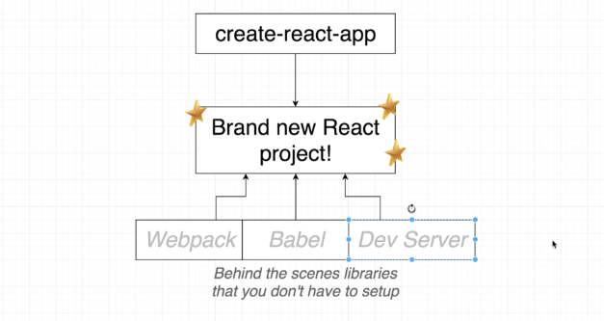

Babel is a command line tool that can take any version of JavaScript and spit out a newer version ES5 JavaScript

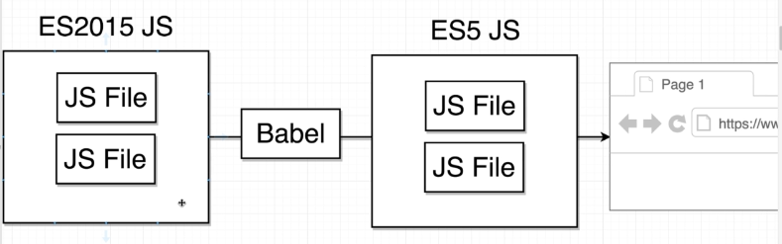

7. Exploring a Create-React-App Project

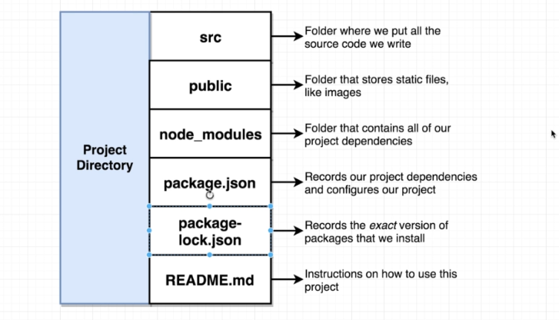

9. Javascript Module Systems

The difference between ES2015 and CommonJS module system

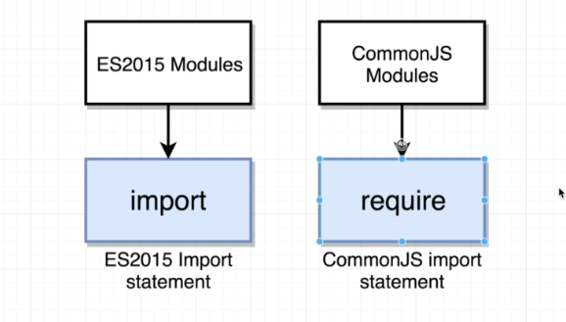

We make use of an import statement that is a reference to a module system called ES2015

This module system is essentially a set of rules that describes how code can be shared between different JavaScript files.

CommonJS Module System: this is a different set of rules that also governs how to share code between files.

10. Displaying Content with Functional Components

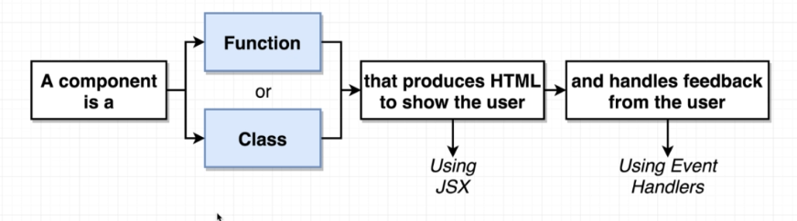

What is React Component is?

3 basic steps to show on the browser using react.

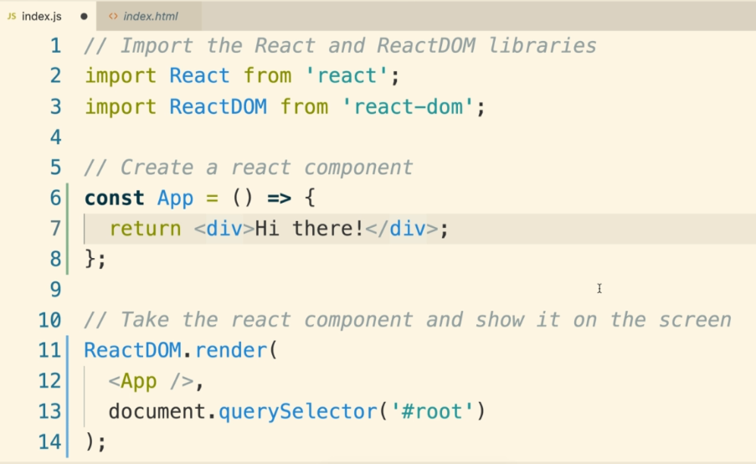

2. Building Content with JSX

1. What is JSX

Babel is also use to process the JSX as well. Before it was sent to browser, it just converts JSX into normal JavaScript code.

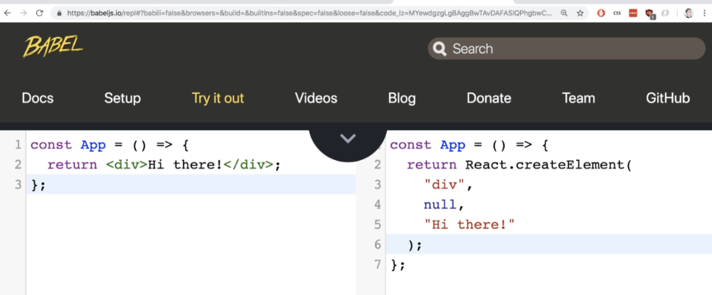

To make syntax simpler, we use JSX

6. Referencing JS Variables in JSX

You can use **array** as variable reference but, you cannot use **object**

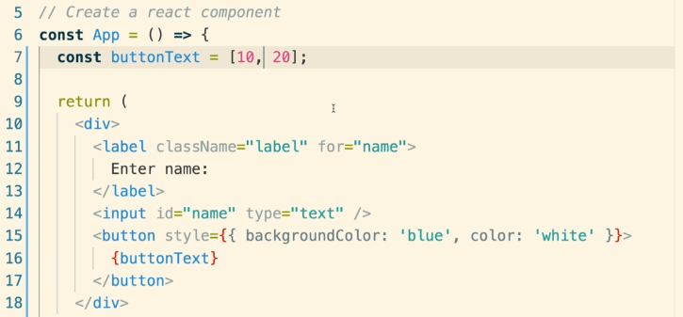

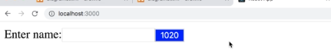

**You can print the whole array by giving reference like above**

Below, you can see, object cannot be used as variable reference.

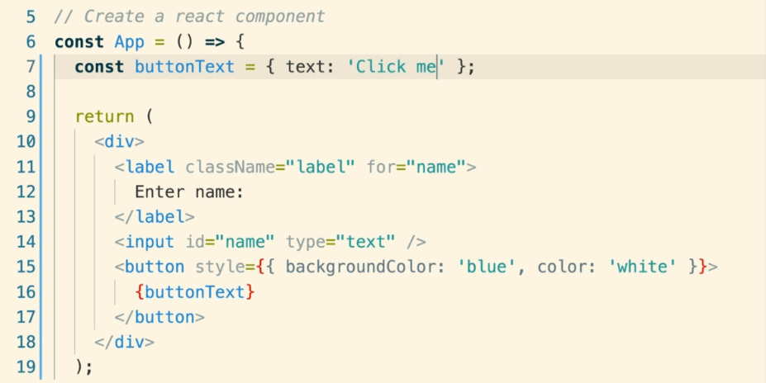

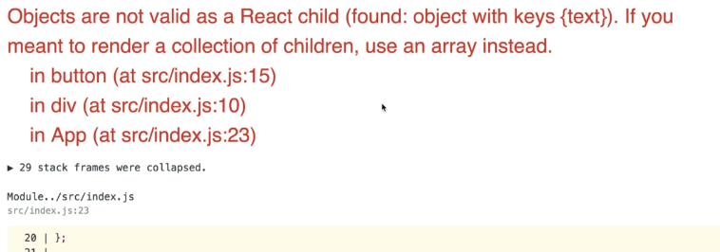

You can fix it by, extracting primitive value

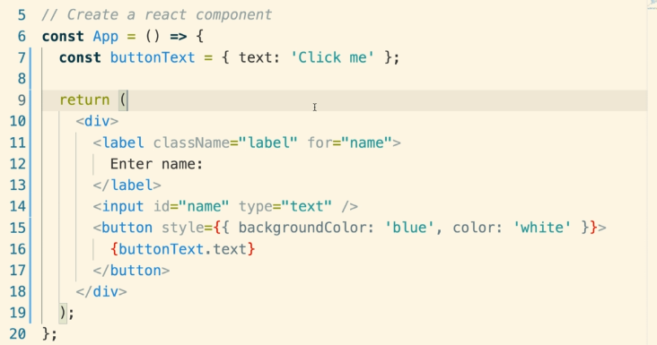

8. Finding Forbidden Property Names

**HTML properties** which are not available in **JSX.** You can find it into browser development tool like here **“for”** is unknown property that we used in label.

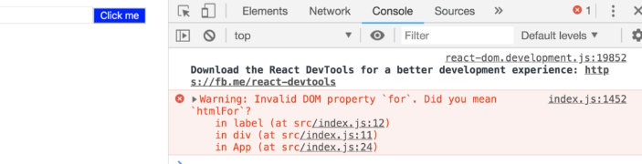

React wants “for” to be replaced with “**htmlFor”**

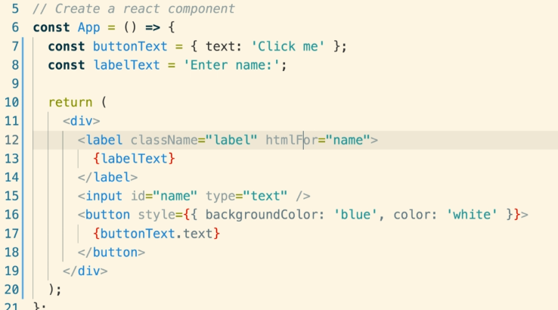

**3. Communicating with Props**

**1. Three Tenets of Components**

Three big important concepts of components

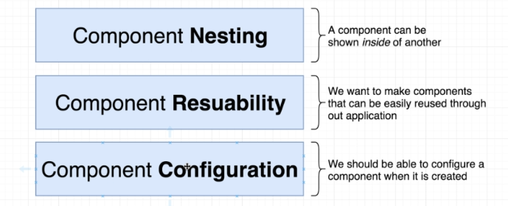

**Component Configuration:** A component must be customizable like a button can have different names.

3. Getting Some Free Styling

For styling, we used

<https://cdnjs.com/libraries/semantic-ui>

Added this into index.html

<https://cdnjs.cloudflare.com/ajax/libs/semantic-ui/2.4.1/semantic.min.css>

`

**5. Specifying Images in JSX**

When we don’t have data, we can use a library called **faker js** for dummy data.

[**https://github.com/marak/Faker.js/**](https://github.com/marak/Faker.js/)

Let’s use it for fake avatar image

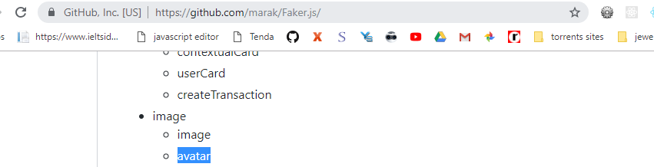

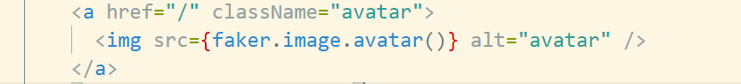

7. Extracting JSX to New Components

Keep these things in mind before creating a new component.

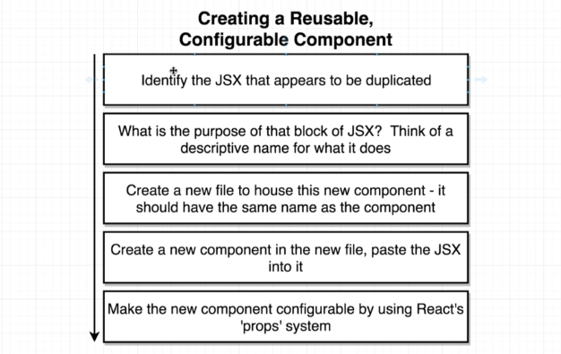

The name of a component should start with a capital letter and with camelcase style

Example:

**CommentDetails.jsx** component

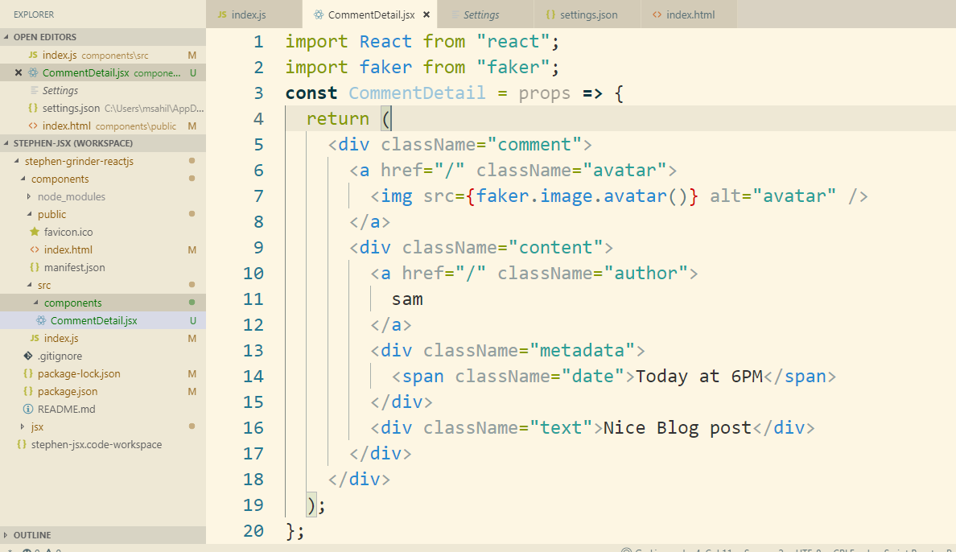

9. React's Props System

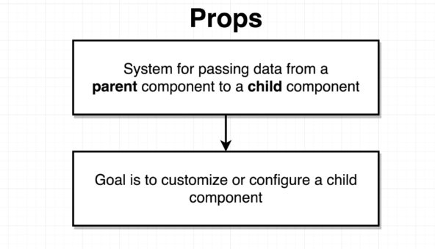

10. Passing and Receiving Props

**Note:** the first param in a component will always be “props”

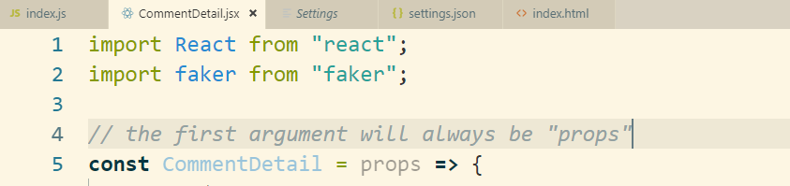

11. Passing Multiple Props

2. Passing Props - Solutions

This is the way we pass multiple props

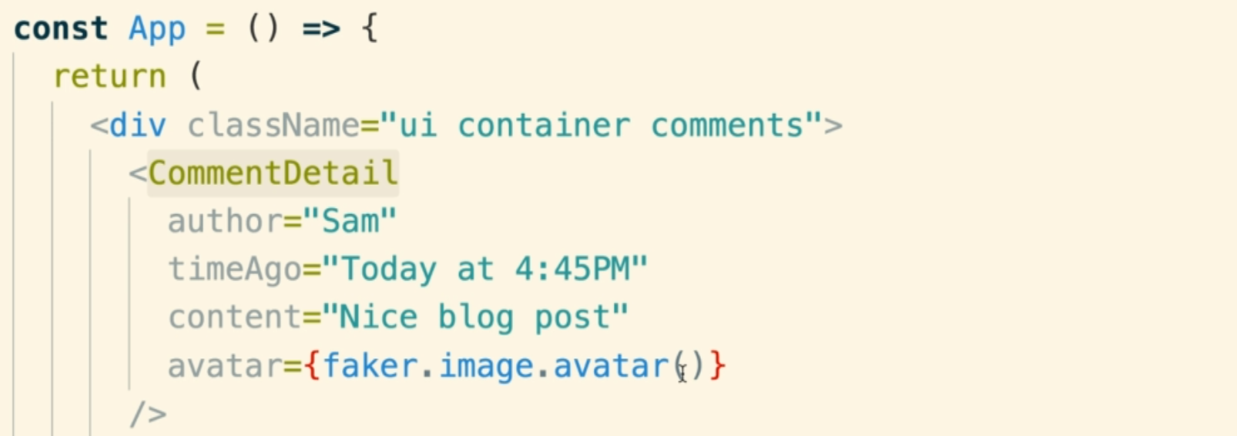

13. Component Reuse

14. Implementing an Approval Card

Get card HTML from semantic ui website in the view section and make a new component called ApprovalCard.jsx and add the HTML.

Add this component into index.js

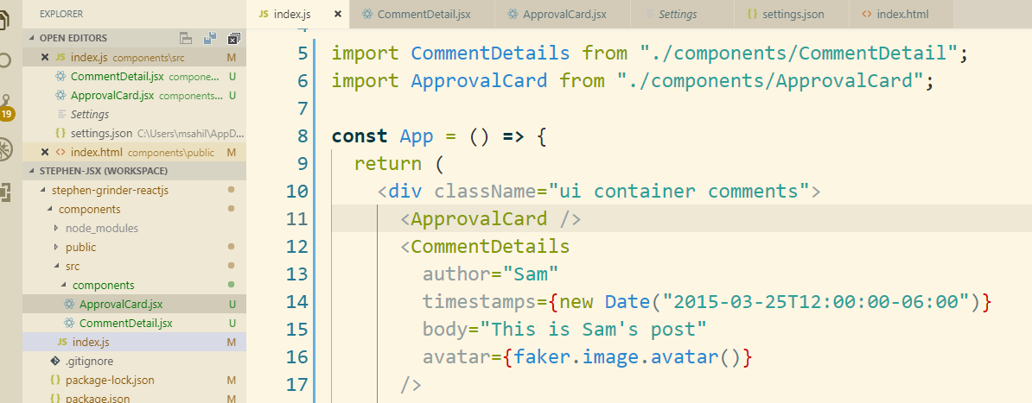

15. Showing Custom Children

If we add a component inside a component then that inside component becomes children of the parent component and it is available as “props.children” on the parent component.

Example:

Index.js

We added <CommentDetails> inside <ApprovalCard> component.

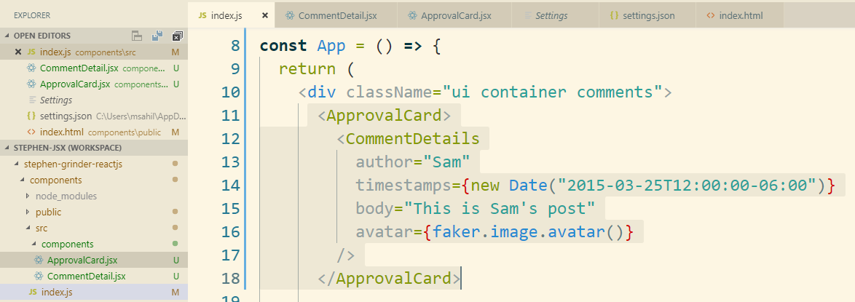

Let’s see how we can display this children component using “props.children”

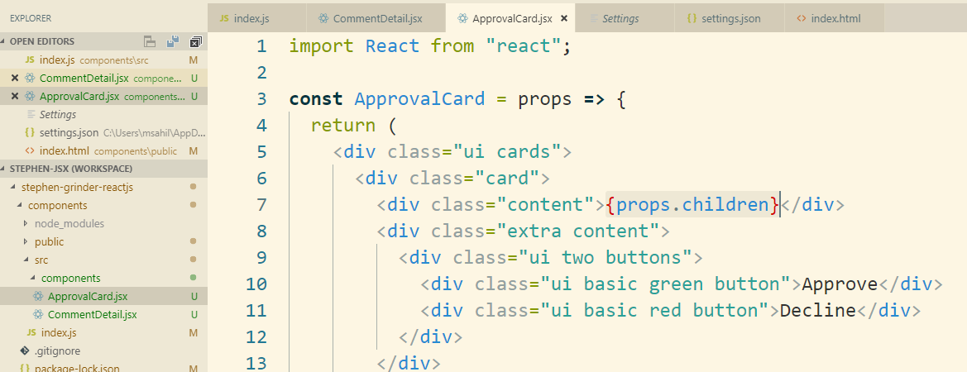

4. Structuring Apps with Class-Based Components

11. Class-Based Components

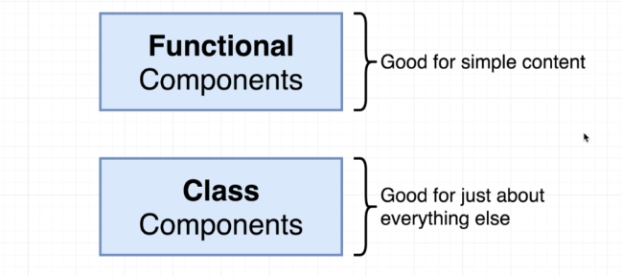

**Functional Component:** creates some kind of JSX and simply return it.

**Class Component:** complex logic, anything that needs to respond to user input.

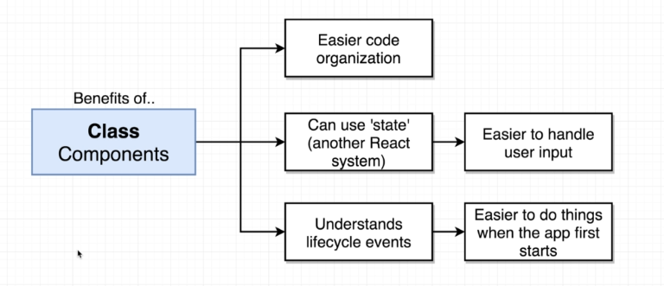

2. Application Overview

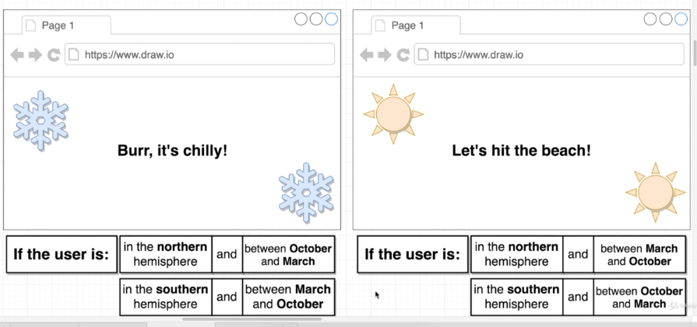

We are going to detect season what user experiences

These are the data we will need to build this application.

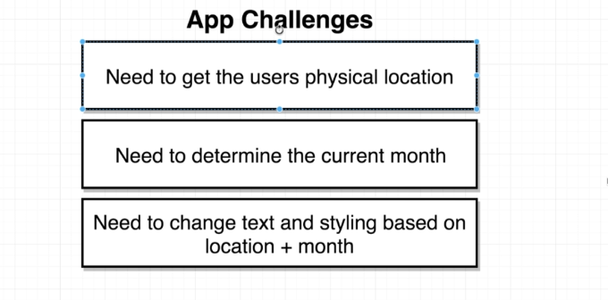

Let’s create a new app called “seasons”

**npx** create-react-app **seasons**

3. Scaffolding the App

These are the components we will need to build the app

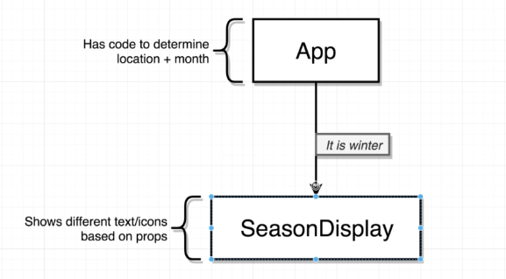

4. Getting a Users Physical Location

**GEO location** is built-in into most modern browsers.

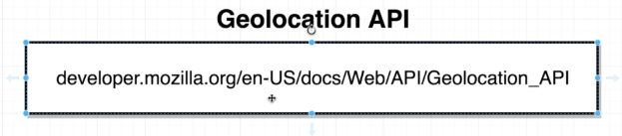

**window.navigator.geolocation.getCurrentPosition()**: it takes 2 callback functions.

1. It gets called when the function gets user’s location successfully.

It returns longitude and latitude

1. It gets called when the function is not able to get the user’s location. It is a failure callback

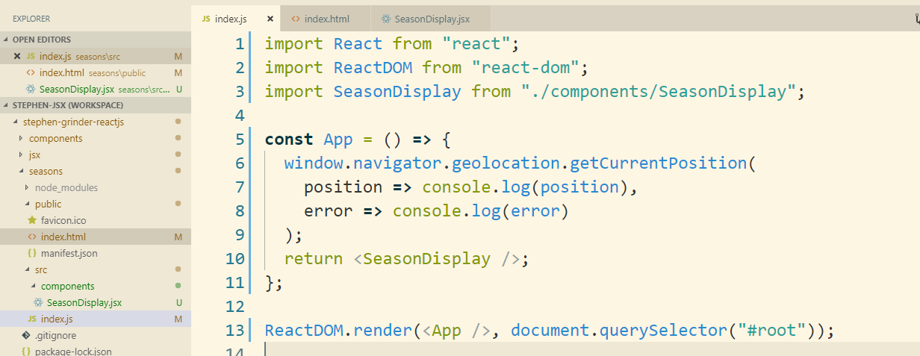

5. Resetting Geolocation Preferences

You can reset browser location settings to test your application.

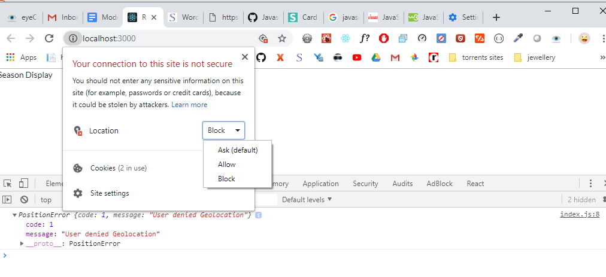

6. Handling Async Operations with Functional Components

For handling **Async operation** , we need to convert this functional component into class component. Since when the async result comes, we don’t have functionality to re-render the component with update values.

7. Refactoring from Functional to Class Components

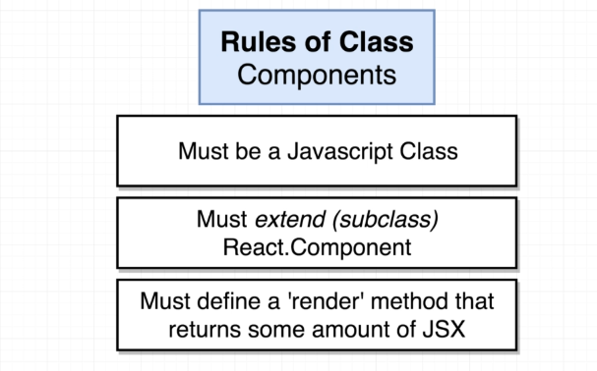

5. State in React Components

1. The Rules of State

**Note:** we can also use **“state”** with functional component using **“hooks system”**

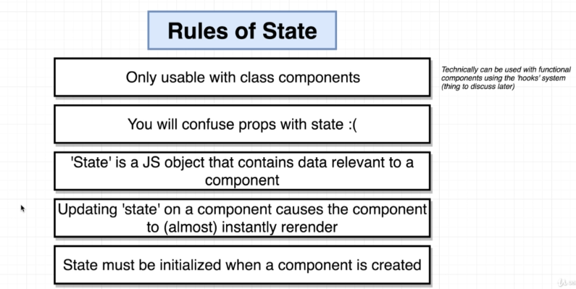

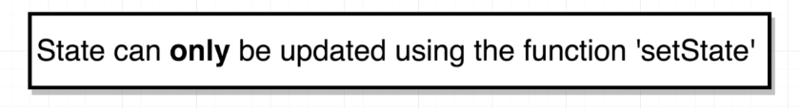

2. Initializing State Through Constructors

Note: When we define a **constructor function**, it is going to be automatically called with the **“props” object**

As we are using constructor, we have to call **super(props)** with props inside the constructor

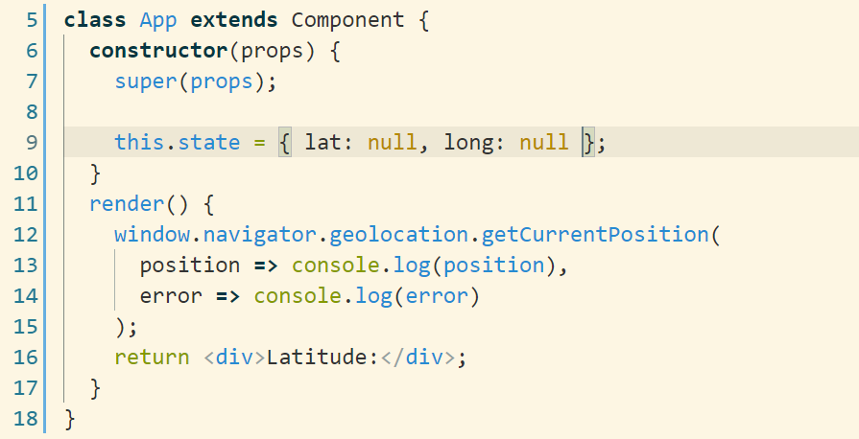

3. Updating State Properties

**Note:** We must not initialize something in the render method since it calls frequently.

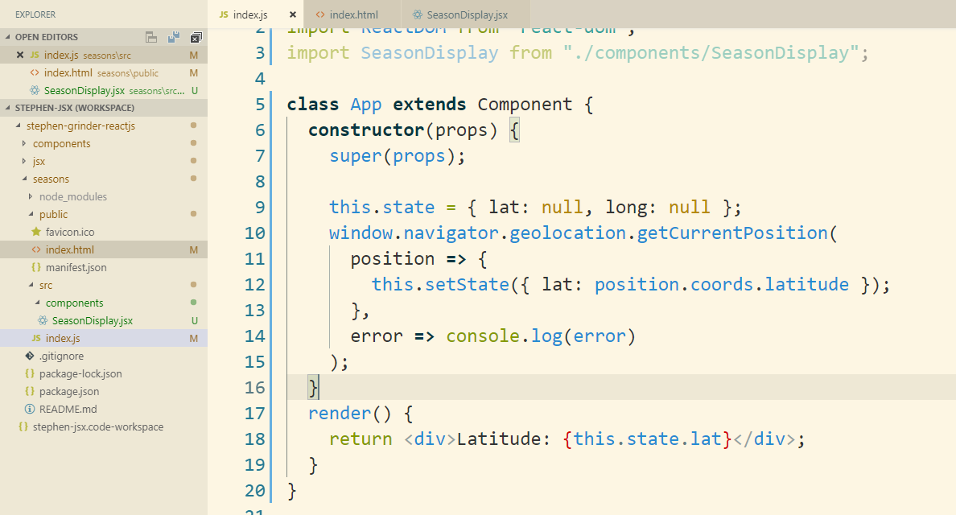

4. App Lifecycle Walkthrough

Steps to React lifecycle

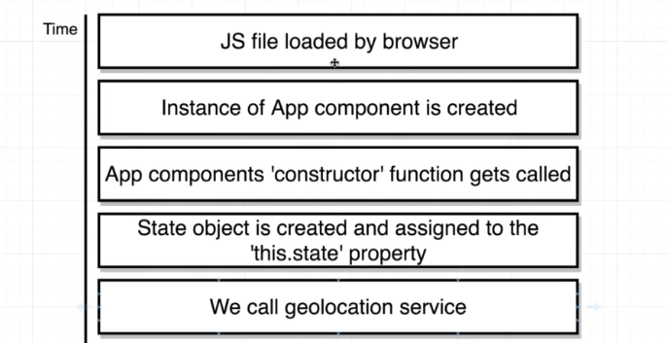

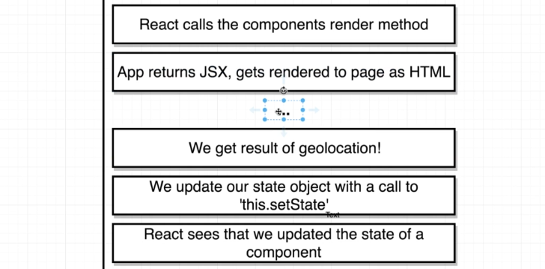

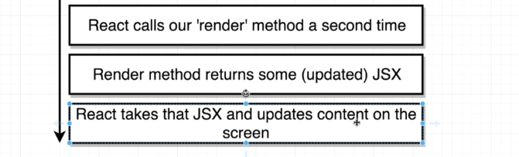

1. We load index.html inside our browser and that requested a JavaScript file with all of our React code inside of it
2. JavaScript file was loaded by the browser and then execute
3. When the JavaScript file was executed, we created a new instance of the **“app components”.**
4. The first function that is going to be called inside our component automatically is **“constructor” function**
5. It is optional. We can use if we want to require some initialization. If we use it, we have to call super(props) function with props.
6. In the constructor, we initialize **“state” object**

7. We call the geolocation function

**Note:** The below position callback functions inside **“getCurrentPosition(callback1, callback2)”** is not going to be invoked until we eventually returns from the constructor.

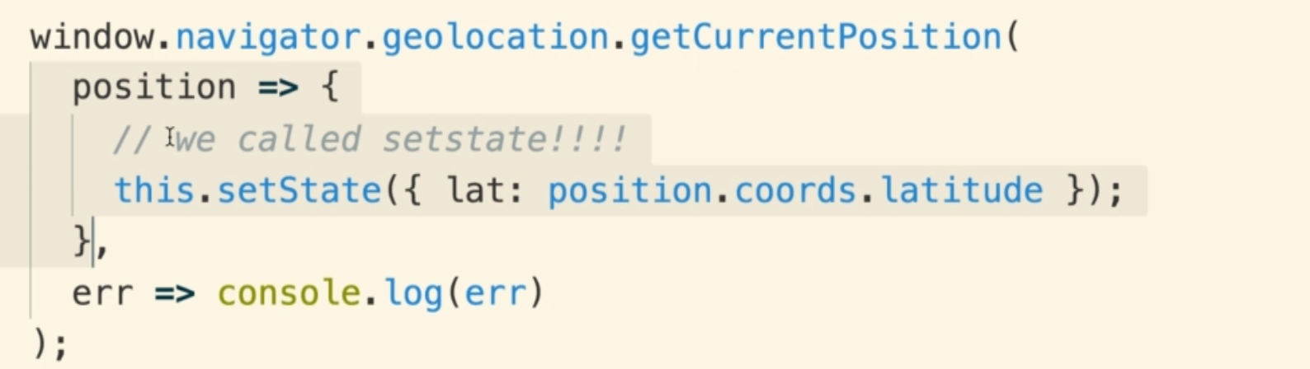

5. Handling Errors Gracefully

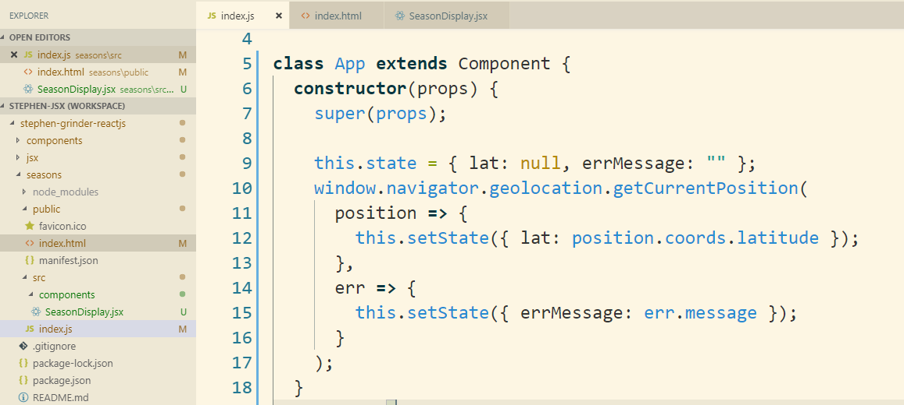

6. Conditionally Rendering Content

We have 3 states that we need to consider and based on these conditions, you can write code.

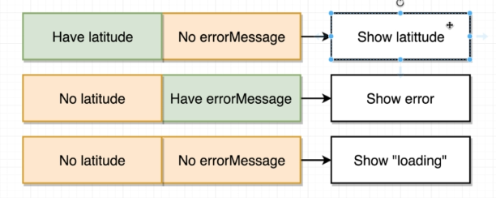

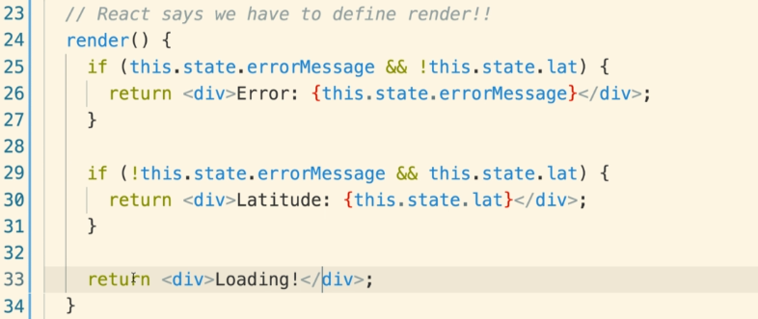

6. Understanding Lifecycle Methods

1. Introducing Lifecycle Methods

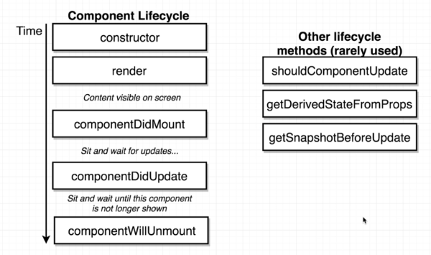

**ComponentDidMount:** When the component is mounted into DOM. It calls one time.

**getDerivedStateFromProps** is one of those newly introduced lifecycle methods replacing componentWillReceiveProps

**Note:** You don’t need to use **above 3 rarely used lifecycle** methods unless you are very sure of it

2. Why Lifecycle Methods

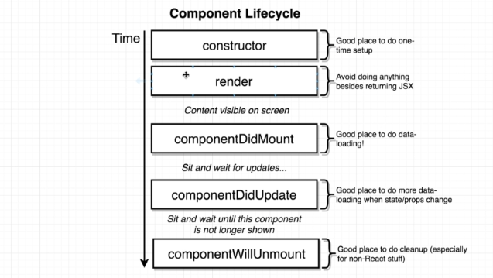

**Constructor function** is a good place to do our state initialization. We can also do some data loading inside of a constructor like making a network request to some API. We need something before the component is shown on the screen. (it is recommended to make data loading inside ComponentDidMount())

**render():** we just try to get some JSX returned.

**Note:** We aren’t going to make a network request.

We will not fetch something like user’s location.

It is just about returning JSX, and not doing anything else

**ComponentDidMount():** it is a perfect location to do some initial data loading

for your component or some outside process like call APIs.

**Note:** it only gets invoked one time.

**ComponentDidUpdate():** it gets called every single time when a component is

updated. It can be updated due to state change or component

gets a new set of props.

It is also a good location to do some data loading that needs

to be done every single time.

A good example of this is that if we wanted to make some type

of network request every single time that user click on a button

or every single time that they enter some text into an input

or every single time that we get some new props from a

parent component

.**ComponentWillUnmount():** it is used every time we remove a component from the screen

and we need to do some cleanup after it.

**Note:** it only gets invoked one time.

3. Refactoring Data Loading to Lifecycle Methods

Just moved geo location from constructor to ComponentDidMount() since is recommended for data loading.

4. Alternate State Initialization

These 2 state initializations are 100% equal so let’s use the shorter one in the project.

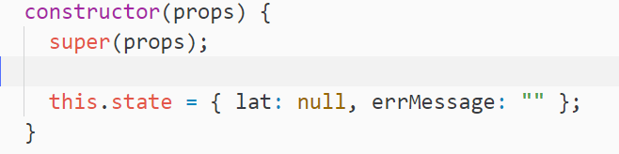

VS



5. Passing State as Props

6. Determining Season

On the basis of latitude, we will decide the month

To get current month, here is a function.

Note, it starts with 0

 returns 1 as february

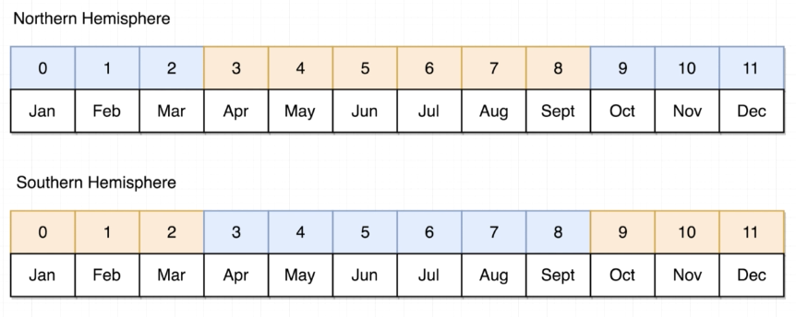

This is the way we implemented above diagram

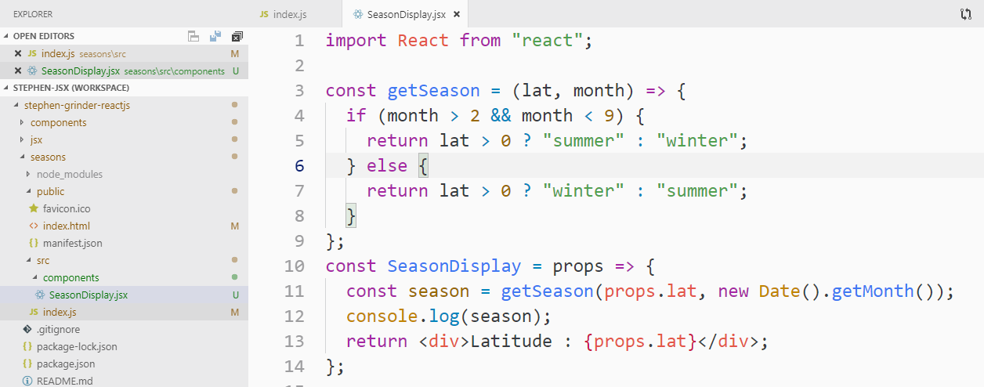

7. Ternary Expressions in JSX

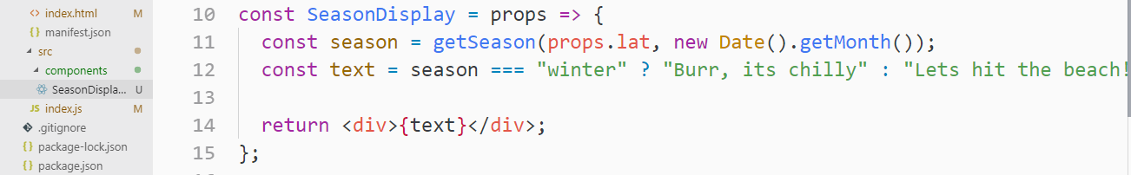

8. Showing Icons

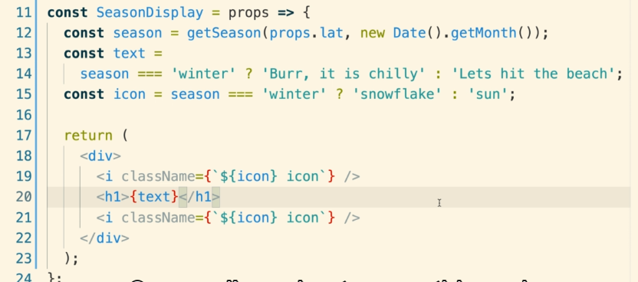

9. Extracting Options to Config Objects

To avoid duplicate condition like below, We use the **“config object pattern”**



**This is the solution to the above duplication code**

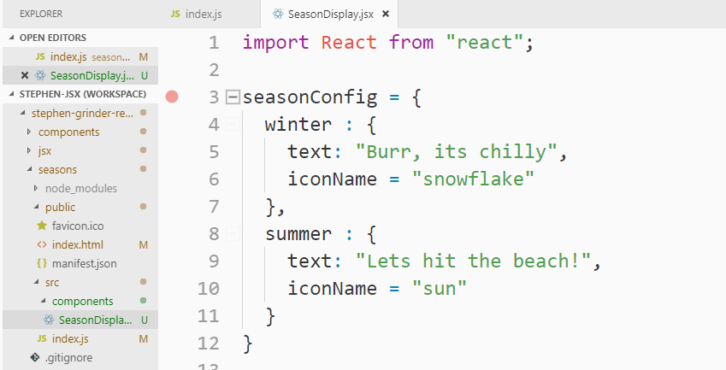

**Destructuring the above seasonConfig object**

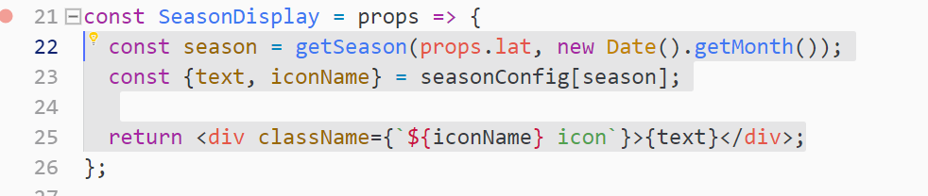

**10. Adding Some Styling**

When we add a CSS file like this inside a component, Webpack takes the imported CSS file and adds that to index.html

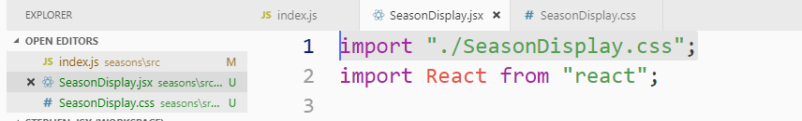

**Note:** Keep the root element class name same as Component name like dashed version as I have used. It is just a proper naming convention.

SeasonDisplay => season-display

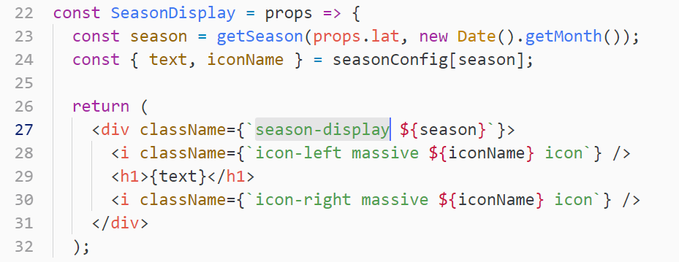

**11. Showing a Loading Spinner**

Note: we added loader/spinner in the render() method

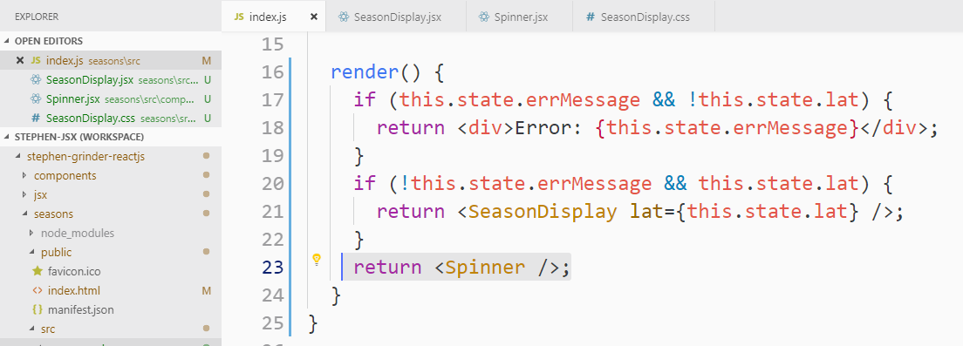

You can get spinner code from semantic UI

12. Specifying Default Props

There are 2 ways we can add default props

1. Using ternary condition like this, but this is not the best approach



This is the best approach!

2. Spinner.defaultProps = {message : “...Loading” }

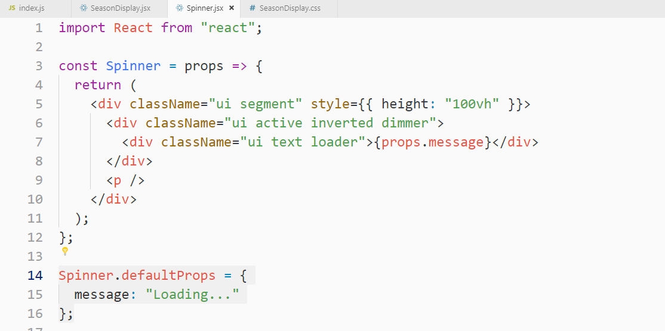

If we don’t pass this props while using <Spinner> component, it will take this default props.

13. Avoiding Conditionals in Render

Instead of multiple returns on the basis of condition in the render() method, user helper function instead.

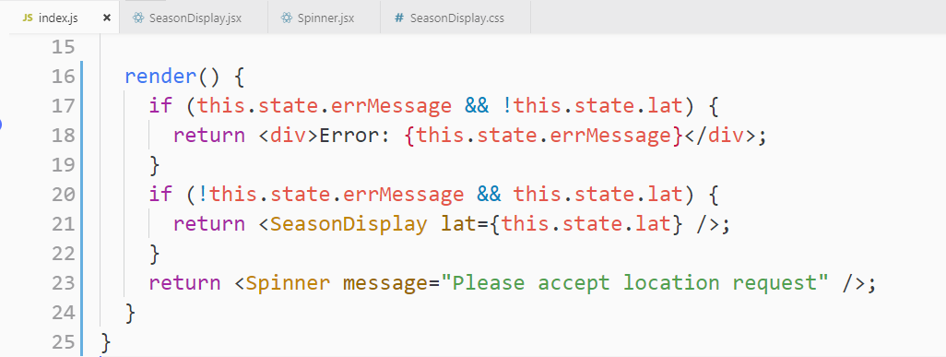

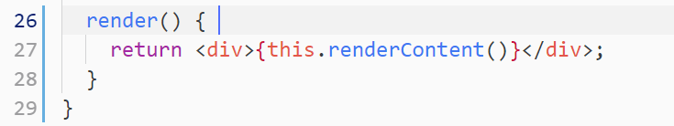

Let’s create the above helper function

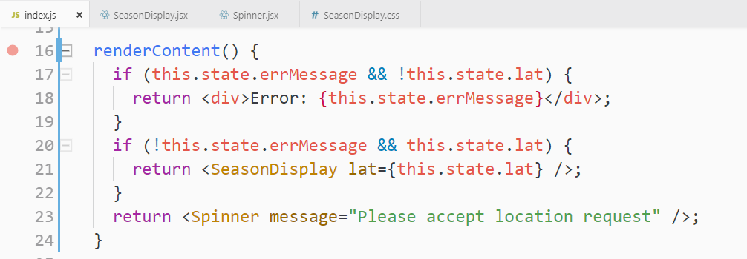

**Note:** never use multiple returns in render() method instead use a helper function.

14. Breather and Review

**Note:** Always put component at the last and put all the config object and helper functions above the component declaration. In the below Seasonal component we declared component at the end and helper function **“getSeason()”** above it.

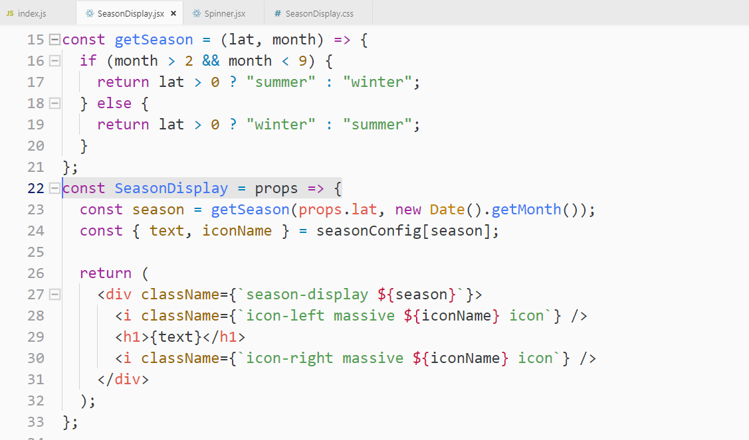

7. Handling User Input with Forms and Events

1. App Overview

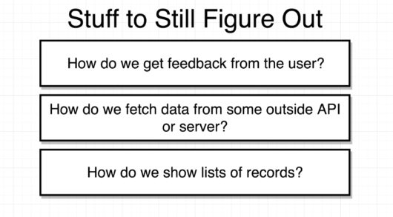

There are 2 versions of the application that we are going to build.

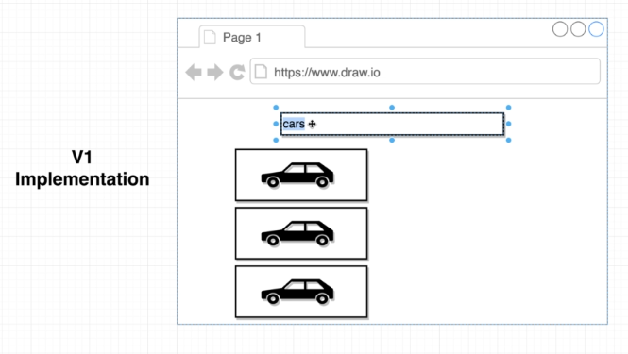

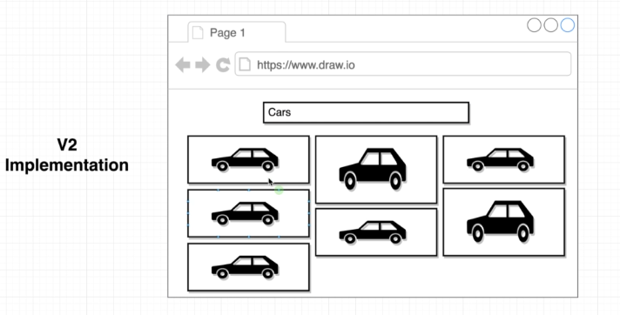

2. Component Design

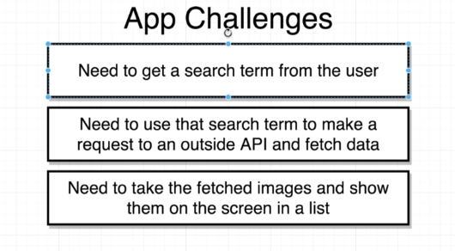

Structuring components for our App. There are 2 component we will create.

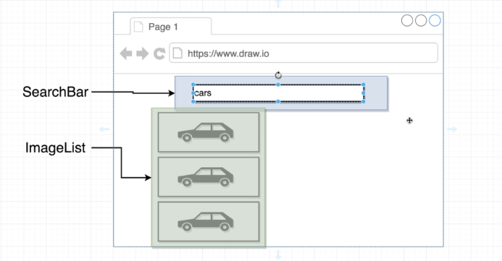

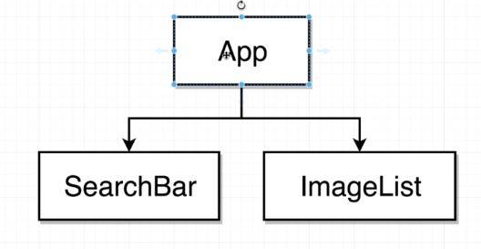

3. Adding Some Project Structure



This is the way we structure our components

Index -> App -> SearchBar

-> ImageList

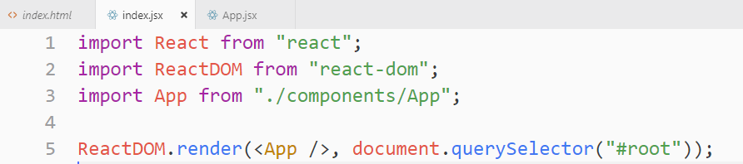

4. Showing Forms to the User

6. Creating Event Handlers

Note: Whatever function we add to an event on input field is a callback function so we just pass a reference of a function like this without parentheses

**“onInputChange”** is a callback function. This callback will be ran with one argument being passed to it automatically and we refer to the object as **“event” object.** This is a normal JavaScript function that contains a bunch of information about the **event** that just occurred.

We mostly want text that the user entered and we can get that using

**event.target.value**

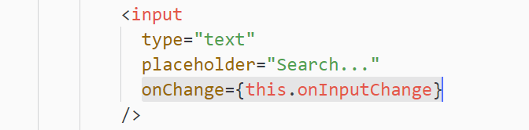

**Note:** certain events will not work with every element. For example

With “Div” **onChange**, and **onSubmit** will not work, but **onClick** will work.

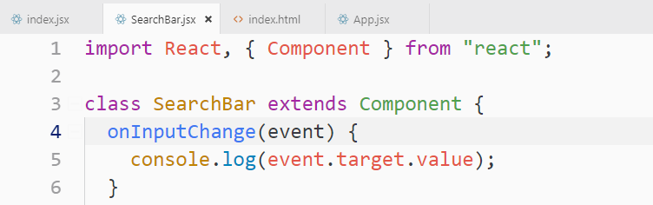

7. Alternate Event Handler Syntax

The below 2 syntaxes are identical. The **arrow function** is just an abbreviated syntax.

We use the **“arrow function”** frequently anytime we have a single line of code that we want to execute or anytime that some event occurs

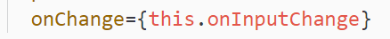 

8. Uncontrolled vs Controlled Elements

This input is an uncontrolled form element. We generally prefer to work with **“controlled” element**



Here we will convert the above **uncontrolled** form element into **controlled** element.

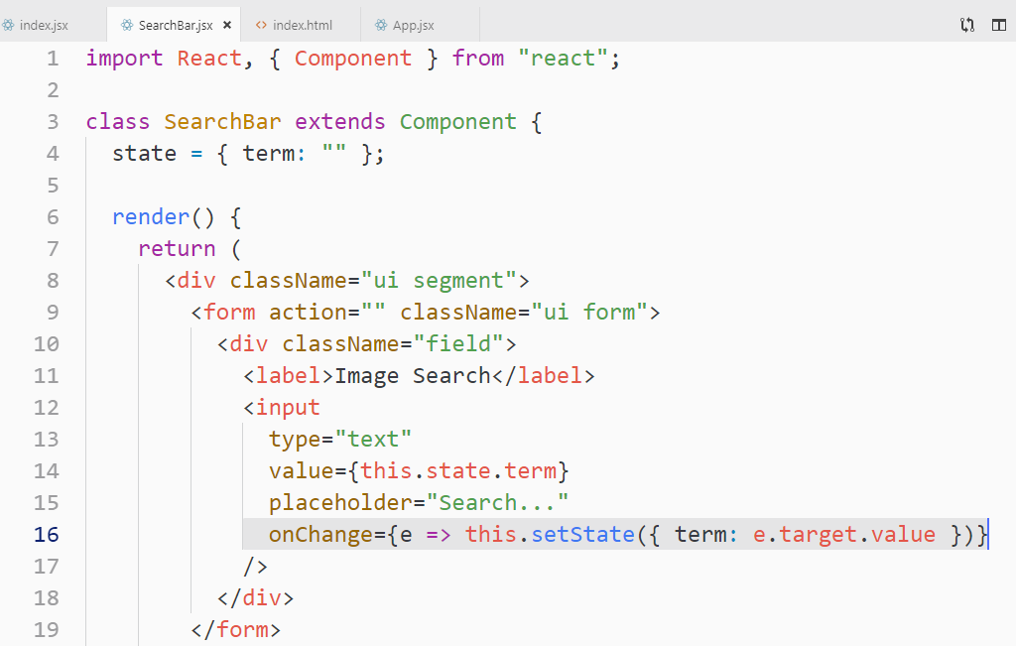

This is the flow of the above setState into input box

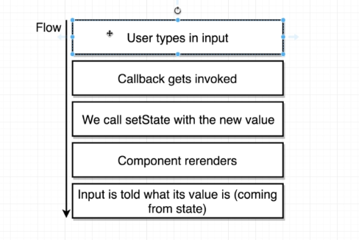

We can control the element like setting initial value to input or making the typing capitalized.

Example:



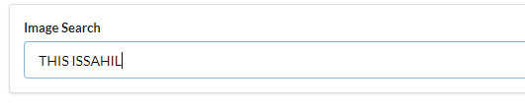

10. Handling Form Submittal

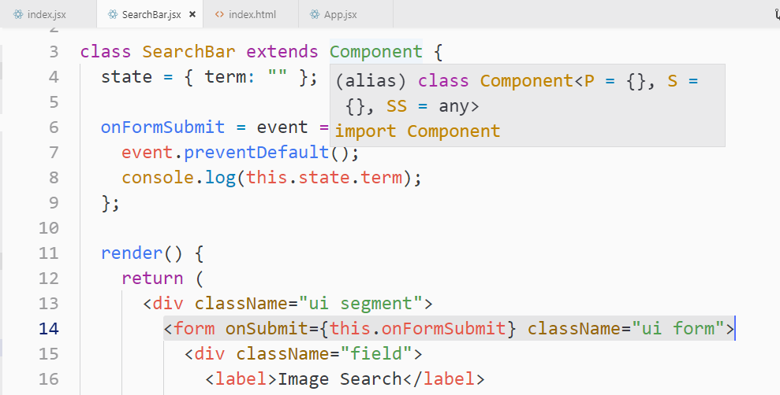

11. Understanding 'this' In Javascript

**Note:** an Instance of a component is created anytime it renders to screen.

**“this”** refers to left side object after dot

Like in the given example **“driveMyTruck”** has “this” as **“truck”** object

**Note:** Don’t look at the function where it is, just look where it is called by looking at left side of the dot.

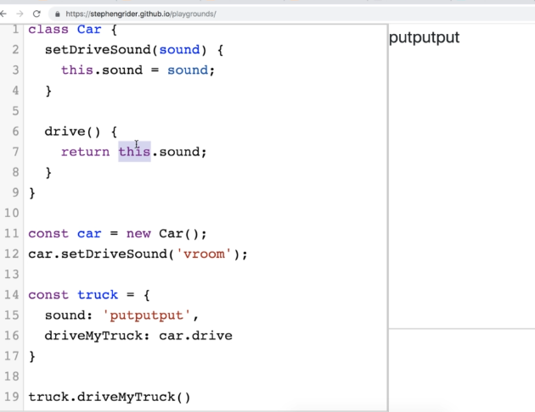

12. Solving Context Issues

There are many ways we can solve this context problem.

1. Using the constructor function and bind the required function

**Note:** if we are not extending class, we don’t need to call the super() inside constructor.

This is one way of solving context problem.

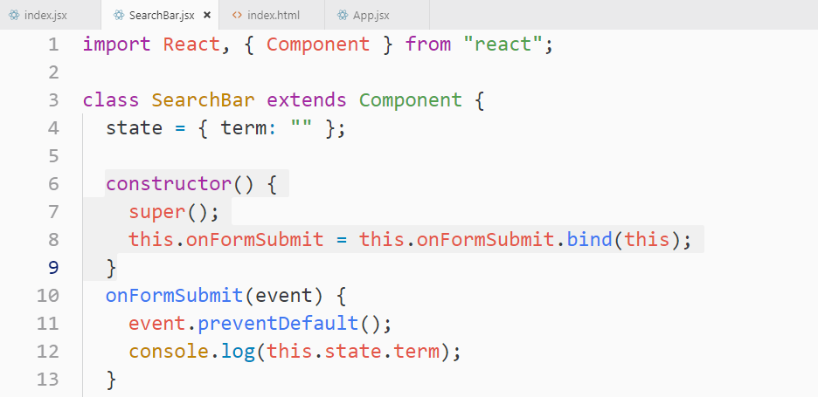

**The 2nd ways** we can use above onFormSubmit function one is by using **arrow function**

**Note: arrow function => automatically binds the value of “this” for all the code inside the function**

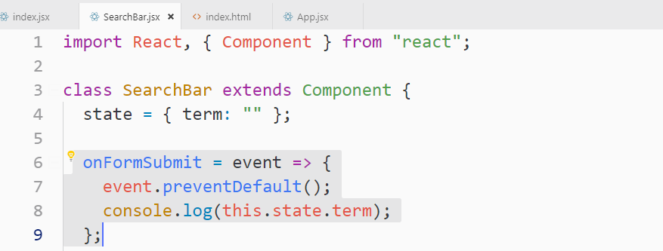

**The 3rd way** we can use is to add callback function using arrow function

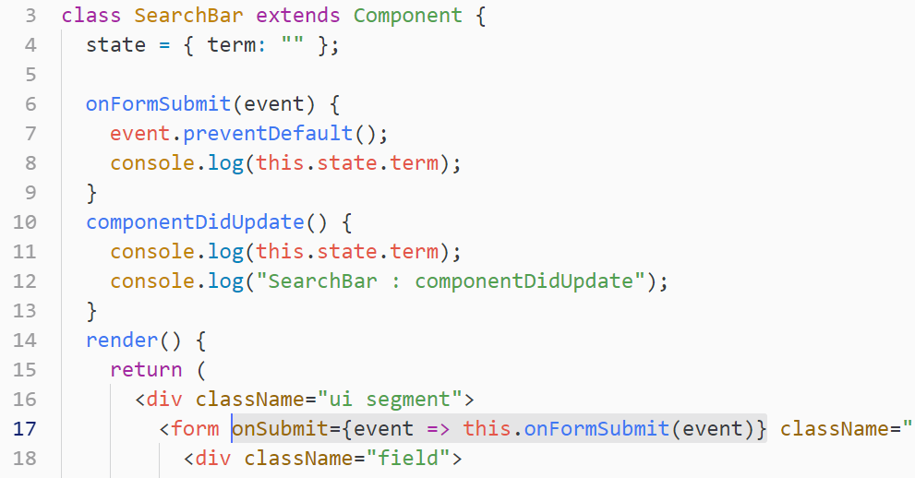

13. Communicating Child to Parent

To get the data from child to parent, we pass callback from parent to child. An event happens on the child like click or submit and passes the callback that it was given to parent and there the callback called

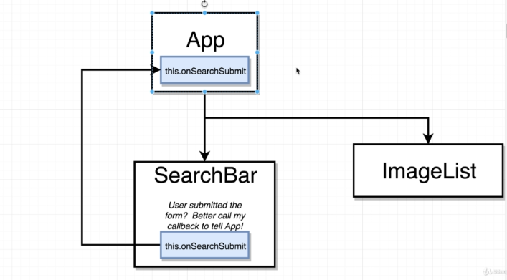

14. Invoking Callbacks in Children

The difference between functional props and class base props is that

On functional component we call it => **props.property**

On class base component we call it => **this.props.property**

Steps to pass a callback

1. Created a onSearchSubmit() function on App.js
2. Pass it as a props on <Search onSumit={this.onSearchSubmit}> component with the name of props as **“onSubmit”**
3. On search component call onSumit() props function inside the seachBar components` local function called **onFormSubmit**

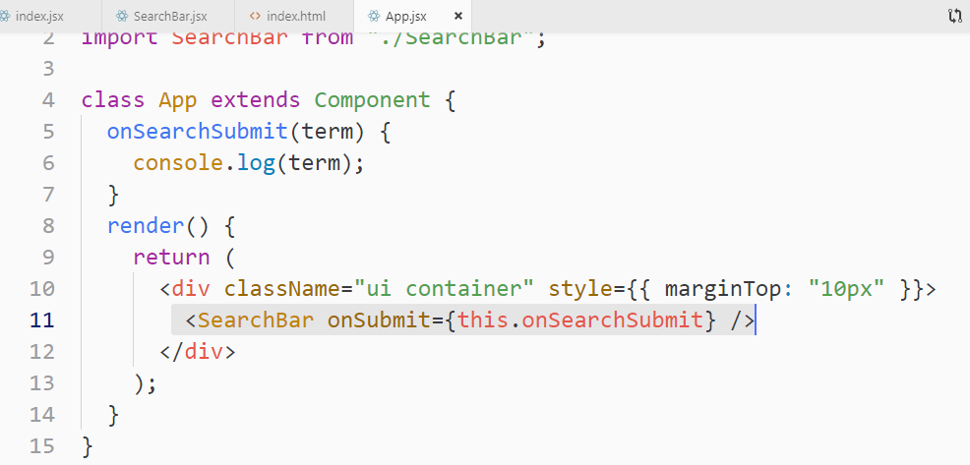

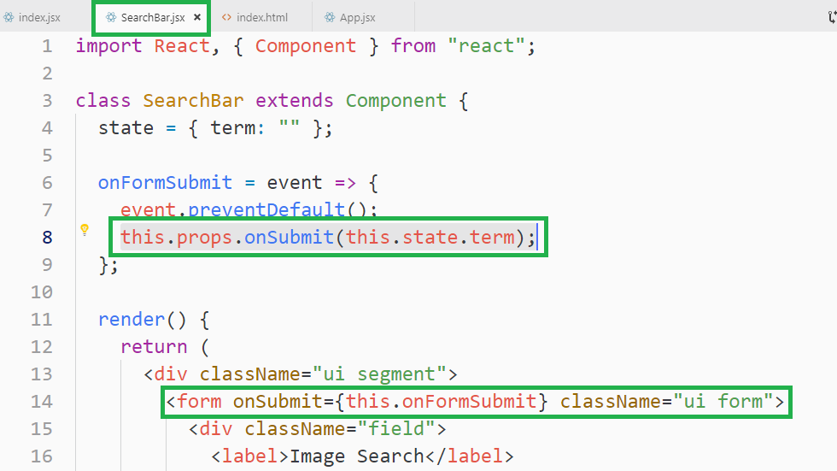

8. Making API Requests with React

1. Fetching Data

We will use this service to fetch images data

<https://unsplash.com/documentation#list-photos>

Access Key

1b499e9510d0d3b4ef9ea9e2a0665aab98af6fbac838d0f8613cfaaa83cb973a

Secret key

Fded9500ce372946a1d08e89f50f7791349589f7b143b6ab9fd3ea542eaaed62

2. Axios vs Fetch

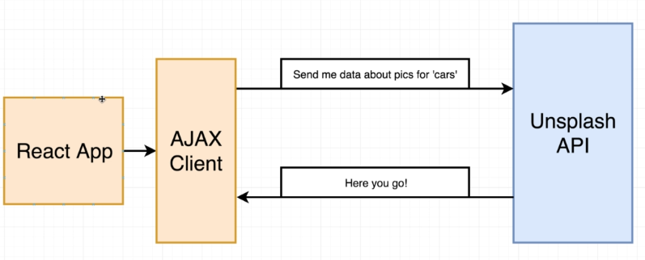

It is not the job of “React Library” to make API request. React as a library is only about showing HTML content to our users and interacting and handling user interaction.

There is a separate library to make Ajax / API calls. These are 2 libraries to make API requests

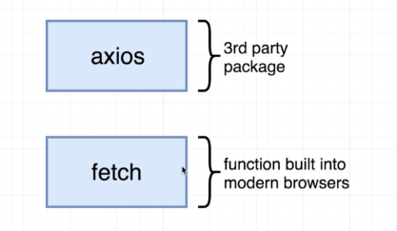

**Axios** is a 3rd party package that can be easily installed using NPM

**Fetch function** it is not a separate package like Axios. It is a singular function that is built into almost all modern browsers. With **fetch**, we don’t have to install any extra package which means that our final application size or the amount of code we have to send down to a user’s browser is slightly smaller if we make use of **fetch function**, but it gives you basic functionality and you have to write a lot more code for other functionality which is already written in **Axios**

3. Viewing Request Results

4. Handling Requests with Async Await

This is the way we make Axios request with Async and Await.

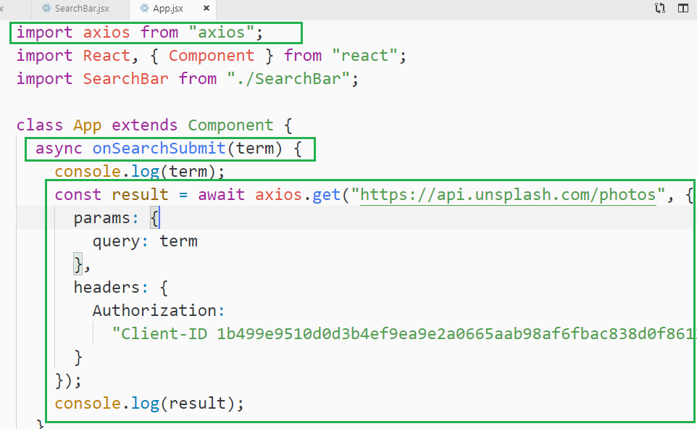

5. Setting State After Async Requests

Note: Initialize the state value as expected result type instead of null so If I initialize it with empty array I can call map method on it. If the actual result it empty I won’t get any error, but if initialize it with null, it will throw an error of map of undefined

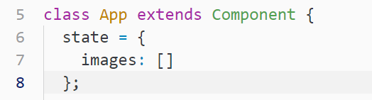

For setting state, we need to convert **onSearchSubmit** function into a fat arrow function as it will give **context issue** while setting a state

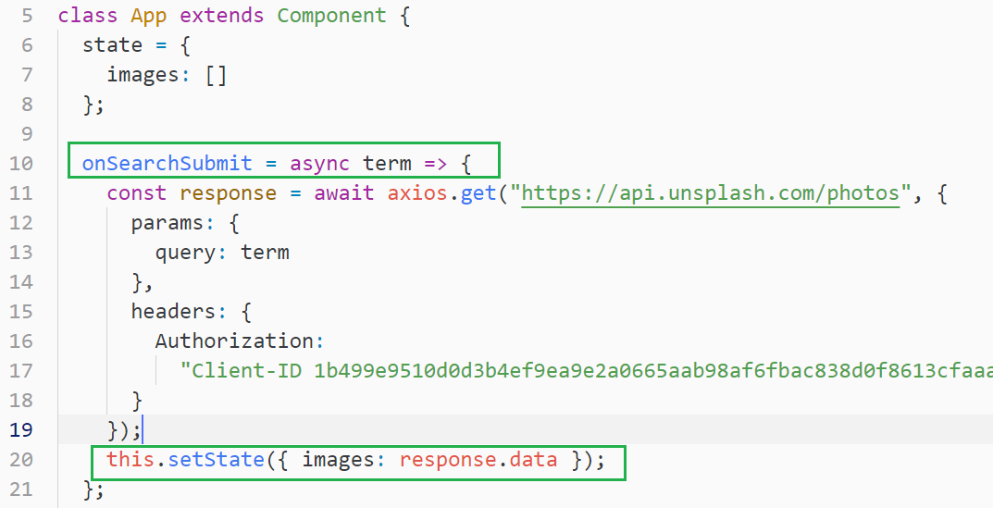

7. Creating Custom Clients

**Axios.create** => this method creates an instance of axios client with couple of default properties

1. Create a folder called apis
2. Create an api source file like the name of the API. here in this case we are calling unsplash api so **create unsplash.js**
3. Added default configuration for unsplash apis

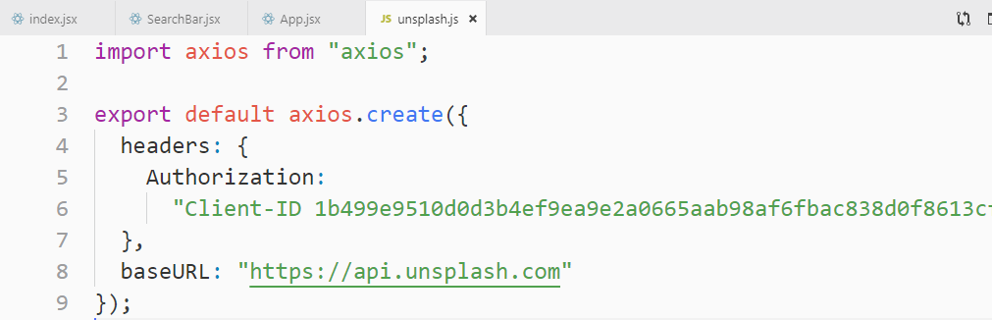

Now instead of calling axios, we will call unsplash

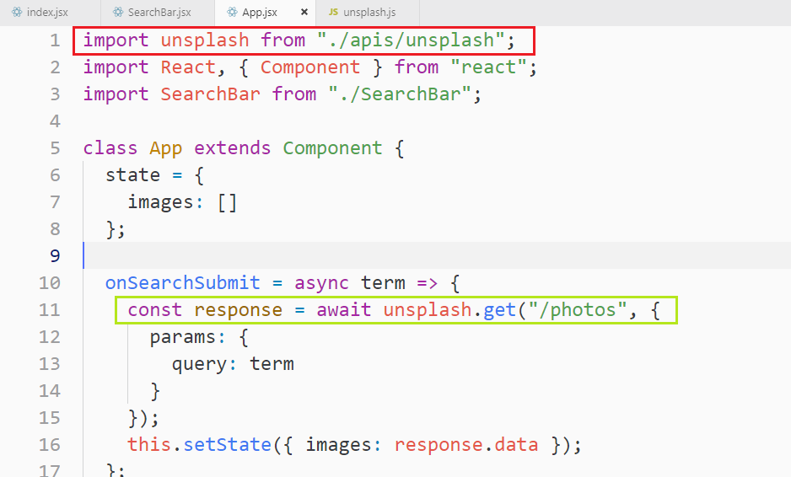

9. Building Lists of Records

1. Rendering Lists

2. Review of Map Statements

3. Rendering Lists of Components

4. The Purpose of Keys in Lists

**React compares** the key and the text inside it if both are the same, it won’t render it to the screen.

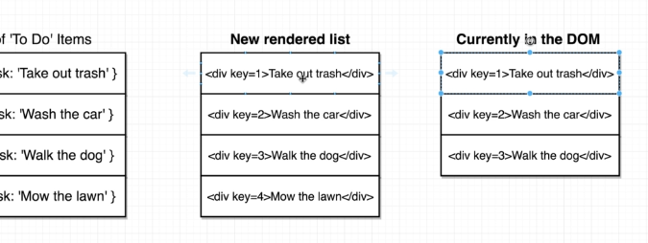

5. Implementing Keys in Lists

This is the whole code of the above 1-5 sections.

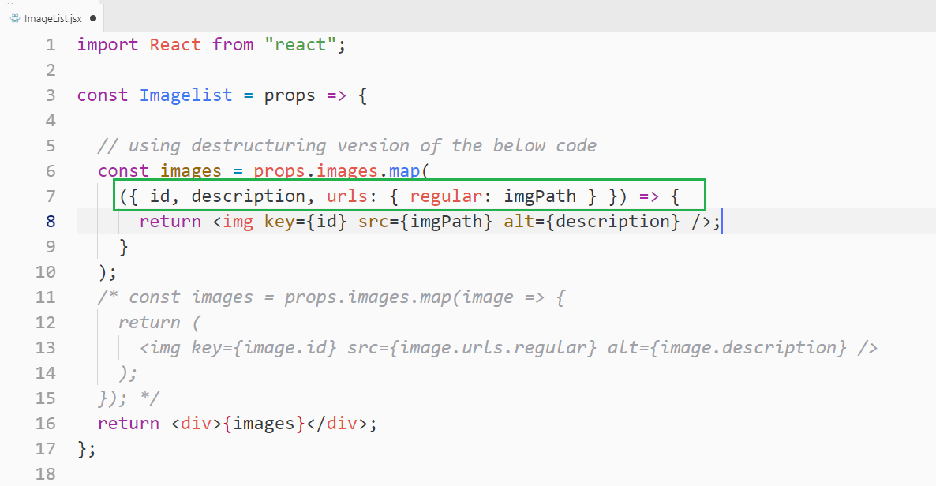

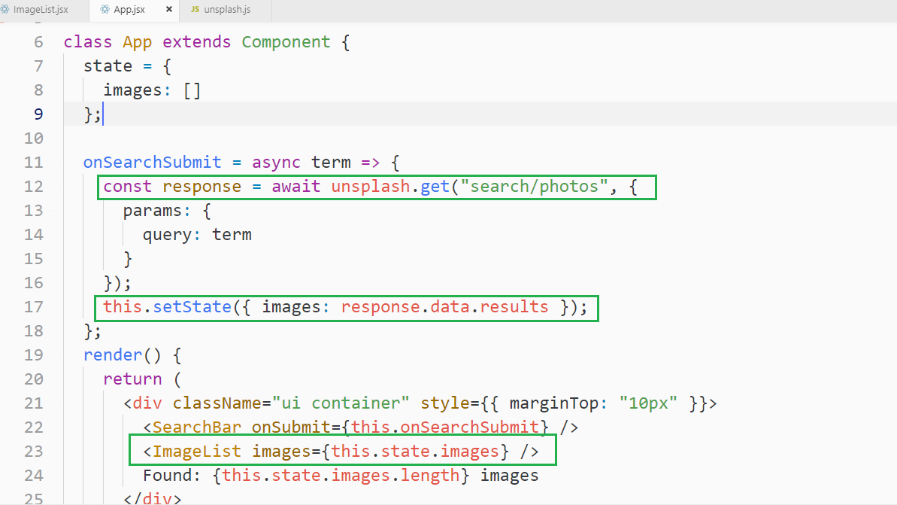

10. Using Ref's for DOM Access

1. Grid CSS

We used CSS3 grid system.

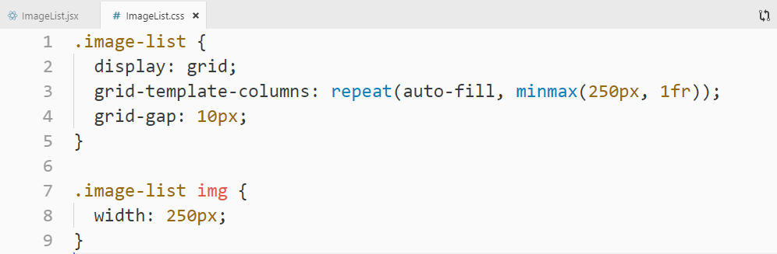

**1fr** : it means, every column that we create, we want them to be equally same size

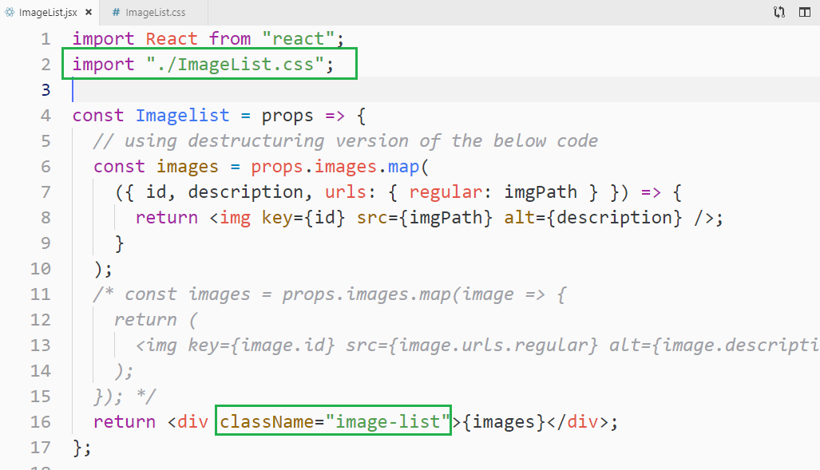

2. Issues with Grid CSS

Grid-row-end: span 3

This will add space all the images, but only want the span to be added if an

image is needed. This we will do by React.

3. Creating an Image Card Component

Created a new imageCard.jsx component

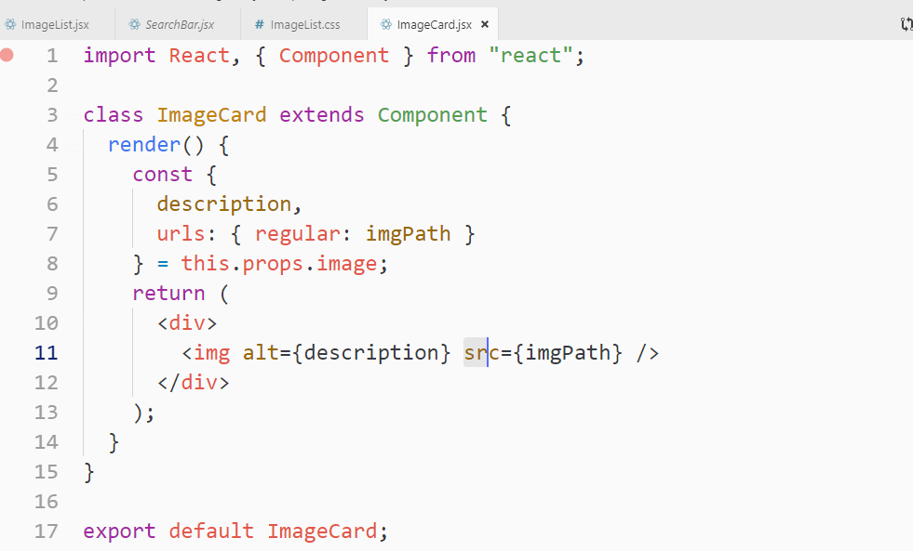

Adding above imageCard component into **ImageList.jsx**

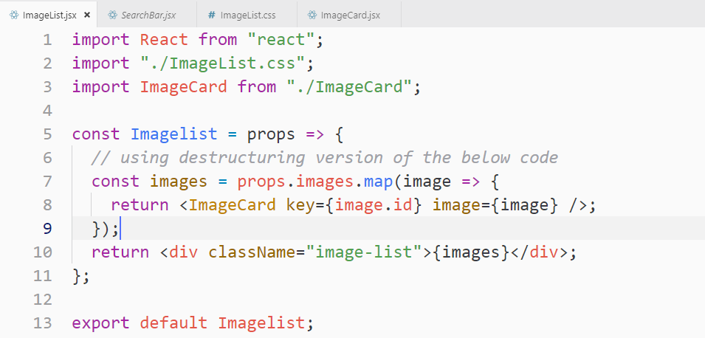

4. Accessing the DOM with Refs

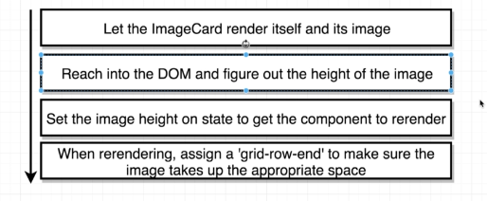

To work directly with DOM, we use **ref**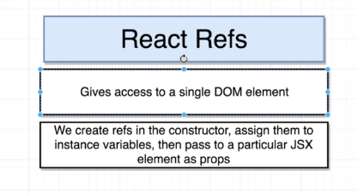

**5. Accessing Image Height**

**Accessing image in componentDidMount() will not give you entire image object as the image did not load instantly!**

**Here clientHeight will be 0, but you can see the image object in the console,**

**Note:** when you expend the “img obj” in the console then only it fetches the image data like clientHeight and so on. This is the reason we are getting

0 for “this.image.Ref.current.clientHeight” to overcome this, we will use callback on image as shown in below section.

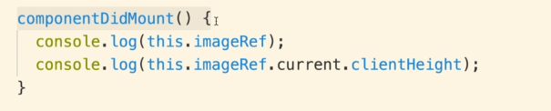

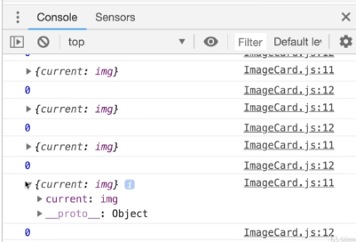

**6. Callbacks on Image Load**

The solution of the above problem is that We will access the height after it has been loaded and used a callback function for it

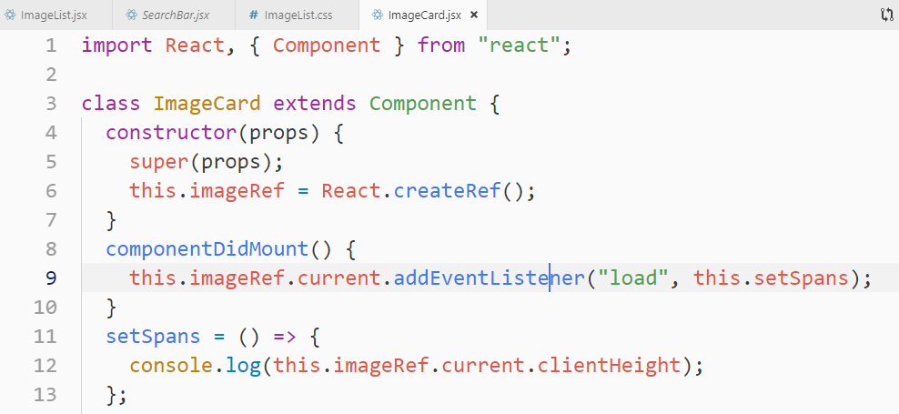

**7. Dynamic Spans**

**Adding Dynamic height to the actual image div**

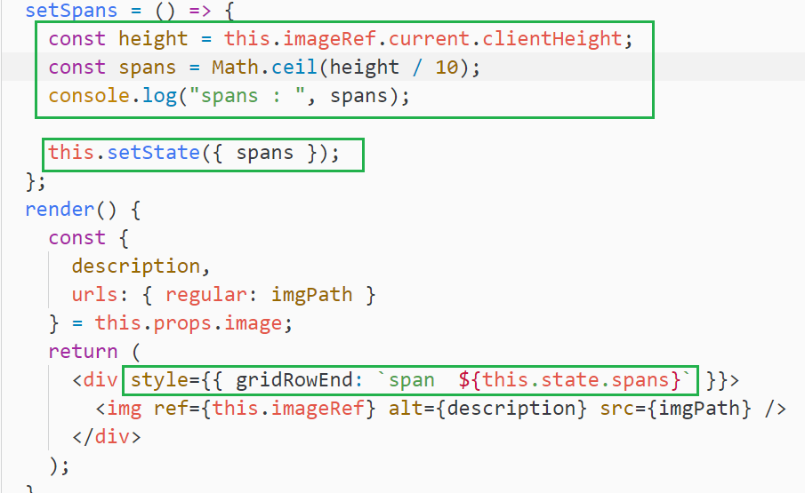

**11. Let's Test Your React Mastery!**

**-------We will practice it later!!!-------**

**We will use youtube APIs to build this app**

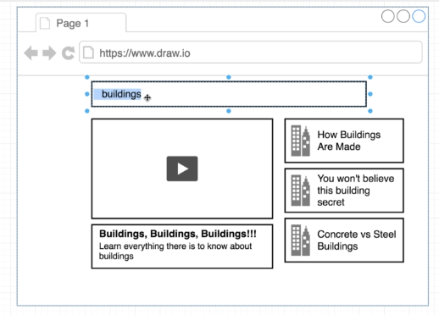

**2. Component Design**

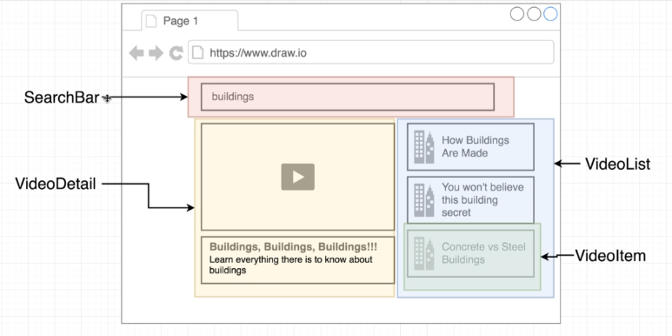

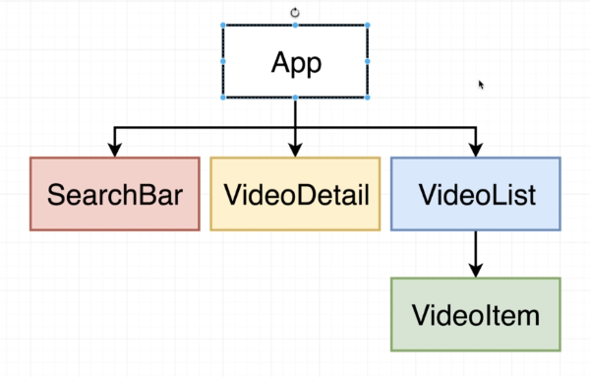

**3. Scaffolding the App**

**12. On We Go...To Redux!**

**1. Introduction to Redux**

**Rather than maintaining state inside our react components , we extract to Redux Library.**

**Maintaining.**

**We make Redux incharge inside of our application. It makes complex applications a little-bit easier**

**2. Redux by Analogy**

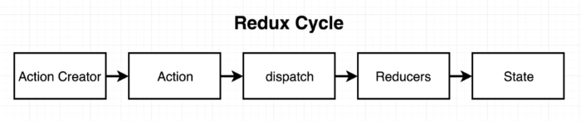

**Insurance company departments :** Claims History, Policies, and accounting

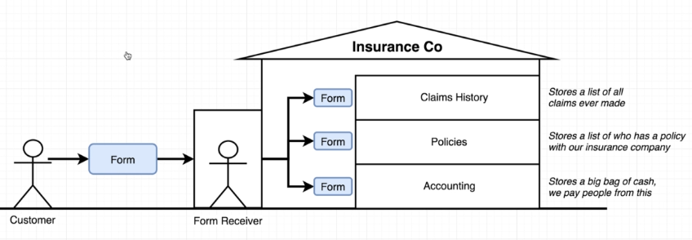

**3. A Bit More Analogy**

**Policy section in the above diagram is to add a new customer list who took their policy.**

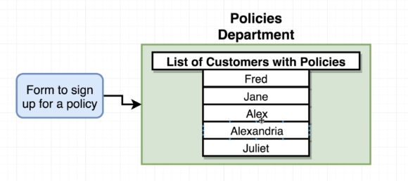

**Let’s assume a customer come to take a new policy so it goes to Policy department as shown above.**

**The problem in the above given diagram is that management has to ask all the time to policy department for all the active and deactive policies.**

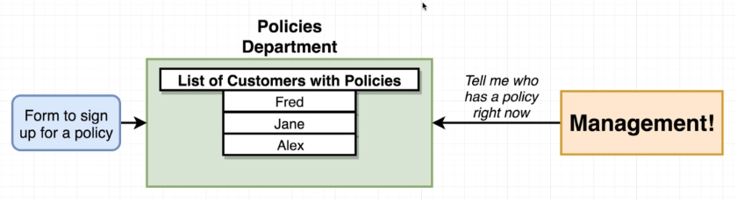

**The solution to the above is to centralized the policy user list**

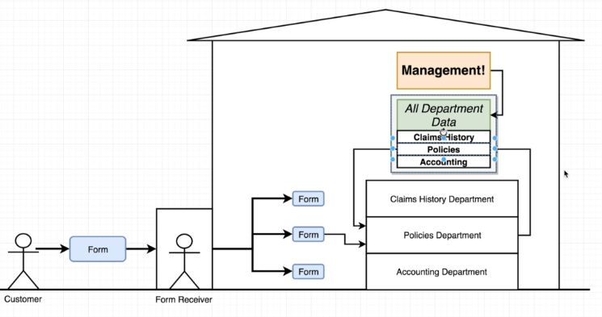

**Form receiver** ask policy Department to process a new form and gives him a list of all the policies from the center location ( from the store). The policy Department updates the list of policy in the center location.

**The Management can see all the latest updated data very easily**

**4. Finishing the Analogy**

**Type: is says what the purpose of the form is**

**Payload: what they are trying to do**

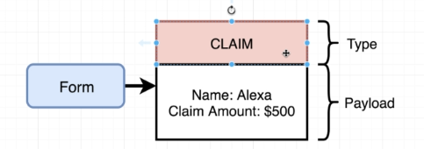

**There are 3 types of claims forms**

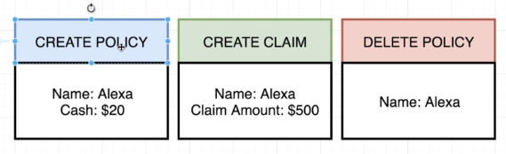

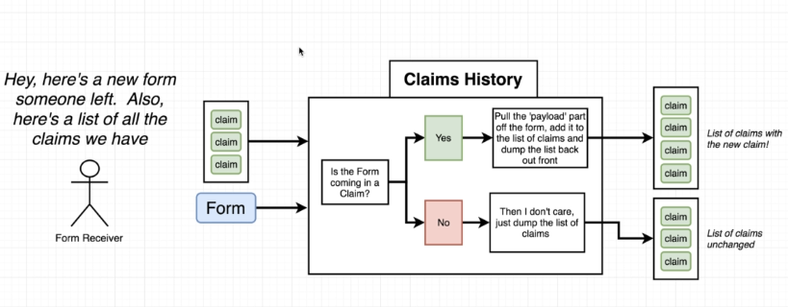

**Policy internal process**

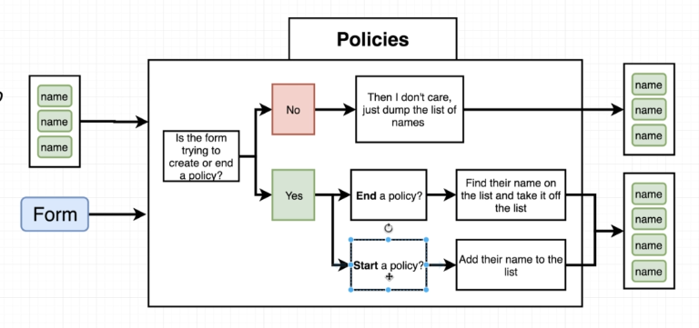

**Account Internal process**

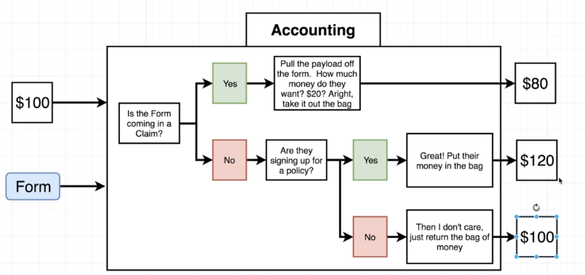

**5. Mapping the Analogy to Redux**

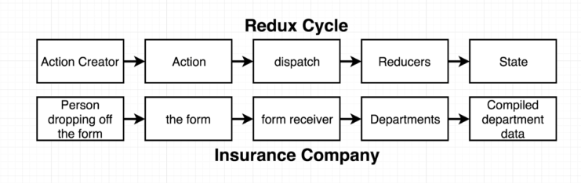

**Action creator::**

* **is a function that returns a plain JavaScript object which referred to as**

**the action. This “plain JavaScript object” is an action with type and payload**

* **The action is just like our form and it's going to have type that describes the purpose of the form and a payload.**
* **Type => it is a property on an action describes some changes that we might want to make inside of our data**
* **Form: in Redux, refers Action Creator and Action**

**Action**

* **The action is just like our form and it’s going to have type that describes the purpose of the form and a payload.**

**Dispatch::**

* **It takes an action(type and payload) and makes copies of that object and passes off to a bunch of different places inside our application**
* **Form Receiver: It makes copies of that form and handed off to each department**

**Reducer::**

* **It is a function that is responsible for taking in an action and some existing amount of data, and process that action, and make some changes to the data and then returns it to some centralized location.**
* **Department: each department has his own little separate piece of data, like a list of policies, or a list of all the claims**

**State::**

* **It is a central repository of all information that has been created by our reducers.**

**All the information gets consolidated inside our state object so that our React**

**Application can very easily reach in to Redux application, Redux side of the app**

**and access to all the data for our application.**

* **Compiled department data when a department returns some data or is done processing a form, it then spat out some list of data and all that information is assembled into some common repository of data**

**6. Modeling with Redux**

**Below we created 3 action creators**

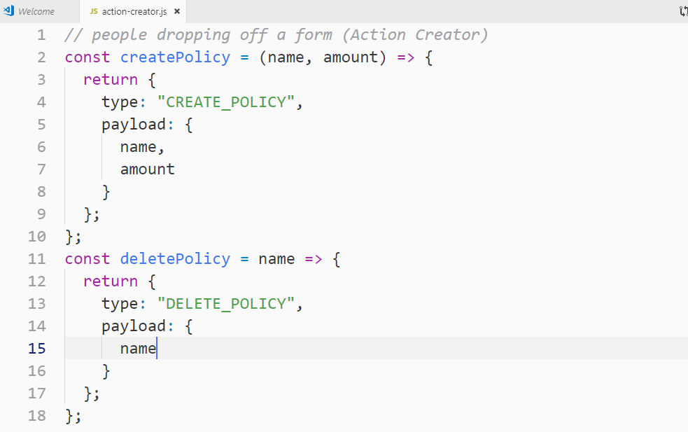

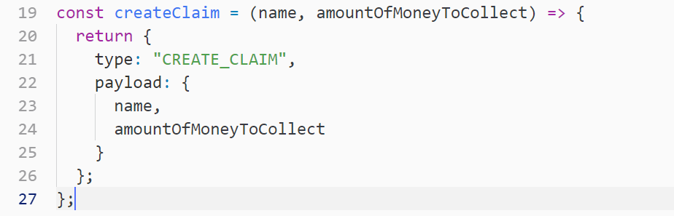

**7. Creating Reducers**

**Dispatch is a part of redux library so let’s move to reducers**

**The idea behind this reducers things are that we are going to write out a couple of different functions and each function is going to model a different department inside our company.**

**We will create these three reducers::**

1. **Claim reducer: We will create a claim reducer to modeling the behaviour of claim department**
2. **Accounting reducer:**
3. **Policies reducer**

**Each of the above reducers is going to be called with an action or a form that has been created by an action creator. The reducer is going to inspect that action/form and decide whether or not it needs to modify some data based upon that action.**

**Every reducer is always going to be a function. It always gets 2 arguments that are always passed in the exact same order**

1. **The first argument is going to be whatever existing little piece of data from our central repository that belongs to a specific department.**
2. **The second argument is an action which is a from with type and payload**

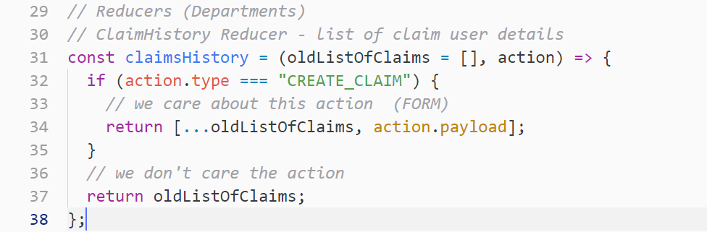

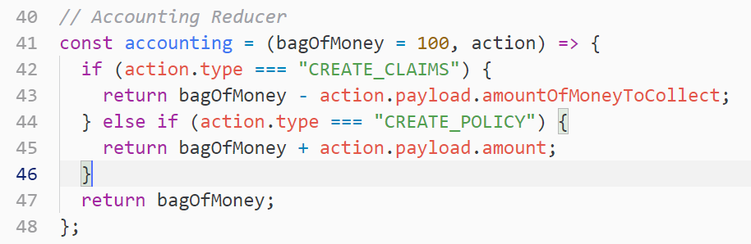

**8. Rules of Reducers**

The overall goal of a reducer is to take some existing data **(listofPolicies)**, some action and then modify and then return that existing data based upon the content of an action

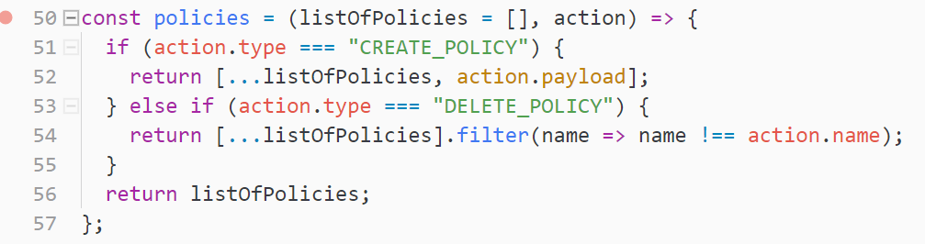

**9. Testing Our Example**

**A store in redux is essentially assembly of a collection of different reducers and action creators.**

**Note:**

1. **“combineReducers” takes an object of all the reducers as key and value as shown below**
2. **“createStore” takes whatever returns from the “combineReducers” and create a store.**
3. **“dispatch(action) and getState()” are available on store.**

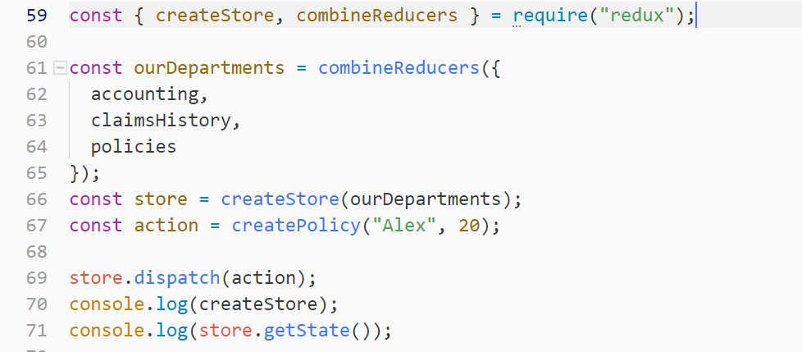

**We can also pass action directly**



**10. Important Redux Notes**

**Anytime we want to change state, we call an “Action Creator”, calling an action produces an “Action Object”, this action object describes exactly how we want to change data inside of our application. This action object gets fed to the “Dispatch Function”, which intern is going to make copies of “action object” and feed those copies to different “Reducers”, intern the reducers are going to run and process those actions, the forms that came in, modify their data and then eventually returns some new data. The data that gets returns forms into some “New State Object”, so we wait until we need to somehow updates our state again at some point in the future.**

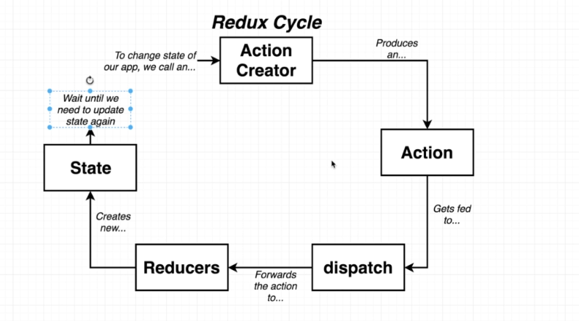

**Note: Each dispatch function that we are calling here is calling the entire Redux process as shown in the above diagram**

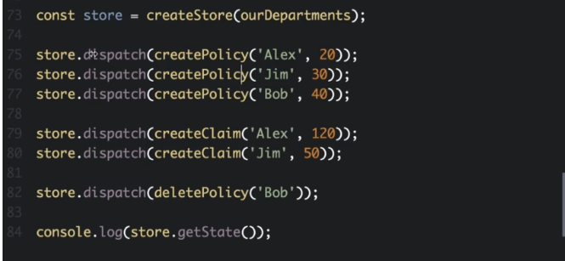

**Note: We can only modify this state object through dispatch function and the action creator. There is no way we can update data to the store directly. We cannot get direct access to state property and modify it.**

**In “combineReducers” the name of the key can be different. Not mandatory to keep the key as same as reducer name. We changed the “accounting” => “MoneyWeHave”**

**Example:**

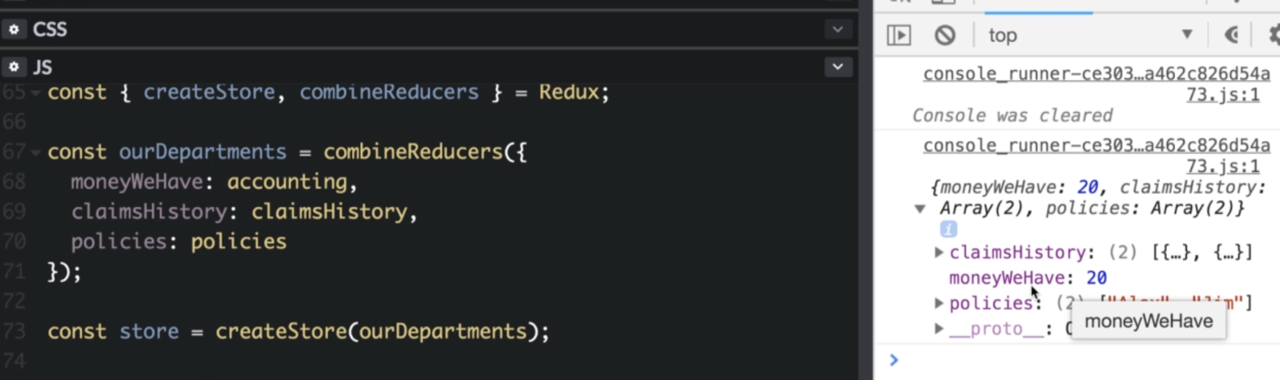

**13. Integrating React with Redux**

**1. React Cooperating with Redux.mp4**

**This is a project that we are going to build**

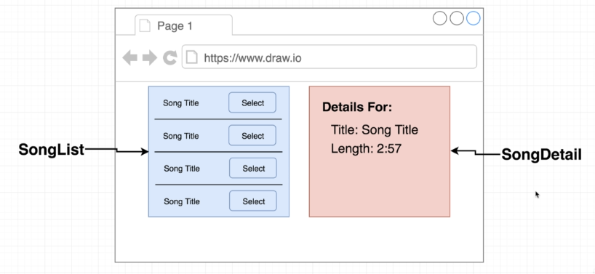

**We need “react-redux library” to enable redux into react**

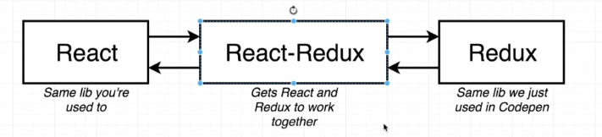

**You need to install “redux” and “react-redux”**

**3. Design of the Redux App**

**We are using “Redux”, we will make use of “component level state” much less frequently as we are using Redux.**

**We have 2 states in our app and 1 Action Creator**

1. **List of songs**
2. **Selected song**

**To change the state, we have to call an action creator**

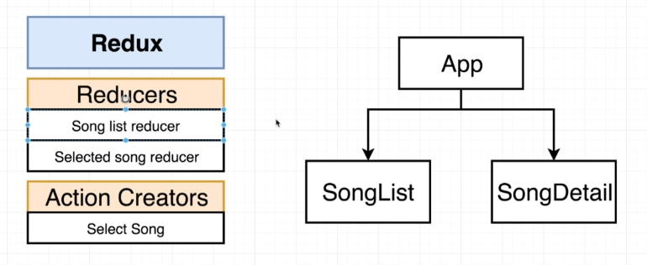

**4. How React-Redux Works**

**Using “react-redux”, we are going to create 2 new components.**

1. **Provider**
2. **Connect**

**These components are created by “react-redux”, we just create instances of them and we pass some props into both of them to configure exactly how they work**

**“Store”, is what contains all of our reducers and all the state of our application. We take that store and we pass it as a prop into “provider”, the provider renders at the very-2 top of our hierarchy even above the <App> component. We show the App inside the “provider”, the provider has internal reference of “store” and provides to all of the components inside of our app.**

**“Connect component”, is very special as it can communicate with the provider component at the very top of our hierarchy. It communicate to provider using “context system”**

**“Connect component”, passes data to child component as props**

**“context system”, allows any parent component to communicate to any child component even if there are other components in between them.**

**“Action Creator”, are not stored in anyway inside of our store, instead we call an action creator, we take the action that gets return and send it into “store.dispatch” function**

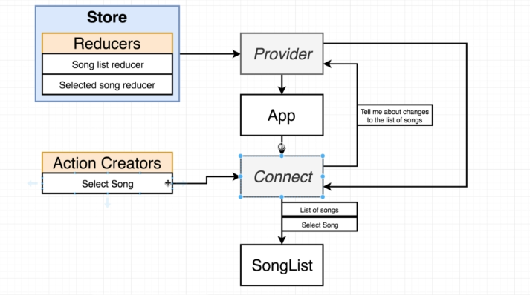

**5. Redux Project Structure**

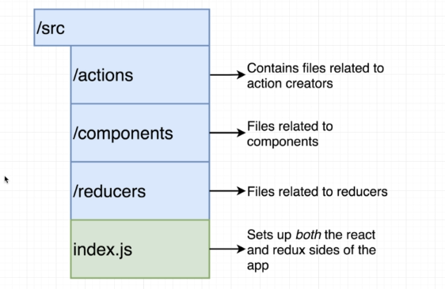

**Inside the reducers and actions, we create file by the name of “index.js”**

**6. Named vs Default Exports**

**A “Named Exports” allows us to export many different functions from a file.**

**Just add “export” in front of a function.**

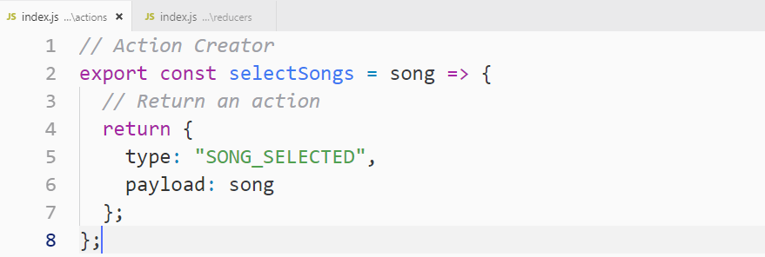

**7. Building Reducers**

**Note: putting static data into reducer, overkill it. We just putting it just for demo.**

**We created 2 reducers down**

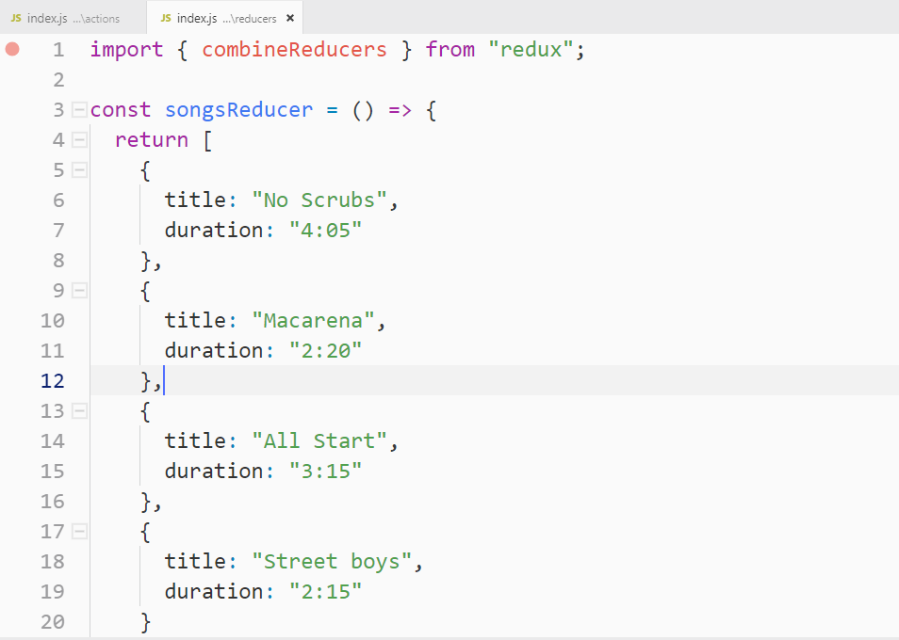

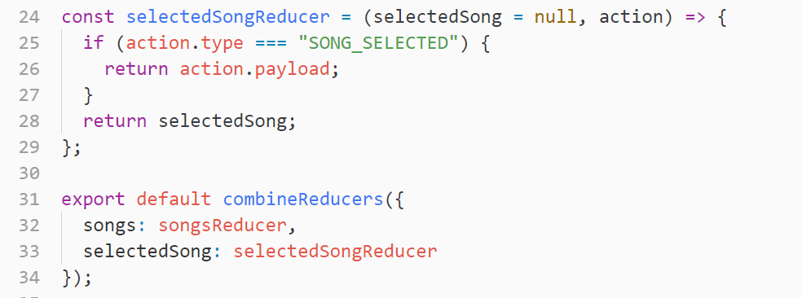

**8. Wiring Up the Provider**

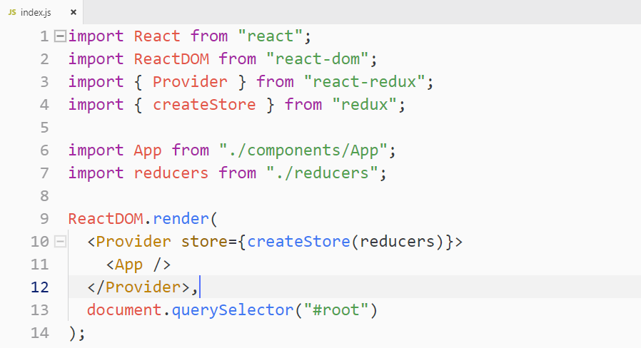

**9. The Connect Function**

**We get state data into child component using connect() function from “react-redux”**

**And this is the way we call it**

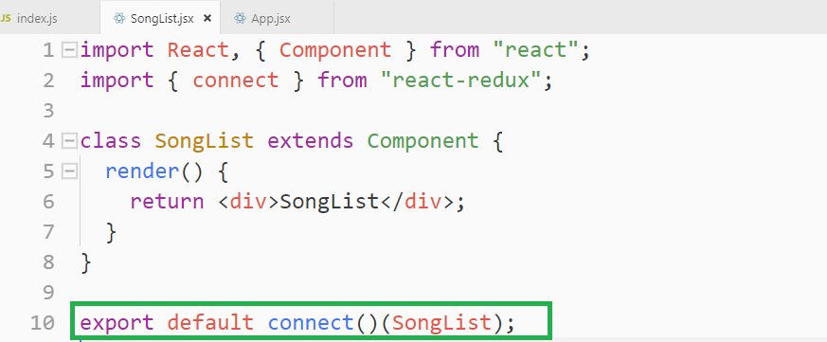

**JavaScript example of what connect function is doing**

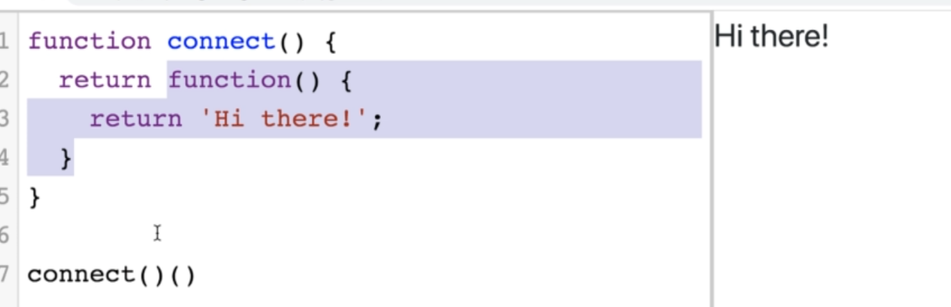

**10. Configuring Connect with MapStateToProps**

**Let’s see how we can configure the “connect function” and tells it that we want to get some “specific data” out of our “Redux Store”**

**By convention, we call it “mapStateToProps”, but we can name it as we want. It is called with all of the “state” inside of a redux store.**

**mapStateToProps => Redux Store Data, We run some calculations on it and that’s going to cause that data to eventually show up as props inside of our components.**

**To configure connect, we pass this “mapStateToProps” function to “connect”**

**There are the actions we must do to get the Redux store data into component.**

1. 
2. **We always call connect(mapStateToProps)(component), with component as the second function call**
3. **“mapStateToProps” is always going to get a first argument as “state” as**
4. **It always returns an object like**

**Note: “mapStateToProps” is called with all of the data inside of a redux store**

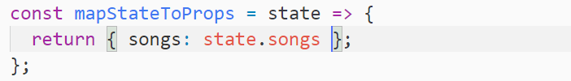

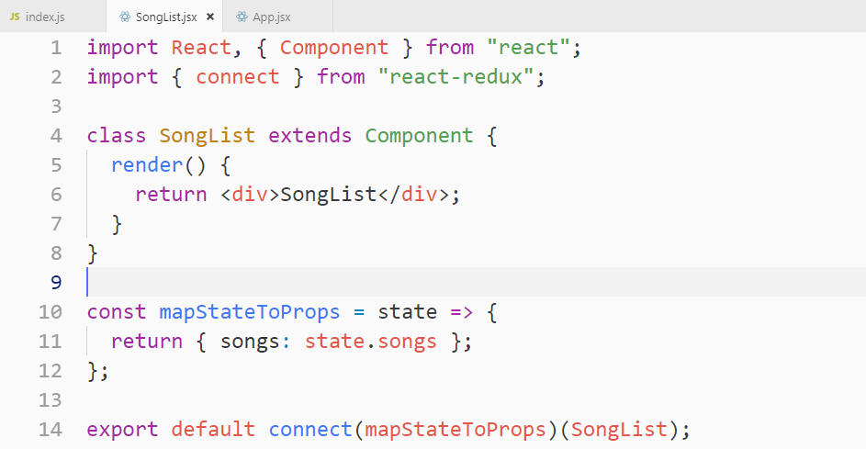

**If we want to ever change data in our component we can make use of the “dispatch function”, but there is a much more convenient way of doing this.**

**11. Building a List with Redux Data**

**We got some by defining the mapStateToProps and then passing it into connect function.**

**You will a**

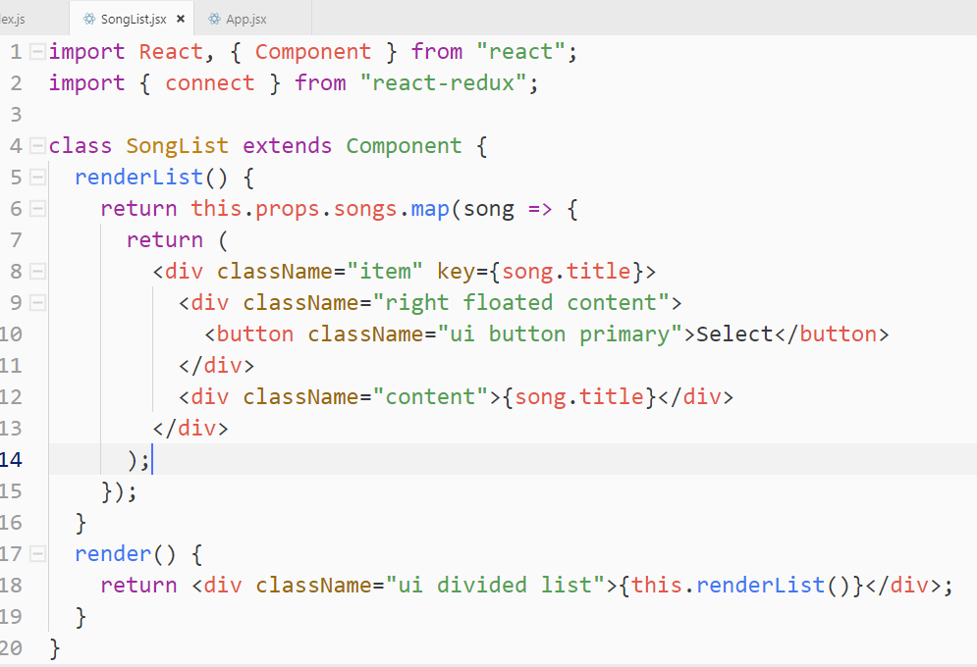

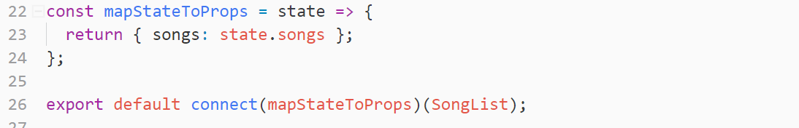

**Note: “this.props” has reference of dispatch() function also**

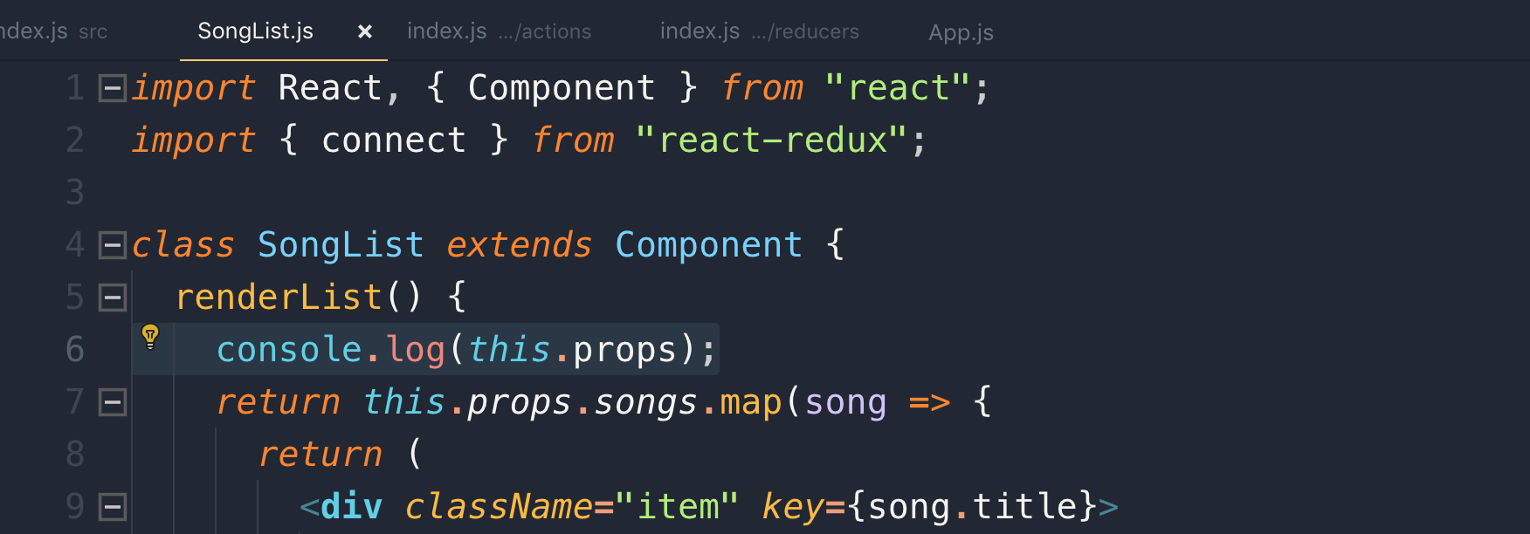

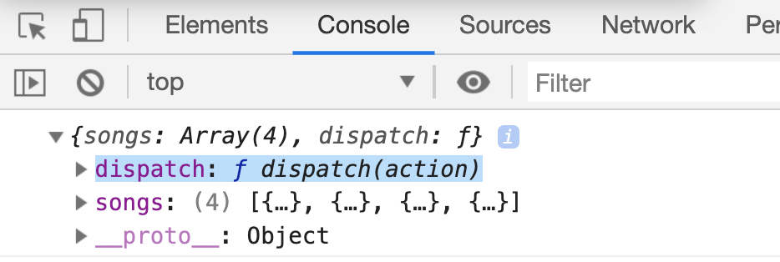

**12. Calling Action Creators from Components**

**Anytime we want to update our data with redux, we have to call an “Action Creator”**

**we pass the “Action Creator” to connect function.**

**The connect function is going to take that “Action Creator” and pass it into our component as props**

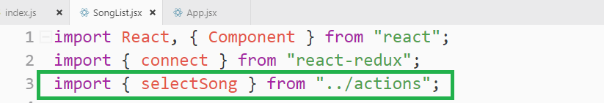

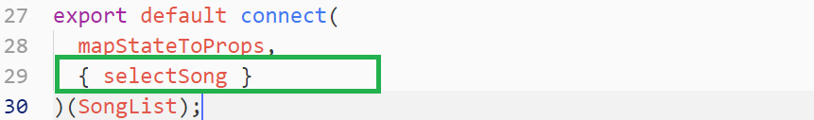

**The connect function is going to take that action creator and pass into our component as props.**

**Note: If we call the action creator, it will take the action automatically and send it to Redux’s dispatch function.**

**Note: Anytime we change state object, or run reducers and produce some state object, the mapStateToProps “re-runs” with the newly created state object.**

**This is the way we are calling “selectSong Action Creator”**

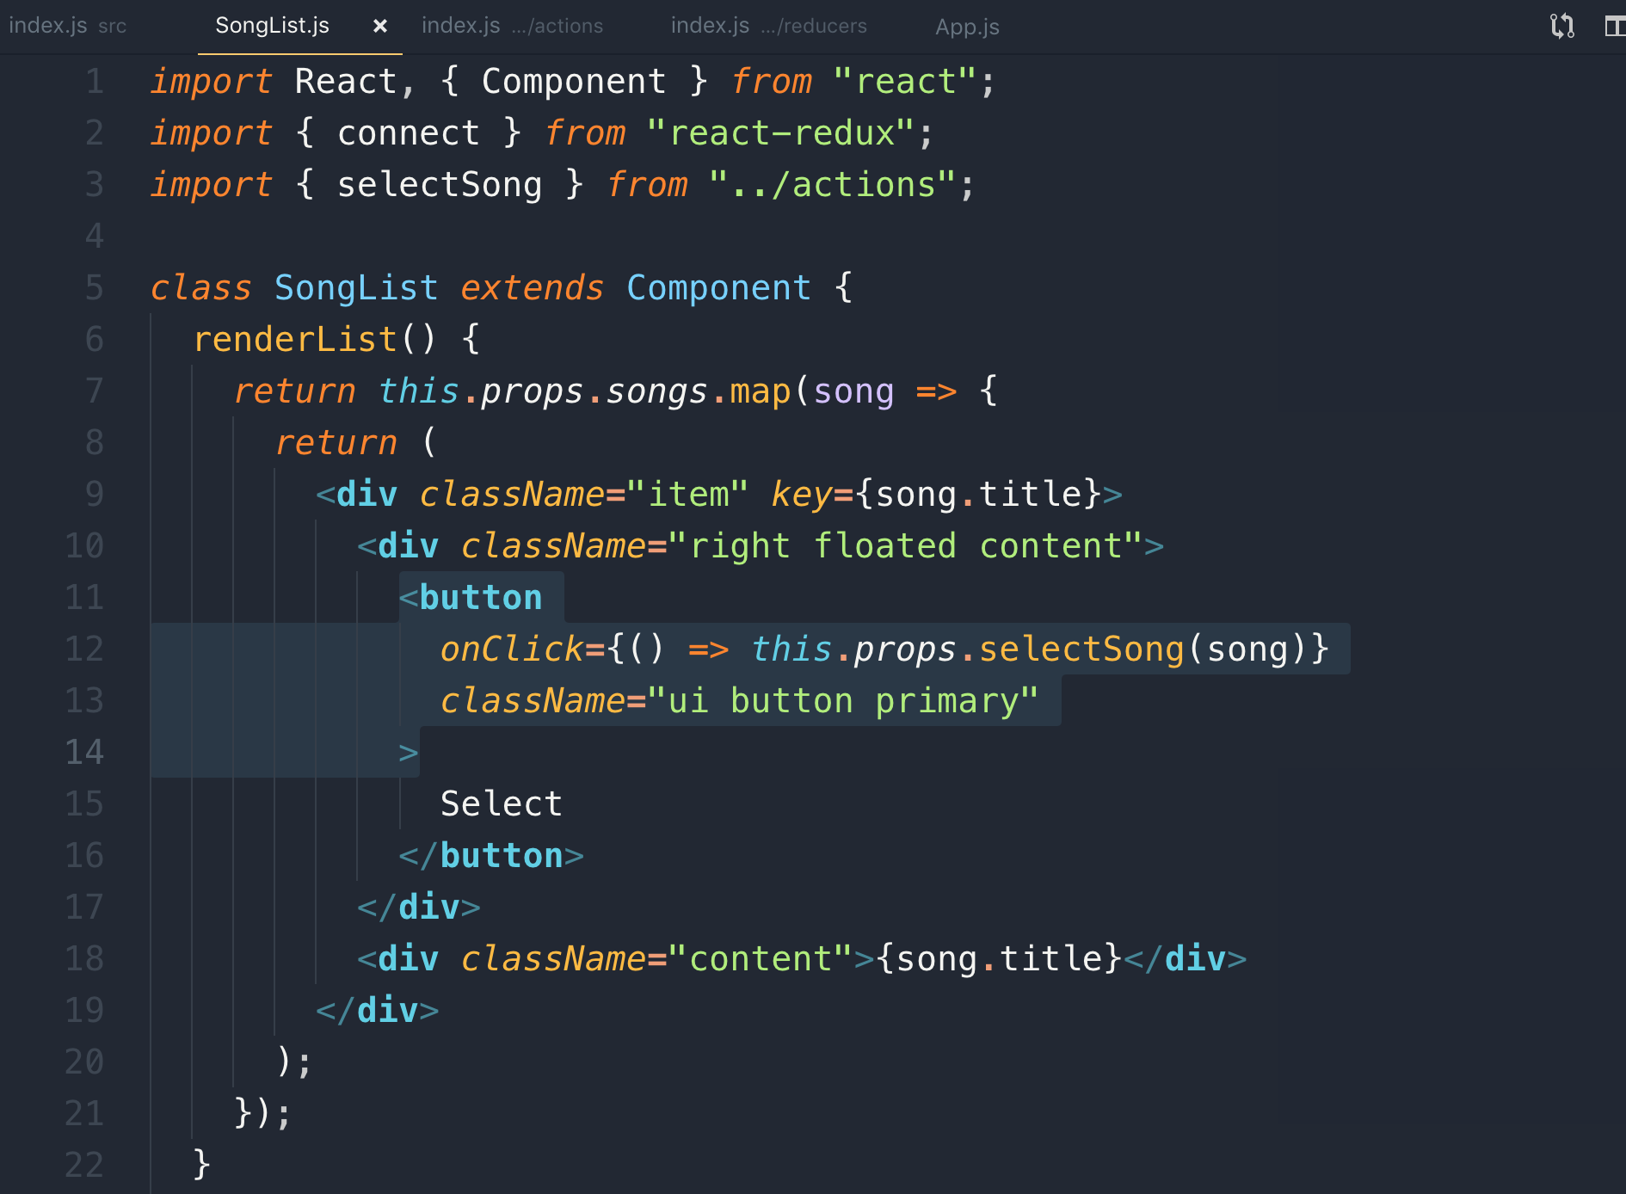

**13. Redux is Not Magic!**

**When we pass our Action Creator in the “connect()” function, the connect function automatically calls the “dispatch()” function for us.**

**Note: Whenever we call “*this*.*props*.selectSong” Action Creator, “connect()” function is going to automatically take the action that gets return and throw it into the dispatch function for us.**

**14. Functional Components with Connect**

**Note: you don’t have to make class based component with the connect function. You can use functional component as well**

**Note: Anytime we update data inside of Redux store by dispatching an action or essentially calling and action creator, it causes all of our components that are hooked up to the connect function to automatically re-render.**

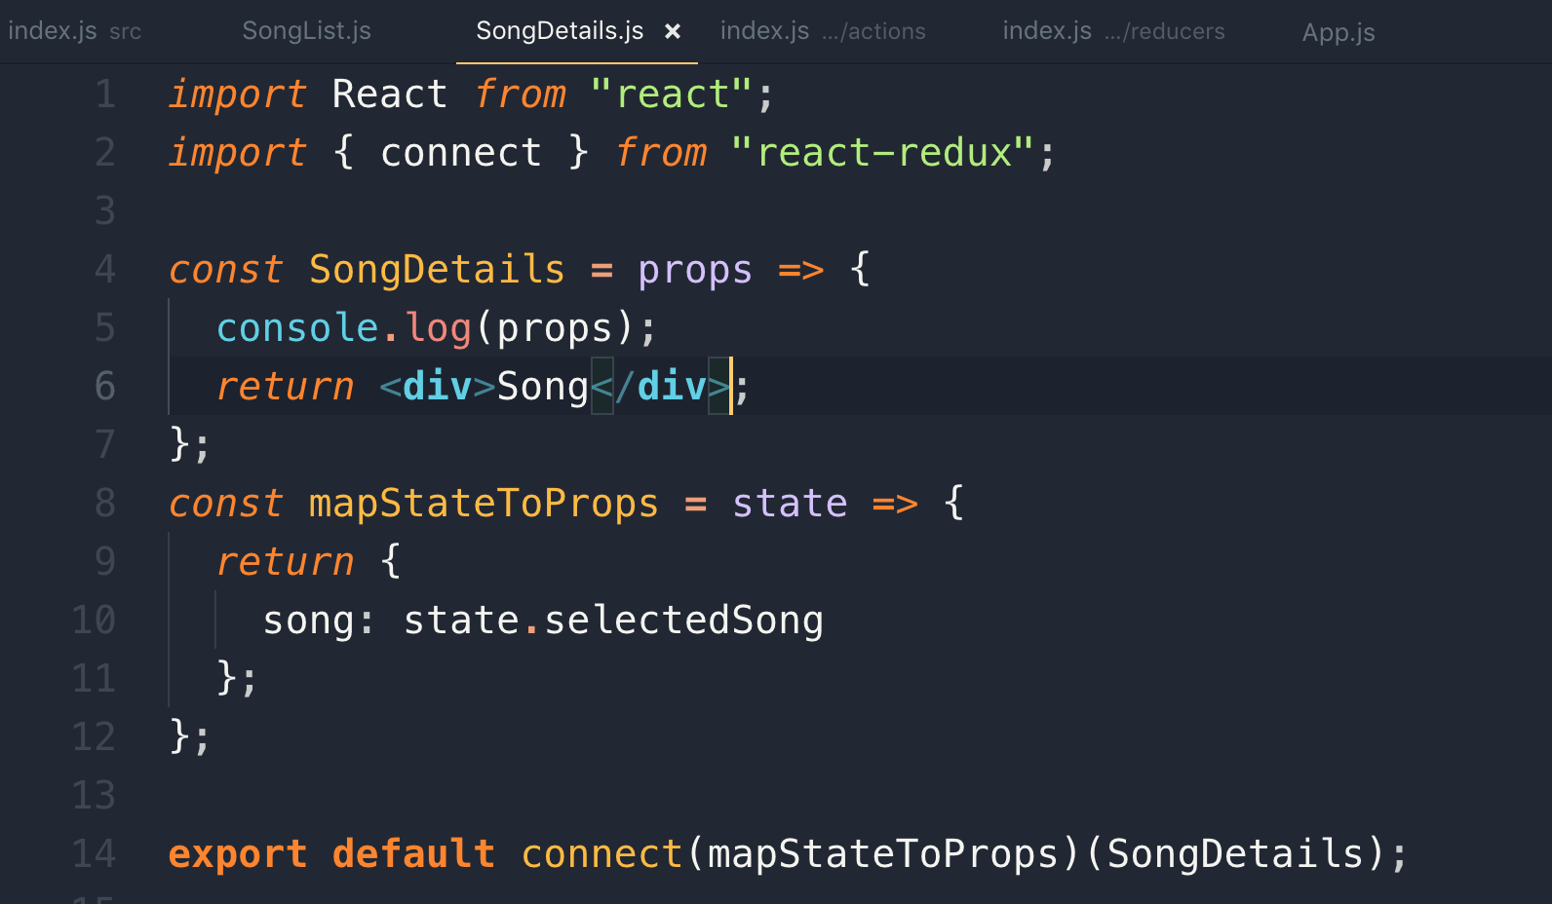

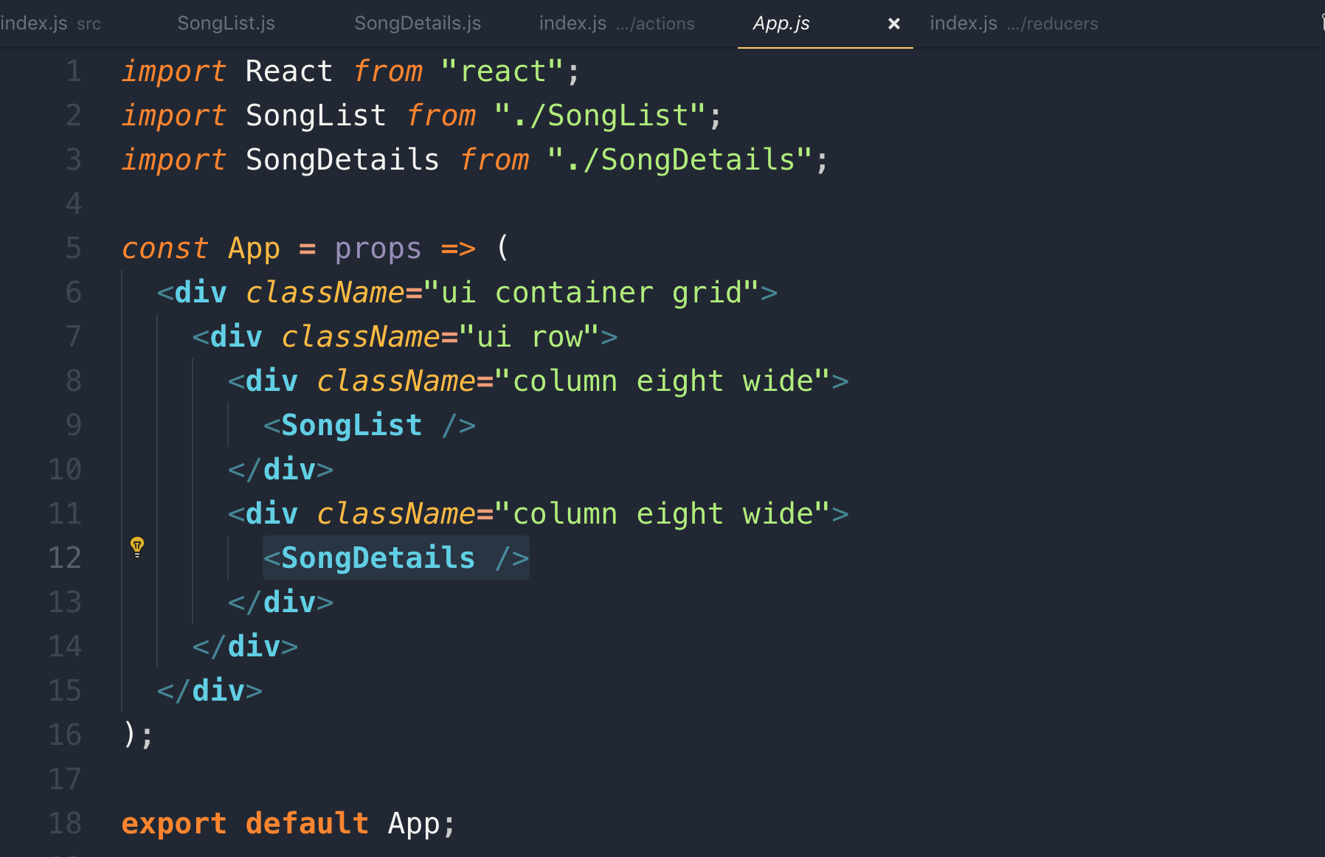

**15. Conditional Rendering**

**Initial value of selected song will be null as we set it. So on the Redux boots up, it sets up to null so we add a check if it is not null**

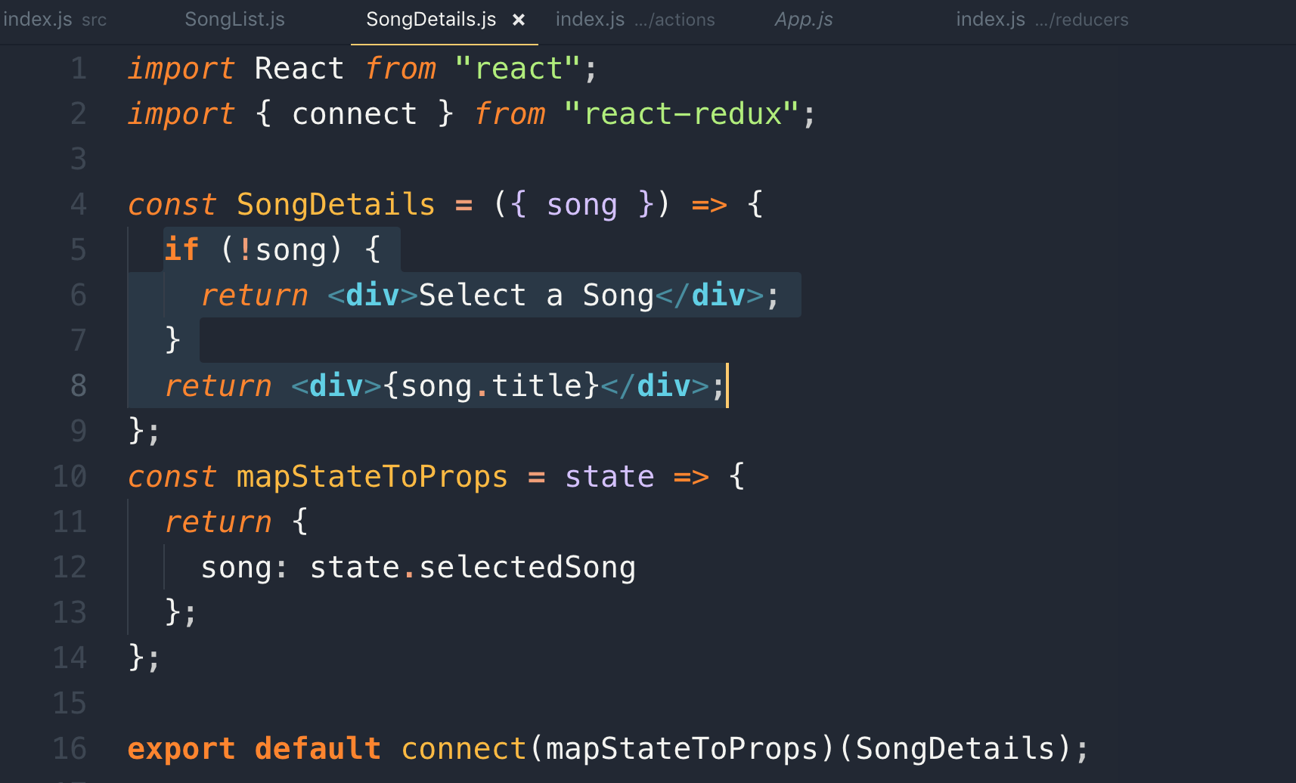

**14. Async Actions with Redux Thunk**

**1. App Overview and Goals**

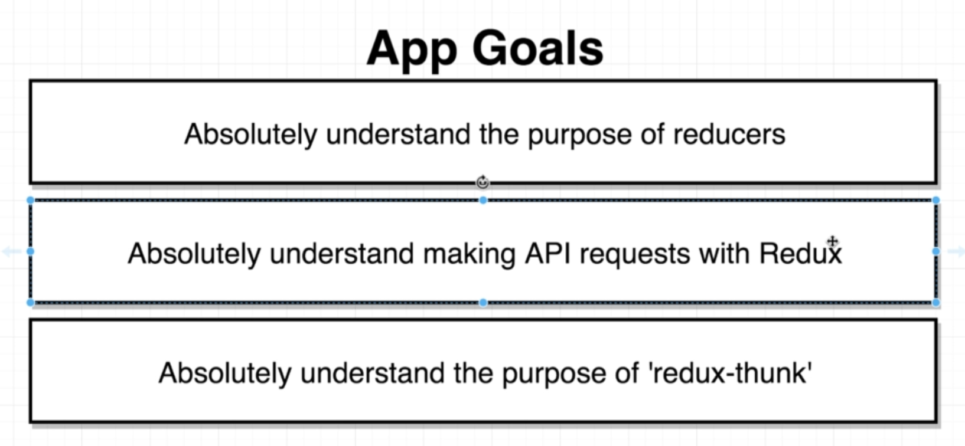

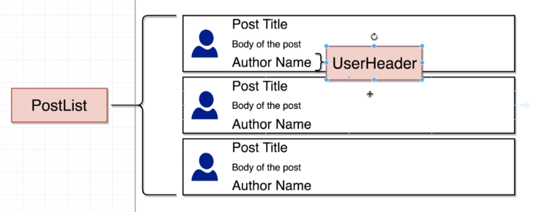

**UserHeader: it is a separate component.**

**We will get above data from this API**

[**https://jsonplaceholder.typicode.com/**](https://jsonplaceholder.typicode.com/)

**2. Initial App Setup**

**We need to install these dependencies.**



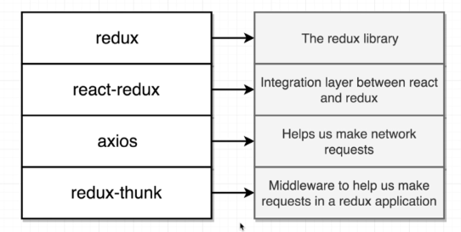

**Redux-thunk: It is a middleware. It applies to the Redux library. It is essentially a function that are going to slightly change the behaviour of our redux store. The add-in new features to the Redux side of your application.**

**It helps us make network requests from the Redux side of our app.**

**3. Tricking Redux with Dummy Reducers**

**If we don’t pass any reducer, it will give you error so pass a dummy reducer like this**

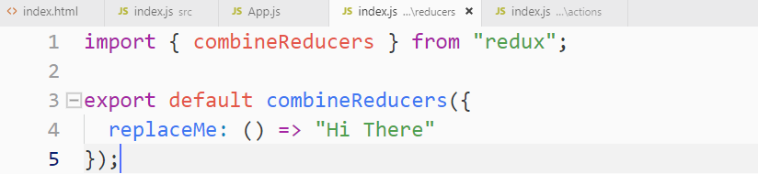

**Application setup with redux configuration**

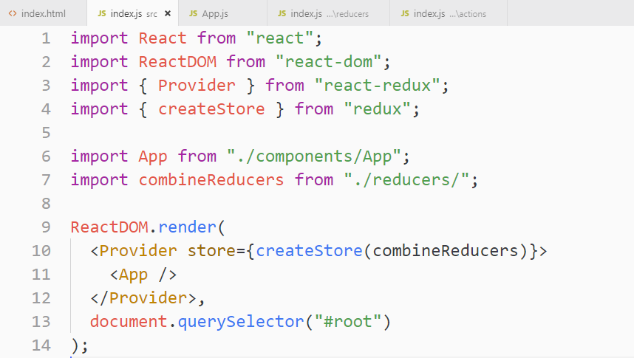

**4. A Touch More Setup**

**Creating PostList component and adding it to <App> component**

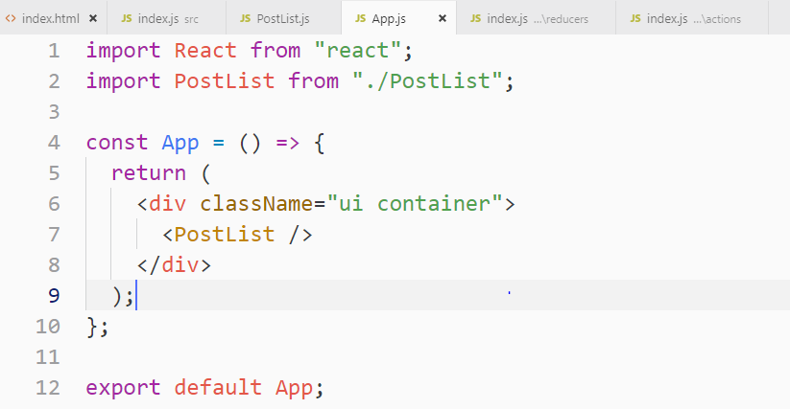

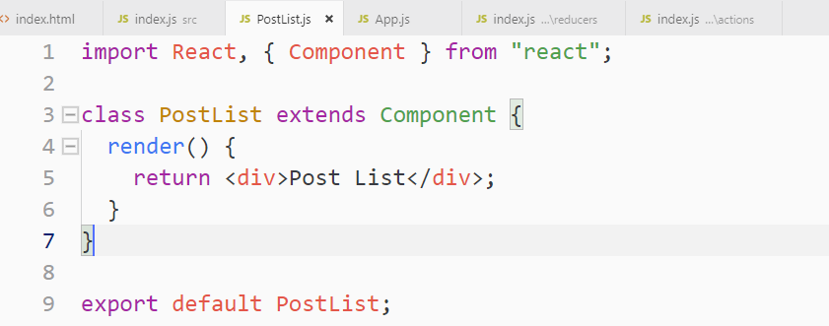

**5. How to Fetch Data in a Redux App**

**Let’s see how to fetch data in Redux from API**

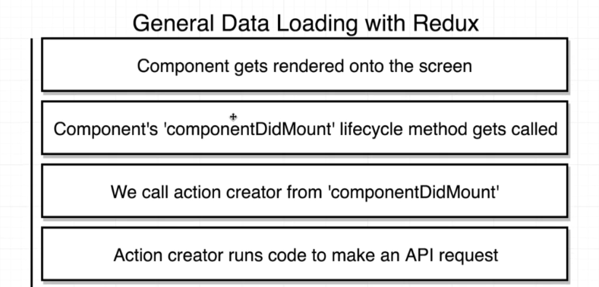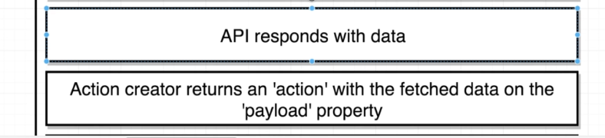

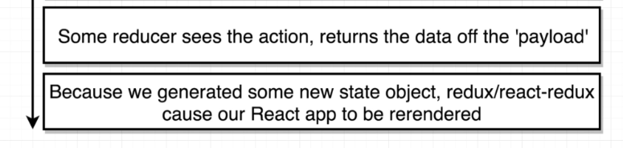

**Our PostList Component will call API to get the list of posts.**

**For calling API, we need lifecycle method called “ComponentDidMount”, on our component class that is why we created “class base component”**

**Inside the “ComponentDidMount”, lifecycle method, we will call an action creator so anytime our “PostList” component initially shows up on the screen that “Action Creator” will automatically called.**

**“Action Creator”: will call an API using axios, the API will respond with data that it will return and an “Action” and the “action object” is going to have our fetched data, the payload property.**

**“Dispatch method”: is going to dispatch that action and send it off to different reducers inside our app. Our configured reducer that is going to see the action and pull off just the data from that payload property.**

**Anytime our reducers run, they return some values. These values are going to form up a new state object inside of a redux store.**

**Anytime a reducer runs and produces a new state object, we take that state and sent off to the react side of our application so it causes react side to be re-rendered.**

**We use “mapStateToProps” function to get the list of post from the global state object into our “PostList Component”**

**This is the entire flow of the above diagram**

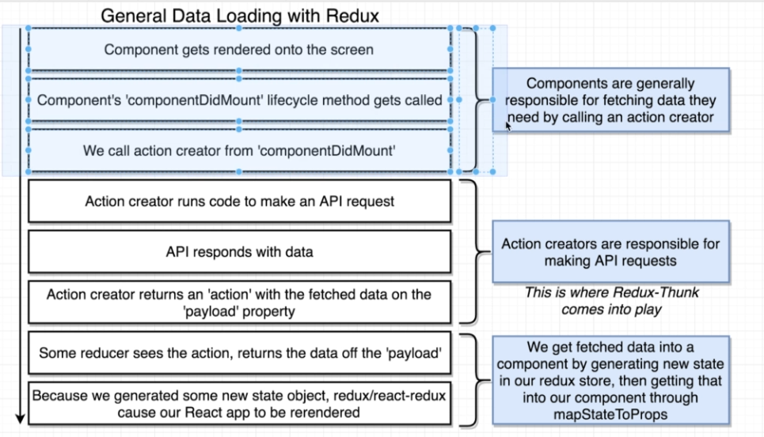

**There are other places than “ComponentDidMount” where we can call “Action Creator”, which involve some other libraries.**

**6. Wiring Up an Action Creator**

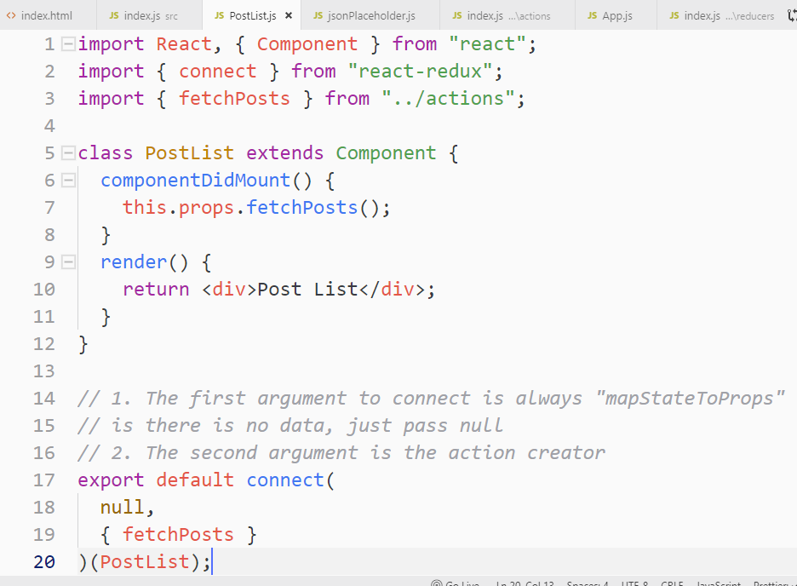

**7. Making a Request From an Action Creator**

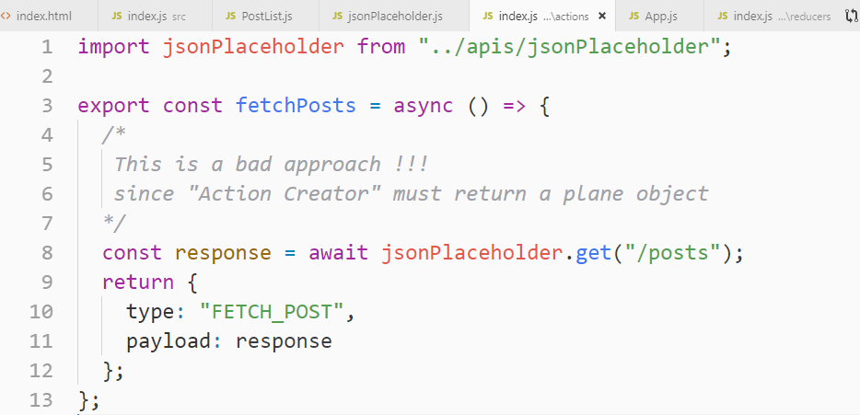

**The above code will give you error like this.**

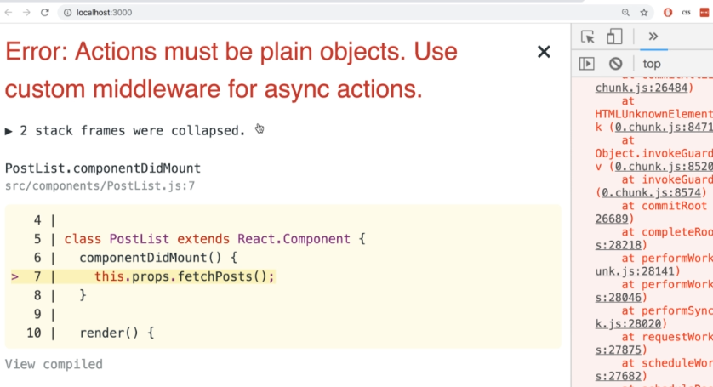

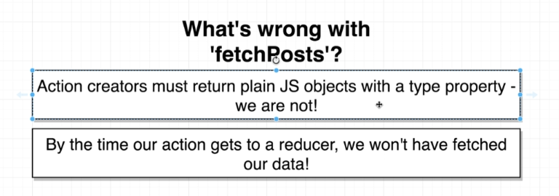

**Let’s fix the above “fetchPosts Action Creator” in the below section using “Redux-thunk”**

**8. Understanding Async Action Creators**

**“Action Creators” inside of “Redux” are supposed to return plain JavaScript object that had a type property and optionally a payload as well.**

**These 2 problems are in the above action creator**

1. **The error in the above action creator is that we are not returning plain object instead we are making an asynchronous API call.**
2. **The second problem is that by the time our action gets to a reducer, we haven’t fetched our data.**

**This is the code behind the scene, so it is return JSON API request which does not have a “type property” instead of returning plain JavaScript Object**

**Below are the diagram which elaborates why the above action creator is throwing error.**

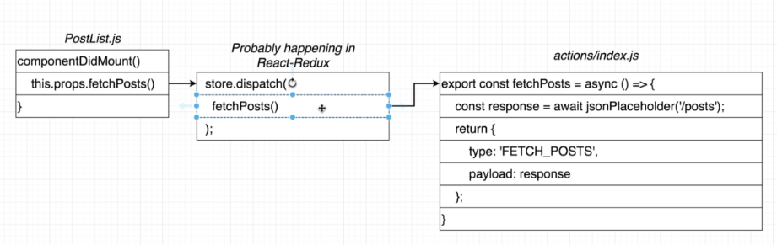

**The action creator in the above diagram will convert into ES5 and there it is not returning plain JavaScript object which breaks the rule of Redux and hence throws error.**

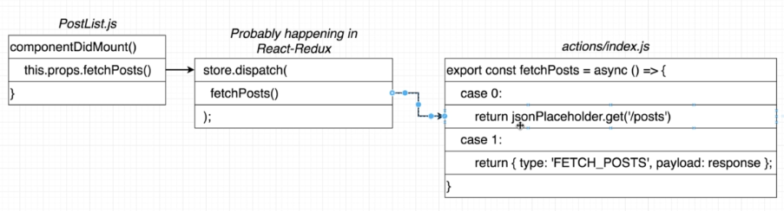

**9. More on Async Action Creators**

**This the flow of redux process which does not wait for the async API call. It doesn’t have a way to tell the reducers to wait until it gets async data back from the action creator. So without data reducer doesn’t do anything.**

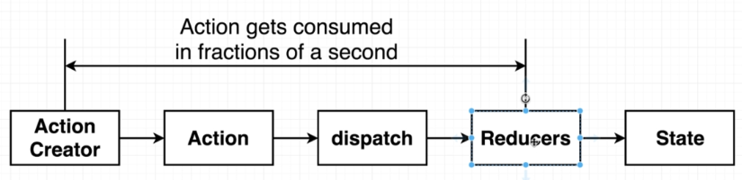

**It removes the error, if we do not use async/await, and use promise, but the problem is same as it doesn’t wait for the data to come back from API. So this is not a solution**

**The solution to this problem is to use “Redux-Thunk”**

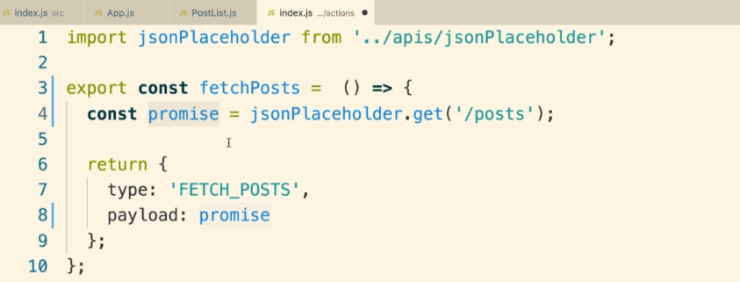

**10. Middlewares in Redux**

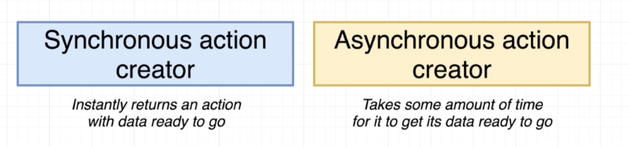

**If you want to have an “Asynchronous Action Creator” inside of a “Redux Application”, you have to install a “middleware” that is going to allow you to deal with these asynchronous action creators.**

**“redux-thunk”, is a middleware which help us deal with this “Asynchronous Action Creator”**

**When we dispatch an action, rather than sending it directly off of our reducers, action is going to send through all of the different middlewares inside of our applications.**

**Inside a single Redux app, we can have as many or few middlewares as want.**

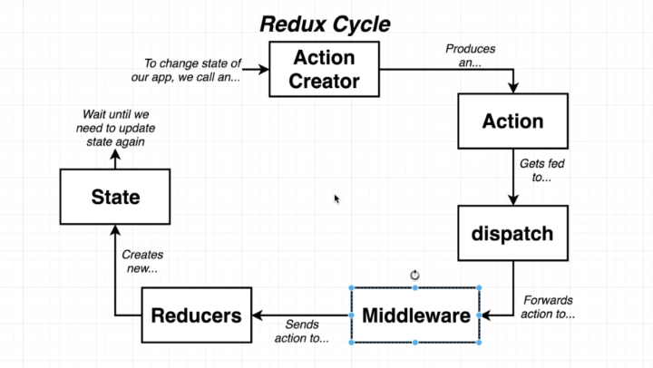

**Role of a middleware**

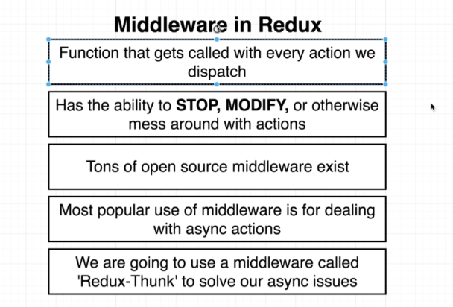

**We can even use our own custom middleware instead of “redux-thunk”**

**11. Behind the Scenes of Redux Thunk**

**Let’s see what “redux-thunk” does**

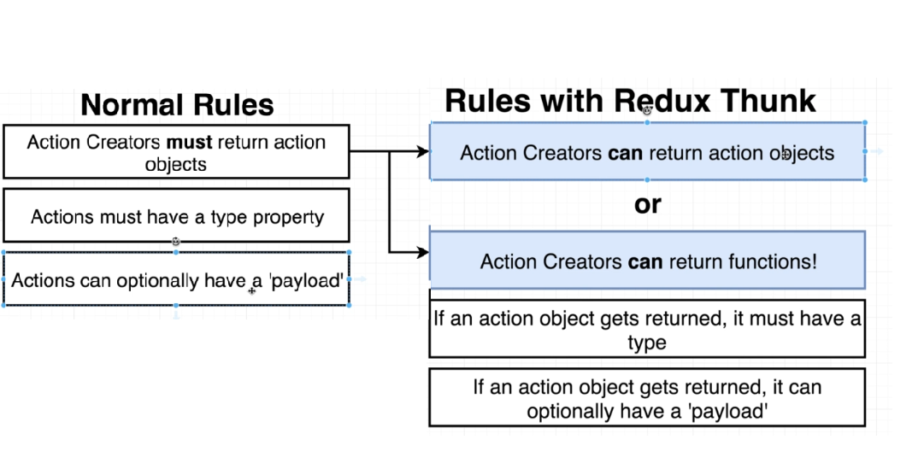

**This is the only change that “redux-thunk” makes you to your application. With “redux-thunk” installed.**

**“redux-thunk” allows you to return either an action object or a function and if you return a function “redux-thunk” is going to automatically call that function for you.**

**Note: if you pass action as an object “redux-thunk” will just pass it to all the different reducers inside you application, it doesn’t do anything to action object, but if you pass action as a function then it is interested.**

**“redux-thunk” invokes our function and it passes to dispatch and the getState functions as arguments**

**Through dispatch we can change any data we want**

**Through getState we can access any data we want**

**“redux-thunk” we can manually dispatch an action at some point in time in the future, when we dispatch an action, we get a new action(a plain JavaScript Object) and it passes to dispatch again and then to reducers**

**Take away:**

**With “redux-thunk” we can return a function, if we do, that function will be invoked with the dispatch and getState arguments with those two functions we have unlimited power over a redux store. We can change any data, we can read any data some point of time in the future, after our request completes, we can then manually dispatch an action and update the data inside our store.**

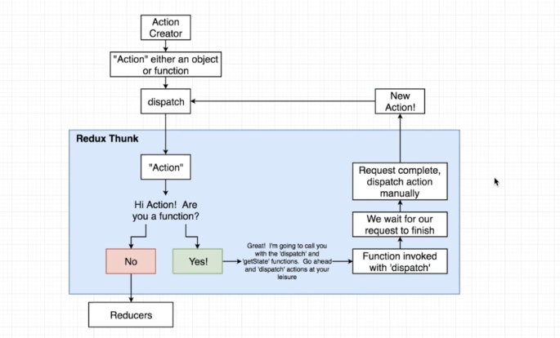

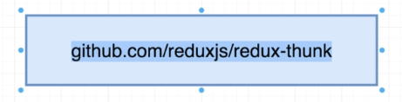

**12. Shortened Syntax with Redux Thunk**

**Let’s see how to integrate “redux-thunk middleware” into our app**

**applymiddleware function is how we connect a middleware to our redux store itself.**

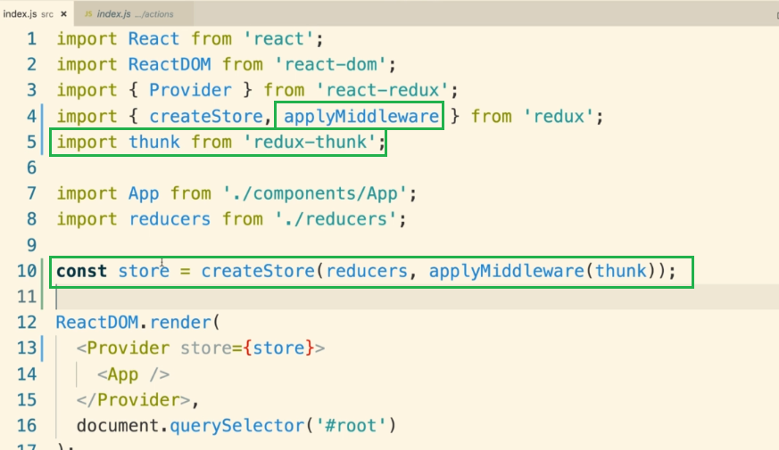

**Note: when we are making use of “redux-thunk”, we will not return any actions from the inner function anymore like this.**

**This is wrong!!**

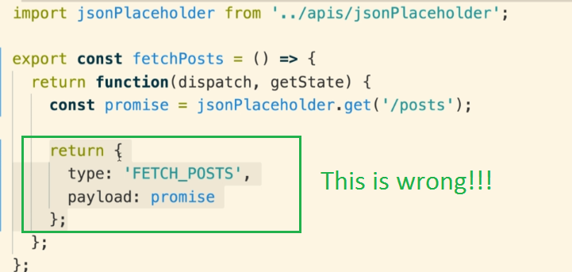

**Instead, we can still have normal action creators like this that returns “Action Objects”**

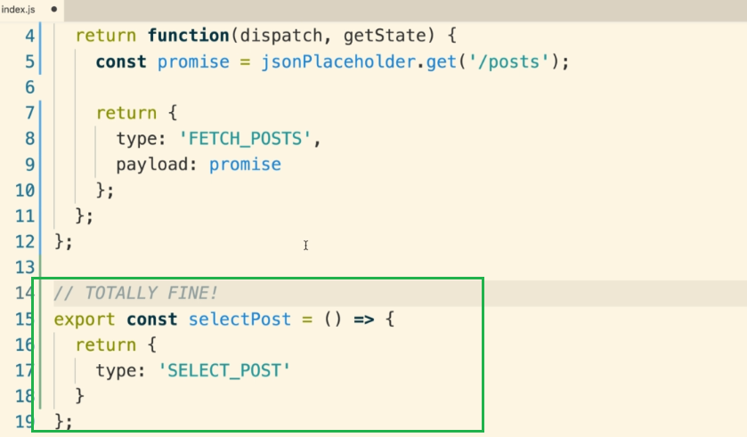

**Bu, we are returning a function so we will use like this**

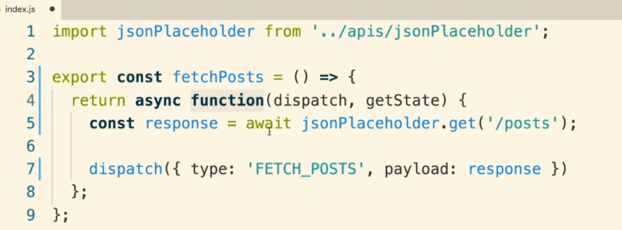

**As we don’t need “getState” so let’s refactor the above function**

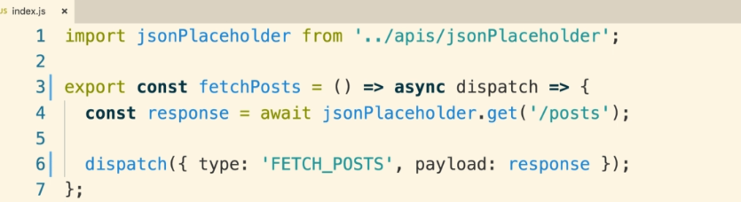

**15. Redux Store Design**

**1. Rules of Reducers**

**We will create all the reducers into separate files and add them into index.js reducer file**

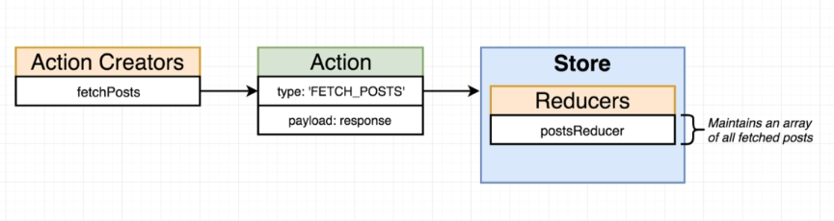

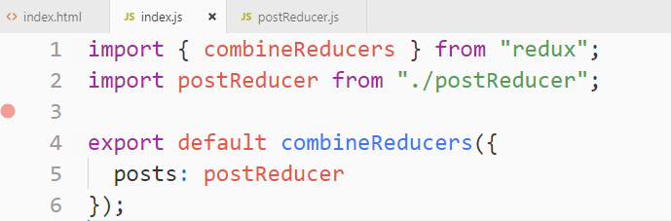

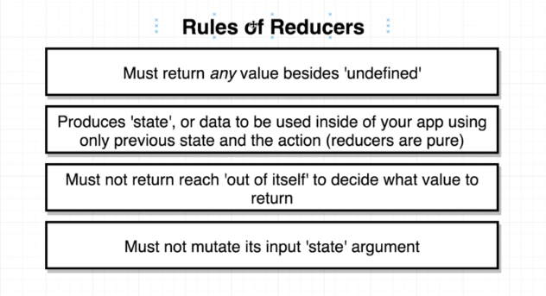

**2. Return Values from Reducers**

**Note: reducer must not return “undefined”**

**but can return null if we want.**

**Note: When redux boots up, it runs all of your reducers one time**

**3. Argument Values**

**Reducers are supposed to produce or return state or data that is going to use inside of our application. The reducers return the state or data using only the previous state.**

**This is the diagram of a reducer the very first time it gets called inside your application.**

**When you first start up the redux application, each reducer is going to be automatically called exactly one time.**

**The first time your reducer gets called during that initialization process, it is going to receive 2 arguments.**

1. **The first argument is a value of “undefined”**
2. **The second argument will some action object**

**Reducer takes the above 2 values and return some state or data.**

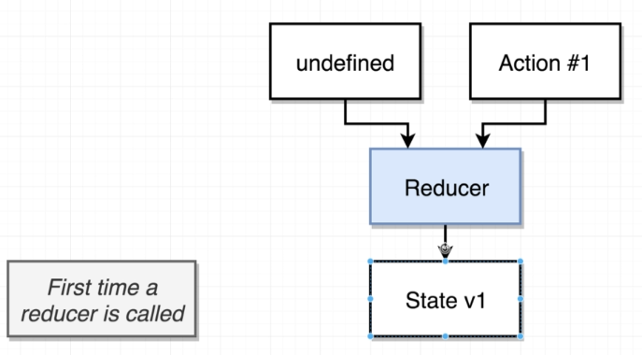

**First time the reducer internally called like this**



**The second time your reducer gets called, the first argument becomes the last returned state by the reducer**

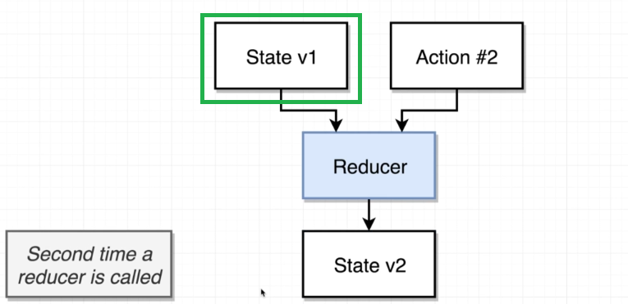

**4. Pure Reducers**

**With the Reducer, we must not reach “out of itself” to decide what value to return (reducers are pure)**

**Anytime we call a reducer with an action and our previous state value our,**

1. **We are not supposed to reach out of this function whatsoever**
2. **We are not supposed to go out and make an API request**
3. **We are not supposed to read file from our hard drive**
4. **We are not supposed to reach into DOM and manipulate that**

**When a reducer gets called it is only supposed to look at the previous state value and the action object to decide what to return**

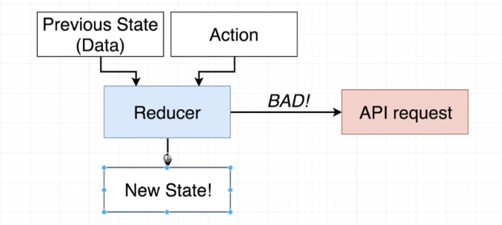

**5. Mutations in Javascript**

**By convention the first argument is always a “state”. Do not mutate state inside of your reducer**

**Note: strings and numbers are immutable values**

**Note we tried to change the value of name string, but it is still same as “Sam”**

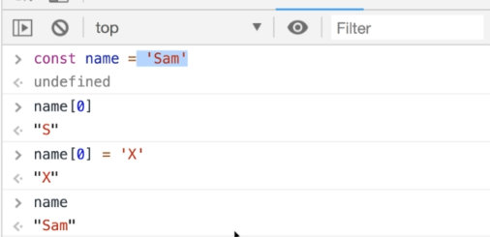

**6. Equality of Arrays and Objects**

**Array compares exact same reference in the memory, if it is, it return true else false.**



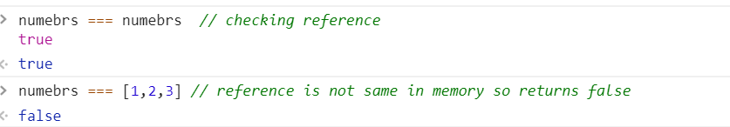

**7. A Misleading Rule**

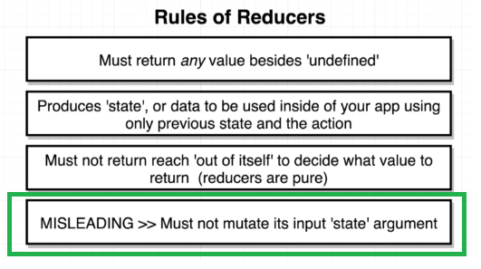

**Changing state directly without setState()**

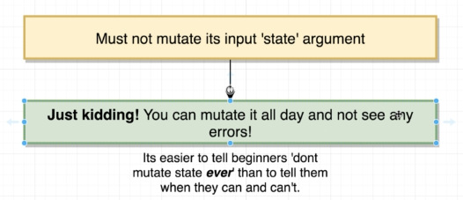

**We can mutate state but there is tiny little corner case in which mutating the state argument is going to land you in trouble, your application is not going to work the way you expect.**

**Let’s see the that “corner case” and also know why people say must not mutate state argument.**

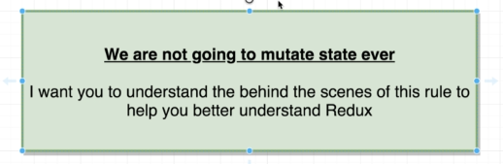

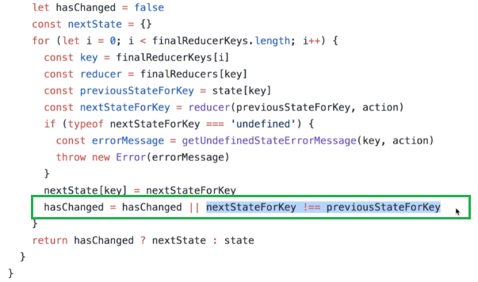

**If the returned state from the reducer is not brand new array, it will not update state as shown in the above redux library code.**

**This is the reason people say, you must not mutate state!!**

**The reason this is relevant is that if Redux returns the old state value then Redux is not going to notify the rest of your application that any of your data has changed.**

**8. Safe State Updates in Reducers**

**These are the good and bad practices while updating state in reducers**

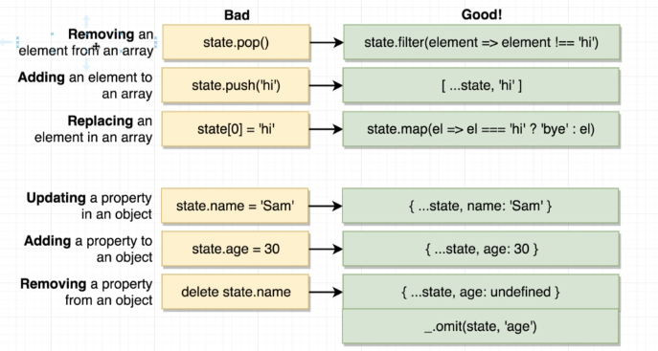

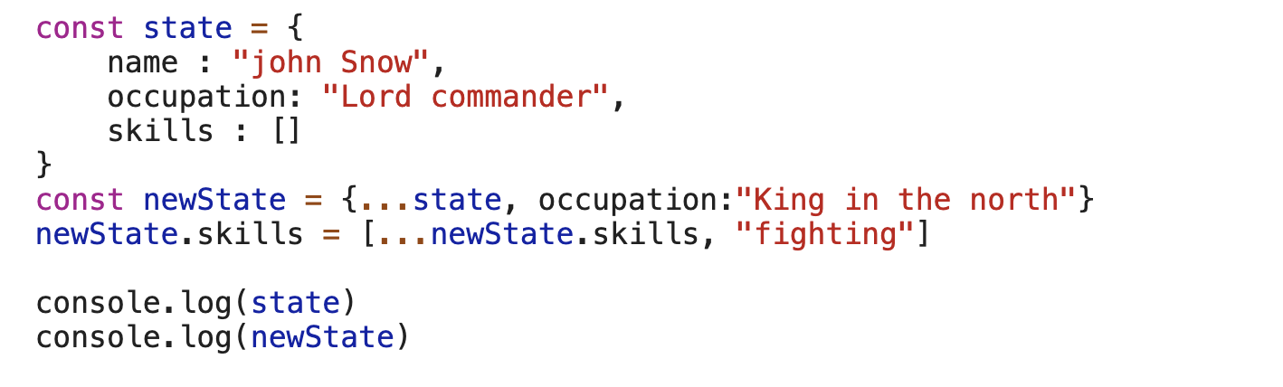

**Changing at one go**

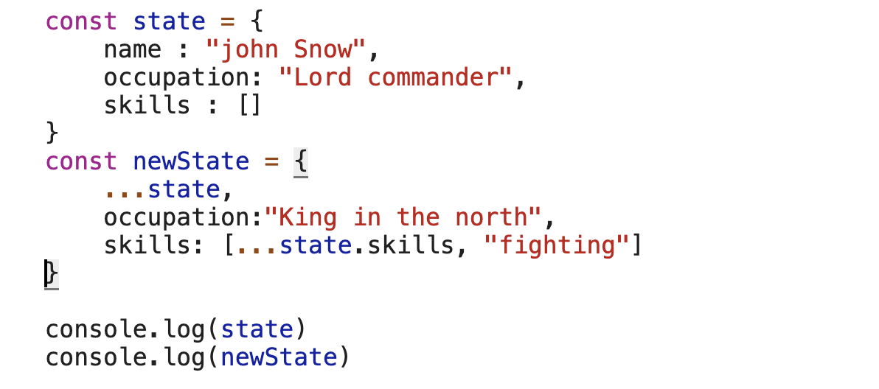

**9. Switch Statements in Reducers**

**Instead of using “if statement”, we should we use switch statement**

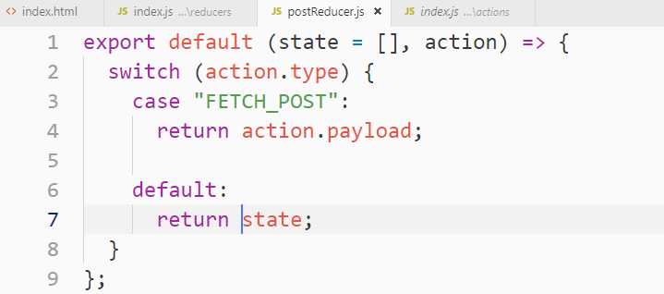

**10. Dispatching Correct Values**

**As soon as the reducer update the Redux store, the application should be re-rendered.**

**Once the reducer update the state, the last thing is to update the component. Let’s see how we update that.**

**Note: Anytime we want to get some data from redux side of our application into the react side, we always define “mapStateToProps” function passes off to connect function.**

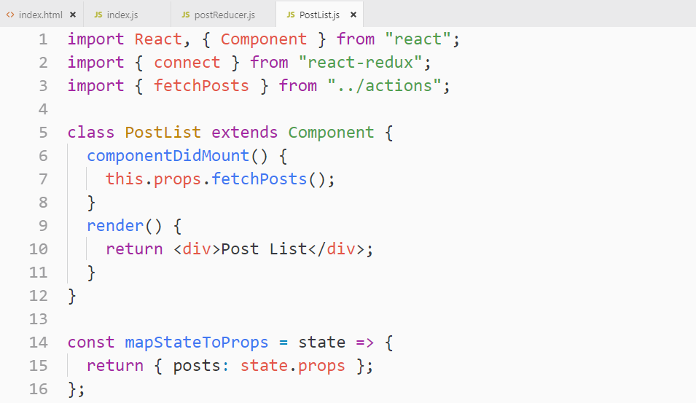

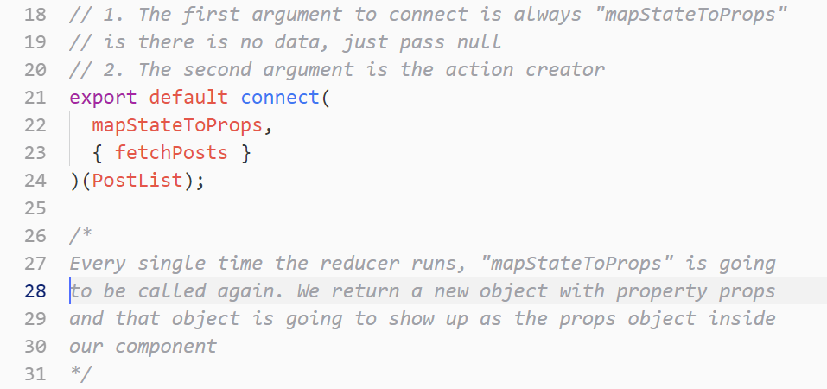

**We can test in the render method using “this.props.posts”**

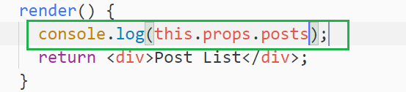

**There is one issue in the above code when we console log we get 2 arrays like this**

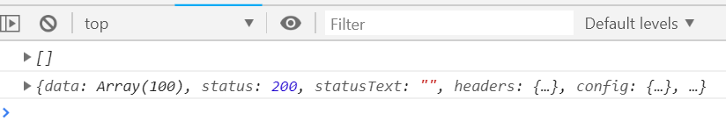

**The reason for the 2 arrays is that when our application is first time loaded up inside our browser, all of our reducers run one initial time and that time we don’t have any action type so it returned an empty array.**

**After all of our reducers run, The react side of our application is going to be rendered one time on the screen so the post list component is going to be displayed on the screen one time during that initial one time. During that initial time, it console log the empty array**

**Immediately after our PostList component shows up on the screen, our component lifecycle method will be called and then we go to the entire process of getting API data. Once we get that API data, we dispatch an action to reducer, our reducer checks the action type and returns the state accordingly. At this time, Redux sees that we have not returned same object in the memory, not returned that same array, so Redux tell to React to re-render itself with this new data so our post list component is going to render to the screen a second time. “mapStateProps” calls second time, and it gets a new value of state.posts time and it is going to show up inside our component, and the render method gets called again and we see that in console.**

**Just get the specific data that we want from the APIs. So getting just the “data object”**

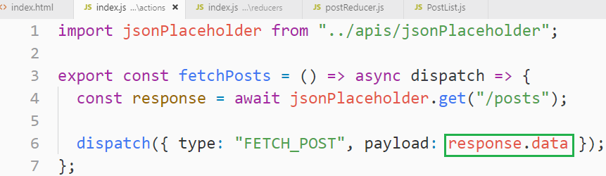

**11. List Building!**

**This is the entire PostList component**

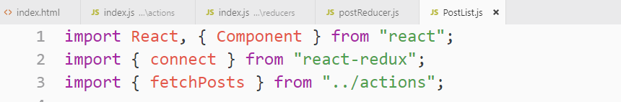

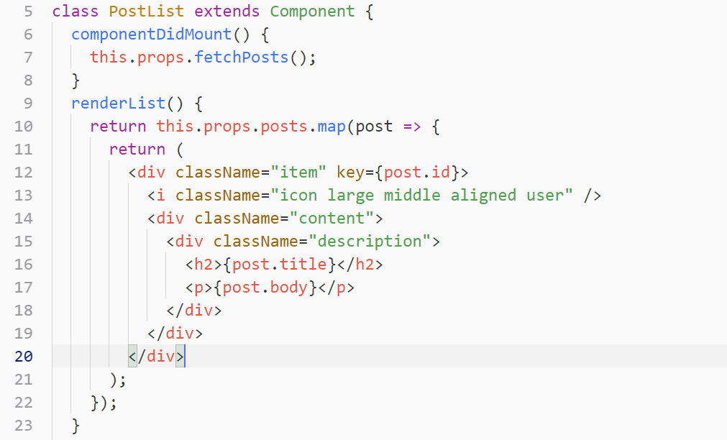

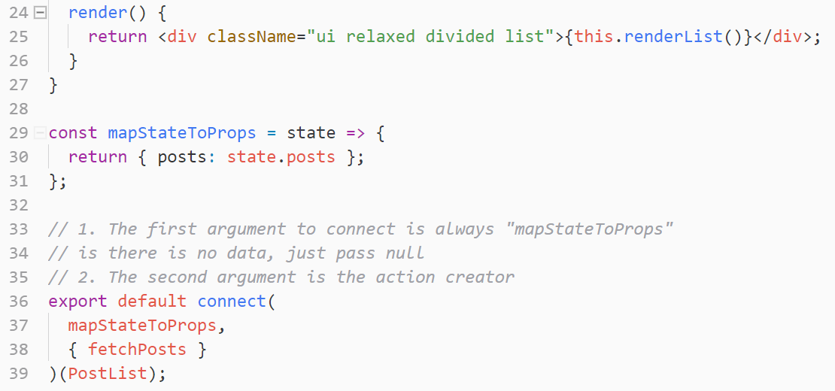

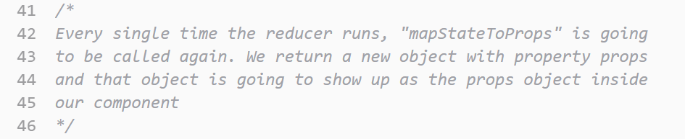

**12. Displaying Users**

**We will fetch details of user by calling another API by passing userID. We will create a new component of Author name**

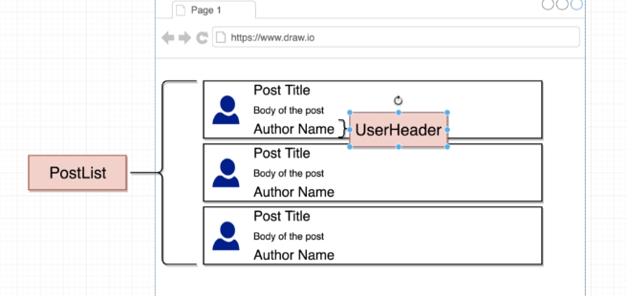

**Relationship of the 2 tables are following**

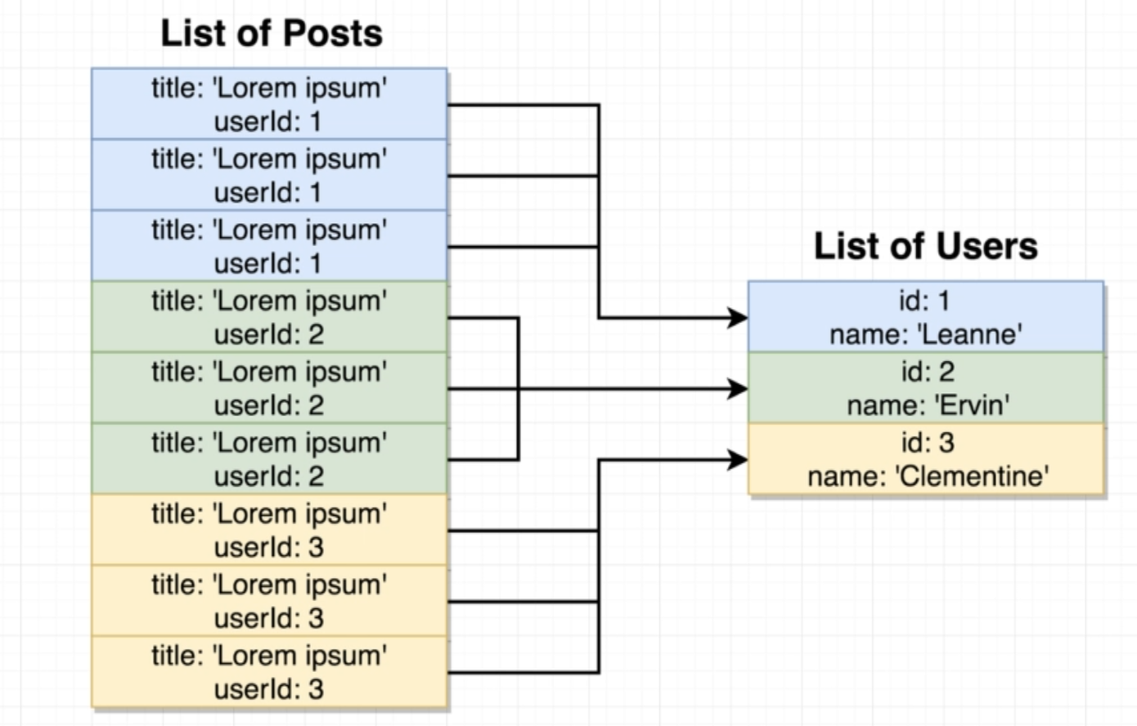

**There are 2 ways we can achieve this so first let’s see the easiest way**

**This is the way we will achieve this goal**

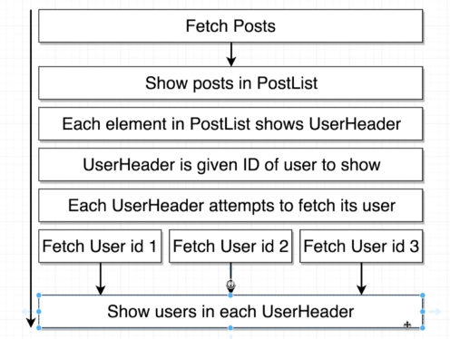

**Rough code example just to implement above diagram**

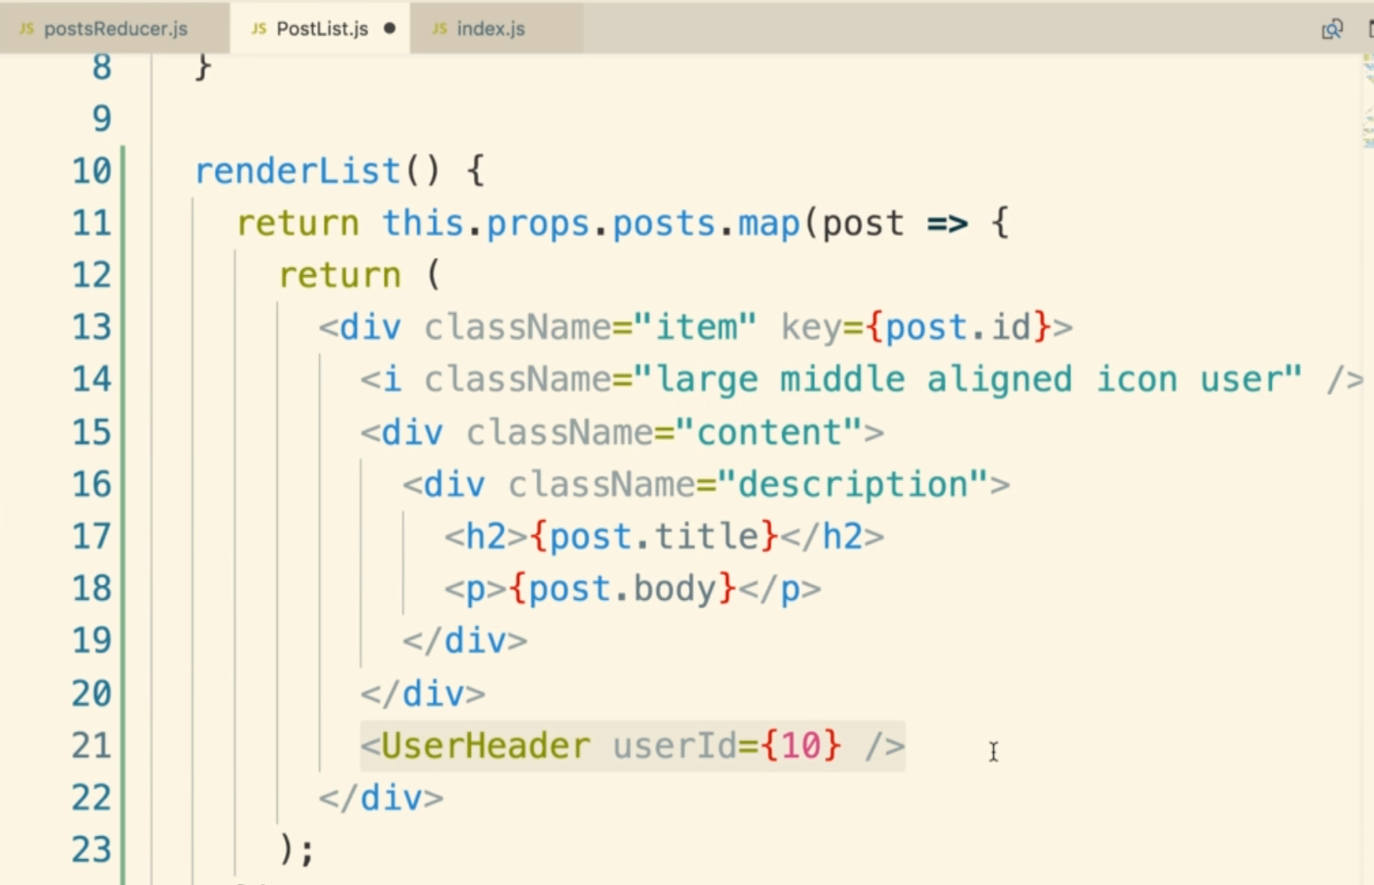

**13. Fetching Singular Records**

**We will create a new Action Creator called “fetchUser”**

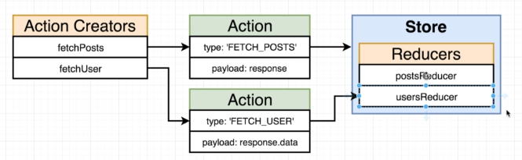

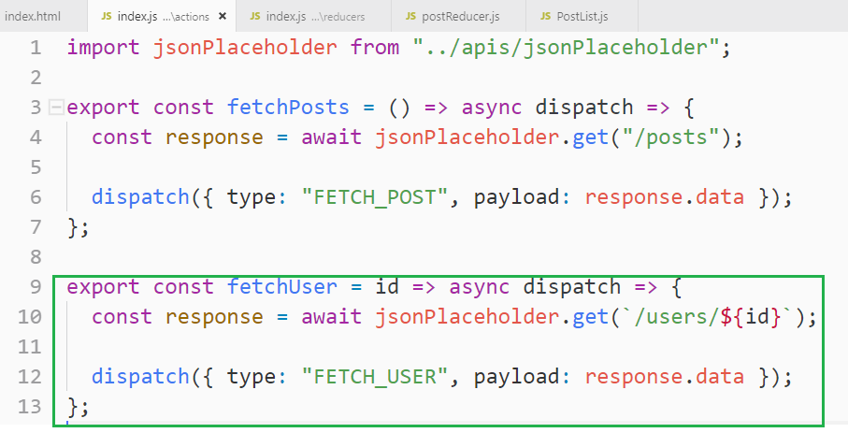

**14. Displaying the User Header**

**Creating UserHeader.js component**

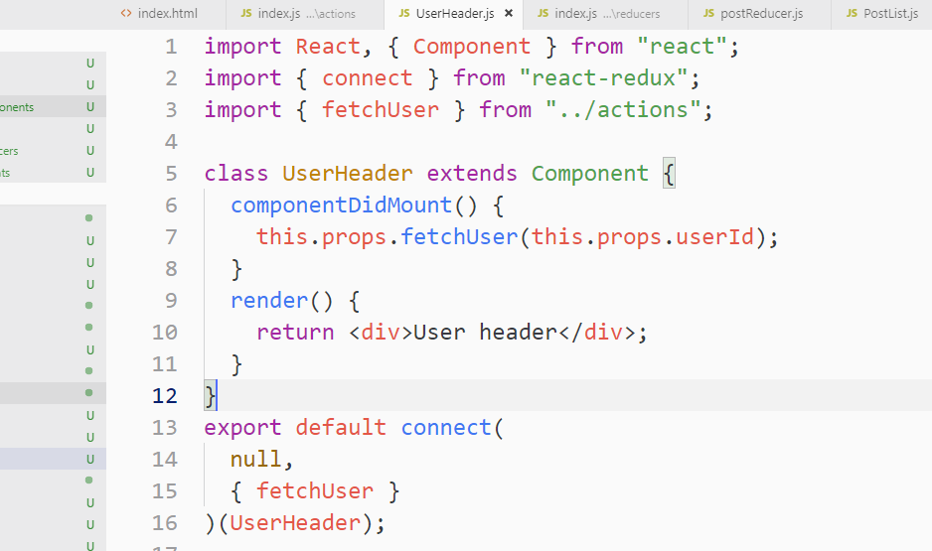

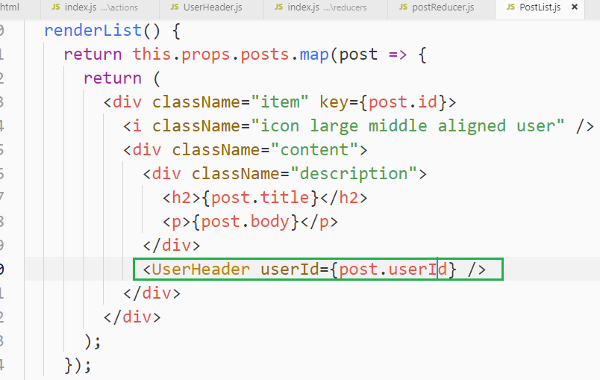

**15. Finding Relevant Users**

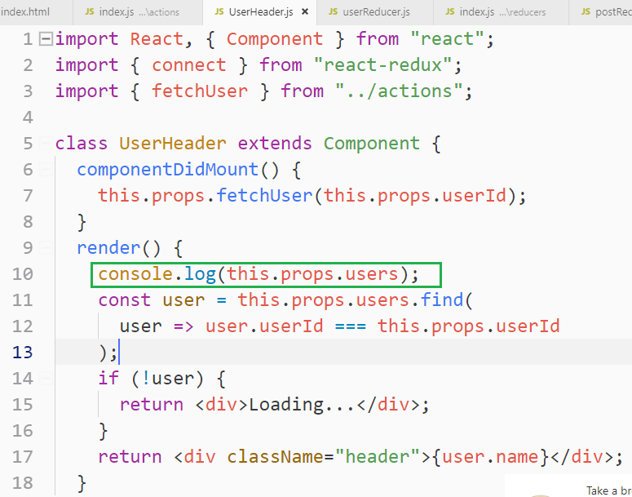

**Note: in the above “UserHeader.js” component we are passing the entire user object while we only need user name So let’s fix it.**

**16. Extracting Logic to MapStateToProps**

**We can do all the above map() function logic in PostList and just pass the username, but there is another way we can do so.**

**It looks “mapStateToProps” is unnecessary in “UserHeader.js” component like anytime we pull some data from out of a component, we have to define this “mapStateToProps” repetitive function and then we have to build up this object right here and get some data out of our Redux Store**

**Rather than passing in like a tons of data to our component and relying upon the component to figure out how to find the user that we care about, we could instead extract all that logic to mapStateToProps() function**

**So rather than going through find() method inside the component itself, write that logic out inside of mapStateToProps() function.**

**Writing down the find() user functionality to mapStateToProps doesn’t scale it, but it is an increase in re-usability because developer creates a separate file for mapStateToProps() function and connect() function**

**The advantage of this is that you will have a component that can be used own its own without having to reach to the redux store.**

**Note: “mapStateToProps() function” also gets a second argument as well that is referred to as own props, and with this own props object. This “props Object” is reference to that is about to be sent into “UserHeader.js” component**

**17. That's the Issue!**

**The issue is that we are making 10 requests for same user**

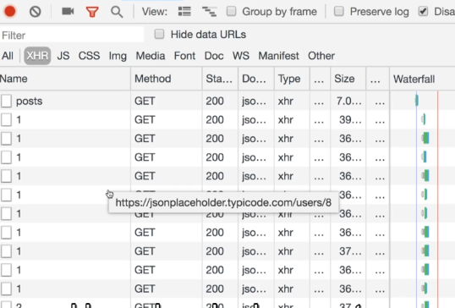

**We are showing one instance of UserHeader.js component for every single blog post that we fetch.**

**Everytime that a UserHeader component is rendered on the screen, componentDidMount() is called so call the Action Creator inside it with particular UserId.**

**Because we are rendering a 100 instances of UserHeader.js component, our action creator gets called a 100 different times even though we are fetching some very-2 repetitive data.**

**So this is the issue!!!**

**Let’s figure out a way to stop duplicating requests.**

**18. Memoizing Functions**

**Solution 1:**

**Let’s use the Lodash _.memoise() function to solve this.**

**_.memoise takes our function and wraps it up with a bunch of code and returns a new copy of our function. This new copy is called the memoised version of our function.**

**This new version is same with only one difference that is we can call memoise function one time with unique set of arguments. After we call it one time, we can still call it, but the original function is not going to be actually invoked instead, it returns whatever we returned last time we ran it with the identical set of arguments.**

**Go on lodash website and try in console**

**fetch() is available on browser to make API request.**

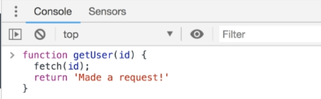

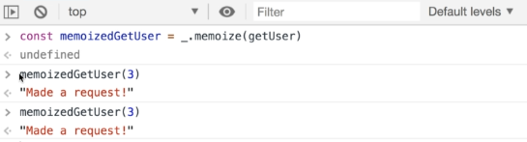

**Memoising “Action Creator” could be a good solution here**

**19. Memoization Issues**

**If we call _.memoise() on internal function, it won’t work as it is creating a new function every time it is called and returning it. It behaves like even if you call it on outer function as there it is also return the entire function.**

**Doesn’t work as expected!!**

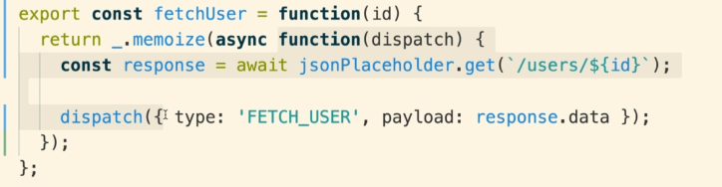

**Doesn’t work either!!**

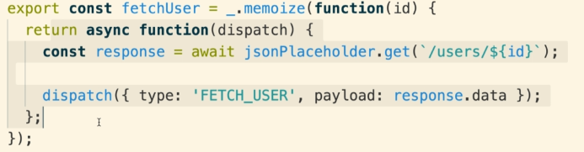

**20. One Time Memoization**

**The solution to the above is that we need to define the function outside of our Action Creator that’s going to actually make the request and then dispatch our action and we are going to memorise it outside of our Action Creator so it only gets memoise exactly one time and not going to re-memorised everytime we call our “Action Creator”**

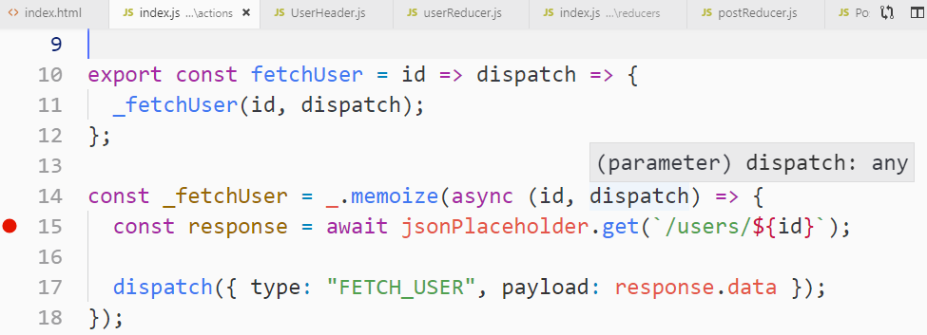

**The one side effect of this solution is that if you ever want to re-fetch a user for some reason like if you have made a change to a user or if you know that the user data has changed or updated on your API and you want to re-fetch it, unfortunately you would not be able to do it again using the above memoised “Action Creator”**

**With this solution, you only fetch each user one time. So if you want to re-fetch a user you would have to declare another action creator that has the same logic, but just does not apply that memoisation step.**

**21. Alternate Overfetching Solution**

**Alternative universal solution to the above memoisation technique.**

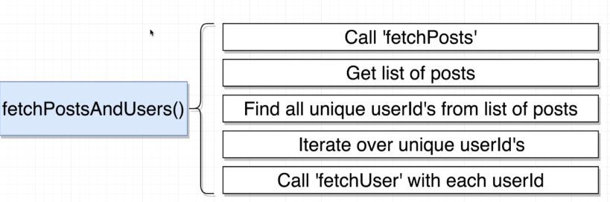

**We will create a new “Action Creator” called “fetchPostsAndUsers()” in actions/index.js**

**22. Action Creators in Action Creators!**

**Now our component will call “fetchPostsAndUsers()” in our UserHeader.js component.**

**We have to manually dispatching this “fetchPosts and fetchUser” functions.**

**Note: Whenever we dispatch a function, Redux-thunk is going to pick it up and automatically invoke it.**

**Note: Whenever we call an “Action Creator” inside an “Action Creator”, we need to make sure that we dispatch the result of calling the Action Creator.**

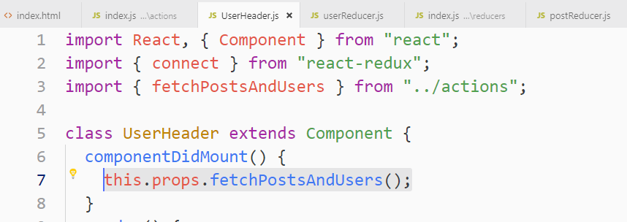

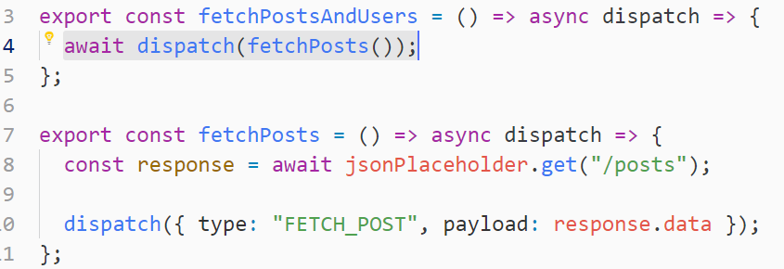

**Note: await dispatch(fetchPosts());**

**Doesn’t allow to go next statement until it finishes to get the result.**

**23. Finding Unique User Ids**

**To get the list of Post in the above code, here is a solution.**

**Note: The 2nd argument that Redux-thunk calls our inner function with for all these actions, in addition to “dispatch” is “getState” function, this function is available on the Redux store that gives us access to all of the data inside Redux.**

**Lodash` function called _map() is we will use to get the userID from the list of post very easily like this.**

**We did not use async and await for “fetchUser” as we did for “fetchPosts”, the reason is that we don’t care about waiting for each user to be fetched inside “fetchPostsAndUser”**

**We don’t have any other logic or operation to do on fetchUser, so we didn’t use asyn and await**

**Note: async and await does not work with forEach, you can use map() instead**

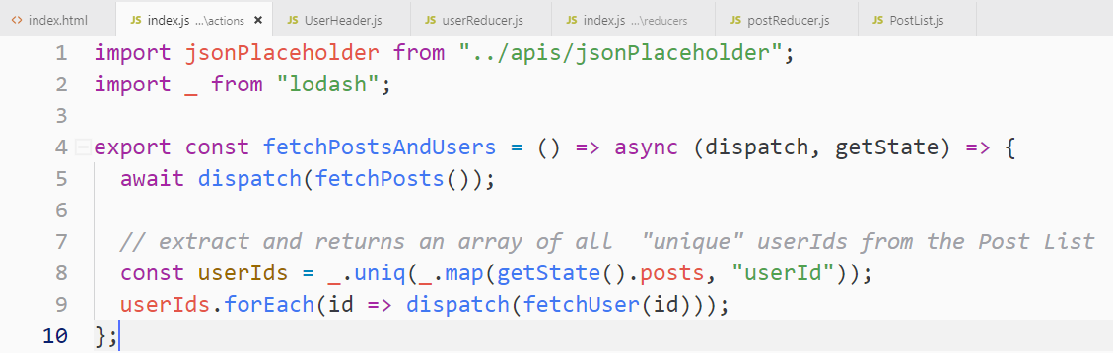

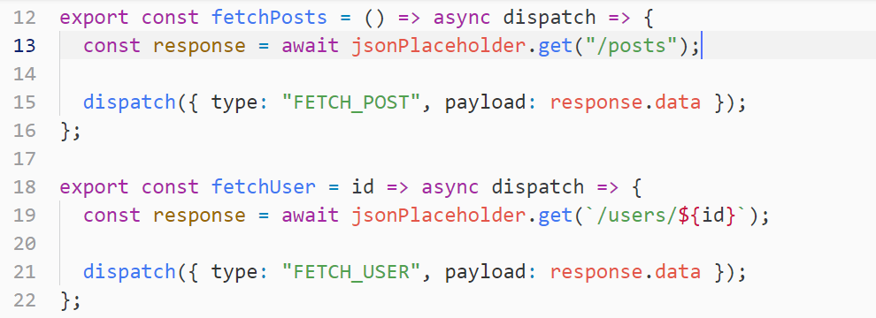

**24. Quick Refactor with Chain**

**We can refactor the below code using lodash` _.chain() method, but requires to call values() at the end of the chain to execute all the functions in the chain.**

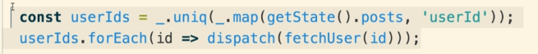

**Refactor using _.chain() method**

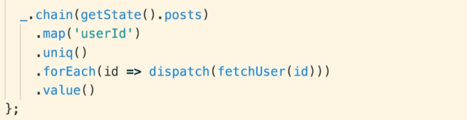

**25. App Wrapup**

**Inside of our root index.js file, we had imported “redux-thunk” and wired it up to “redux store” through the use of “applyMiddleware(thunk)”**

**When we apply that middleware of redux thunk, anytime that we dispatch an action, the action will be first sent to redux thunk as the middleware and then after redux thunk the action will be sent off to all of our different reducers.**

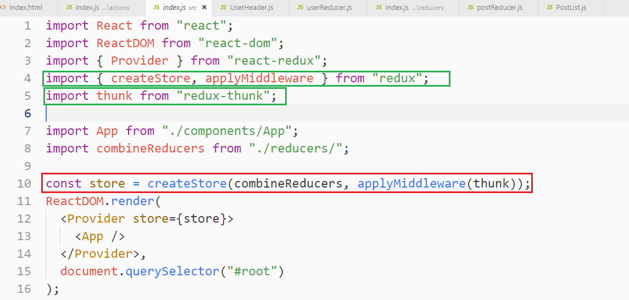

**When we wired up “redux-thunk” it changed the rule of our “Action Creators”**

**So inside our Action Creator, we no longer had to create Action Creator that always returned an action object instead with “redux-thunk”, we could optionally returned a function.**

**If we returned a function, it would be automatically called with dispatch and getState functions as arguments and that essentially gave us total control over changing or getting information out of our redux store.**

**Anytime that we expect to make an API request from an “Action Creator” we will always use of something like “redux-thunk”**

**When we returned a function from our Action Creators, we use this really interesting syntax like below. All it does is it is a function that returns a function.**

**When we call the outer function, it automatically returns the inner function selected code below.**

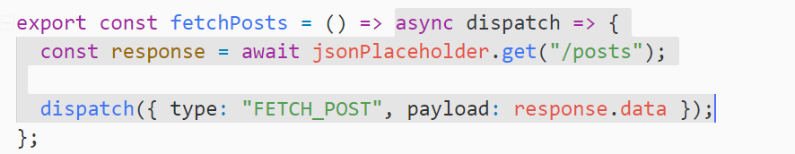

**Action Creator can call other action creators like this**

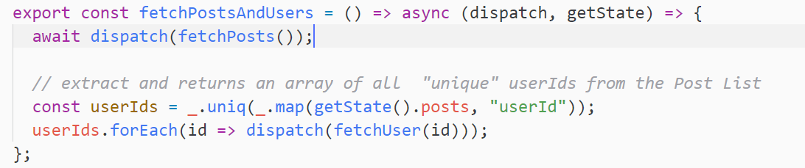

**Reducers:**

**The first argument is a state which is a store object or states. We run this reducer over-2 again and whatever the last returned value that becomes the new state.**

**The second argument is an action object, which must have a type property and an optionally payload.**

**Post Reducer, Just fetching posts**

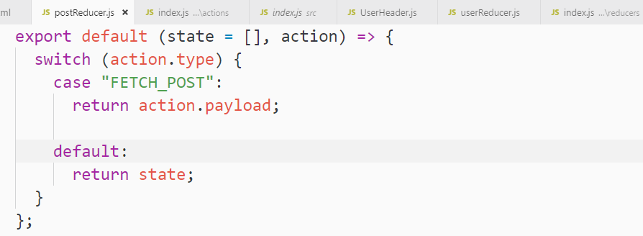

**User Reducer, updating state**

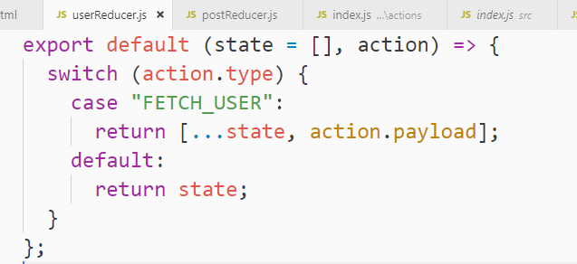

**16. Navigation with React Router**

**1. App Outline**

**OBS => A popular streaming video software. It can also record your videos from your desktop.**

**OBS streams that video to some outside server. One way of putting this video streaming service together is to create something called RTMP server**

**RTMP is a specialized server that is going to receive an incoming video feed and then broadcast that video feed out to a bunch of viewers who can watch from their browser.**

**A RTMP server is not limited to one stream at a time, but RTMP could have several different streamers, all send video to our single server (RTMP) here and then many different viewers could be watching each of these different streamers at the same time.**

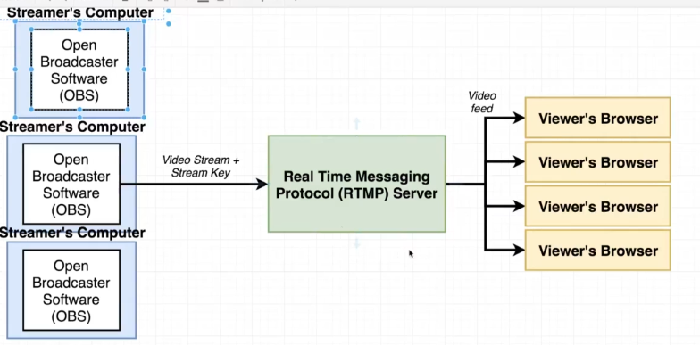

**Instead of just streaming videos, we can other information as well like “what streams are currently broadcasting” or what streams exit inside of our application.**

**So we will have a separate API server that is just going to store a list of all the different streams or channels that are available inside of our application**

**So a user inside the browser visit the API server and see the list of streams that are available. Once they see an appropriate stream, they can then select that stream and that will essentially make a request over to the RTMP server to get the live video feed and then show it on the screen to the user’s browser.**

**So we have 3 pieces here for the application**

1. **React App (browser)**
2. **Tiny API server**
3. **RTMP server**

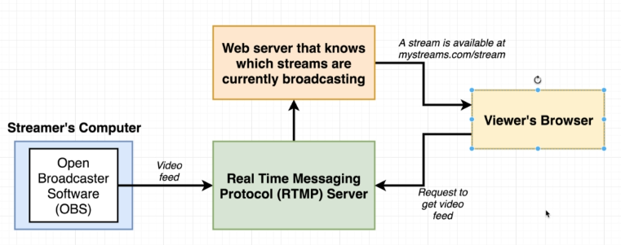

**2. Mockups in Detail**

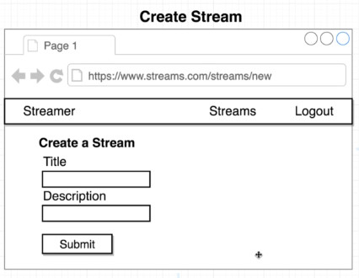

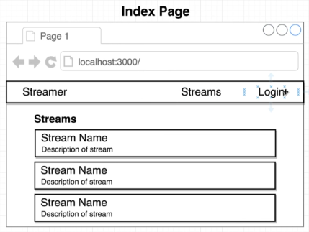

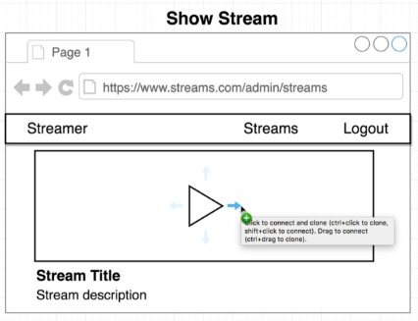

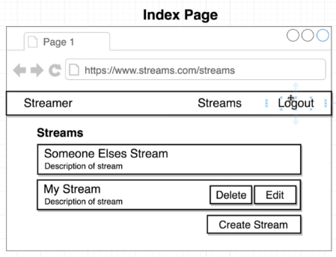

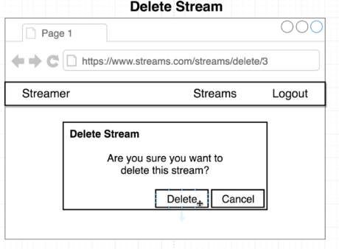

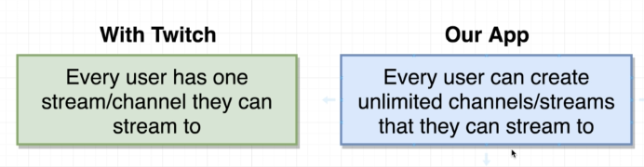

**When the user visits website, he has to follow certain rules**

**our** 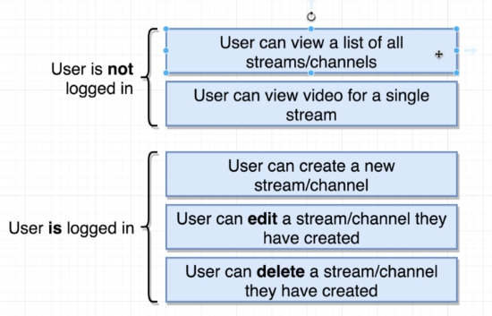

**3. App Challenges**

1. **react-router is a separate library to add routing to our react application.**
2. **Google Oauth is a library to add authentication to our react application.**
3. **How to handle forms in Redux**
4. **Need to master crud operations in**
5. **Need good error handling**

**4. Initial Setup**

**Note: for Bootstrapping app, it needs to have index.js in the src folder**

**Initial setup for the project with these 2 files index.js and App.js**

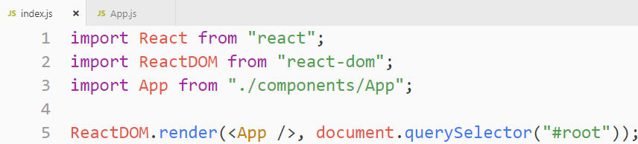

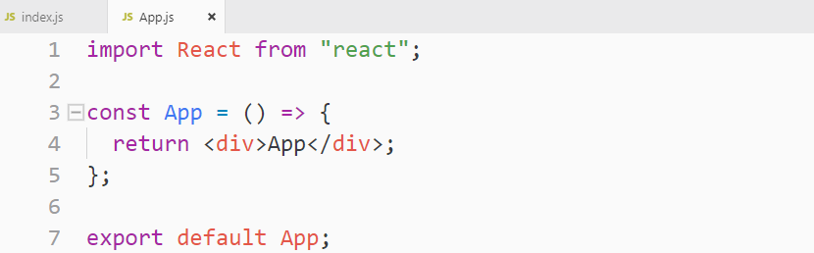

**5. Introducing React Router**

**Let’s see how to do navigation. To make navigation enable, we need to have react-router-dom.**

**We installed “react-router-dom” instead of “react-router”**

**Inside of the react-router family of libraries, there is a couple of different dependencies that you could possibly install.**

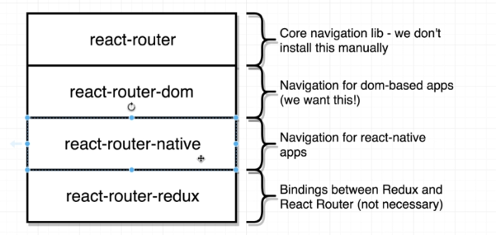

**We need to have these component from the “react-router-dom”**

1. **BrowserRouter (component from React-router-dom)**
2. **Route**

**This is a simple implementation of Navigation**

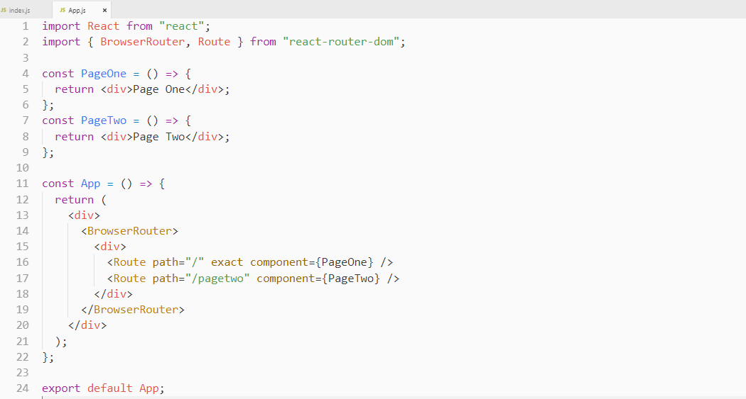

**6. How React Router Works**

**React Router only cares about the characters that are listed after the domain and port definition**

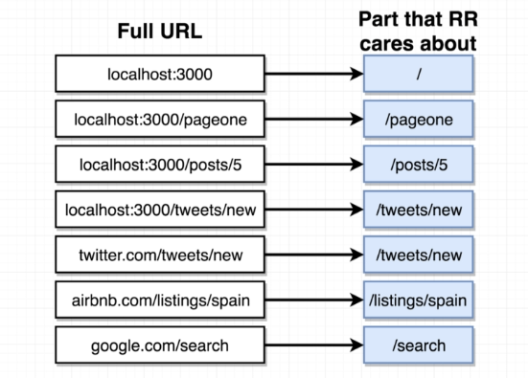

**When we created our application and loaded up in the browser, we created an instance of BrowserRouter component. The BrowserRouter internally creates an object of its own called “The History Object”. This “History Object” is going to look inside of your address bar and it is going to extract just that portion of the URL that “React Router” cares about.**

**This “History Object” is then going to communicate that path over to BrowserRouter and then BrowserRouter is going to communicate that path down to both of your route components.**

**The “React Component” are then going to decide either to show themselves or hide themselves depending upon the path inside of the URL that the user is visiting.**

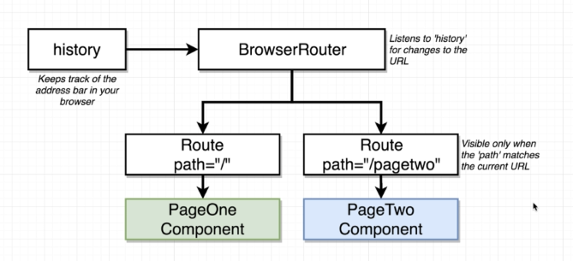

**7. How Paths Get Matched**

**Note: In a React application different routes can be matched by the same URL so all the components will be loaded on the screen**

**Example 1:**

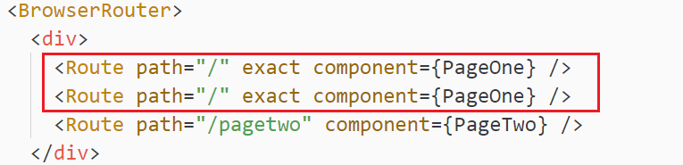

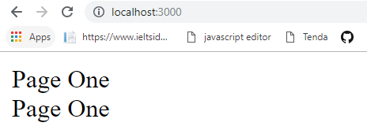

**So with above implementation, we can load multiple component on the same URL.**

**Another thing to note about exact keyword is that, if we don’t use it so all the further matching router will be loaded and this is by design.**

**Example 2:**

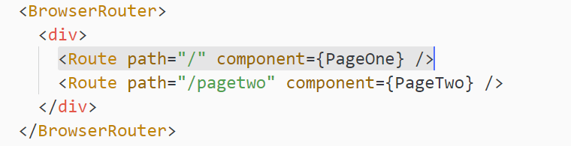

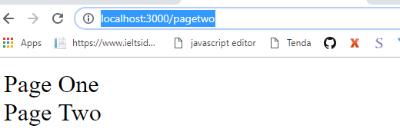

**Let’s see why it is doing like this.**

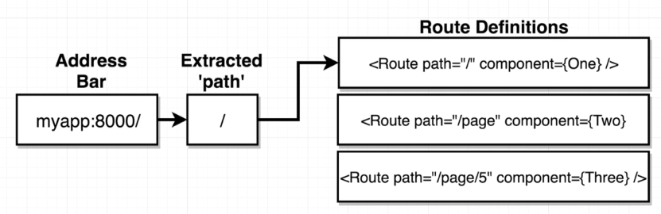

**React Router uses the contain() method due to which it includes all the matching routes if there is no exact keyword present.**

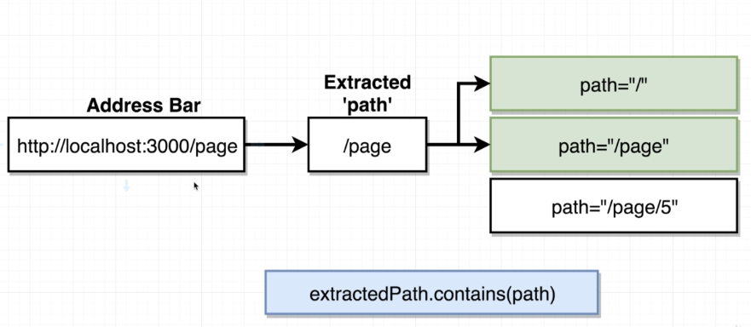

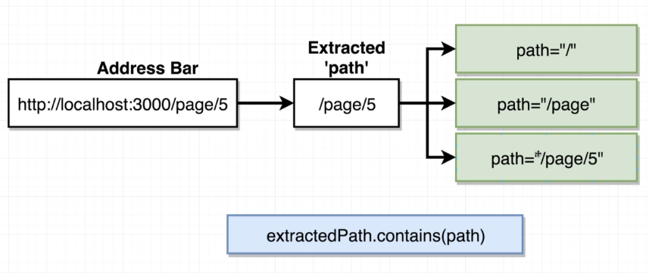

**exact === exact={true}**

**If we added the exact word then it doesn’t use contain() method instead it directly overwrite the exact path.**

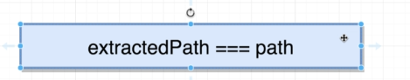

**8. How to Not Navigate with React Router**

**<a hrer=”/”> :: never user anchor tag inside of a React App. It uses the standard way of navigation which loads up the entire page and you lose the data.**

**9. Navigating with React Router**

**Let’s see how we can navigate between different routes inside of our application.**

**<a hrer=”/”> :: never user anchor tag inside of a React App**

**We need to import “Link component” that we are going to use instead of <a> tag**

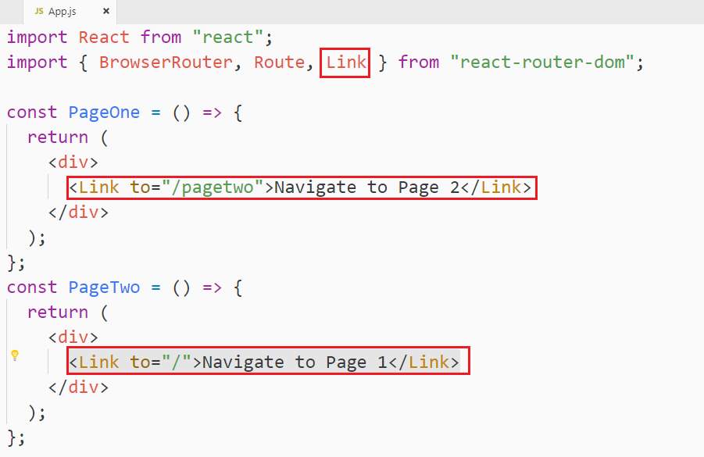

**<Link> component**

1. **It doesn’t reload the page**
2. **It doesn’t even make any additional request**

**If you inspect the <Link> tag in the browser, it will show you as <a> anchor Tag.**

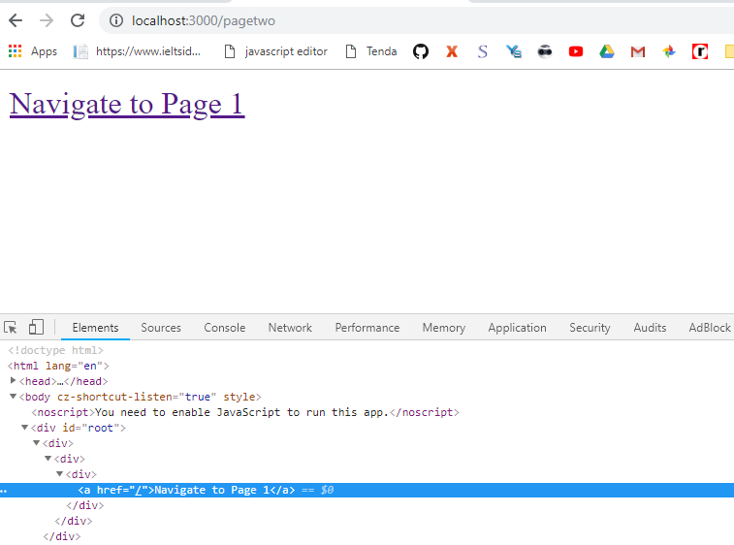

**React router prevents browser to navigate to route shown in the above code and History object is going to see the updated URL so it takes that URL and sent off to the BrowserRouter, the BrowserRouter communicates down to all the different routes, and the router component then re-render to show a new set of component depending upon the path.**

**We are just showing and hiding component based upon the URL path**

**10. [Optional] - Different Router Types**

**React-router has 3 different types of routers are available. The difference between them is the part of the URL that they look at when deciding what content to show on the screen.**

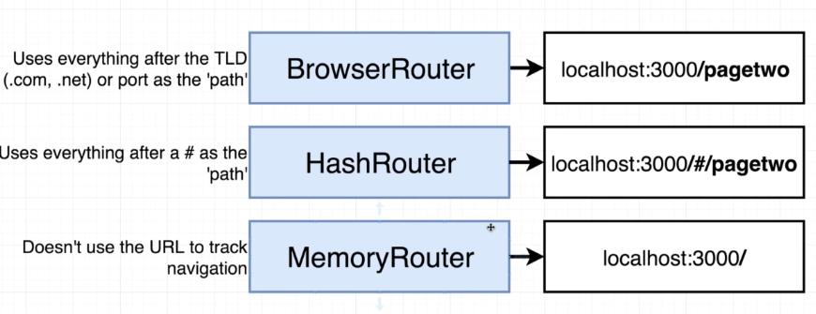

**TLD : top level domains like “.com, .net” etc.**

**HashRouter: it add # into the URL and it reflects the current path after that # character.**

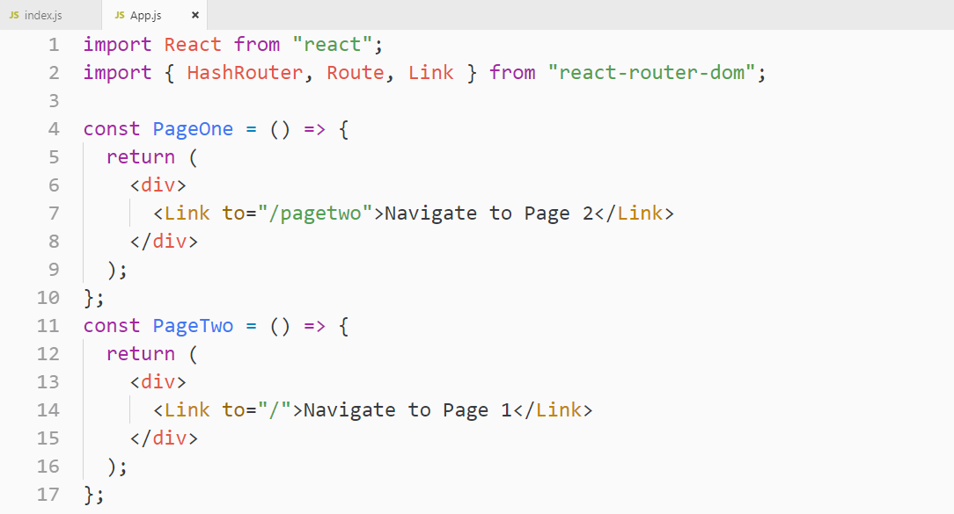

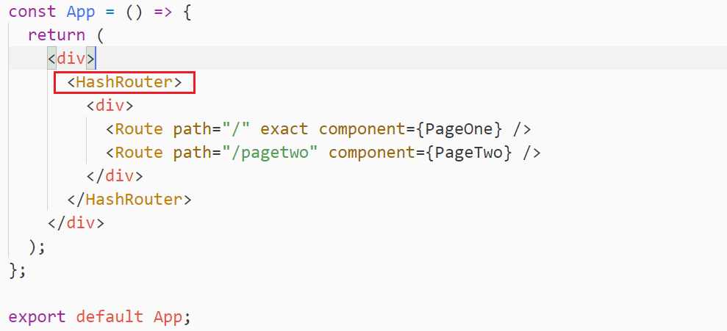

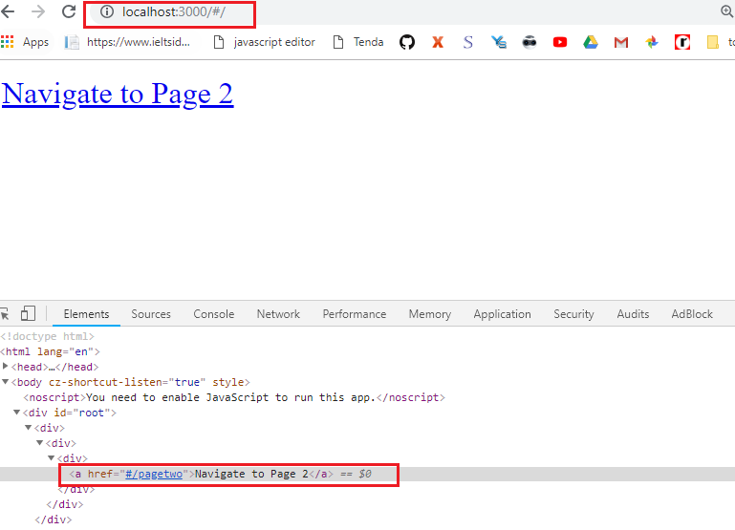

**Let’s see the MemoryRouter now.**

**It just doesn’t update the URL, but changes the component depending upon the path**

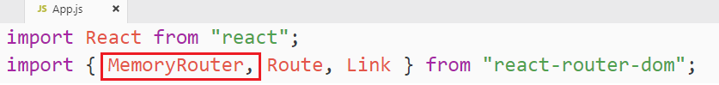

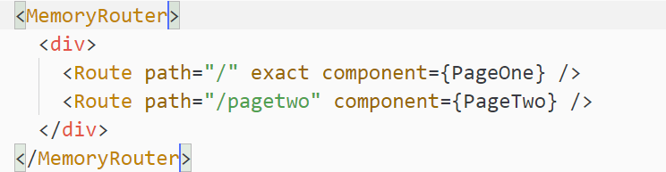

**The question here is that why do we care about all these 3 different routers?**

**This comes into picture when you deploy your application.**

**The BrowserRouter is by far the most complicated to deploy inside of any realistic setting.**

**In many case, doing deployment with browser router is very easy because most of the services understand that you are going to use BrowserRouter.**

**In react application, if the router is not define, it doesn’t respond back with 404, instead it returns index.html. This is the reason, it is difficult to deploy with <BrowserRouter>. You server has to configure that it has to return index.html even if route is not available.**

**With HashRouter, you are supposed to be setting up your server to not take a look anything after the #. The reason that we use HashRouter is that we can make request to always localhost:3000.**

**# is only for client/browser use.**

**HashRouter is a lot more flexible because it does not require special configuration by your backend server.**

**You can have a single index.html file and you can always make request to that route so when the application loads up, React-router will look after the # and decide what to show up on the screen.**

**11. Component Scaffolding**

**Let’s create all the required components for our streaming app.**

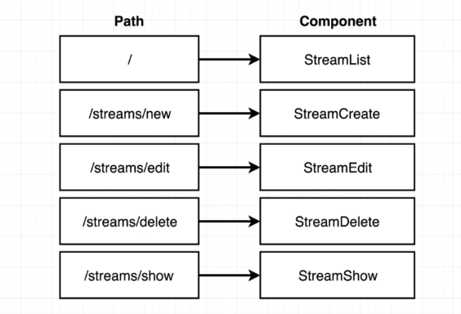

**Created all these components into src/streams/**

**12. Wiring Up Routes**

**12. Wiring Up Routes**

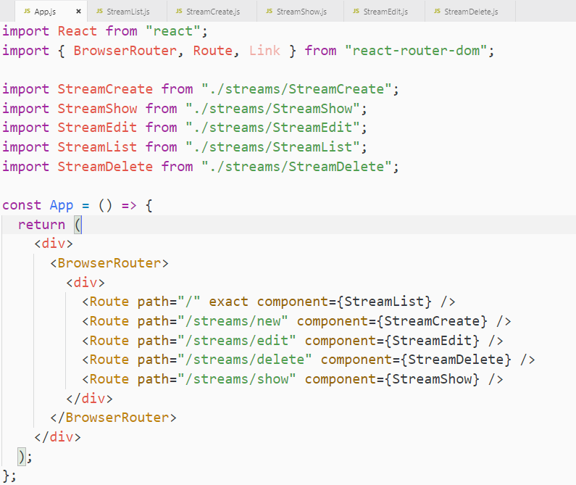

**13. Always Visible Components**

**If you want to show something always then put that outside of the <BrowserRouter> component.**

**As we shown in the below code.**

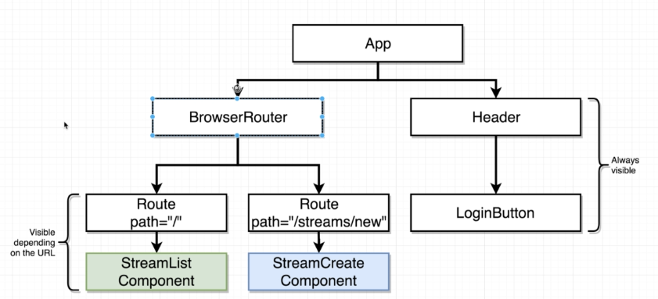

**14. Connecting the Header**

**Creating and adding Header.js to App.js**

**We are using “Semantic UI CSS framework”**

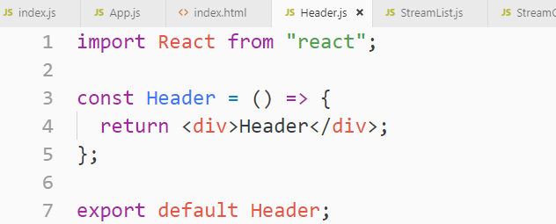

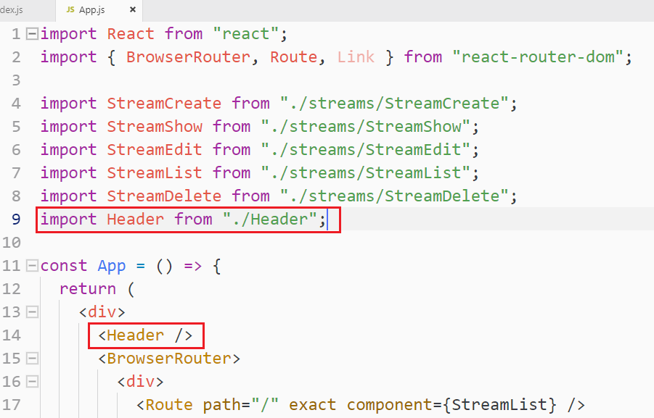

**If you use <Link> without router, you may have this issue.**

**It is saying that any component that is not a child of <BrowserRouter> cannot contain any React router related component like <Link> we used. Our Header is not a child of <BrowserRouter>, we have to move it inside the <BrowserRouter> to make <Link> work**

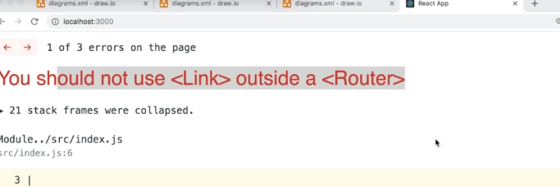

**15. Links Inside Routers**

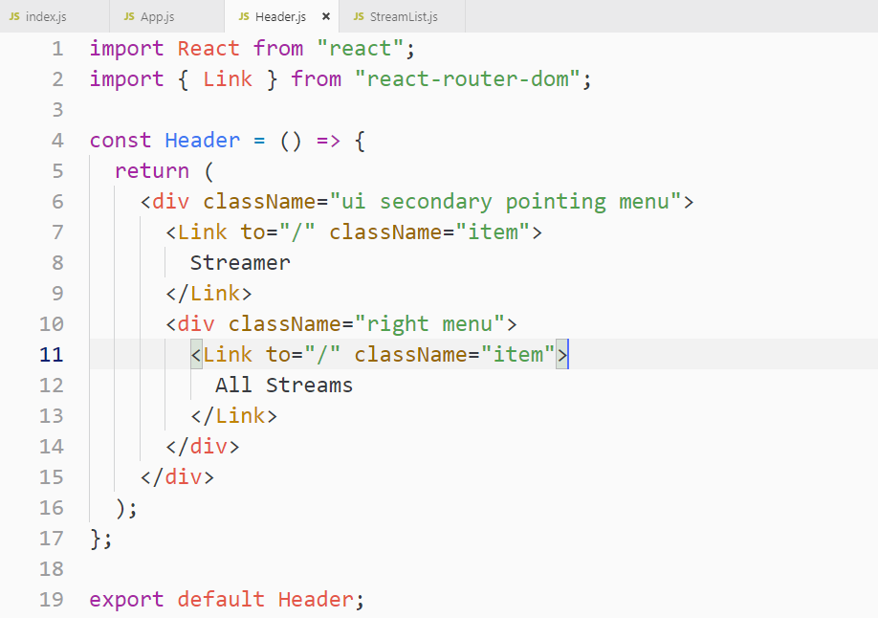

**Note: We moved the <Header> inside the <BrowserRouter> as the required by the react-router to make <Link> work.**

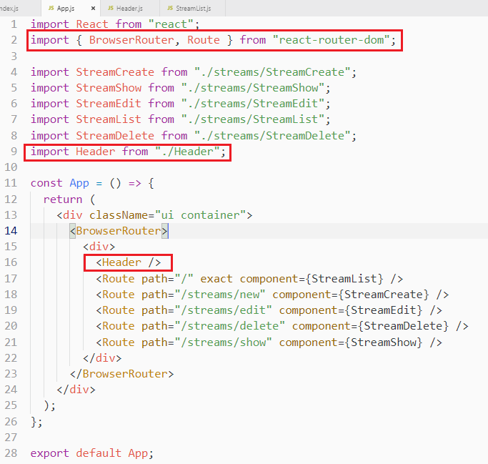

**17. Handling Authentication with React**

**1. OAuth-Based Authentication**

**OAuth is not only about authentication, it’s also about letting our application get access to all that user’s data on some outside service provider.**

**A scope is a list of permission that you are granting to an application. You can search for google OAuth Scope List**

**You can even send email on behalf of user and other actions that are listed in the google scope list**

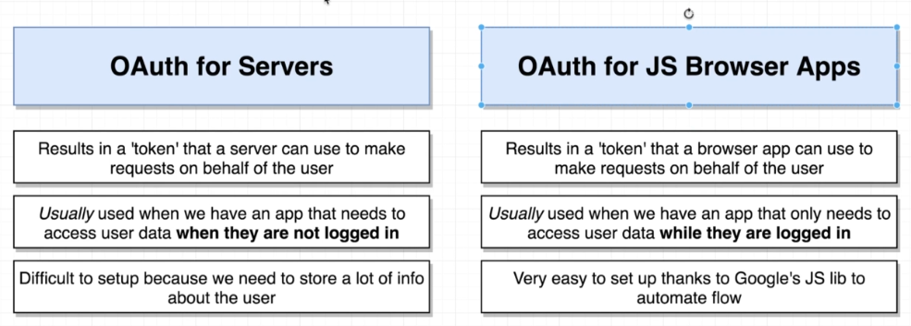

**2. OAuth for Servers vs Browser Apps**

**Diagram for OAuth for JS Browser App**

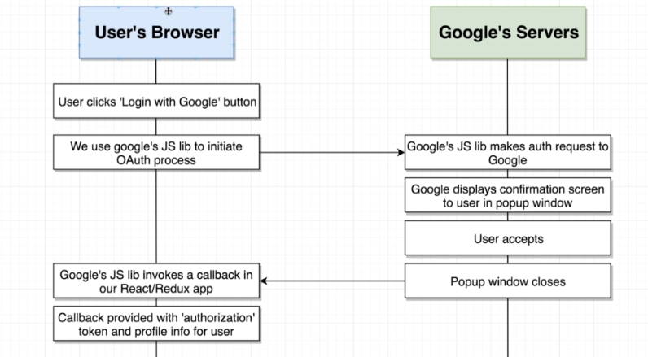**hoo**

**3. Creating OAuth Credentials**

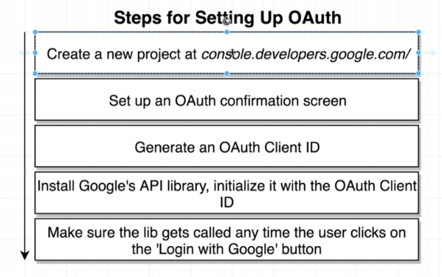

**Click here for a new project**

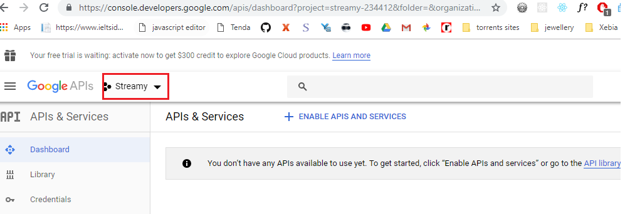

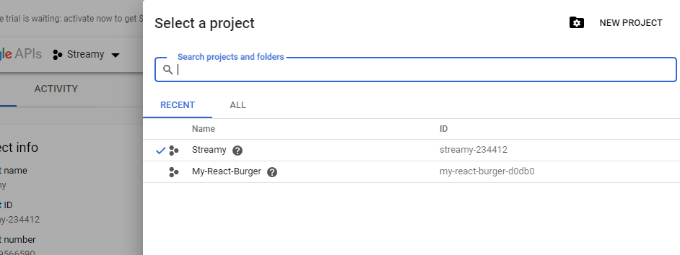

**After creating project, go to credential tab on the left side and then click on “OAuth consent screen”**

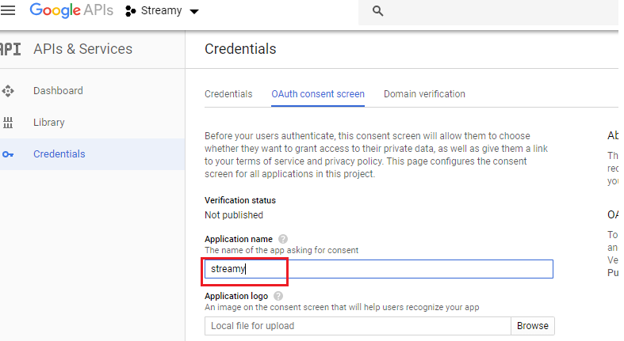

**Now save the project and go back to Credential on the left side and then click on OAuth client ID**

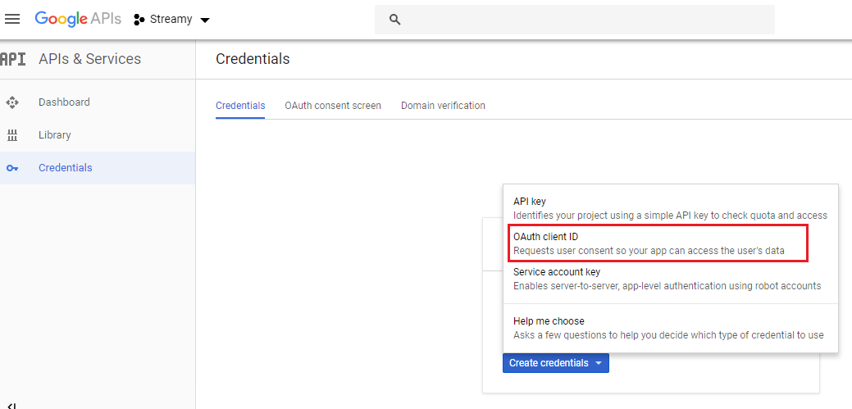

**Once you click on the above selected area, you will on below given screen.**

**Google is only going to allow OAuth request to come in from a domain that is equal to whatever we listed in the below selected URL**

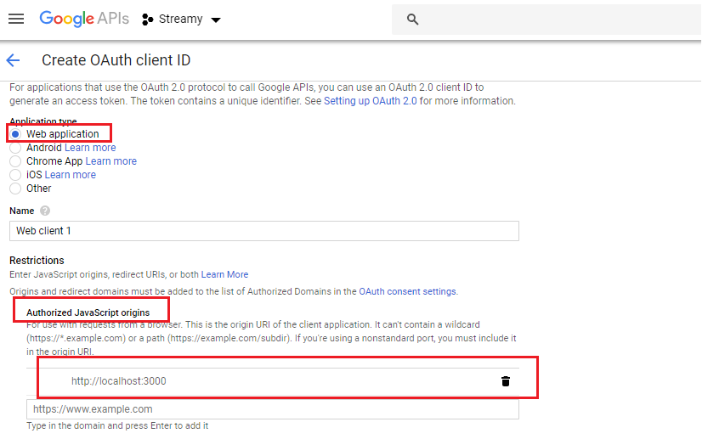

**This is last screen of OAuth Project creation process.**

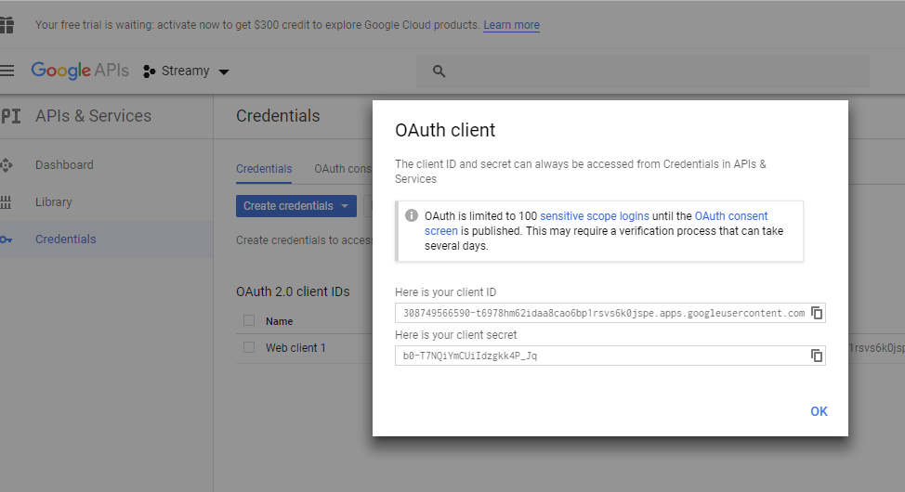

**Client ID**

**308749566590-t6978hm62idaa8cao6bp1rsvs6k0jspe.apps.googleusercontent.com**

**Secret:**

**b0-T7NQiYmCUiIdzgkk4P_Jq**

**We use client secret if we are using creating OAuth for Server, but we are using OAuth for JS application and for that type of flow we only need the ClientID**

**4. Wiring Up the Google API Library**

**Google does not offer this through NPM so we have to manually add it to our index.html**

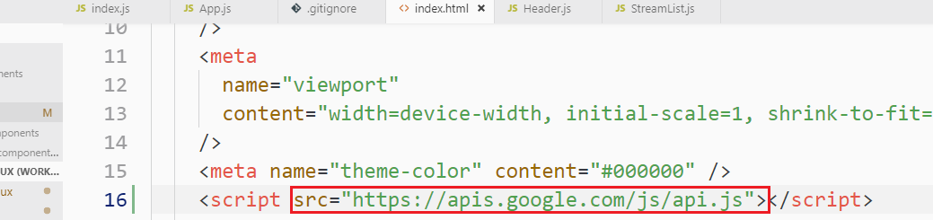

**To test whether it is successfully added type “gapi” in the console**

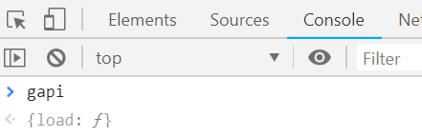

**Gapi: is user for multiple google services so we need tell it to what service we want so it loads that specific code in the browser.**

**To load specific service code, we call gapi.load(“client:auth2”) function**

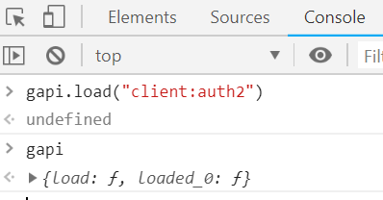

**We want to load this library once so we need to define “ComponentDidMount” lifecycle inside “GoogleAuth.js” component**

**This library is available on window object.**

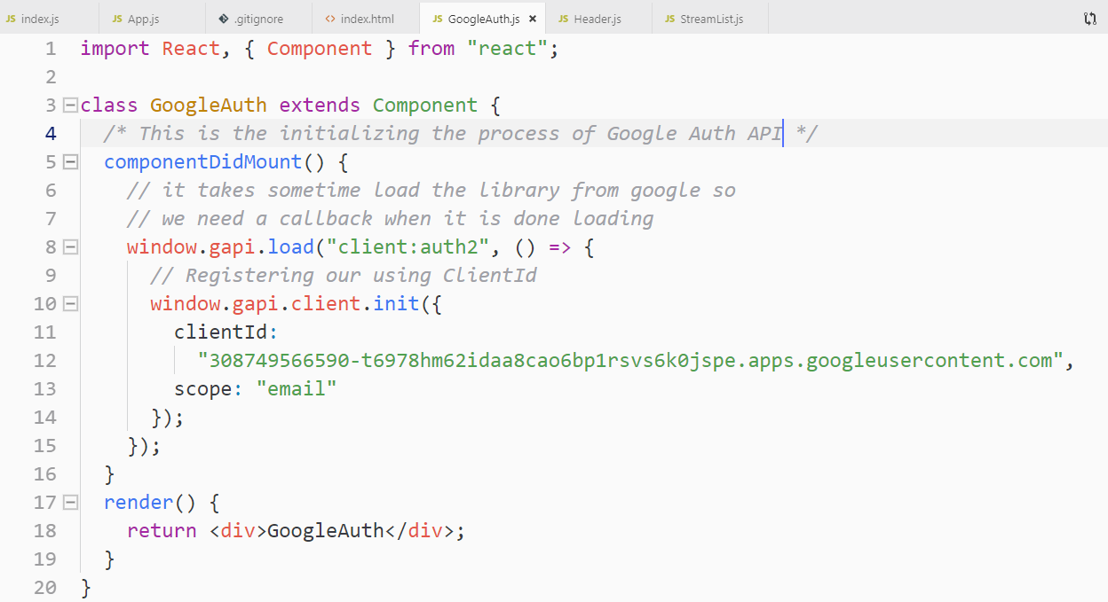

**Adding GoogleAuth.js component to <Header>**

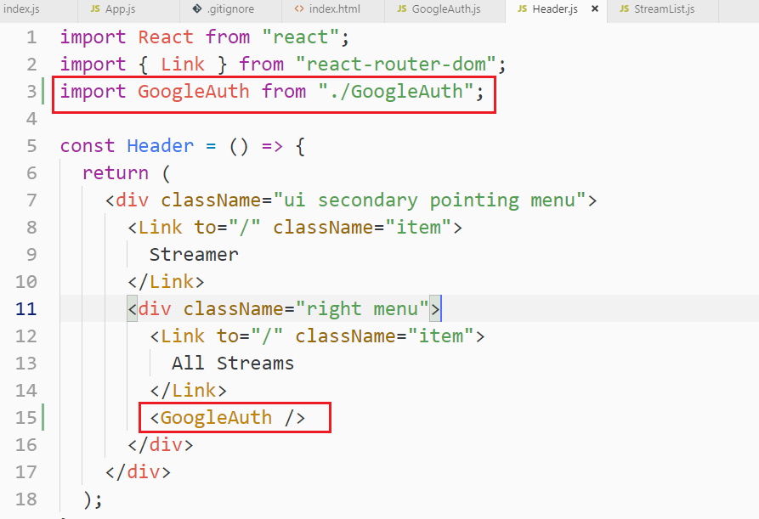

**5. Sending a User Into the OAuth Flow**

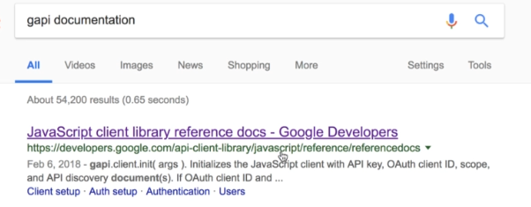

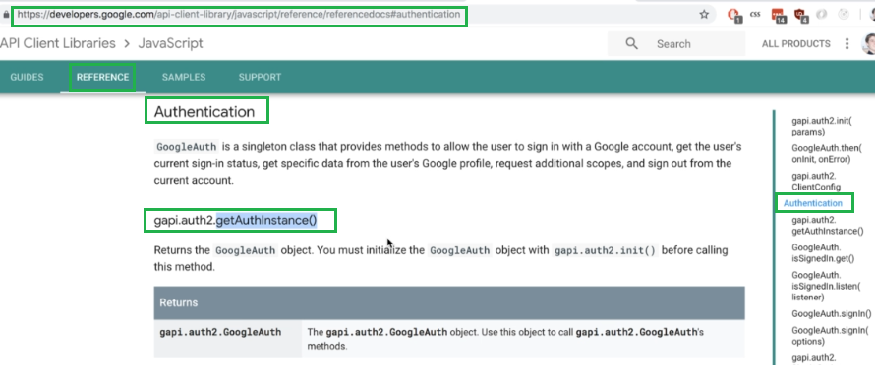

## Authentication

**GoogleAuth is a singleton class that provides methods to allow the user to sign in with a Google account, get the user's current sign-in status, get specific data from the user's Google profile, request additional scopes, and sign out from the current account.**

**gapi.auth2.getAuthInstance()**

**This is the way we create an instance of google oAuth and call signIn() function, once we call this signIn() function the pop window will come to permission to login**

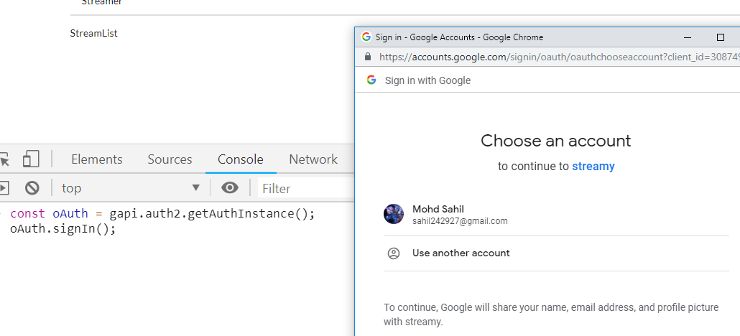

**We can also check if the user signed in or not**

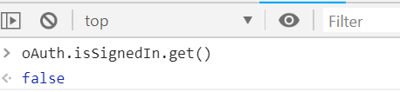

**6. Rendering Authentication Status**

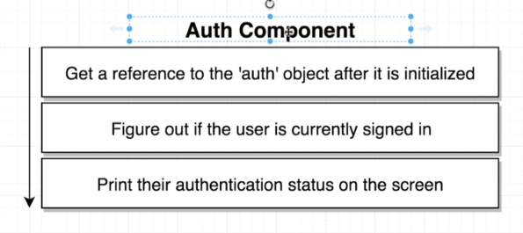

**Implementing Google oAuth component by calling the library and required functions.**

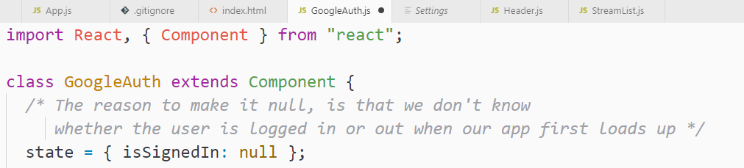

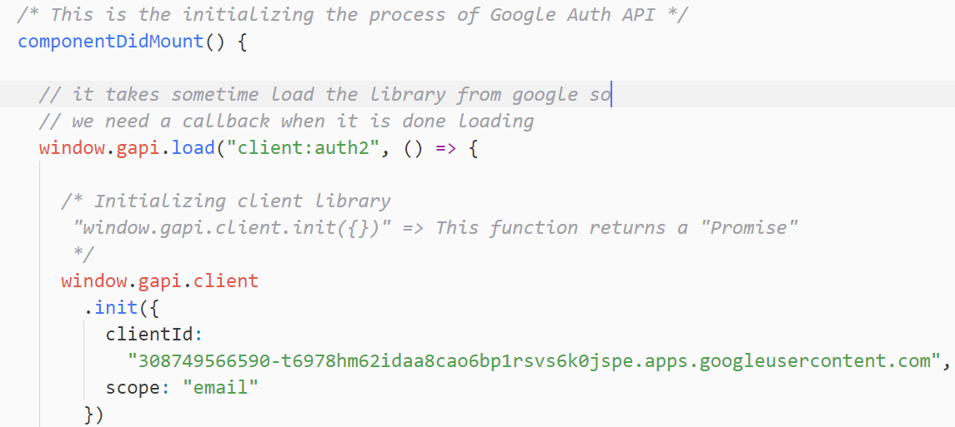

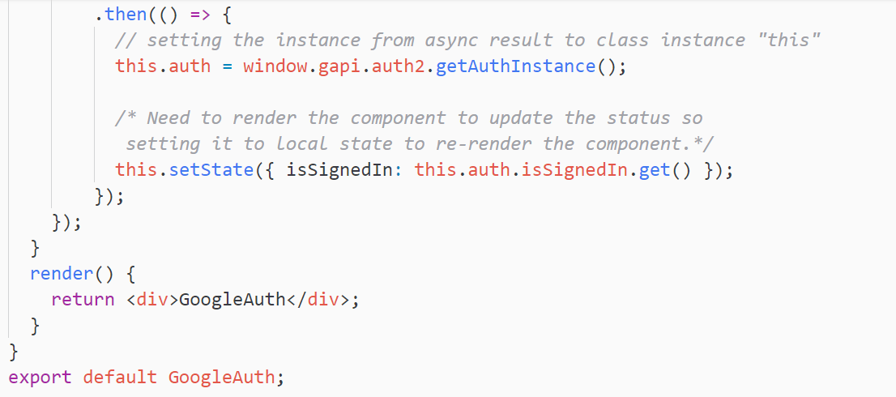

**7. Updating Auth State**

**Let’s update the google OAuth status automatically on the component when user logged in or logged out**

**There is a listen() function on the prototype of isSignedIn. If we pass a callback function to listen(), it will be invoked anytime user’s authentication status is changed. So we can update the state there,render the component.**

**GoogleAuth.js Component**

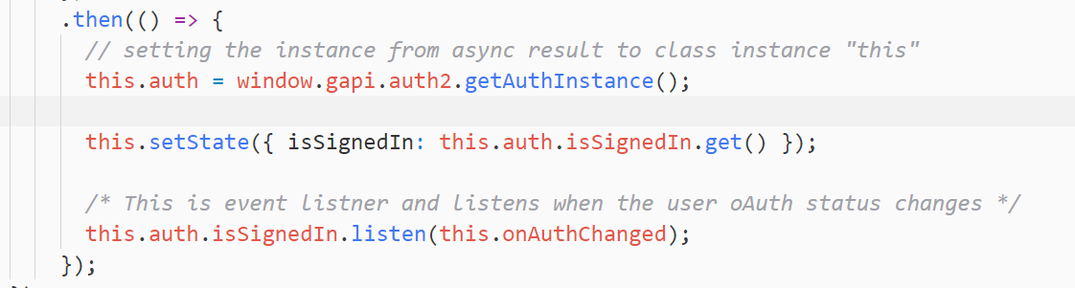

**We added listen() function and added a callback to update the screen**

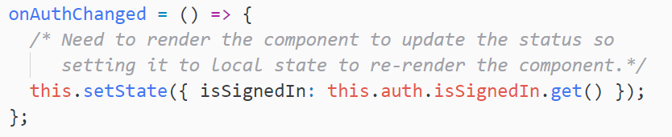

**8. Displaying Sign In and Sign Out Buttons**

**9. On-Demand Sign In and Sign Out**

**We are creating 2 helper method on GoogleAuth.js to singIn and signOut**

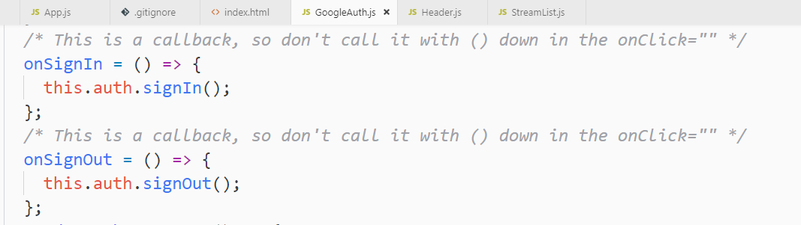

**This is the render method to change the signIn or signOut status automatically**

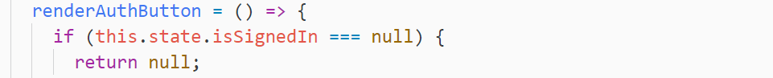

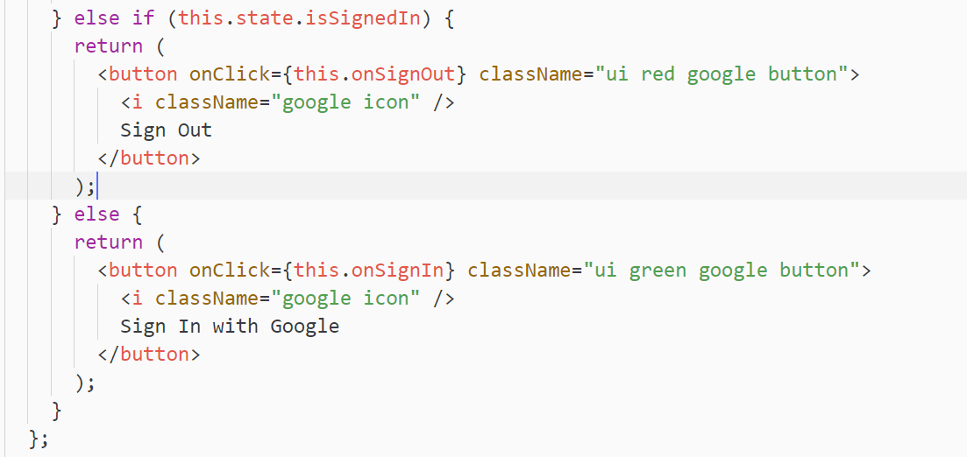

**10. Redux Architecture Design**

**Just changing the name of onSingIn to onSignInClick to clear the meaning of the function.**

**There are 2 ways in which we can interact Redux with GoogleAuth**

**This diagram is not Redux conventions, but as it contains the entire code of GoogleAuth, we are also implementing it. In this approach, GoogleAuth is responsible for changing the status of the singIn or signOut.**

**Note: it is not a best practice to have a component manage state like this.**

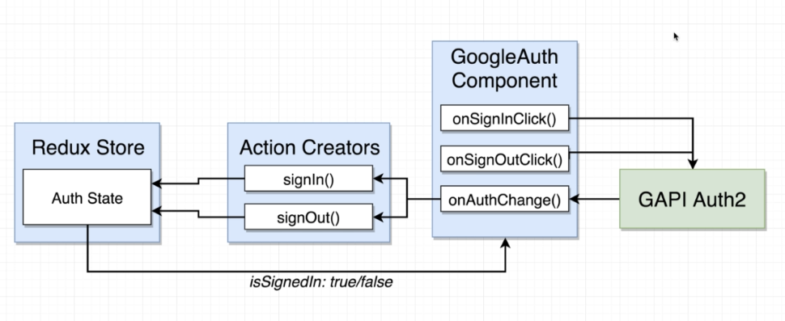

**We will move the signIn status to Redux( to a reducer) from GoogleAuth.js component.**

**In below approach, we want to have our action creators always responsible for changing the state of our application. It is a little-bit better approach to have our actions creators manage access to that Google API object.**

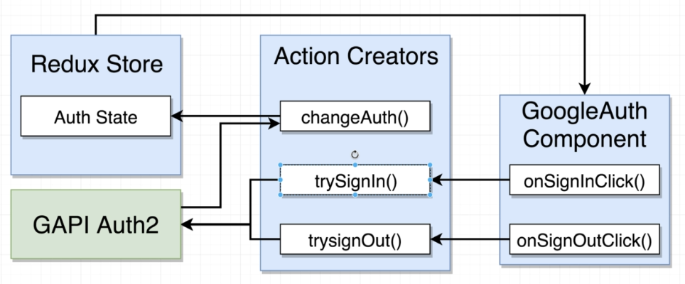

**11. Redux Setup**

Let’s do Redux setup with dummy reducer. **index.js**

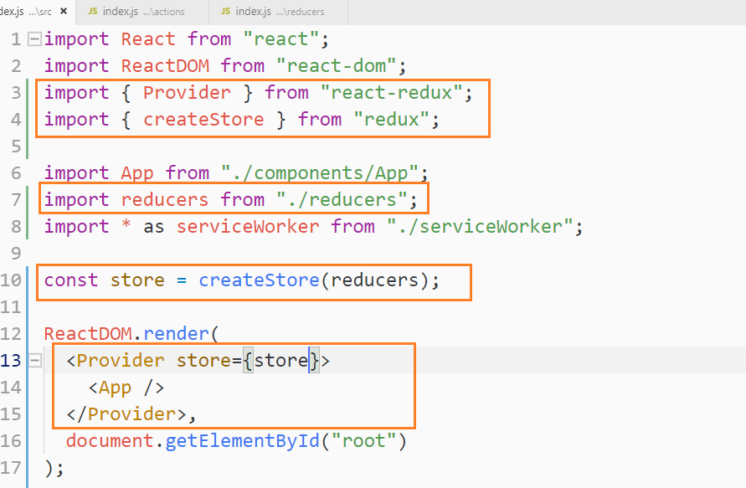

**This is a dummy reducer**

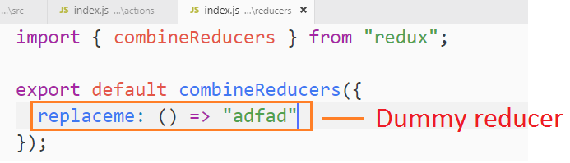

**12. Connecting Auth with Action Creators**

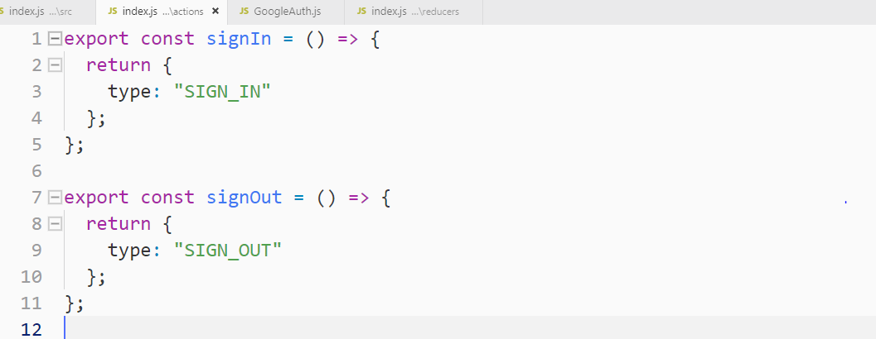

**Setting Redux in GoogleAuth.js**

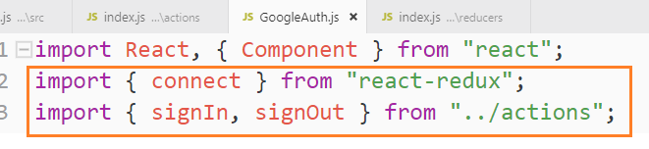

**This listening function, returns the status of the signIn and signOut**

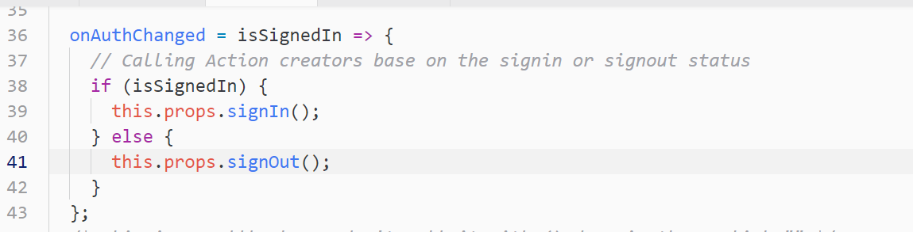

**As of now there is no “mapStateToProps”, we are passing null instead while connecting GooogleAuth.js component using “connect” function.**

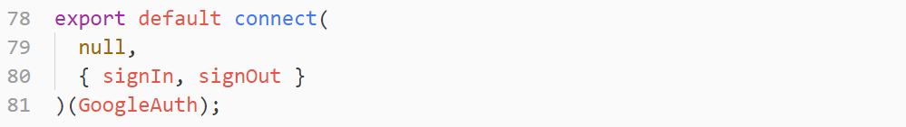

**We are calling appropriate action creators any time that our state changes according to that our state changes according to the google API.**

**13. Building the Auth Reducer**

**We will work on the reducer that’s going to record whether or not the user is signed in at any given point in time.**

**When our Redux application first boots up, our reducer gets called one time to initialize it.**

**If the reducer gets called with a first argument value of undefined then state will be set equal to “INITIAL_STATE”**

**“INITIAL_STATE”: The meaning of this capital means is that do not try to modify this syntax**

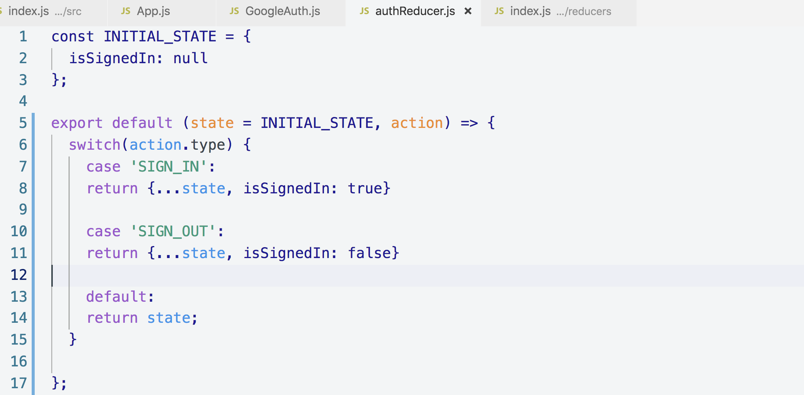

**Adding this reducer to index.js reducer**

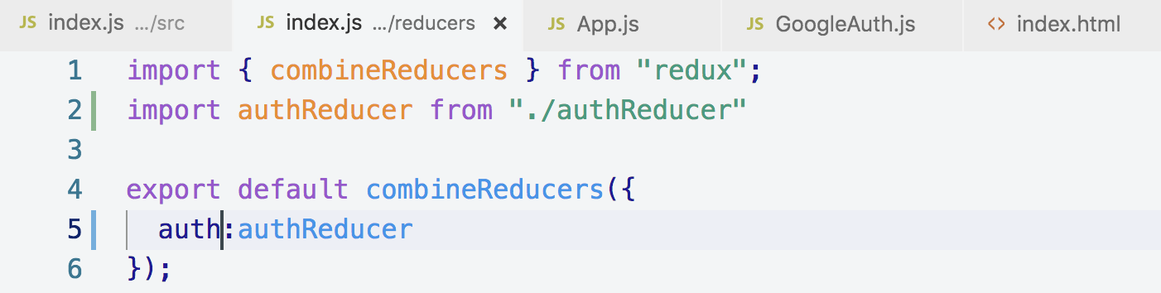

**14. Handling Auth Status Through Redux**

**In the above code we are recording our authentication status inside of our Redux store.**

**In this section we will communicate state from Redux back to our googleAuth Component.**

**We now need to pipe that information back into the component that was already containing that data. This is little awkward, but this is the right way to do it.**

**To get the data in a component from Redux, we need “mapStateToProps()” function.**

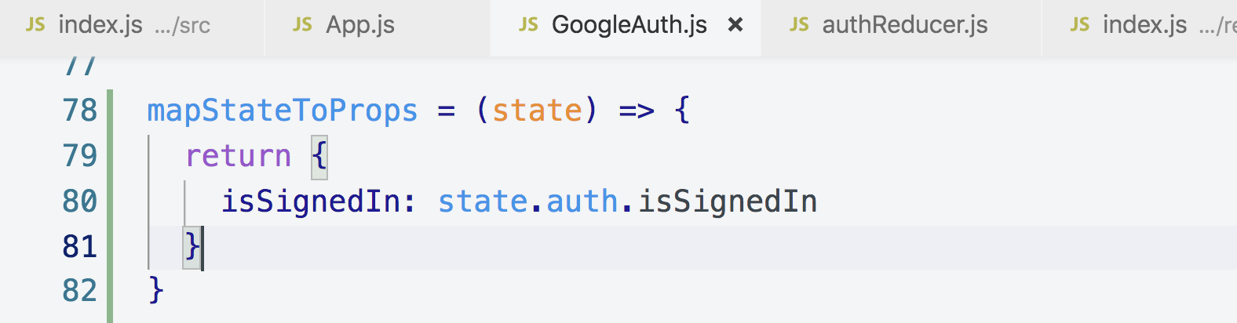

**Now, we no longer need, local state so removing state from GoogleAuth.js component.**

**Setting state based on API result to redux store**

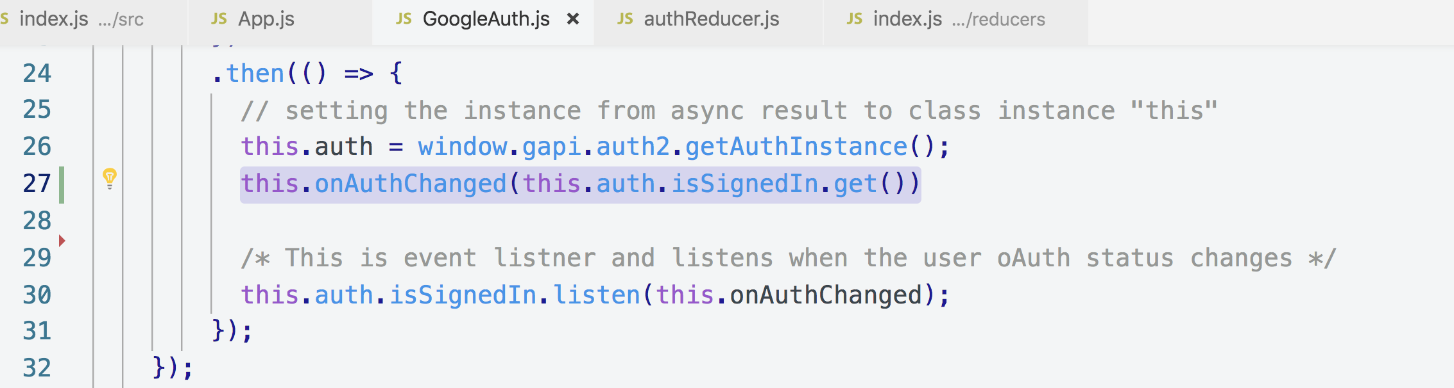

**As we removed local state and used mapStateToProps, we will use props in render function**

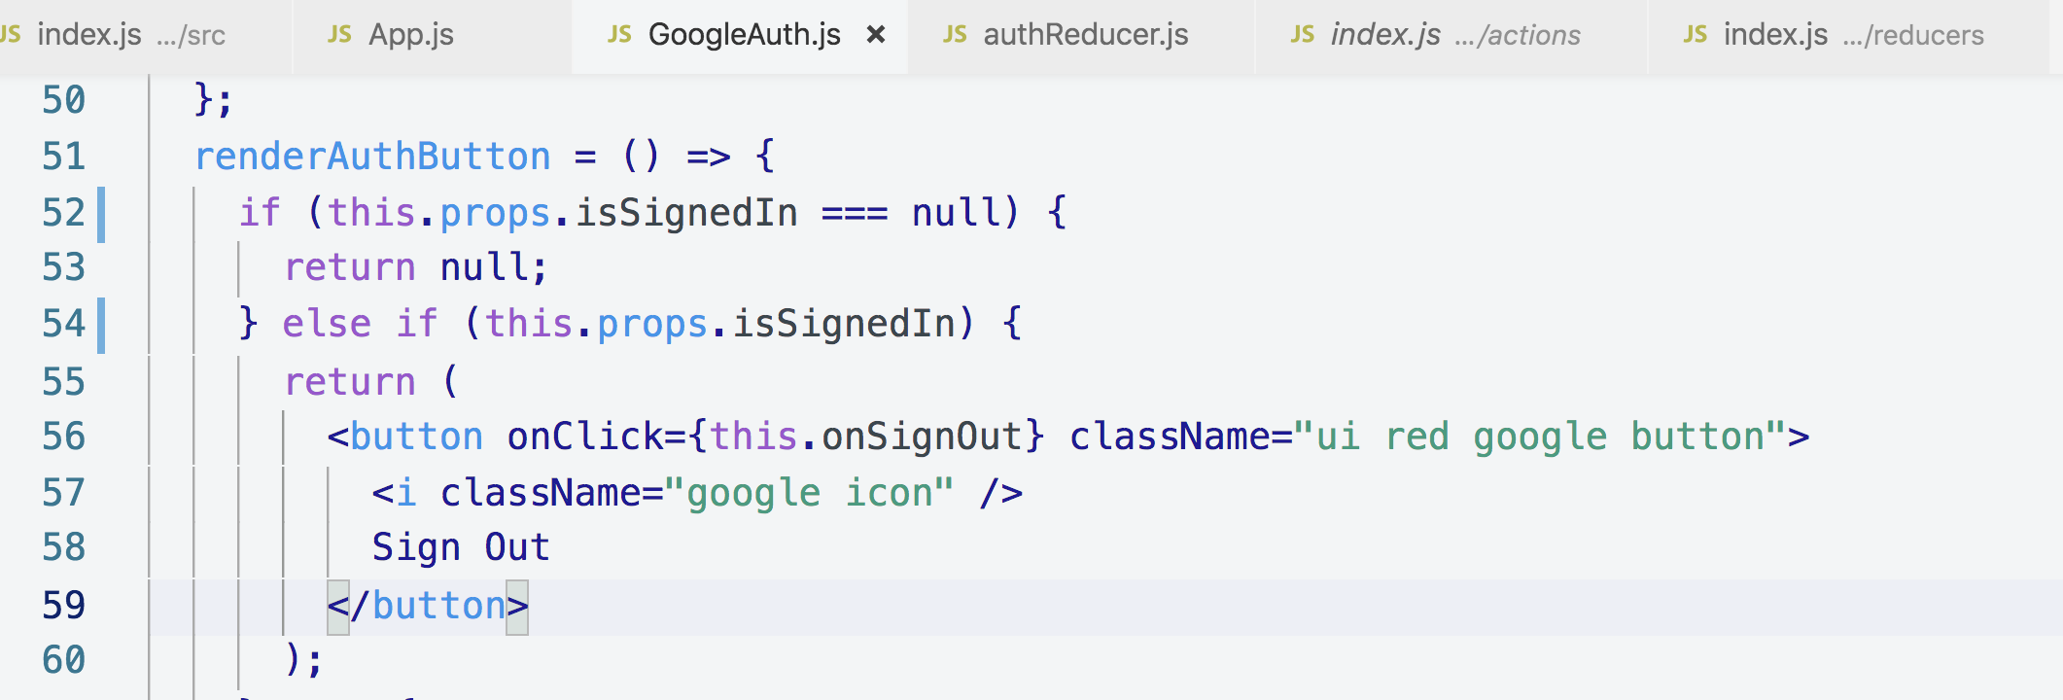

**Getting value from redux store using mapStateToProps**

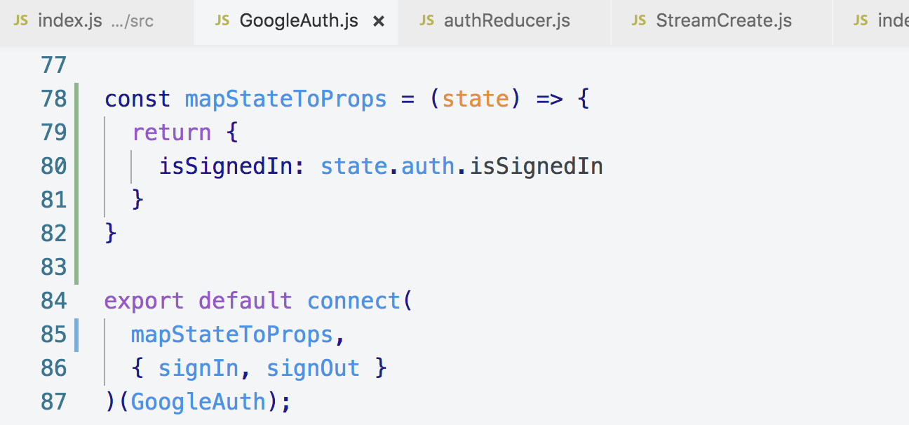

**15. Fixed Action Types.mp4**

**In this video, we will do a quick little refactor to our auth reducers**

**In this video, we will do a quick little refactor to our “auth reducers” and our 2 action creators.**

**Instead of just using strings as type, we will save them in a file and reference that file to action types.**

**Creating a actions/types.js**

**In this file we will define all of the types that are used inside our action creators and reducers.**

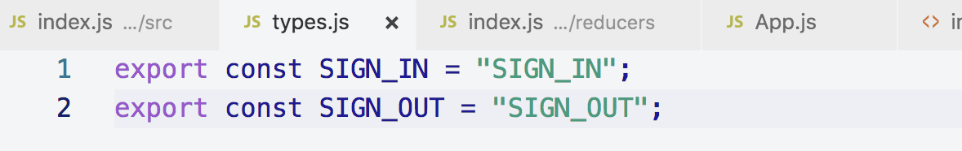

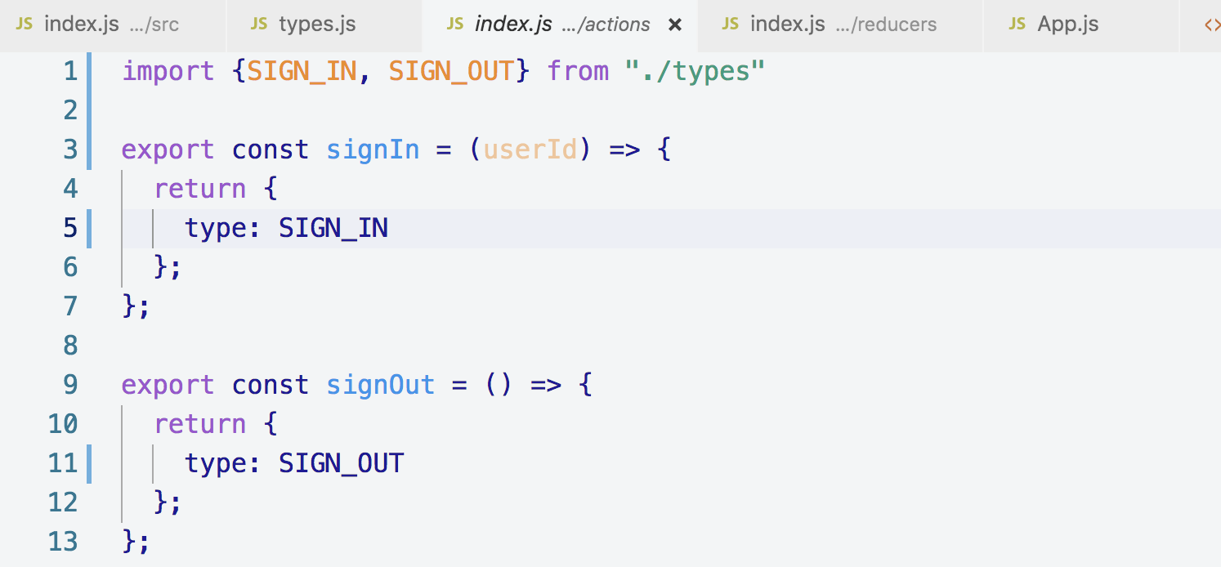

**In the above singIn(), I forgot to add payload as userId so adding that here**

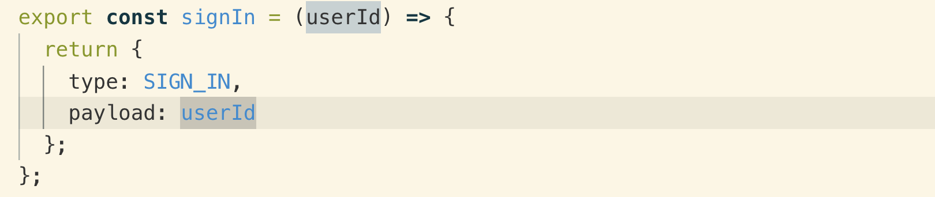

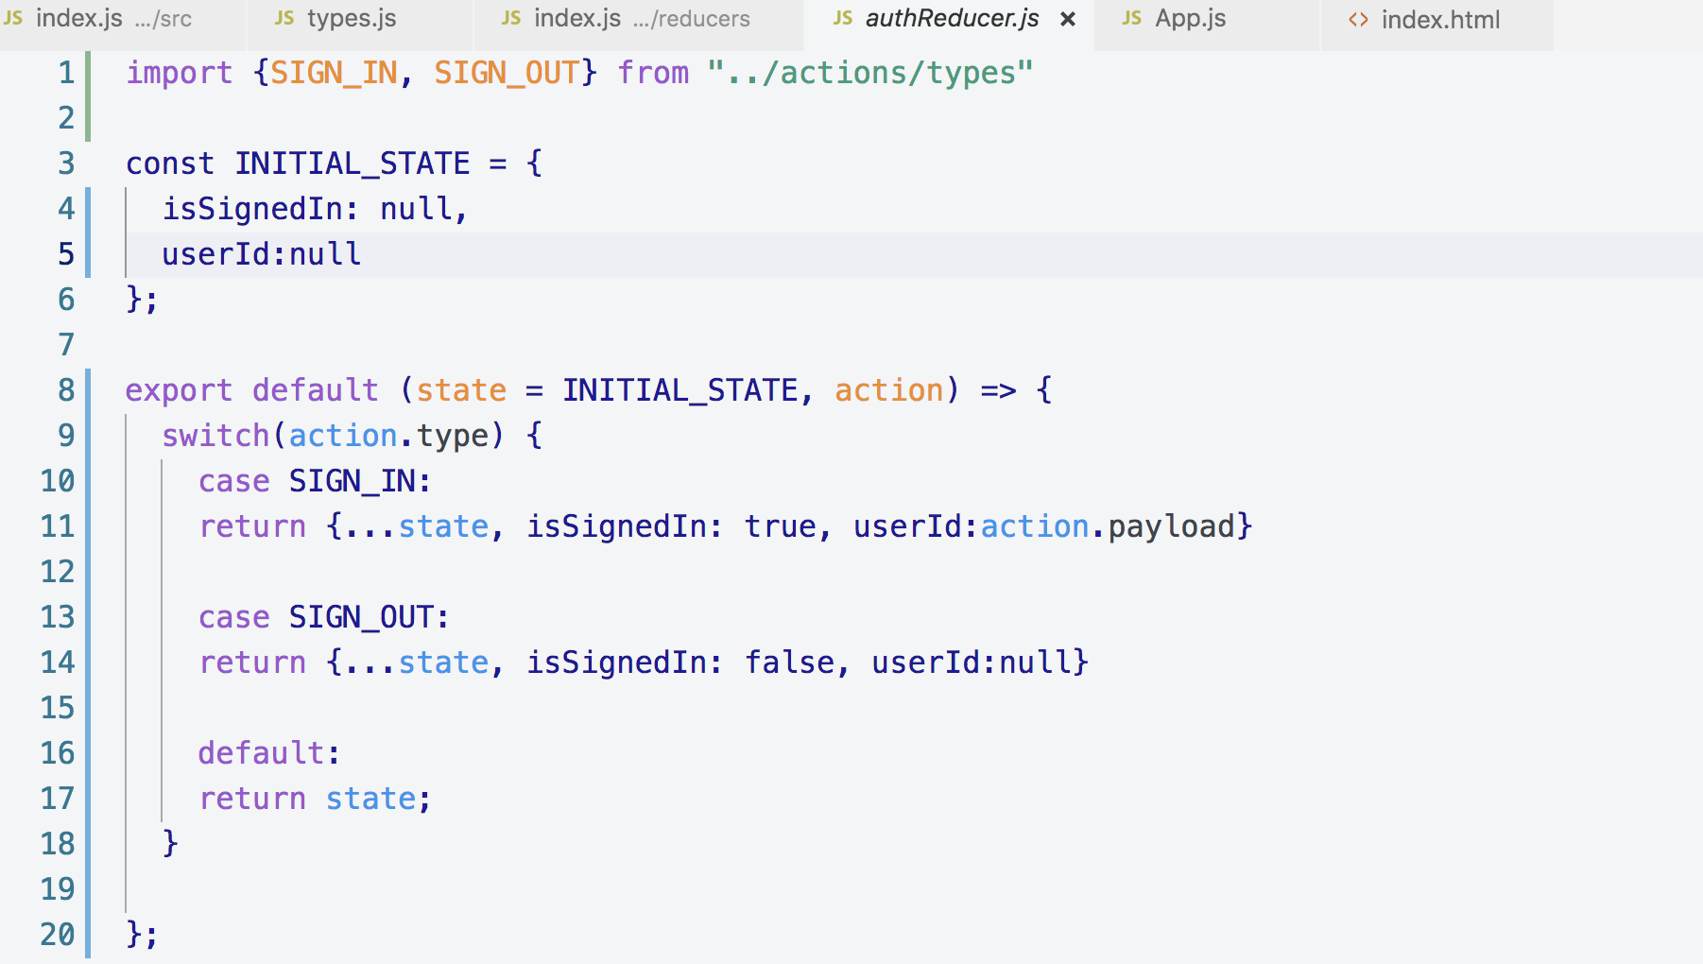

**16. Recording the User's ID**

**We need userId to know who created/modified/deleted streams.**

**We get the id from google using**

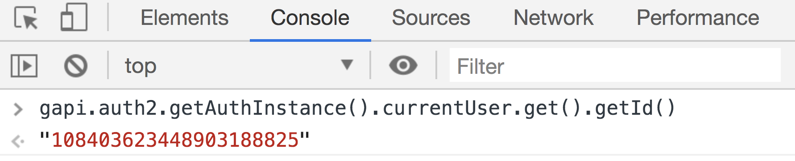

**Now we want to store the google Id into Redux store. We need to pass this userId to “signIn()” function which is inside onAuthChanged() function**

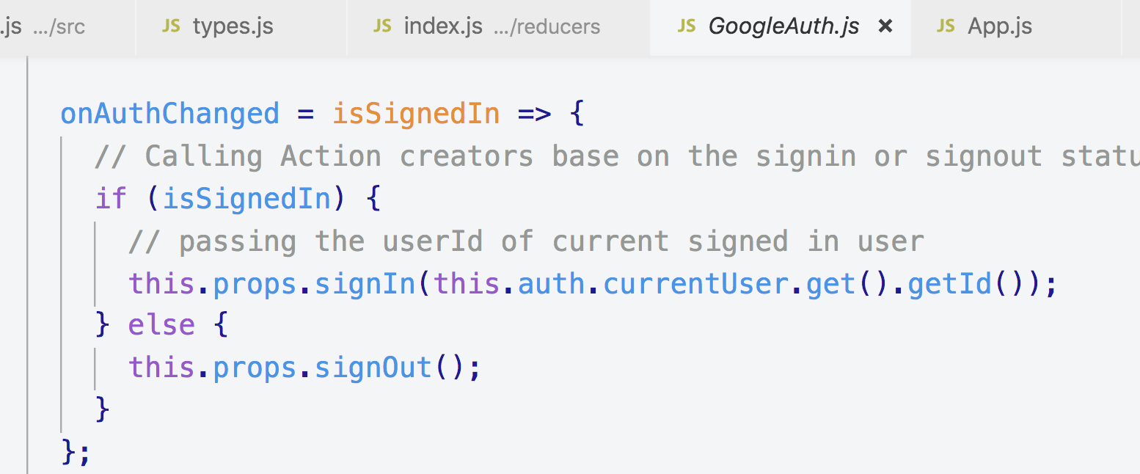

**We also need to set it into authReducer**

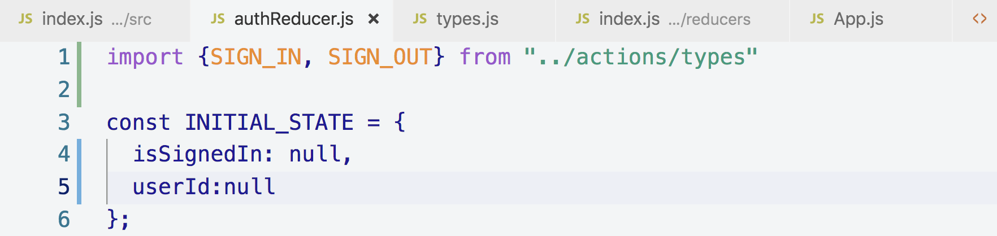

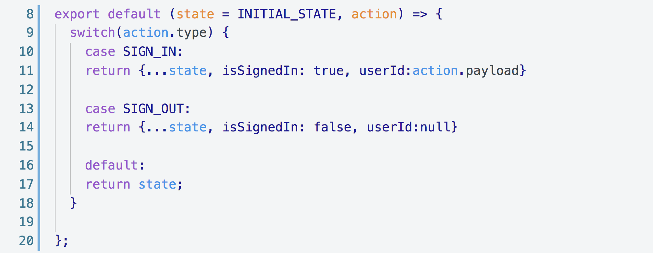

**18. Redux Dev Tools**

**1. Using Redux Dev Tools to Inspect the Store**

**This is the Redux tool to help you see and debug the Redux store**

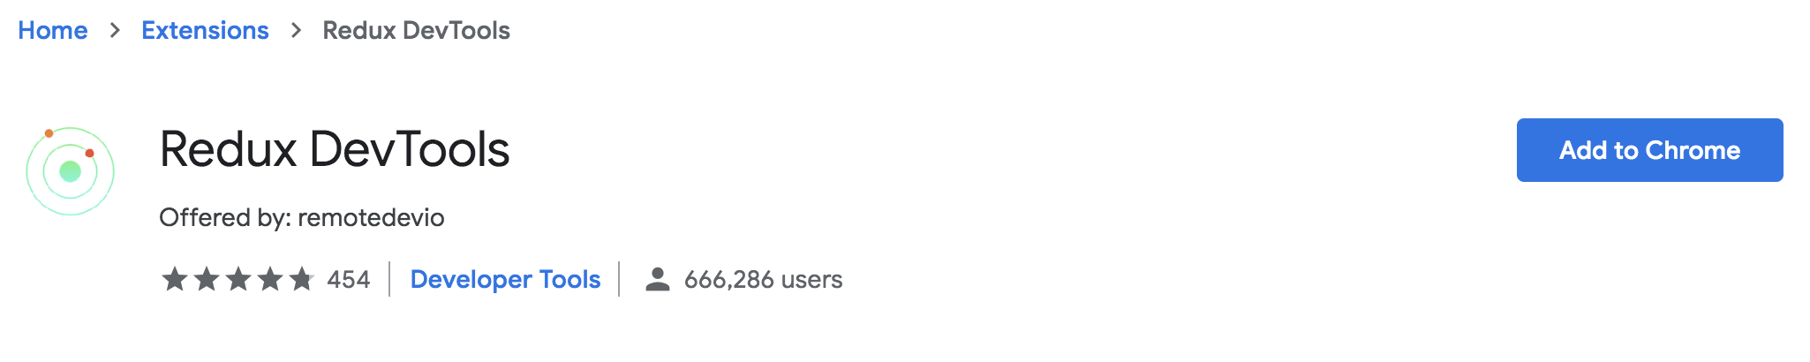

**Once we installed the above Redux Dev Tool, we have to add a tiny bit of code to setup our application to hook in to these Redux Dev Tool.**

**Go to this link and go to Advance Store Setup**

[**https://github.com/zalmoxisus/redux-devtools-extension**](https://github.com/zalmoxisus/redux-devtools-extension)

**We will import a little helper from “redux” called “compose” called**

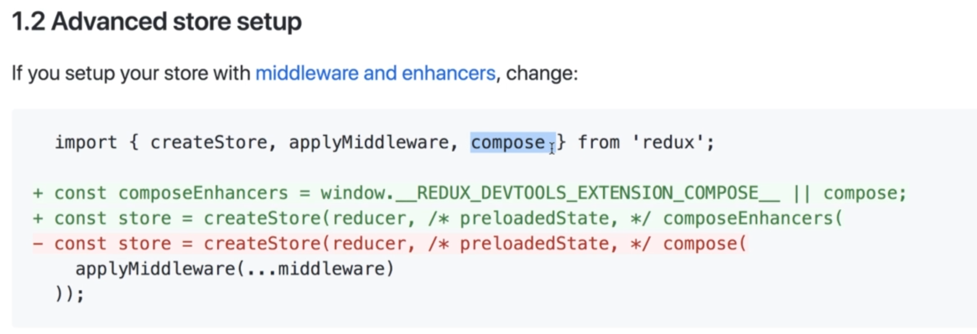

**Index.js**

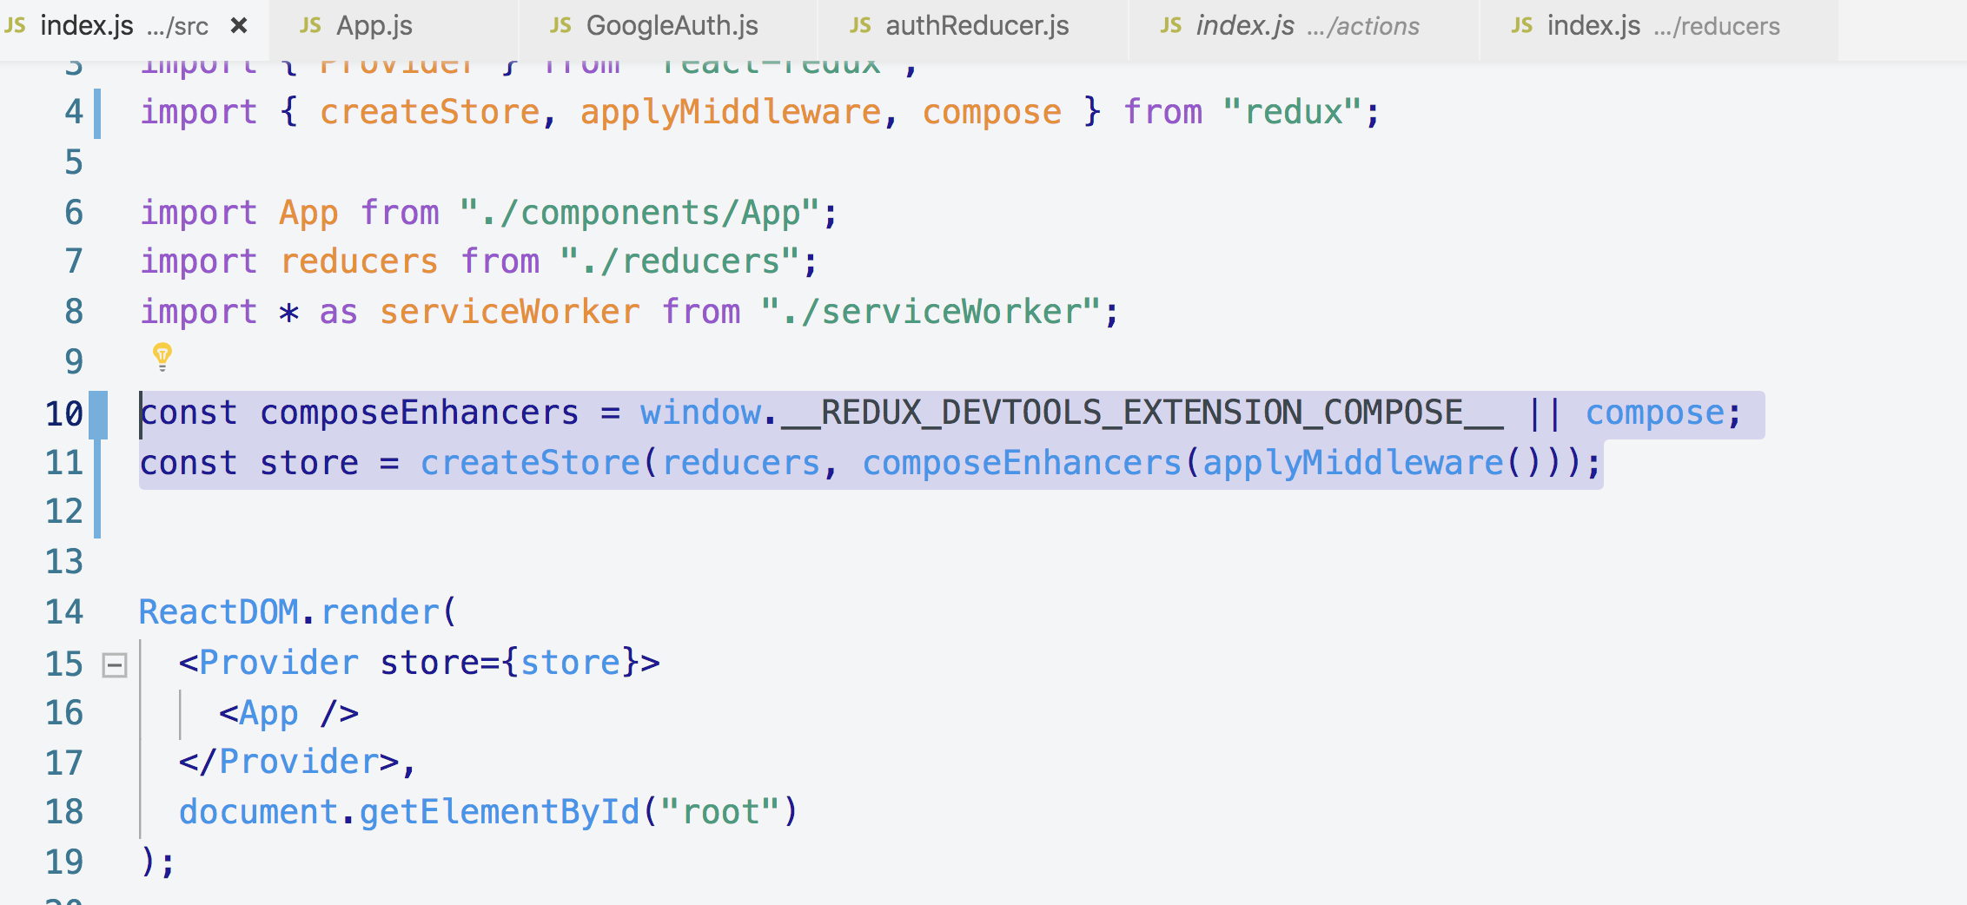

**Note: applyMiddleware() can be used without argument so later you can add it. We will install Redux-thunk and then we will apply that to applymiddleware(thunk) like this.**

**Now let’s see how we used Redux tool in browser**

**Left side in the below screenshot is the number of actions that we dispatched to our store**

**right side in the below screenshot is the state, actions and their differences as shown. The value of isSignedIn was null previously and then later changed to true**

**I can switch to any action and inspect the value in my store at that selected action.**

**Note: Jumping to these actions also reflects the UI at the same time**

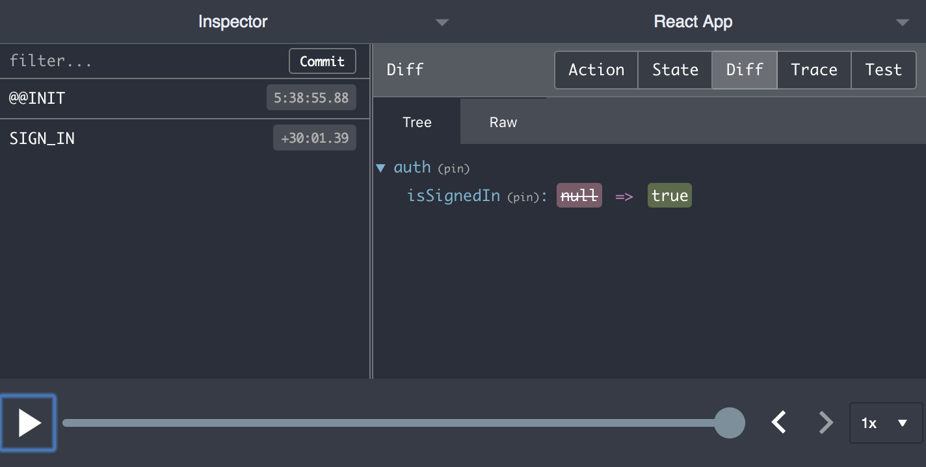

**2. Debug Sessions with Redux Dev Tools**

**When you add “debug_session” in the URL, Redux Dev Tool see that you are trying to start up debug session.**

**Debug Session: is where Redux Dev Tool is going to automatically saves all of the data inside of your redux store and persists across refreshes of your application.**

**Normally, when we refresh all of the inside redux store falls away. We lose it entirely. When you enable this debug_session, Redux Dev Tool is going to make sure that all the data stays around between refreshes of the page.**

**Note: Redux persists all the actions and state data on debug_session mode across browser refreshes**

**If you want to change the data, then remove the session and refresh the browser foer update code**

**We can create multiple session by giving different session keys**

**Like**

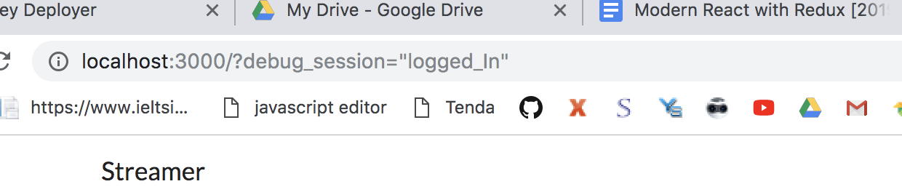

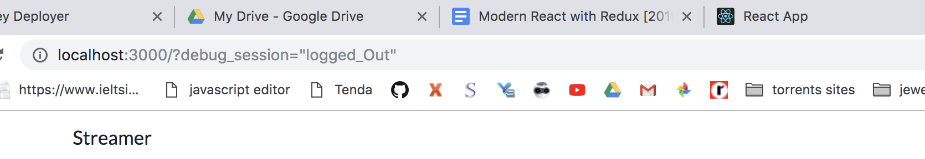

**19. Handling Forms with Redux Form**

**1. Forms with Redux Form**

**We will install a library called “redux-forms” as it does a ton of stuff to your application**

**Automatically.**

**This is a diagram of handling form input without Redux**

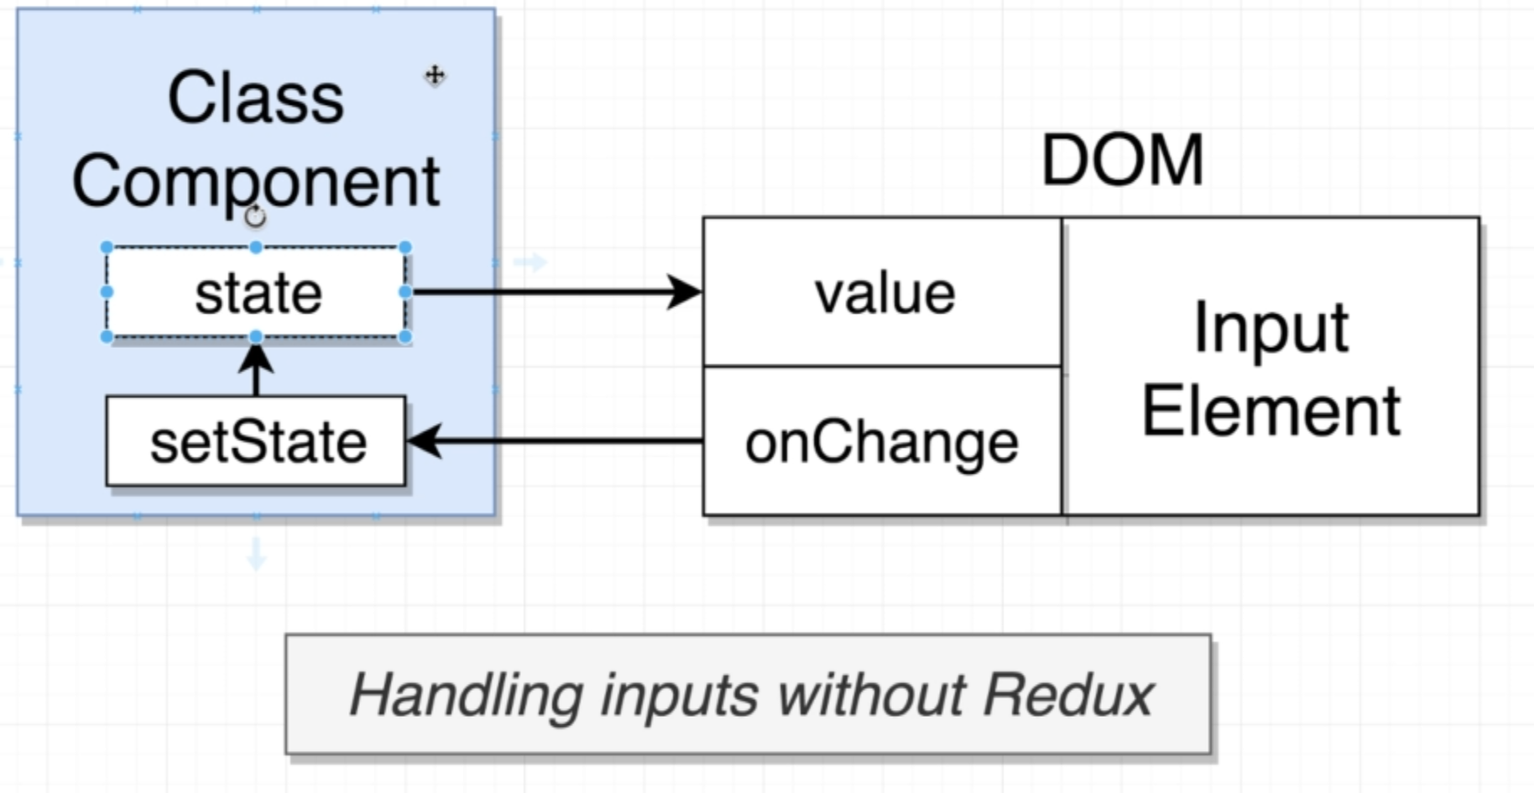

**Below is a diagram of handling form input with Redux-form**

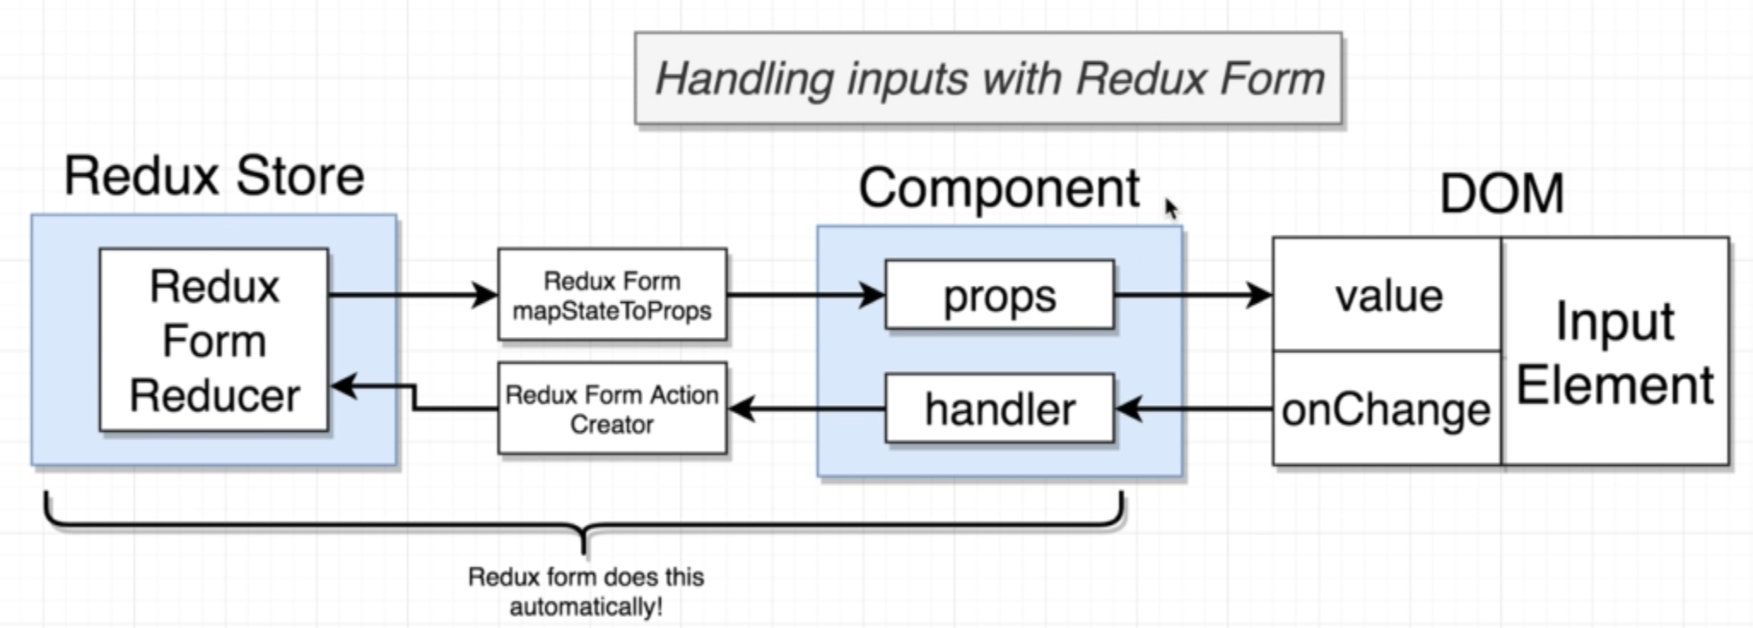

**“Redux-form” does all the above things automatically.**

**Note:**

1. **Anytime we want to change data inside of a redux store, we call an “Action Creator”.**
2. **Anytime we want to get data out of a redux store, we call an “mapStateToProps”**

**The above 2 are pretty repetitive operations so we used “Redux-form” to do all these automatically.**

**“Redux-form” will have a reducer that we are going to wire up to our application. We will not write this reducer. This is included in “Redux-form” library.**

**2. Useful Redux Form Examples**

**You can approach to “Redux-form” library documentation on redux-form.com.**

**3. Connecting Redux Form**

**Combining “redux-form” reducer to our index reducer**

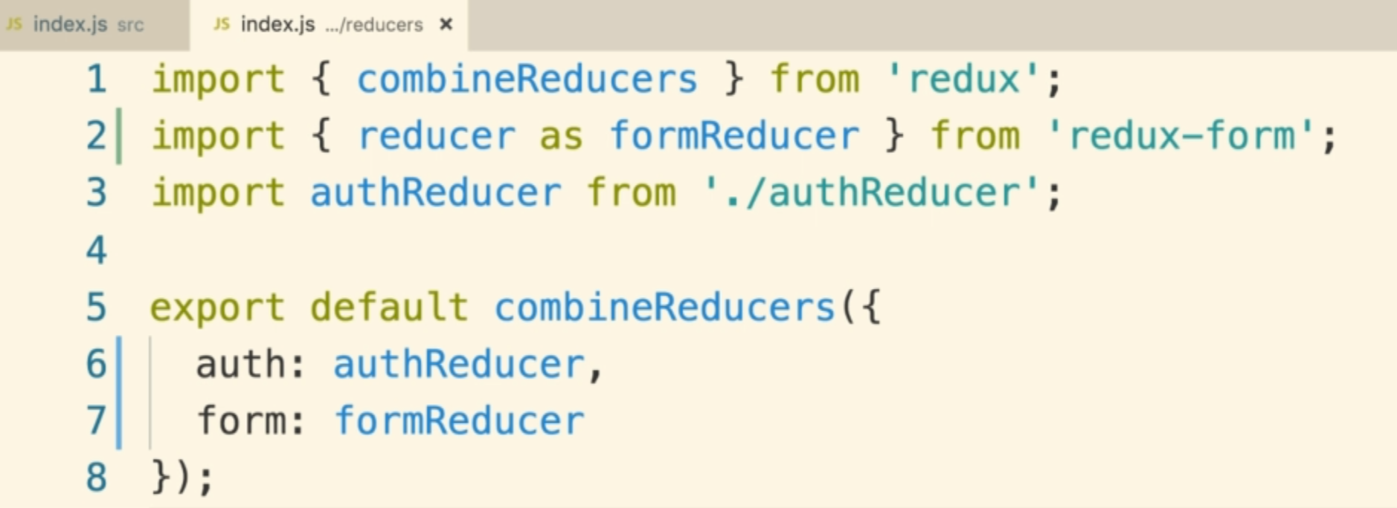

**4. Creating Forms**

**In the StreamCreate.js, We will show our form here and make use of Redux form as well.**

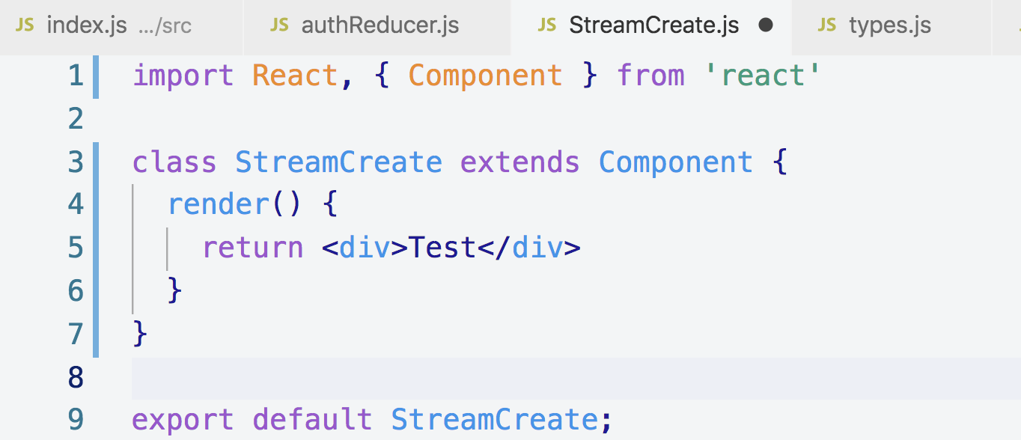

**We converted the functional component into class base component, the reason that we are going to make this as class based component is that we are going to have a bunch of helper functions so we can kind of better organize our code here.**

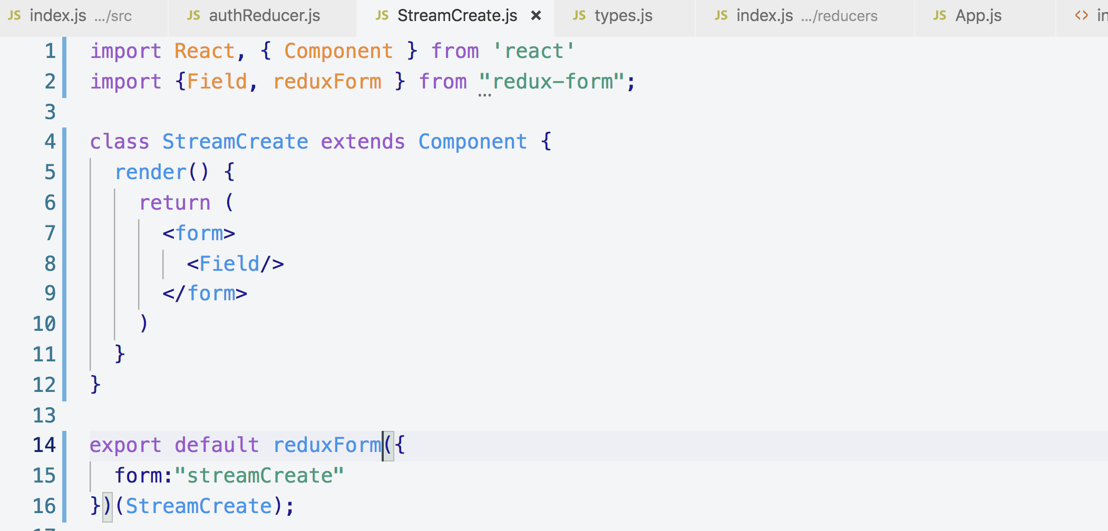

**Field: it is a form component**

**from “redux-form” which we will show on the screen**

**reduxForm: it is a function, this function has the exact same**

**functionality as the “connect” function that we used from the “react-redux”**

**library.**

**reduxForm: unlike the “connect function” which takes separate arguments**

**into it, reduxForm receives a single object and we put a bunch of configuration**

**into that object.**

**5. Automatically Handling Events**

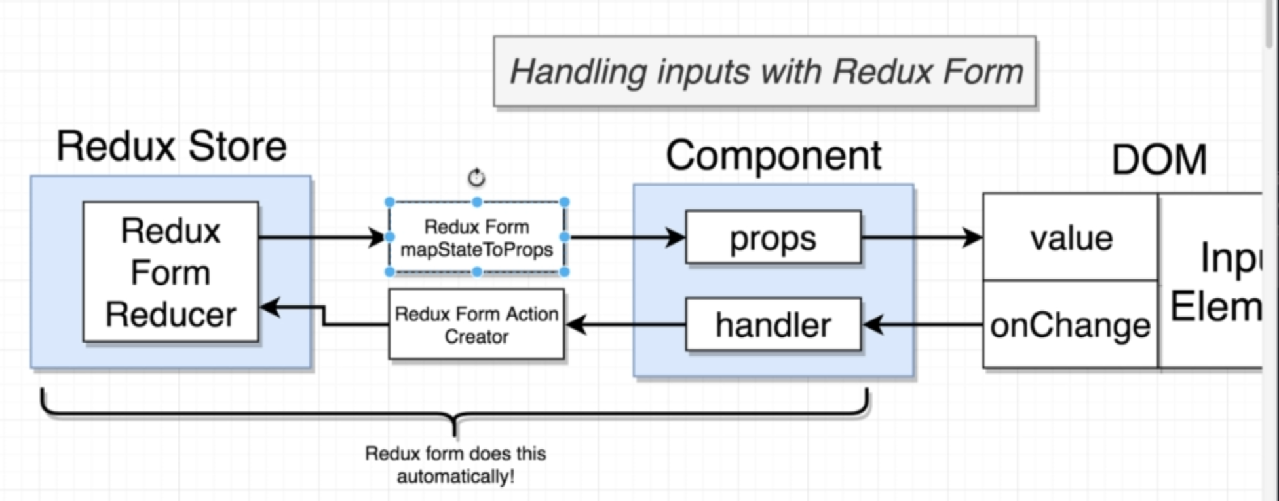

**Since we hooked up reduxForm, StreamCreate.js component is now going to be passed a ton of additional props that was not being passed before like this**

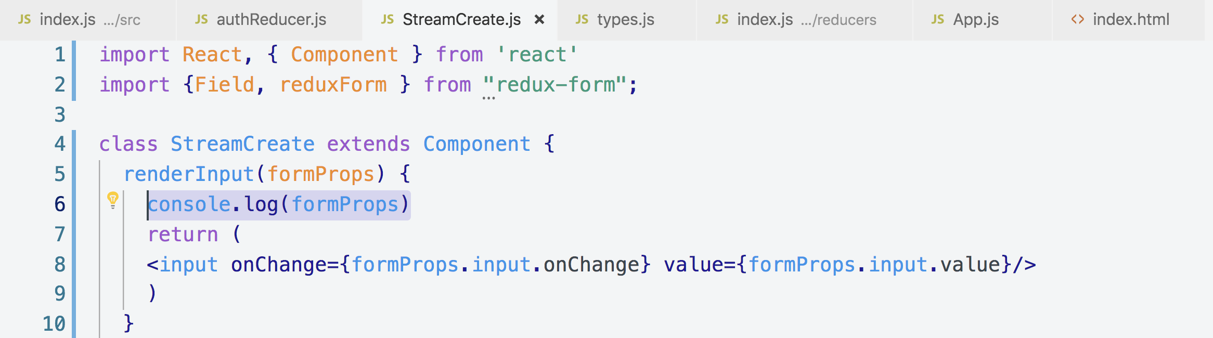

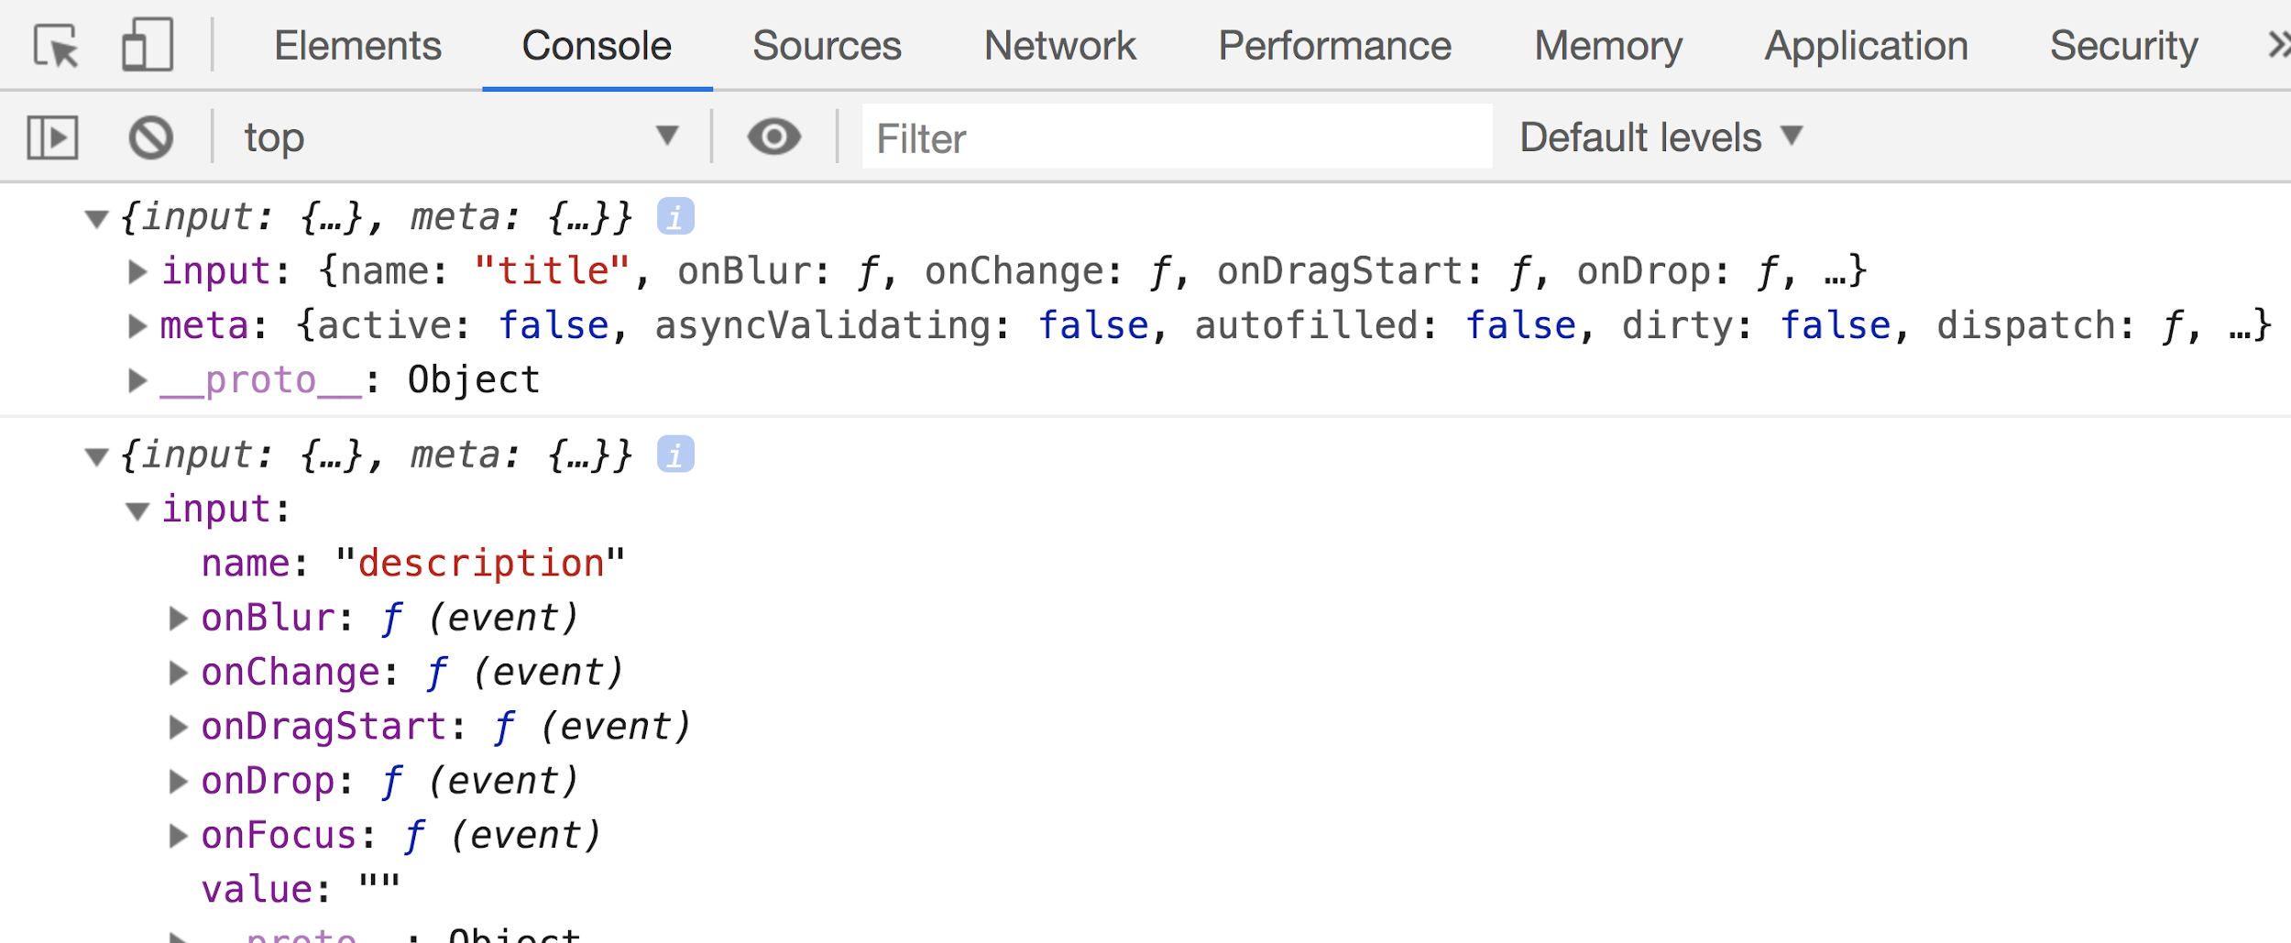

**Now let’s write code for renderInput()**

**Note: Anytime we show input element with react in any capability be it with react or redux, we always are supposed to make sure that we show that input element and assign it’s value property and also give it onChange callback handler.**

**Any time that the <Field> tag calls renderInput() , it will pass some number of arguments right here, but we will receive it as a single argument called “formProps”**

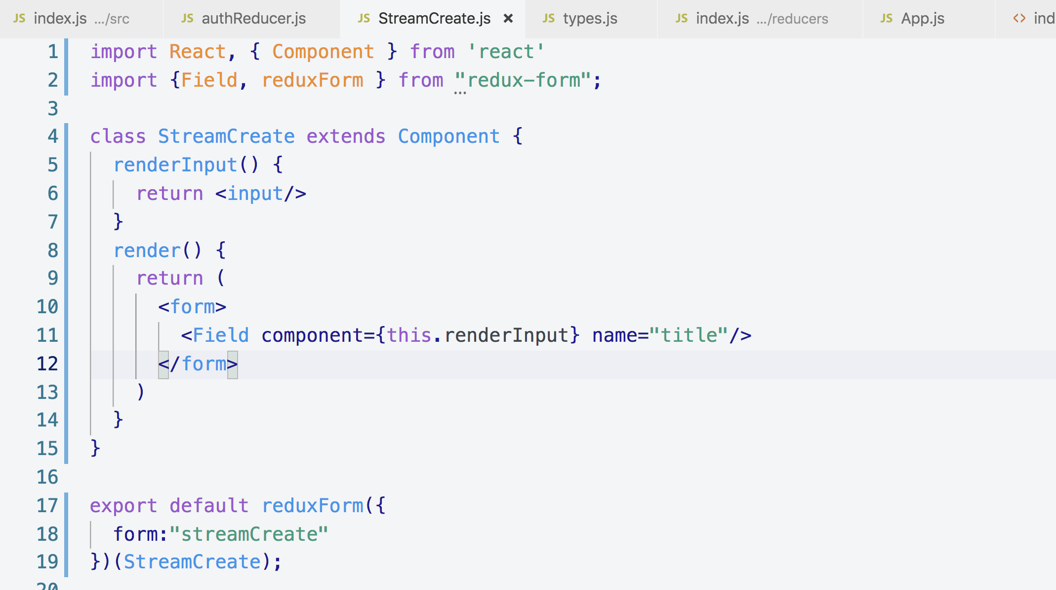

**This is the way we used <Field>**

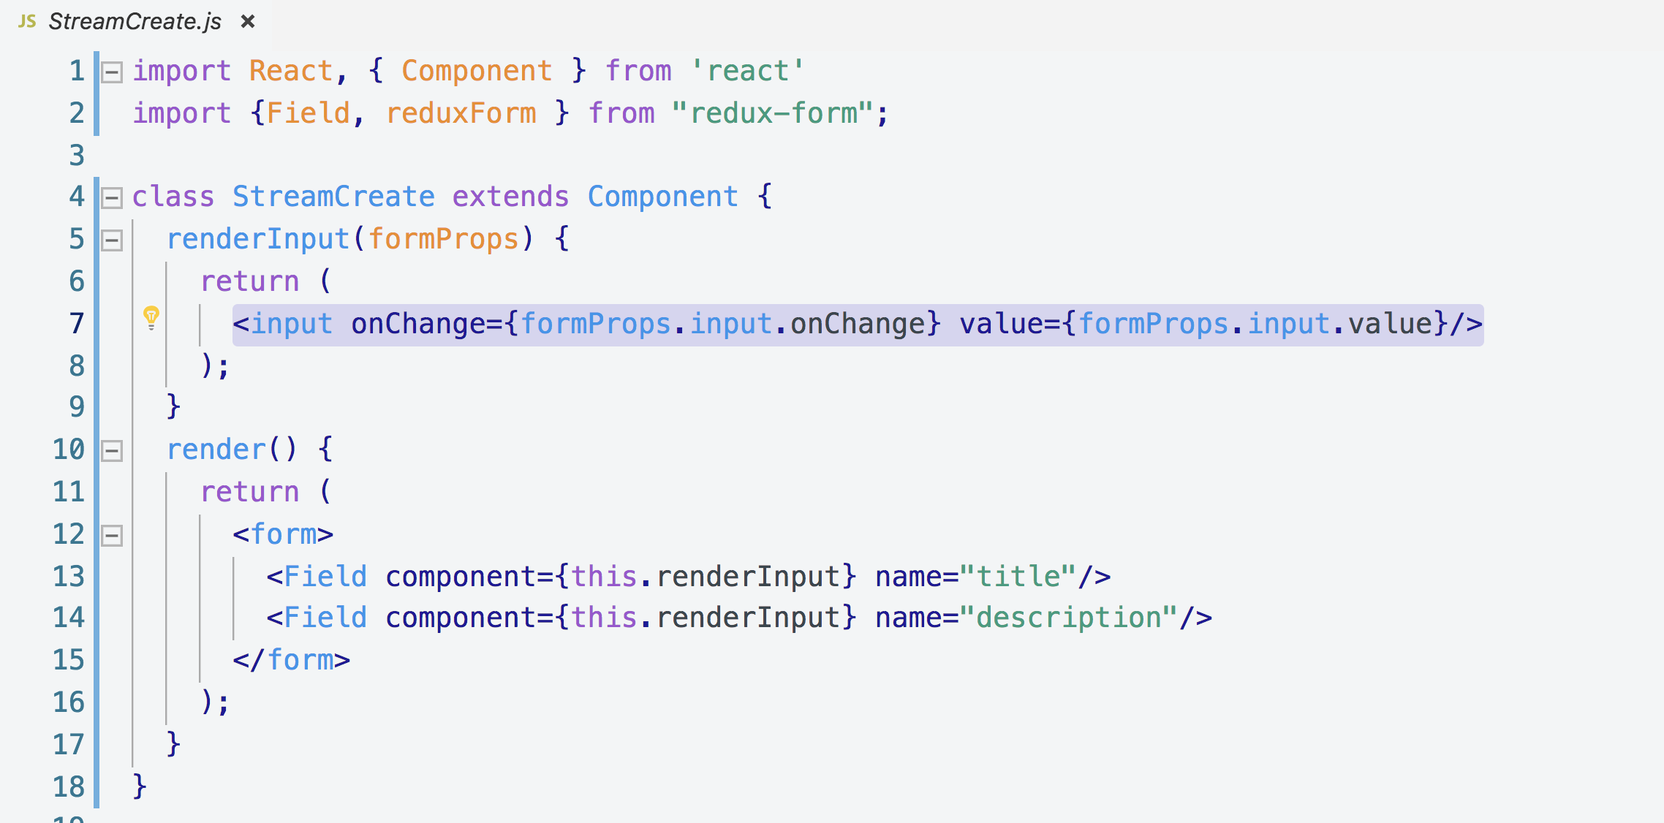

**We can even de-structure the above formProps like this**

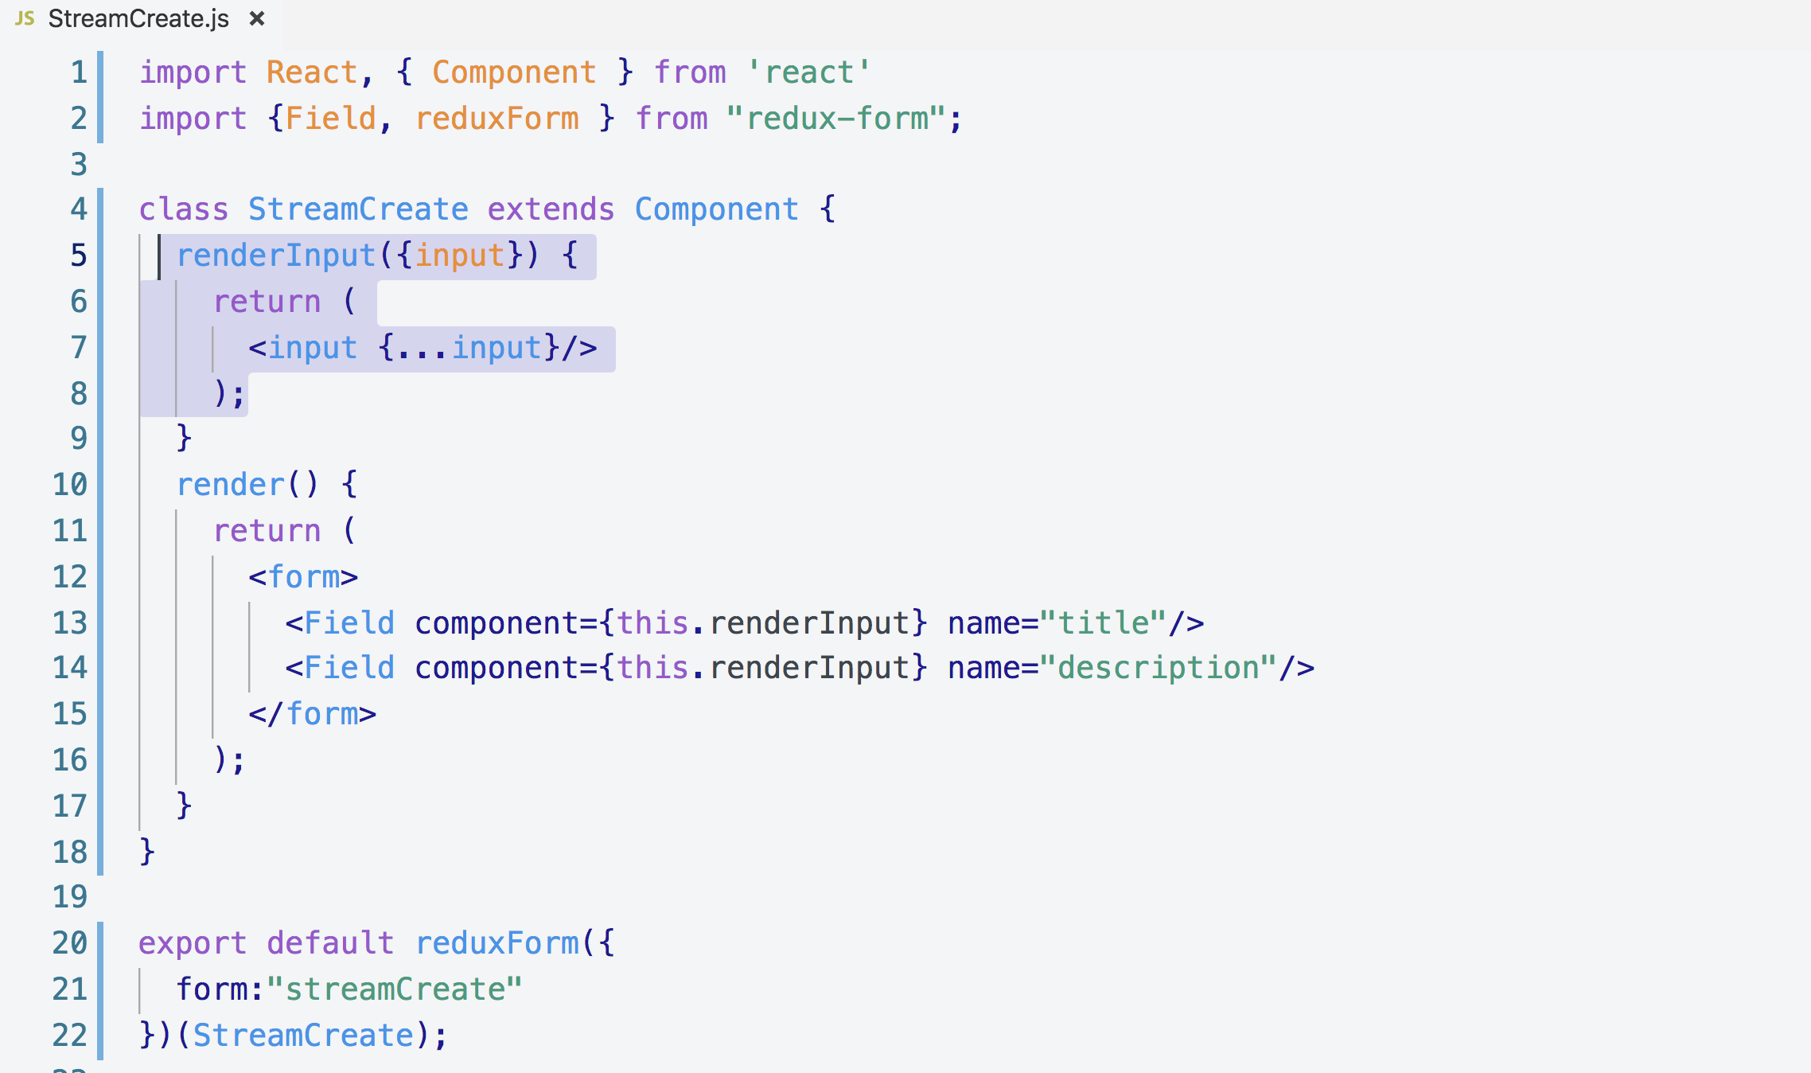

**There is just one issue that you won’t be able to type into input field until you add form reducer to combineReducer like this**

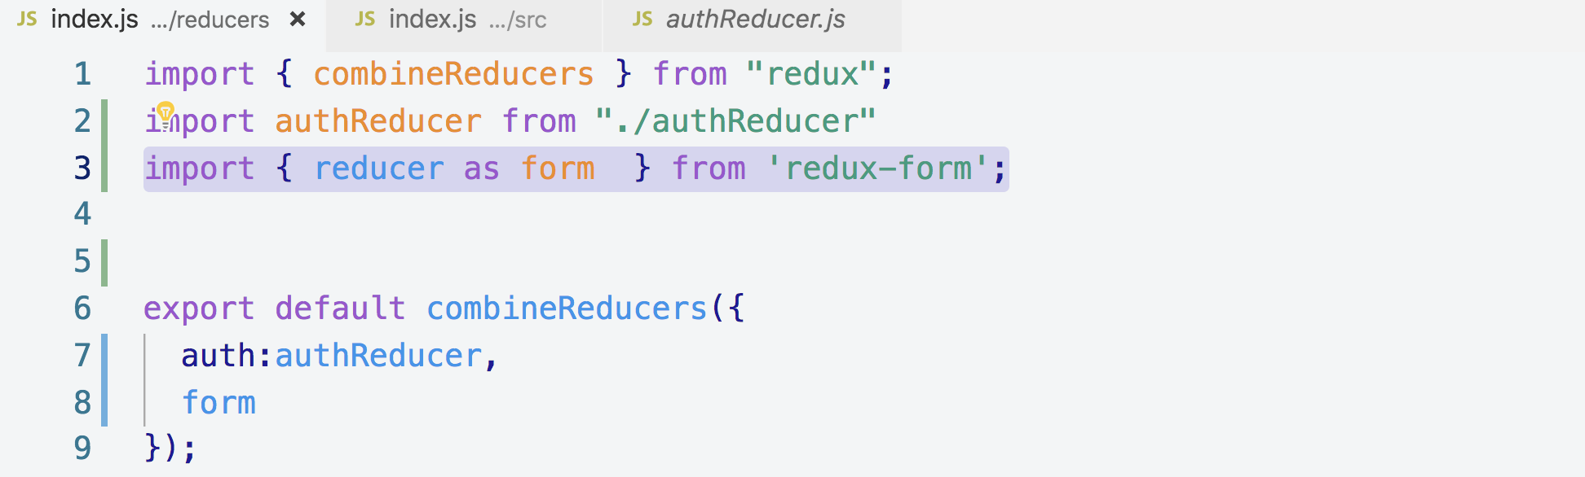

**Now you are good to go!**

**6. Customizing Form Fields**

**We can add props and that will automatically be available into our renderInput() function**

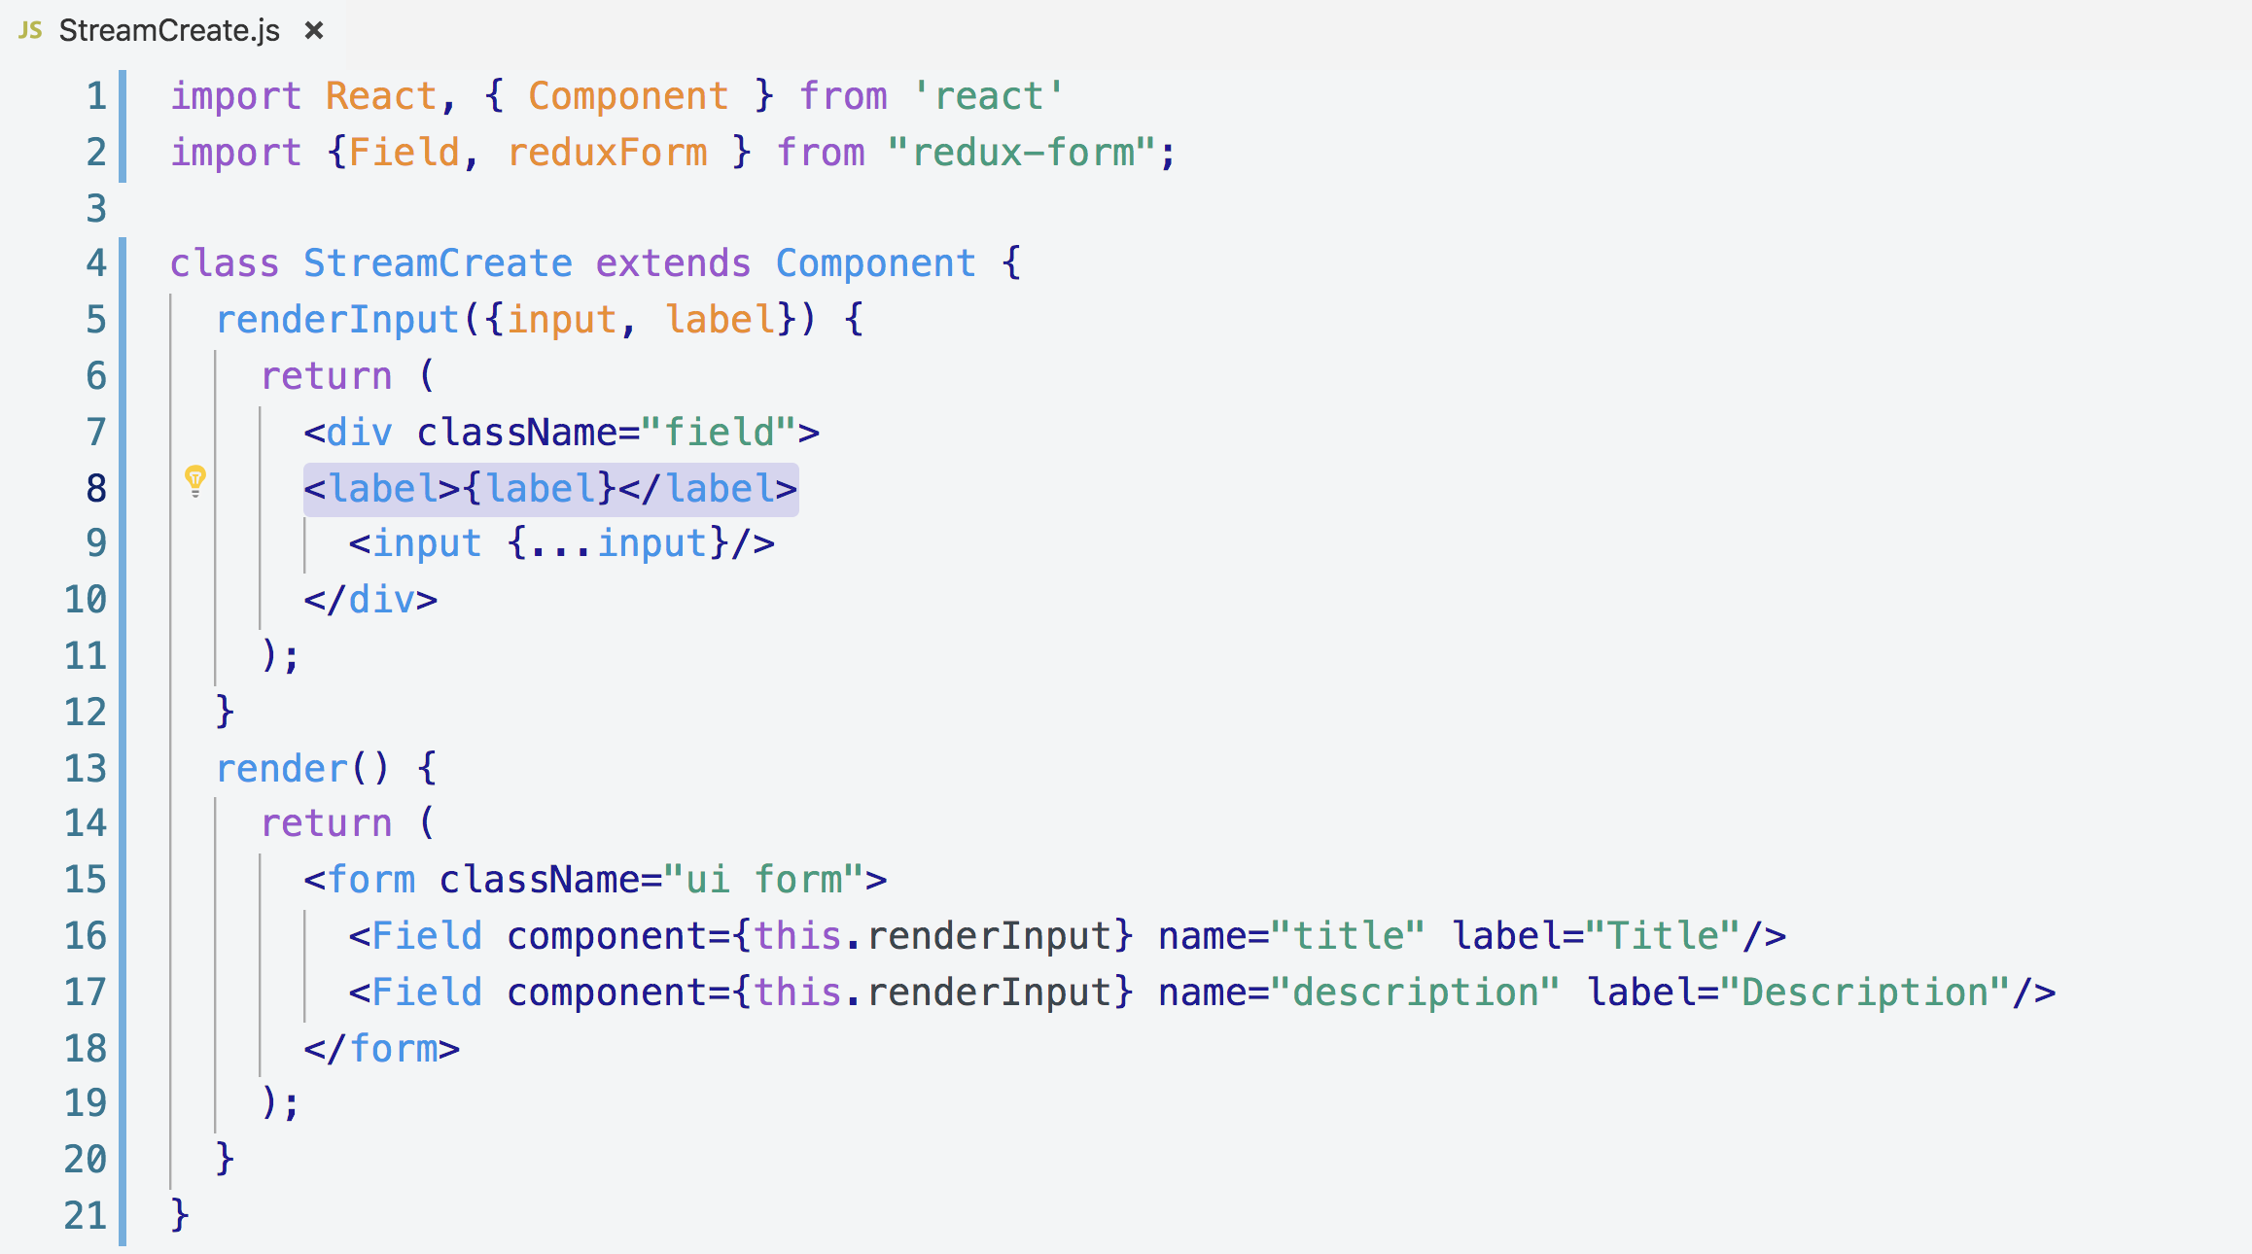

**7. Handling Form Submission**

**Anytime, the onSubmit(event) will call, it will call with an event object.**

**Default props send by redux-form also has handleSubmit() function**

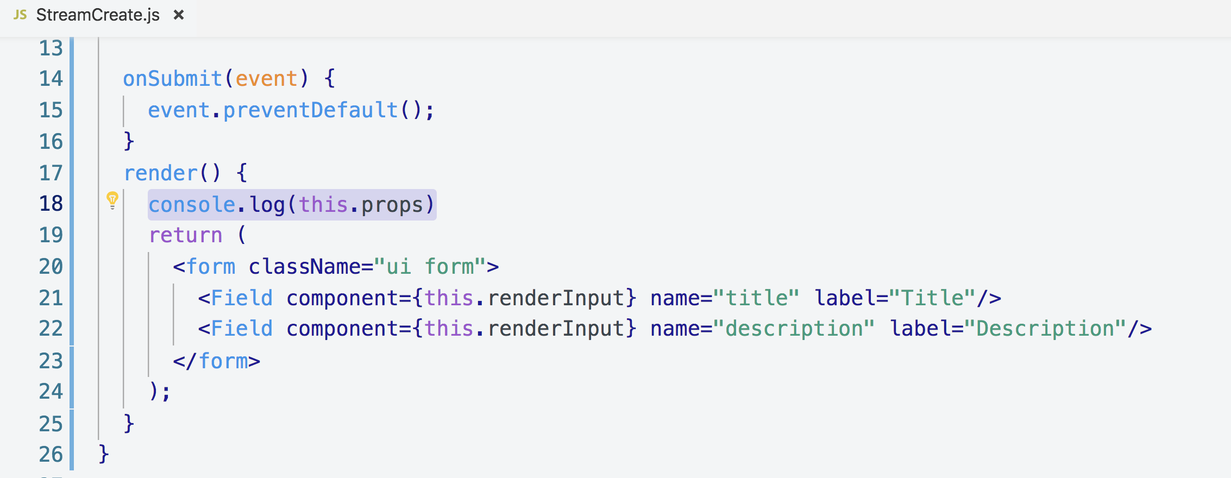

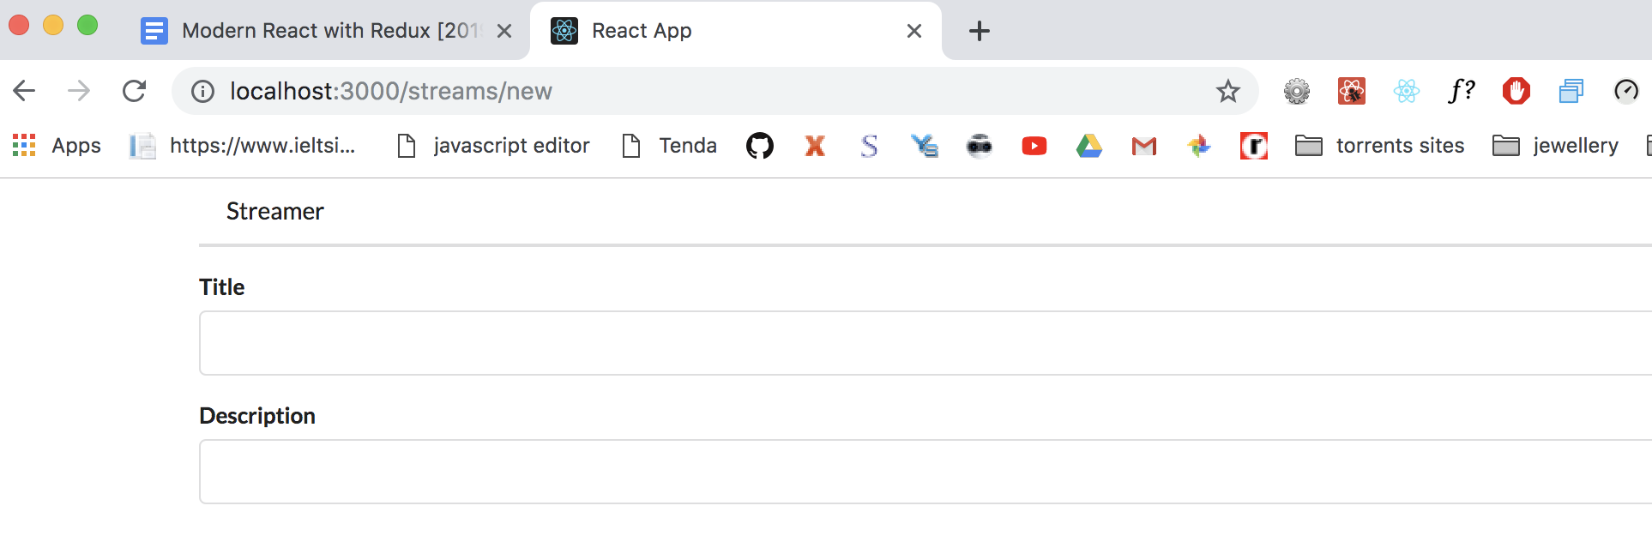

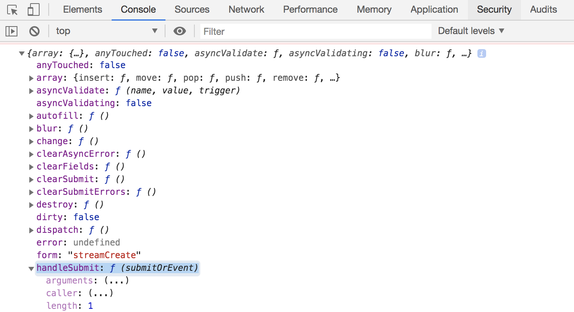

**This is the function that we suppose to call anytime our form is submitted and it is provided by our redux-form to our component.**

**this.props.handleSubmit()**

**When the form will submit, this.props.handleSubmit() will automatically receive that event object and automatically call preventDefault() for us so we don’t have to call preventDefault() in our onSubmit() function.**

**Infact, onSubmit() is not even going to call with event object at all, instead, it will call with whatever values existed inside of our 2 fields input.**

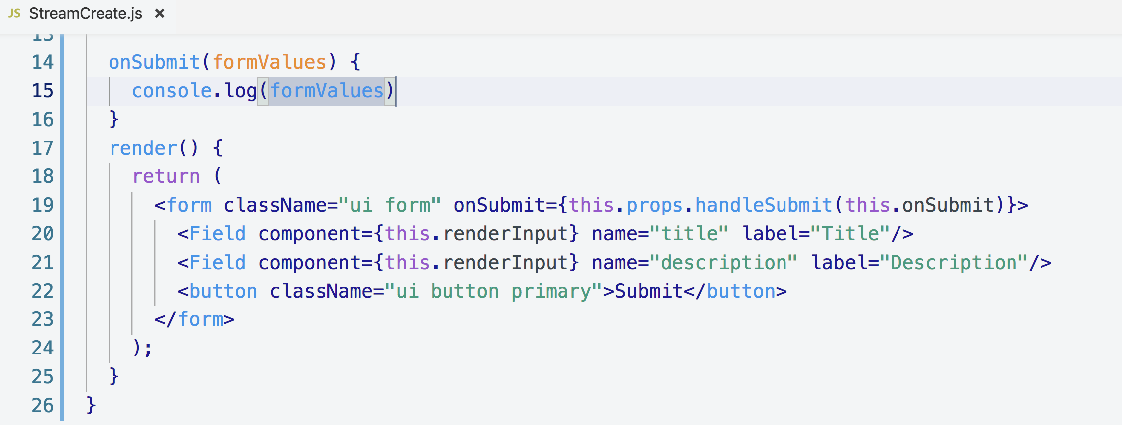

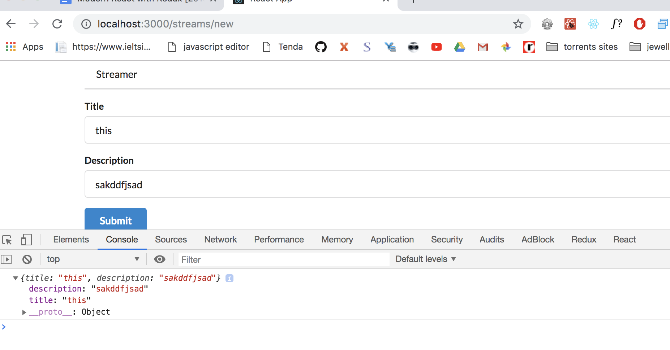

**8. Validation of Form Inputs**

**Every interaction you can image that occur to your form like selecting a field, typing something “redux-form” is going to attempt to validate your inputs.**

**For every interaction, “redux-form” calls a function called validate(), You have to define this validate function.**

**validate(), This validate function will be called with all the values in the form.**

**This is the diagram of this validate() function  
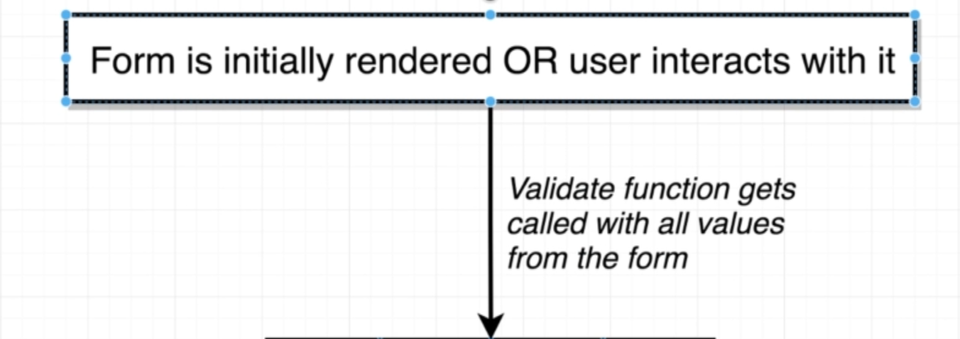**

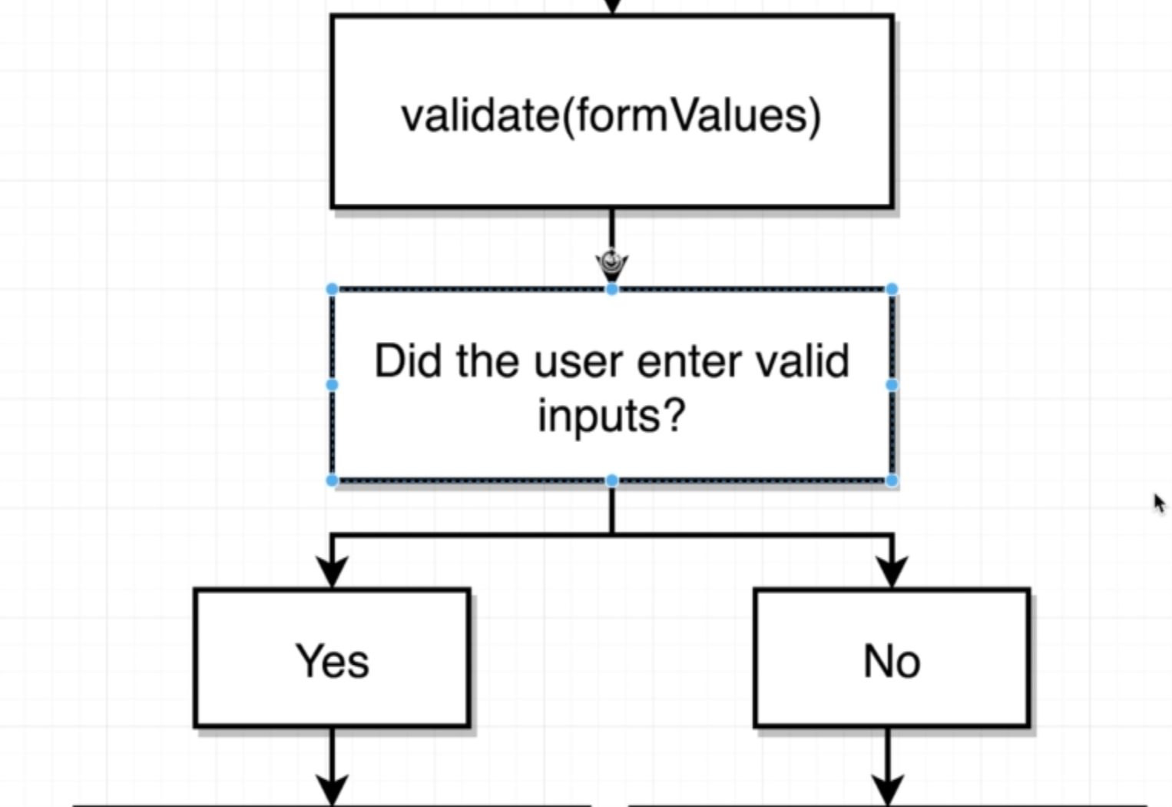

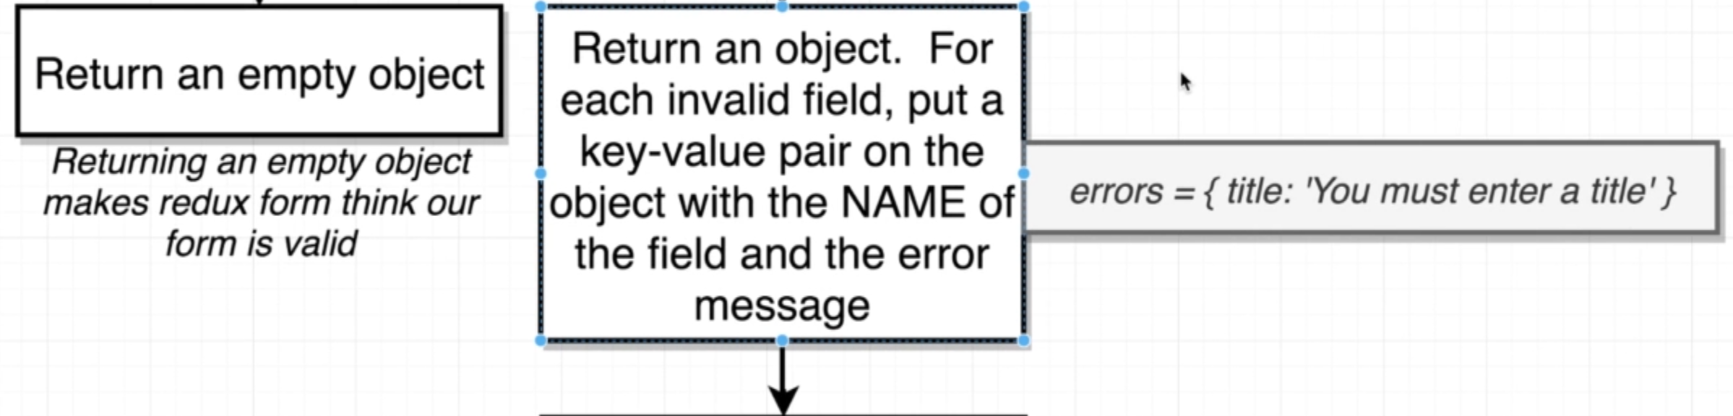

**We will define it outside of the class and this will be called with a “formValues” object**

**formValues contains all the different values inside of our form.**

**StreamCreate.js**

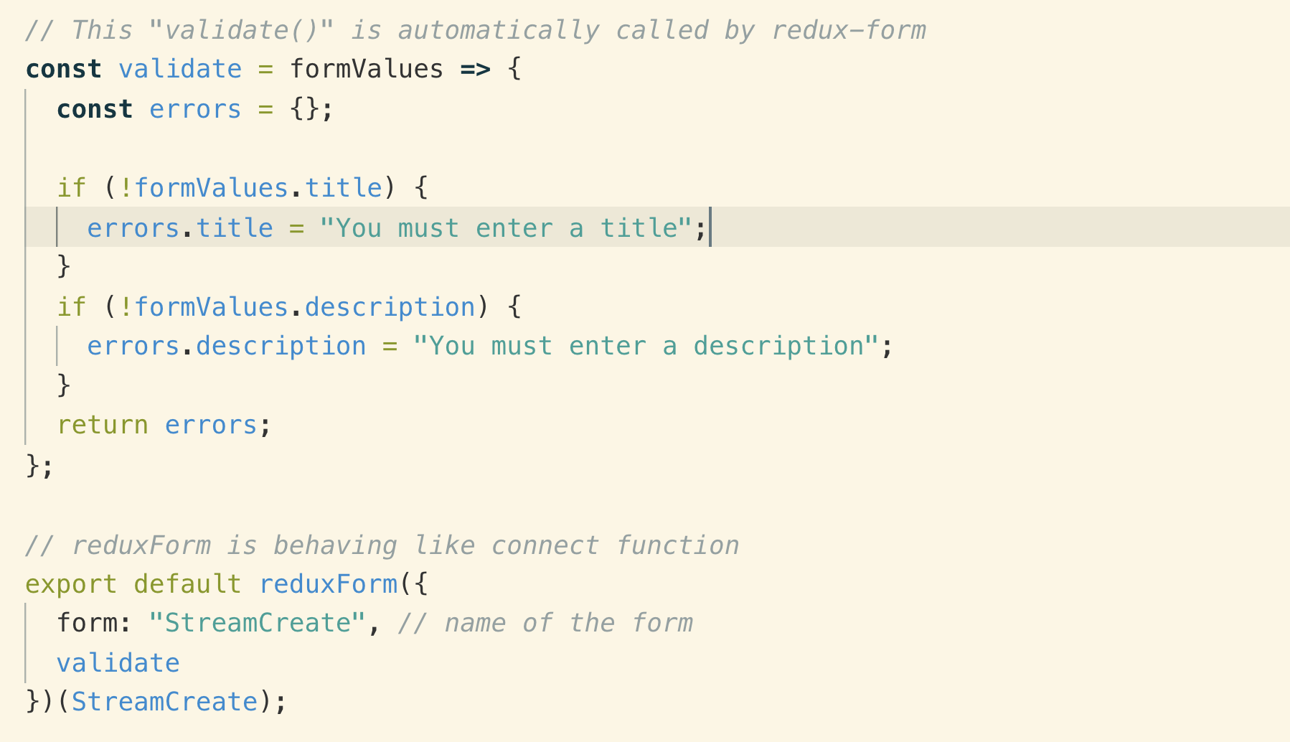

**9. Displaying Validation Messages**

**We need to make sure that the above validate() function gets wire up to redux-form so that it knows to use the validate function.**

**So we take that validate() function and add into redux-form like this**

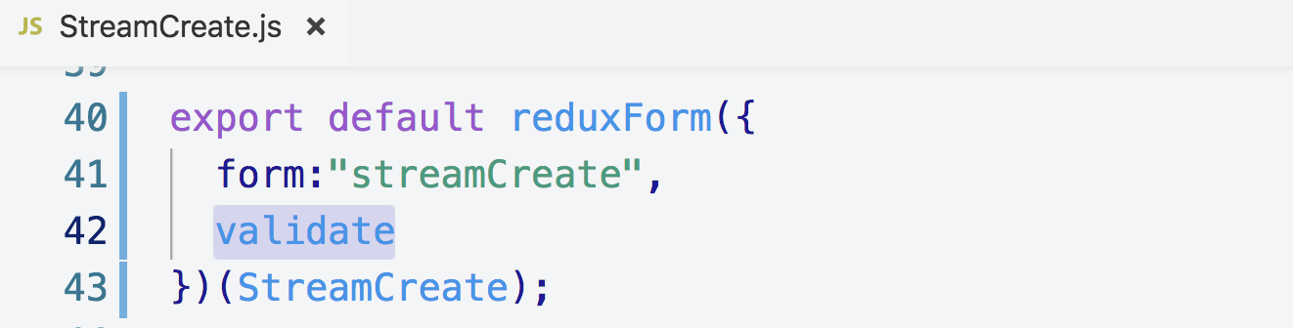

**As key and value are same so removed the validate key above.**

**If we return an object from this validate function then redux-form is going to automatically re-render our component.**

**To actually get these error messages to appear in the screen, redux-form is going to take a look at every field component that is rendered.**

**It’s going to look at each field’s name property and then looks in the errors object that we return from validate.**

**If a field has the same name as a property that exists inside error object then redux form is going to take that error message and pass it to our renderInput() function**

**We extracted, “meta” properties down in the picture which contains if there is any error.**

**I have also print it in the console to get better idea.**

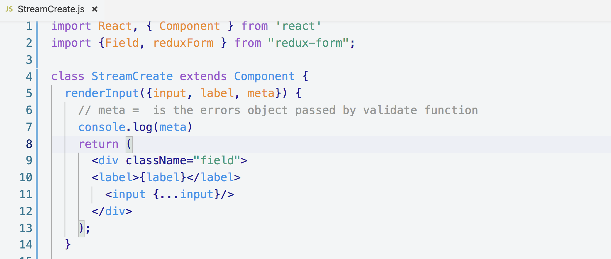

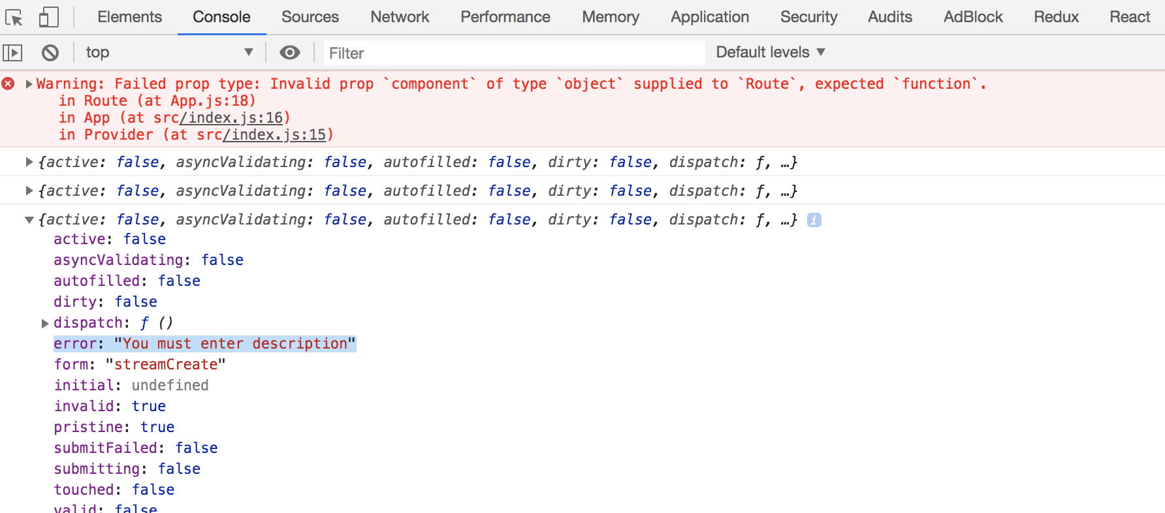

**Let’s see how to display input error message**

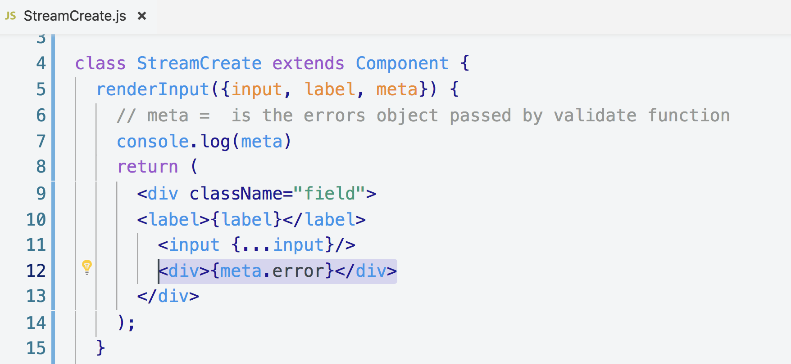

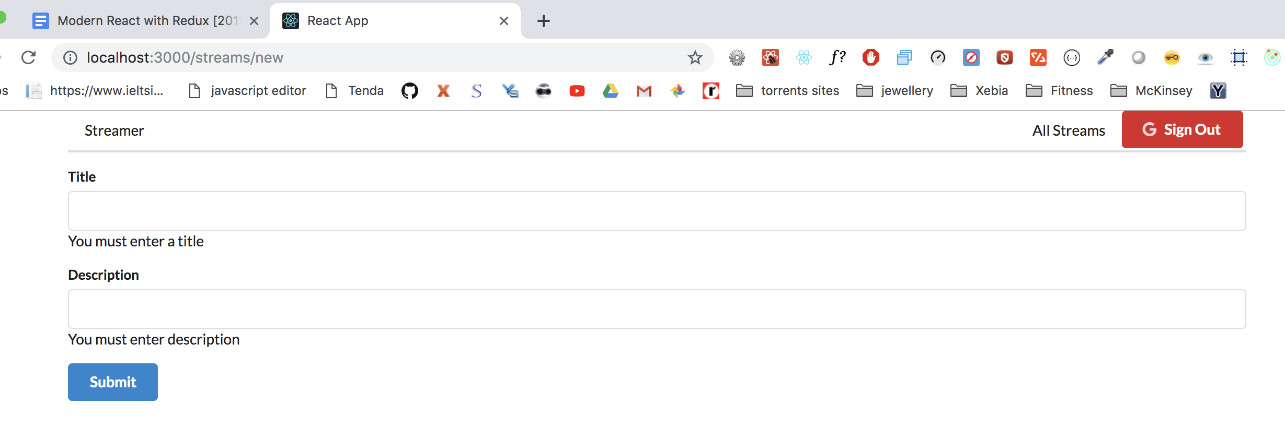

**The issue with the above is that errors are showing on load, without interacting with the user so lets show messages when the user interacts with form.**

**10. Showing Errors on Touch**

**We are manually disabling autoComplete=”off” because on auto completes error messages are hiding.**

**We will use the touch property of meta props. This touch property tells whether the user has touche the input field.**

**We used renderError() and pass it to renderInput() function**

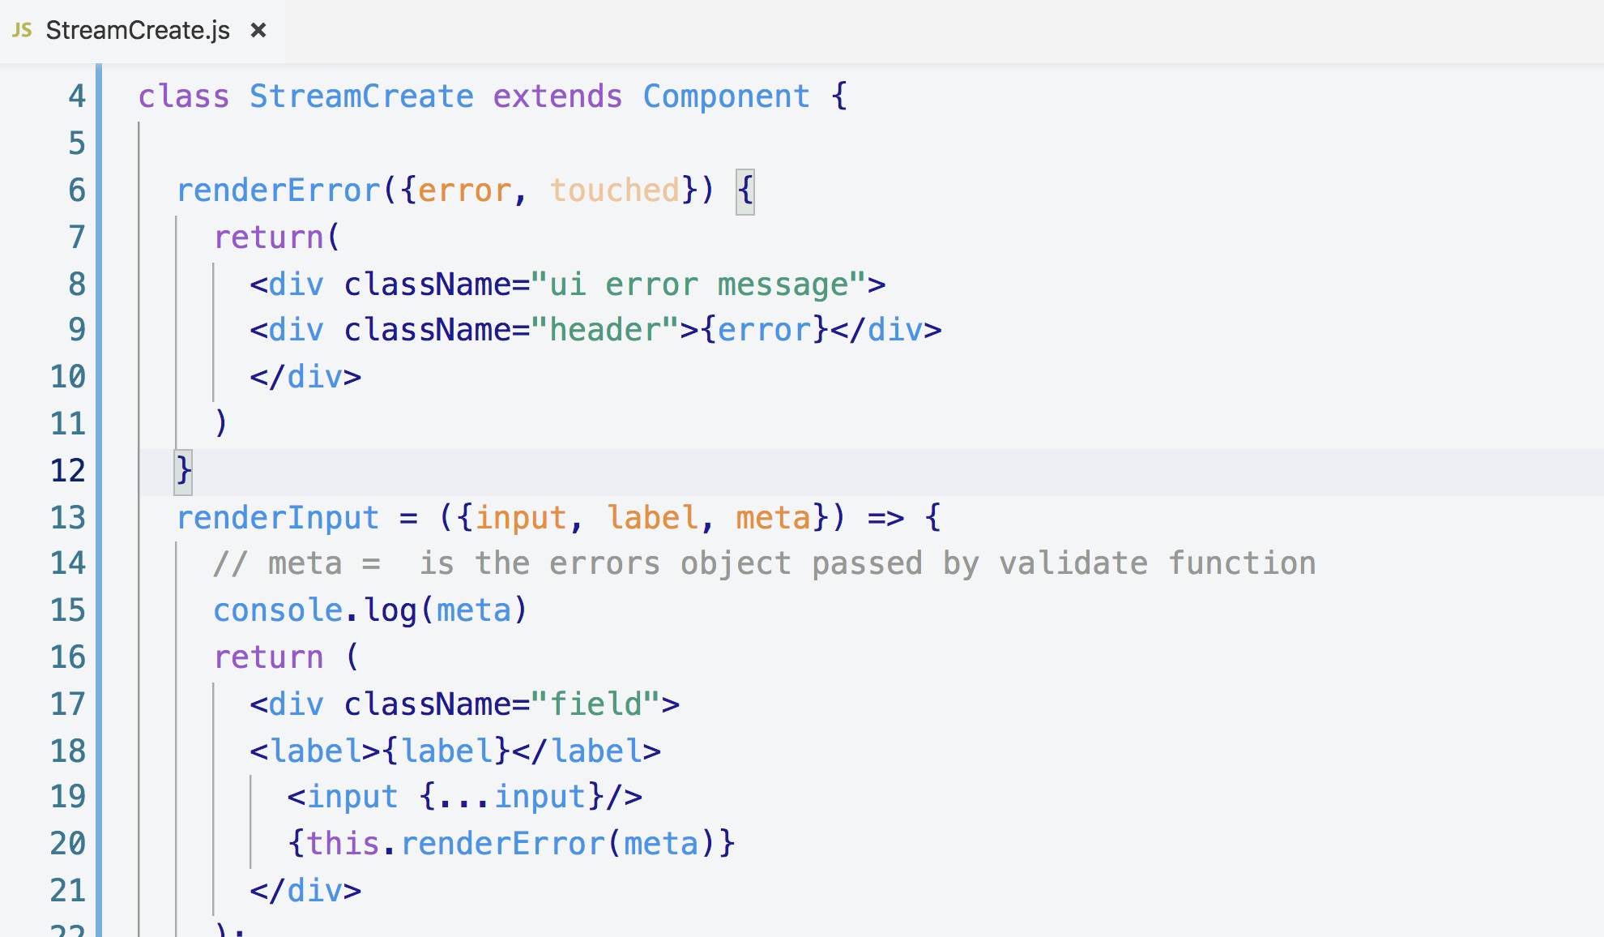

**11. Highlighting Error Fields**

**In the above code our error messages were not showing and that is due to sementic UI**

**So let’s fix that issue.**

**Semantic ui requires to have error class on <form> to show error messages so let’s just add it**

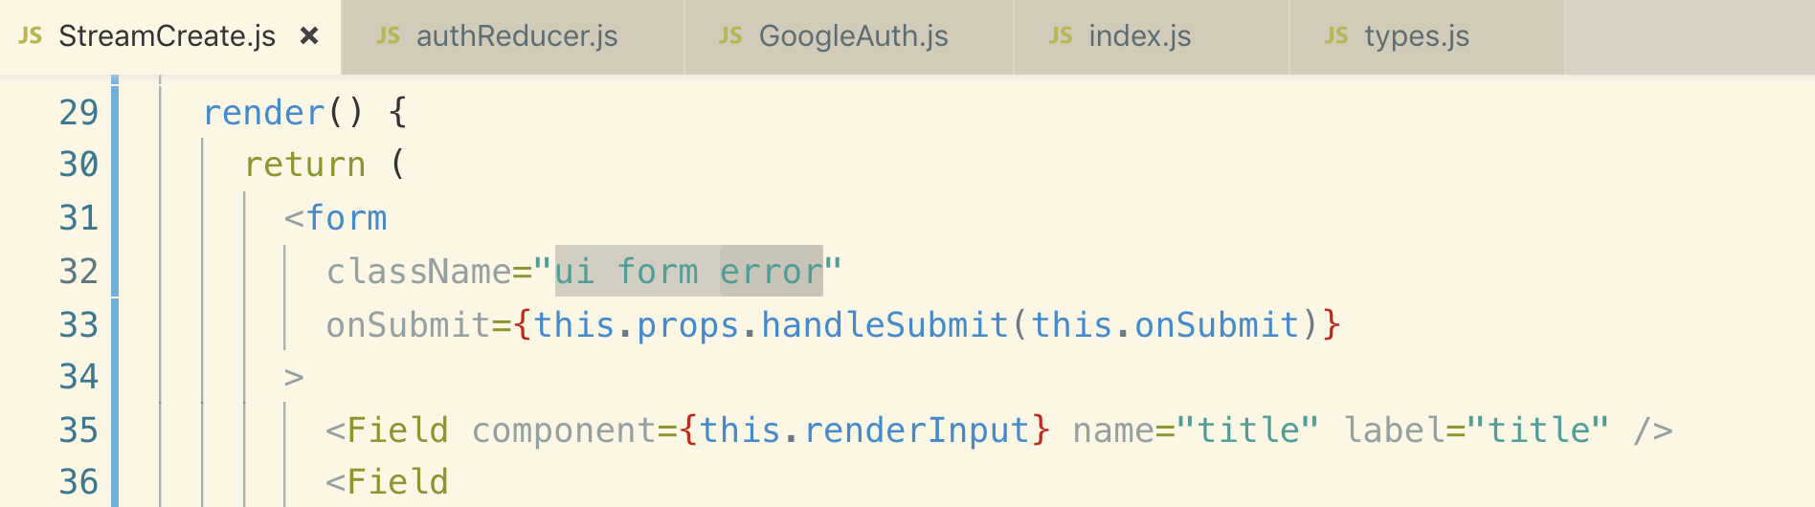

**But this will show the error initially which we don’t want.**

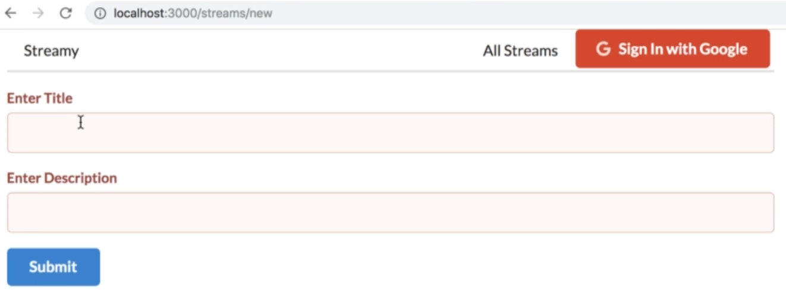

**Let’s fix the above error on initial stage of form**



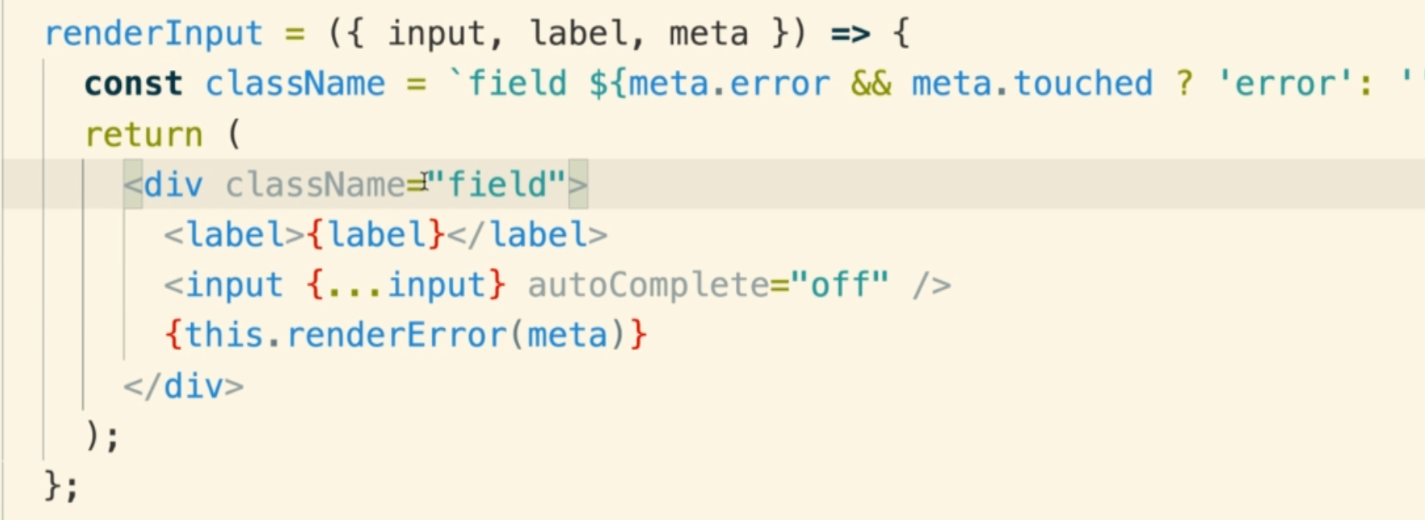

**20. REST-Based React Apps**

**1. Creating Streams**

**This is the diagram of our streaming app**

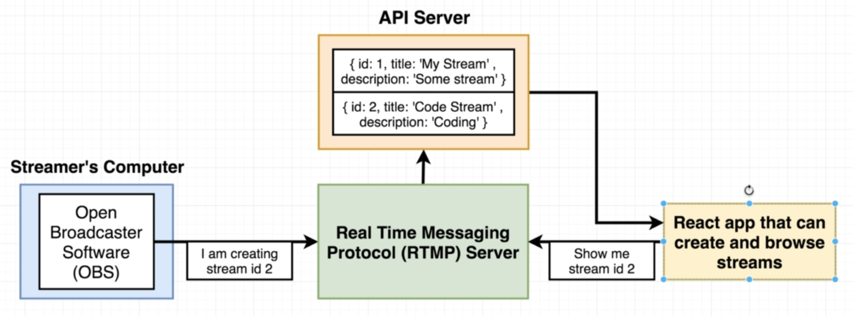

1. **We list all the available streams o user’s browser**
2. **When user clicks on a particular stream, the browser asks the RTMP server to get the clicked stream.**
3. **RTML server fetches the requested stream from OBS server send it back to browser.**

**2. REST-ful Conventions**

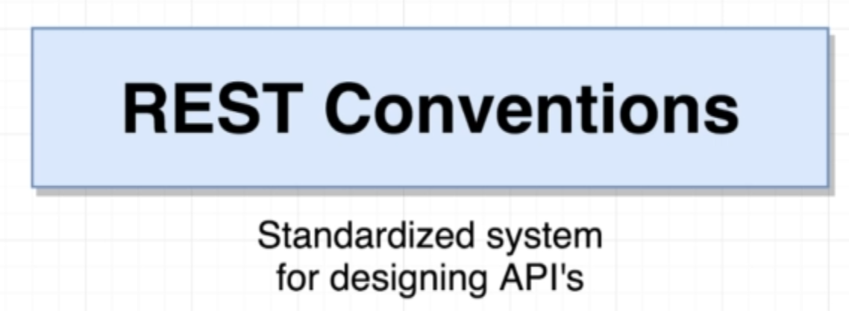

**This is a standard way of implementing Restful API. Note how we define end-points of these APIs**

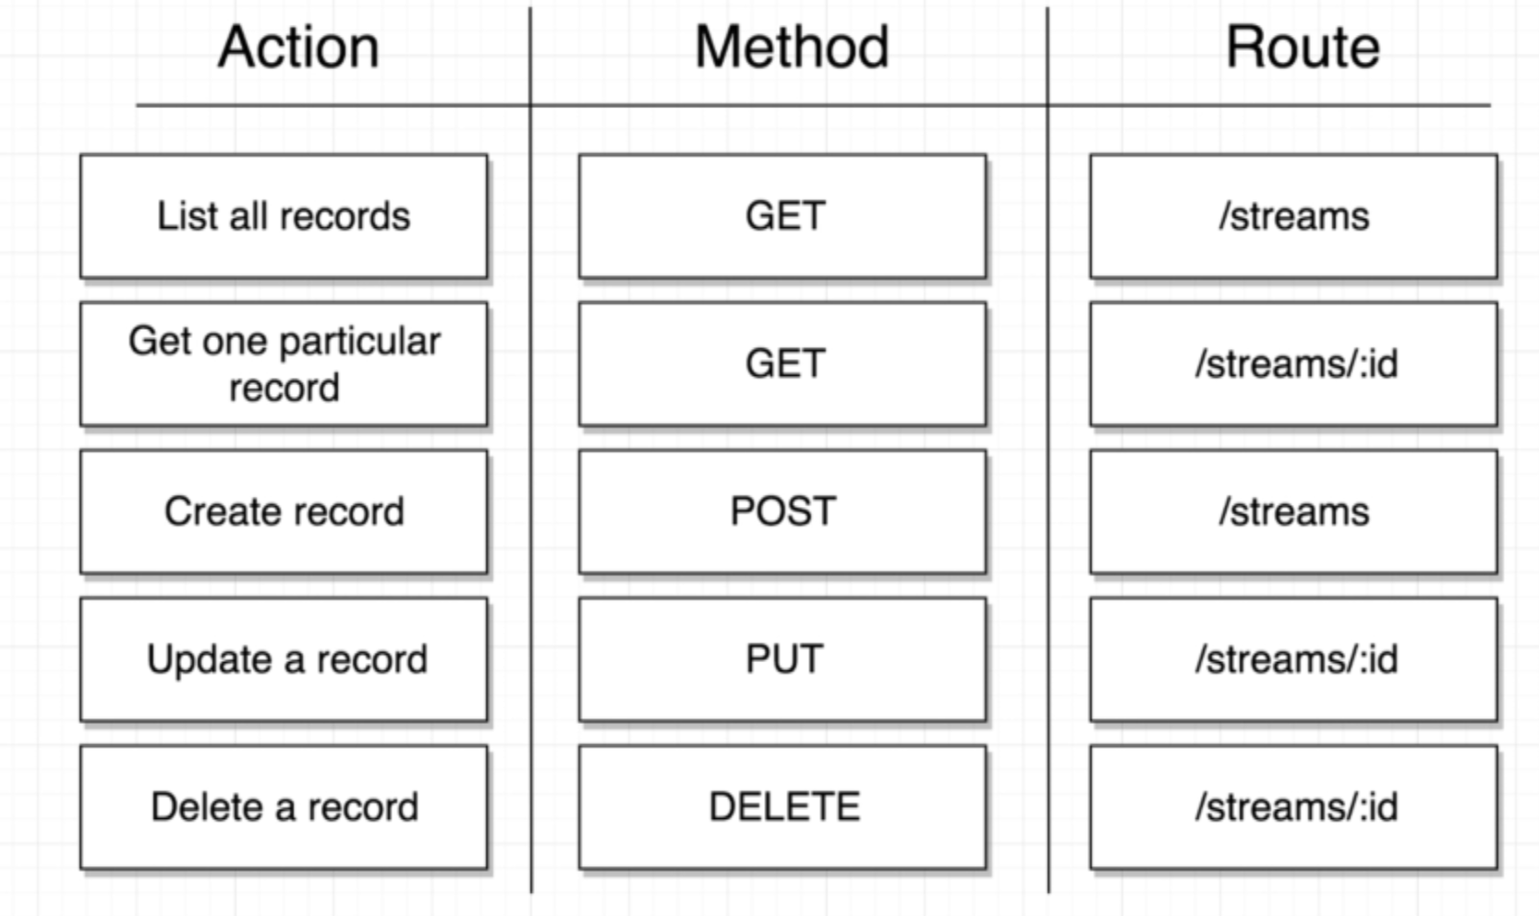

**The term Restful convention is referring to a standardized system of routes and request methods used to operate all the above actions.**

**So following restful conventions if we want to list all records of streams that are stored on an API server then by convention, we will make a GET request to the routes /streams on our API server.**

**If our API server follows Restful conventions then whenever we make a GET request to a /streams the API server should return an array of all the different stream objects that it holds.**

**If you want a one particular record, you make a GET request to /streams/:id**

**We will use dummy NPM JSON server for API for our streams project.**

**3. Setting Up an API Server**

**Let’s install “json-server”**

**npm i json-server**

**Now we need to create a file called db.json which saves all of our APIs data.**

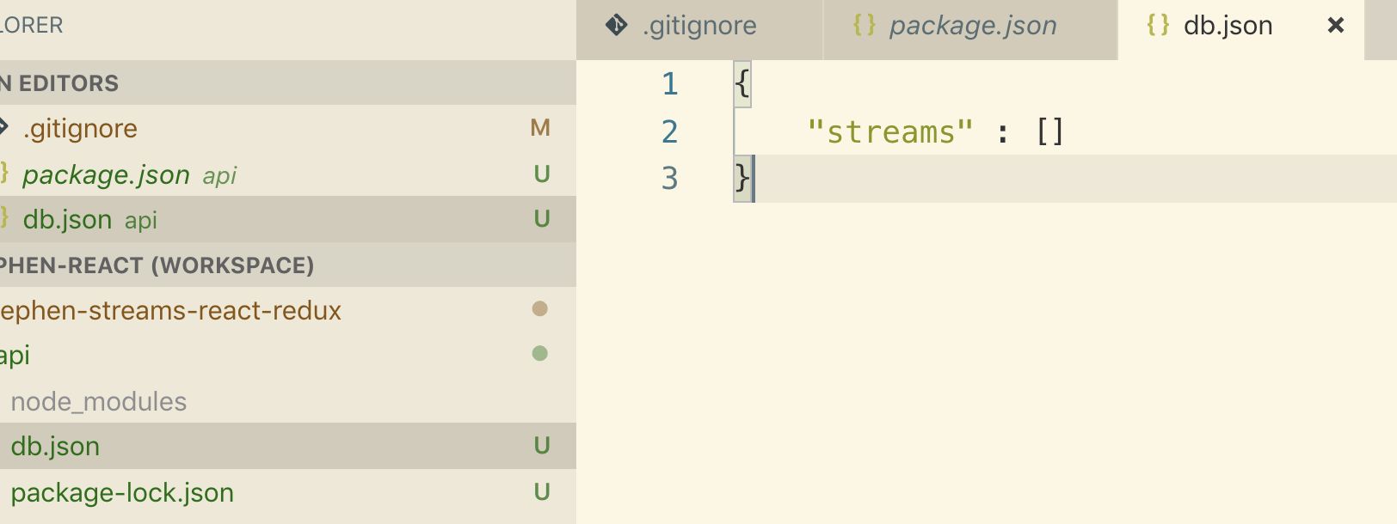

**Let’s add server startup script in package.json**

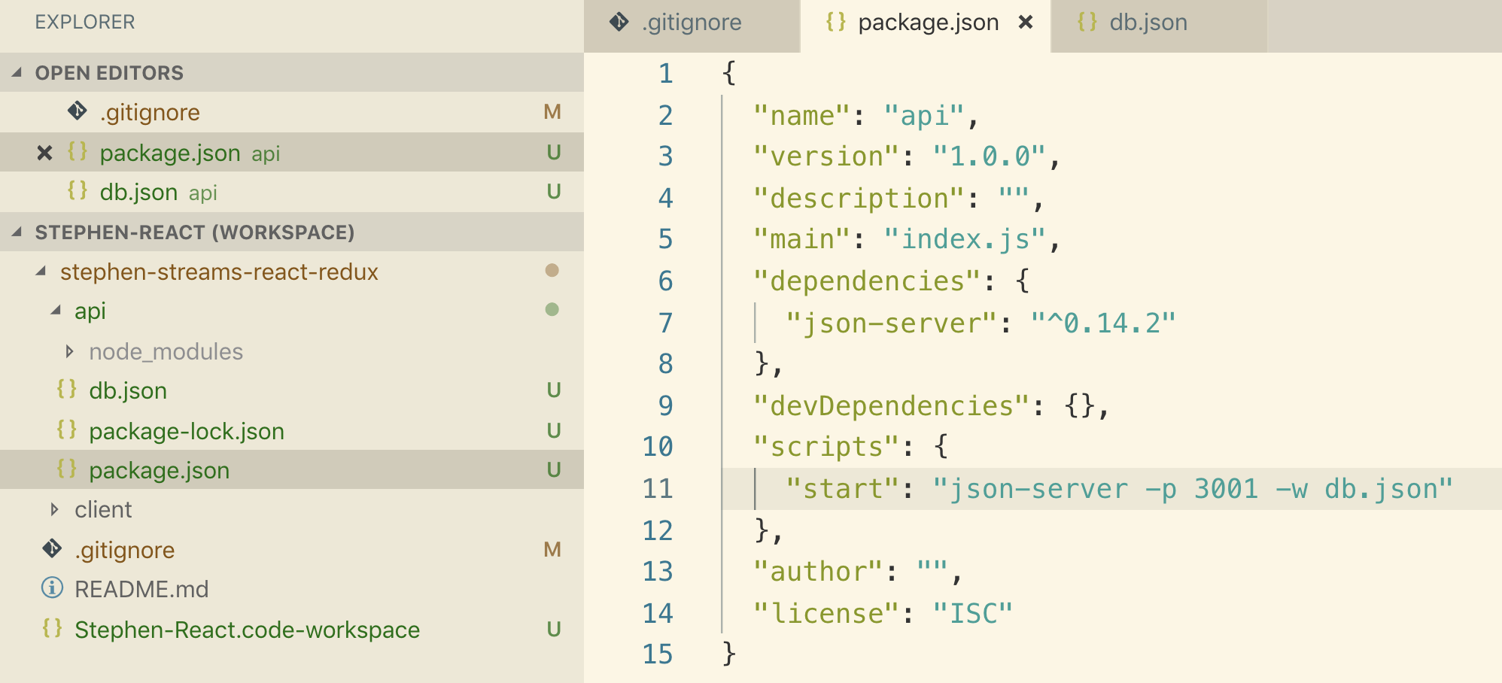

**In the above selected text shows => start the json-server on port 3001 and watch db.json for any change.**

**Now let’s go to APiI folder and start the server**

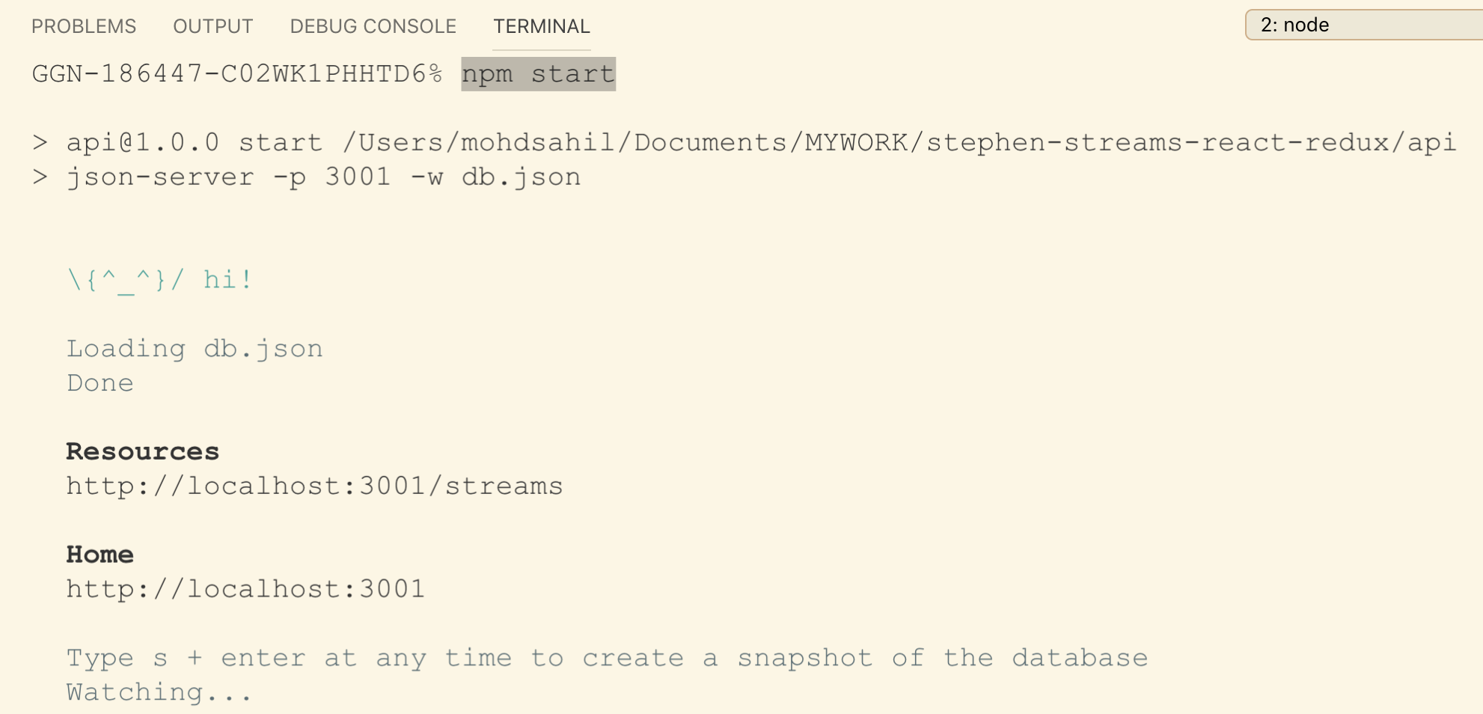

**4. Creating Streams Through Action Creators**

**Anytime the user submits a form from the streamCreate component, we attempt to make an Ajax/network request over to our API.**

**To make a network request, we will define an Action creator, needs to make sure that we wire up that action creator to our component with the connect helper.**

**We will call the action creator from onSubmit() and the Action Creator is going to user axios for making network request to our API.**

**We need to install axios and redux-thunk because we are going to need both to write out an asynchronous action creator.**

**Let’s implement it.**

**Create api folder inside src directory and then create streams.js which is the axios configuration file.**

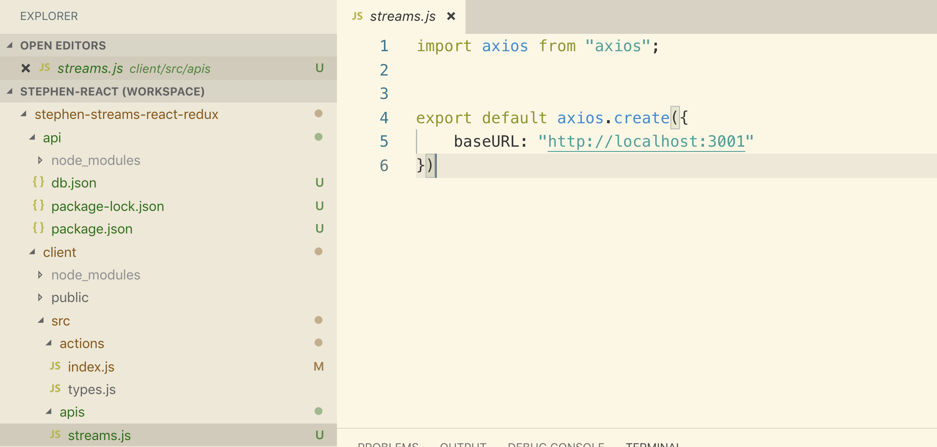

**Now let’s use this axios instance inside action’s index.js**

**Create Action creator inside action.js.**

**This action creator will receive all the form values**

**Note: Anytime we make an asynchronous action creator, we make use of redux-thunk**

**We make dispatch function async as shown below in the code**

**actions/index.js**

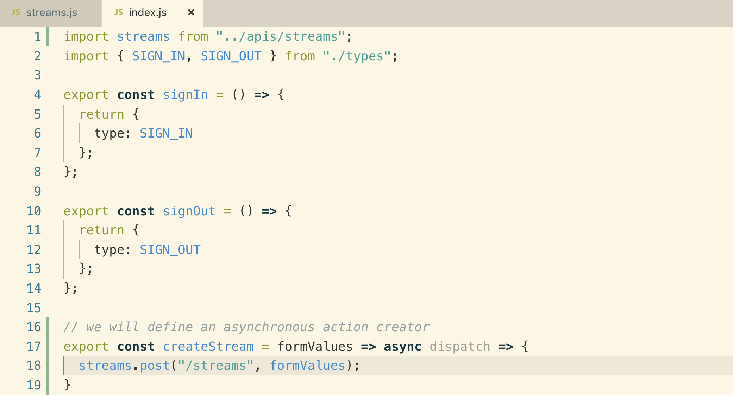

**Now we need to hook up the above action creator to StreamCreate component and there we will call it**

**In the next lesson. Let’s see how to wire up both “connect” and “redux-form” at the same time in StreamCreate Component.**

**5. Creating a Stream with REST Conventions**

**This is the way we wire up both connect and redux-form at the same time. As we are not using “mapStateToProps” we are putting null instead.**

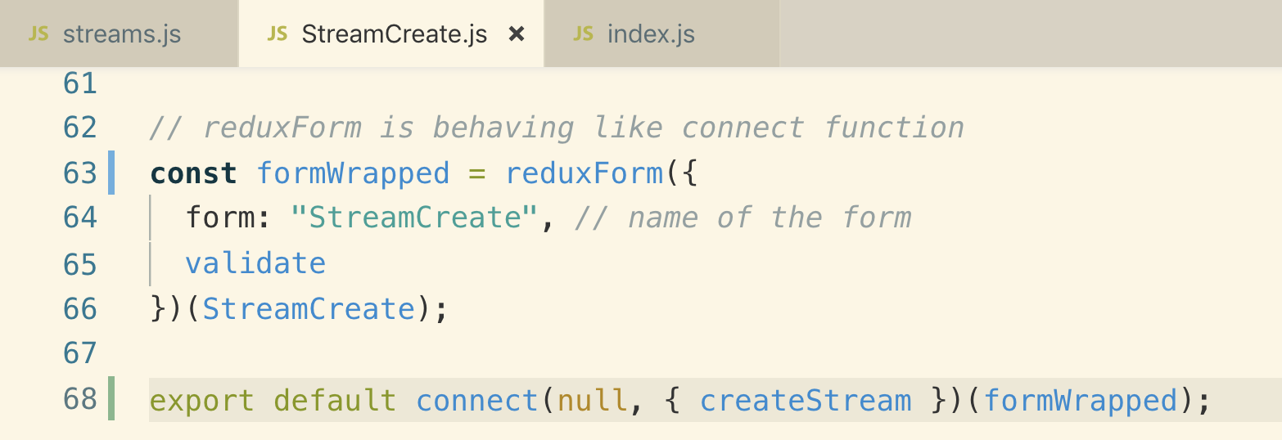

**Now let’s see how we used the above {createStream} action creator.**

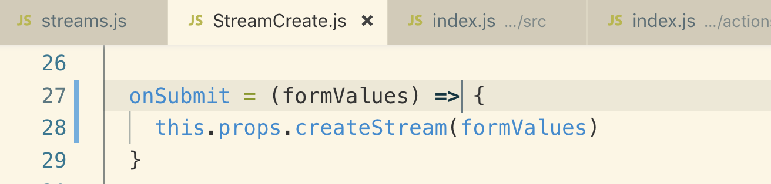

**root index.js**

**We forgot to wire up “redux-thunk” so let’s do it.**

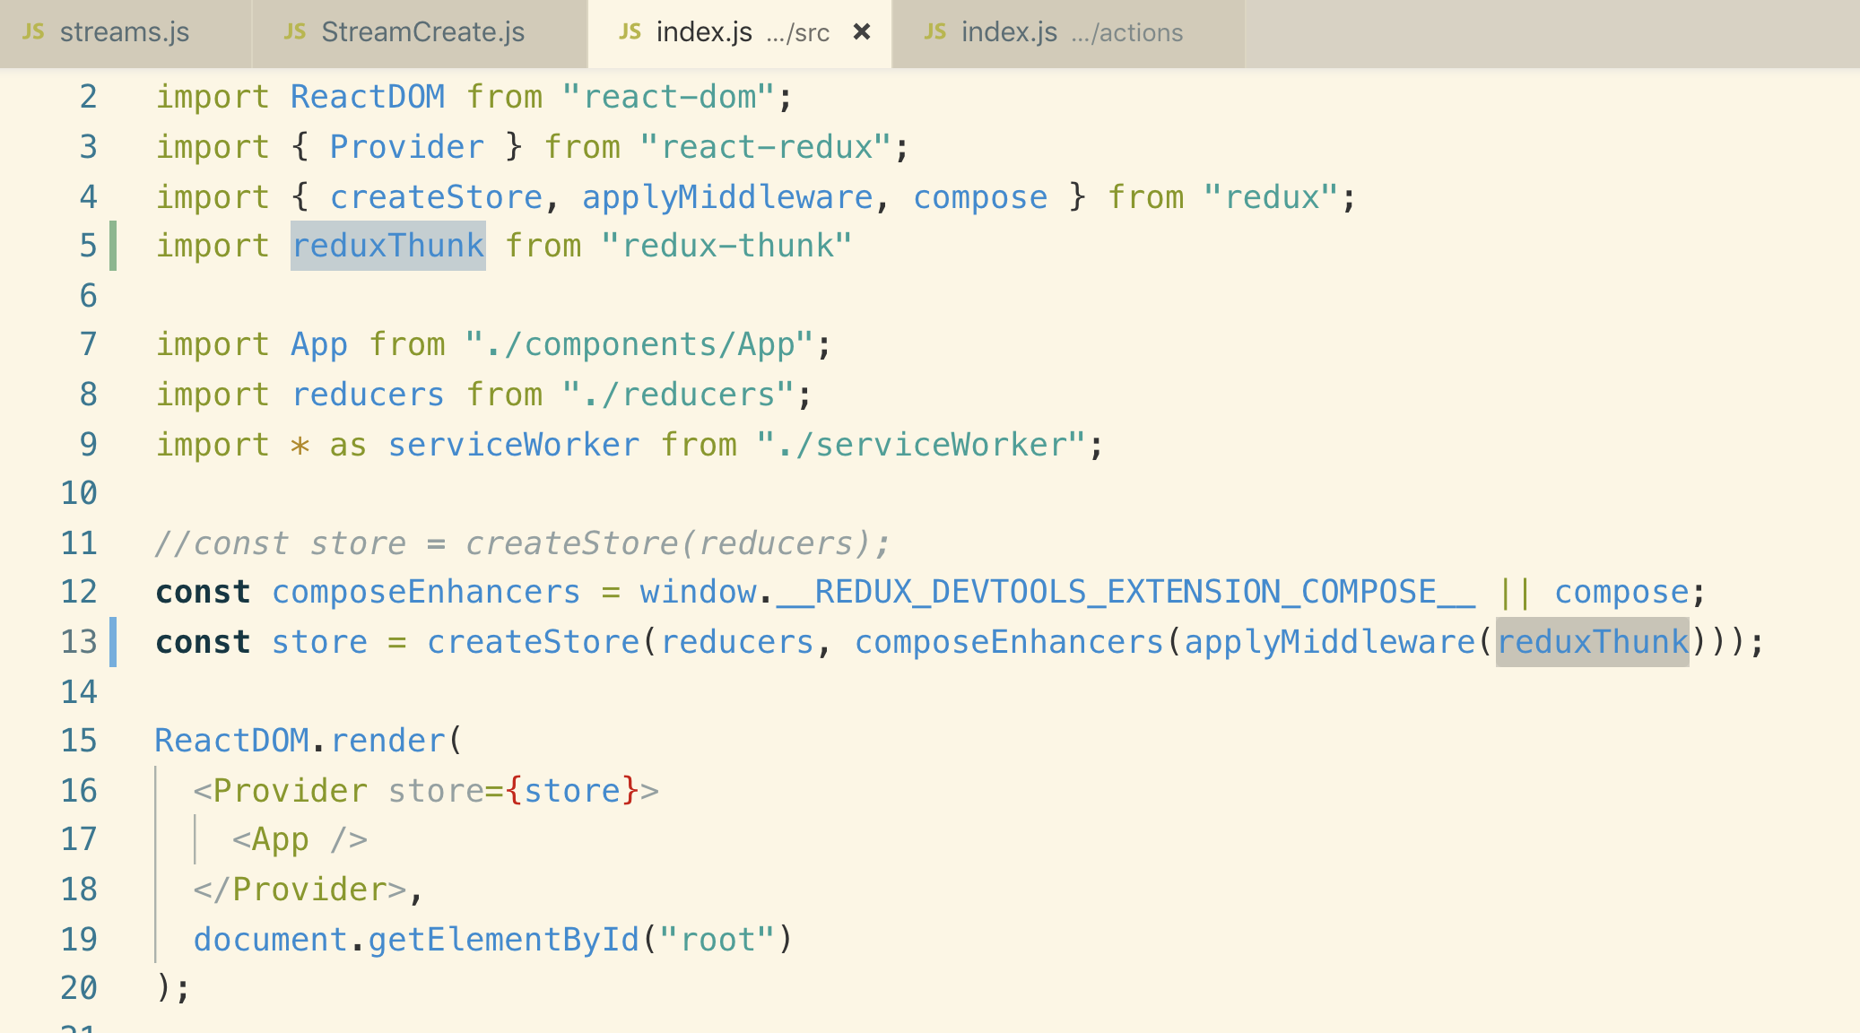

**We are making this “OPTION REQUEST” is because our server is running on a different port. This is related to CORS**

**We successfully created a post request**

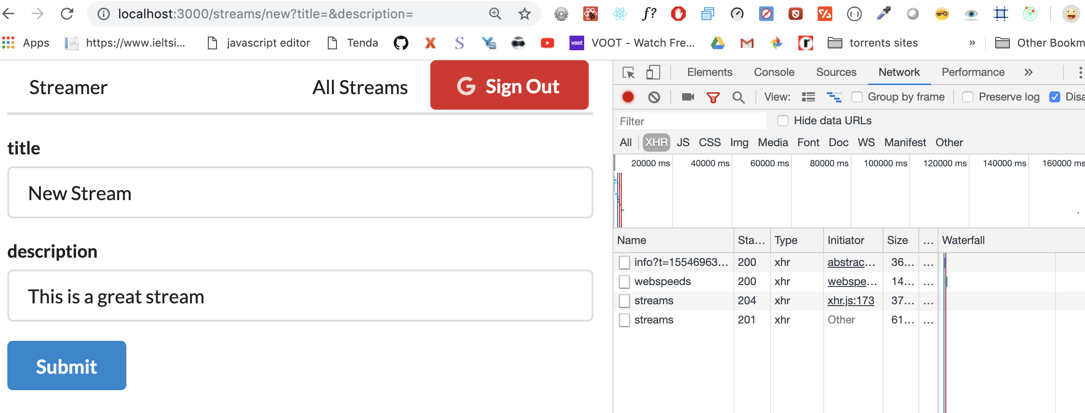

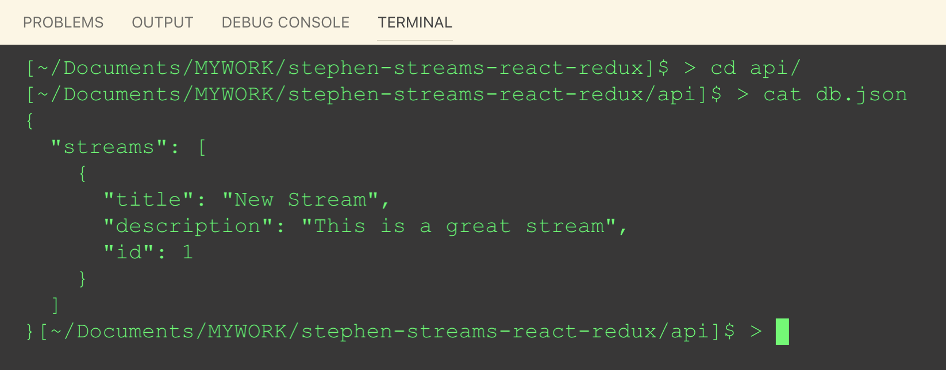

**6. Dispatching Actions After Stream Creation**

**We can get the stream data that we just created or you can say a handle to post request.**

**We want to dispatch an action with a payload of that stream and then we can actually create a reducer and pick up that stream that was created and save it inside there**

**In order to dispatch an action, we first need to have a type. Create a type in actions/type.js**

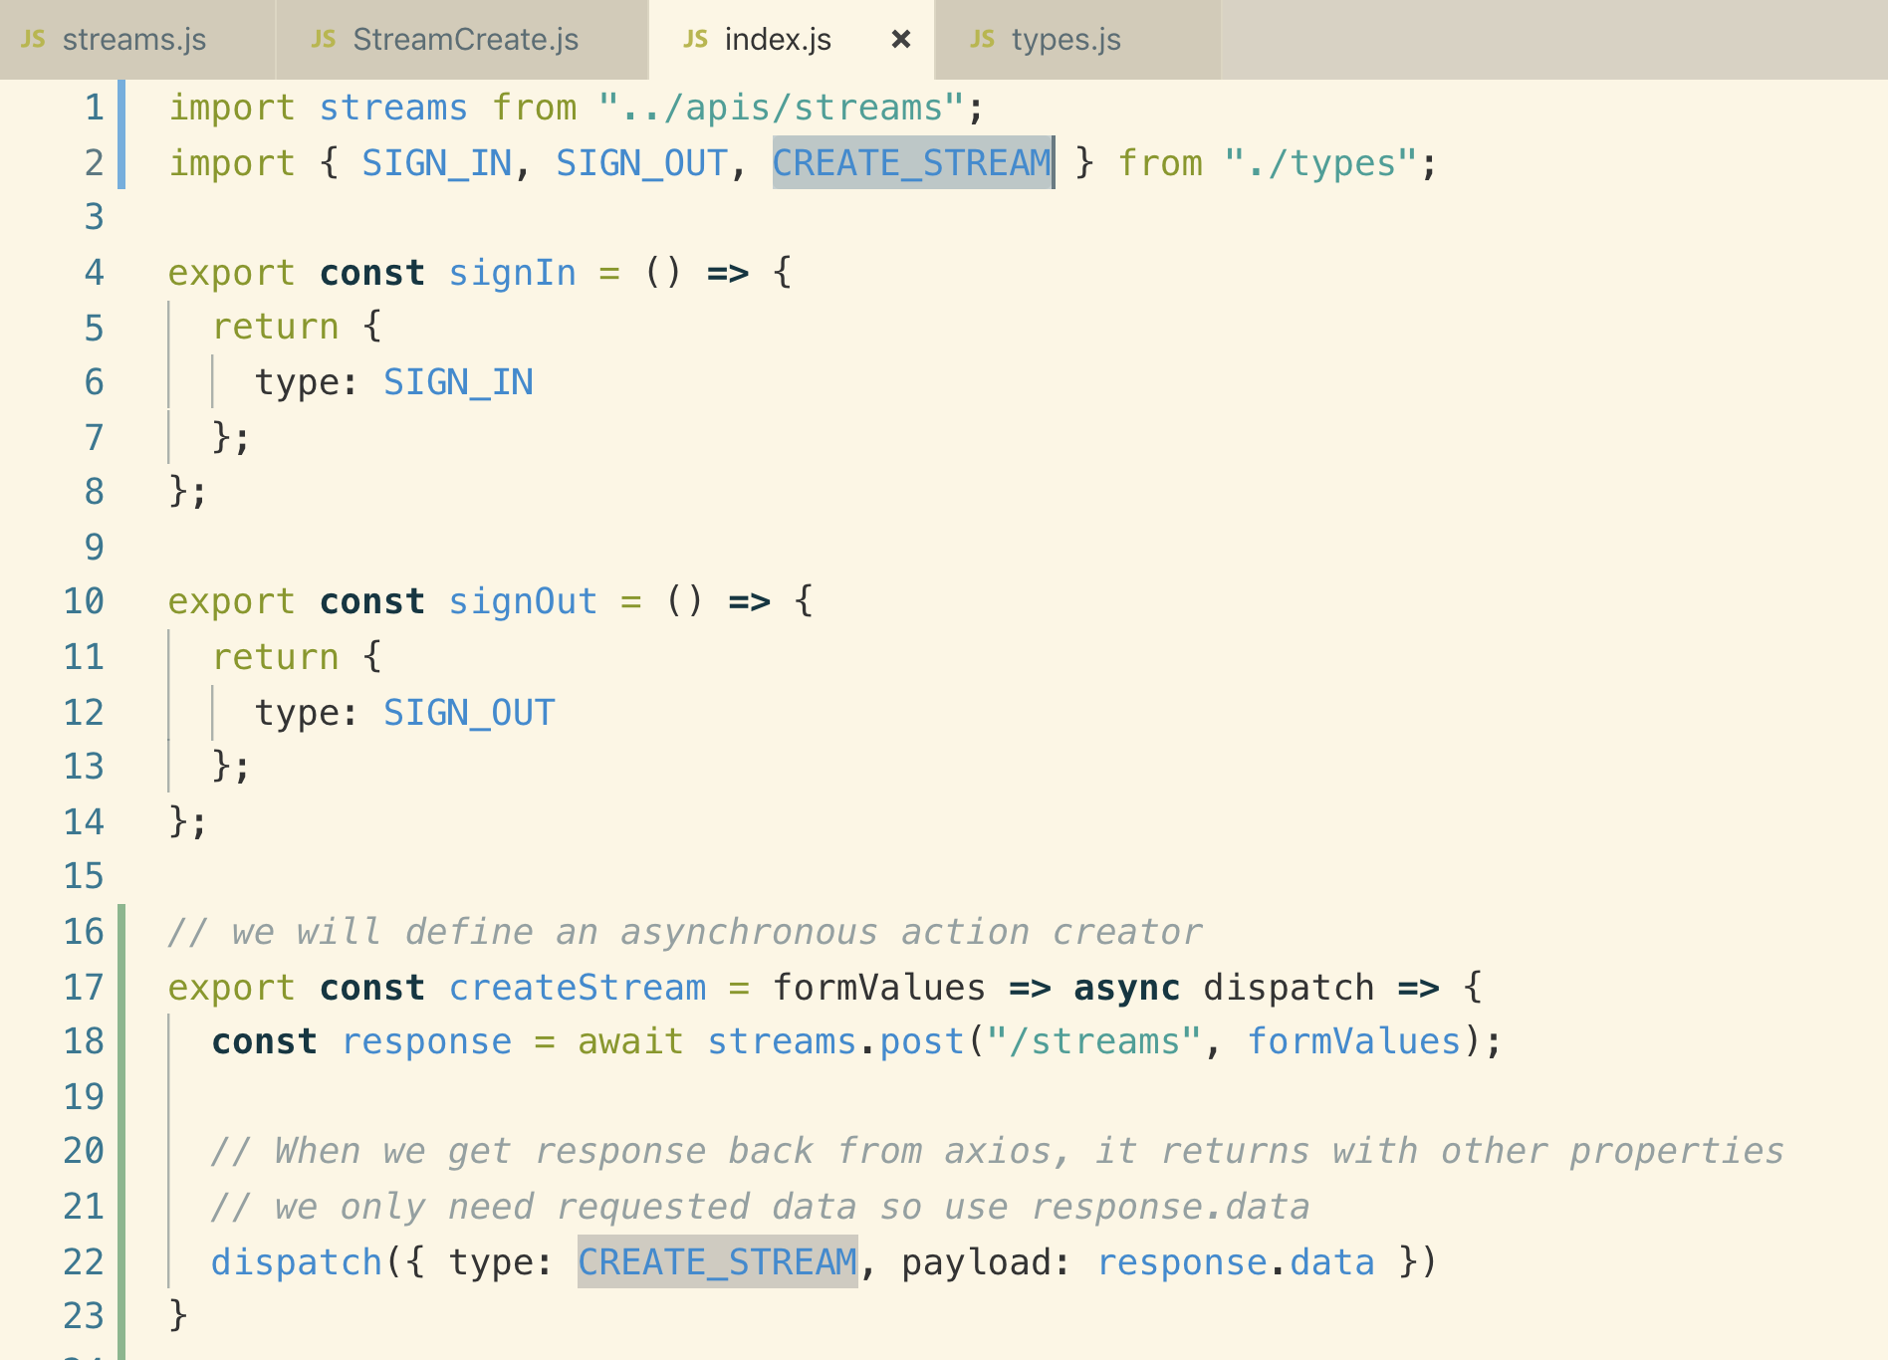

**Now we need to create a reducer which will save the stream that we have just created inside of our application**

**7. Bulk Action Creators**

**In the RESTful convention, we also need to know what our API server is going to return anytime that we make this type of request.**

**We added a response column in the RESTful convention.**

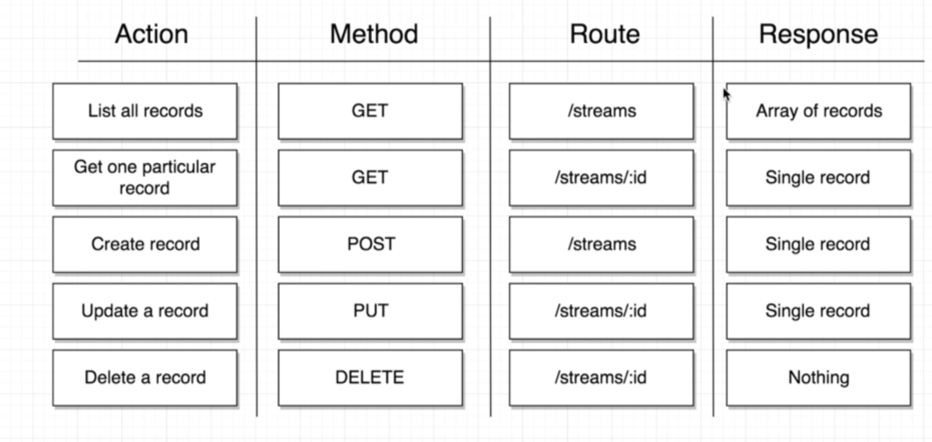

**We are adding all the actions types in the type.js**

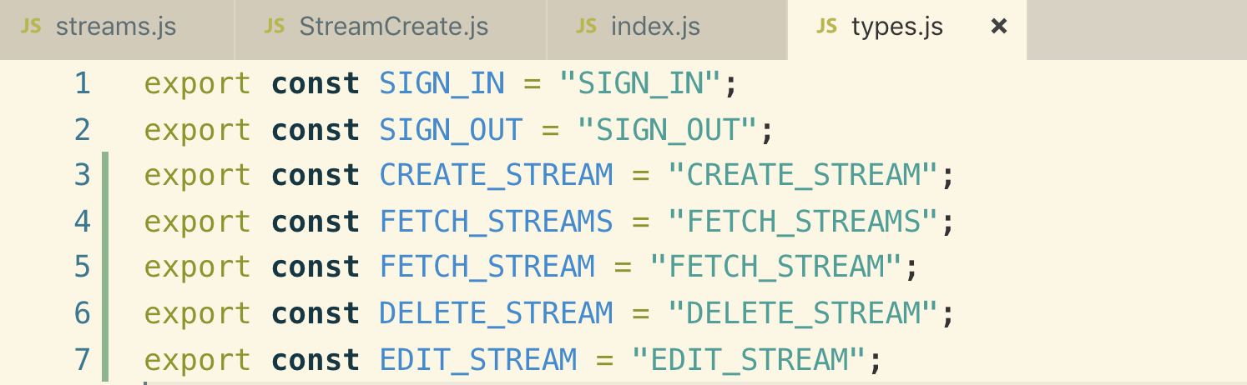

**Now let’s add these types into actions/index.js and creates stream CRUD action creators**

**actions/index.js**

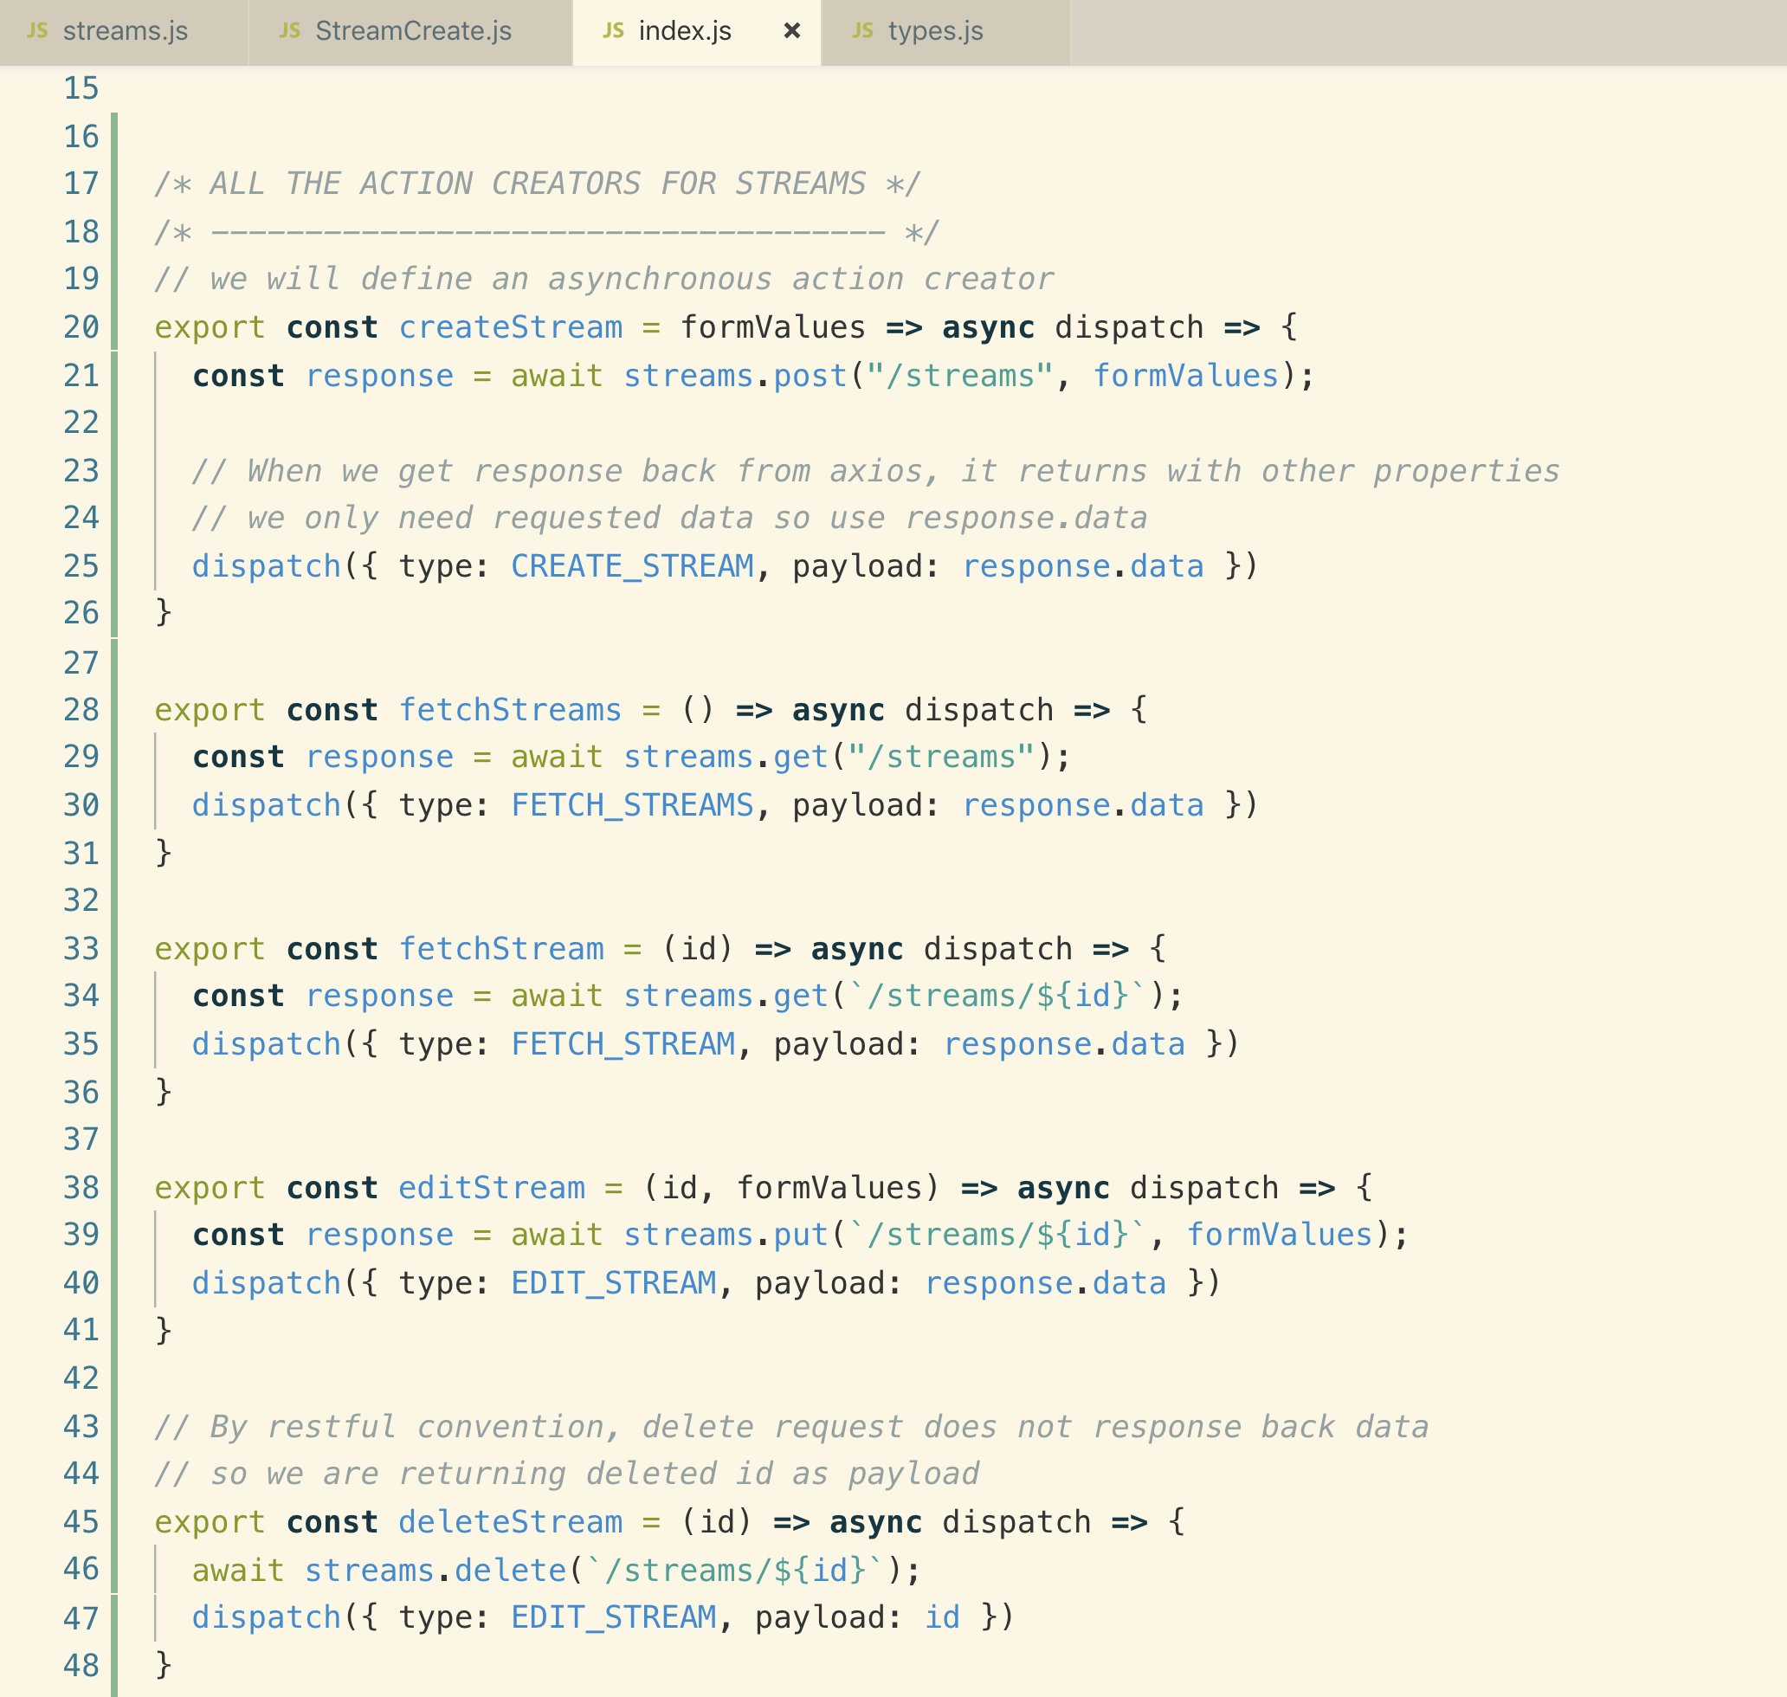

**8. Object-Based Reducers**

**We will return object instead of array in reducer as it will make update, get specific and delete operation easy.**

**Let’s see this with an example**

**Array based Approach**

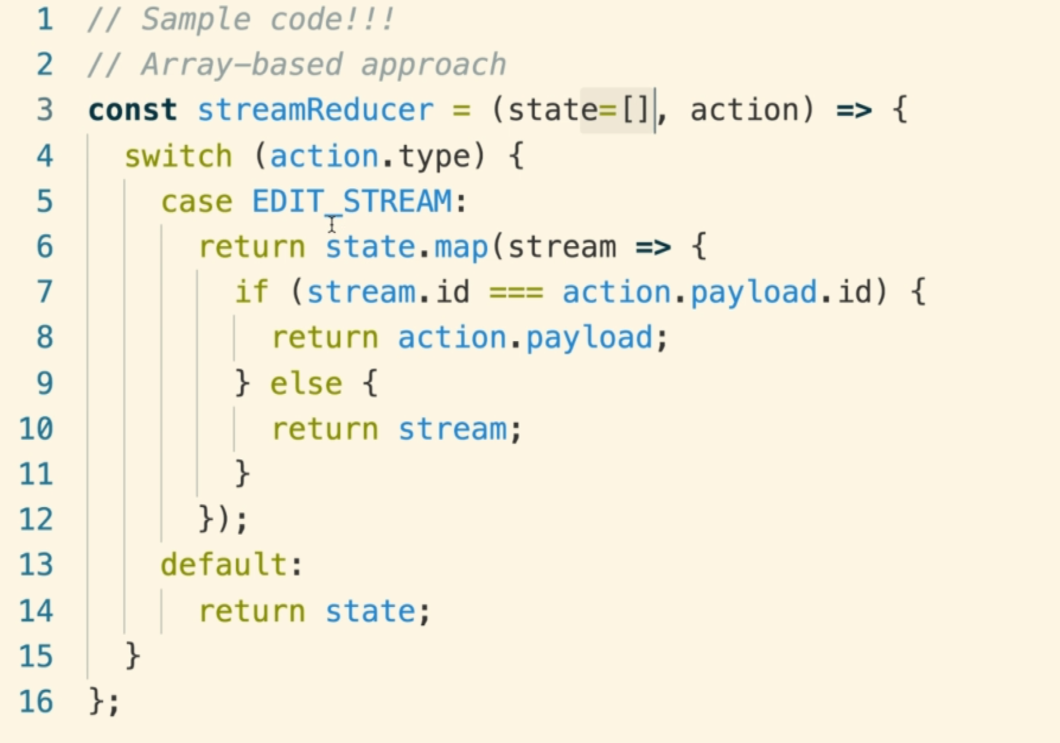

**9. Key Interpolation Syntax**

**Object Based Approach**

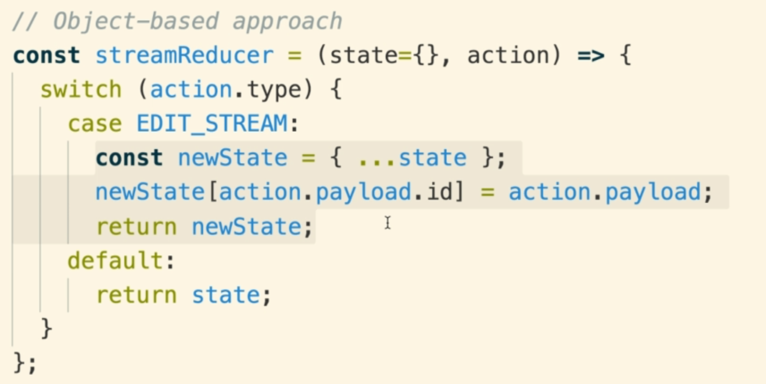

**Let’s optimize the above “object based approach”**

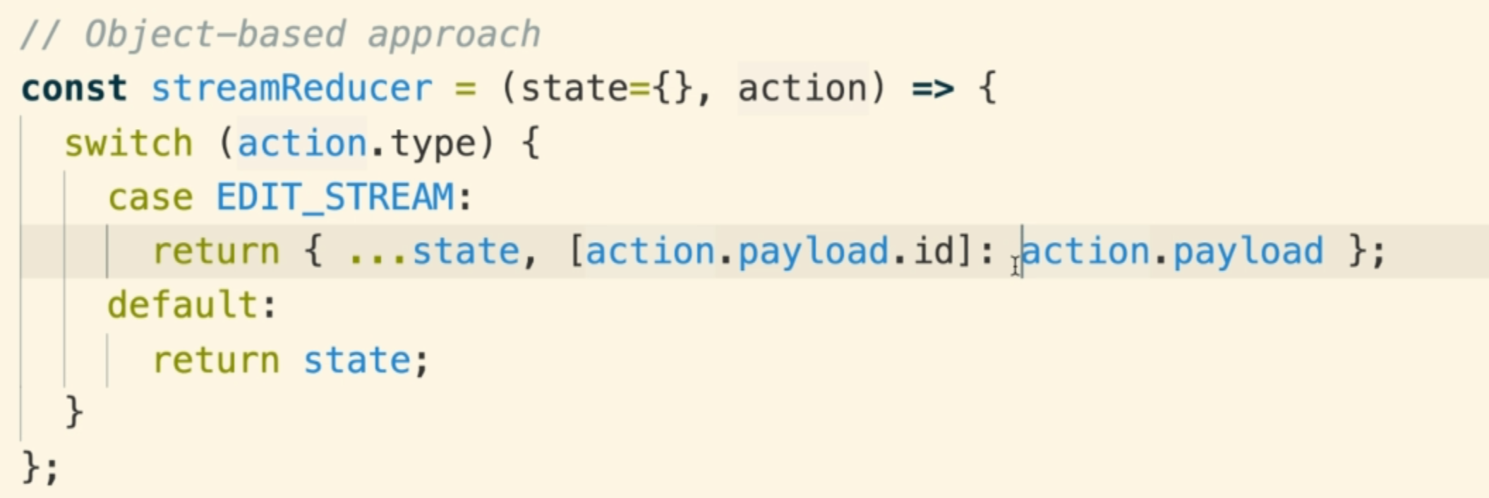

**[action.payload.id] : it doesn’t mean that we are creating array, it just ES2015 key interpolation**

**10. Handling Fetching, Creating, and Updating**

**11. Deleting Properties with Omit**

**For delete reducer, we will install a lodash library for easy removing records.**

**Npm install lodash**

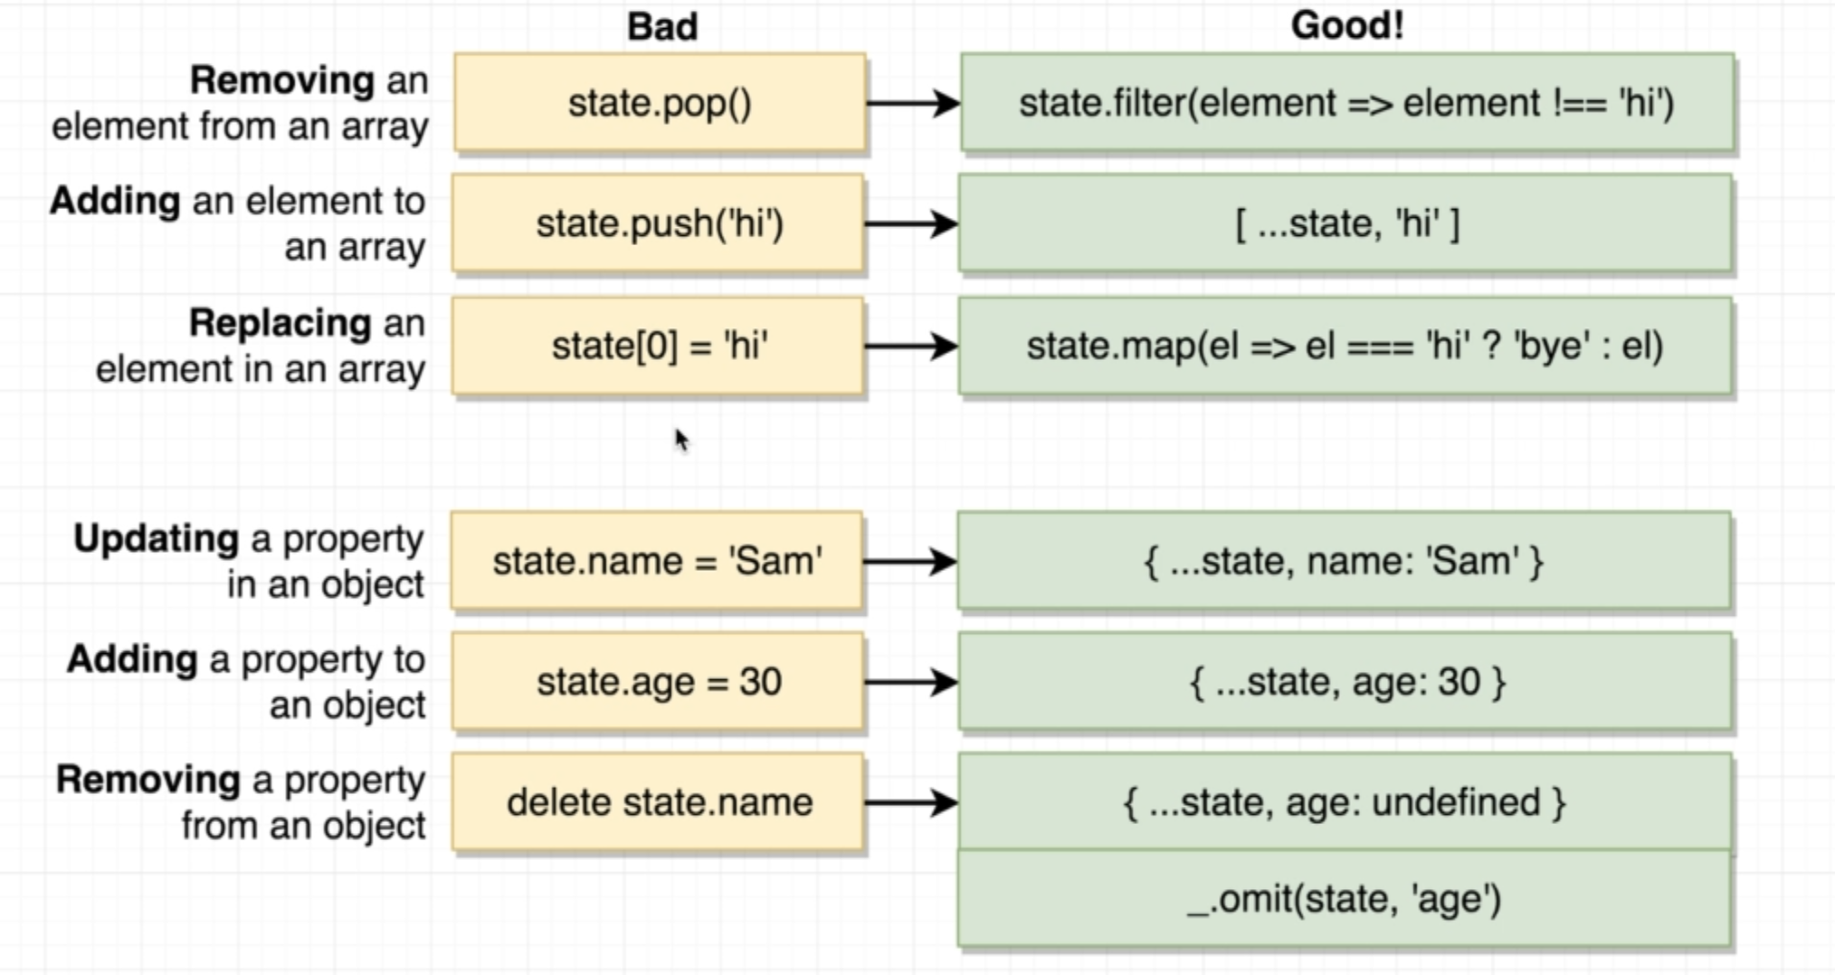

**React Method for CRUD operations**

**12. Merging Lists of Records**

**We will get an array as a result of list of streams, but we have object as state data so we need a clever solution to add array into object in one go. Let’s see how we do it.**

**This is what we need to do.**

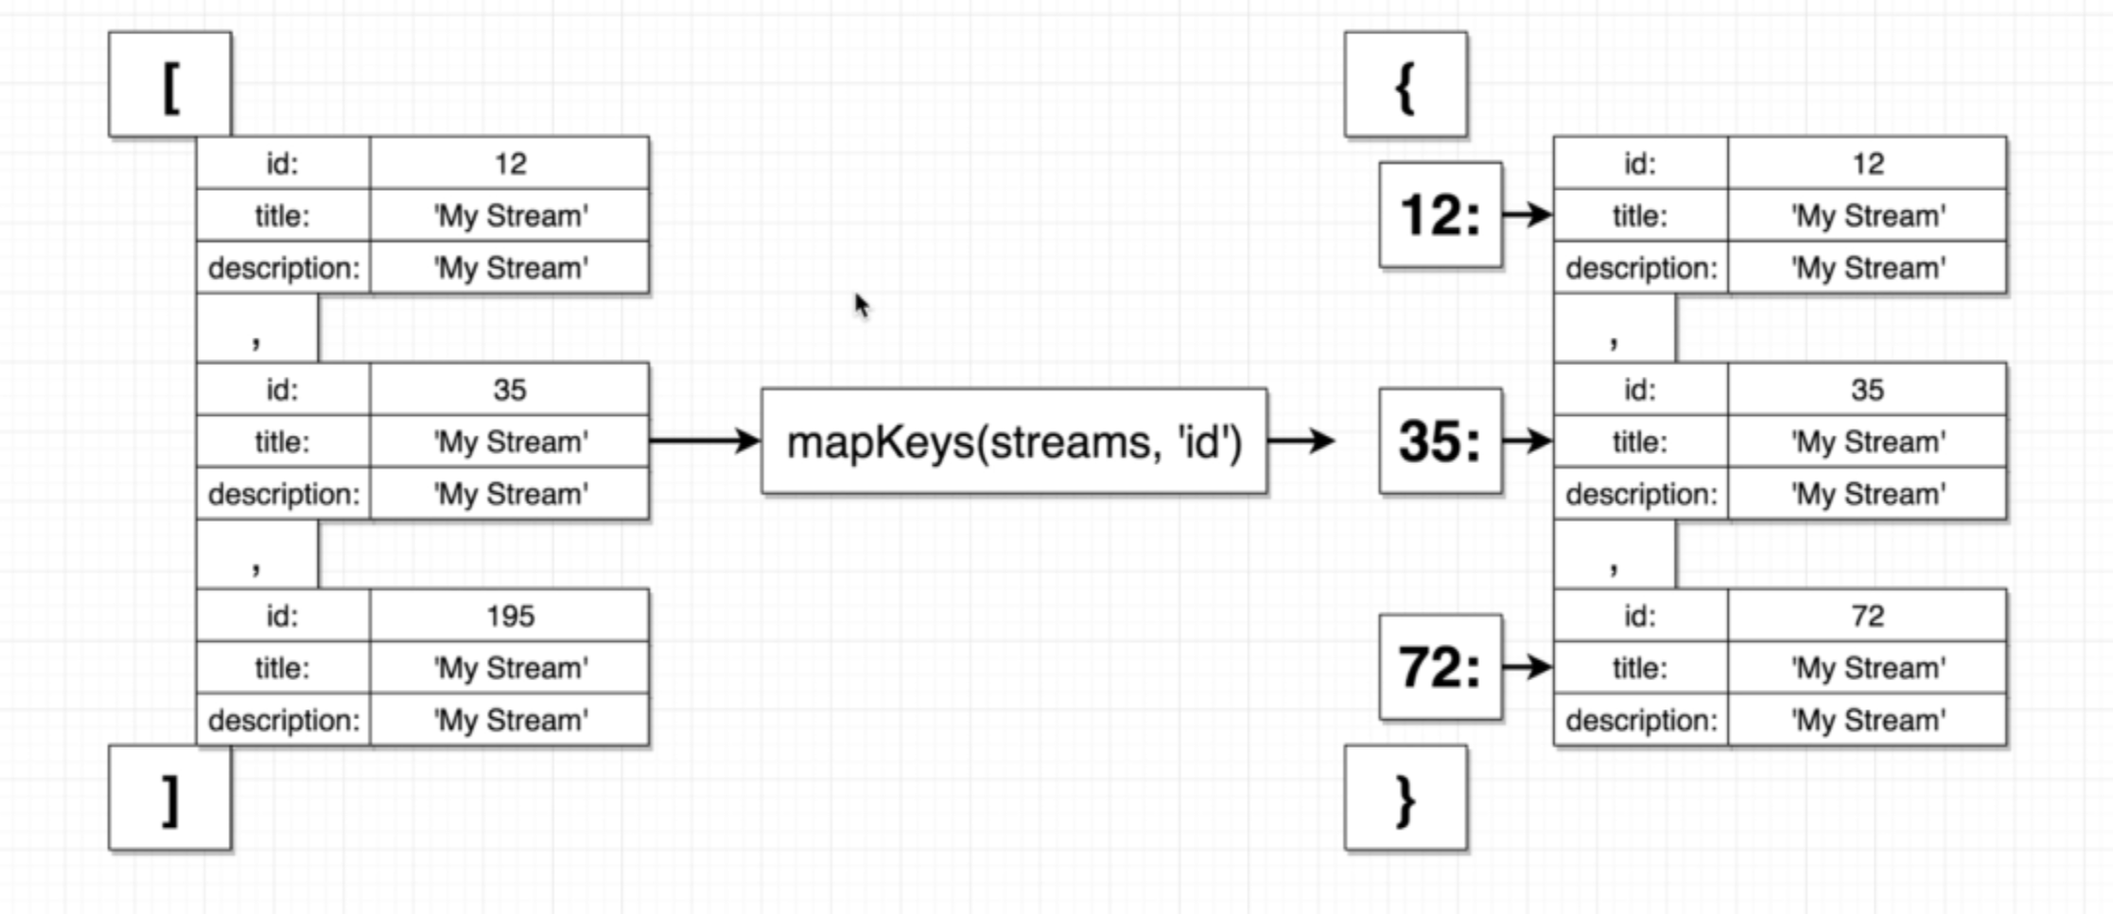

**We will a function from lodash called “mapKeys()” which converts the above array into shown object.**

**Example code**

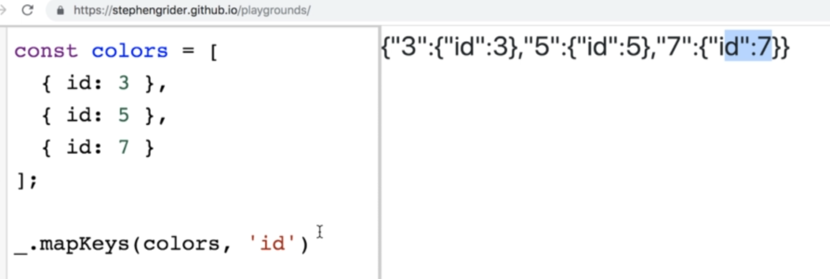

**reducers/streamReducer.js**

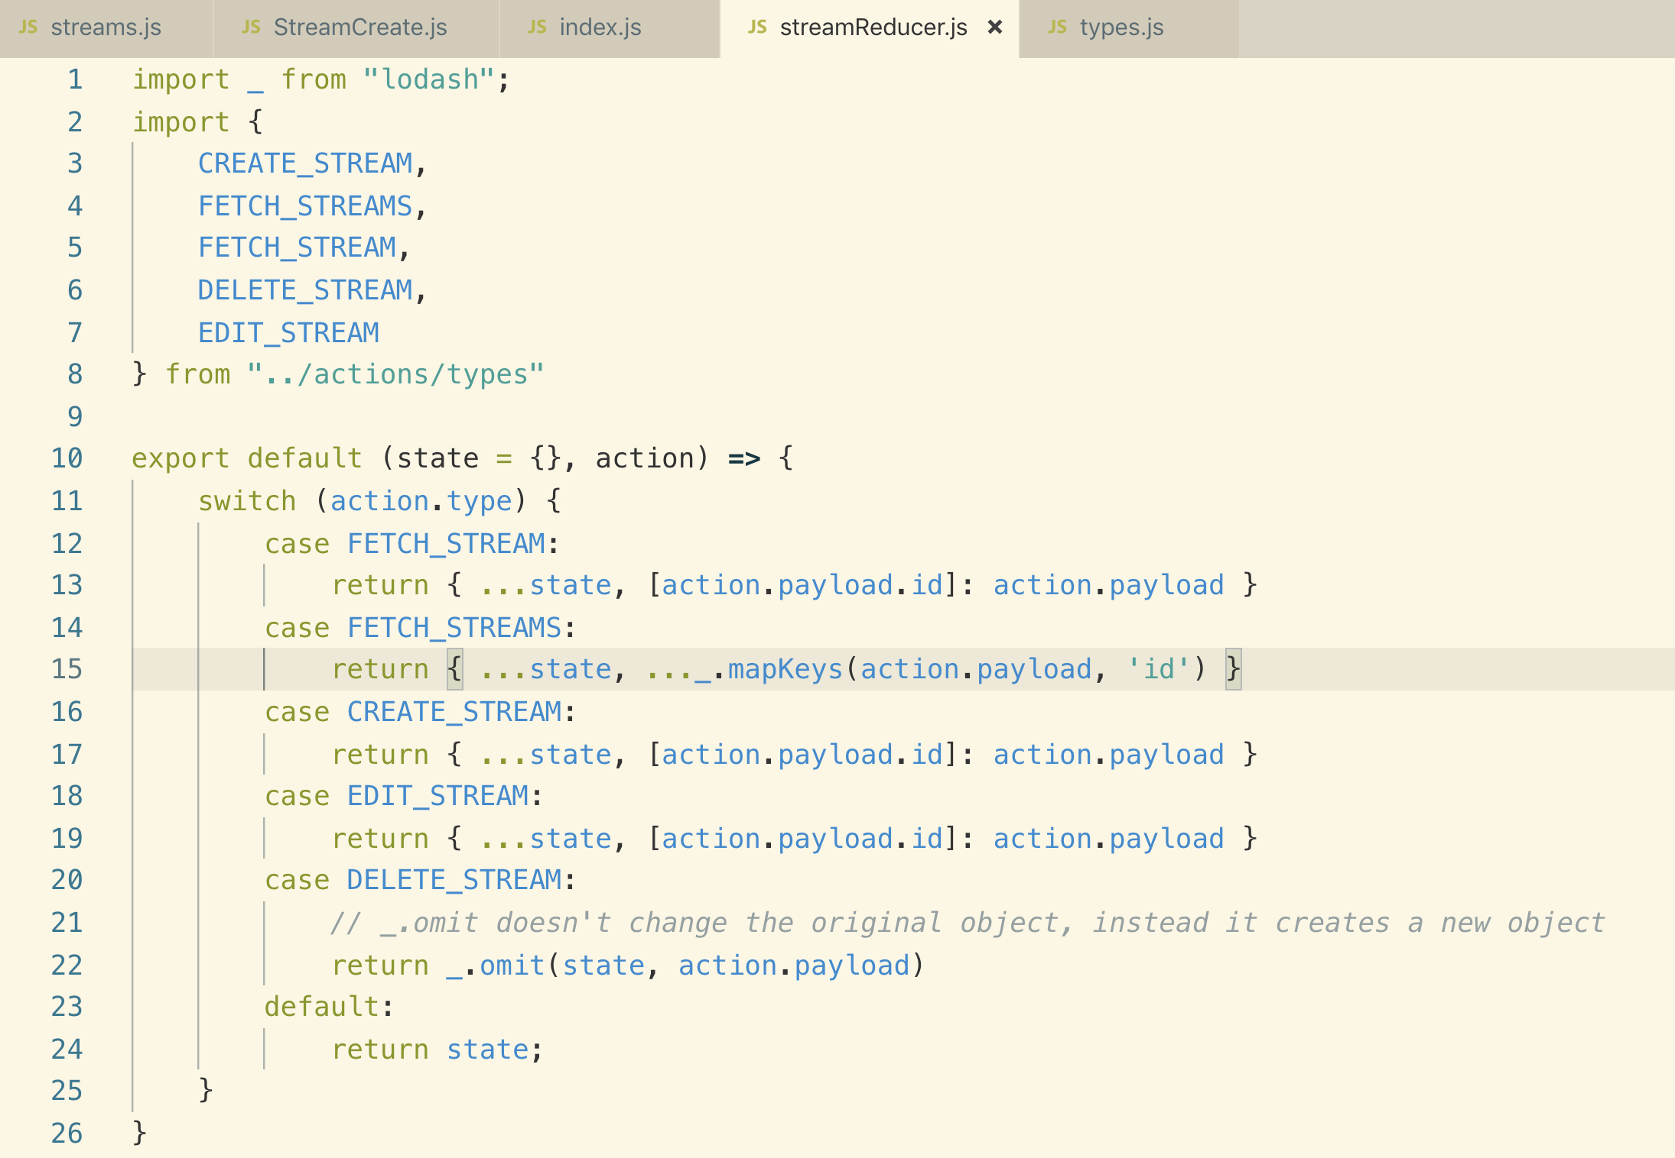

**Now let’s add this “streamReducer” to reducers/index.js**

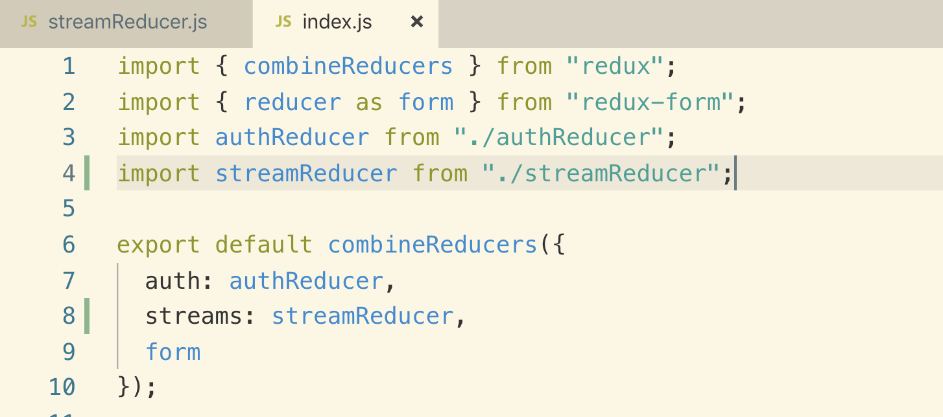

**13. Fetching a List of All Streams**

**The reason to convert the functional component into class base component is that we need to call our action creator into ComponentDidMount() lifecycle method.**

**components/streams/StreamList.js**

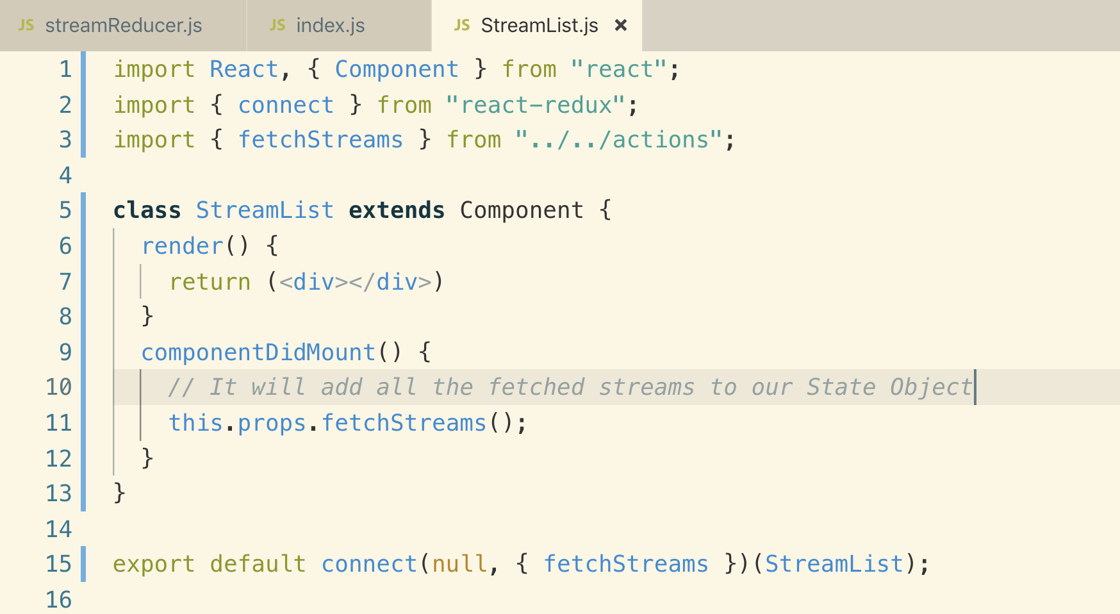

**14. Rendering All Streams**

**To make streams available from state into streamList component, we need mapStateToProps function.**

**Object.values() is a built-in JavaScript function which takes an object as an argument and all of the values inside the object pulled out and inserted into an array.**

**We are using this function because map() function work on array and we need to convert data into <ul> and <li> to display on the screen.**

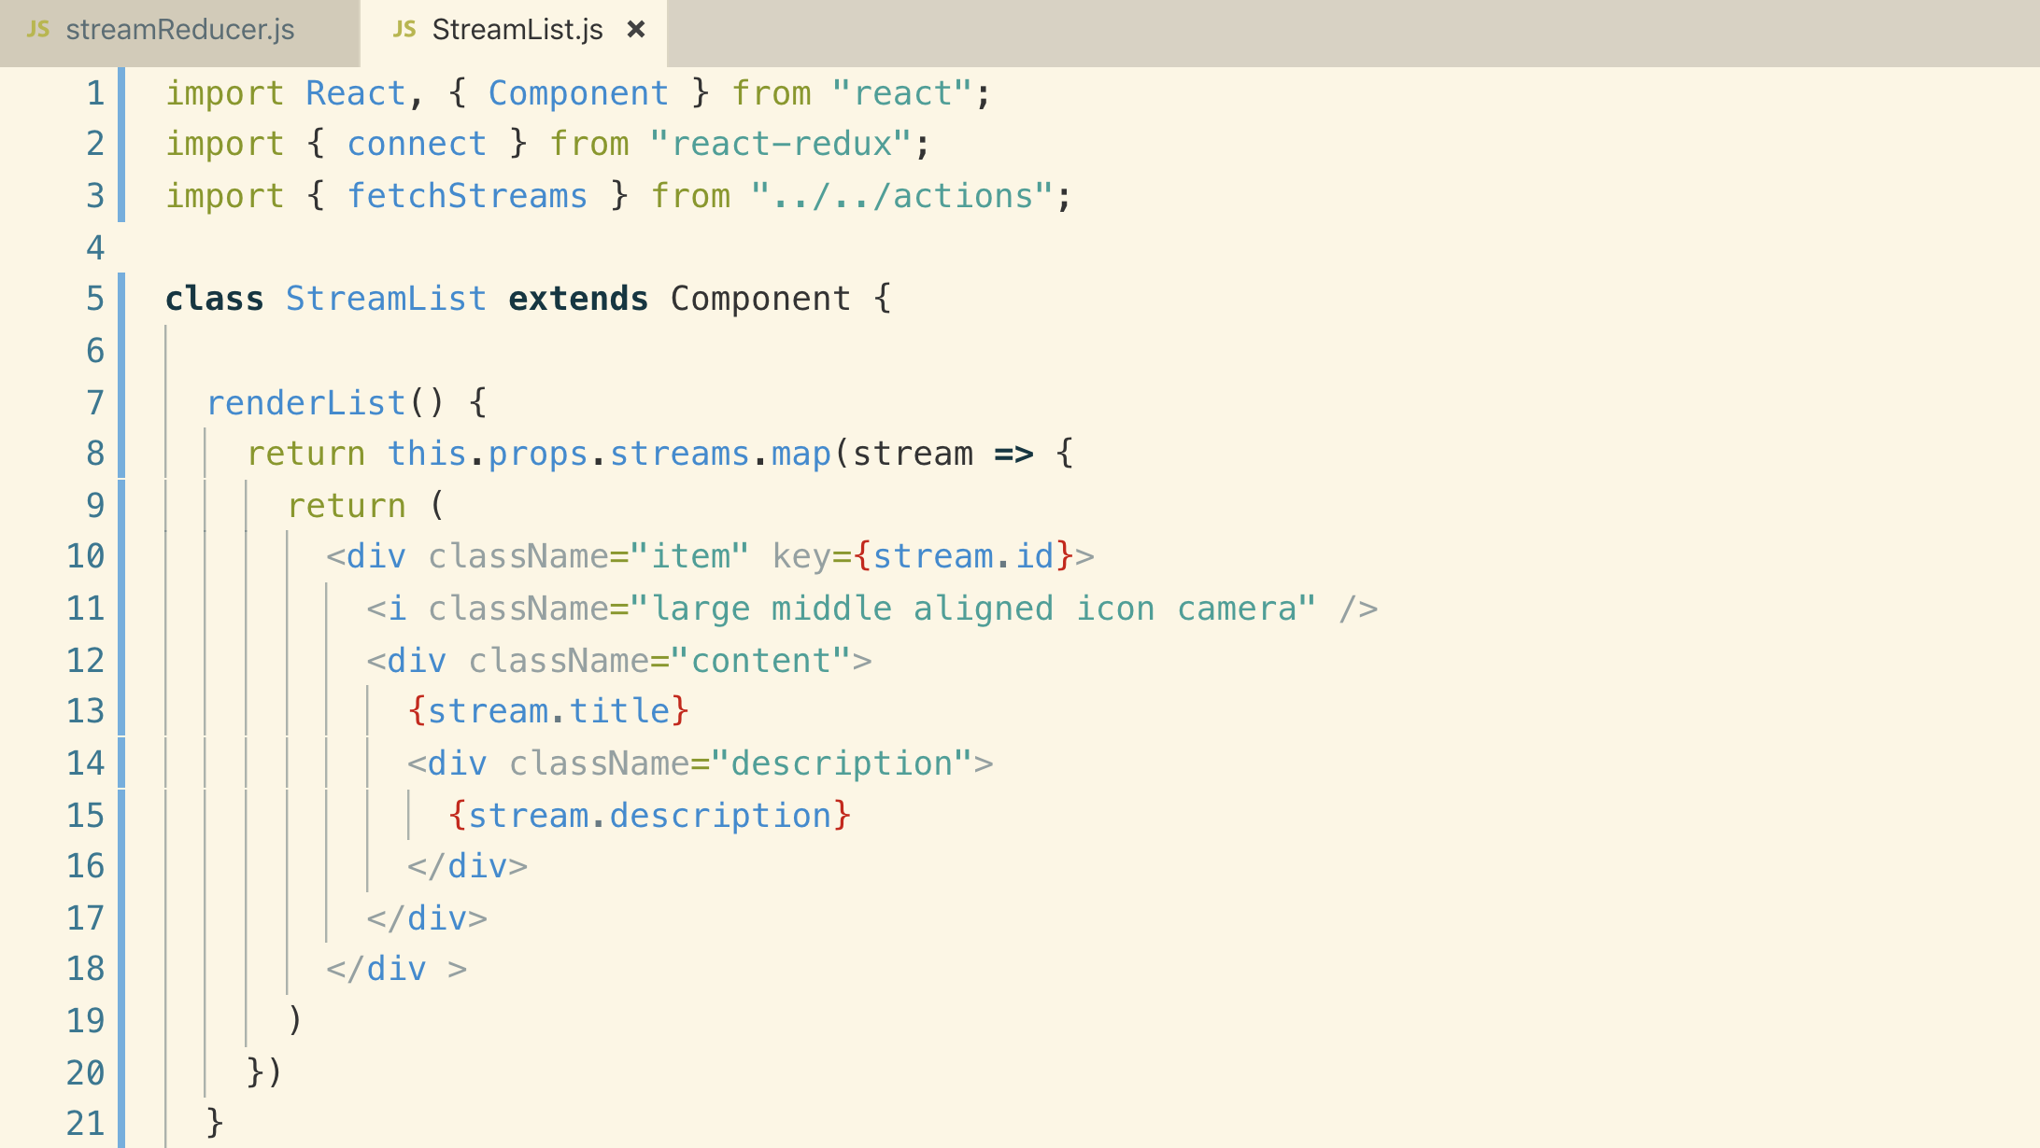

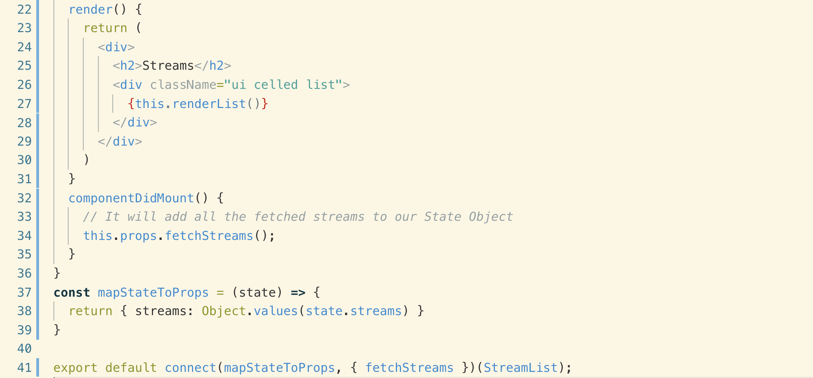

**This is the result of the above StreamList component. We have successfully fetched data from API and listed on the screen.**

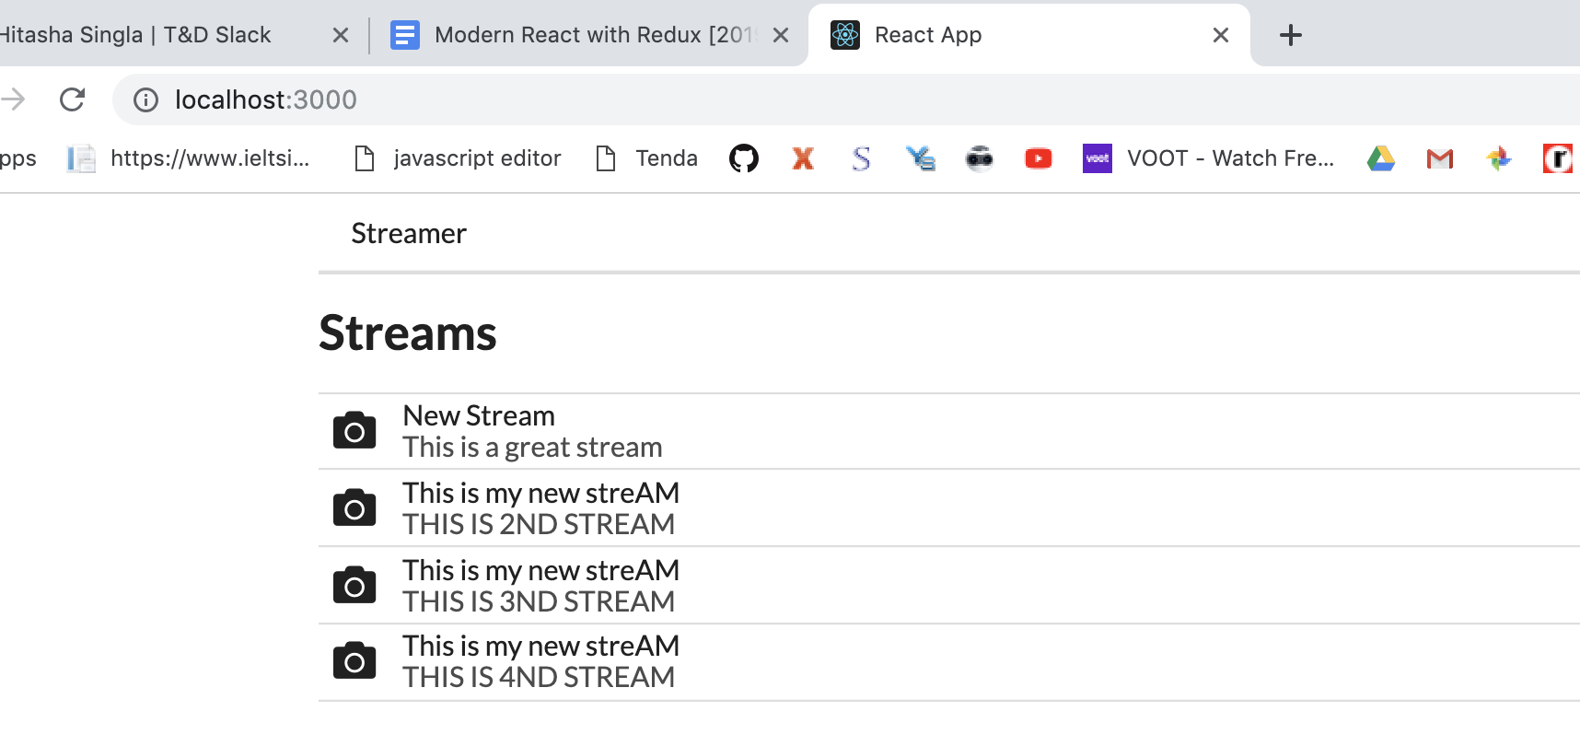

**15. Associating Streams with Users**

**We will display edit and delete buttons for streams owner else buttons will not be shown to other users**

**In order to figure out which stream is created by who we need to actually attach a user Id to our streams when they get created.**

**This is the object structure that we need**

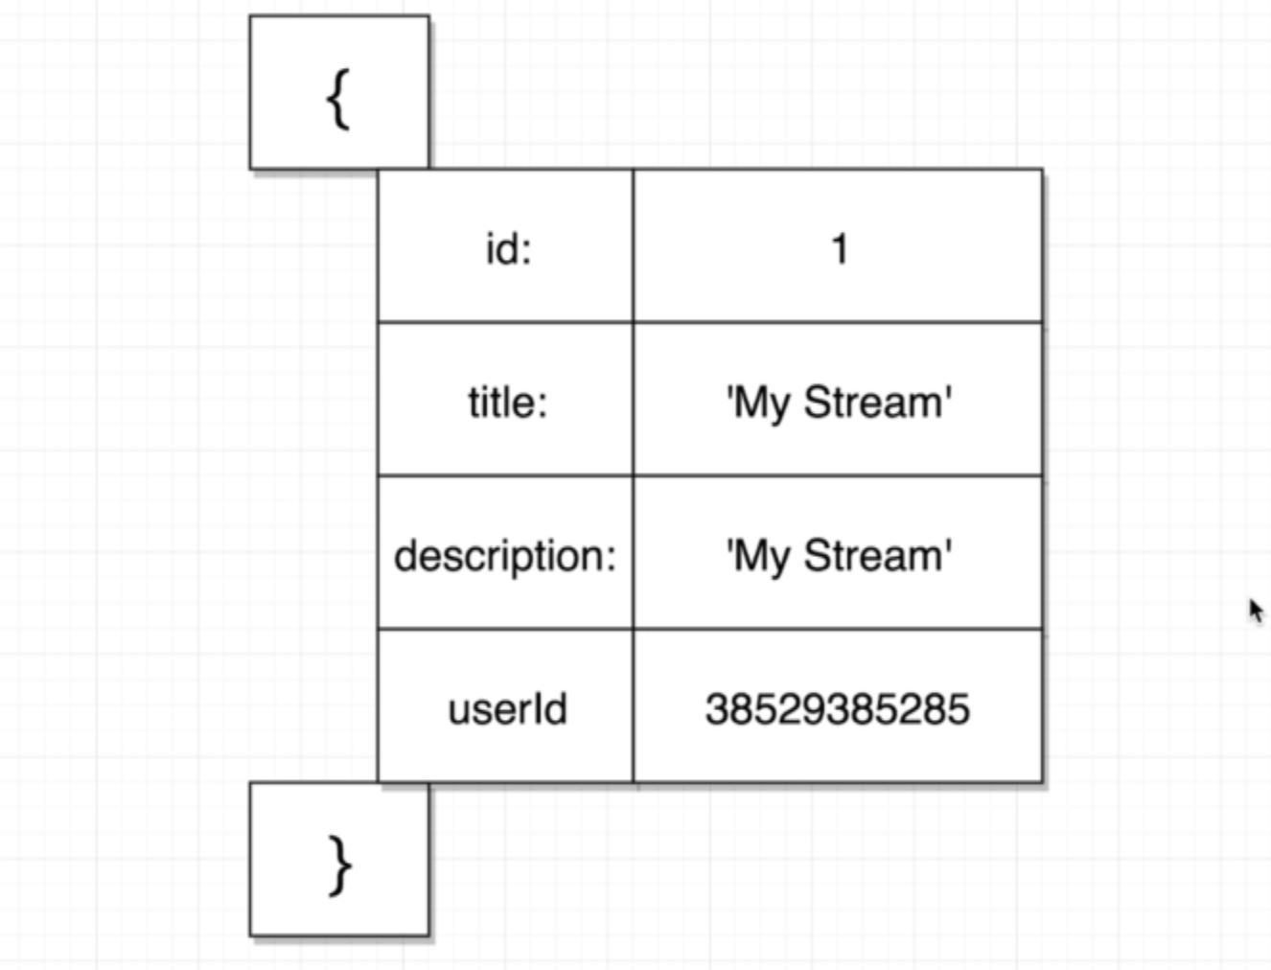

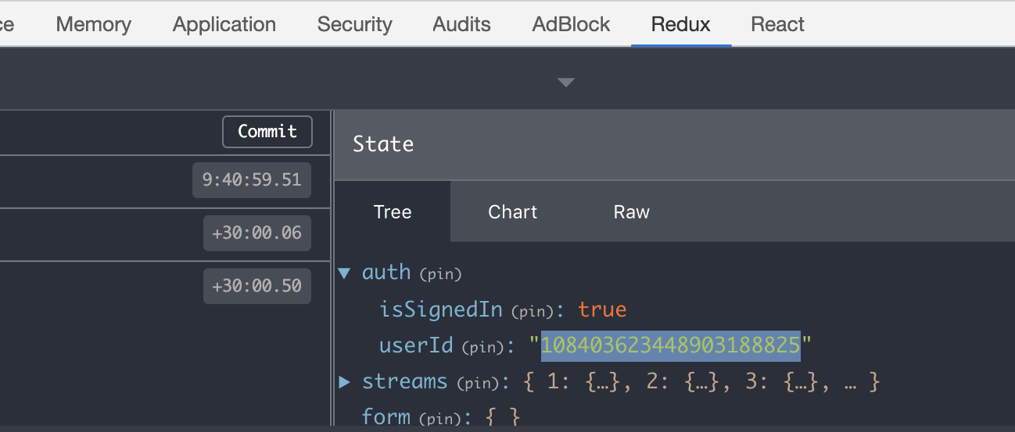

**Once we logged in to Google, we get this userId. We will take this userId and attach it to our stream Object when we create it through stream create form.**

**To get the userId inside our “createStream” action creator.**

**Remember: When we return a function from an action creator, the function gets called automatically by redux-thunk with 2 arguments**

1. **Dispatch()**
2. **getState() : it allows us to reach us redux store and pull out some piece of information .**

**Adding a userId on creating a new stream**

**actions/index.js**

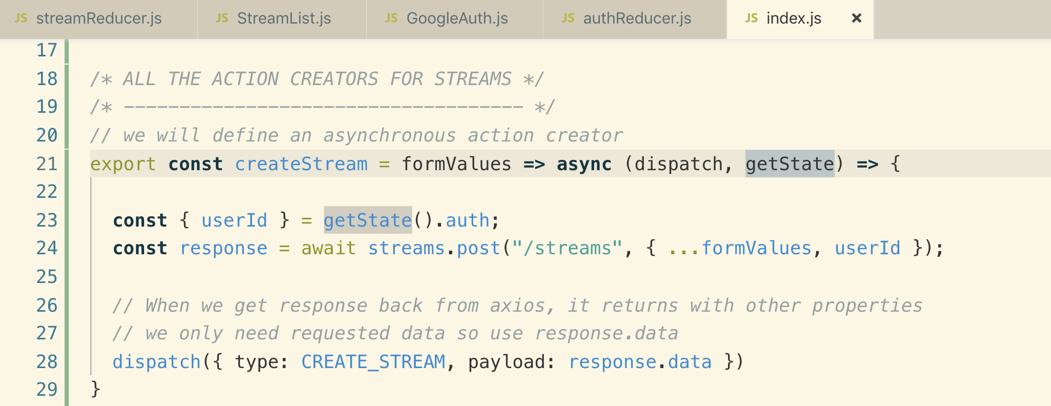

**16. Conditionally Showing Edit and Delete**

**When we list the streams, we just want to compare the userId and show or hide buttons.**

**Getting the current UserId from state object**

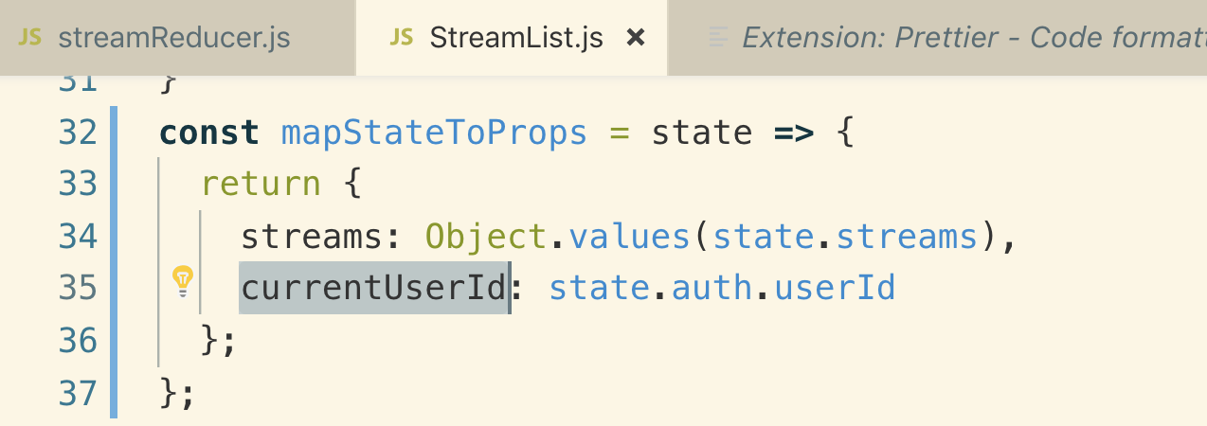

**We will create a helper method to put the logic of show and hide buttons**

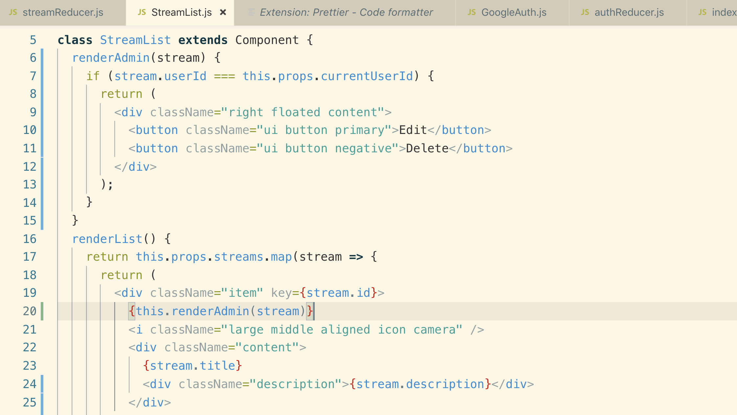

**17. Linking to Stream Creation**

**Whenever the user is not signed in , the current userId is set to null. We will not use it as we already have a property in our state object called “isSignedIn” which shows the logged in state.**

**To get this property inside our StreamList.js component, we have to add it to our mapStateToProps() function.**

**streamList.js**

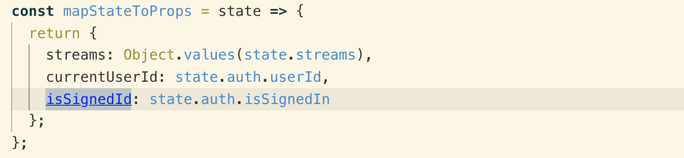

**We will create a render method to show createStream button.**

**Note: we only want to show this if user is signed in.**

**Remember: anytime we do navigation between pages, we make use of react-router-dom‘ s “link” component**

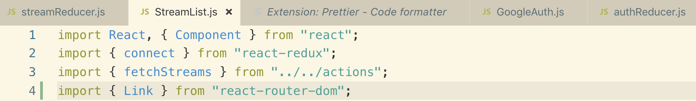

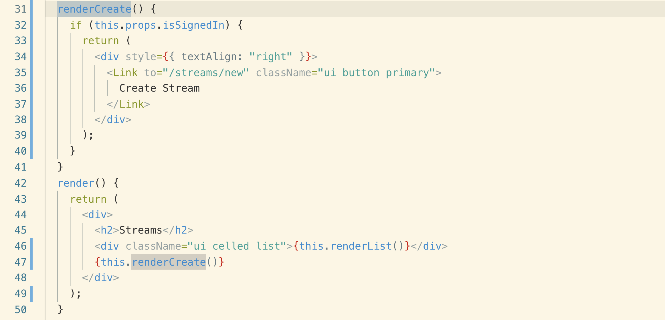

**18. When to Navigate Users**

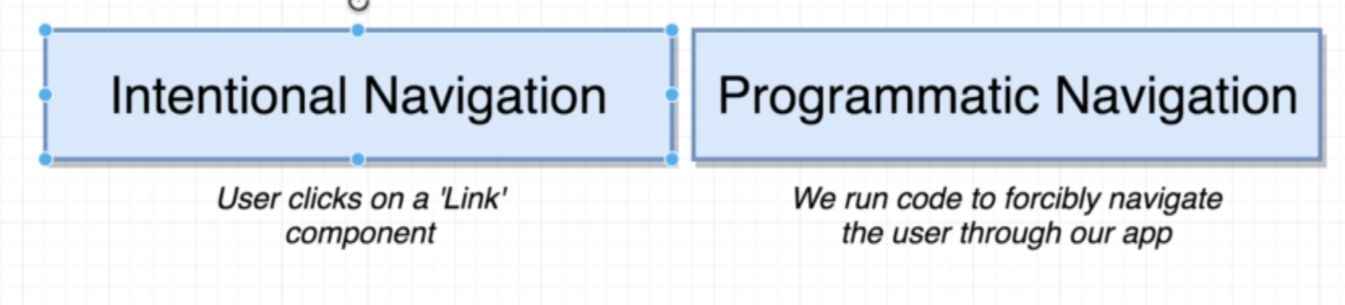

**We will navigate user to StreamList once we are done creating a new stream**

**We instantly navigate user to streamList without validating whether stream is created successfully or not**

**This is not a good approach**

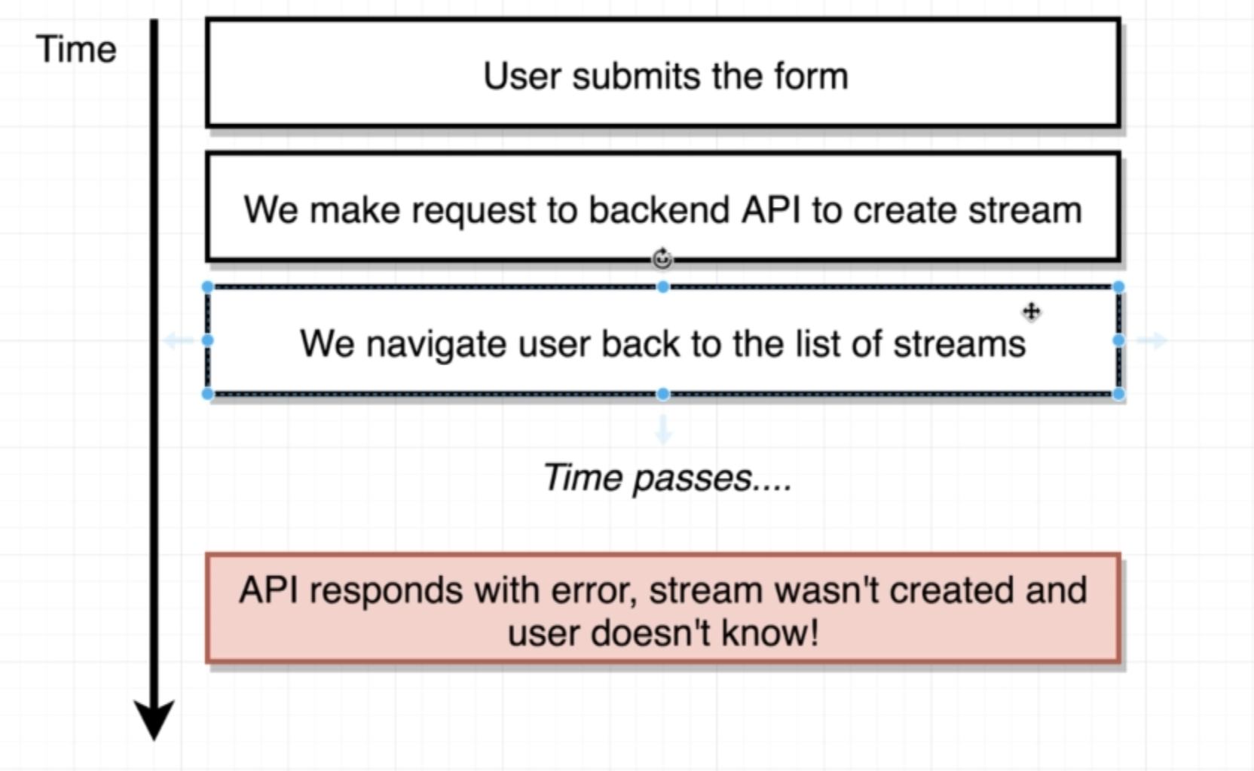

**This is the good approach**

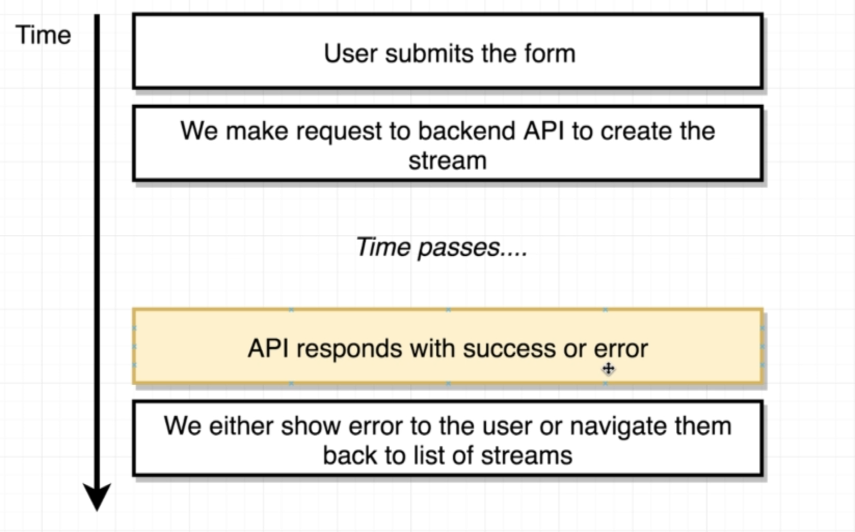

**We want to trigger navigation from our “createStream” action creator after we get successful response from our API**

**We can trigger navigation before or after the dispatch() function. It doesn’t really matter.**

**The ideal way to navigate after the dispatch() function**

**actions/index.js**

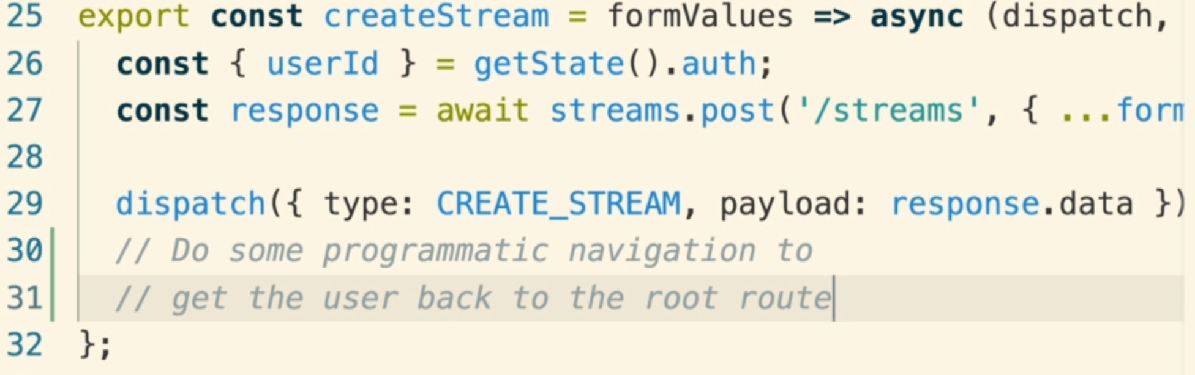

**19. History References**

**Programmatic navigation is sometimes with react-router-dom is really easy, but sometimes it is not easy at all.**

**Anytime the address in the address bar changes the history object communicates over to BrowserRouter**

**Internally “BrowserRouter” creates “history object”. The “history object” also has the ability to change the address bar and that’s how we will do programmatic navigation.**

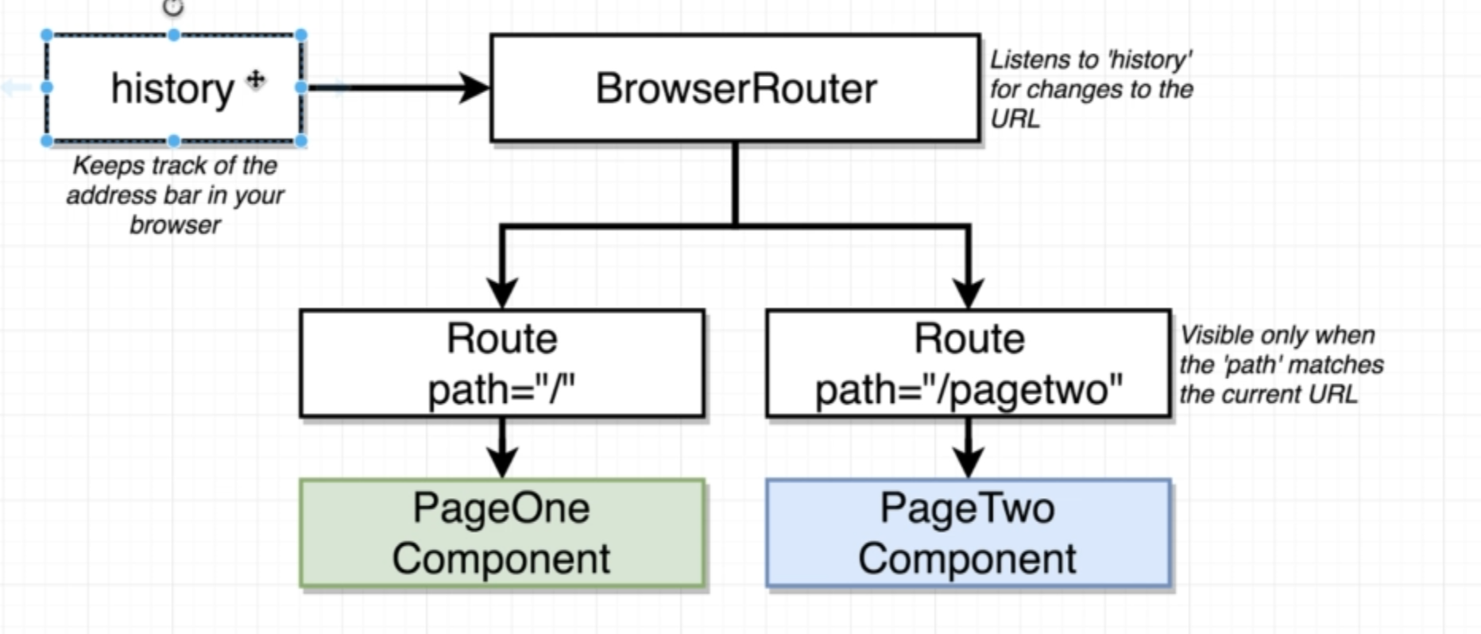

**The reason of saying that programmatic navigation is sometimes hard is the fact that the “history object” is created by the browser router. It is kind of challenging for us to write code that can get a handle /reference to that “history object”. It is more challenging than you might expect.**

**Let’s see why?**

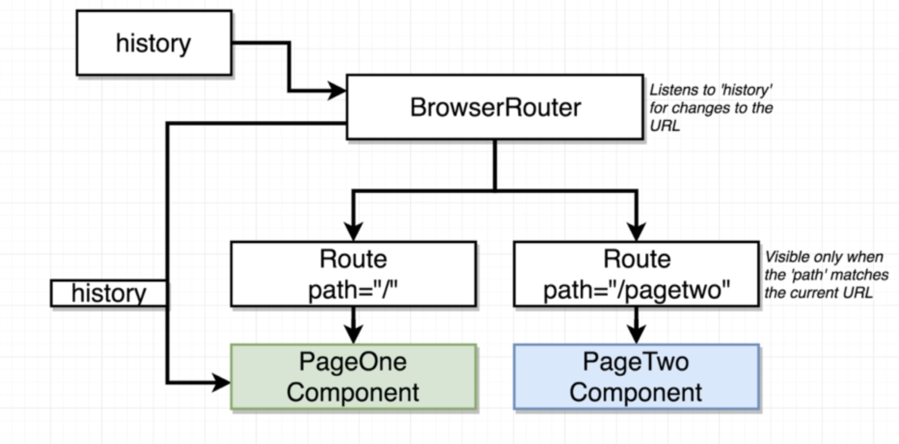

**Here is the essentials what goes on in normal operation with react-router**

**Internally the browserRouter creates the history object then anytime that the browser router renders some component like pageOne as shown in the above diagram, the browserRouter passes that history object as a prop down to your component.**

**So inside any component that gets rendered directly by react-router, it’s going to receive this “histroy object” so the component could very easily trigger some navigation inside of it.**

**But in our case, we are not trying to do navigation from a component instead, we want navigation from an Action Creator.**

**Getting access to the “history object” inside of an action creator any non-react component essentially is what is a little-bit challenging. It is hard for us to get a reference to that history object.**

**One very simple solution to this is like this**

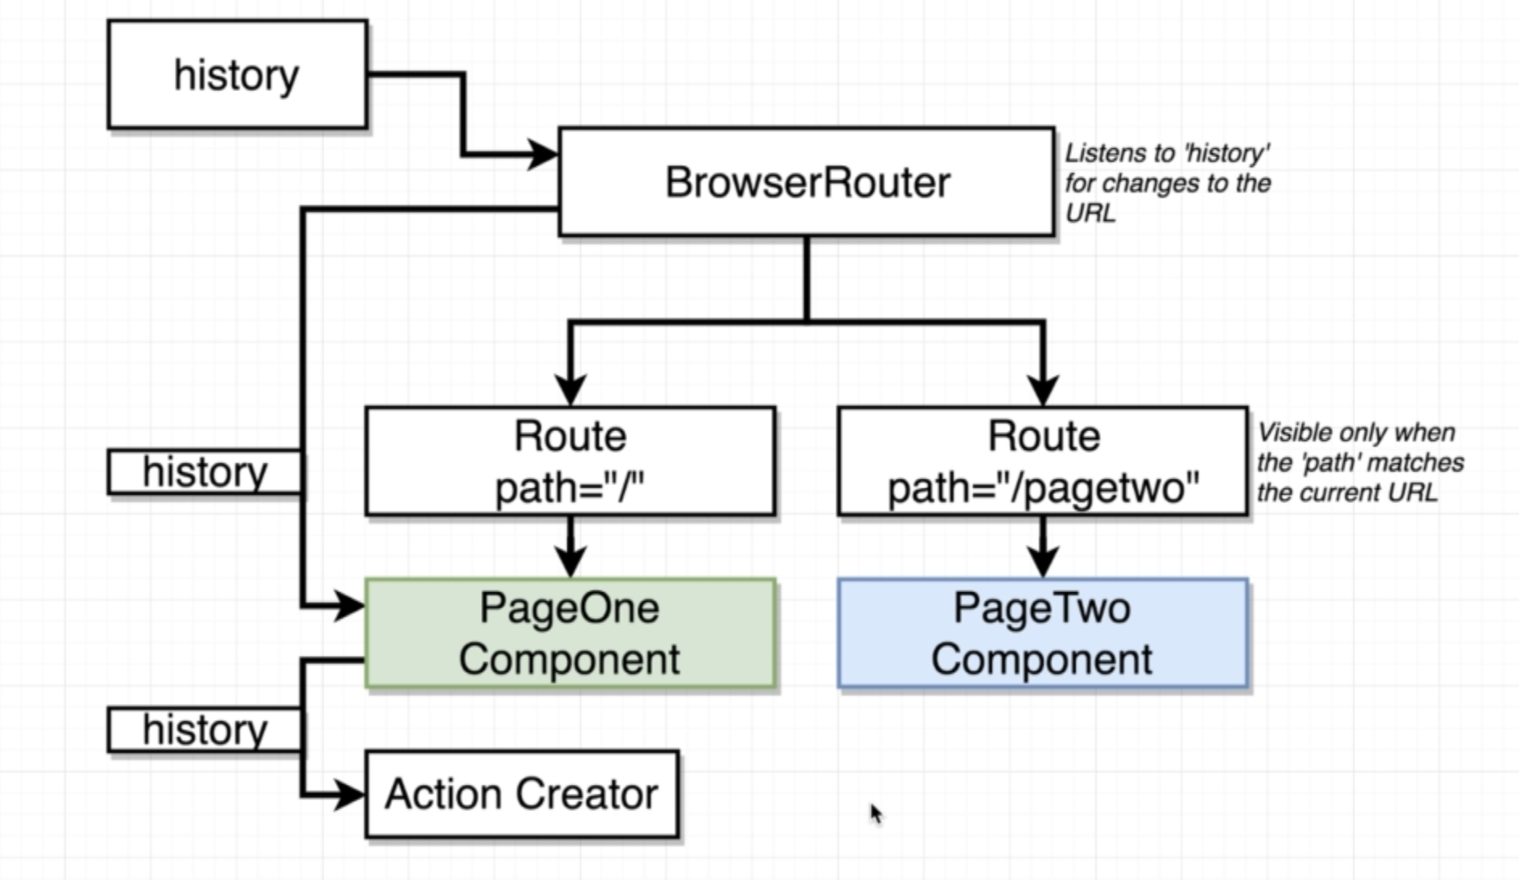

**We could say that anytime that our component calls our Action Creator the component should pass along the history object into the action creator.**

**So in the createStream Action creator, we will also receive history object like this**

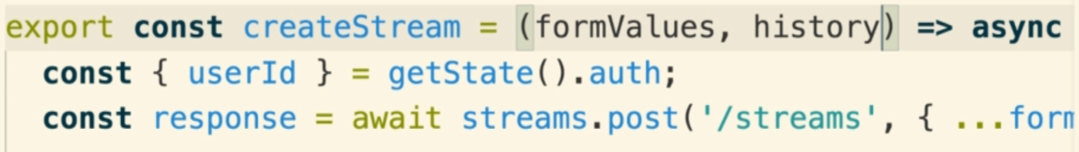

**Important!!**

**This is kind of a pain because it means that every single time we want to do programmatic navigation we would have to write our action creators to be called with a history object and we would make sure that all of our components called the action creator with history object as well.**

**So the ideal solution is that we will create history object instead of BrowserRouter**

**And anytime we want to get access to that history object, we just need to import that.**

**20. Creating a Browser History Object**

**History package is already installed with react-router-dom**

**Creating custom history object inside src/history.js**

**src/history.js**

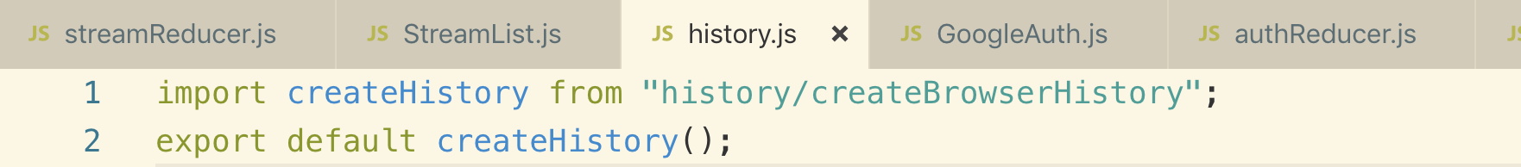

**Anytime we pass a prop called history, the BrowserRouter is going to attempt to use it instead of it’s default implementation which is to create its own internal history object**

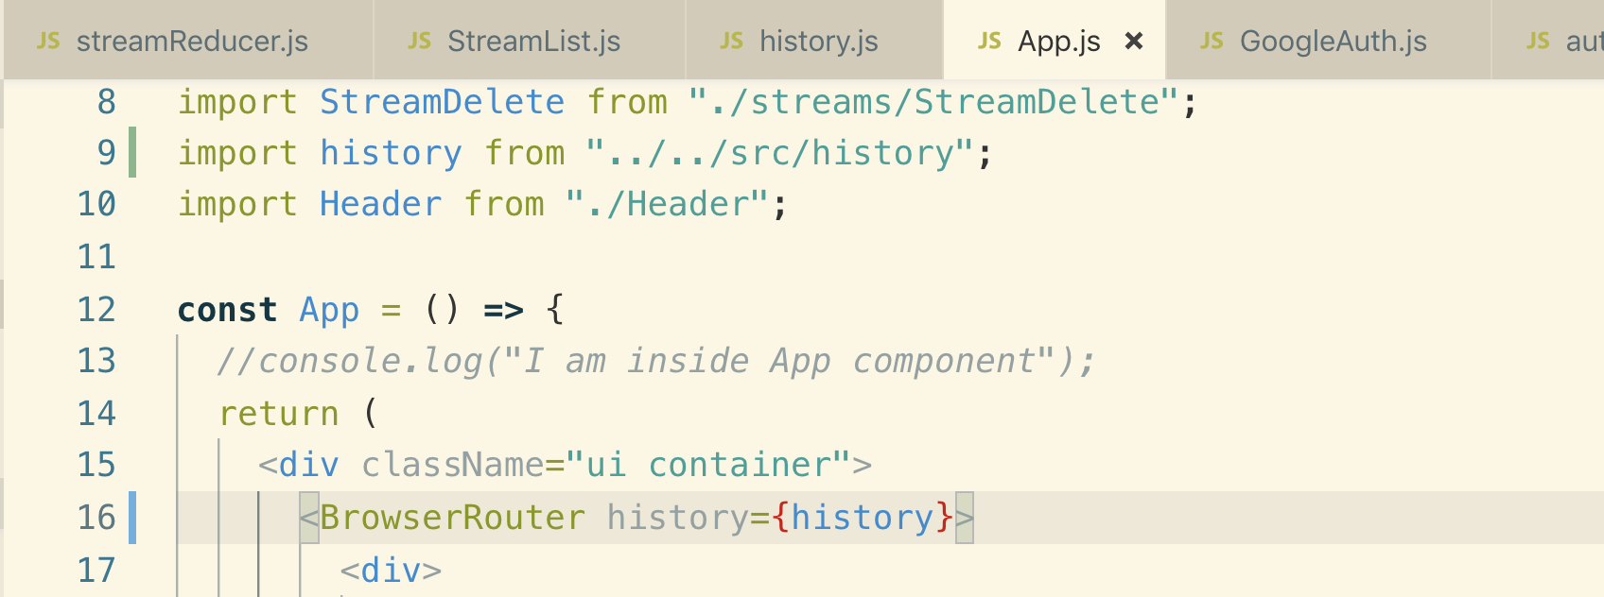

**Custom history object gives you a warning in console like this**



**So we need to import Router instead of BrowserRouter**

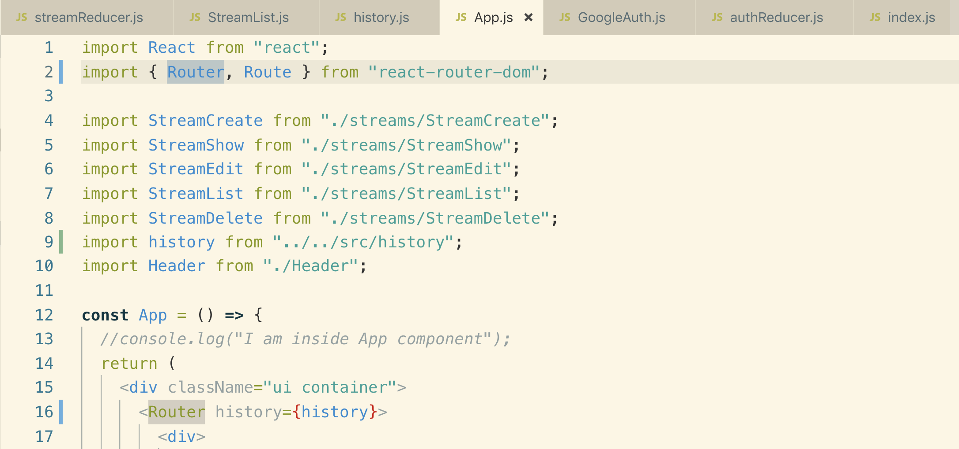

**21. Implementing Programmatic Navigation**

**Import the custom history object into our index.js action creator file and use to automatically navigate to our user around our application.**

**To do programmatic navigation we use this history object like this**

**action/index.js**

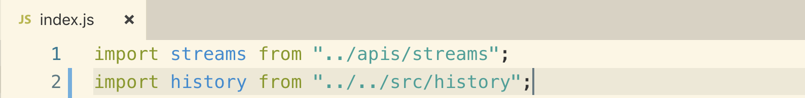

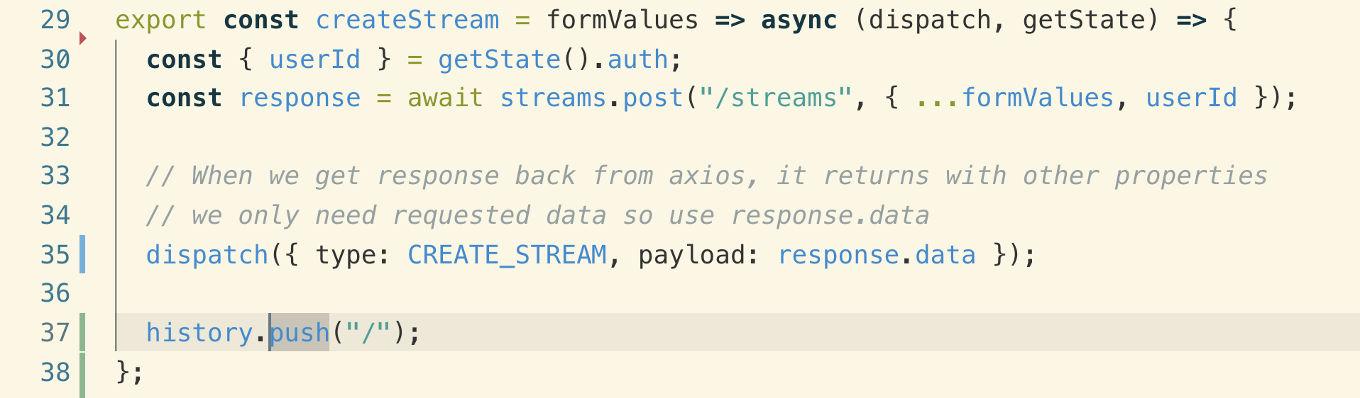

**22. Manually Changing API Records**

**You can go to api/db.json file edit the record there manually.**

**23. URL-Based Selection**

**With URL based selection, we need to change the path as shown below.**

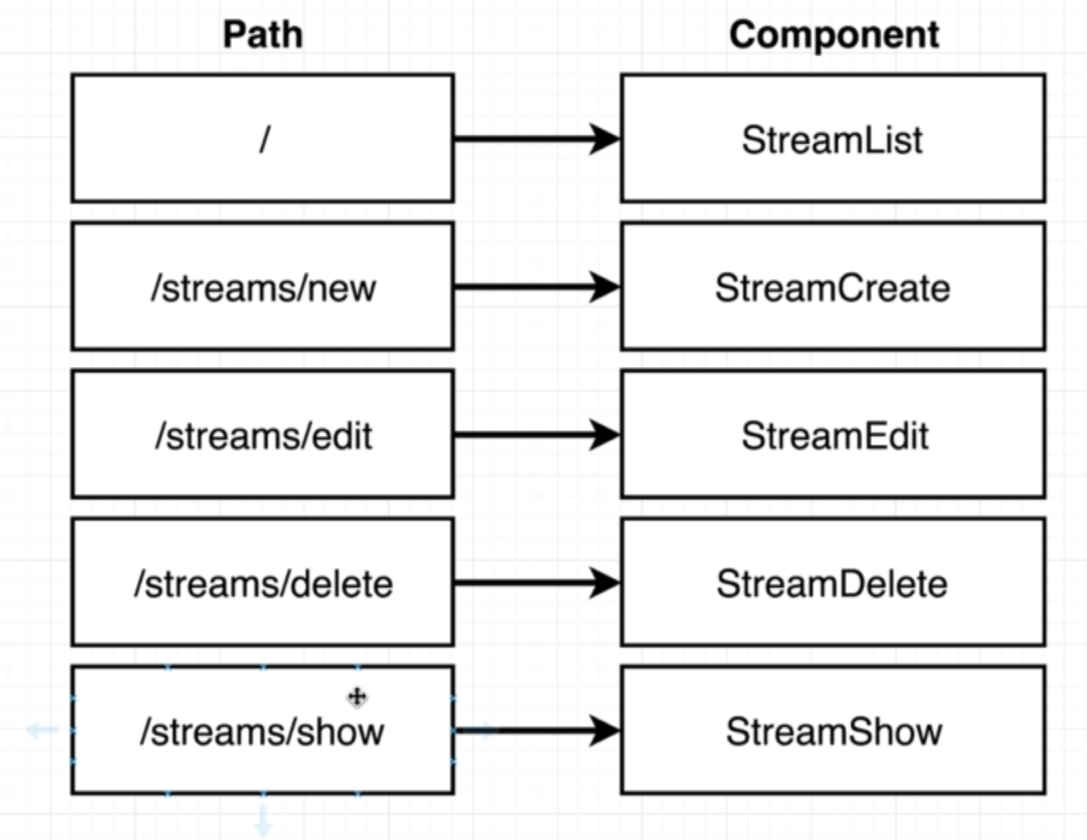

**This is how it will look with URL based selection**

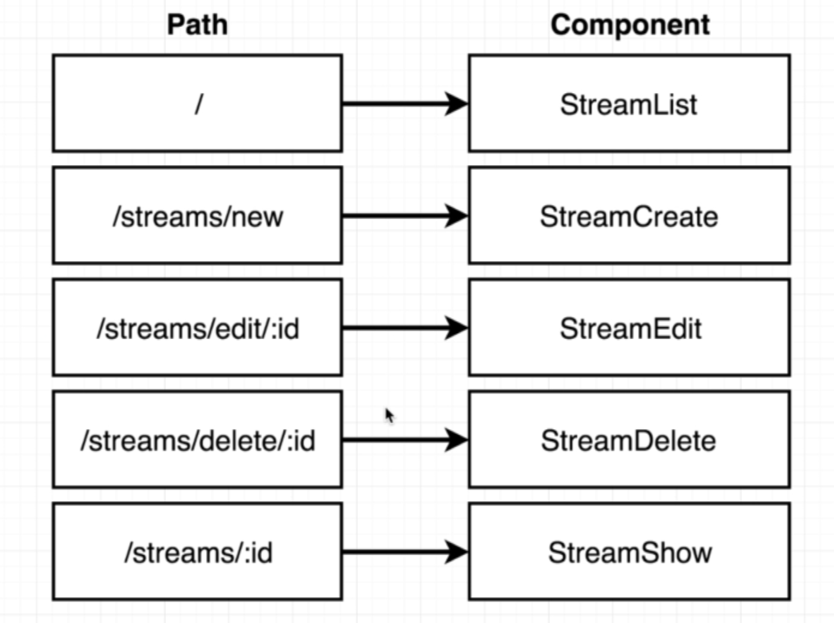

**24. Wildcard Navigation**

**Instead of edit button we used <Link> component to redirect to edit page with stream id**

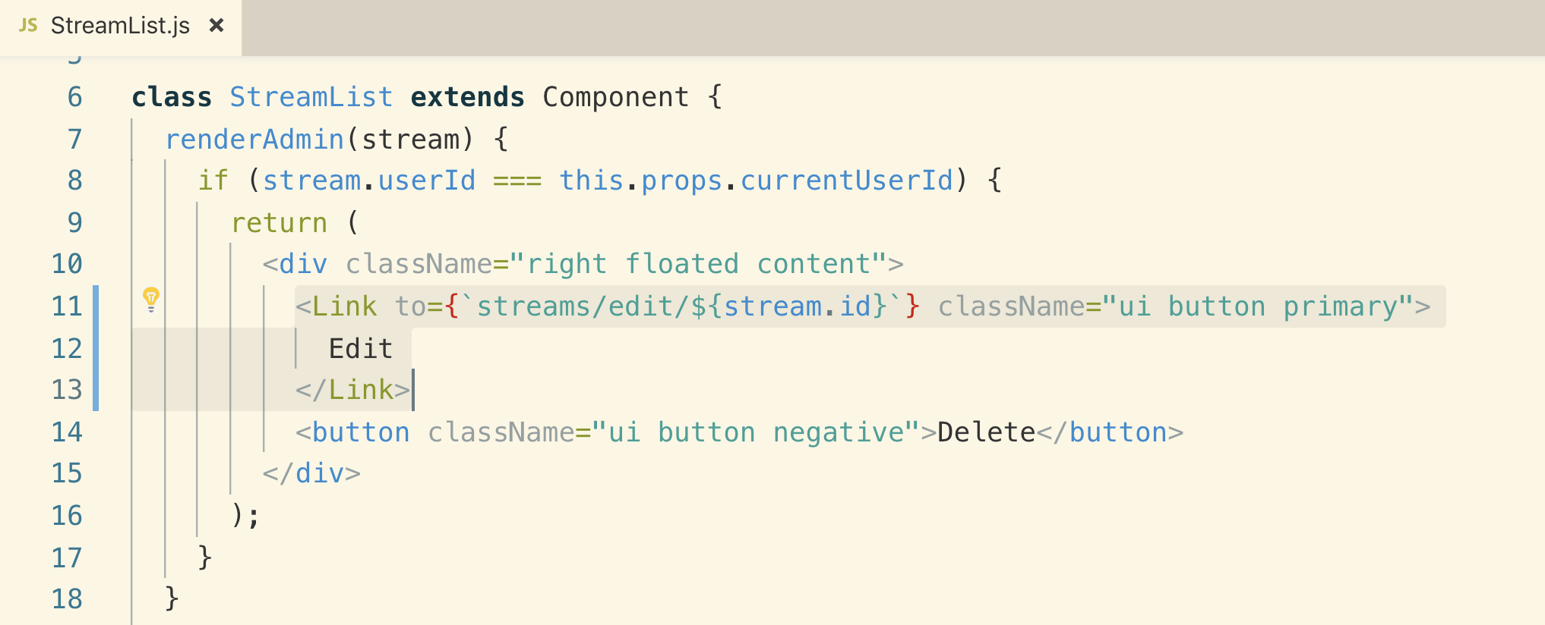

**Now let’s set up the route for edit component**

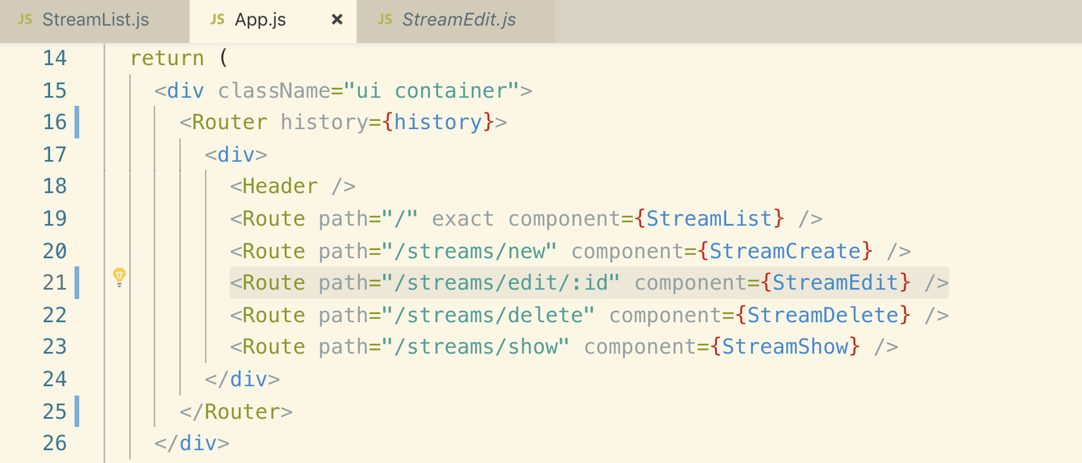

**:id => it means it is a variable and it can contain any value and it will still go to “streams/edit/id” whatever the value of id is**

**:id can be anything like :**



**25. More on Route Params**

**All the props that you are seeing is coming from react-router-dom because it is being rendered by a route component so react-router-dom automatically adds a bunch of different props to StreamEdit component when it gets rendered on to the screen.**

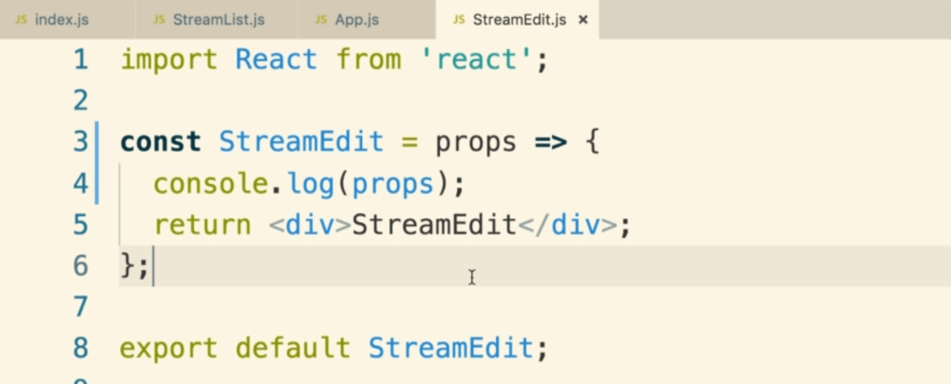

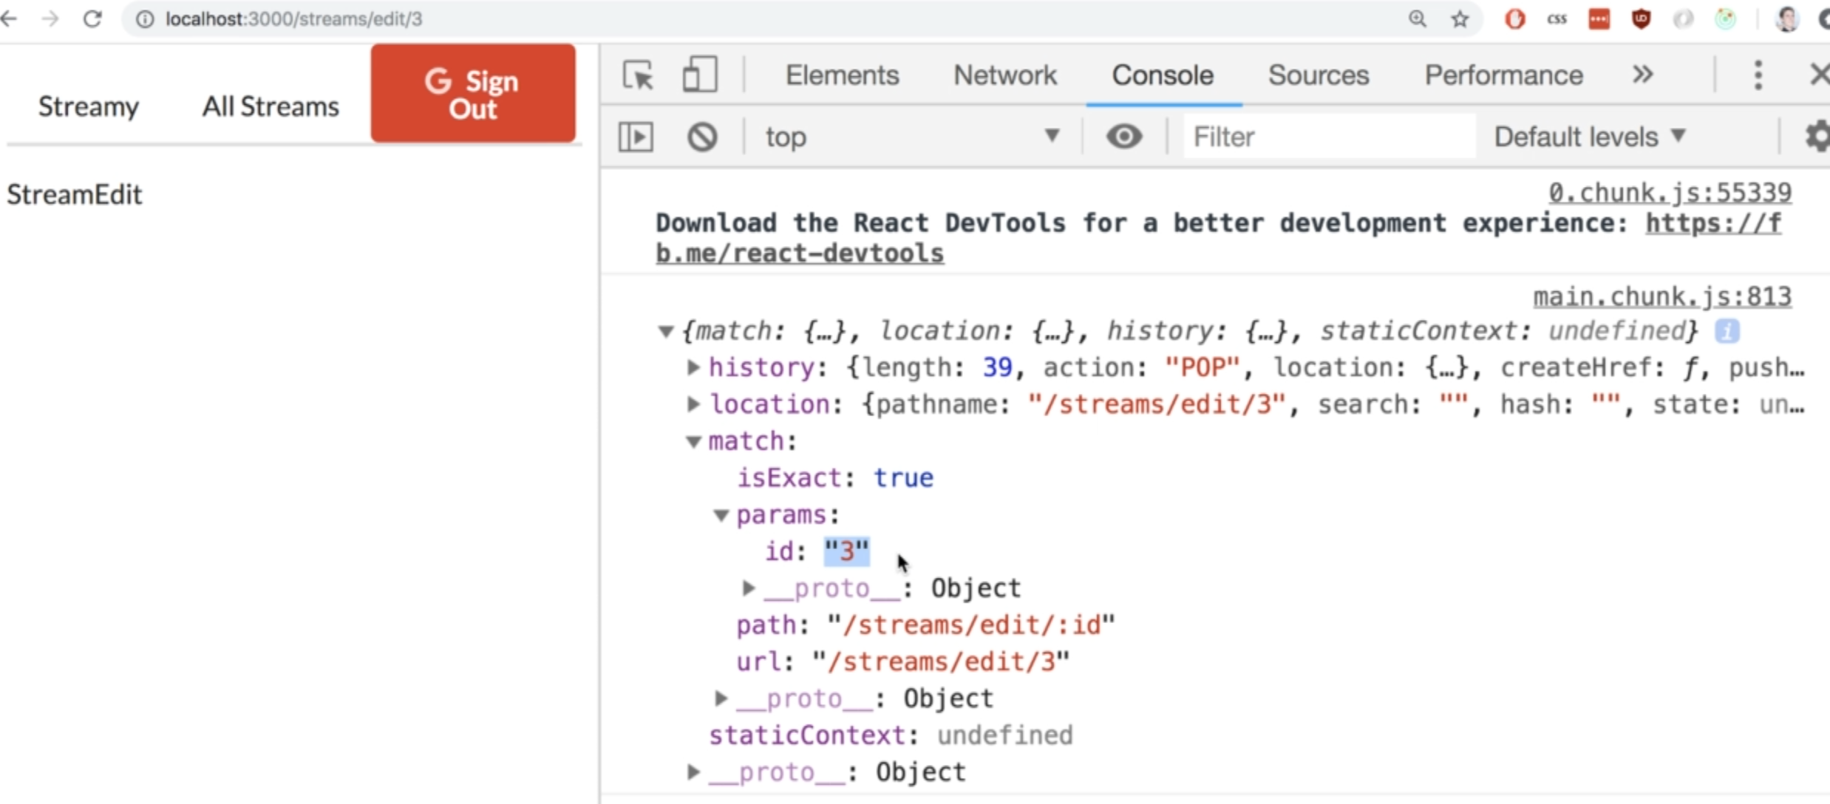

**It is showing 3 because that is the value in the address bar. We see a name of “id” specifically because that is what we put after the column inside our routing definition.**



**We can add multiple param like**

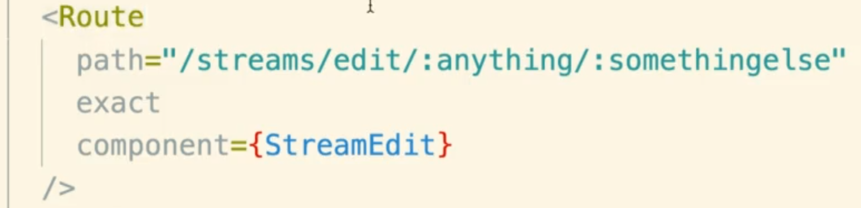

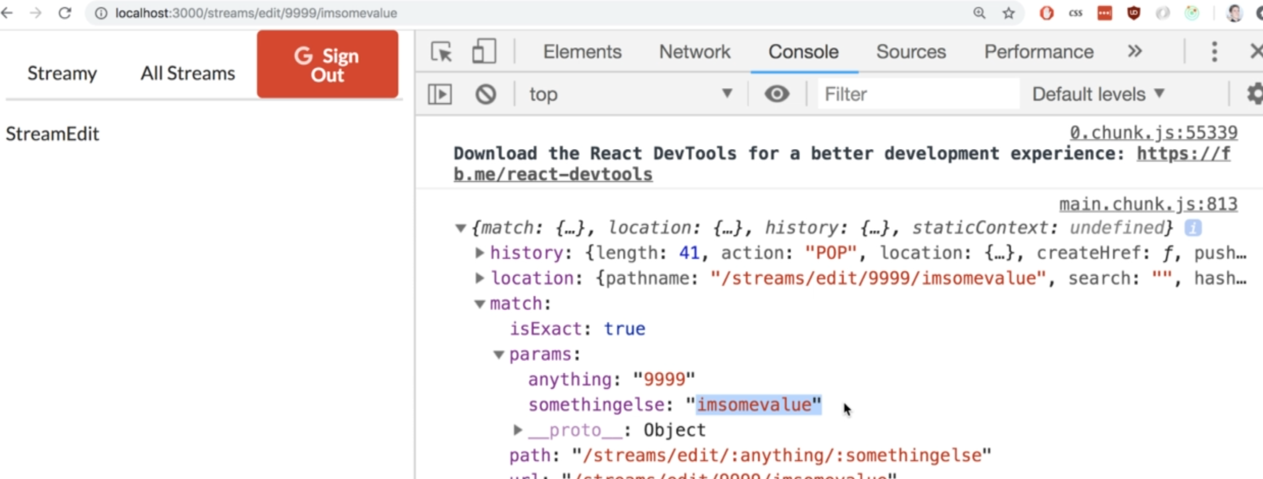

**26. Selecting Records from State**

**ownProps: is reference to the component props object**

**Note: on StreamEdit page if you refresh the page, the stream object will be undefined. You need to go to StreamList and then click on edit button and now you route to StreamEdit page and you will see the stream object**

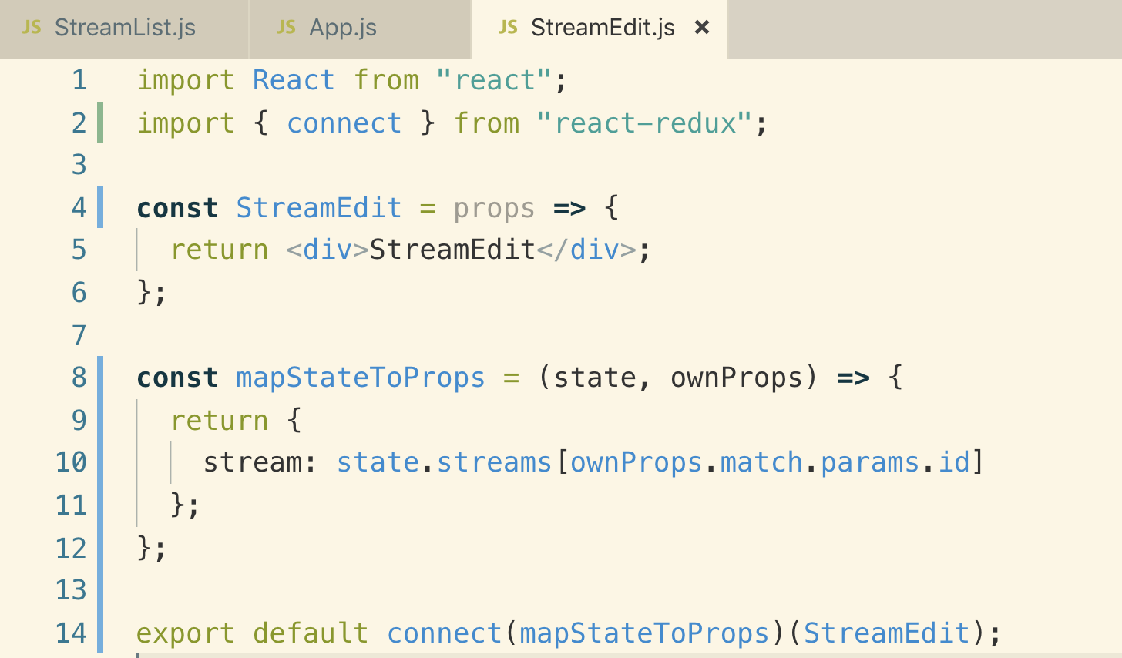

**27. Component Isolation with React Router**

**In the above section, we were not getting stream object on refresh so find out why**

**We hit “streams/edit/3” and app starts to load up into browser, when the user first loads up our application, our redux state object is totally empty. We do not have any loaded streams and we try fetch the id data from the State object which is empty at this point so streams is undefined.**

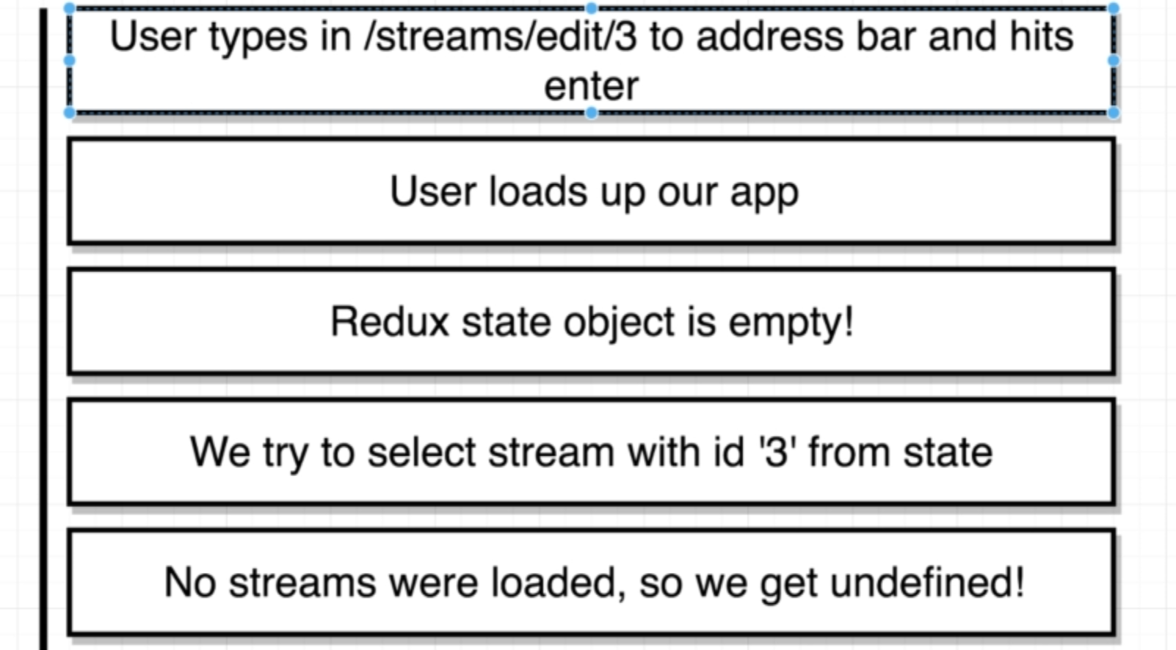

**Now let’s see why it is loading data when we navigate from StreamList. The reason stream object is not empty is that we made a fetch request on StreamList to list all the streams and state object is filled with the stream and when we navigate to /edit page, the data is there.**

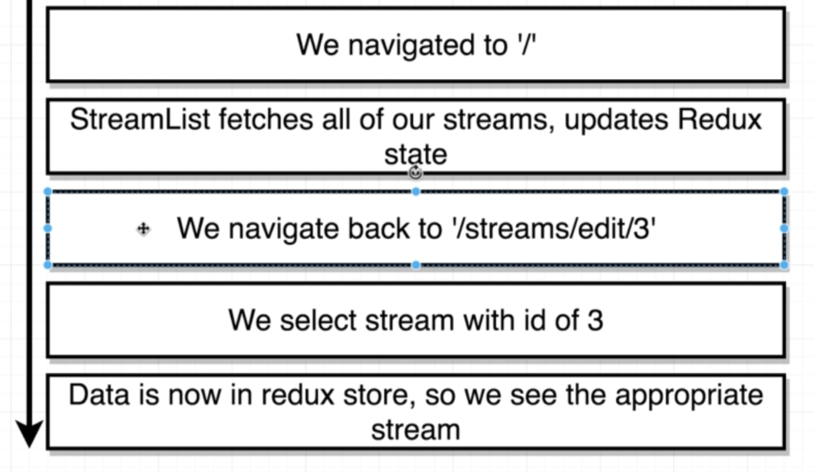

**Anytime you are using id based selection in the URL, we always have to obey this rule.**

**The rule to remember when we are working with react-router-dom**

**Rule: we always need to make sure that any component that is going to be shown on a screen is going to be designed to work by itself or in isolation.**

**Any component that react-router-dom will show needs to fetch its own data. So our StreamEdit needs to call an action creator fetch the appropriate data.**

**Every component does not have dependency of other router or component data.**

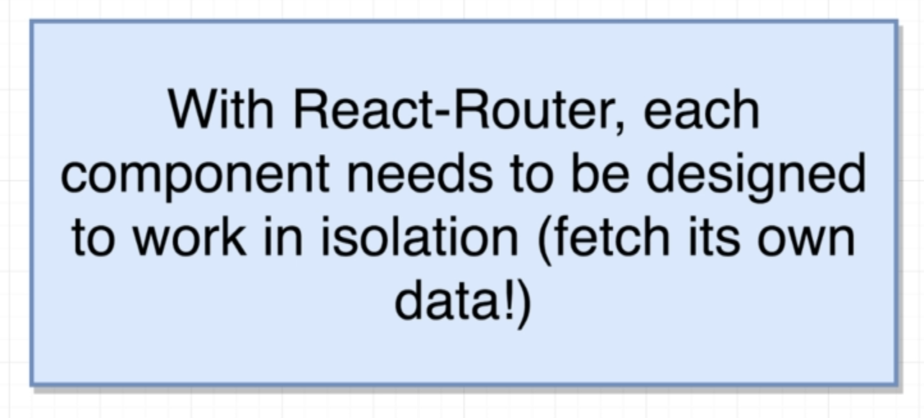

**Let’s fix this issue in the next lesson.**

**28. Fetching a Stream for Edit Stream**

**We will call the action creator that we have already created in action/index.js to fetch the data specific to id**

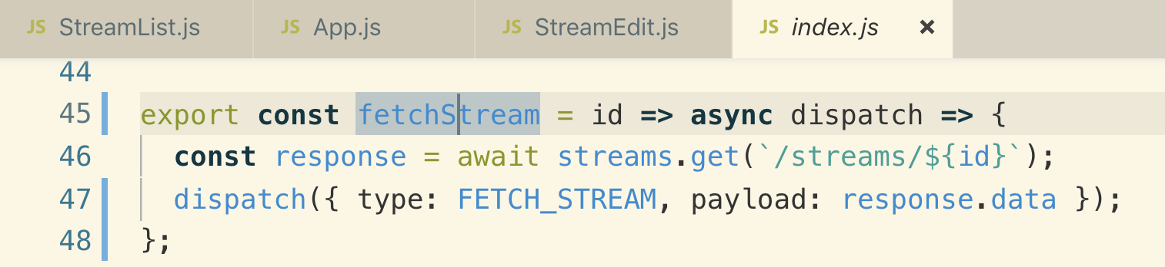

**We need to convert the StreamEdit component into class base component so that we can use ComponentDidMount() lifecycle**

**First time it loads, the stream data will not be there, but ComponentDidMount made request to API and it again load the component with the data so while displaying data, we need to make sure to access data when it is loaded.**

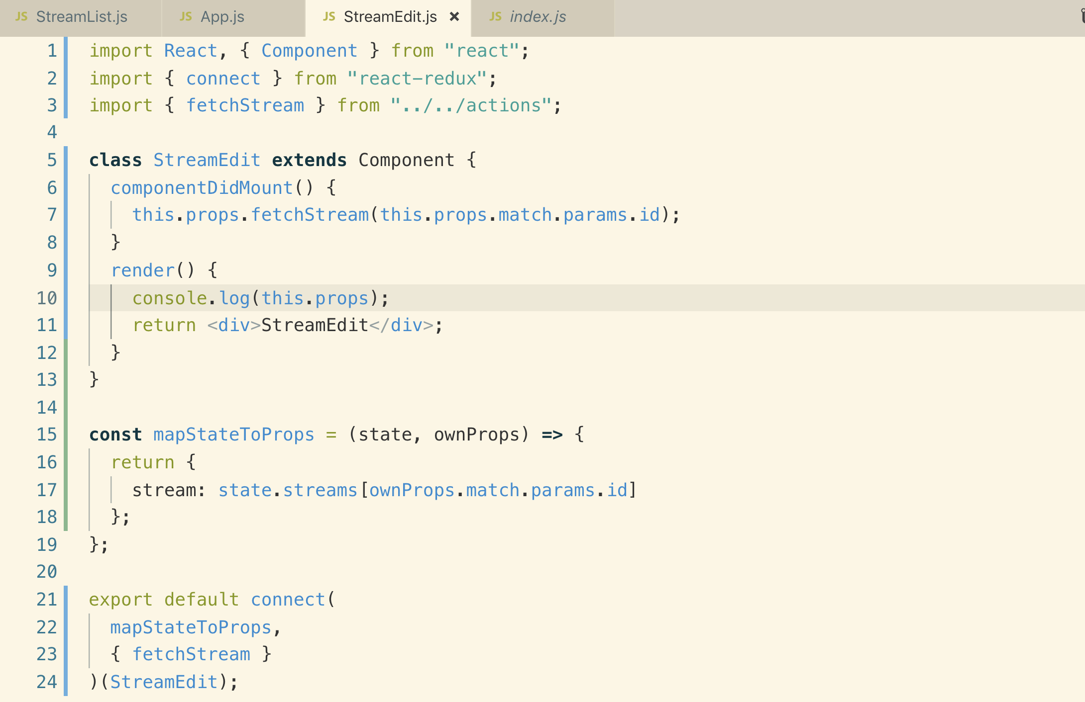

**We just need to add the if condition to handle the case**

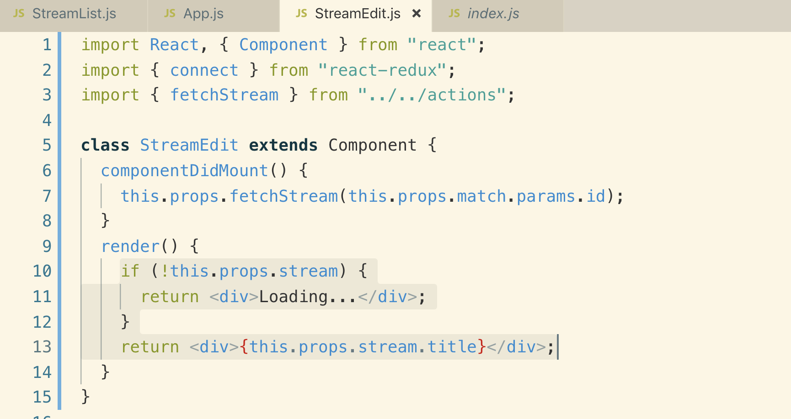

**29. Real Code Reuse!**

**We will create a components/streamsStreamFrom.js which will be used for both StreamCreate and StreamEdit**

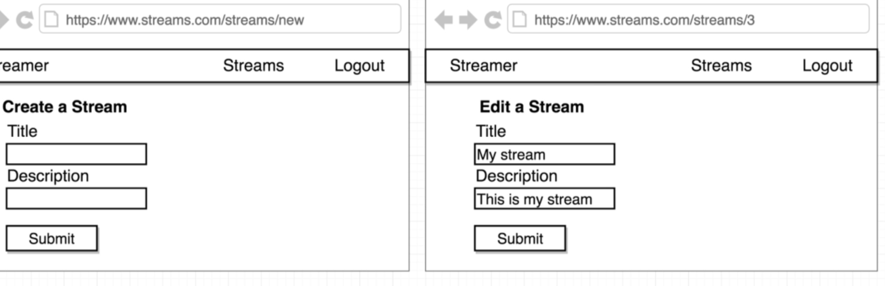

**We will handle all the major work into “StreamForm” like**

1. **Handling text input changes**
2. **Wiring up to redux form**

**“StreamCreate” and “StreamEdit” will just pass down the onSubmit() event to “StreamForm”**

**So that “StreamForm” knows what to do anytime user submits the form.**

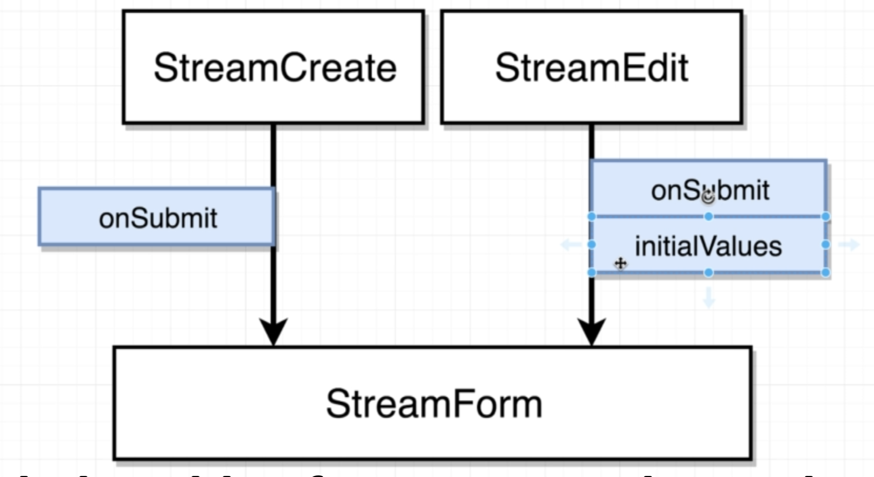

**“StreamForm” is the one that will be used between “StreamCreate and StreamEdit” component**

**Copy all the code from “StreamCreate” and modify it accordingly**

**StreamForm.js**

**30. Refactoring Stream Creation**

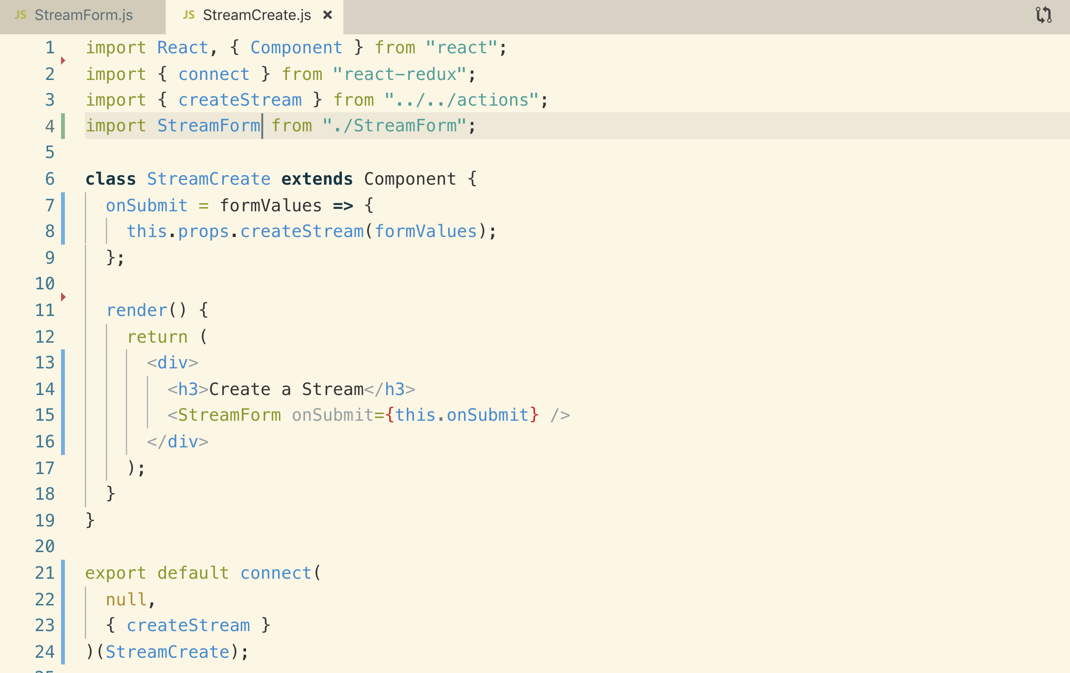

**31. Setting Initial Values**

**StreamForm is wrapped by “reduxForm”**

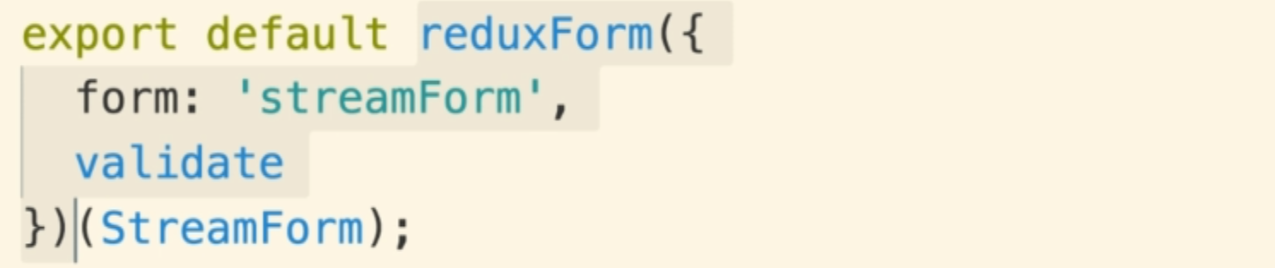

**We have StreamEdit that is showing StreamForm wrapped inside of Redux-form so when we pass props from StreamEdit down to StreamFrom, we are not directly passing to our StreamForm component instead we are technically passing props to “redux-form”. Redux-form then turn around the passed those props to StreamFrom Component.**

**There are some very special props that we can pass down into the Redux-form wrapped component.**

**The special props name is “initialValues”**

**If we pass some initialValue from StreamEdit down to StreamForm it will provide some initial value to show the inside of the text-input inside of StreamForm automatically**

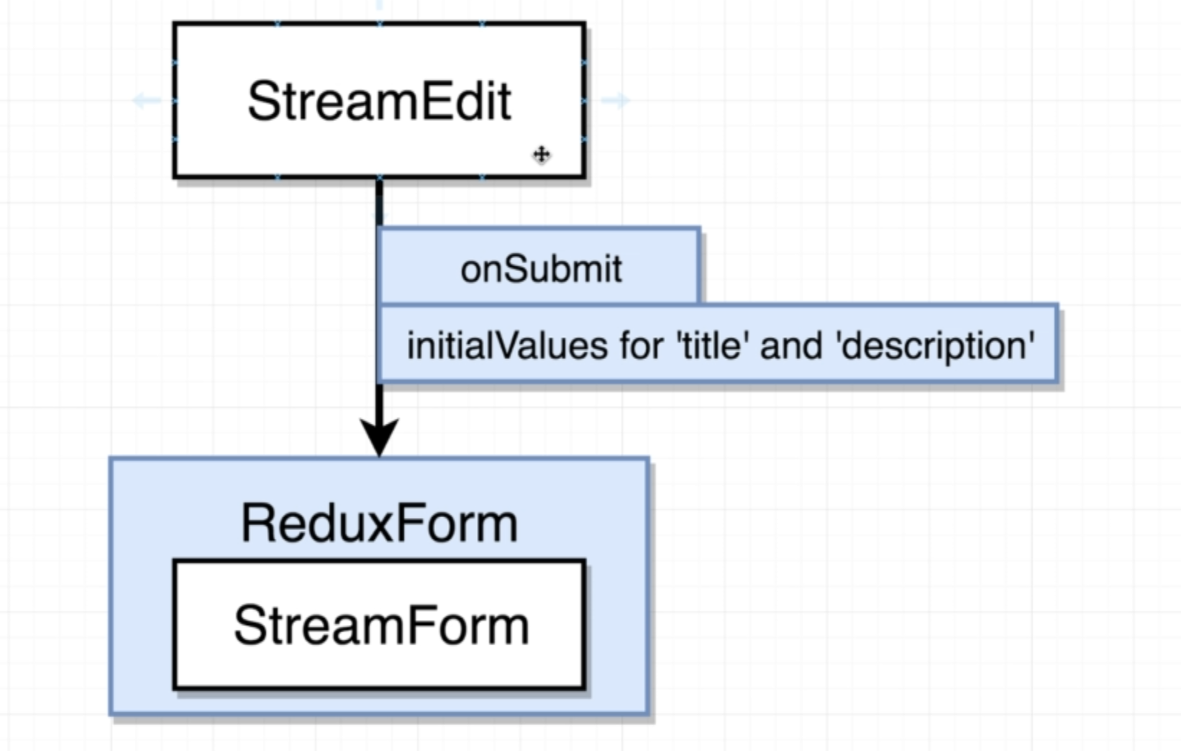

**We need to define an onSubmit() function this is going to be our callback for Stream.**

**So when the user eventually submits our form, this will receive some form values**

**StreamEdit.js**

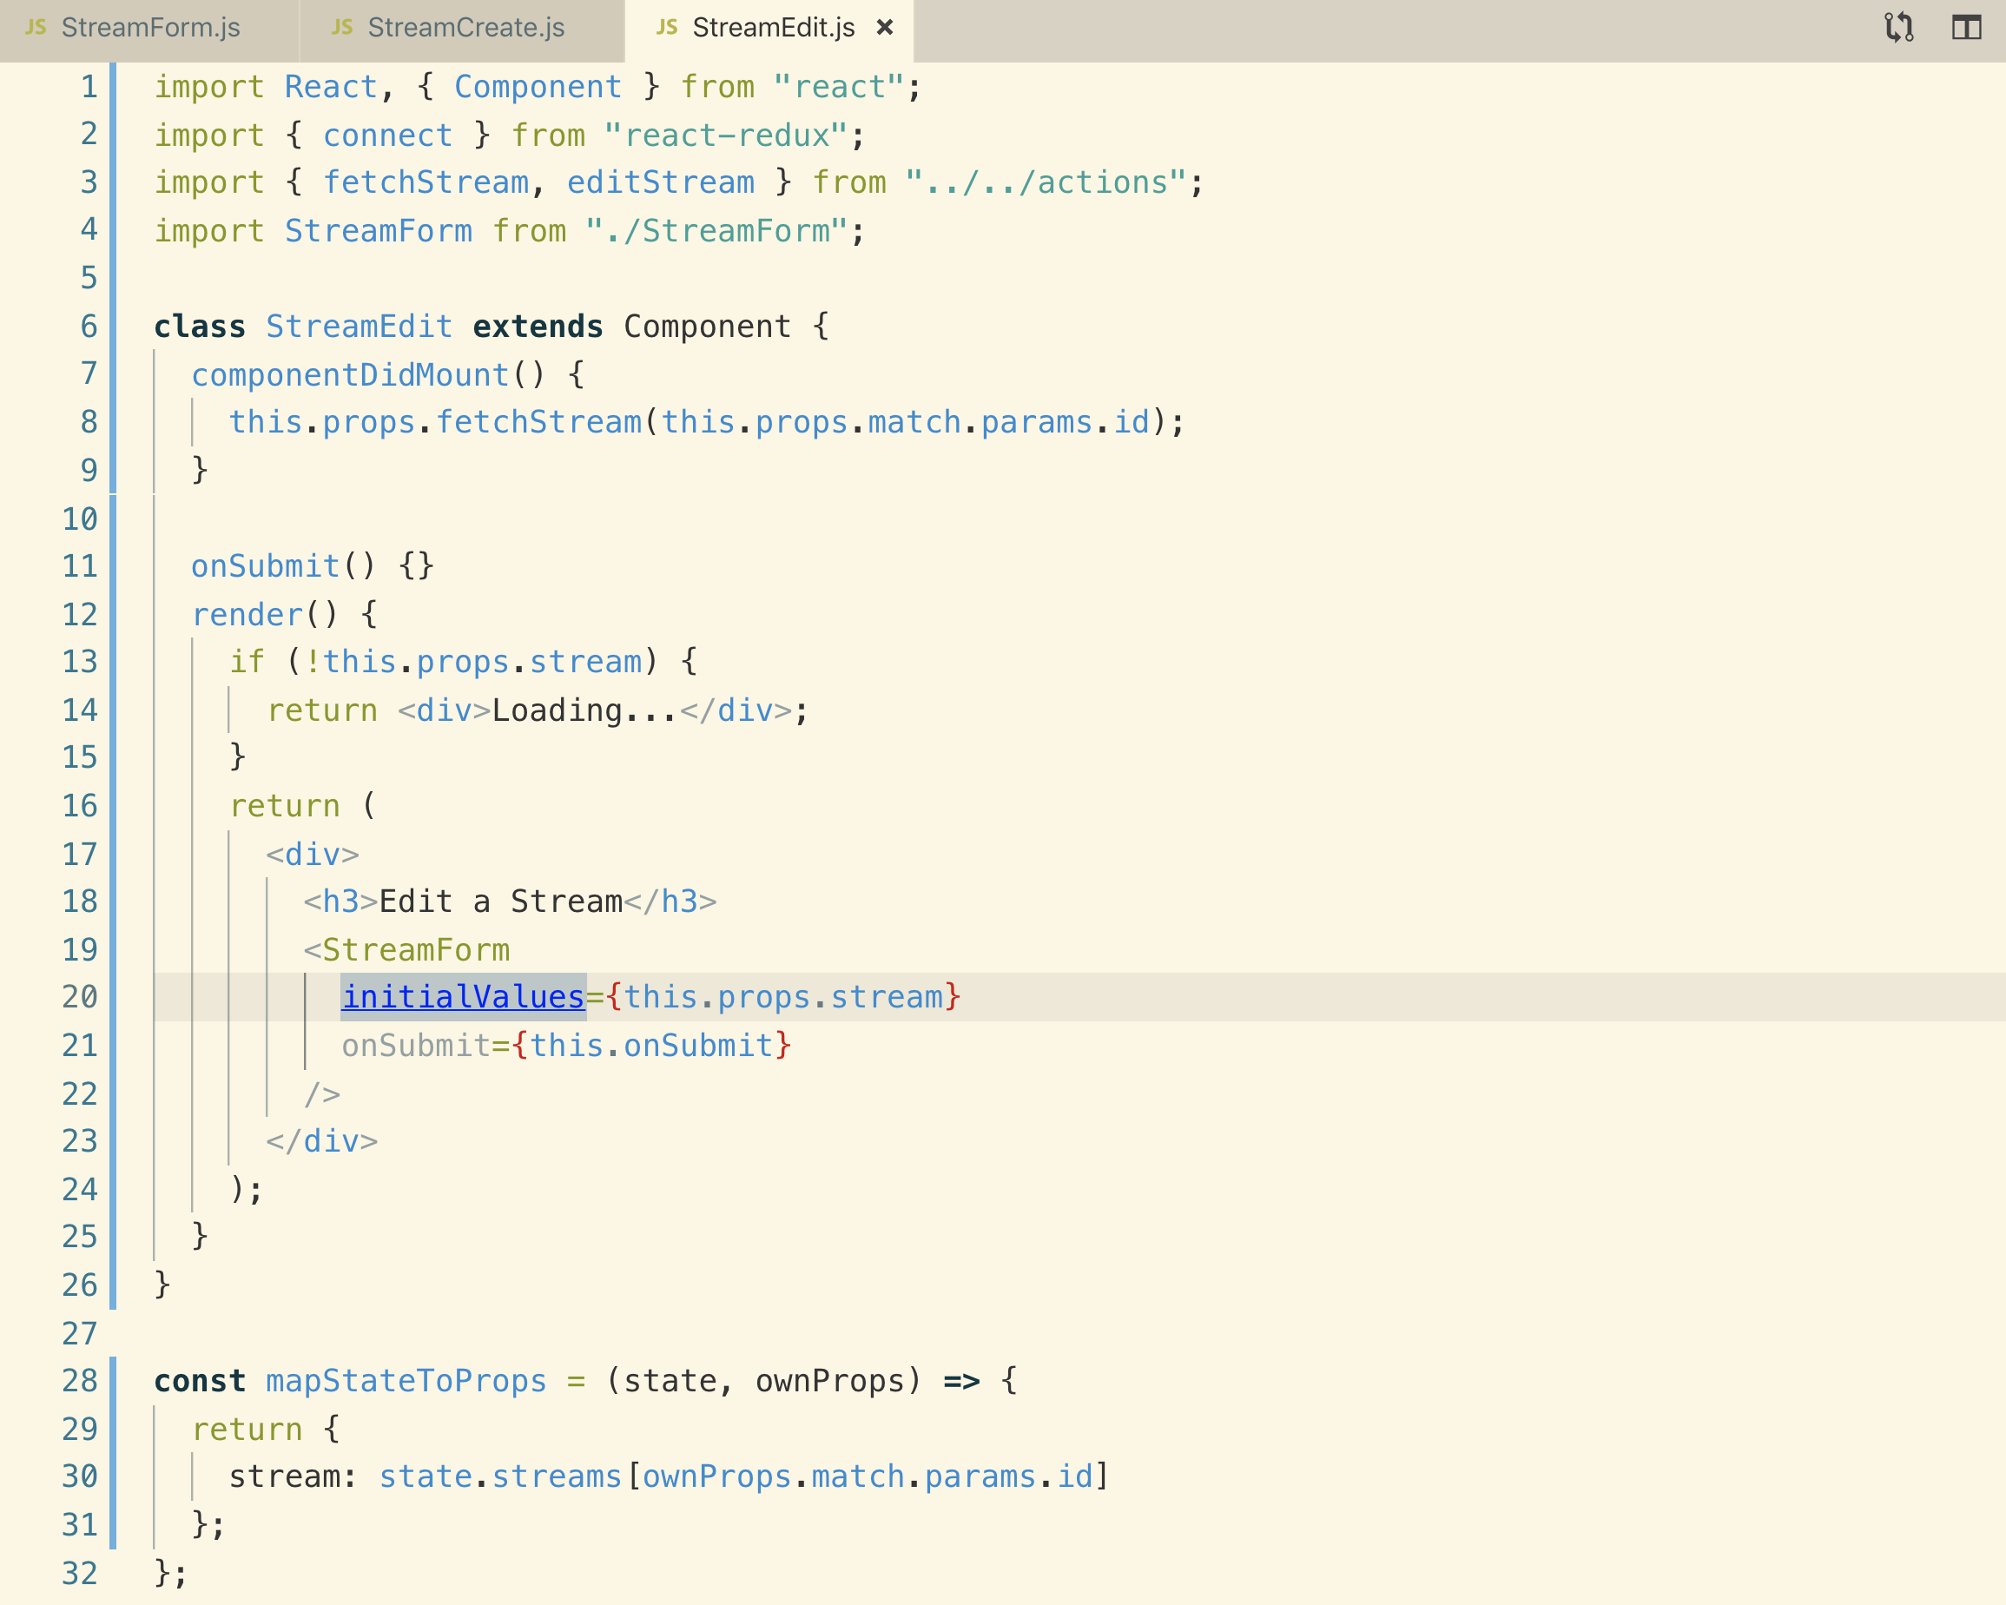

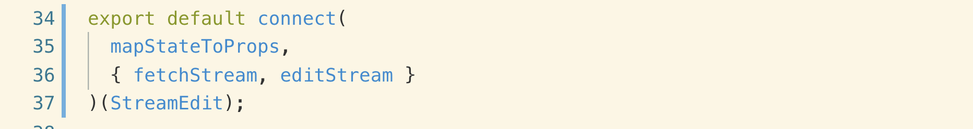

**32. Avoiding Changes to Properties**

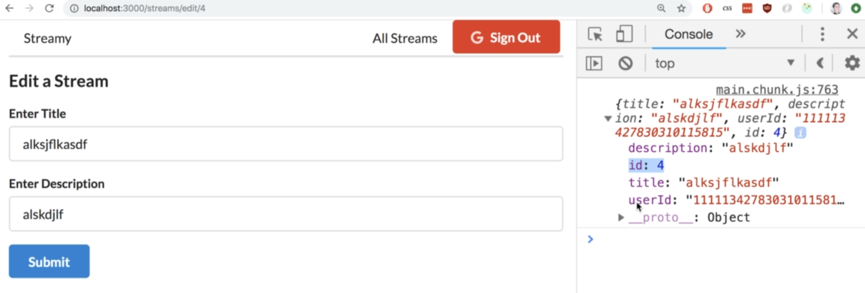

**InitialValues that we are passging from StreamEdit has the above data which includes “id” and “userId” so why this is an issue. Let’s see**

**Our StreamEdit only allows you to change title and description. When we call onSubmit on StreamEdit, we should get updated Stream Object from StreamEdit.js. We are getting “id” and “userId” which seem we also edit these values, but these are the properties that we do not ever want to change.**

**We used lodash’ pick() function to take the values from the object and it doesn’t alter the original object instead it gives you a new object.**

**StreamEdit.js**

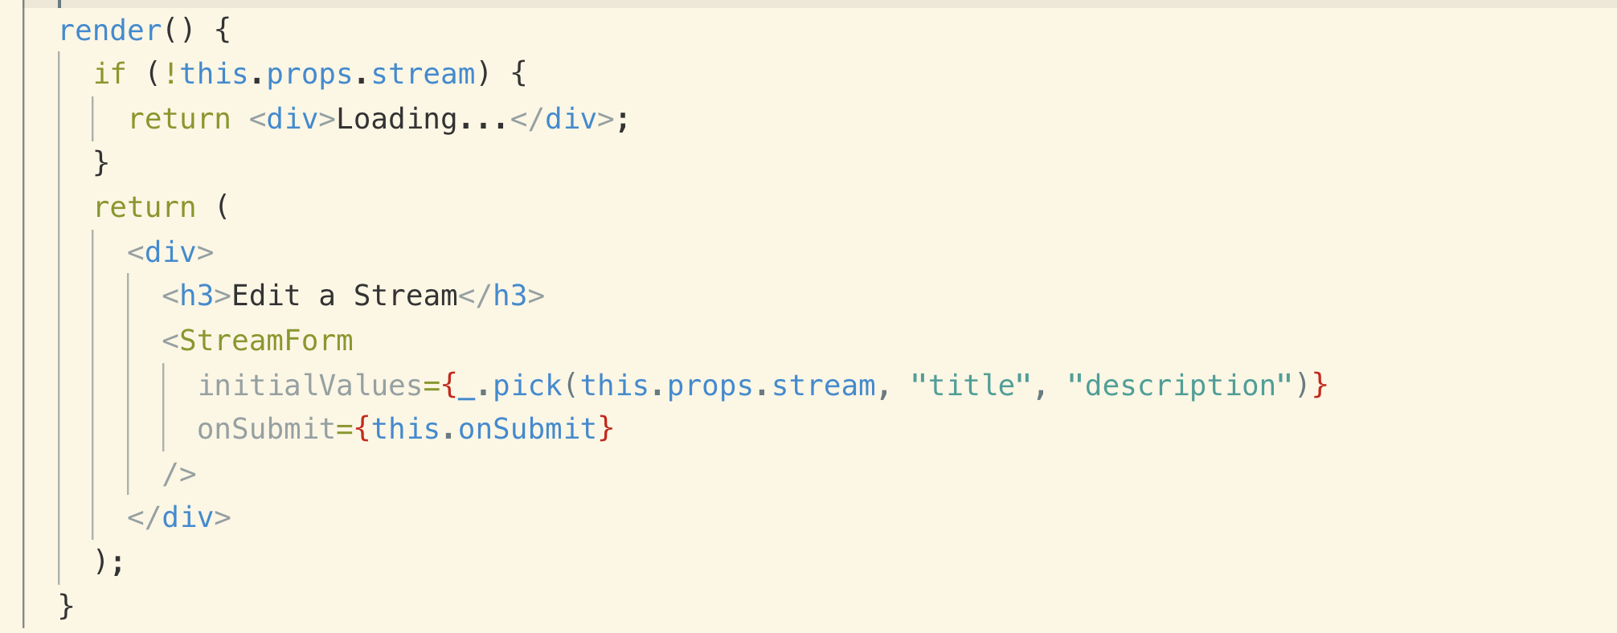

**33. Edit Form Submission**

**Whenever onSubmit() gets called with our brand new title description which are inside our formValues object we need to call editStream action creator.**

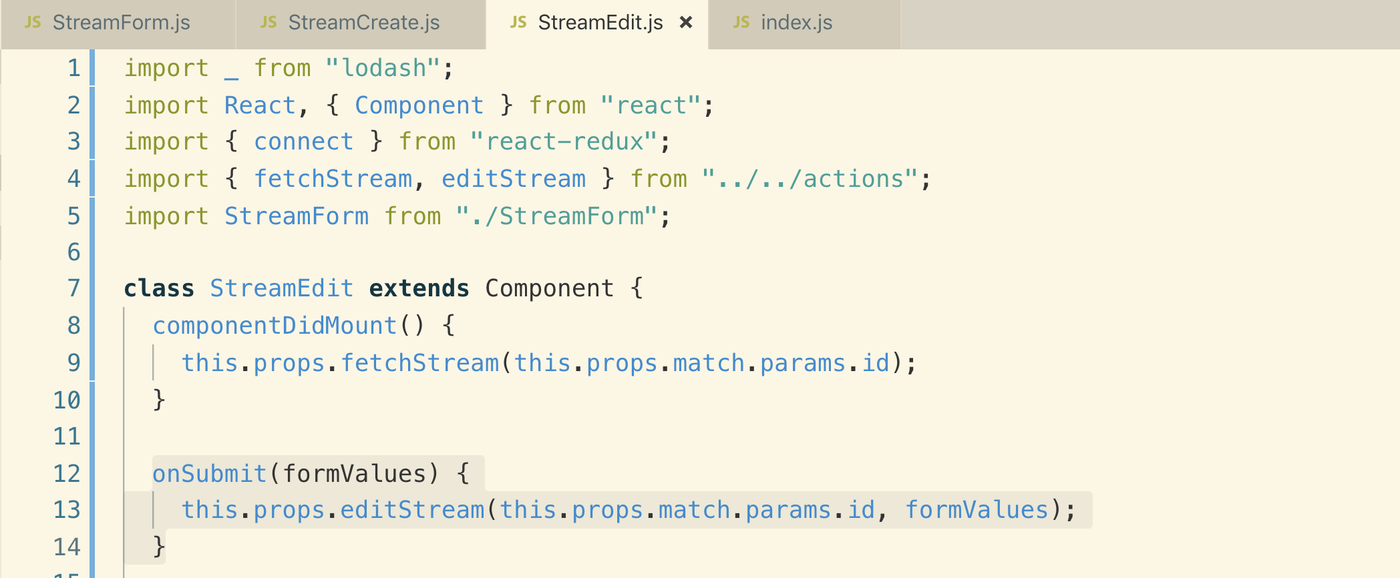

**actions/index.js**

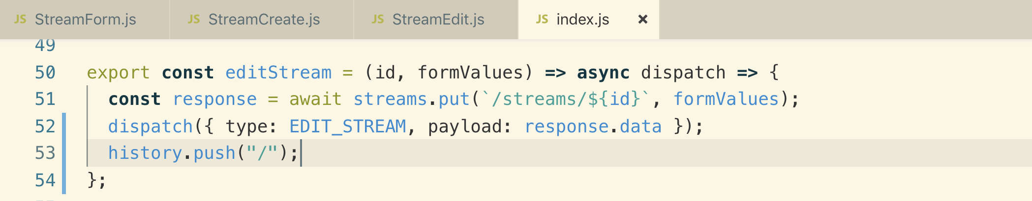

**We have successfully edited the stream but we have lost edit and delete buttons. Let’s why? In the next section.**

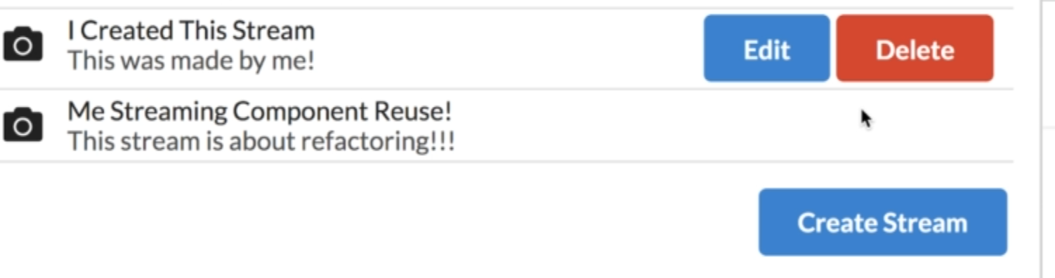

**34. PUT vs PATCH Requests**

**When you make a PUT request so whatever properties you put inside the body of the request are going to replace all the properties inside of the record that you are trying to update that is by convention of REST.**

**If you want to change specific data you should use PATCH request**

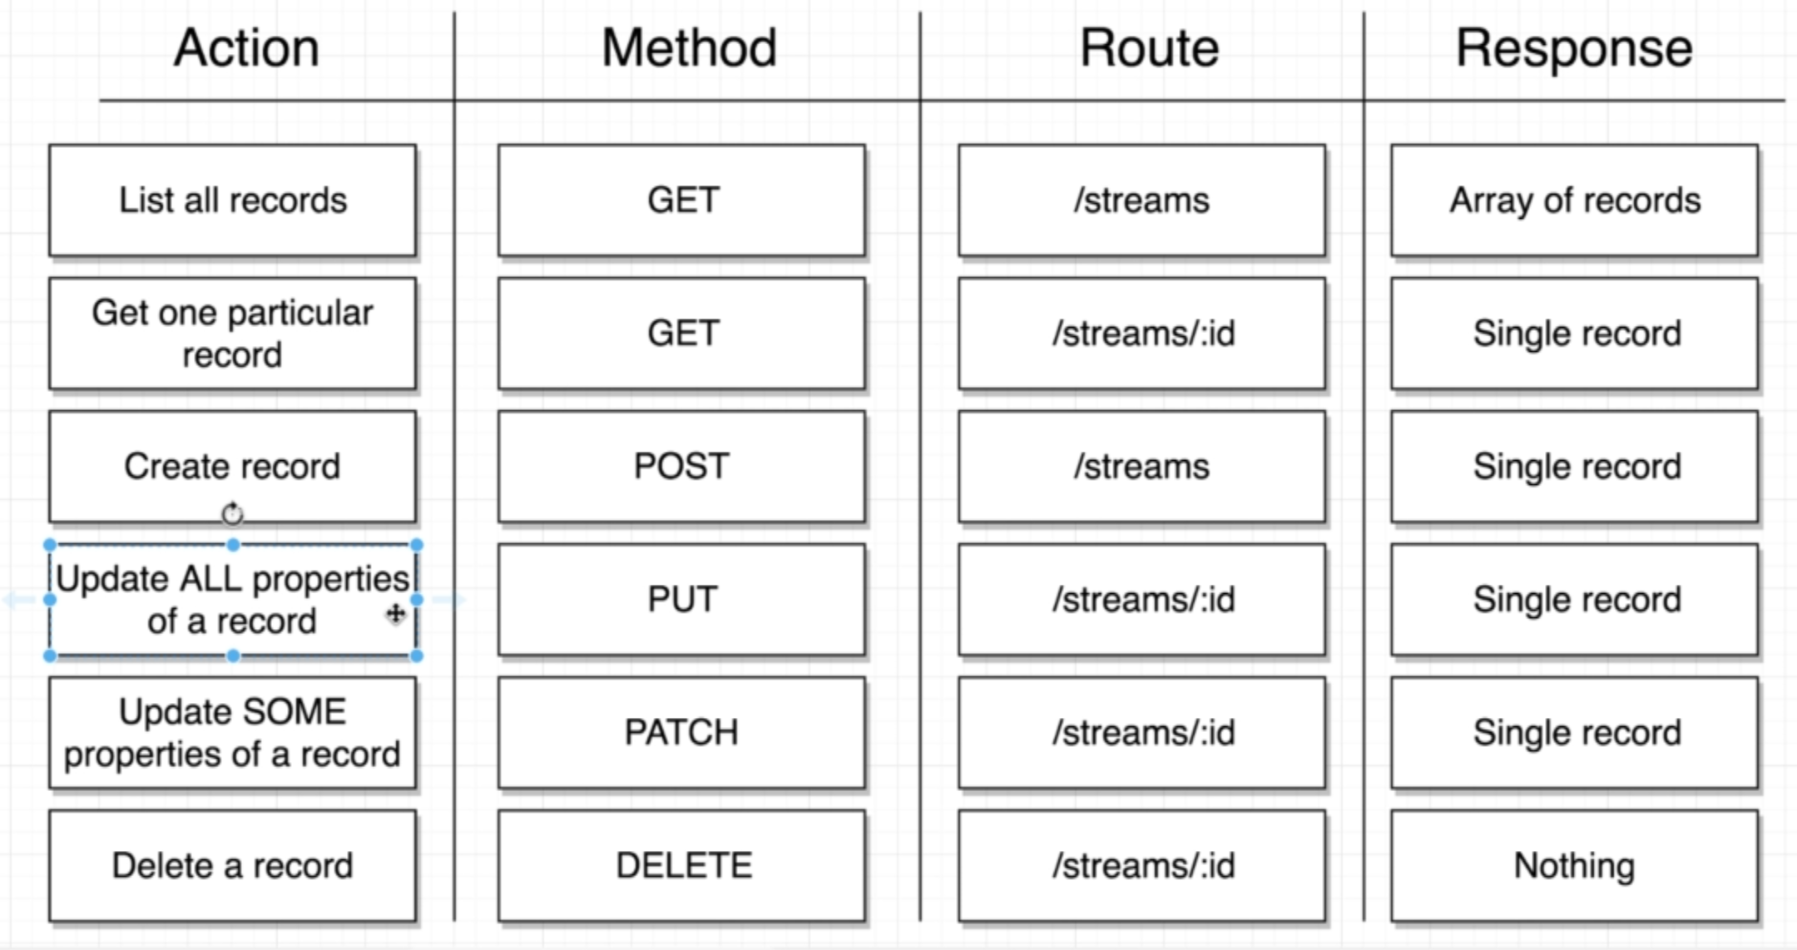

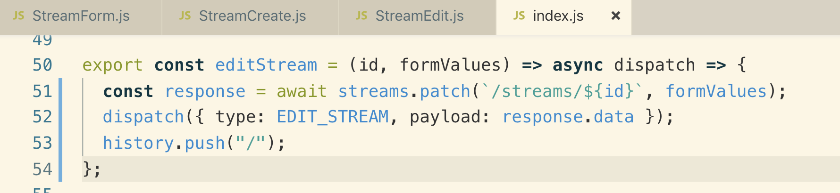

**21. Using React Portals**

**1. Why Use Portals**

**When a user deletes a record it asks the user to confirm by modal window like this**

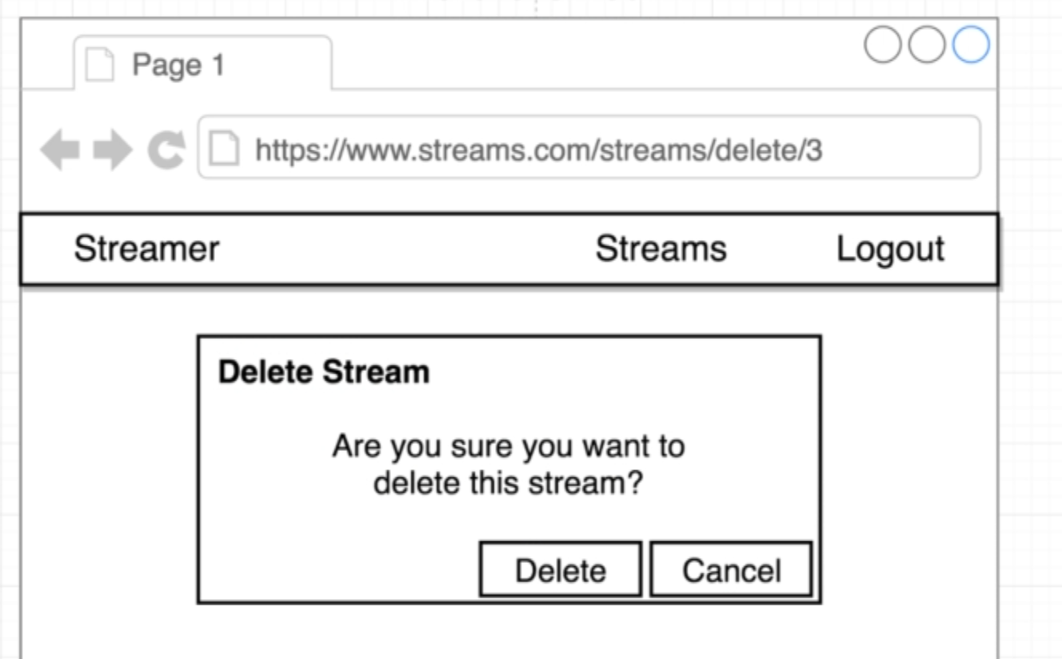

**A modal window prompt a user to take some action.**

**Let’s see how we can create a Modal window with React and Why modal is specifically challenging with React.**

**Note: all of the elements in our React application are nested inside DIV with id=”root”**

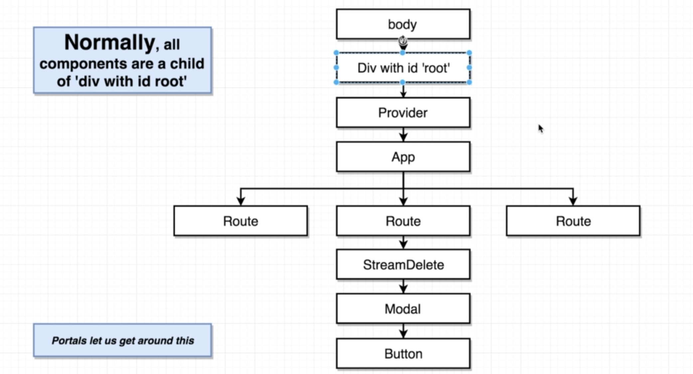

**Note: Whenever we place a DIV with a position of relative and a z-index of some defined value, it creates something called stacking context**

**There are many different ways to create a stacking context with CSS.**

**When we create a stacking context, it creates a new way of comparing different sibling elements that has assigned z-index value that might want to re-render on top of each other.**

**In this case we no longer compare Sidebar z-index with Modal z-index instead it will compare it with root element that has the stacking context which is Positioned Element and Sidebar will win as it is defined after positioned element**

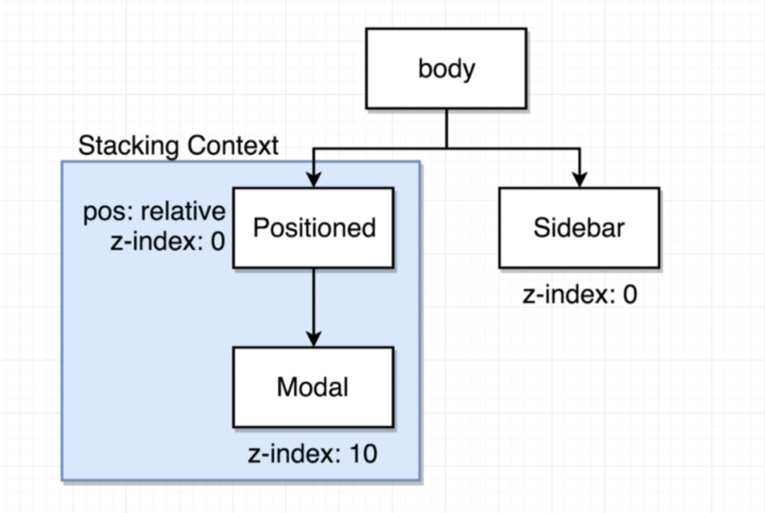

**So the solution of this that rather than following React flow where Div root id is the parent, we break the rule of React and put the Modal under <Body> directly**

**With portals, we don’t have to stick with the hierarchy that we have shown where everything is a child of Div with id=root. Instead, we will use a Portal**

**Portals allows to render some elements not as a direct child. We can instead render that element or that component as a child of some other element inside of our HTML structure. Most commonly the <body>**

**We use portal to get around all the rules of stacking context or trying to show a modal CSS issues or stuff like that.**

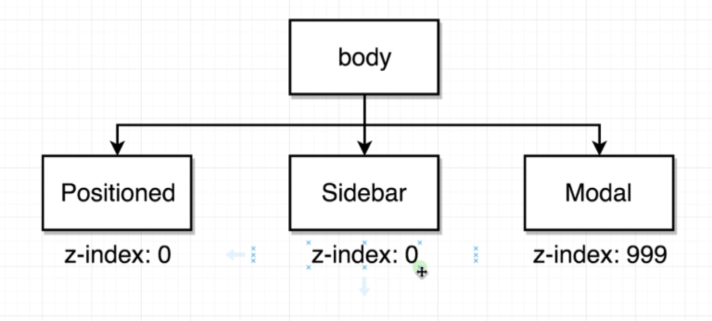

**3. Creating a Portal**

**Anytime we want to get an element not rendered as a direct descendant of some component, we can use a portal to instead place that component as a descendant of some other element inside of our HTML structure.**

**We are going to build this Modal as a reusable component**

**Note: When we create a Portal, the return value is going to change a little-bit like this.**

**ReactDOM.createPortal() : this function takes 2 arguments**

1. **Some JSX. something that we want to show on the screen**
2. **Reference of the element that I want to render the portal into**

**We cannot directly add the Portal into Body so we need to create an Element on the div with id in**

**public/index.html**

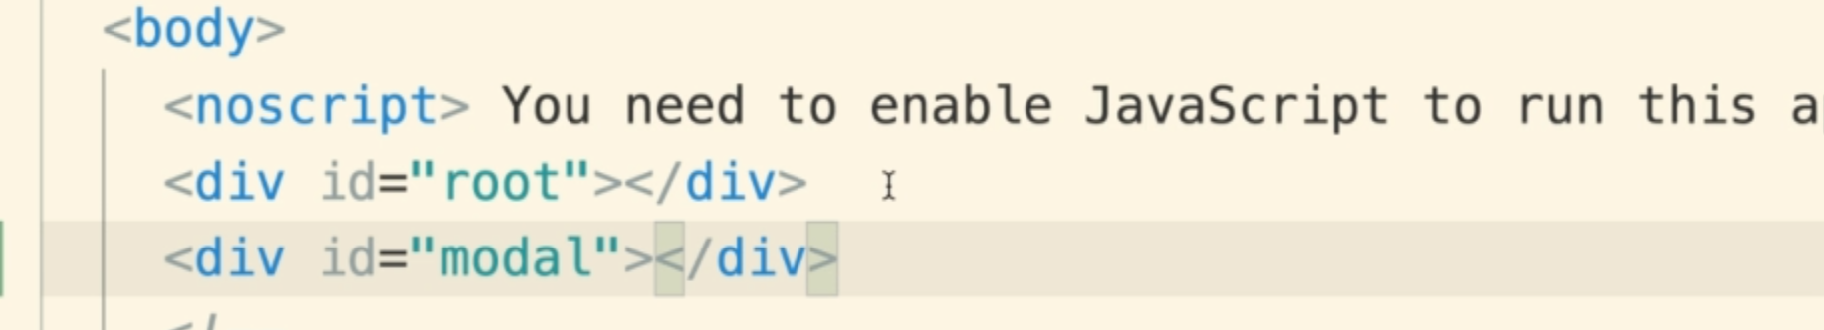

**Components/Modal.js**

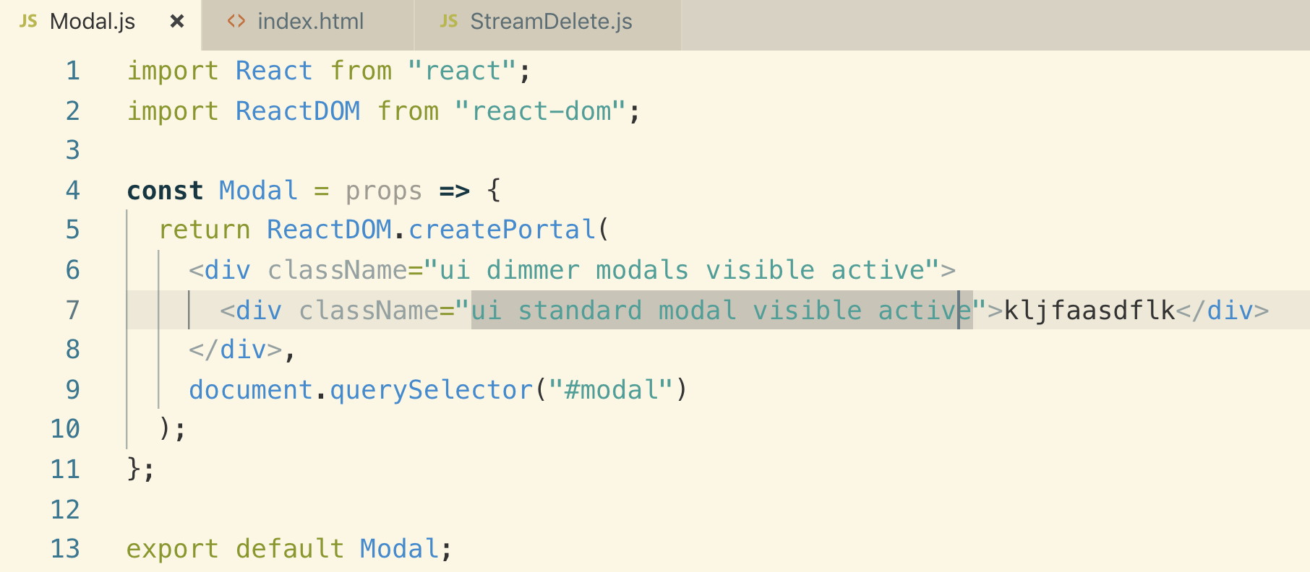

**4. Hiding a Modal**

**history.push(): we used history object to remove the Modal, but that asiring a problem called event bubbling and that we can fix with Event Propagation**

**Event Propagation: if ever trigger an event on some child element and that child element doesn’t handle that event, the event is going to essentially bubble up to some parent element until it eventually it gets caught with an event handler.**

**So to fix it we need to add a click handler below the element where you don’t the event to go. You can do this with e.stopPropagation()**

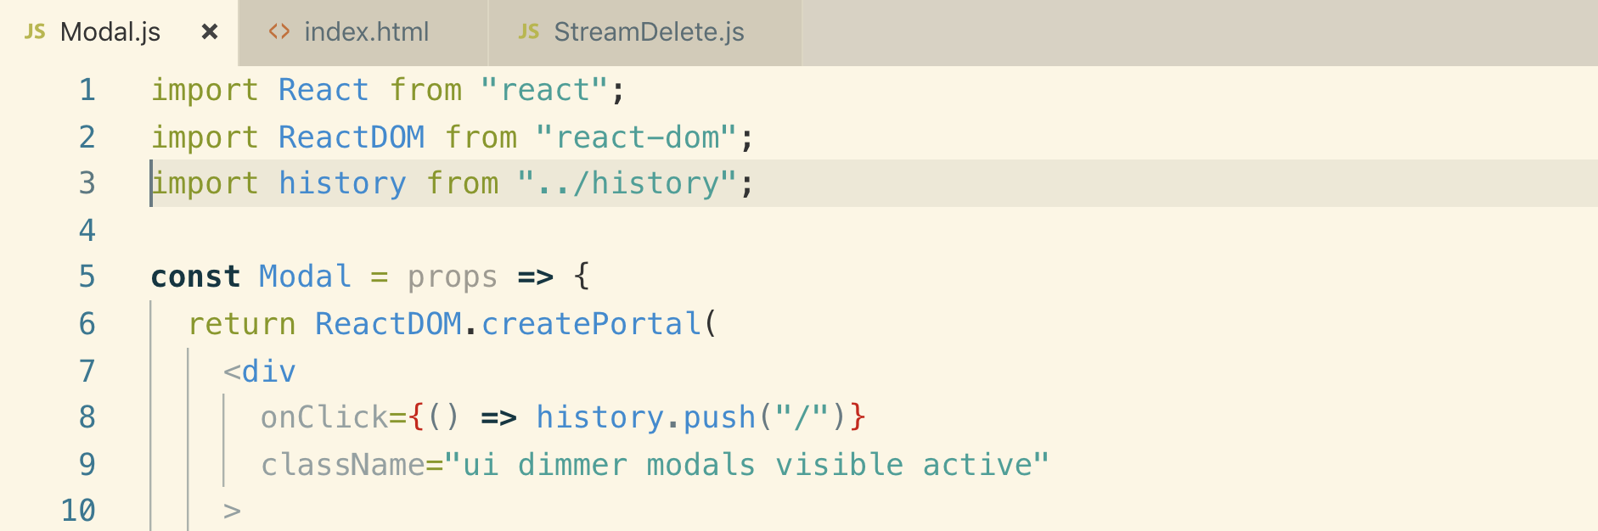

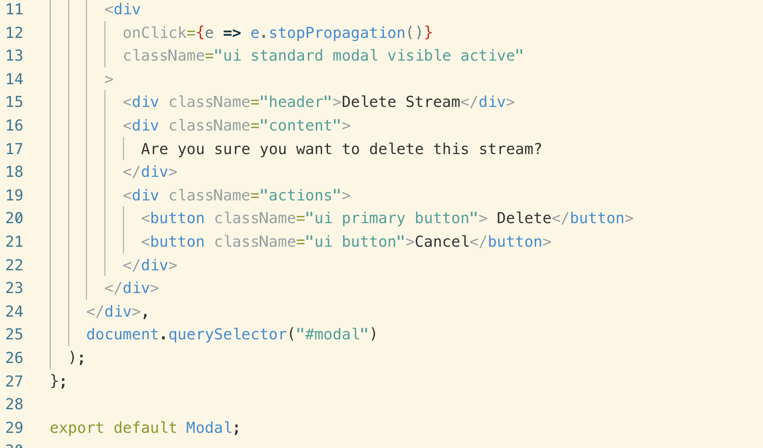

**5. Making the Modal Reusable**

**For button actions we need to pass some JSX unlike title and content.**

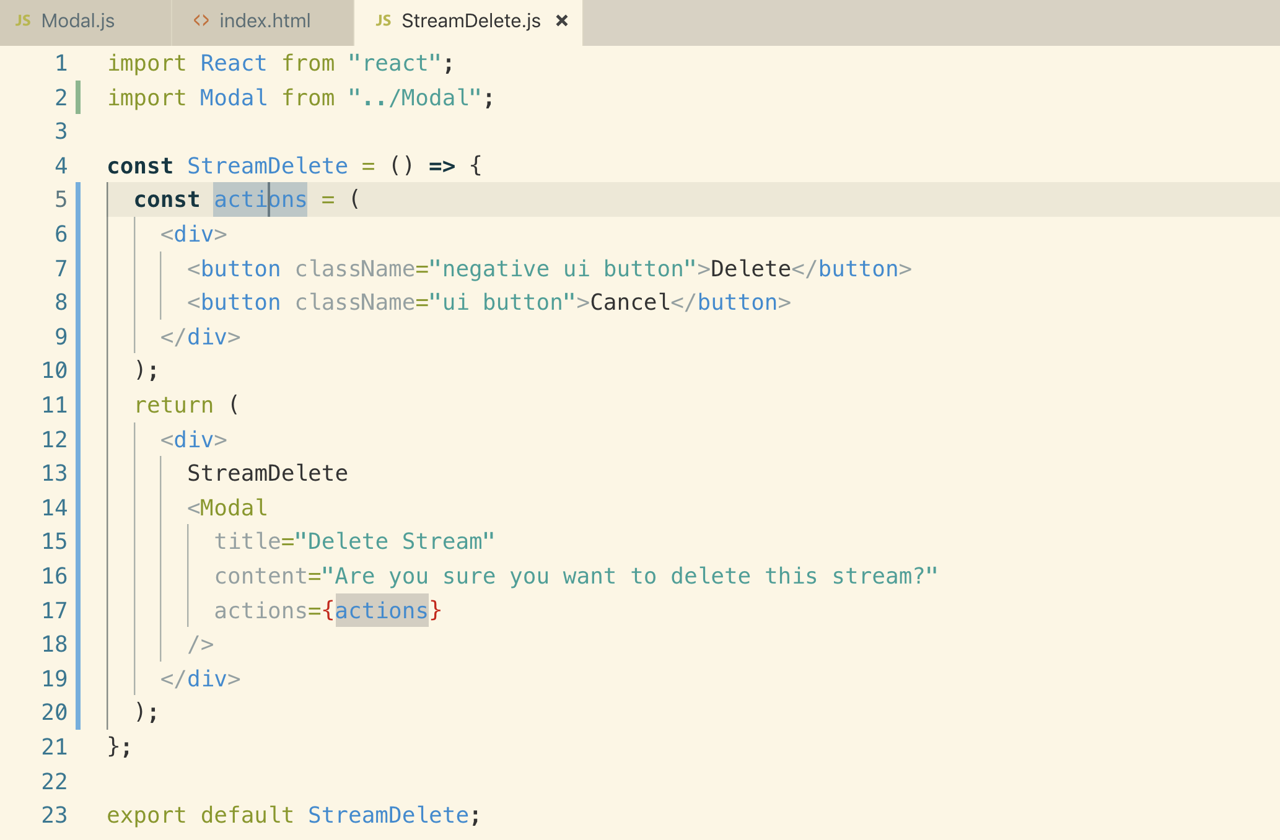

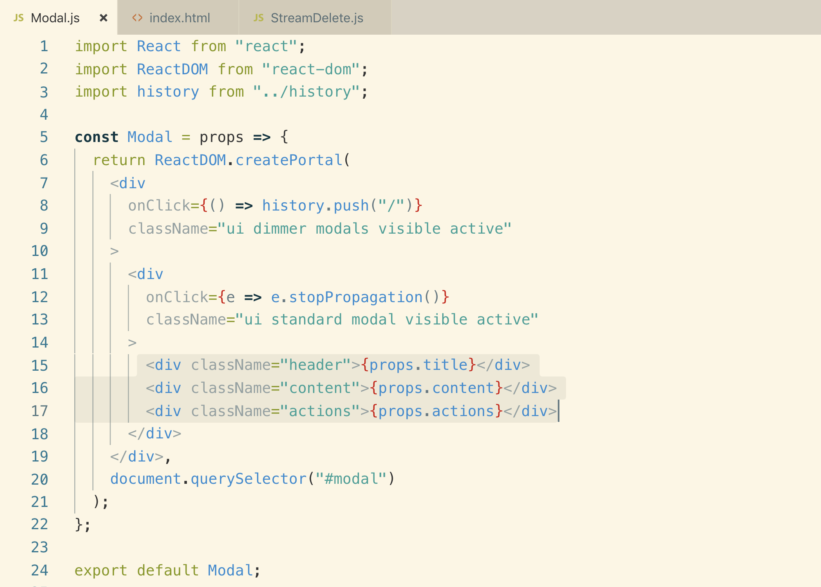

**6. React Fragments**

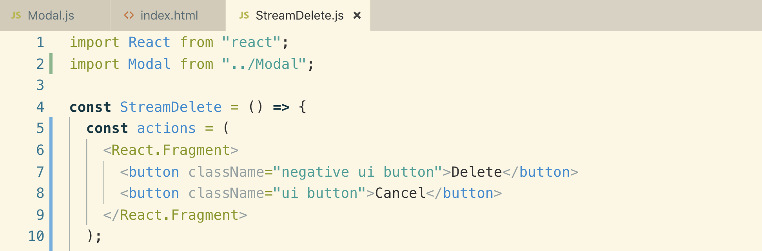

**7. OnDismiss From the Parent**

**The onClick function in the Modal to dismiss the Modal should be provided by the parent so that we can decide which page to show when Modal Dismissed**

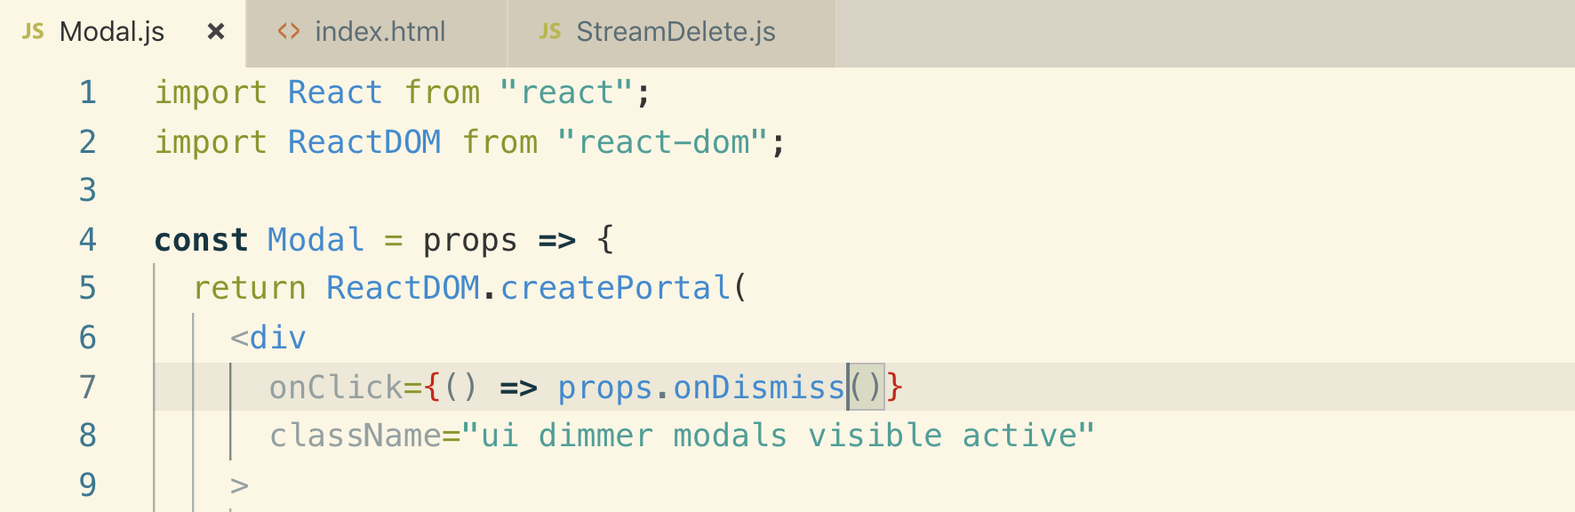

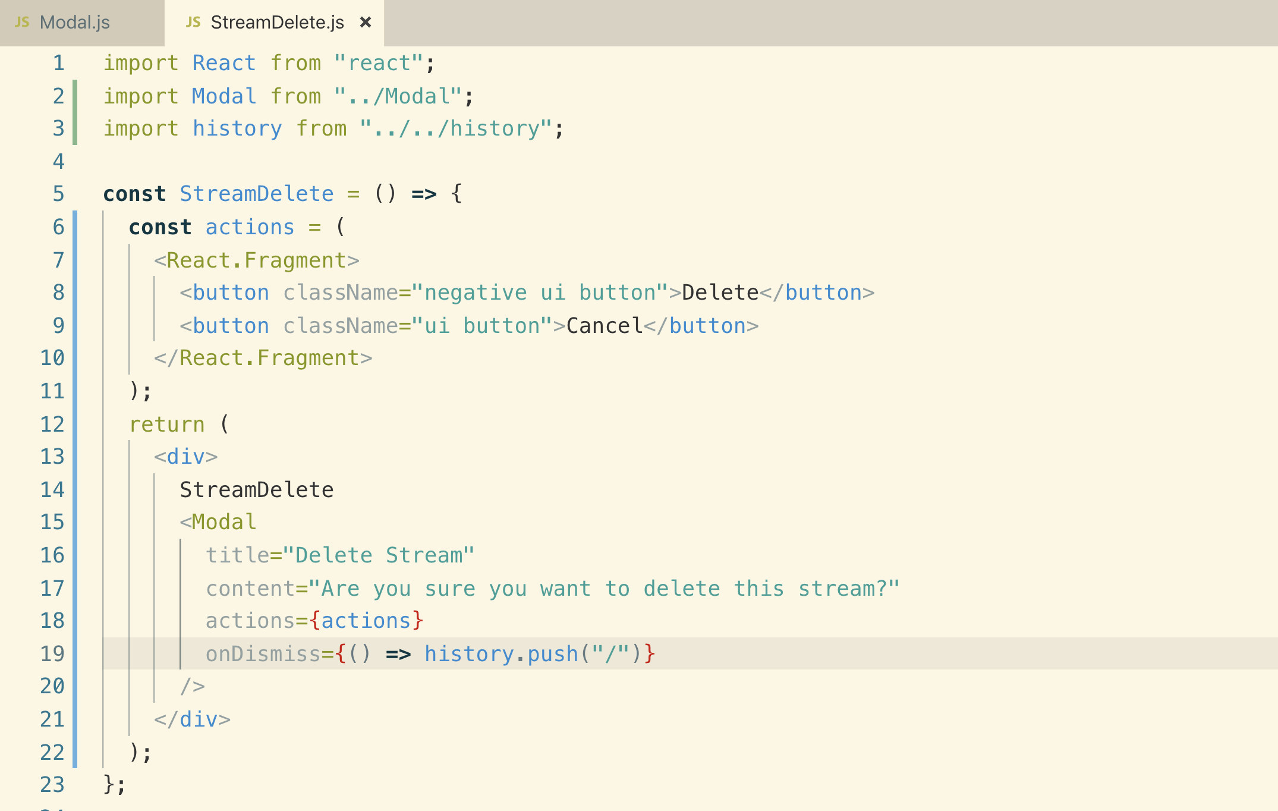

**8. Reminder on Path Params**

**Changing the Route for delete by adding :id to specify which stream is to be deleted**

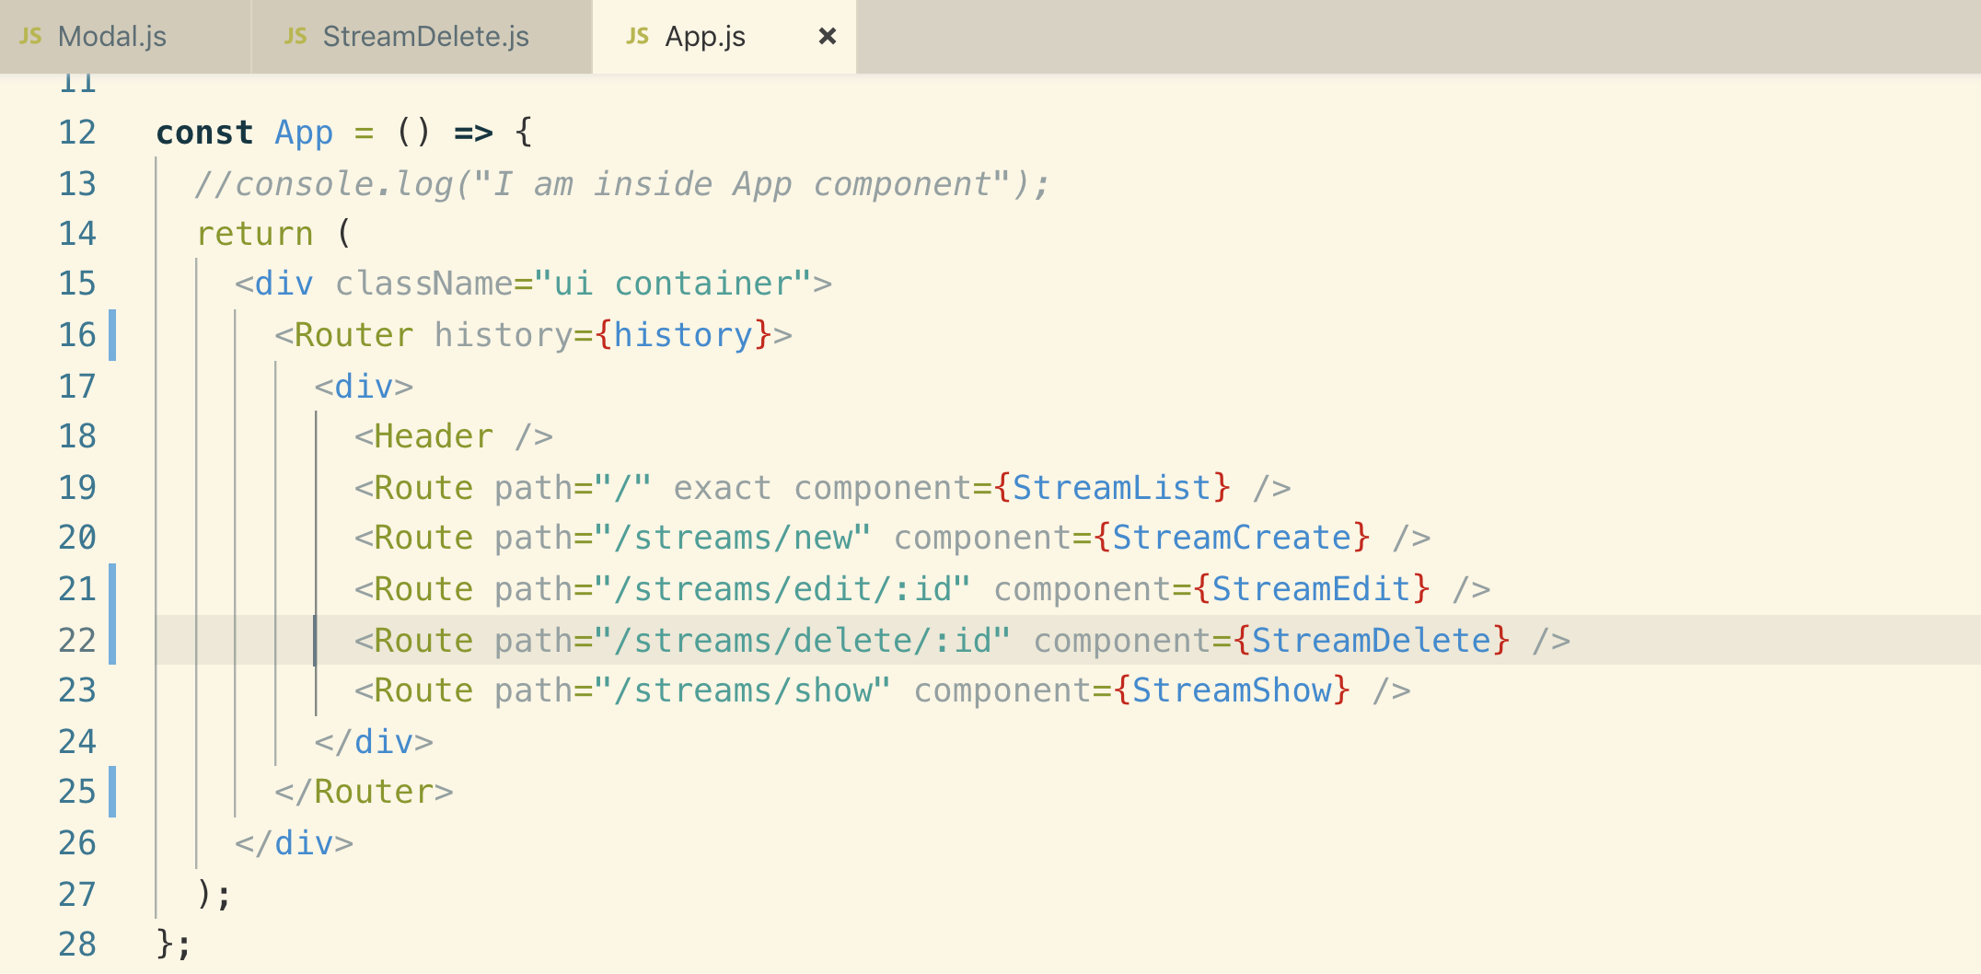

**Next instead of button element, we will use <Link> element to navigate to other page**

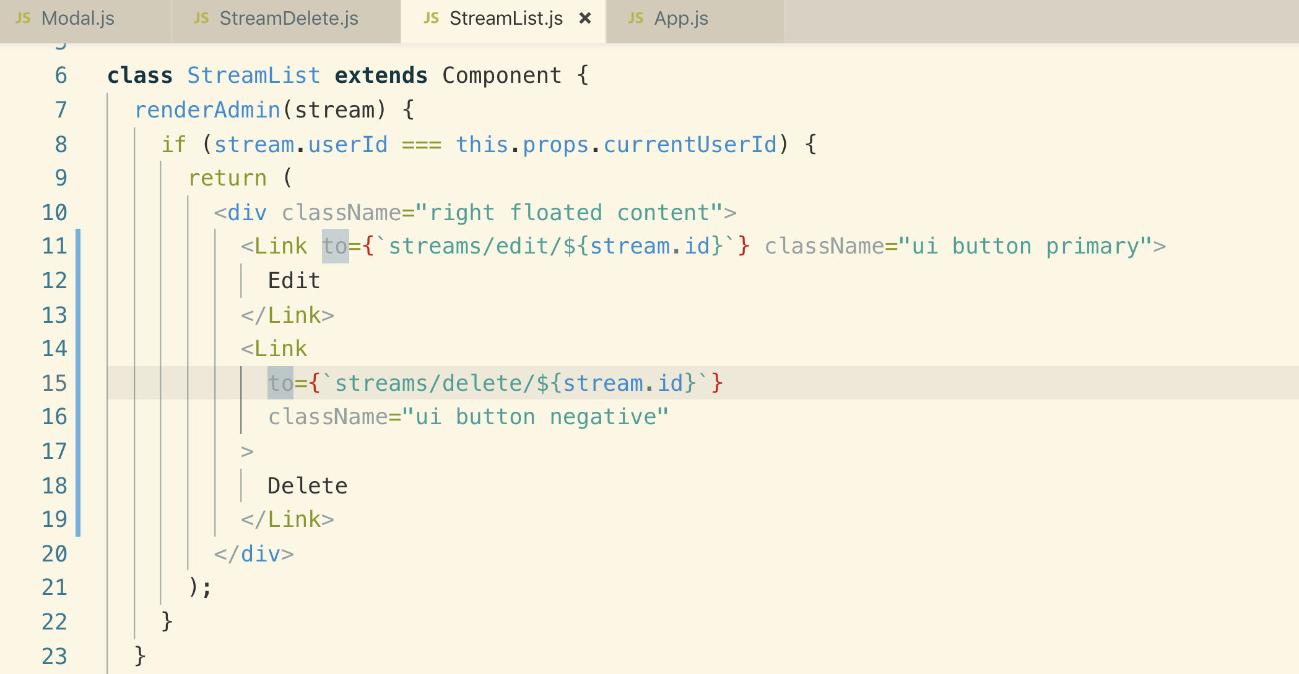

**9. Fetching the Deletion Stream**

**To make the API call we need to convert the functional component into class based component.**

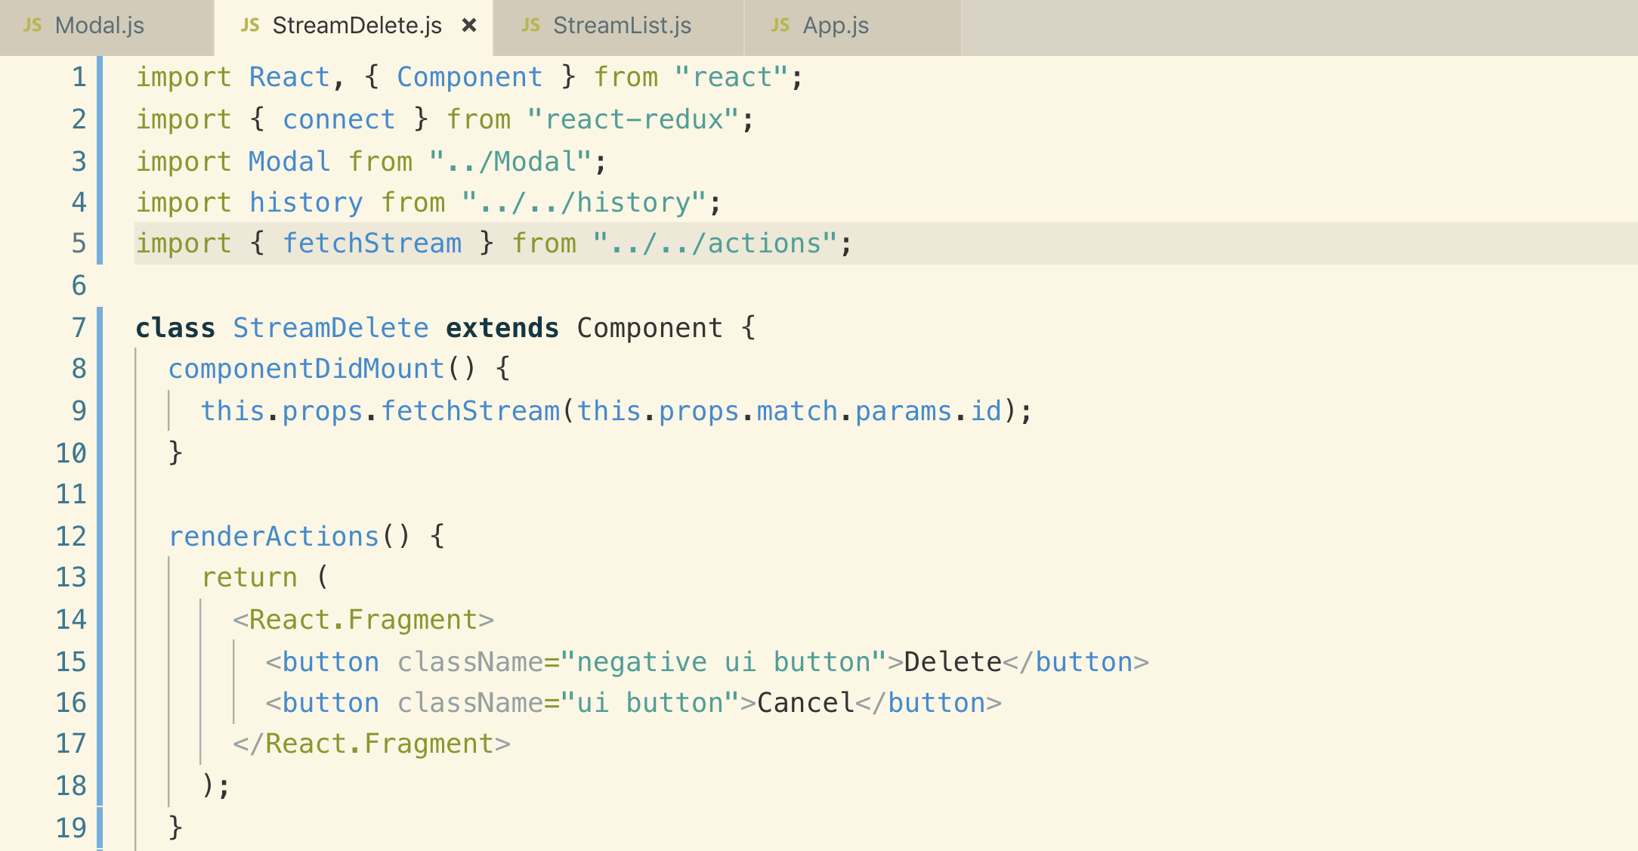

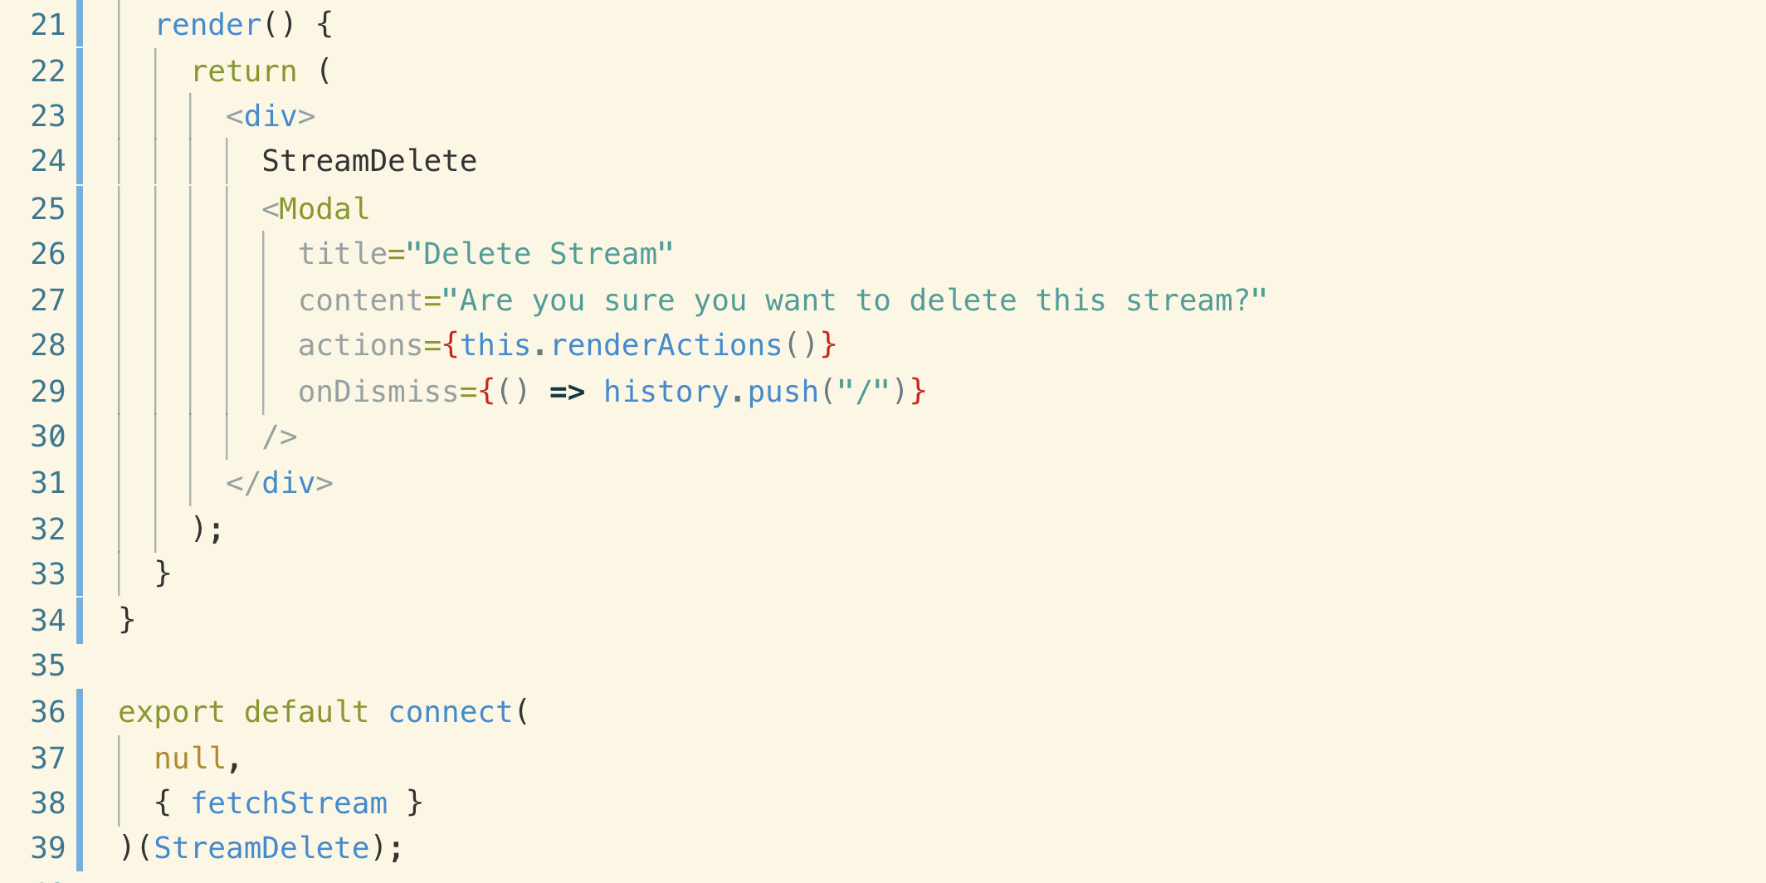

**10. Conditionally Showing Stream Details**

**Note: when StreamDelete.js component first render to the screen, it is entirely possible that we have not streams loaded up just yet because this component is going to be rendered one time then our componentDidMount lifecycle method will be called.**

**So to handle it, we will add a condition and show a loader.**

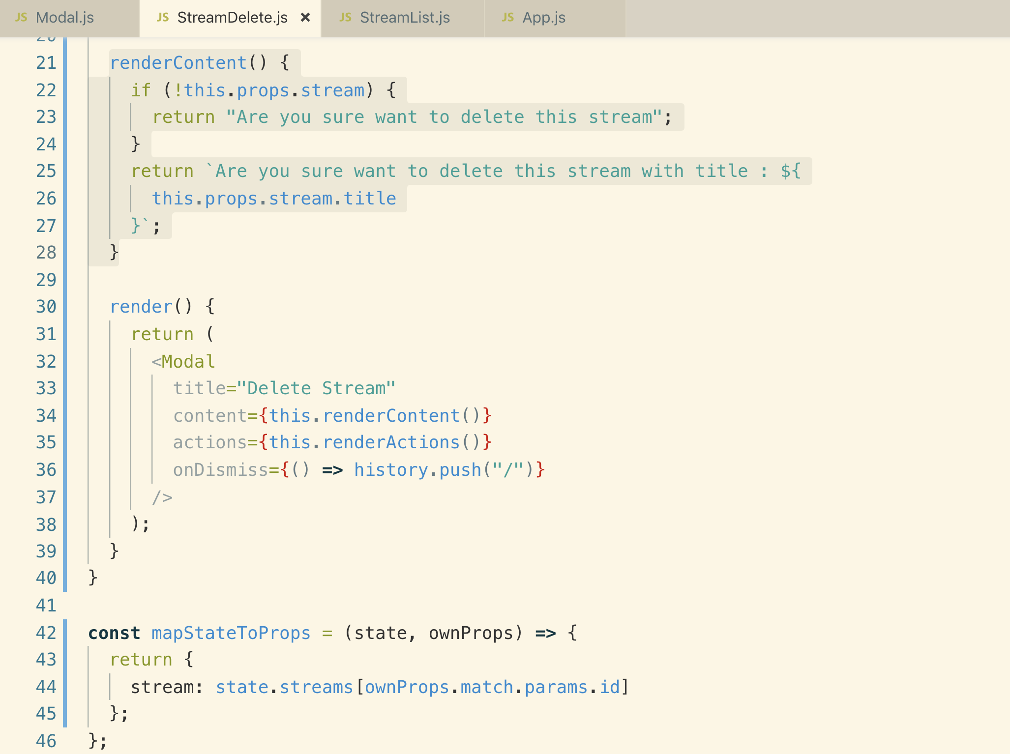

**11. Deleting a Stream**

**On clicking delete button we will call an action creator which is going fetch an API and delete very particular stream.**

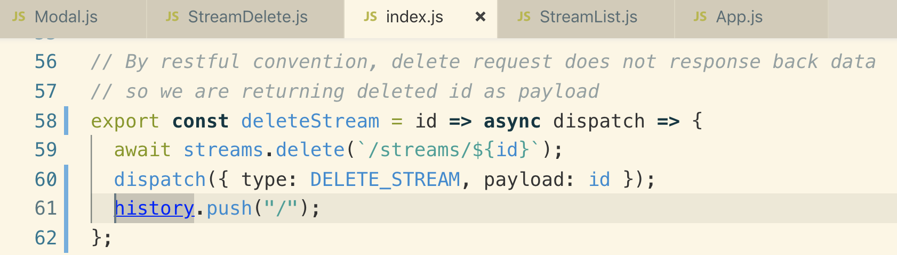

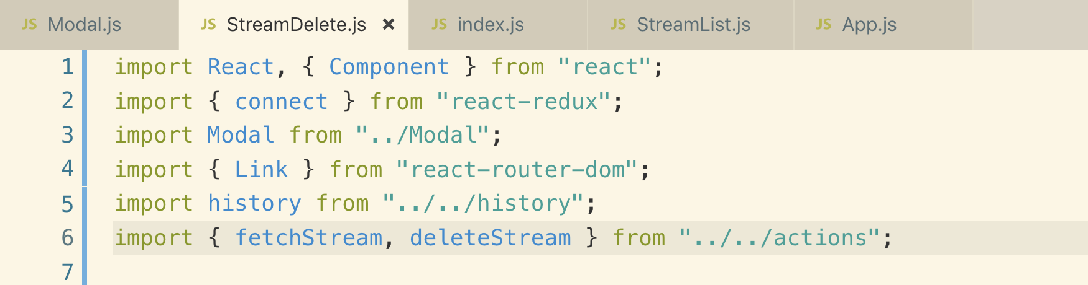

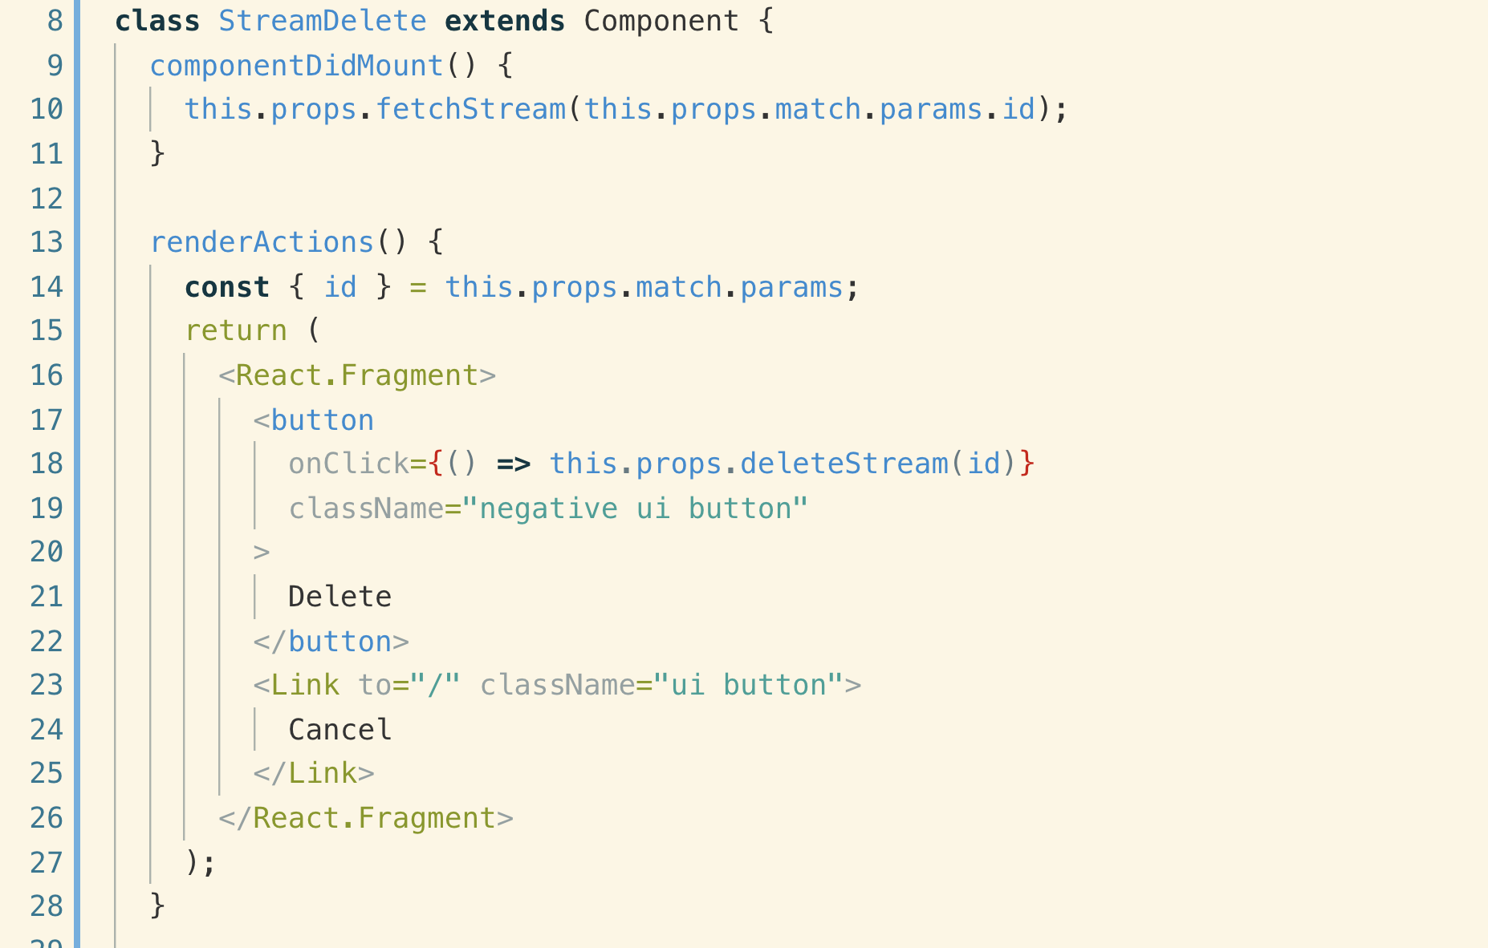

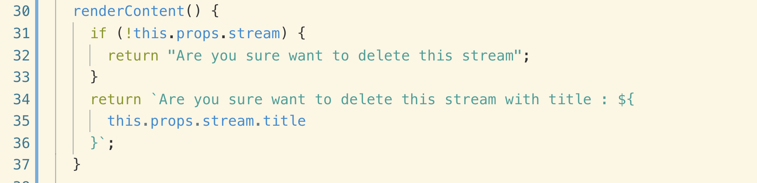

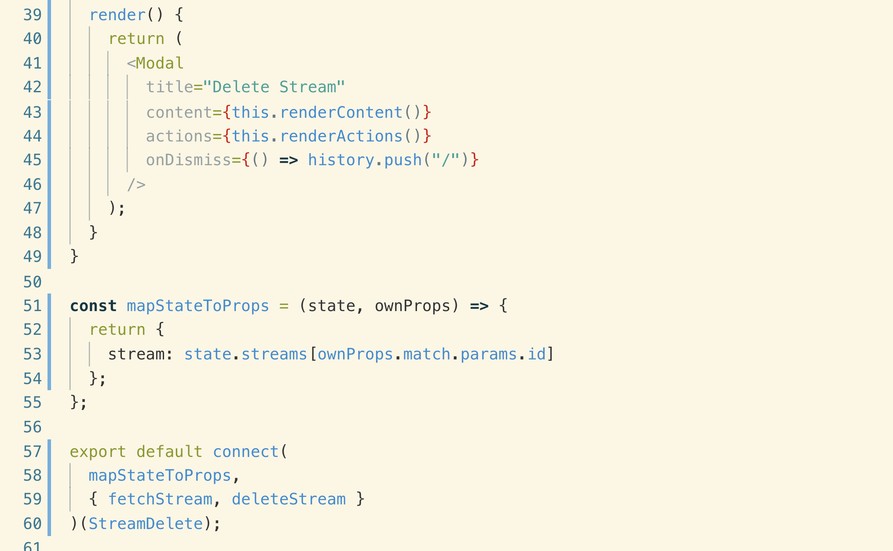

**Remember: whenever we make a delete request, if you are following RESTful conventions, we get no response on success.**

**22. Implementing Streaming Video**

**Changed the streamShow route**

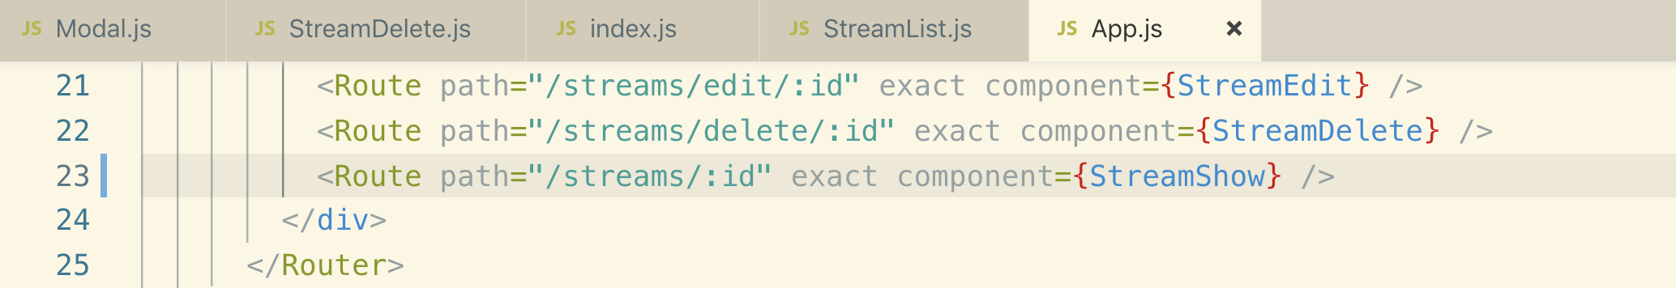

**Adding link on StreamList.js component to go to selected stream**

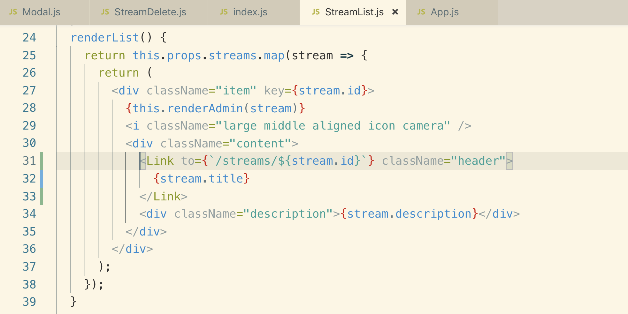

**2. Switches with React-Router**

**The problem with above routing with “stream/:id” is that it will also load when we route to “/stream/new” because :id is considered as a wild card variable.**

**To fix this, we need another helper component from “react-router-dom” called “switch”**

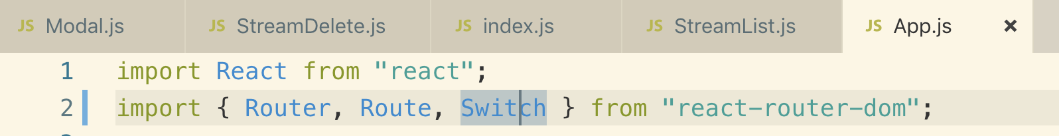

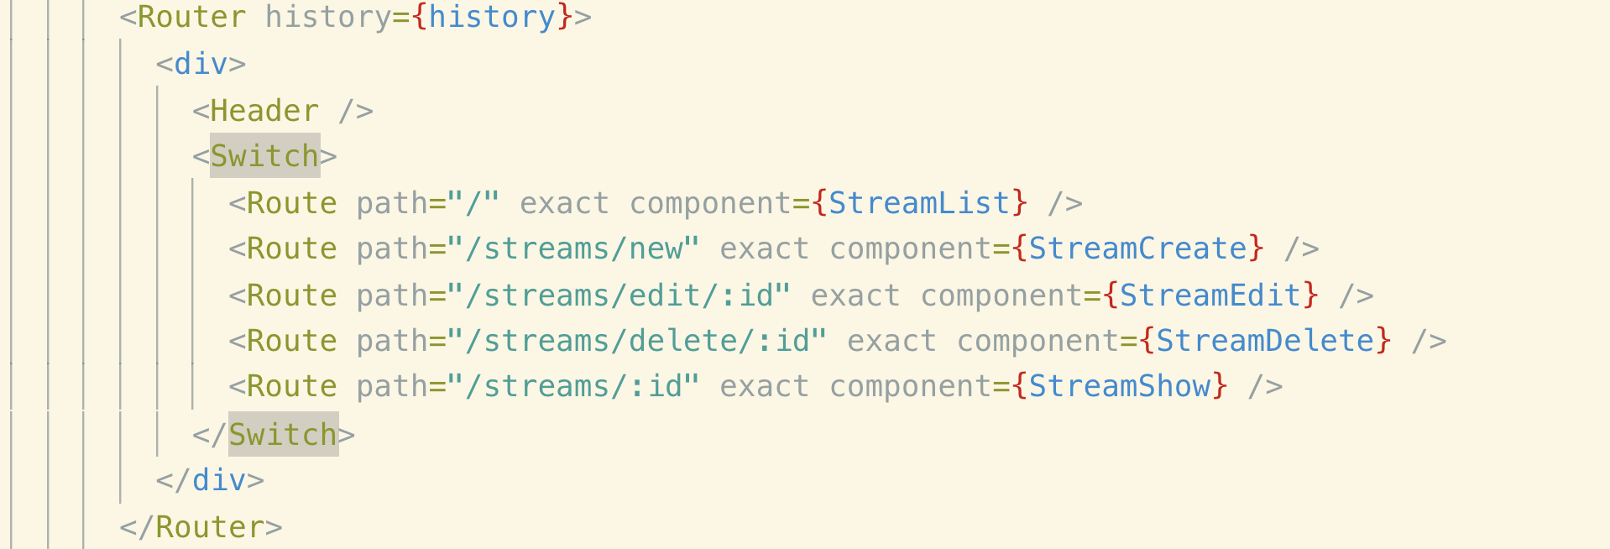

**<Switch> : It only loads first match route.**

**3. Showing a Stream**

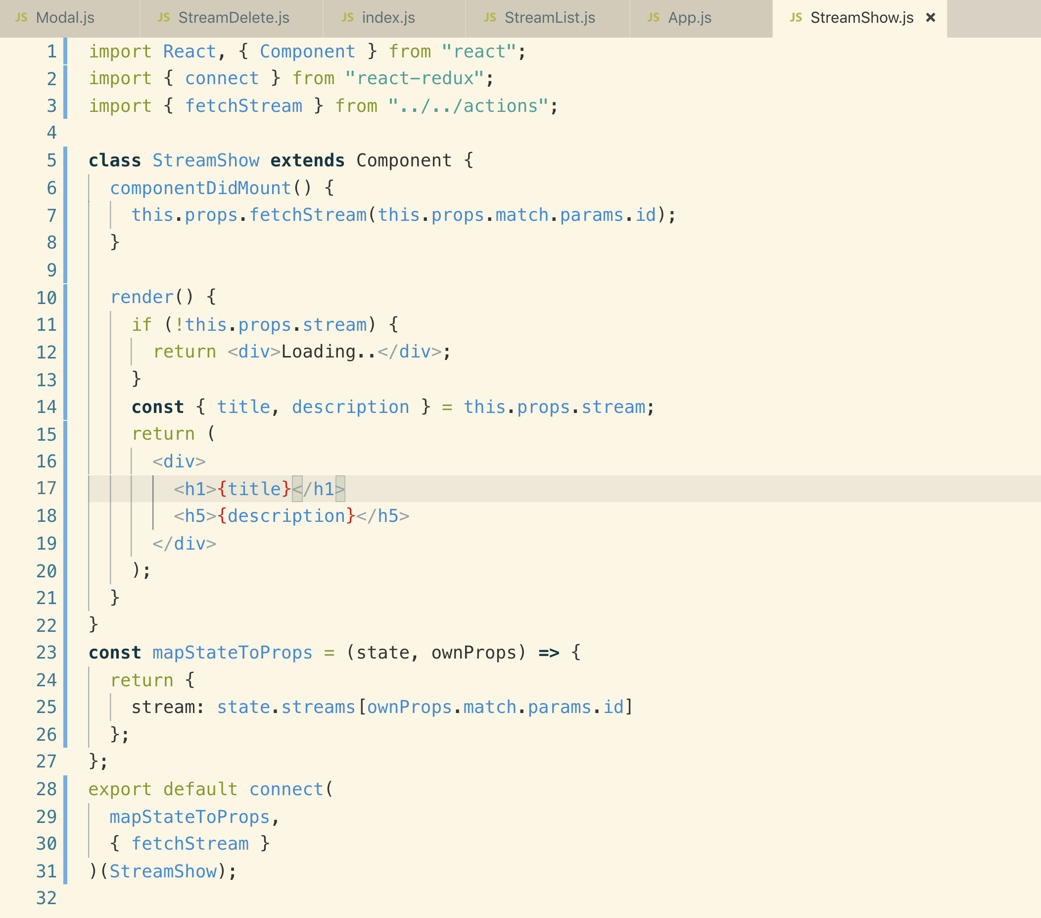

**4. RTMP Server Setup**

**Created a folder called “rtmpserver” on same level as client is. Go to rtmpserver folder create a package.json file by npm init command**



**Now go to below link for RTMP server setup**

[**https://github.com/illuspas/Node-Media-Server**](https://github.com/illuspas/Node-Media-Server)

**Installing RTMP node package**



**Go to “rtmpserver” directory and create an index.js file and paste the following code.**

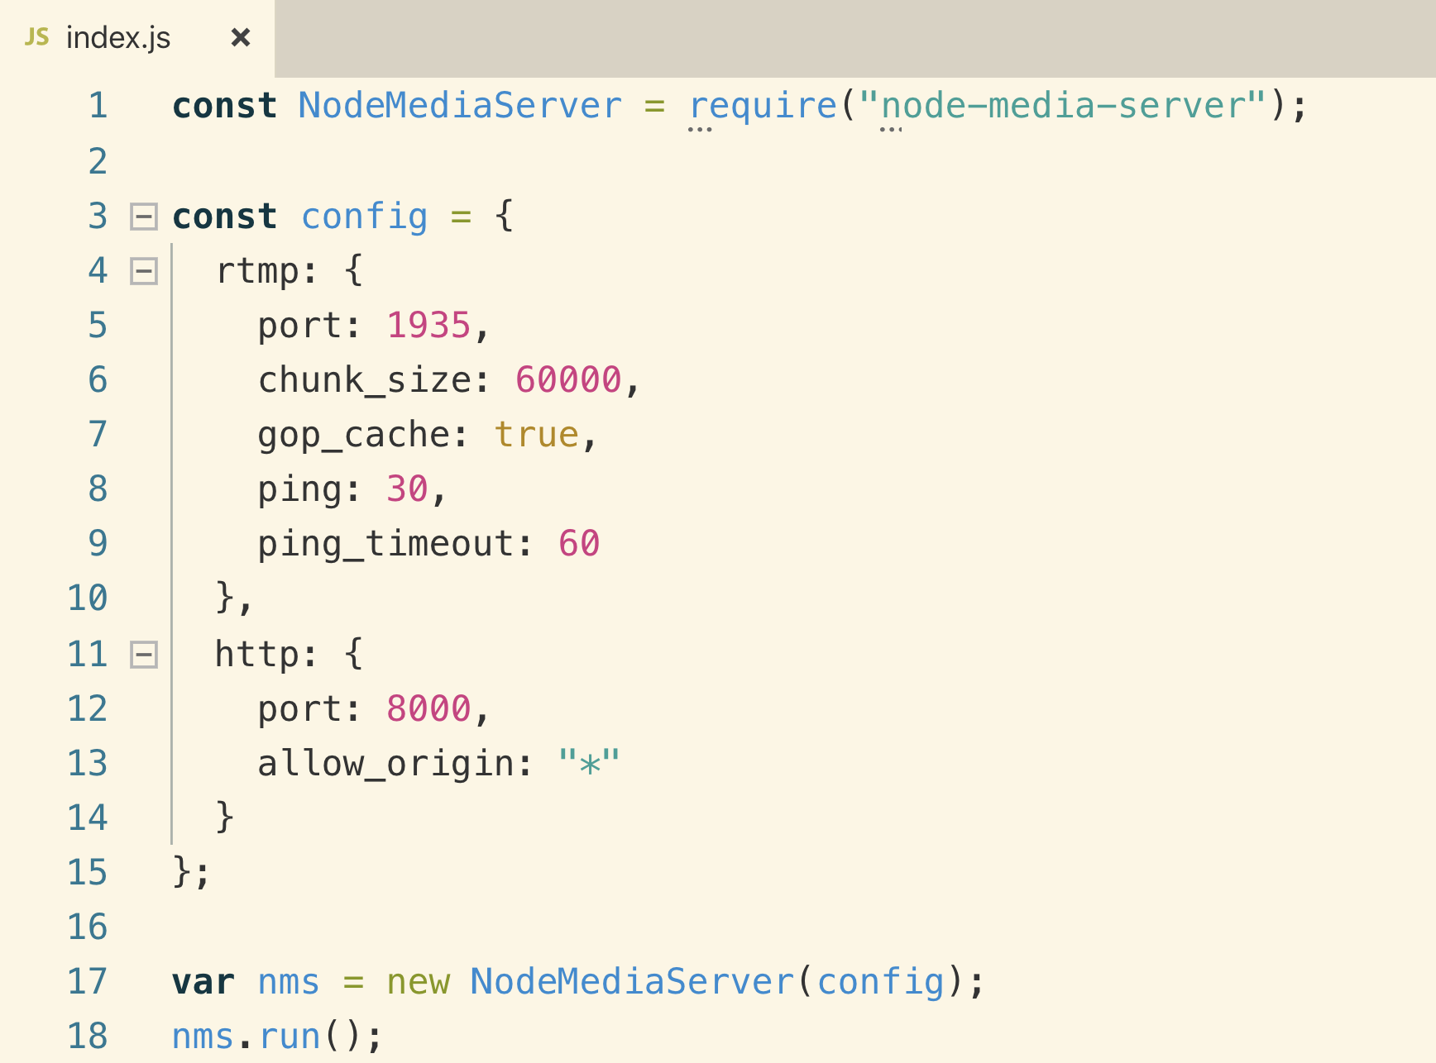

**Now edit the package.json file to to add the server starting command.**

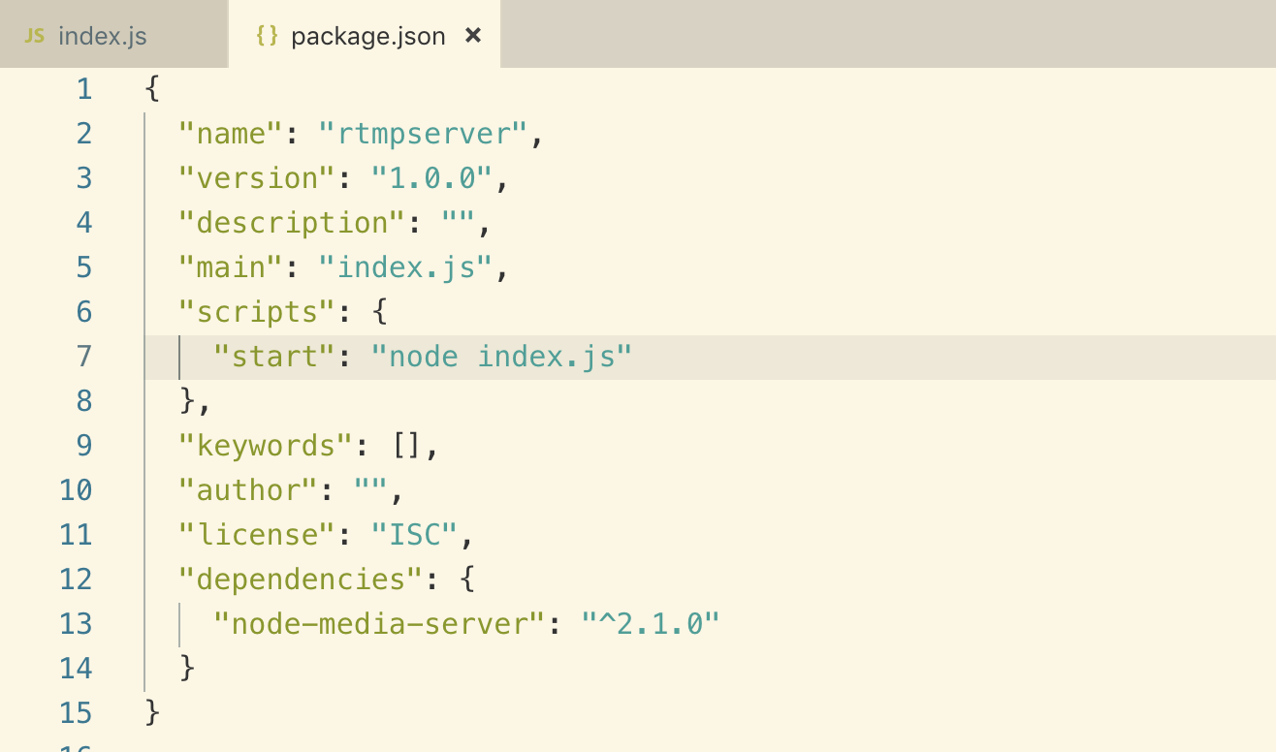

**Now run the command**

**Npm start**

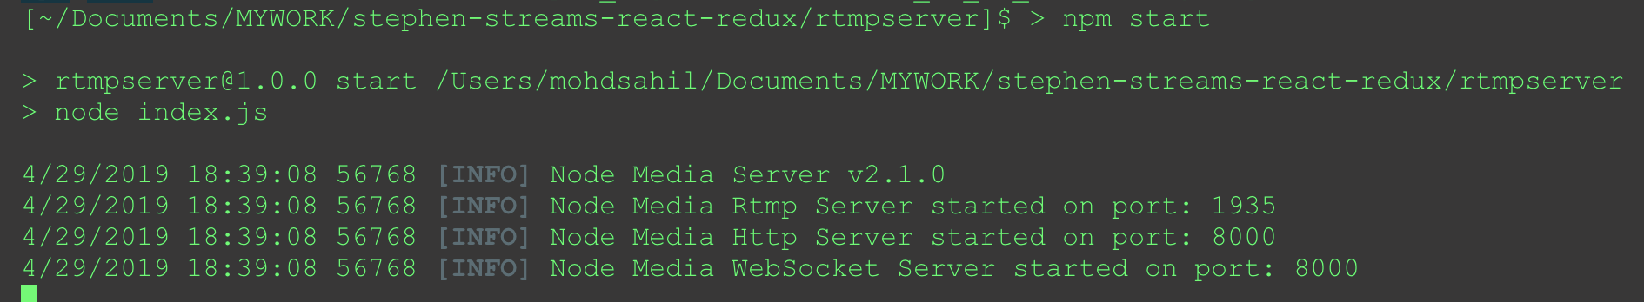

**5. OBS Installation**

**The RTMP server makes video available for consumption inside of our browser on port 8000. This server is also accepting traffic on port 1935 and that’s we are going to send incoming videos streams too.**

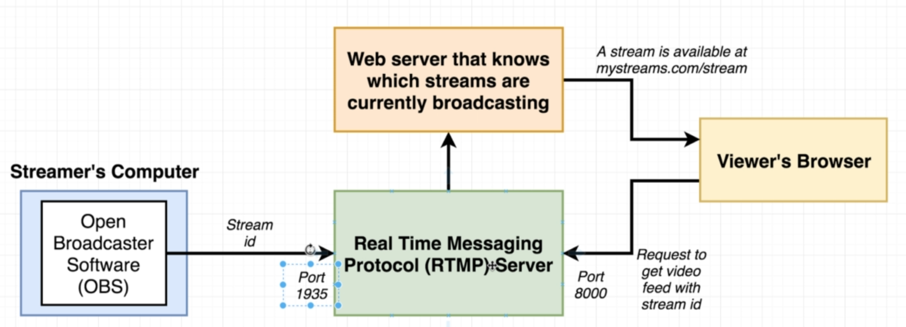

**We will setup OBS from our local computer and this is going to allow you to stream your desktop and some audio from your computer to the local RTMP server and then view that inside of your browser.**

**Let’s install OBS server**

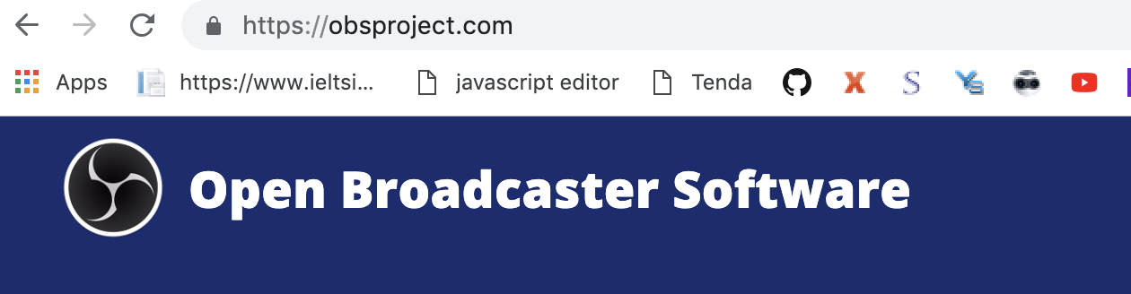

**Let’s configure it for our RTMP server.**

**Select Display capture from sources section**

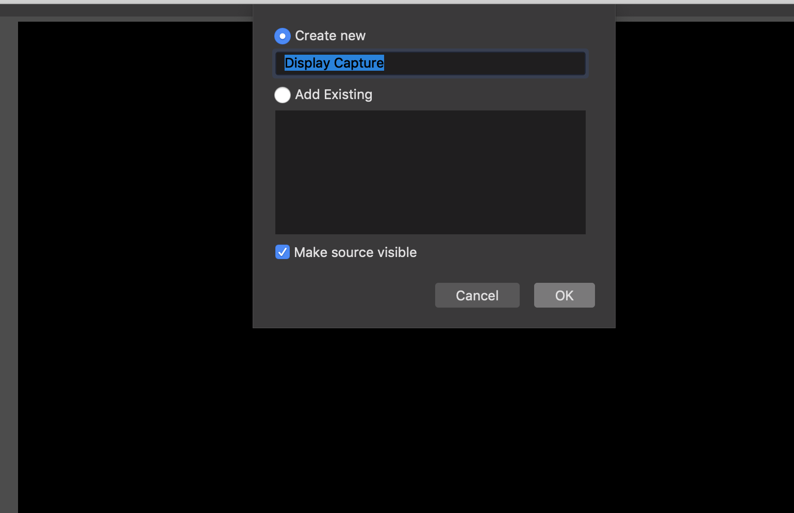

**Now add audio input capture**

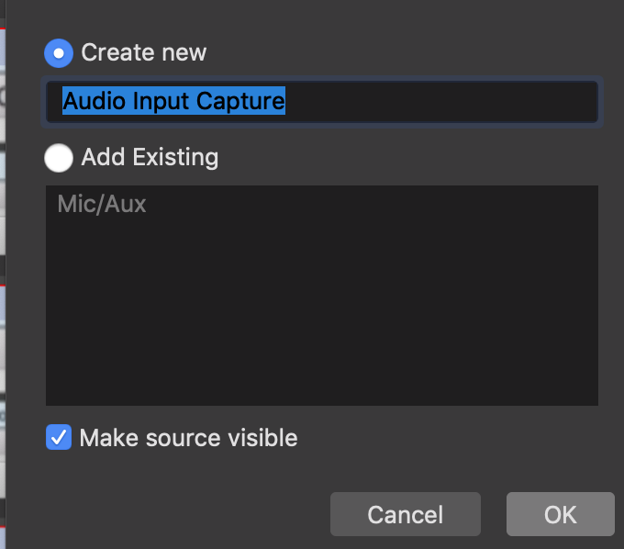

**Now click on start recording. It will save video on the following path**

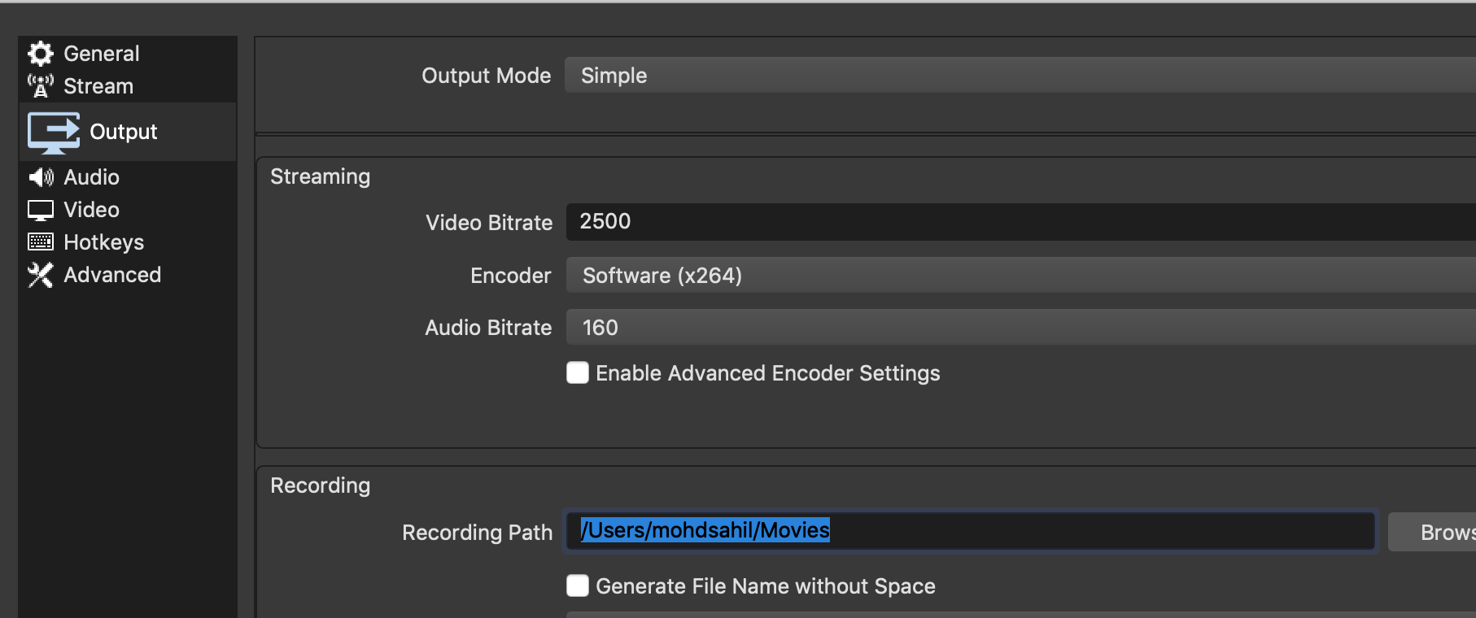

**We have set up our OBS server.**

**7. Video Player Setup**

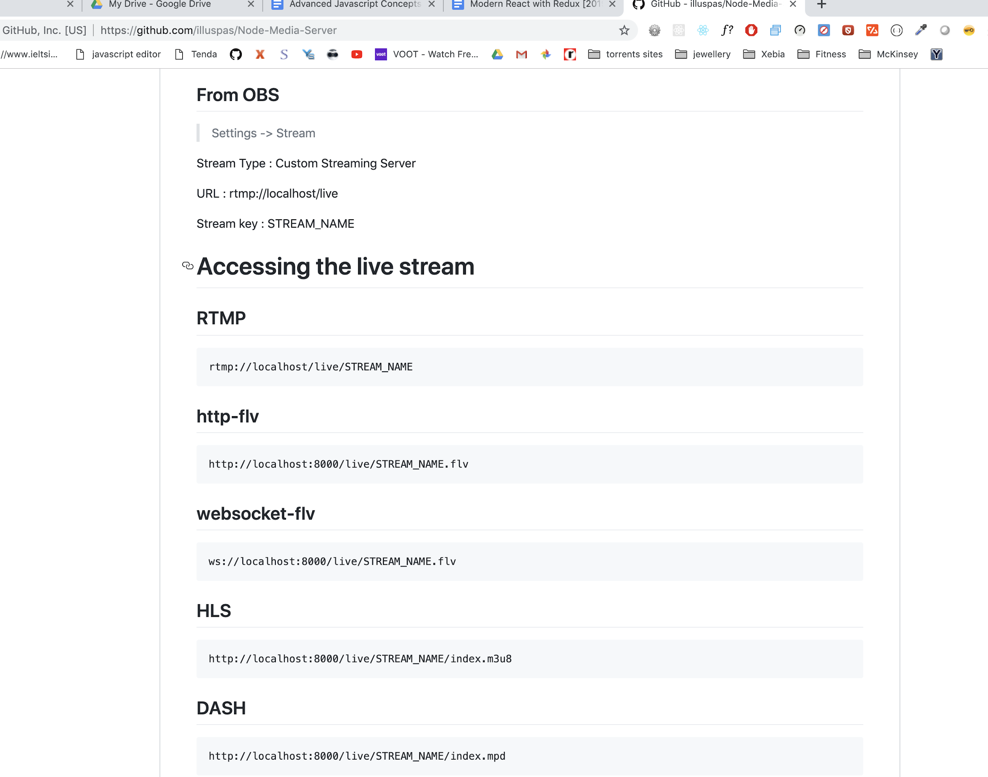

**Go to above node-server-media. They have to shown how to get stream of different formats.**

**Note: DASH and HLS are the latest one which are using these data for internet streaming.**

**We will use flash file and now lets see how convert the code into React.**

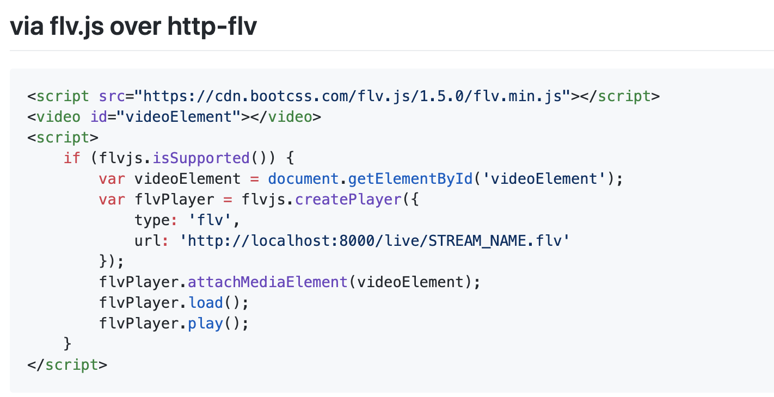

**As you can see it needs flv.js library**

**We will install this library on “client”**



**8. Implementing FLV JS**

**We need to get a reference of the video element that actually gets created on the screen.**

**Remember: the ref system in React is how we can get access or a reference to an actual DOM element that gets created inside of our DOM tree.**

**So in order to get the reference <video> element, we will define our constructor method.**

**Note: if we need to pass the props with value true so we can simply pass the props**

**Example:**

**controle={true} === control**

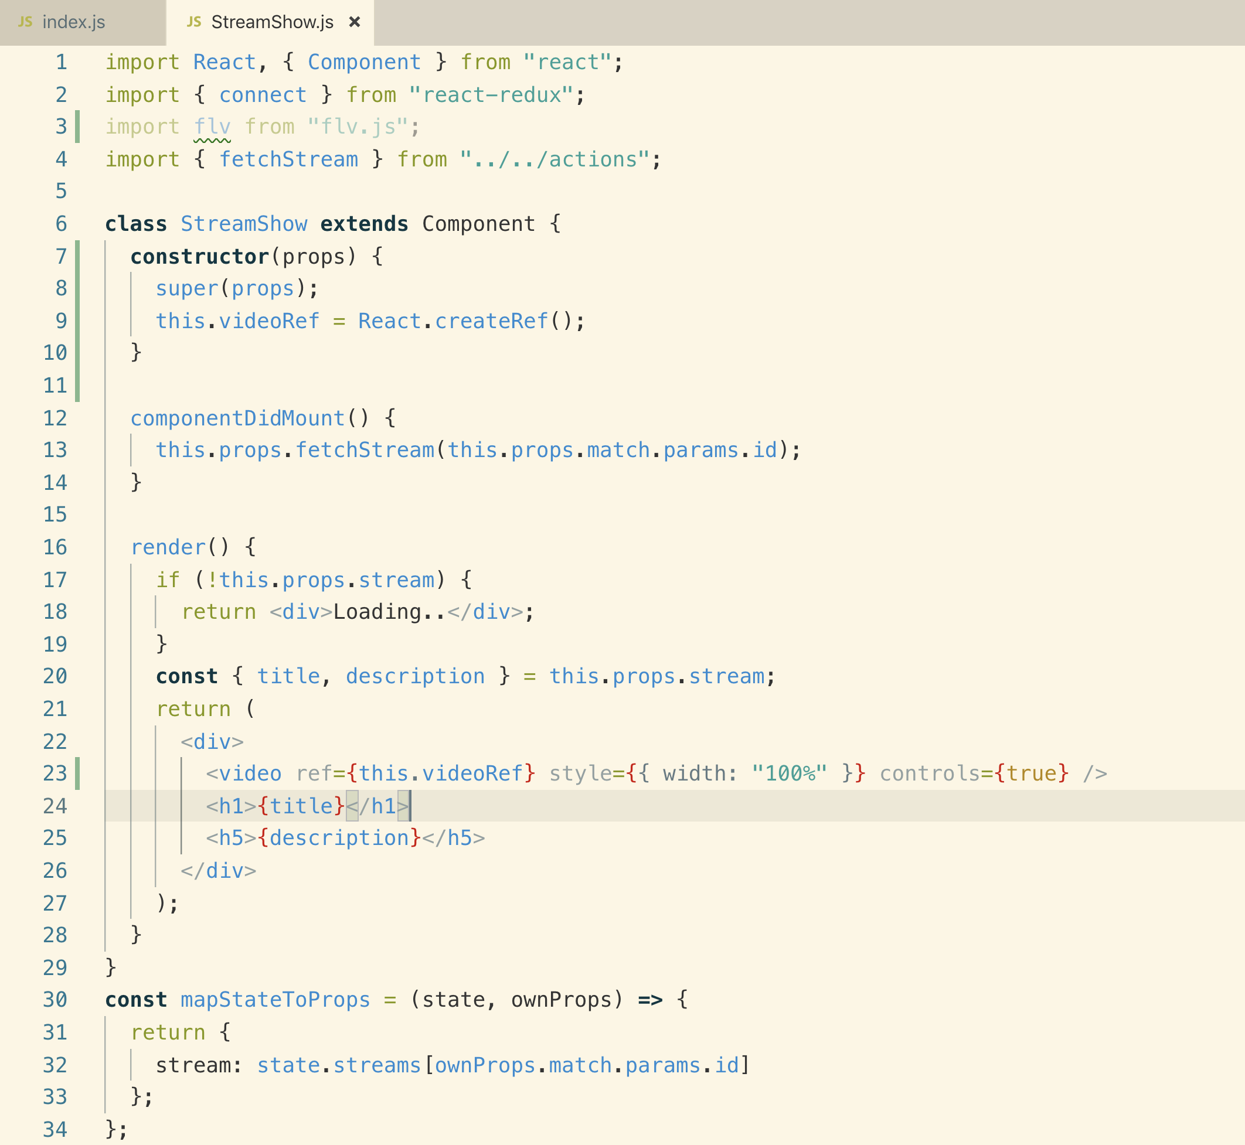

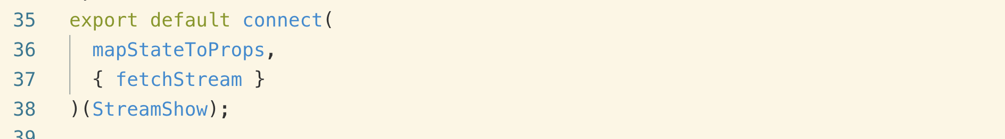

**9. Creating a FLV Player**

**10. Optional Player Building**

**Flv.js is about downloading that video stream and then converting into some file that can actually be played inside of this normal HTML video player.**

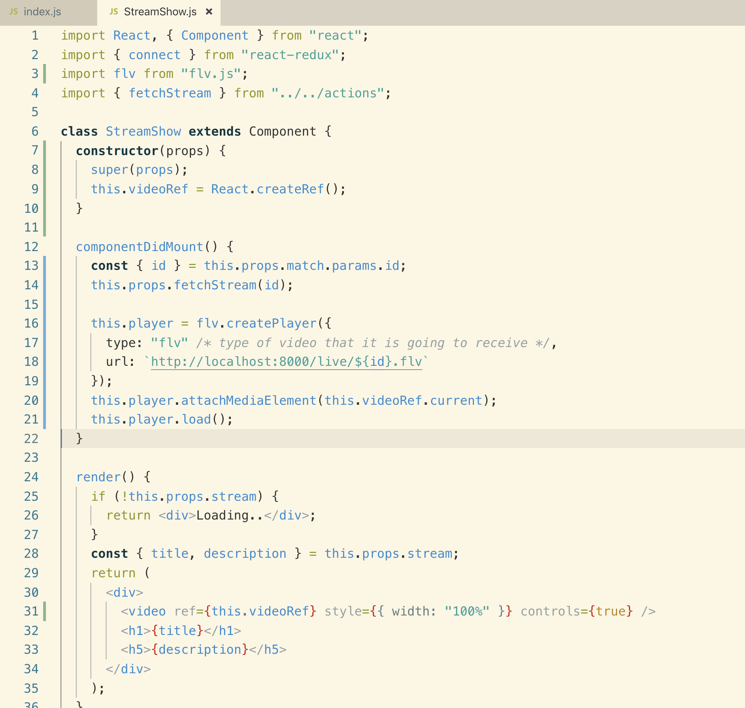

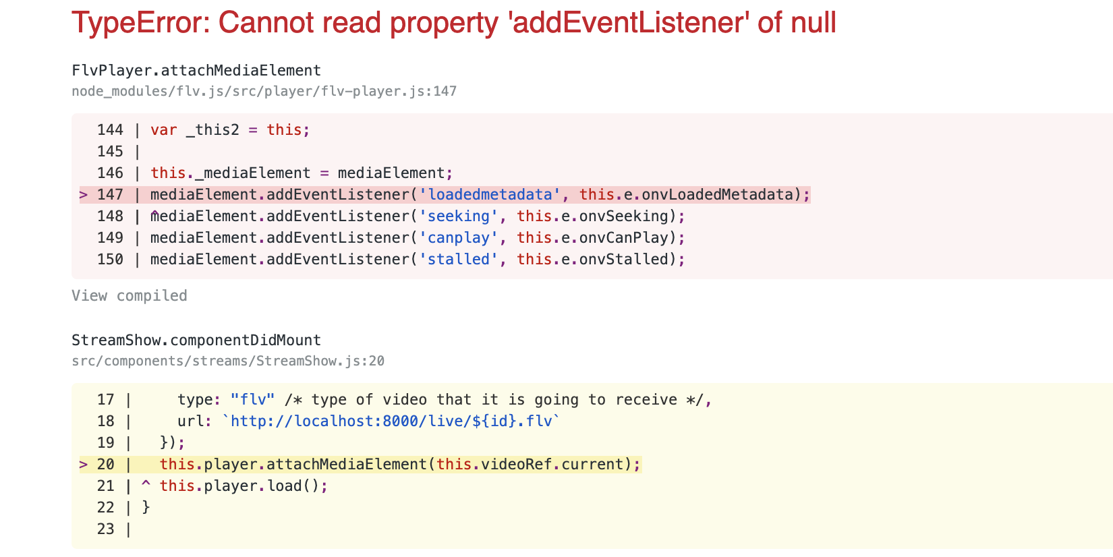

**We get the above. The reason is that we have check that if do not get stream object then return Loading..**

**When our component first renders, if we don’t have the stream then we are not creating the video element at all!**

**So we never create the video and we never attach our ref to that video element.**

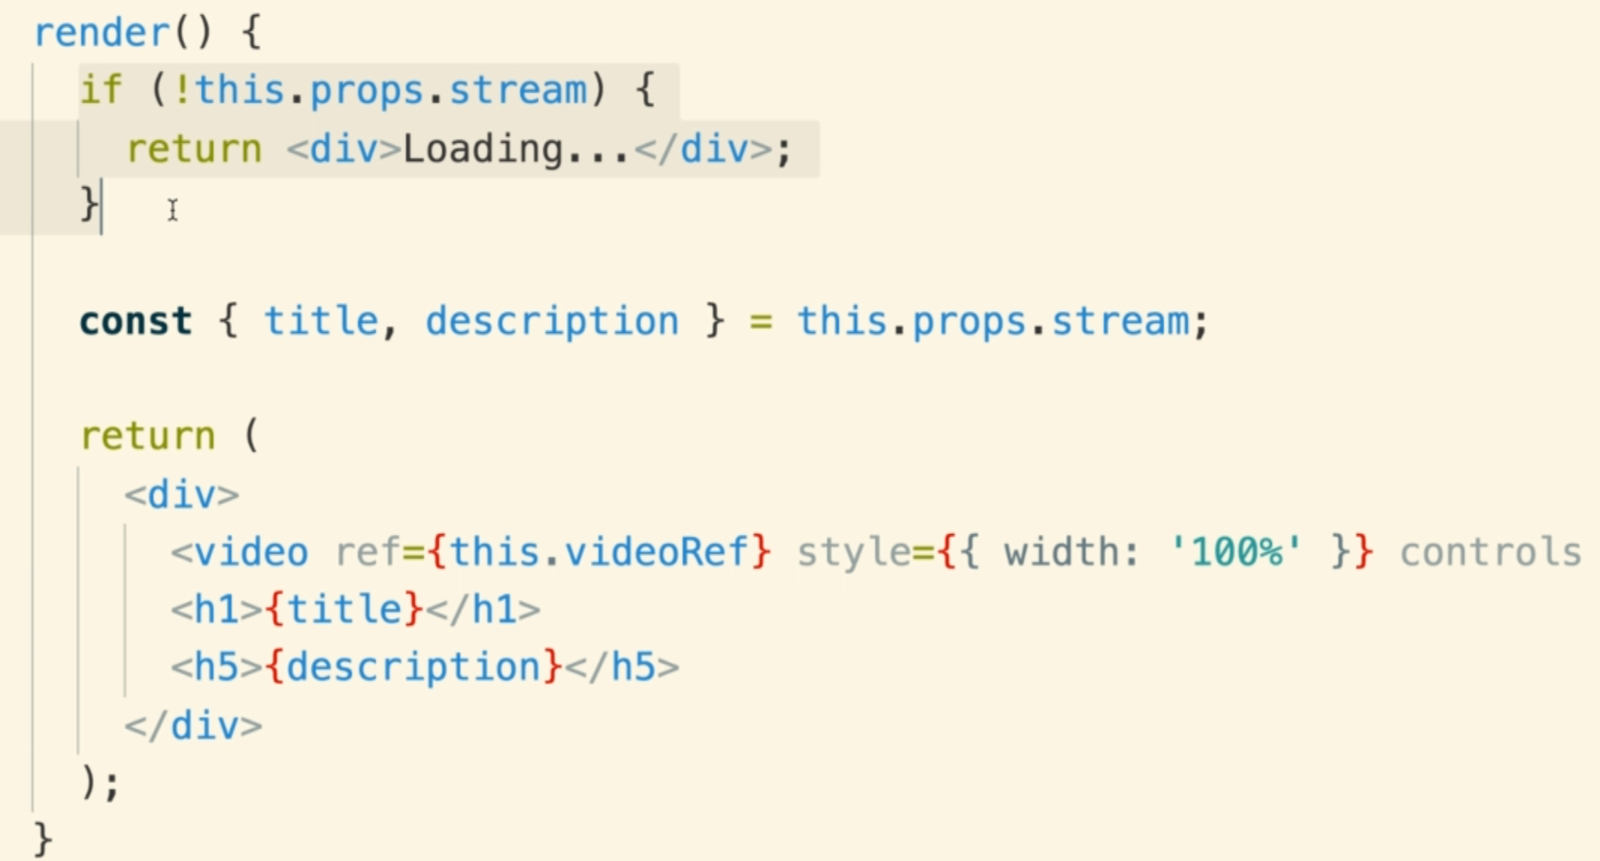

**We will create a helper method that will load the player once the stream is available.**

**If we do not have access to the stream and we are going to fetch it on the fly, we need to have some place to call buildPlayer after we have successfully fetched the stream.**

**For this we will use Update Lifecycle method.**

**If our component fetches the stream successfully at some point in the future and the component re-renders, componentDidUpdate() will be called, and we will attempt to call buildPlayer() as well**

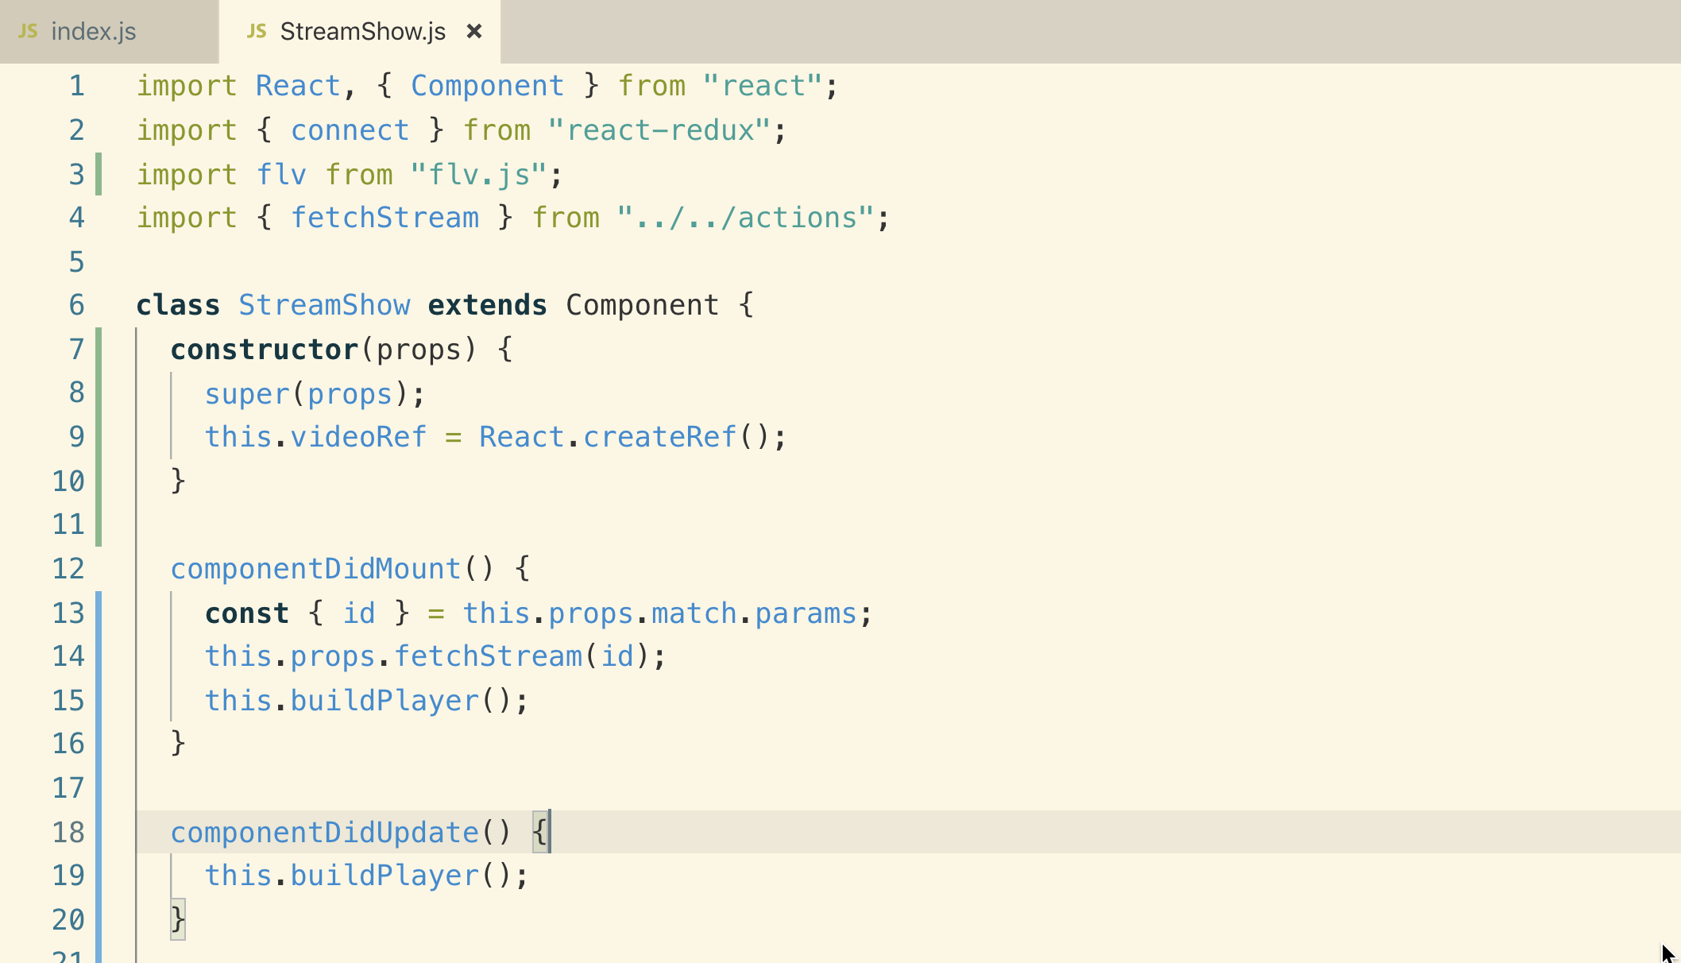

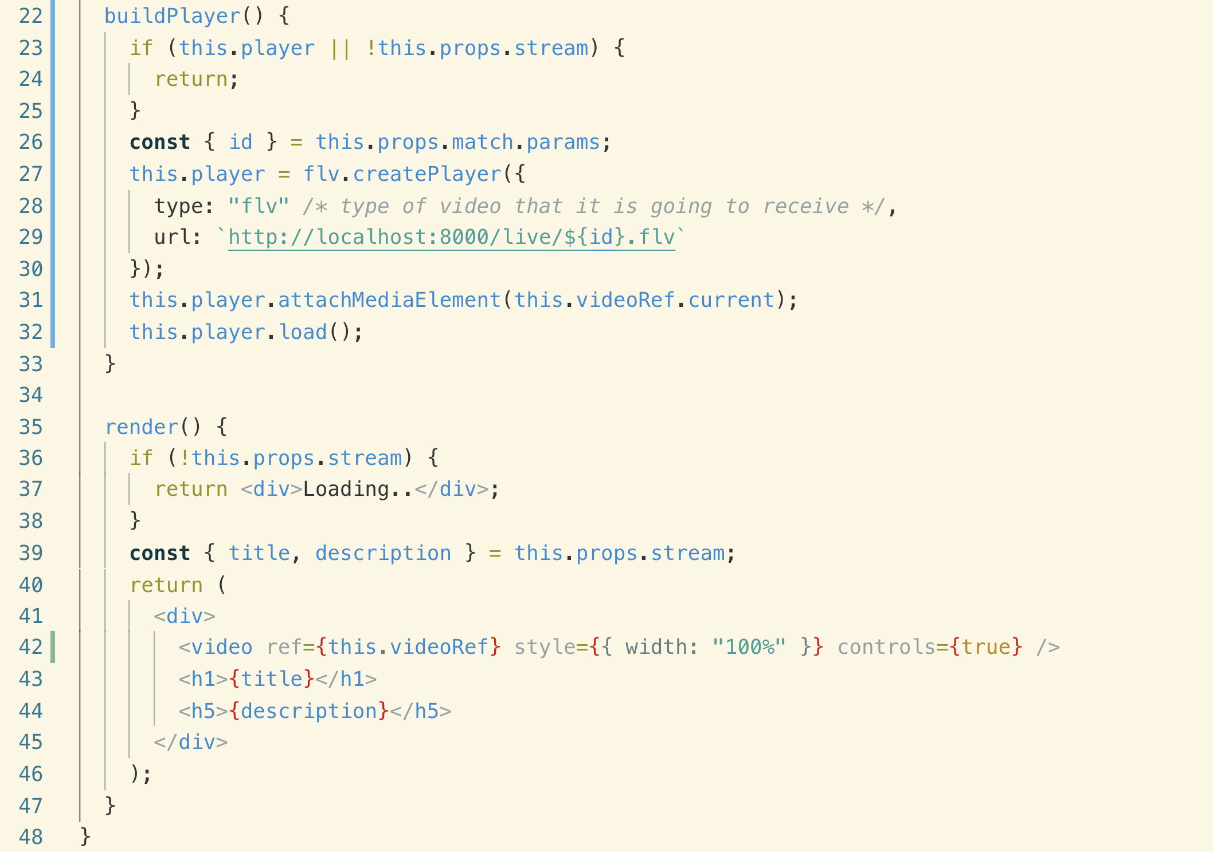

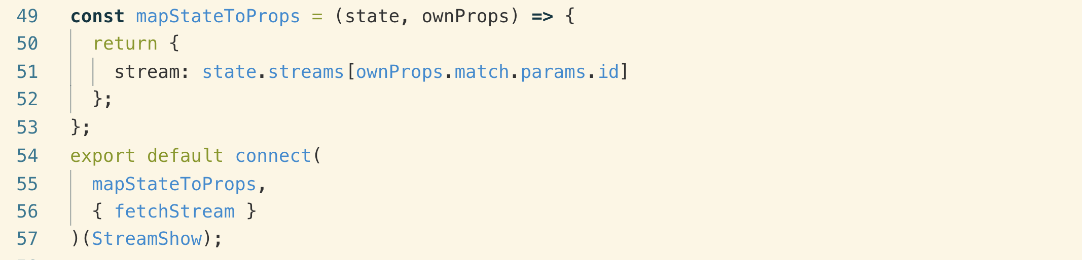

**11. It Works!**

**We need to configure OBS for streaming videos**

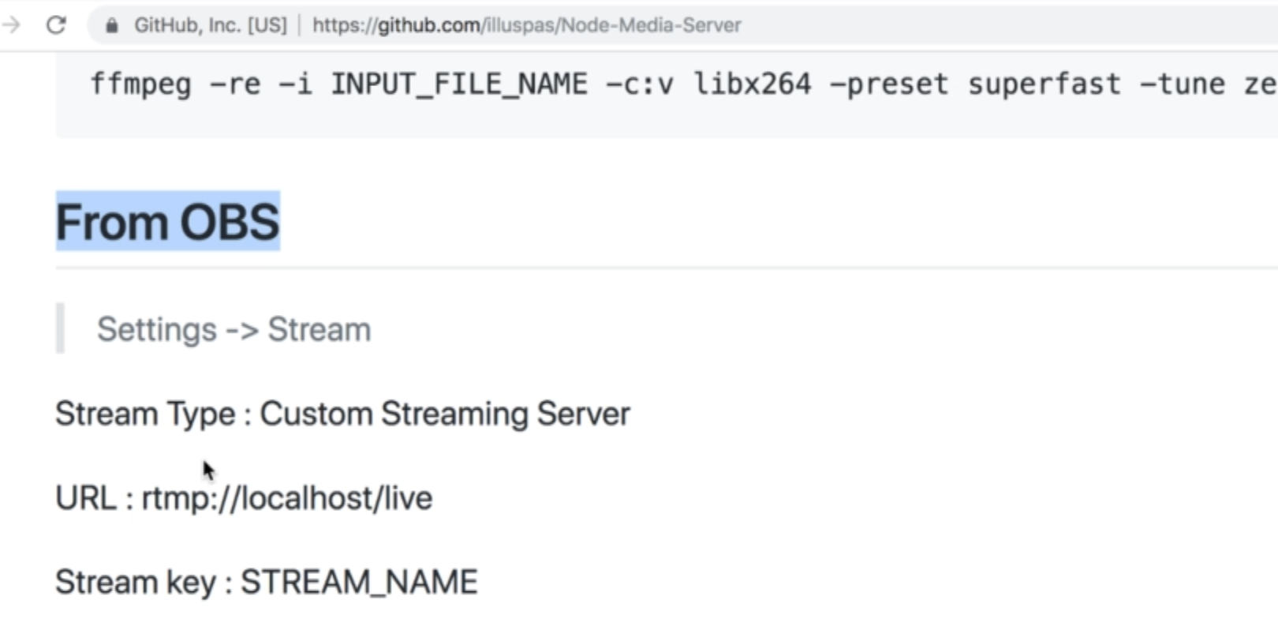

**We need to add the same stream id on which we are**

**Example: we are on stream id : 2**

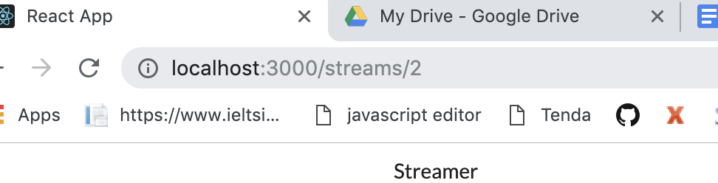

**In OBS setting**

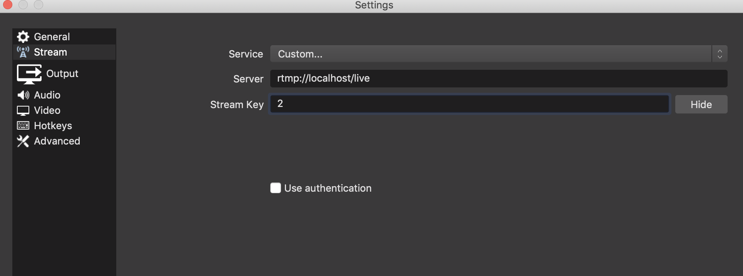

**12. Cleaning Up with ComponentWillUnmount**

**When we stop stream, we see an error message inside of our console.**

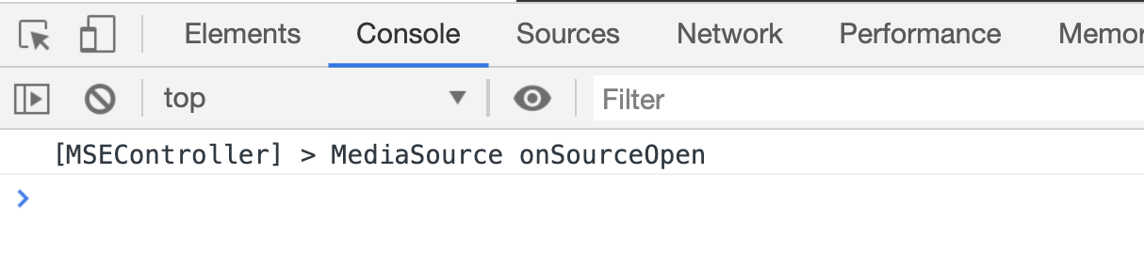

**When we navigate from streamShow component, there is no code that tells this video player that create to stop steaming from our video server.**

**So even though we are no longer looking at that video player, the video player is still attempting to download and process video and that’s why when we stop our stream we eventually see this console log of “MediaSource”**

**So we want to try and process any of that video when the video player is not present on the screen.**

**componentWillUnmount: use this method anytime to clean up some resources that are being used by our component.**

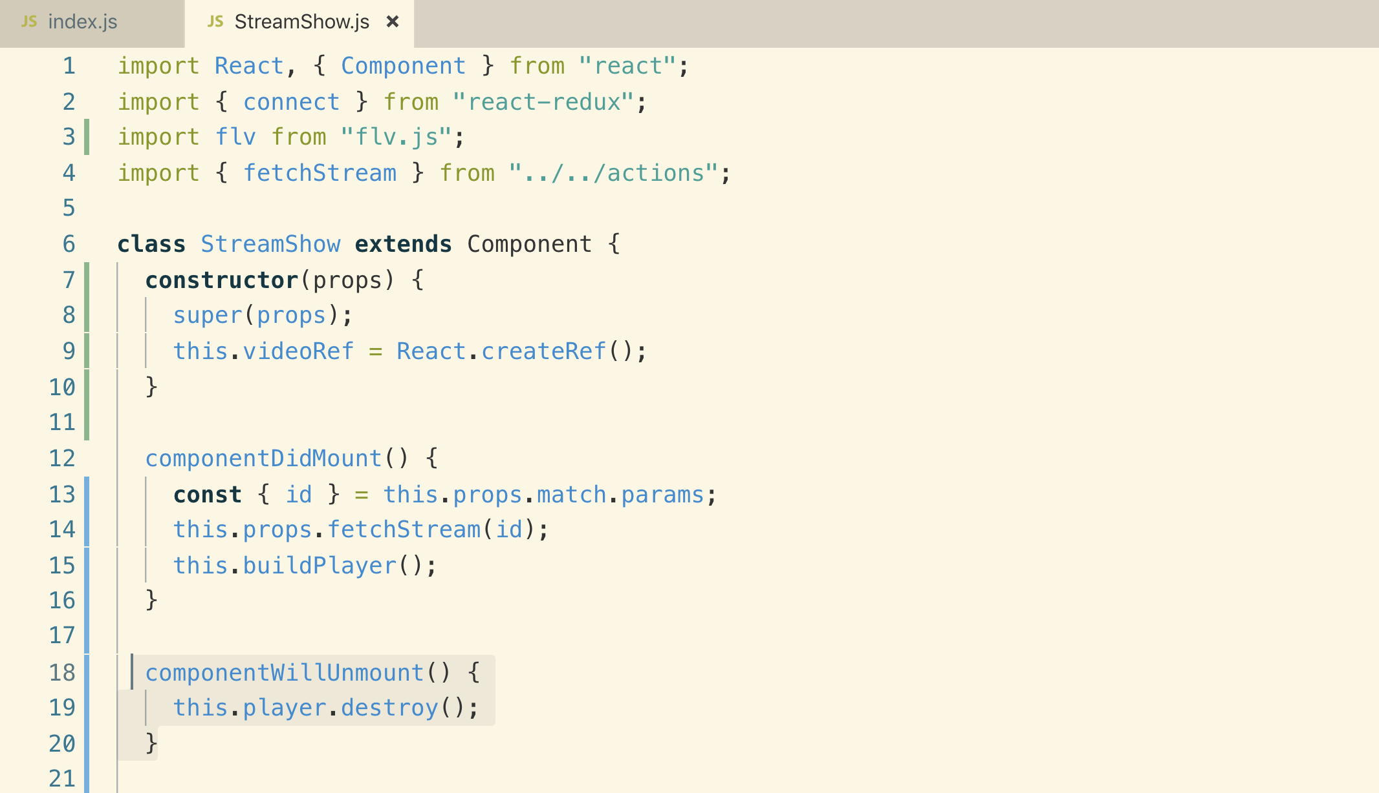

**23. The Context System with React**

**1. The Context System**

**A new version of Context is released in React 16.**

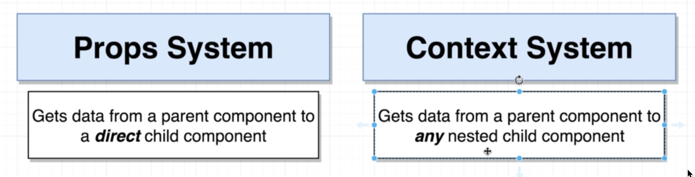

**Props system passing button text from parent component to child component**

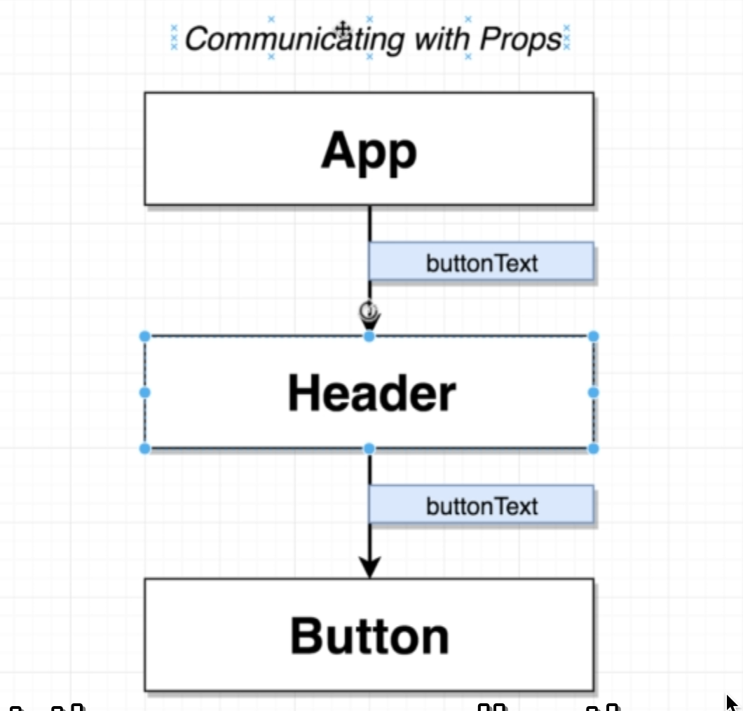

**Context system: is all about communication of data that is it!**

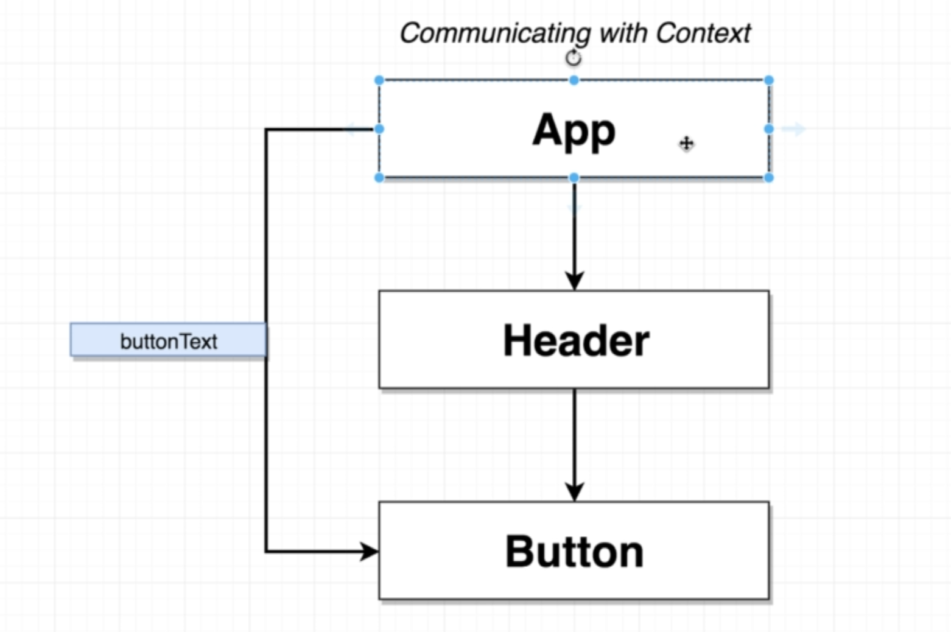

**2. An App with Context**

**This is the App we are going to build**

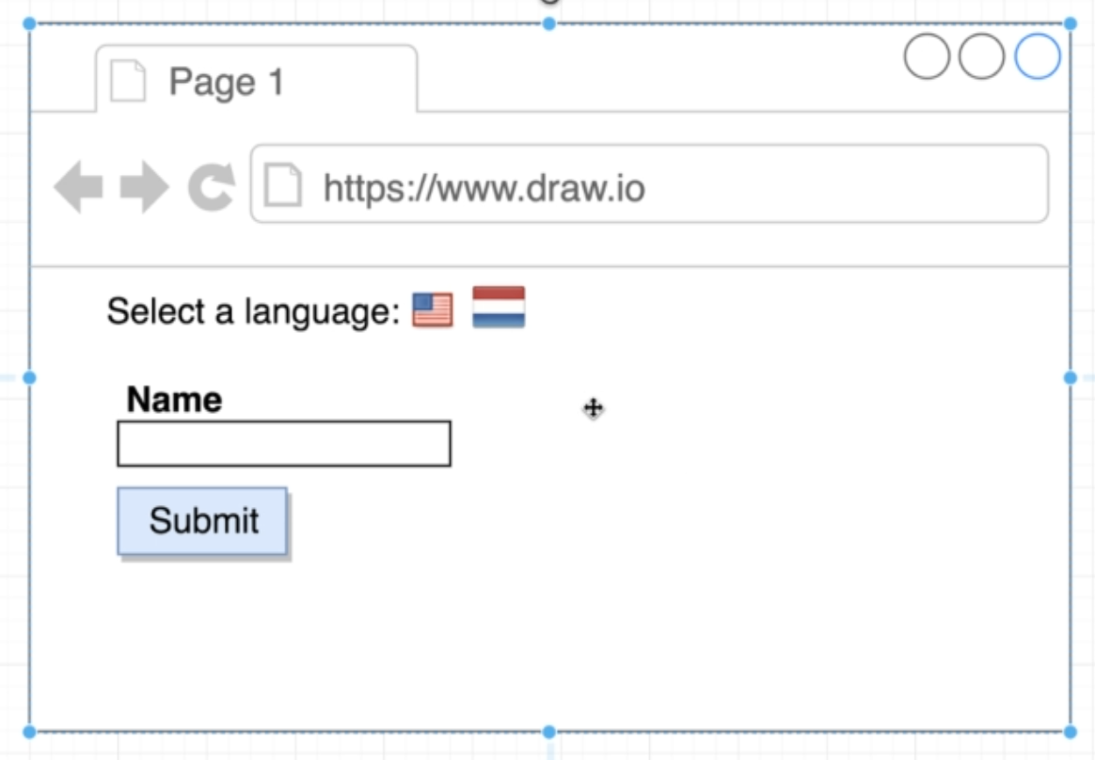

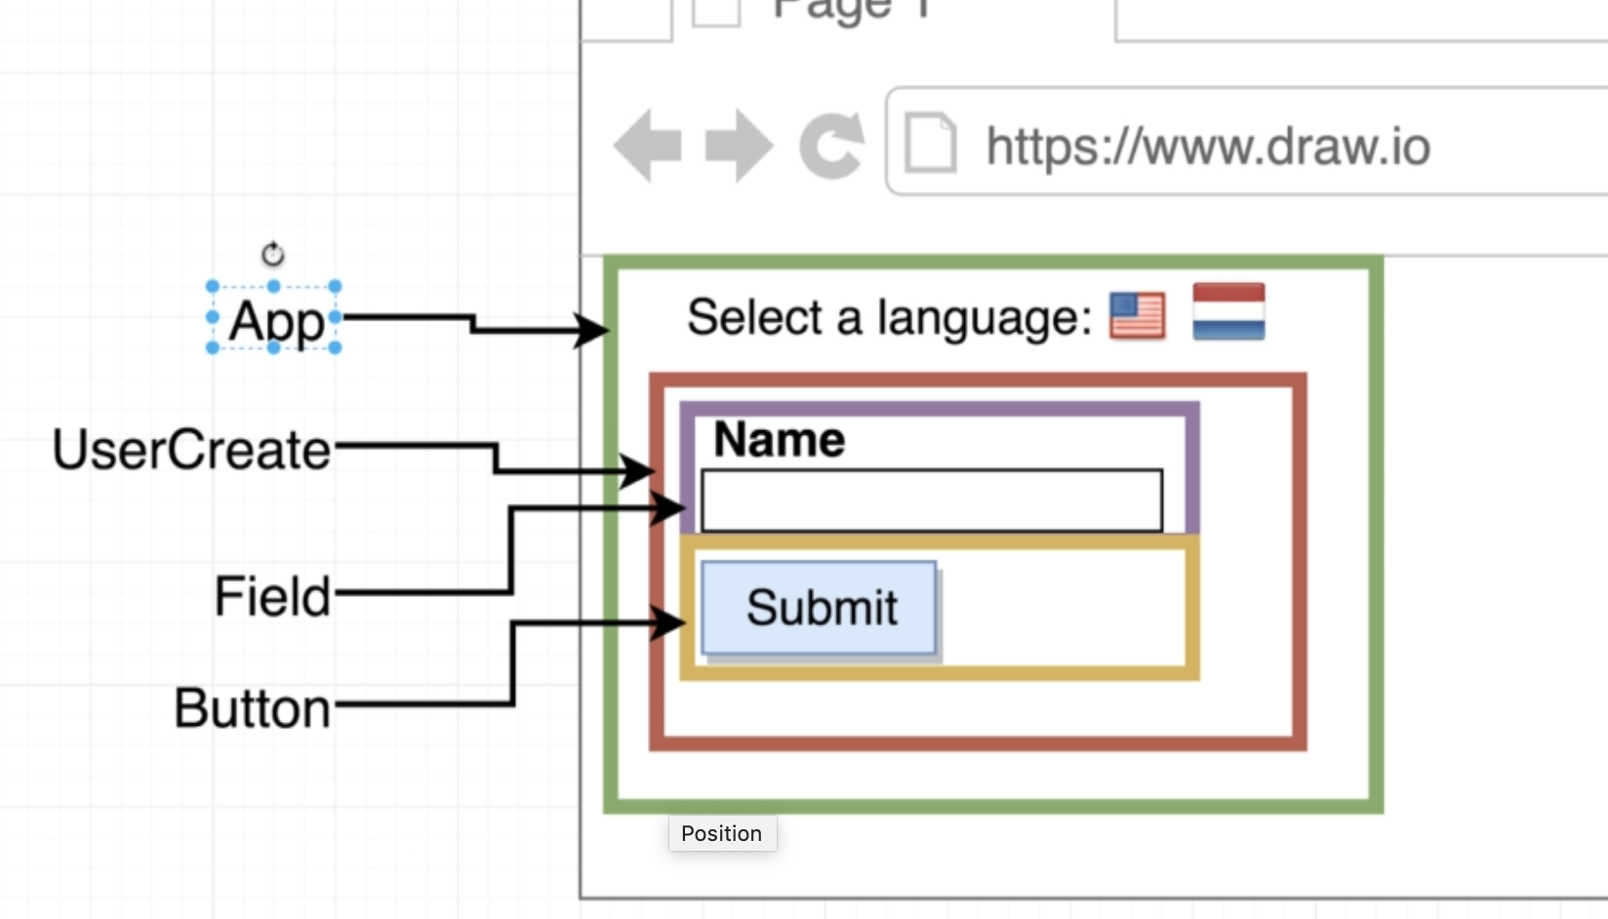

**We will use “Context System” as “UserCreate” component doesn’t require language props so can directly pass props to field and button and to directly sending props to field and button we will need “Context System”**

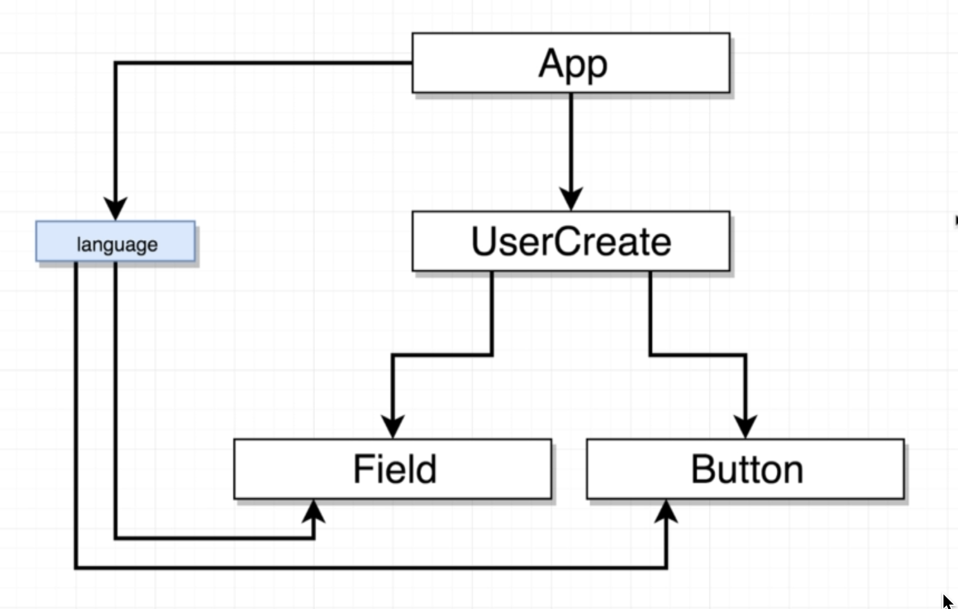

**We created a new project npx “create-react-app” translate-app on that same level as client.**

**3. App Generation**

**Let’s just do basic setup that we have been doing for a long time.**

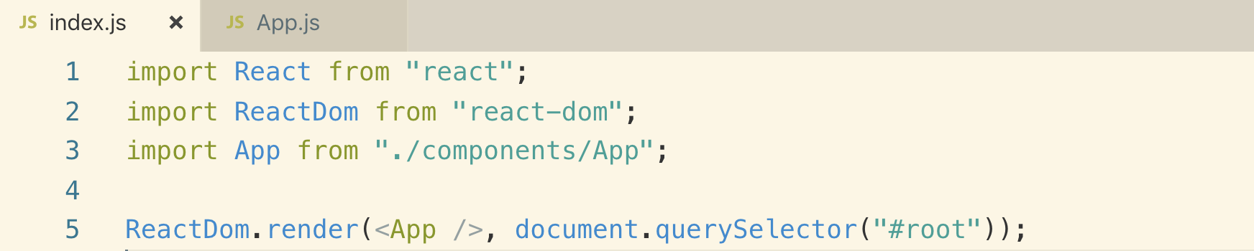

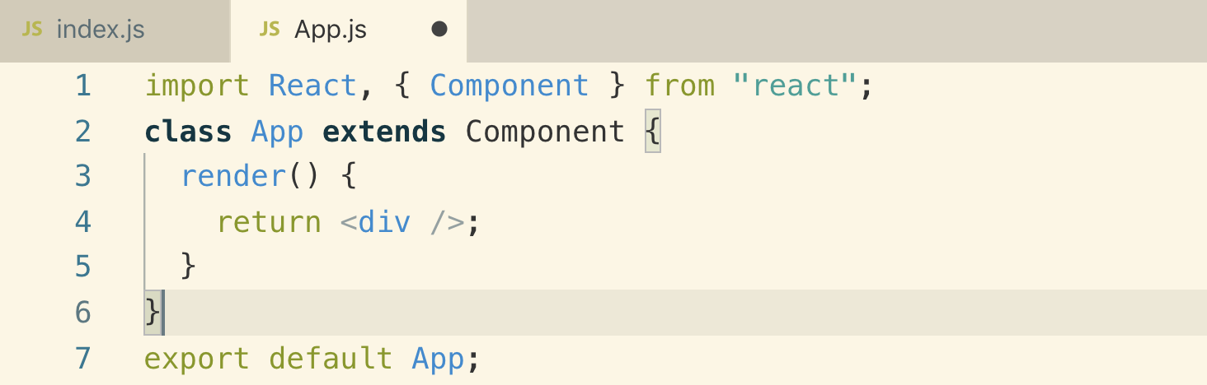

**4. Selecting a Language**

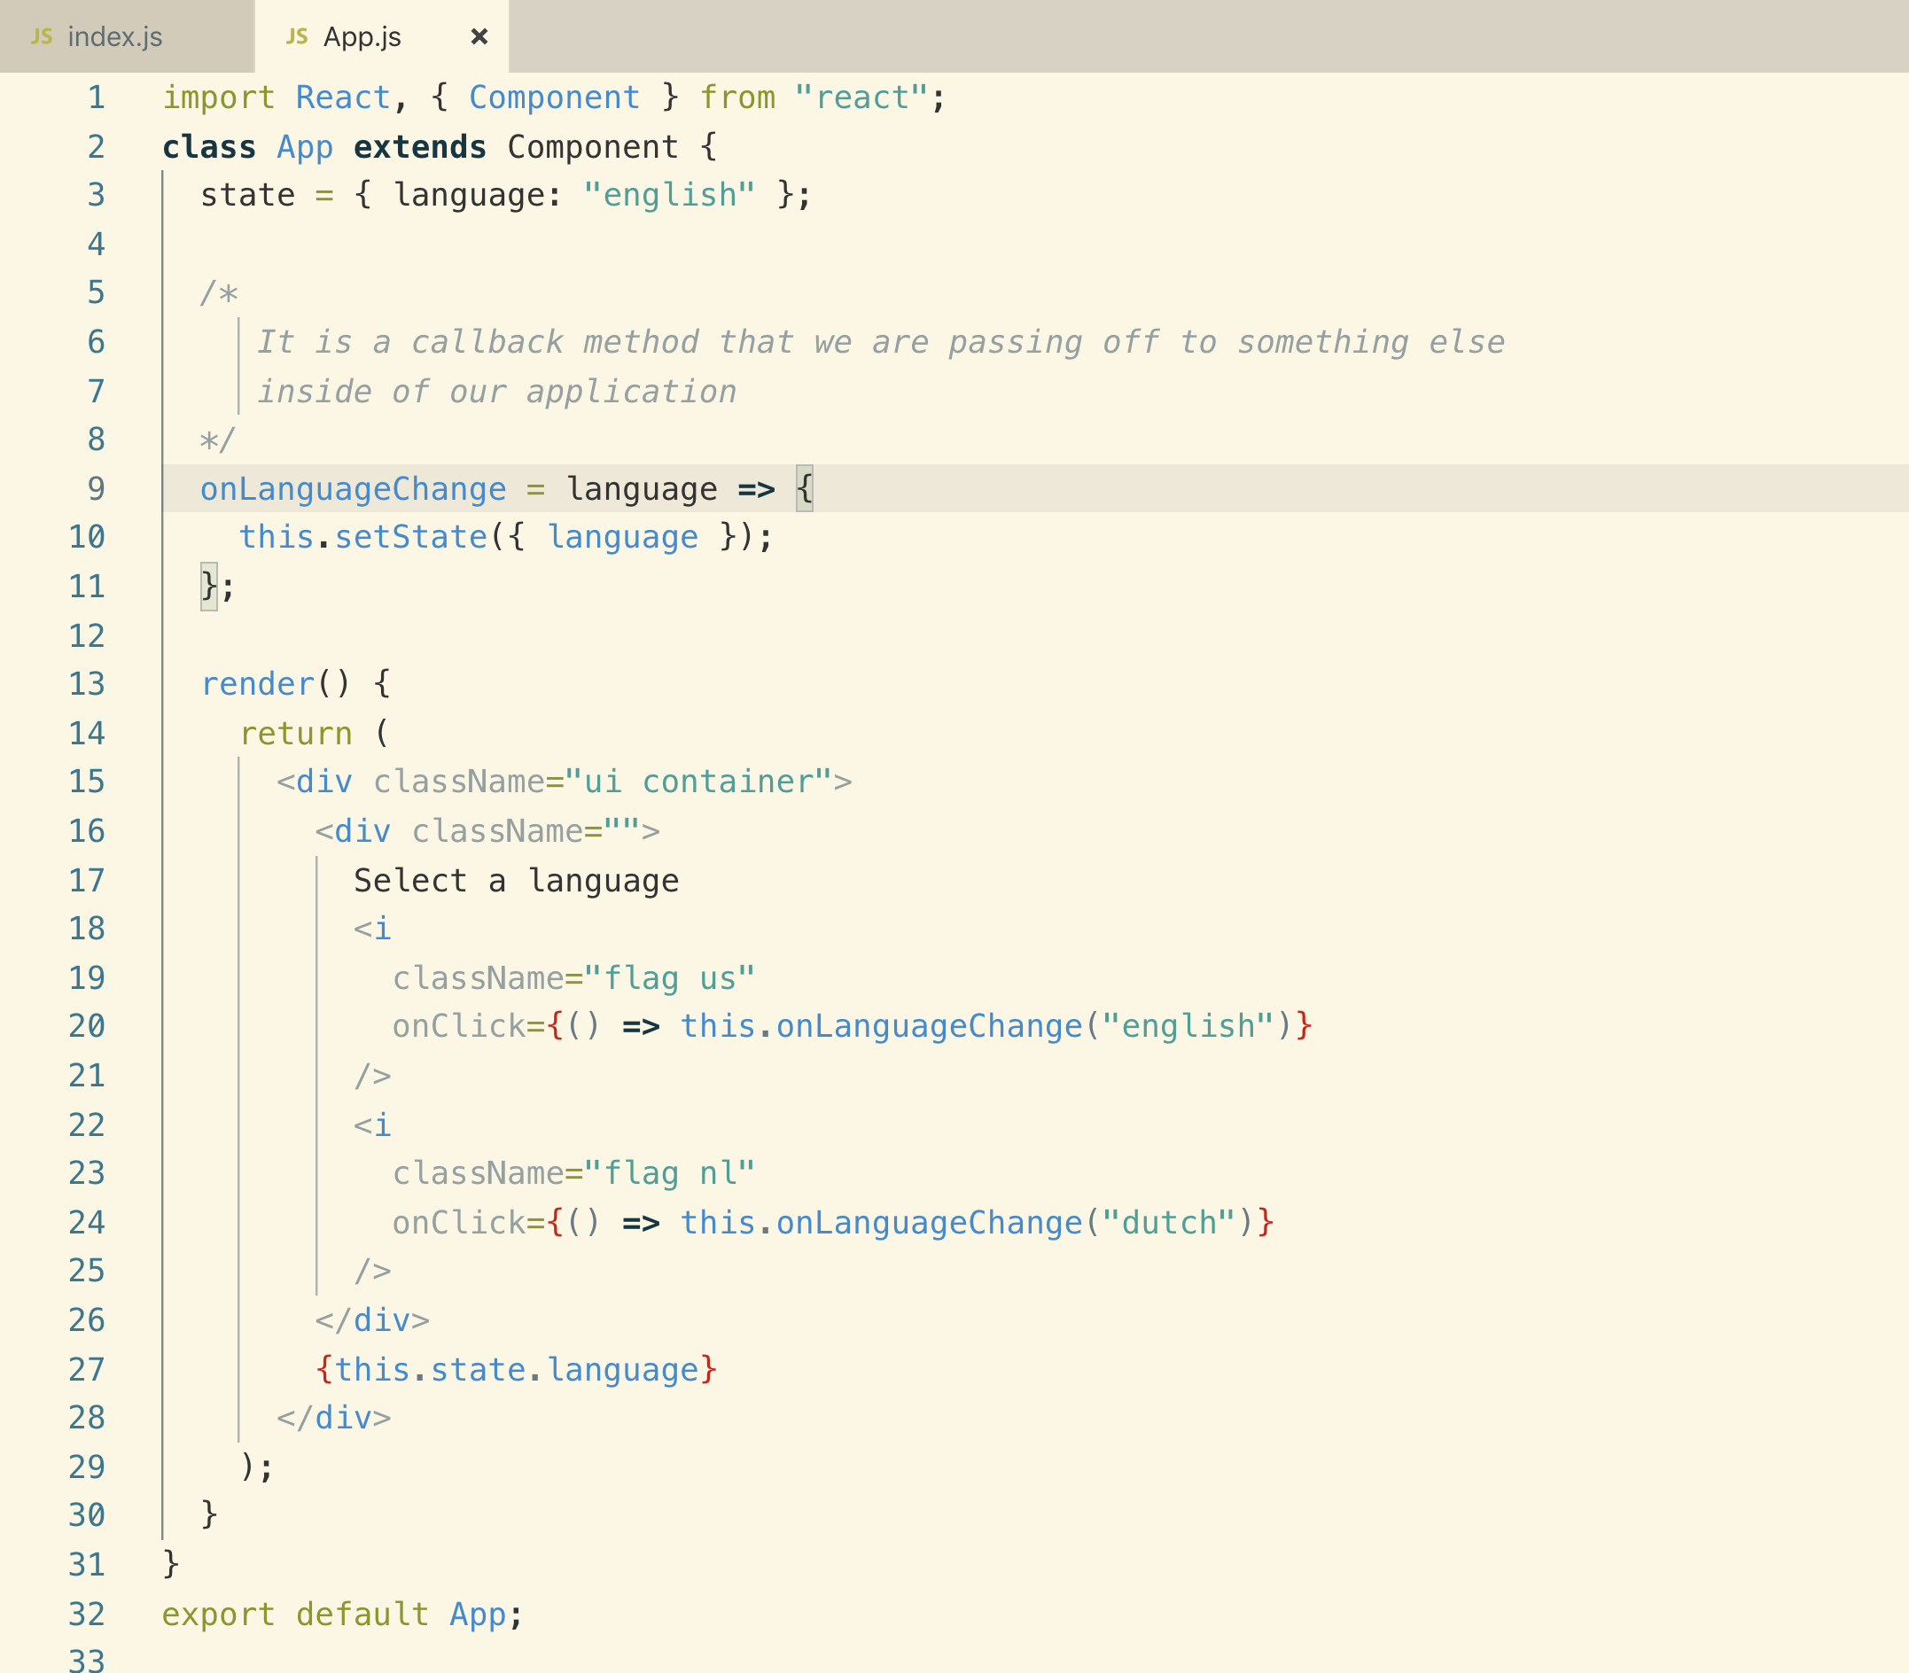

**5. A Touch More Setup**

**Let’s create the required 3 components**

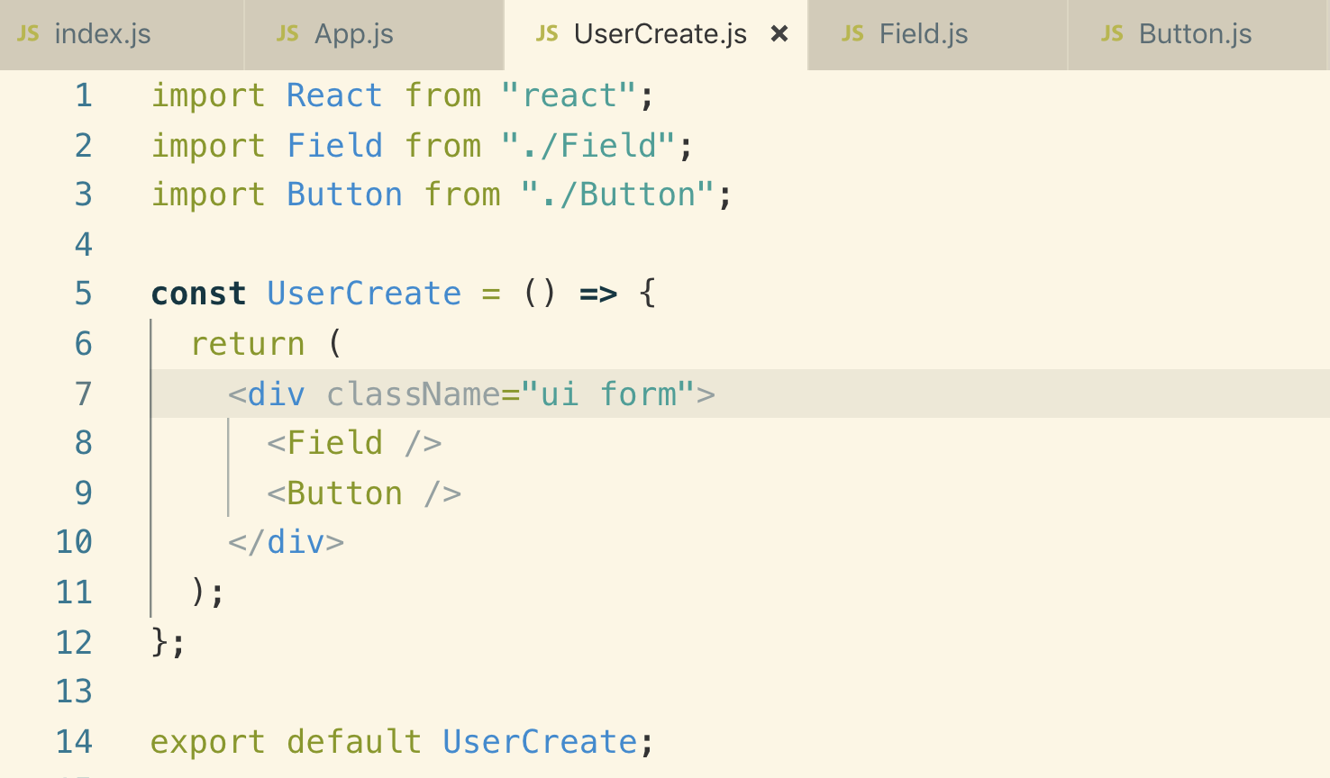

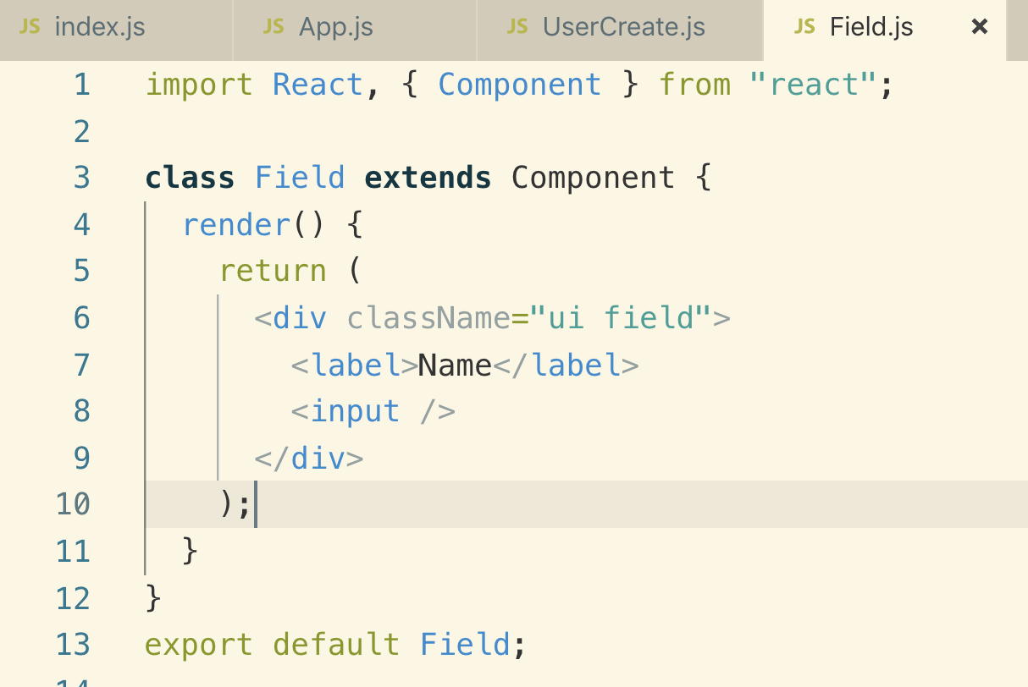

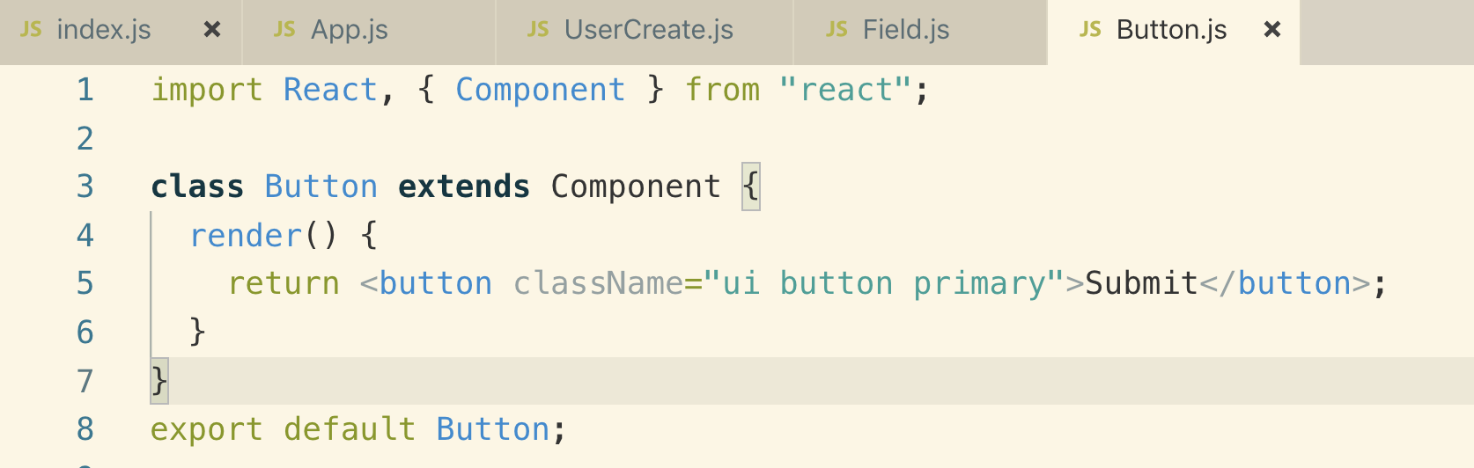

**6. Getting Data Out of Context**

**Let’s see how to use Context object. We pass data to nested child components**

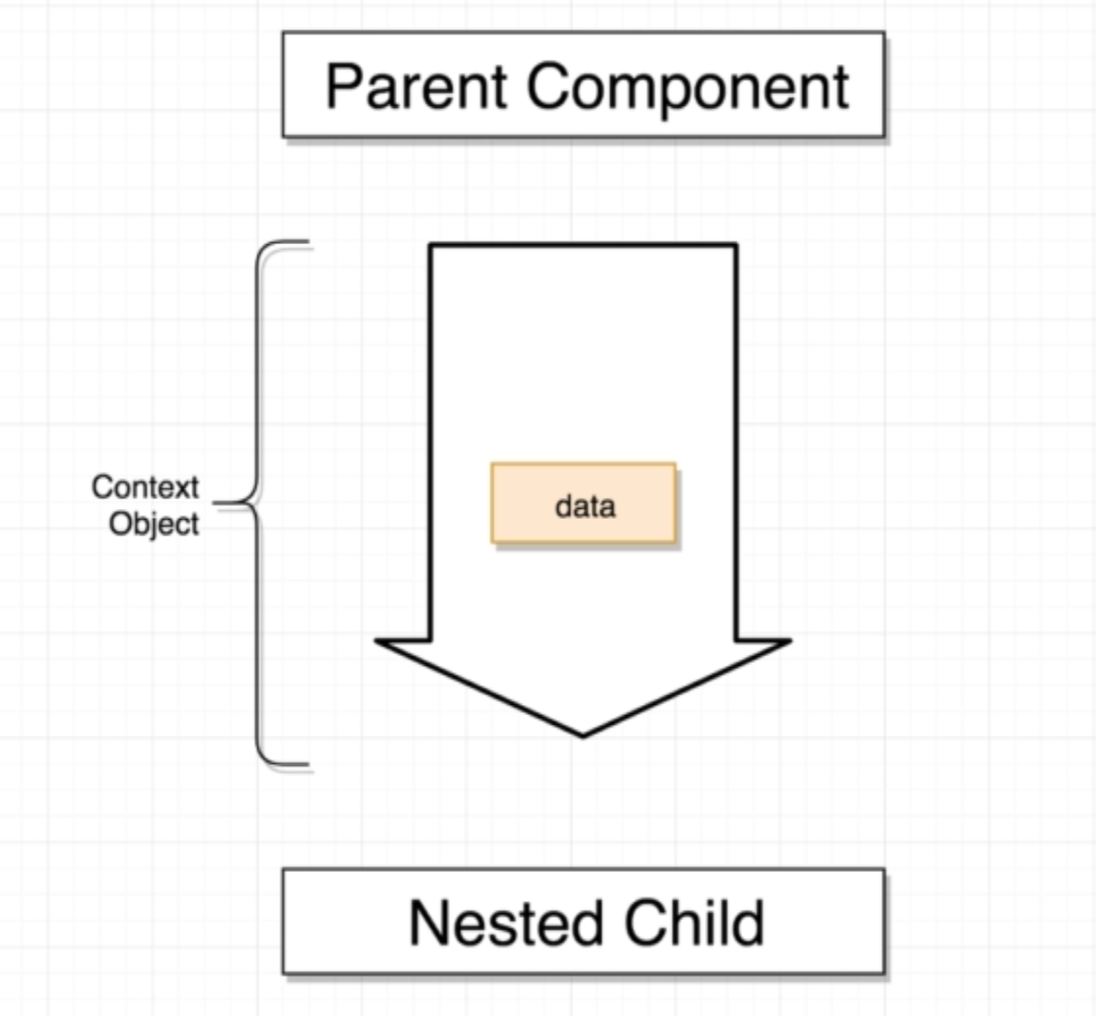

**In our case App is the parent component and Button and Field are the nested child components**

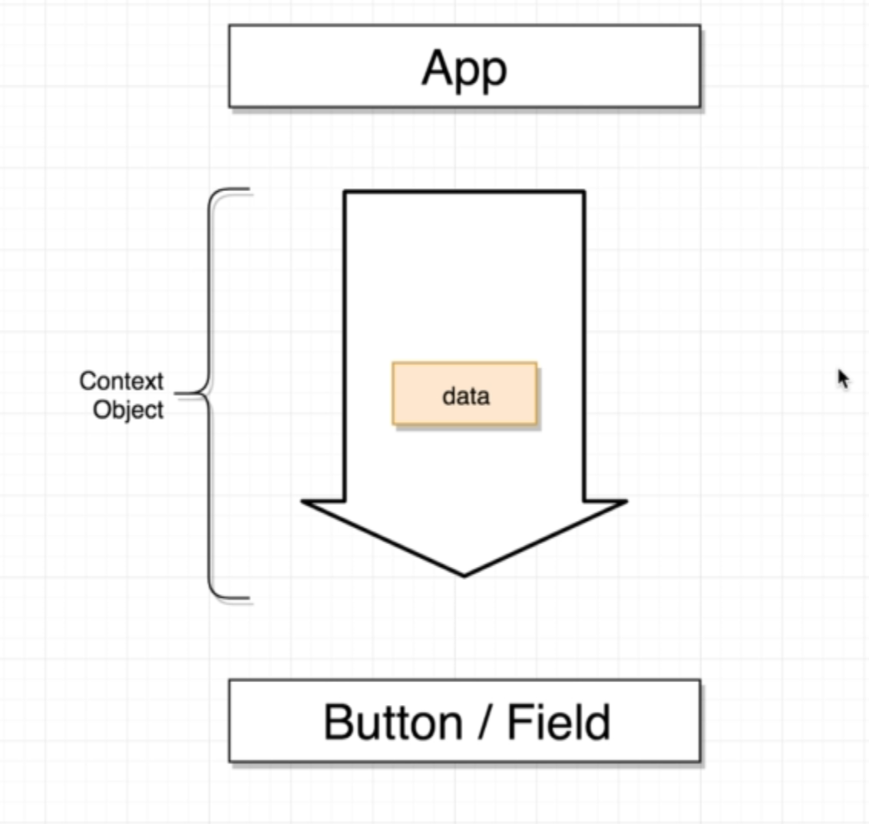

**There are 2 ways we can set and get information to our Context Object**

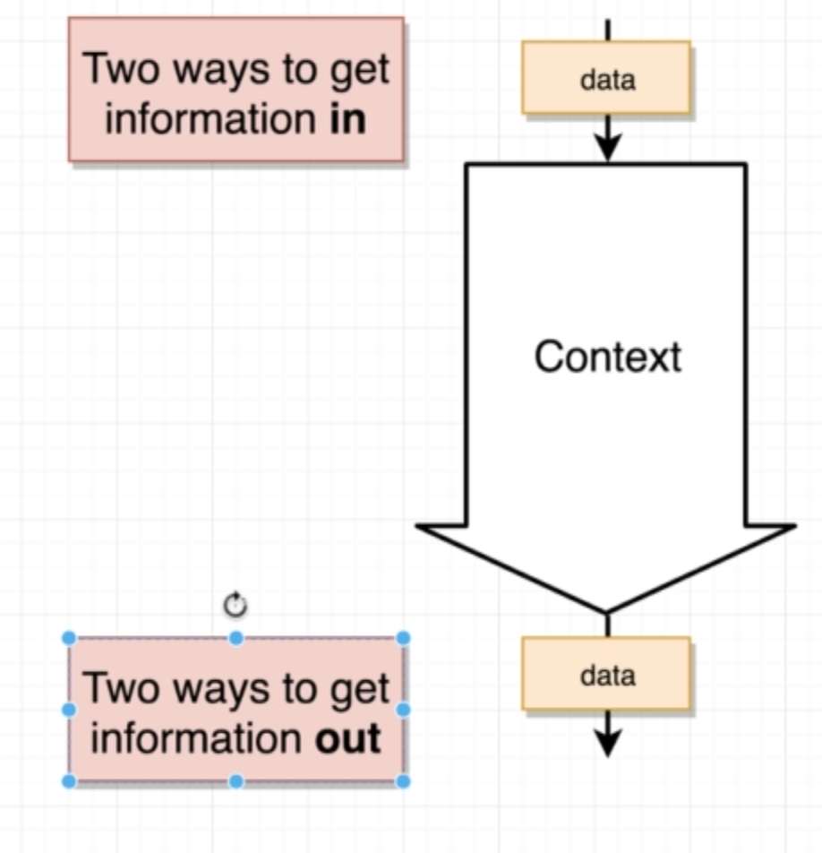

**2 ways to set data into our Context Object**

1. **One way to set value into our Context Object is to set default value when is created.**
2. **The 2nd way we can create a Provider inside our parent component. The Provider Component can essentially push information into the Context Object**

**2 ways to get data into our Context Object**

1. **One way to get value from our Context Object inside the nested child component is using this.context**
2. **The 2nd way we can create a component called Consumer inside our parent component**

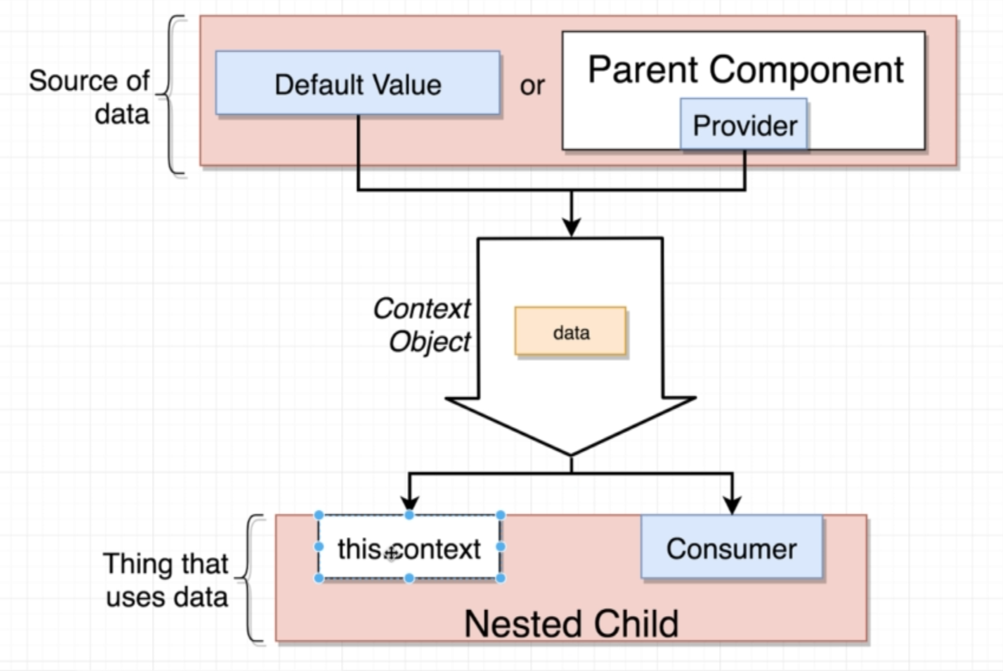

**7. Creating Context Objects**

**Create a contexts/LanguageContext.js The purpose of this file is to create a context object and export it**

**The reason that we are putting this into a separate file is that we can import the Context Object into only the component files that we care about in our application.**

**We will create Context Object with default value of “english”**

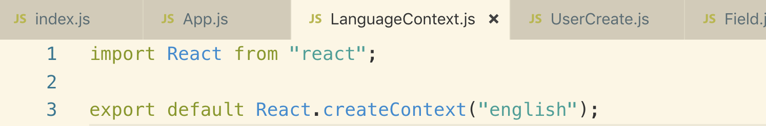

**To hook up the LanguageContext to our Button Component, we need to setup a “contextType”. It is essentially going to link our button component to the Context Object and then reference the information inside the Context Object using “this.context”**

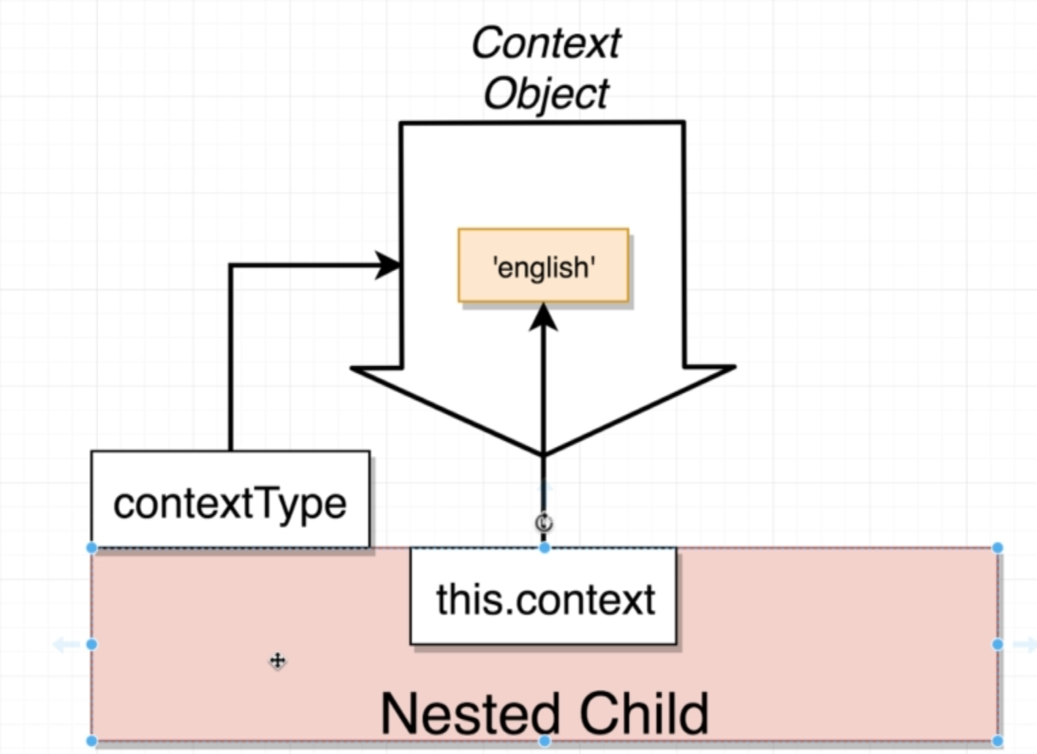

**“Note” : ContextType property is a very special property, if you use any other name, the Context system is not going to work.**

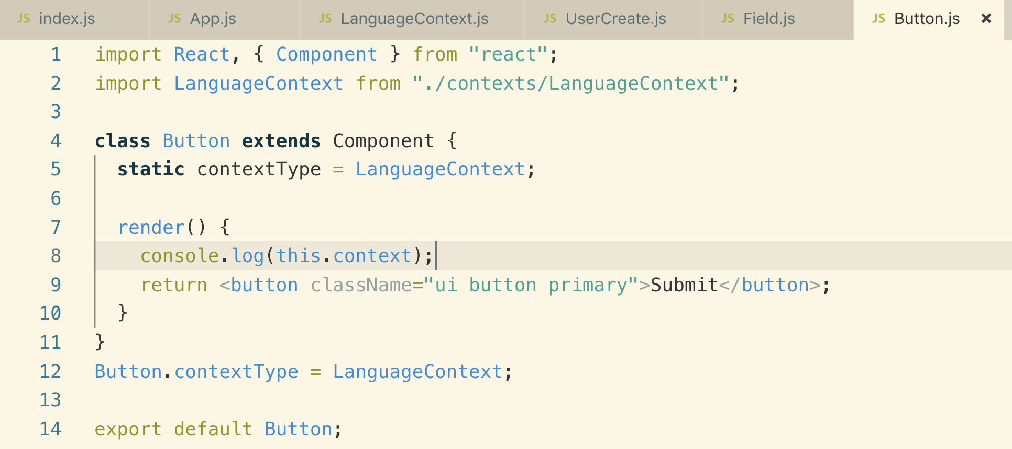

**You can even set this contextType property outside of the class like this. You can choose either way to set it**



**You can set any value you like into Context Object like**



**You can even set an array**



**8. Consuming the Context Value**

**Using ternary condition we are changing language**

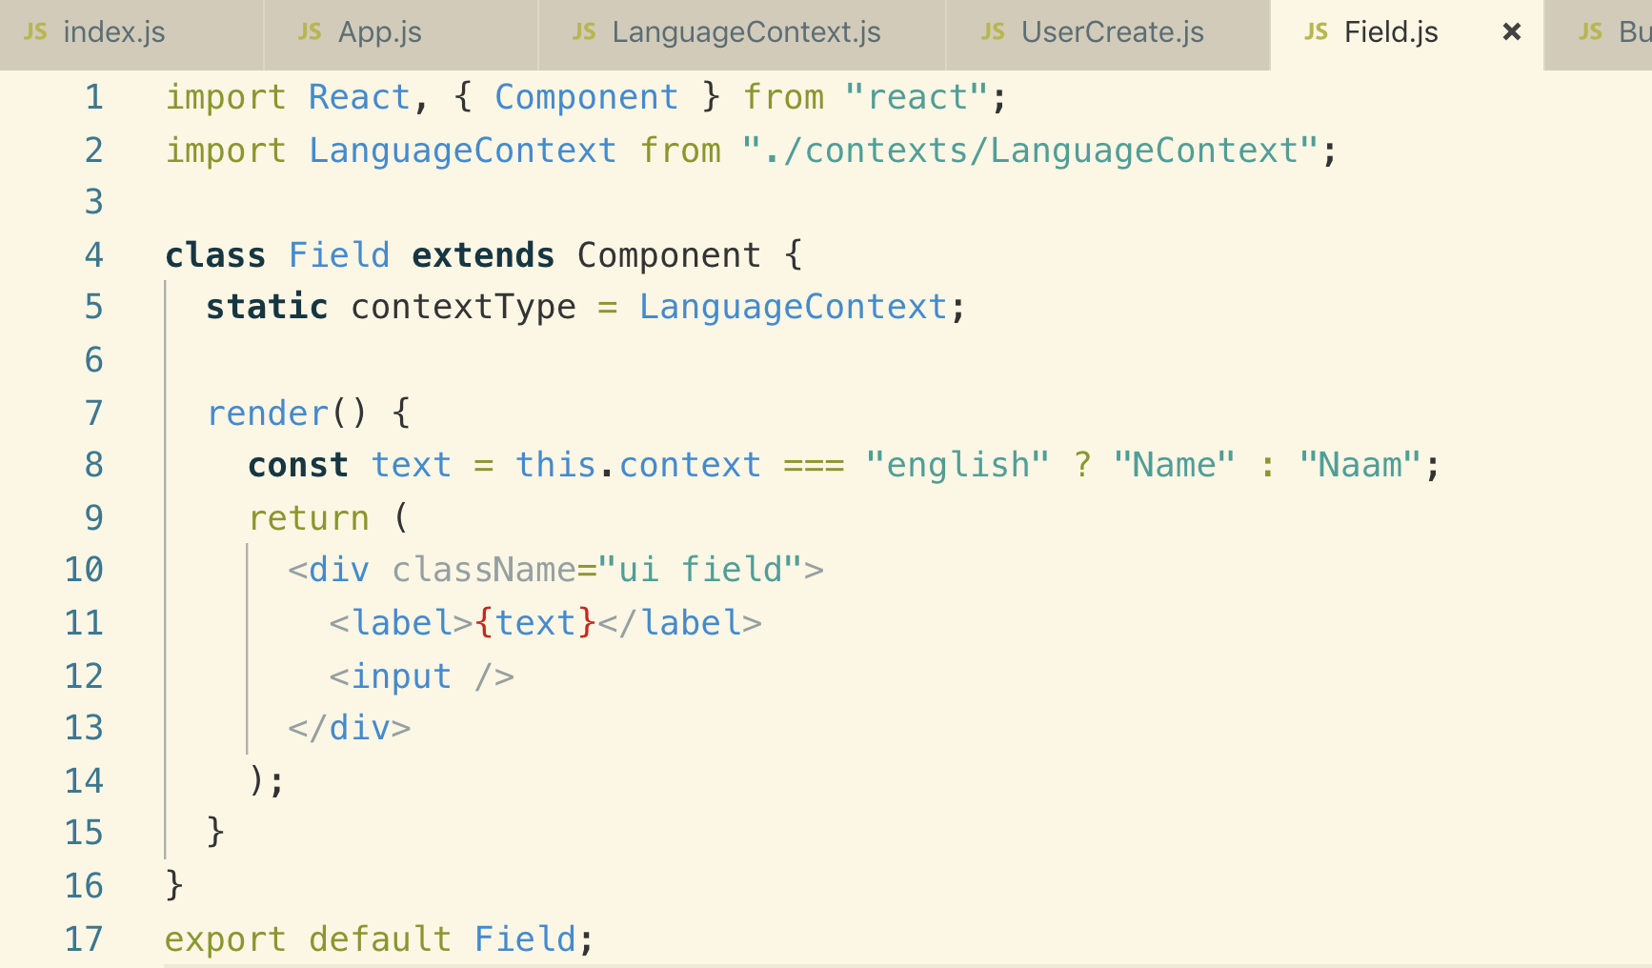

**9. The Context Provider**

**Let’s now see the 2nd way of setting and getting value from Context Object using**

**Provider and Consumer**

**Note: we cannot change the default value of Context Object**

**Note: “value” prop in Provider is a special prop**

**We communicate to App component to get that value into our Context Object.**

**This is the way pass value from a component to Context Object using Provider**

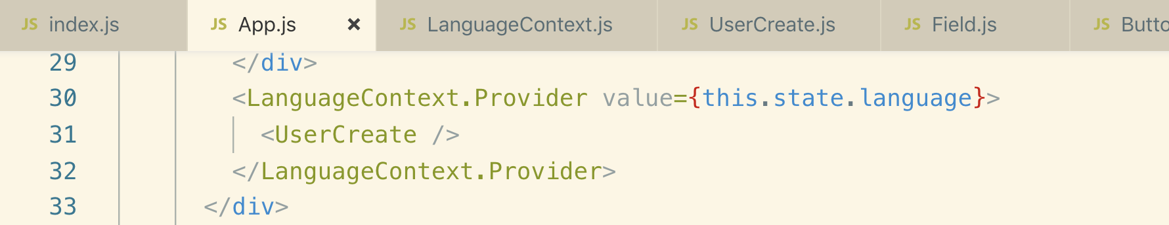

**10. Gotchas Around Providers**

**Context.Provider is a React component that is created automatically on Context Object Initialization.**

**This is what happened when we render our application to the browser**

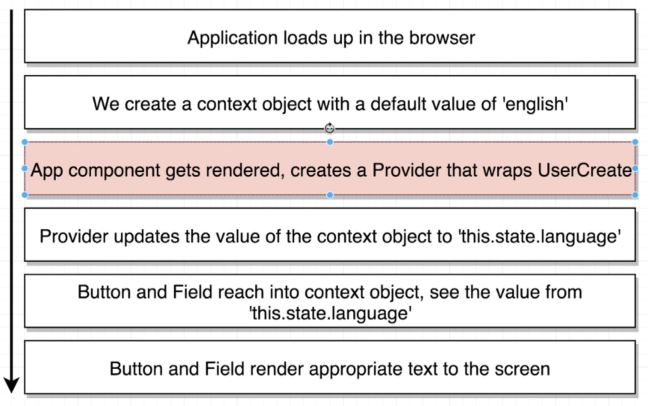

**The meaning of the above selected steps is that everytime you render instance of the Provider, you are creating a brand new and separate pipe of information.**

**Example:**

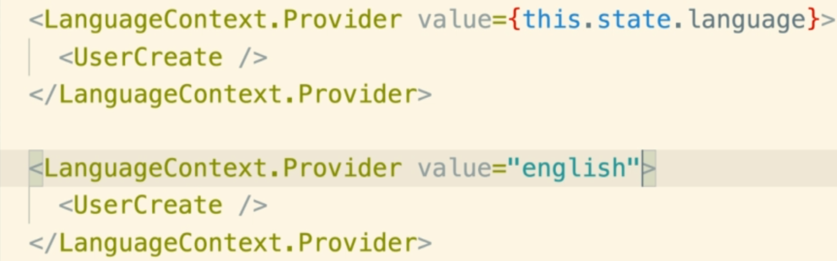

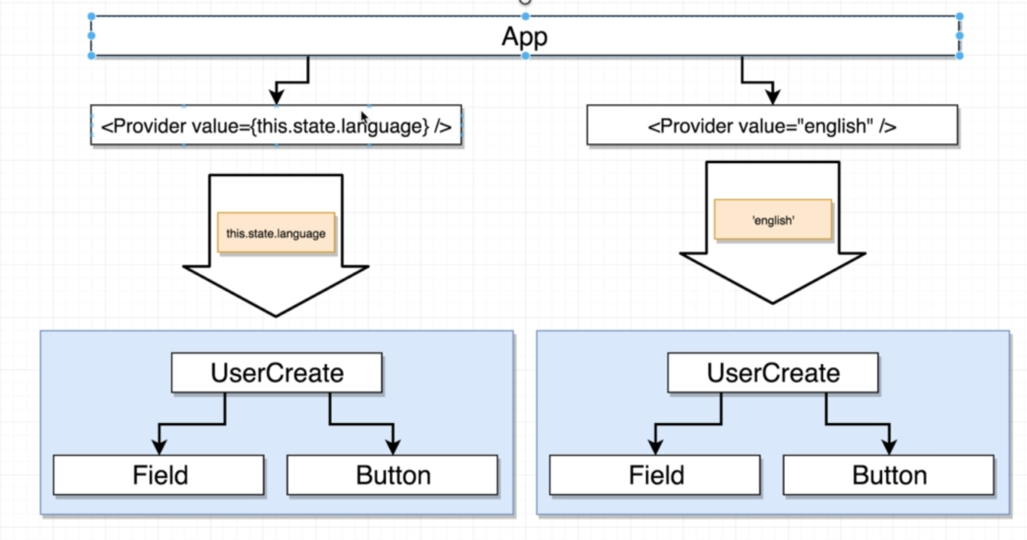

**11. Accessing Data with Consumers**

**Let’s see the 2nd way of consuming information out of our pipe (Context Provider)**

**Note: When we are using a consumer, we do not have to specify a contextType**

**Whenever we place a Consumer, we always provide 1 child and this 1 child is always going to be a function. This function is going to automatically be called by the consumer and it will with the current value inside of our pipe.**

**12. Pulling From Multiple Contexts**

**Why would we use “Context.Provider” instead of “this.context”?**

**Ans:**

**We will make use of consumer anytime that we want to get information out of multiple context objects inside of a single component.**

**this.context is only used anytime we are single context object inside a component**

**Example:**

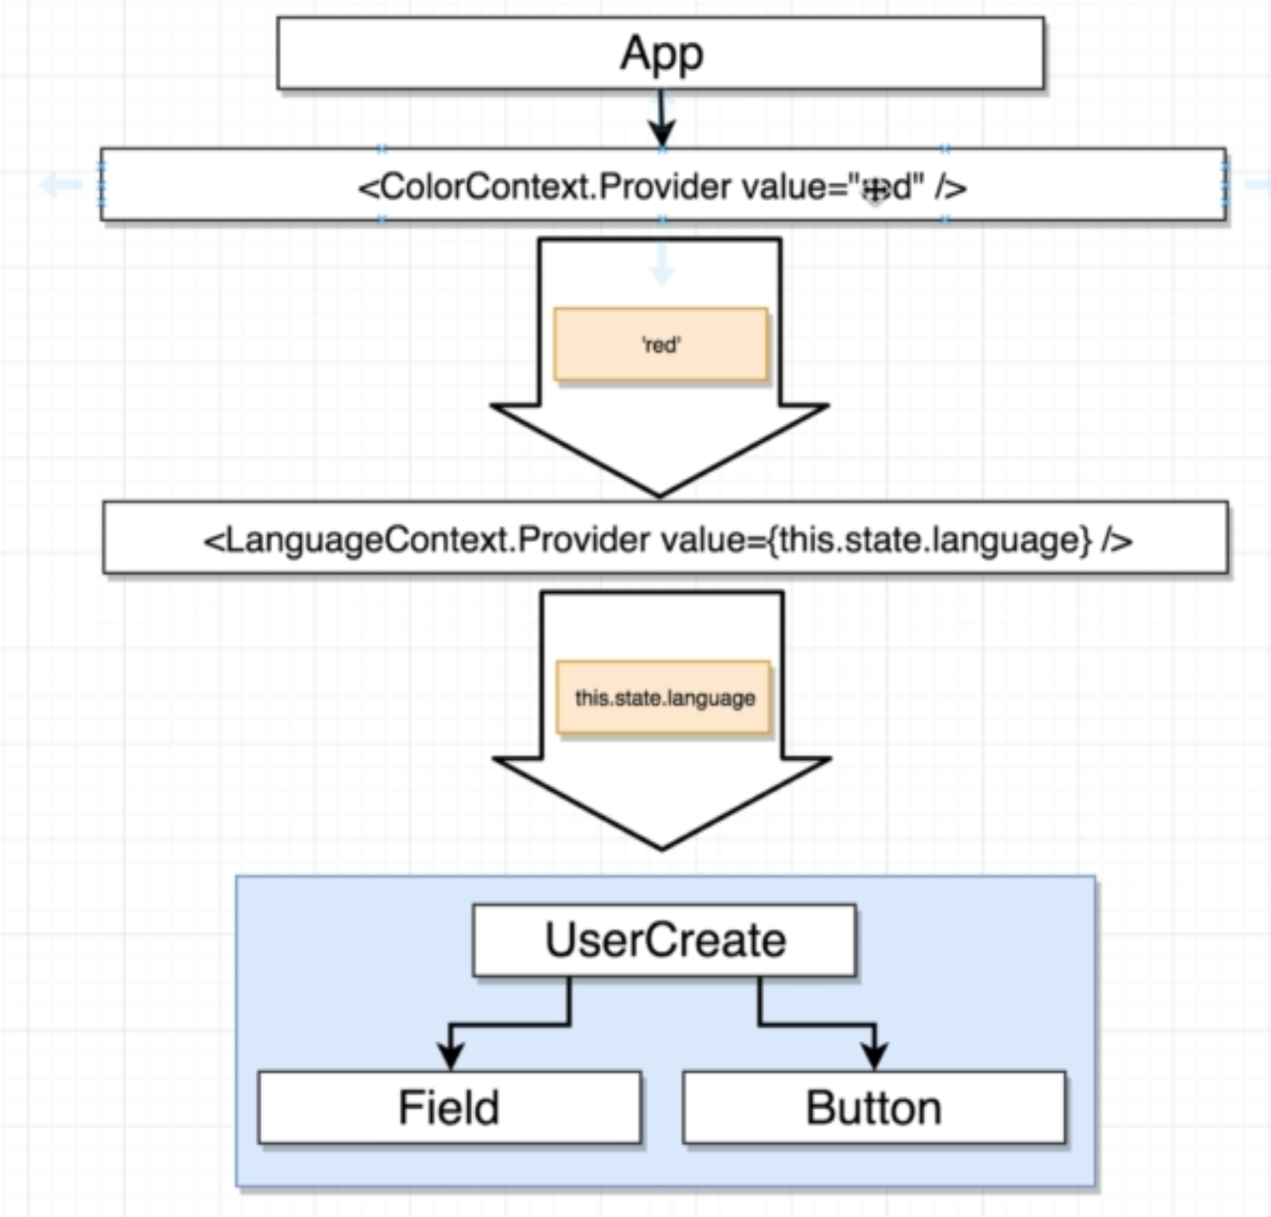

**Let’s create ColorContext to see how to use multiple contexts**

**translate-app/src/components/contexts/ColorContext.js**

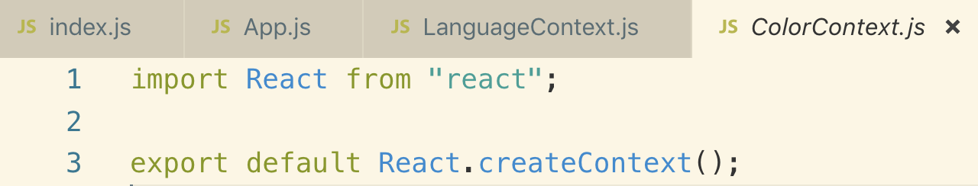

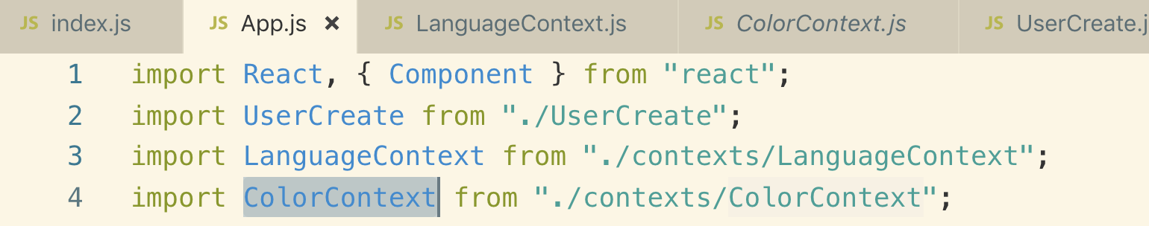

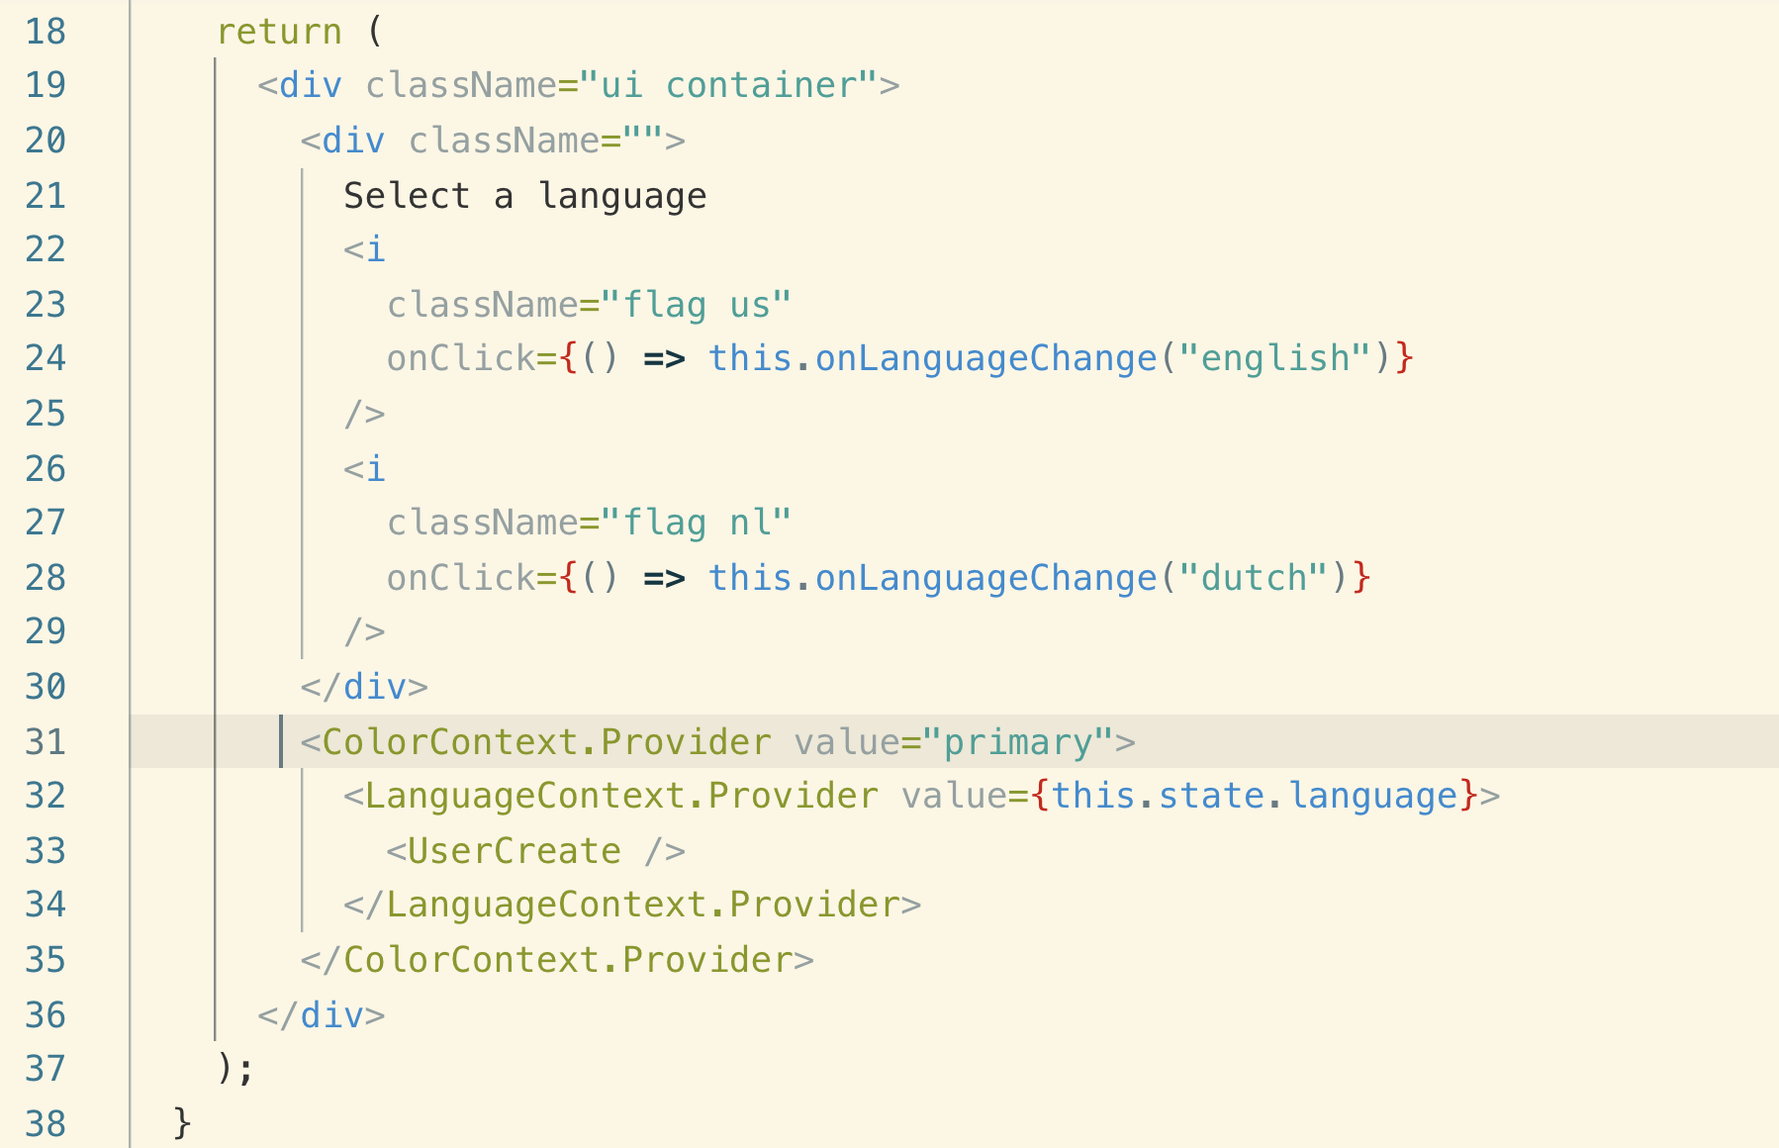

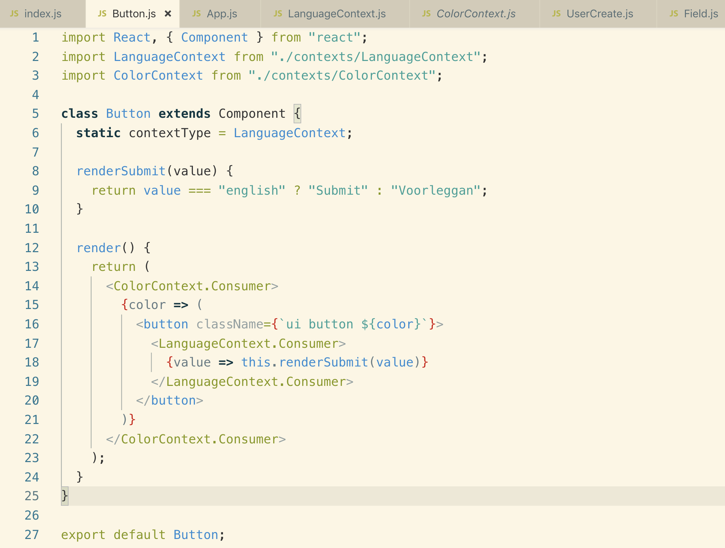

**We can make a helper function to clean the Context code above**

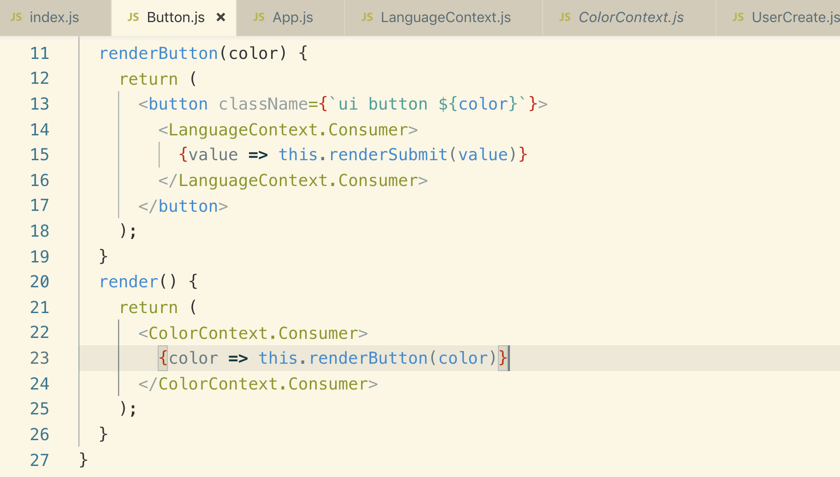

**24. Replacing Redux with Context**

**1. Replacing Redux with Context**

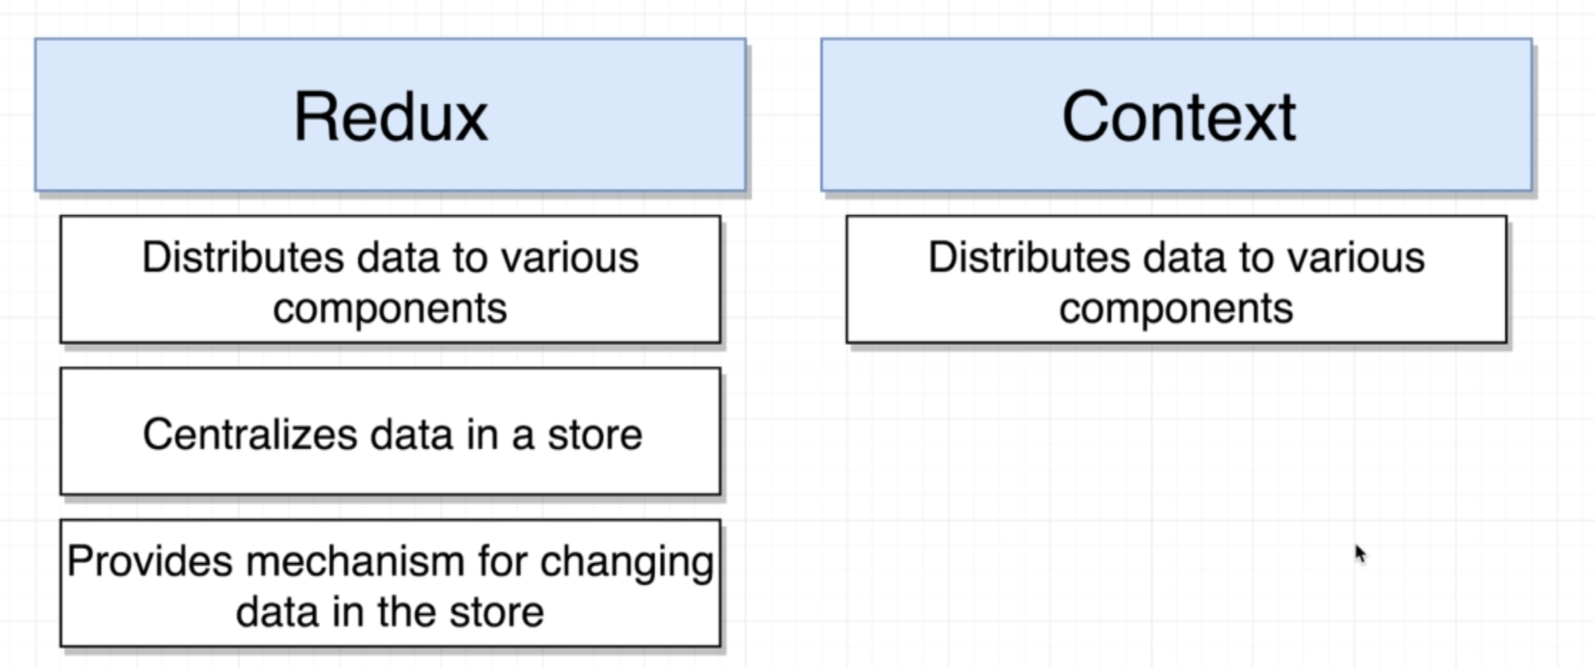

**Redux**

1. **Redux through Redux library and React Redux together provides a way to distribute data to various components throughout our component hierarchy.**
2. **It gives a way to centralized data to a common store**
3. **It also provides some mean to change that data inside that store by dispatching action creators and reducers and all that kind of good stuff.**

**Context System**

1. **It is just to distribute data to various components inside of our application.**

**A way to communicate from a parent component down to a child.**

**Now let’s see how we can use Context in place of Redux. We will see how to use Context to maintain a state inside React Application.**

**We will build a separate LanguageSelector component**

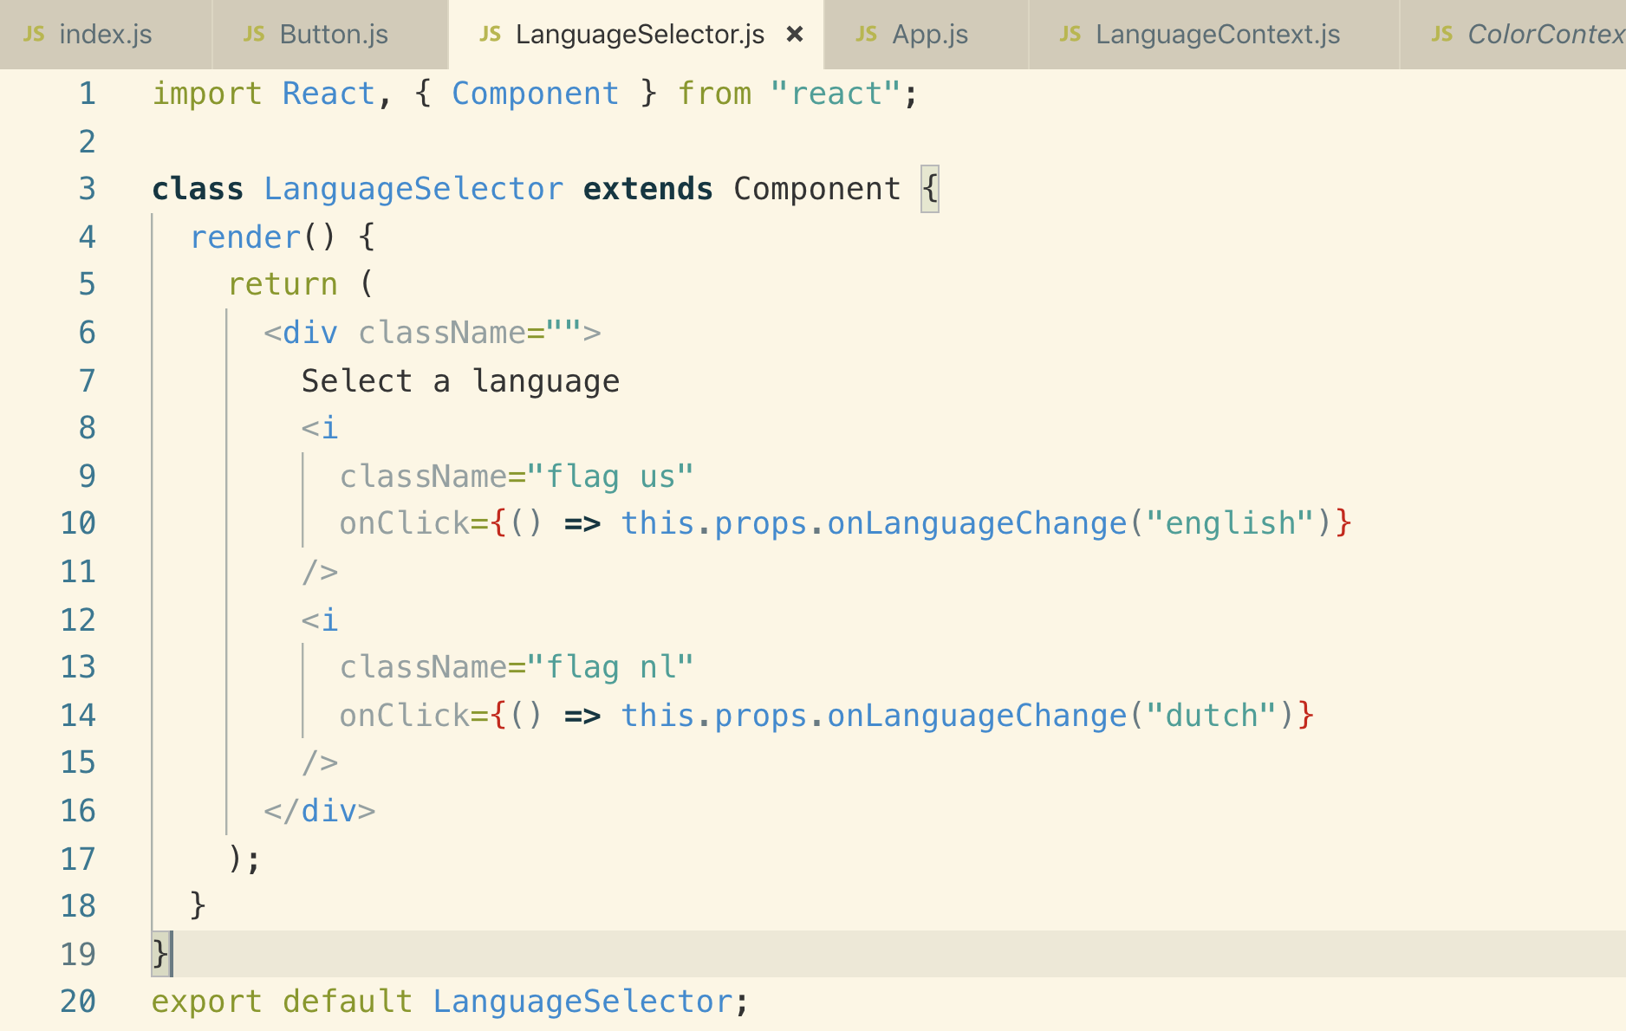

**Using the above LanguageSelector into App.js**

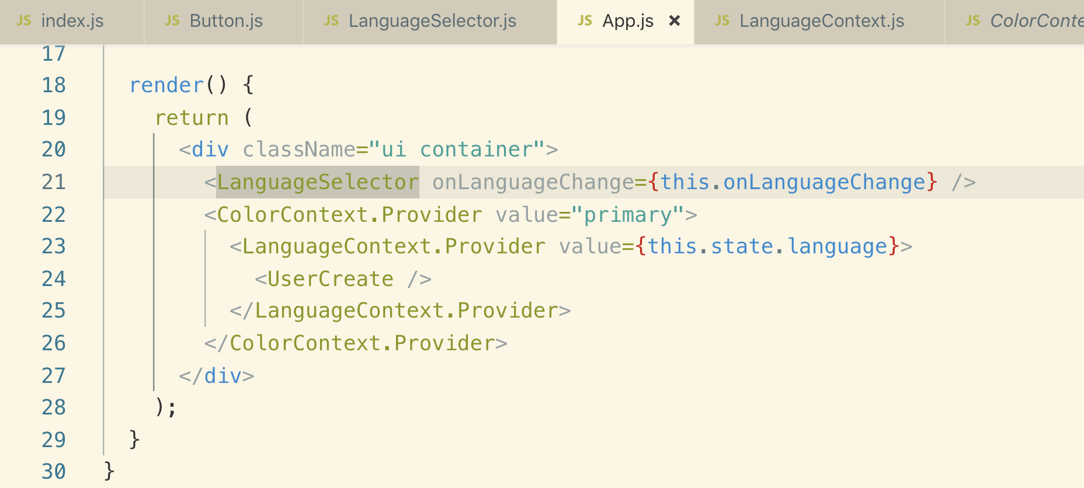

**2. Creating a Store Component**

**If we want to use Context in place of Redux we would have the following issues.**

1. **To separate view and business logic**
2. **Need to be able to split our business logic with multiple files.**

**So the idea to separate business and view logic is to create LanguageStore Component**

**It contains all the business logic related to the currently selected language and inside it we will create a provide so that we share information with different child component.**

**The LanguageStore will also implement a callback() and make that callback available to any of our given component so that any given component can change the currently selected language.**

**We will put this callback function inside of Context Object so that Language Selector could access that callback function and change the currently selected language.**

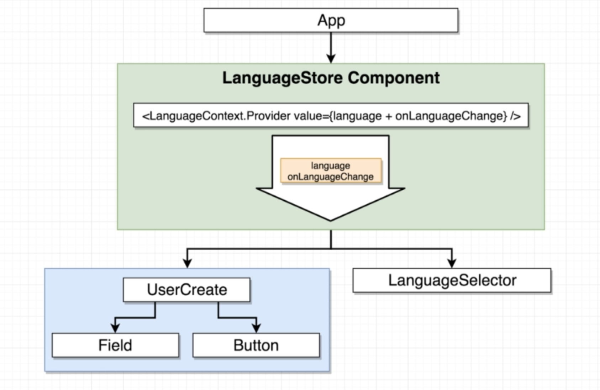

**3. Implementing a Language Store**

**4. Rendering the Language Store**

**Note: Any component we create has to start with Capital letter**

**Now LanguageContext is the incharge of maintaining and changing state**

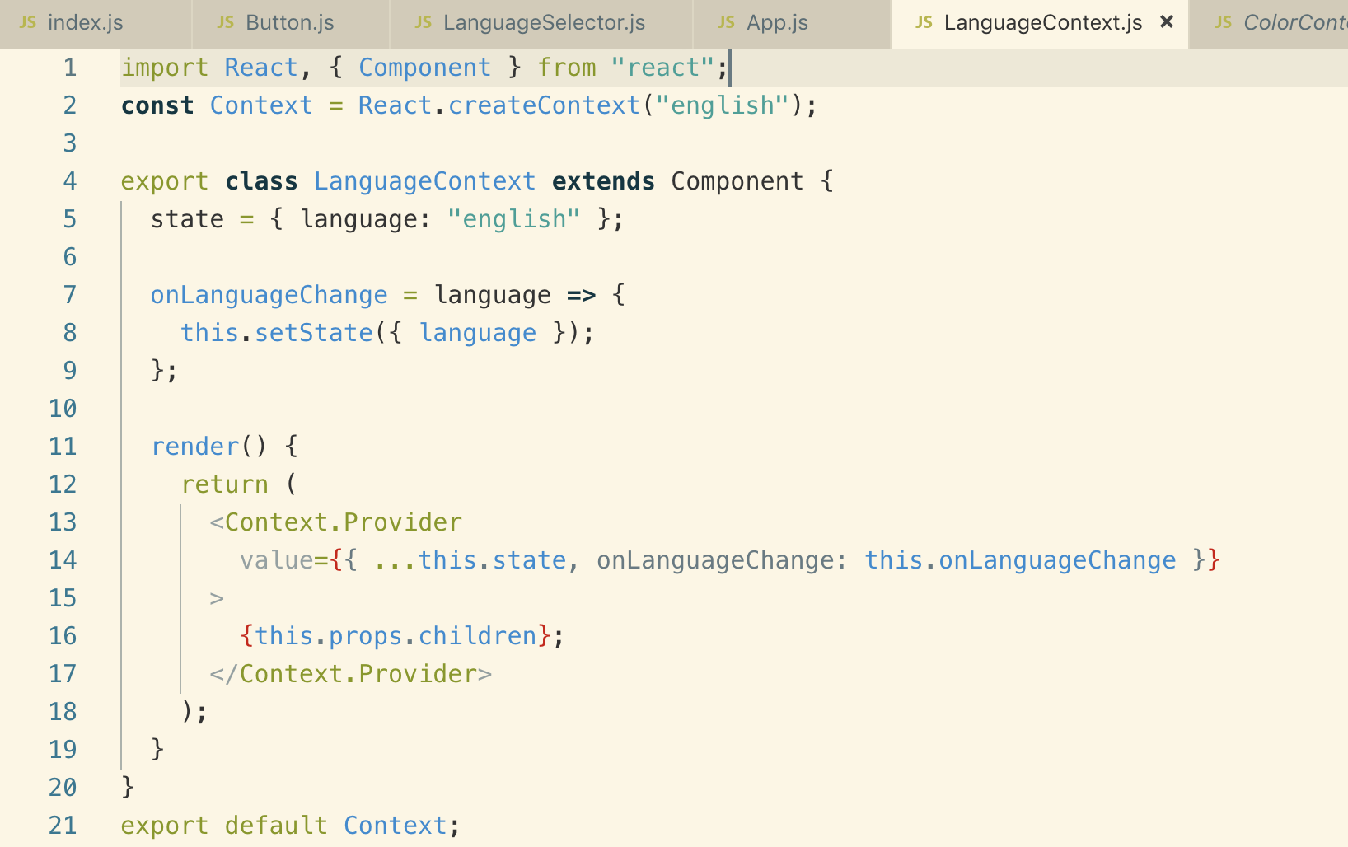

**Adding the new LanguageContext to App.js at the top of tree so all the components will have access to data and methods on Context Object**

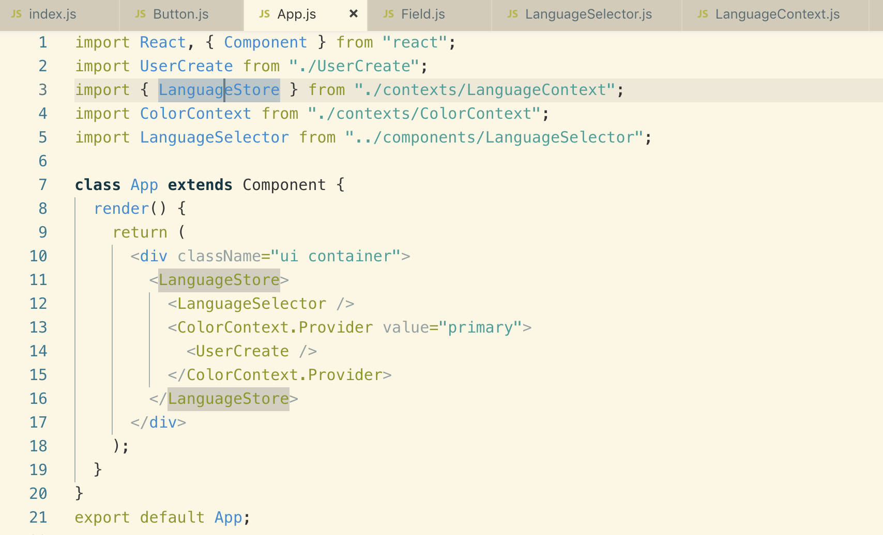

**5. Connecting the Selector to the Store**

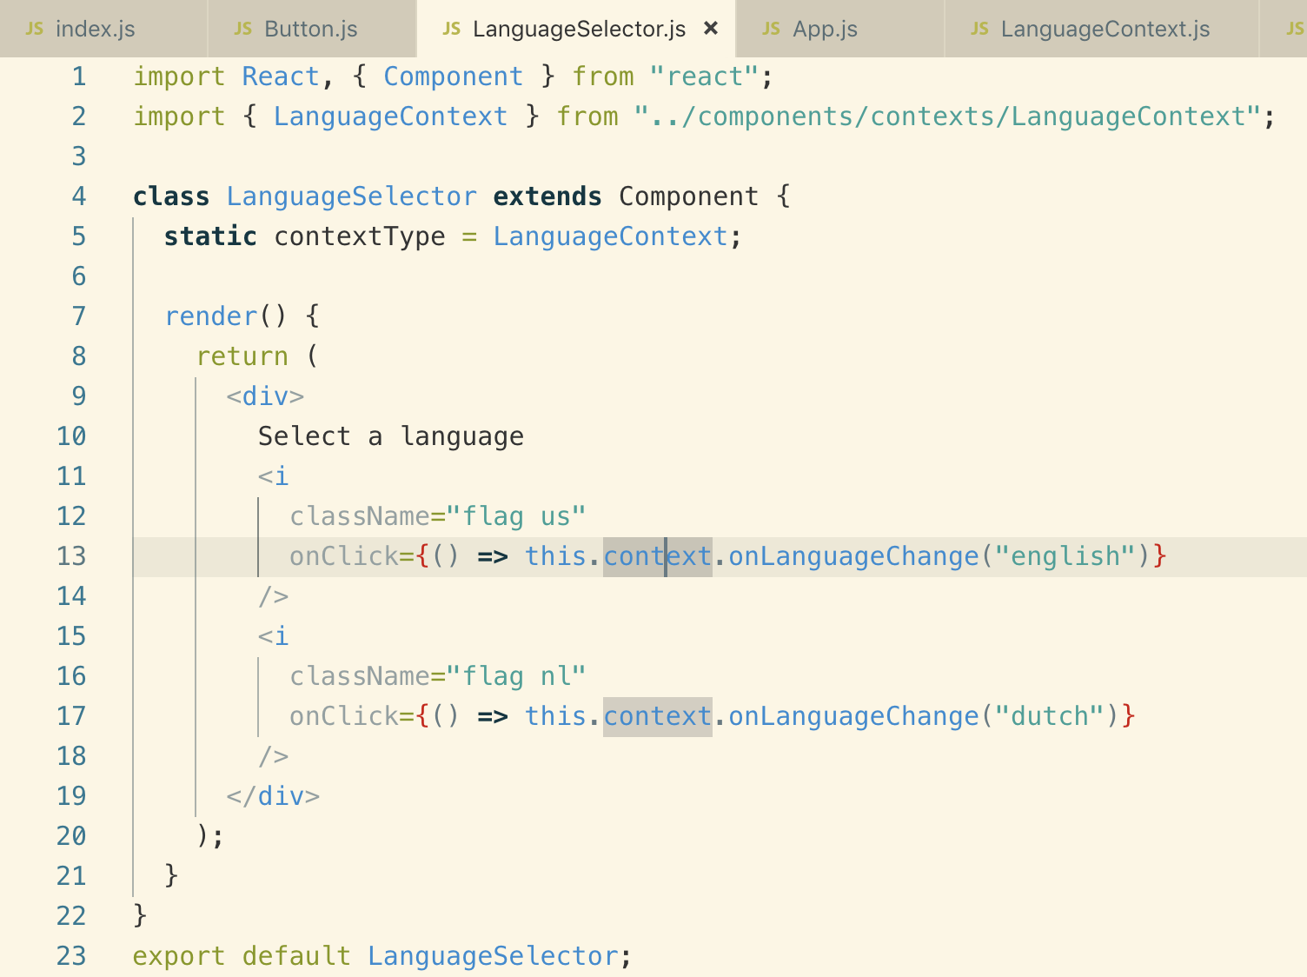

**We are connecting context to LanguageSelector using “this.context”**

**6. Connecting the Field and Button to the Store**

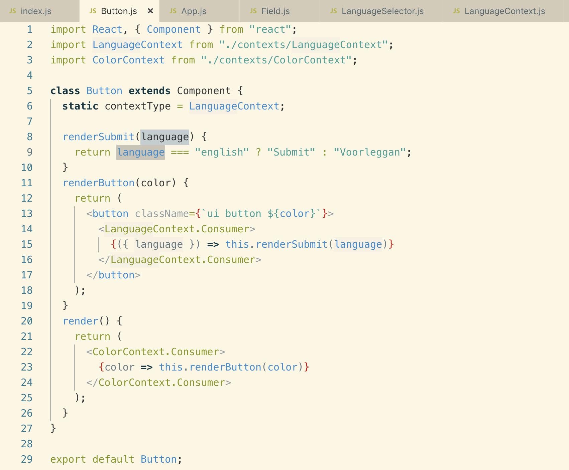

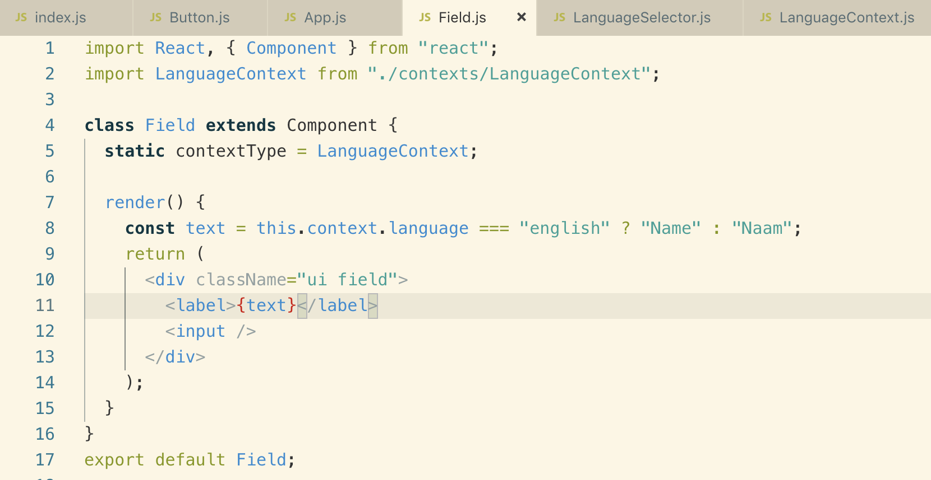

**7. Context vs Redux Recap**

**There are couple of reasons we should still use Redux instead of Context API**

**We create a separate store for each type of resource that we have in our application like we create above as LanguageStore and sharing data between these store is really challenging**

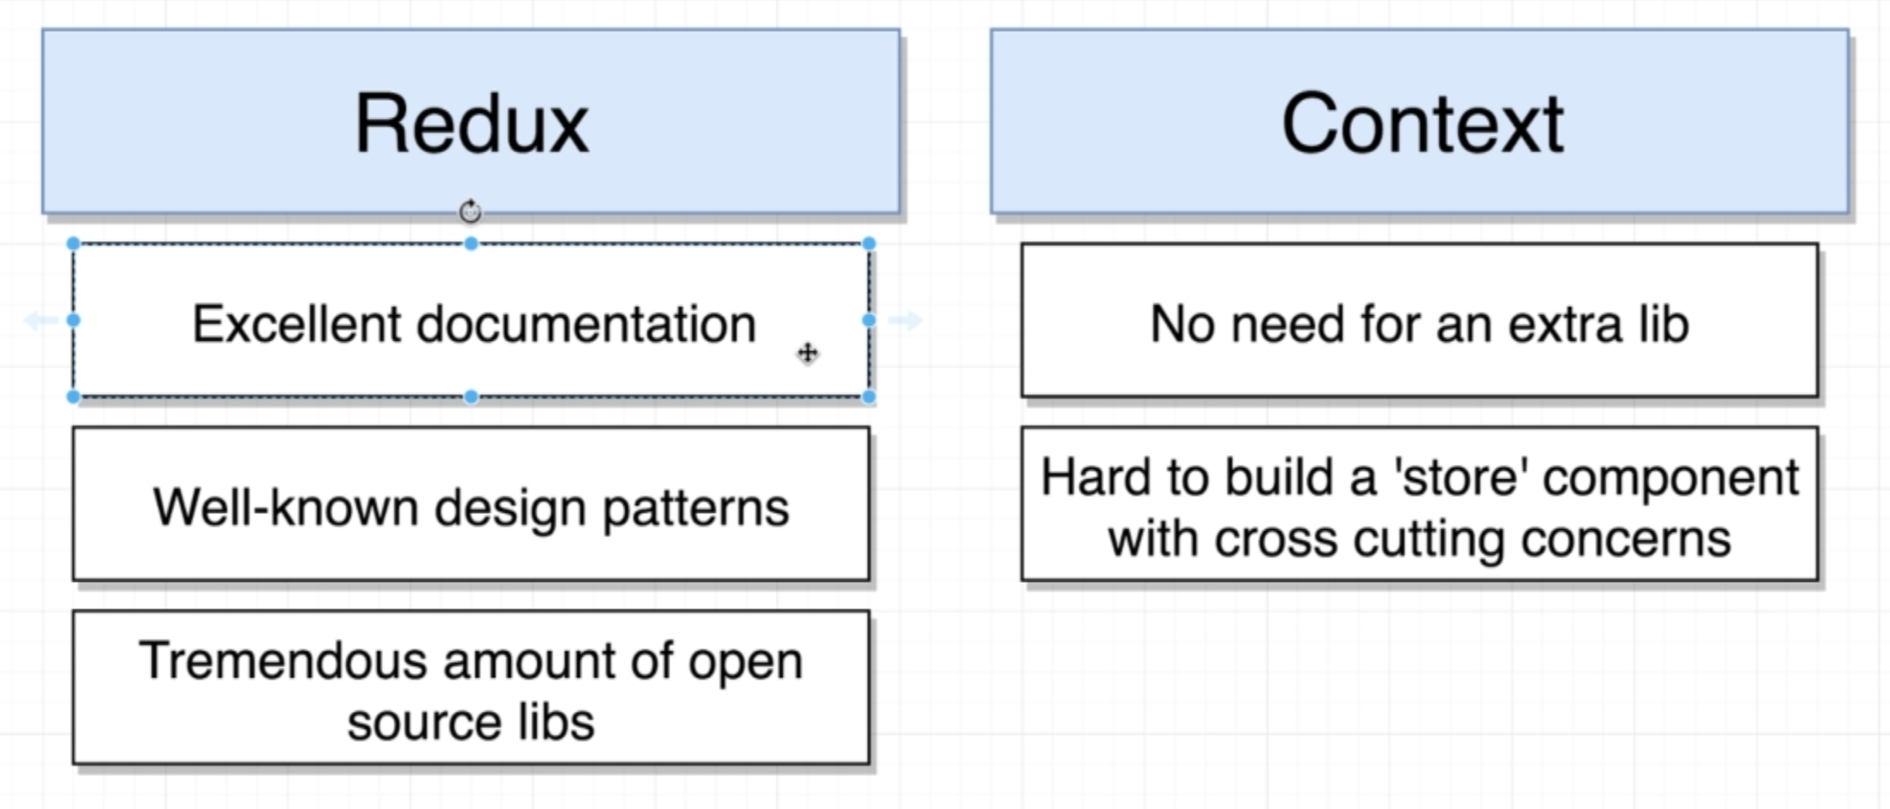

**25. Hooks with Functional Components**

**1. Introducing Hooks**

**With the Hook System we can have state and lifecycle methods**

**Hook System is all about borrowing some functionality from class based component world and adding it to our Functional based component.**

**Q. Why do we use Hook System instead of class based component?**

**Ans: Hooks are going to make it really -2 easy to share login between different components**

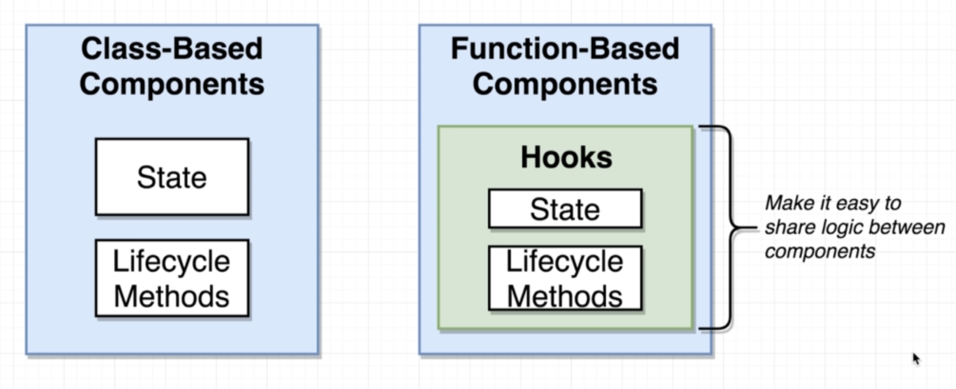

**Hook System also solves code reuse inside typical React Project.**

**2. App Overview**

**We will be using this app APIs for our App for using Hook System**

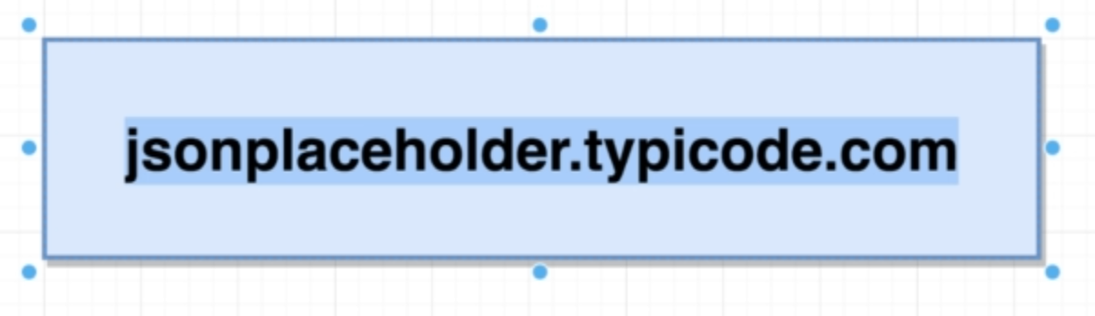

**We will also build our custom hooks as well**

**Note: The entire point of Hook System is writing reusable logic**

**We also need to install these to make hook system work properly**

**npm install react@next react-dom@next**

**4. Building Stateful Class Components**

**Let’s see how we are going to structure this application.**

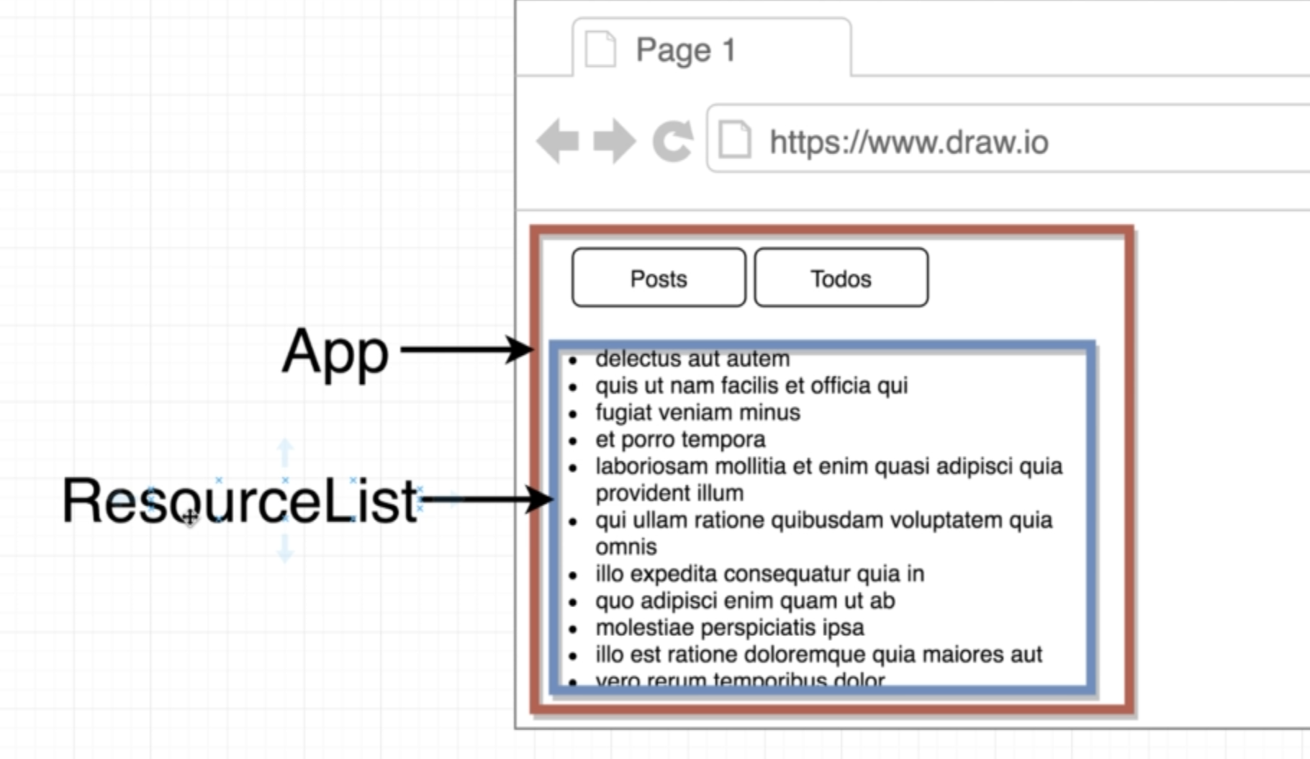

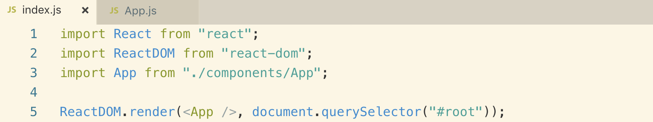

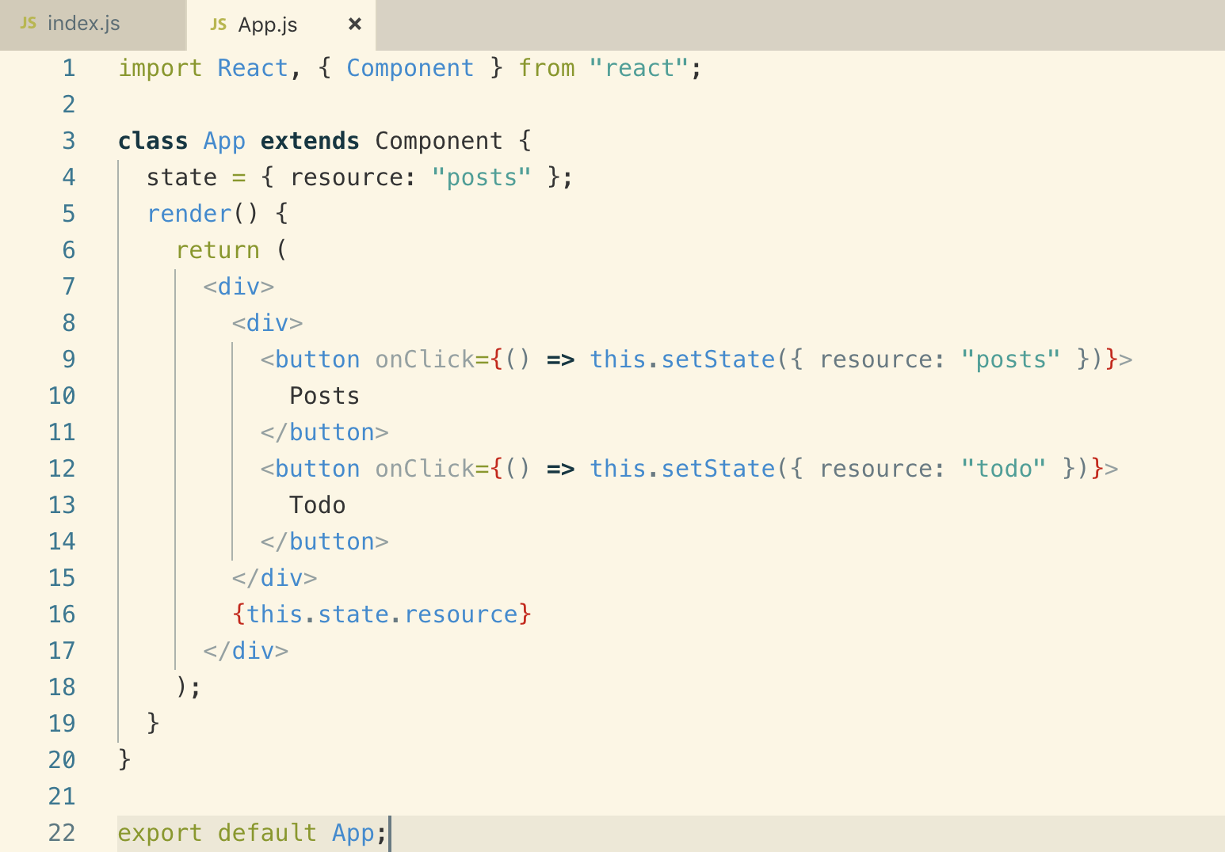

**5. The UseState Hook**

**We will convert the App which is class based system into Functional Component and we will be using state inside functional component using Hook System.**

**Let see how**

**We have couple of Hooks available through the Hook System in React**

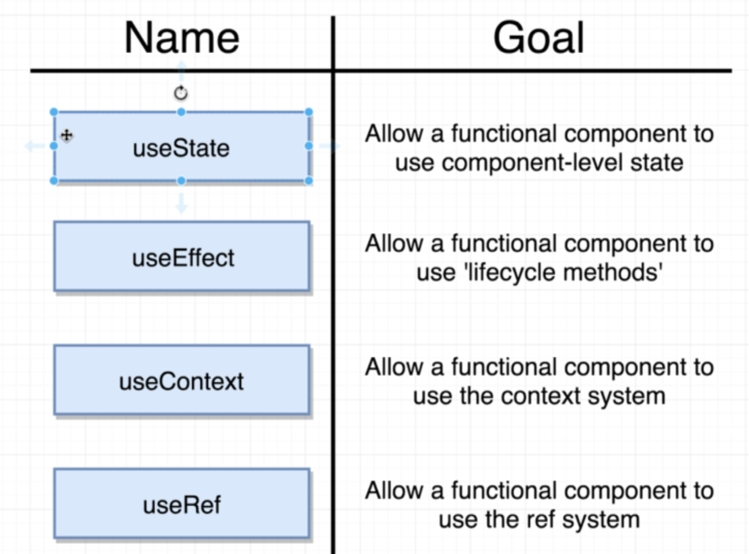

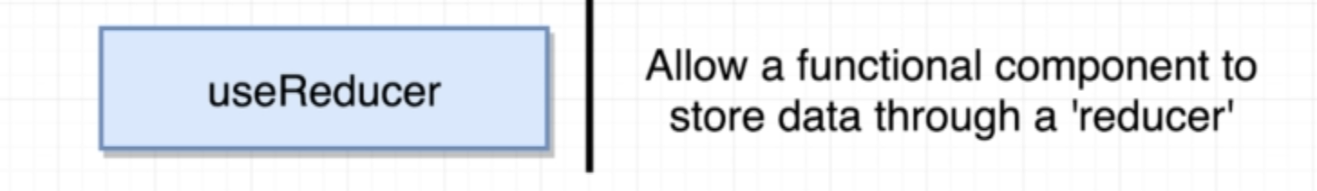

**Converting above App class component into functional component**

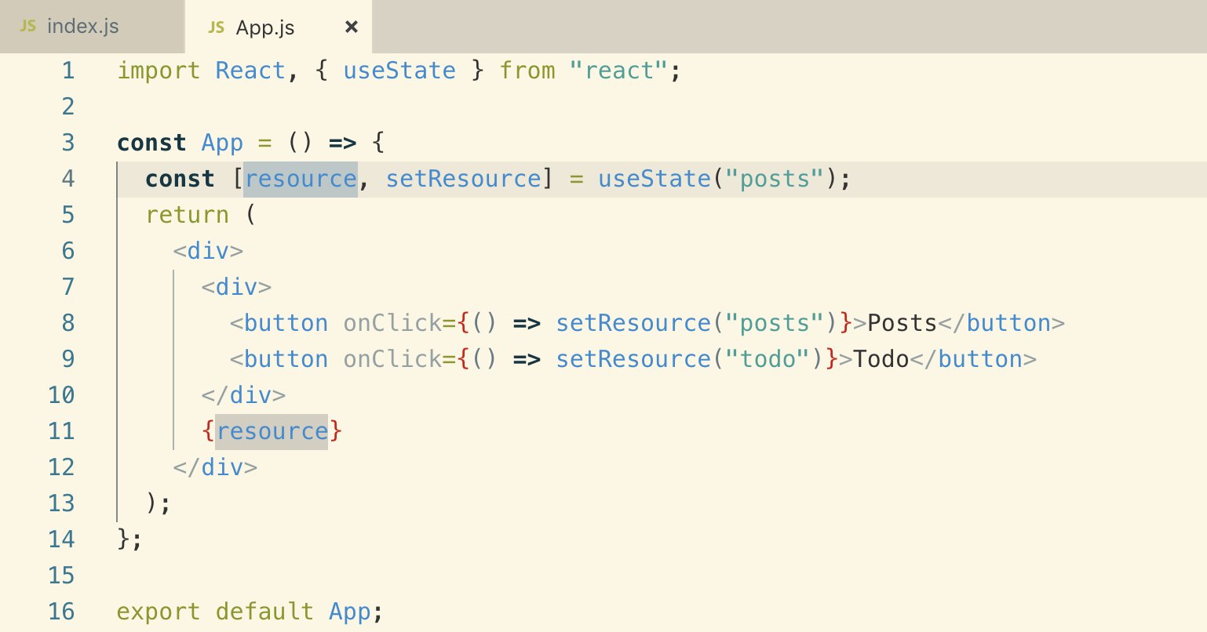

**6. UseState in Detail**

**In the above code we have used Array destructuring. We get the value from the index position.**

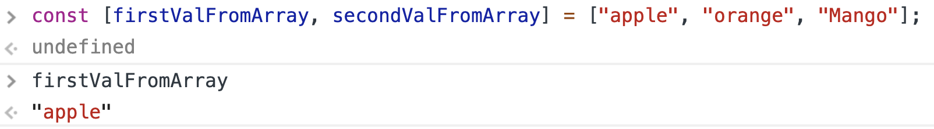

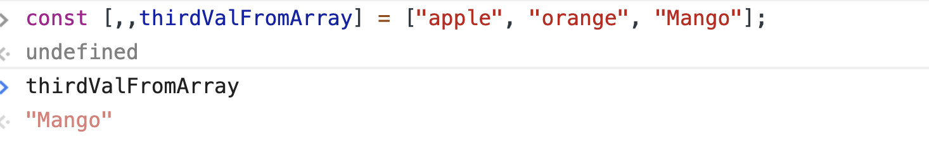

**CurrentValue and setCurrentValue, these names can be anything you want.**

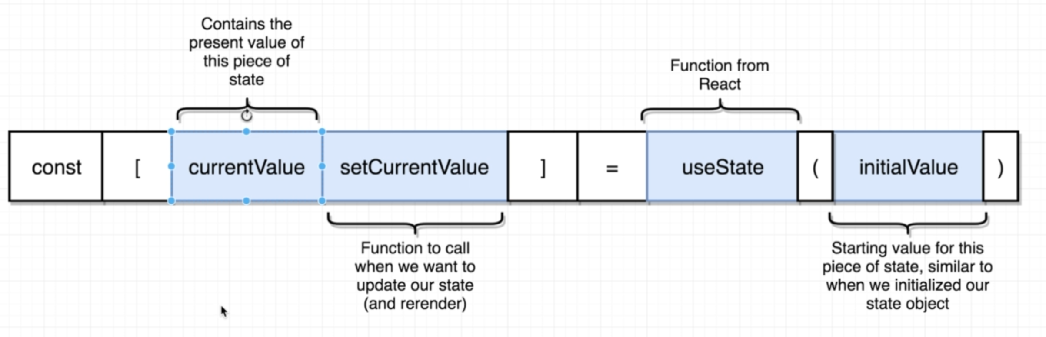

**Note: when we make use of the useState() Hook, we usually store a single value that we care about instead of class state which stores values as object.**

**We can call useState() multiple times if we need another value like**

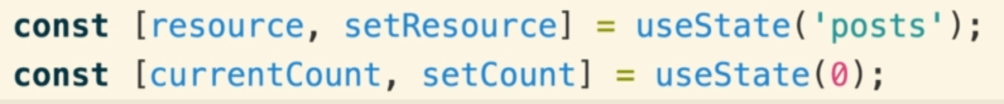

**Anytime we call setResource() it will cause our component to rerender and anything we pass into useState(‘value’) will be set to initial state value**

**7. Building the ResourceList**

**We will build a class based ResourceList to fetch the data from API based on passed props by App component. As we build it we are going to very quickly run into some kind of nasty issues that we are going to have to deal with. Dealing with these issues are challenging inside of a class based component, but once we refactor over to a functional component and use the Hook System, solving these issues will far easier.**

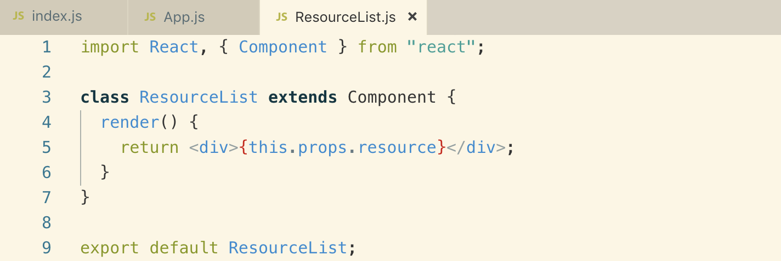

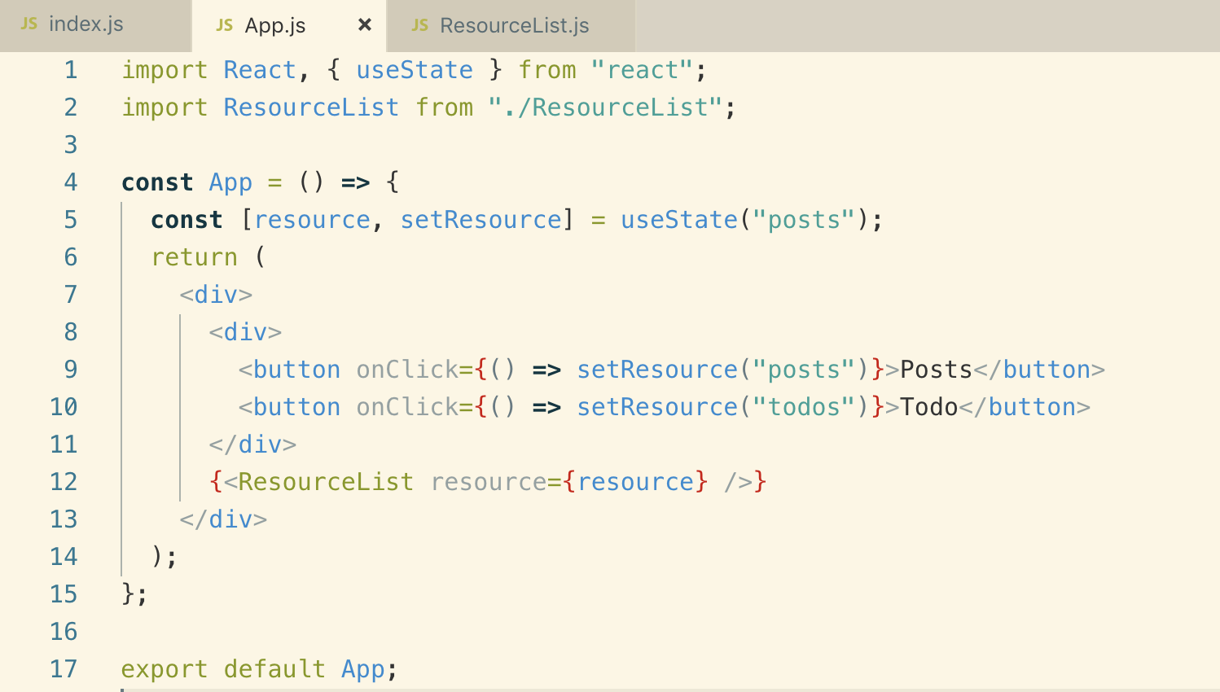

**8. Fetching a Given Resource**

**We will use “axios” to make API requests so install it**

**npm i axios**

**We want to make request asas our component renders to the screen and so we will use**

**ComponentDidMount() lifecycle method**

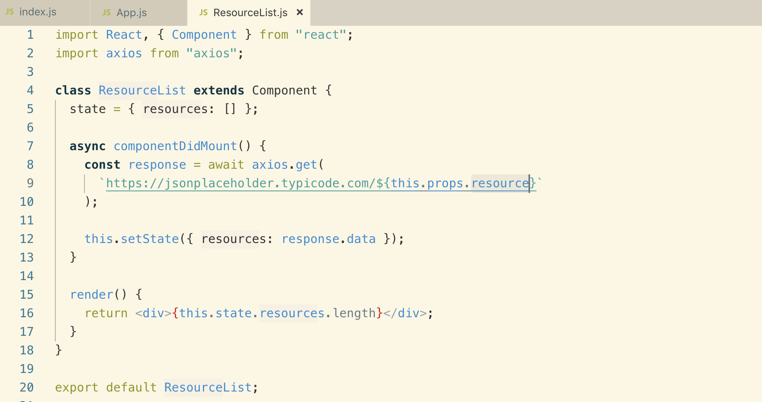

**Notice: API above has dynamic end-point, but our component will load first and to get the componentDidMount to run on different input, we need to use another lifecycle method.**

**Let’s see in the next lesson.**

**9. ComponentDidUpdate vs ComponentDIdMount**

**This is the reason why we are not getting updated records on different end-point**

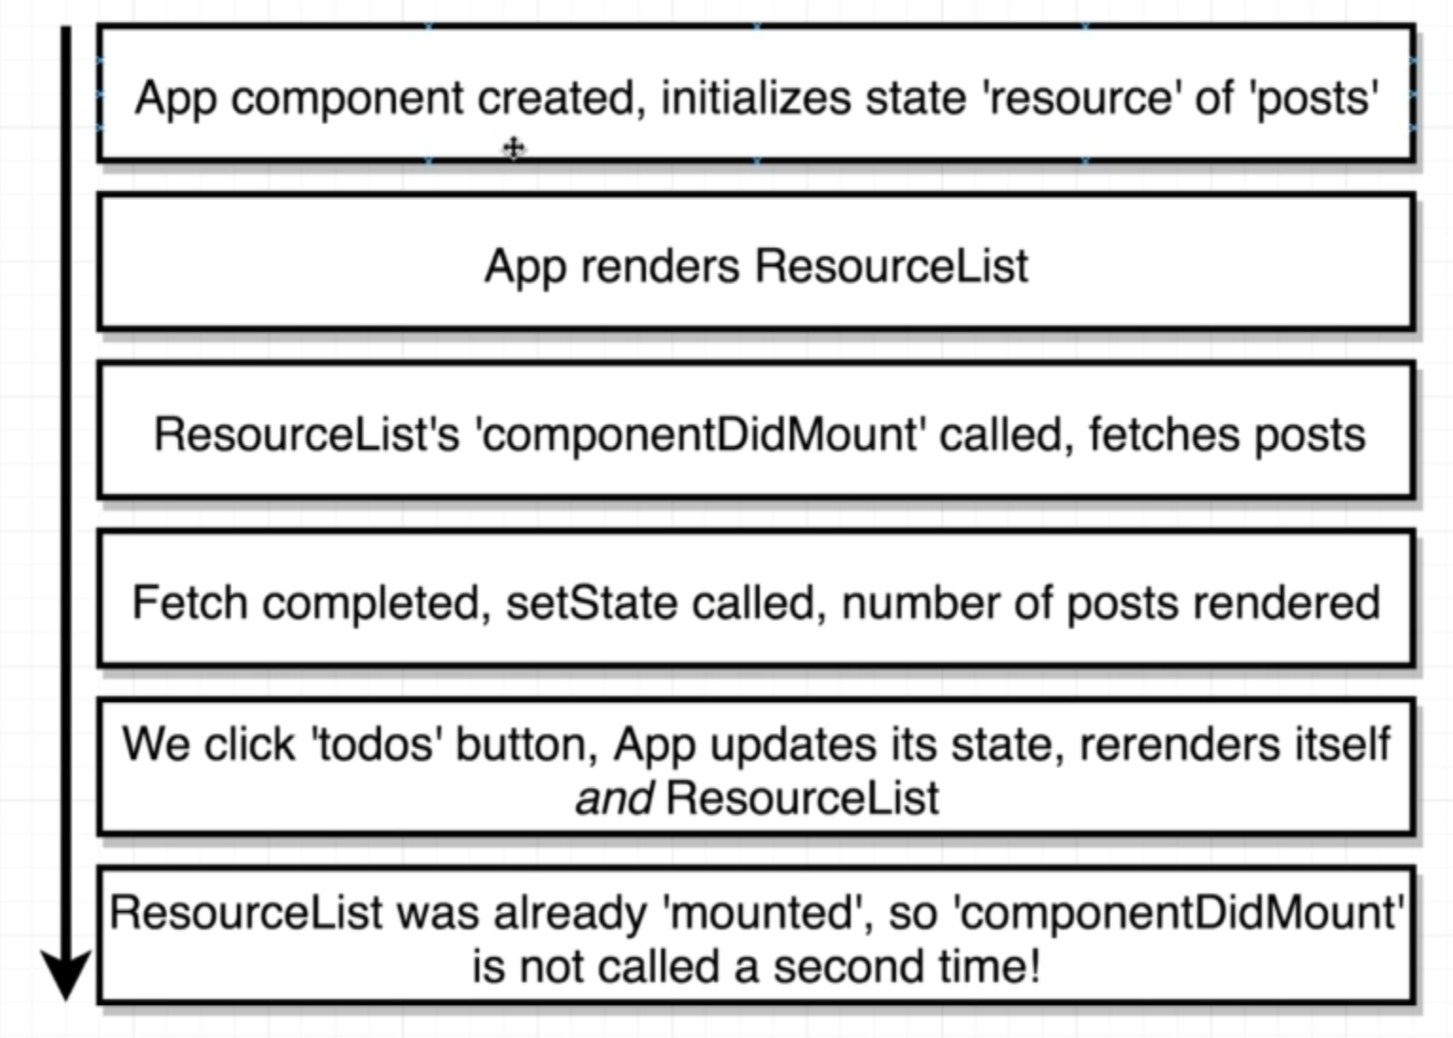

**Note: Anytime a class based component gets re-rendered, the componentDidMount lifecycle method is not called a second time**

**ComponentDidUpdate: this lifecycle method gets called anytime that our component re-renders either because of a parent component or anytime we call setState() inside of the class based component.**

**Note: never use “componentDidUpdate()” like this. This will cause infinite loop**

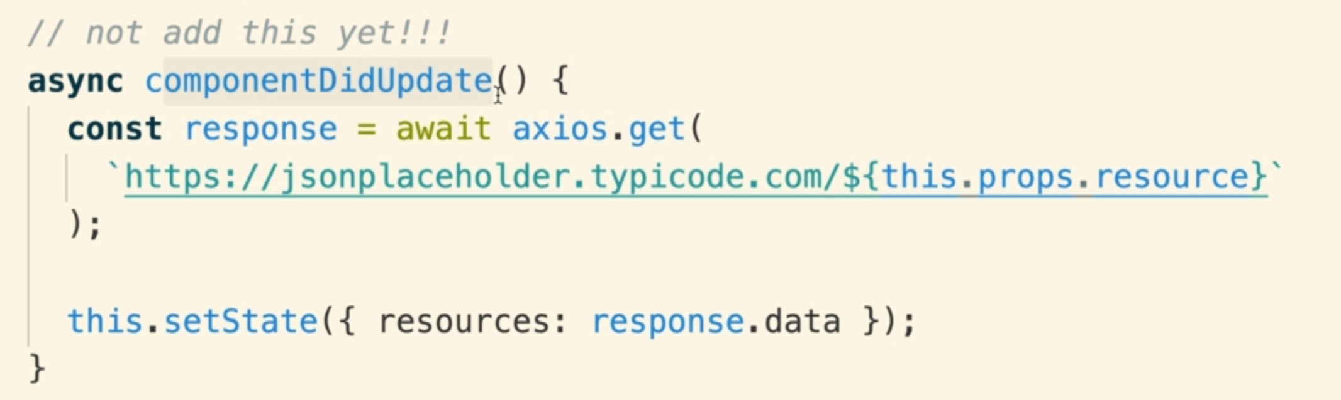

**To use the componentDidUpdate, we need to add a check before fetching the request like this**

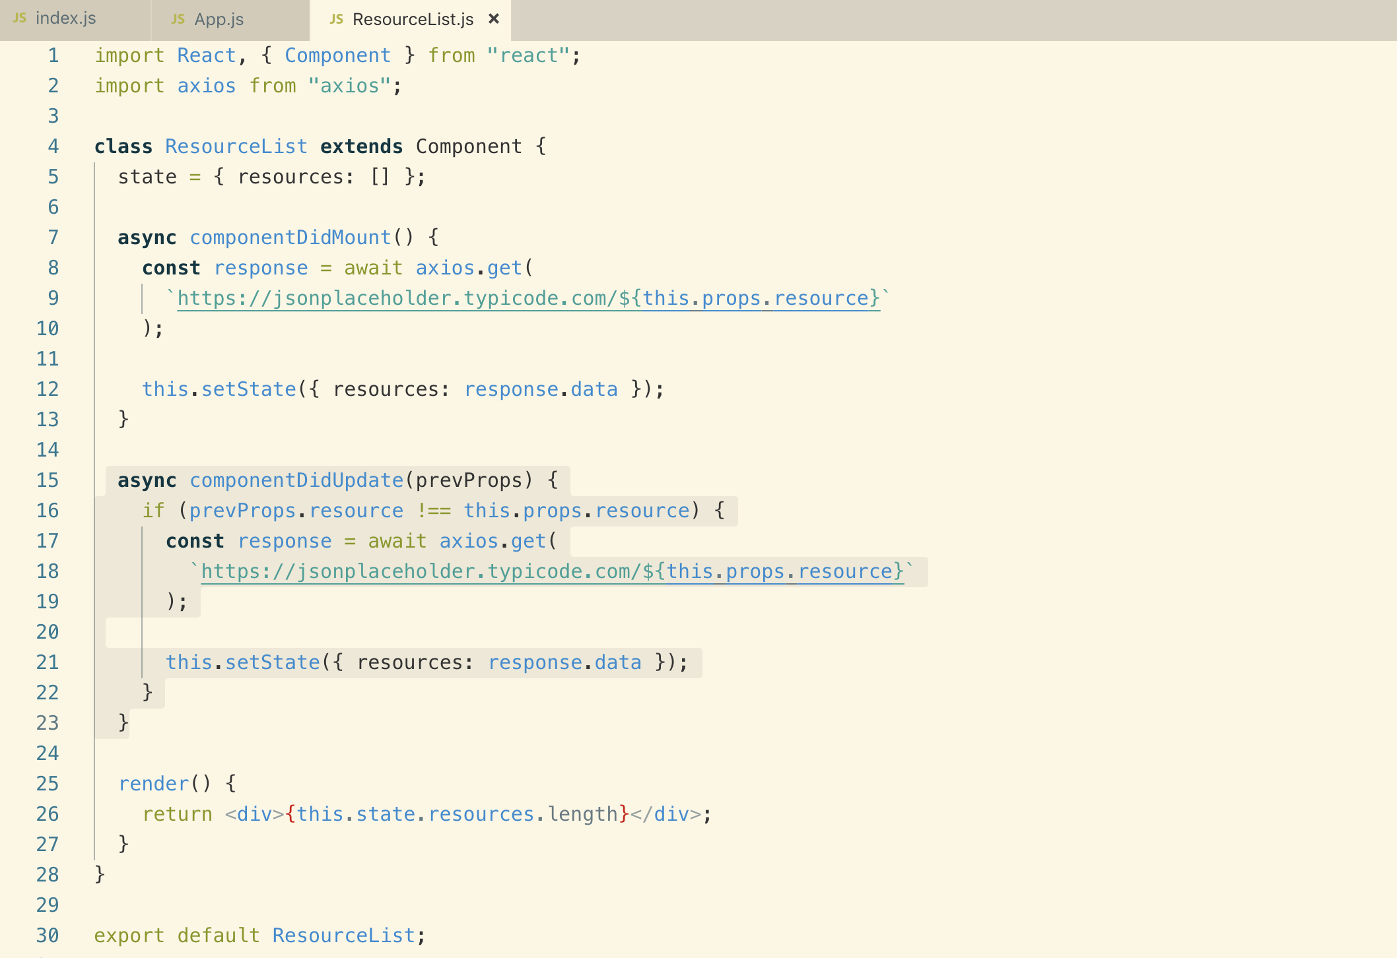

**Anytime we render a class based component, we got multiple lifecycle methods like in the above code and most of the time they have repetitive logic inside them and a check in componentDidMount.**

**Let’s see how we can easily do it with Hook System.**

**10. Refactoring a Class to a Function**

**11. Lifecycles with UseEffect**

**We will use useEffect hook which is similar as lifecycle method**

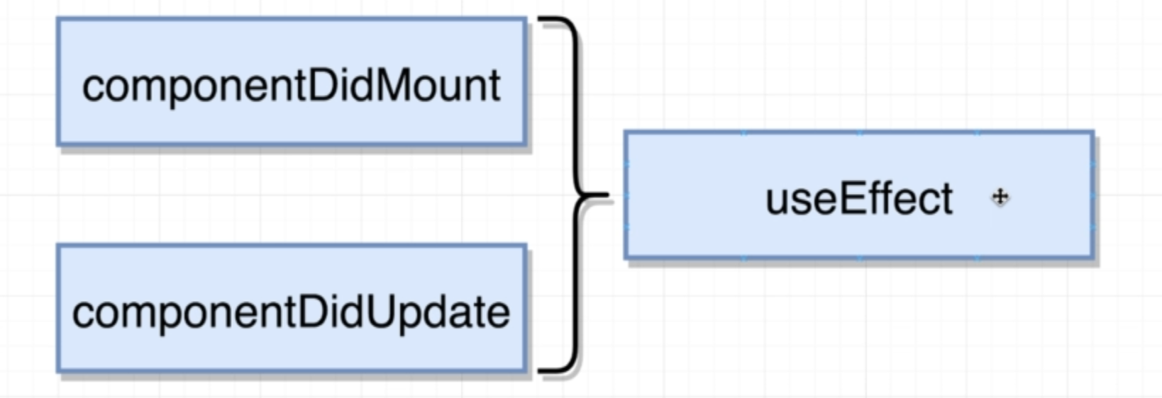

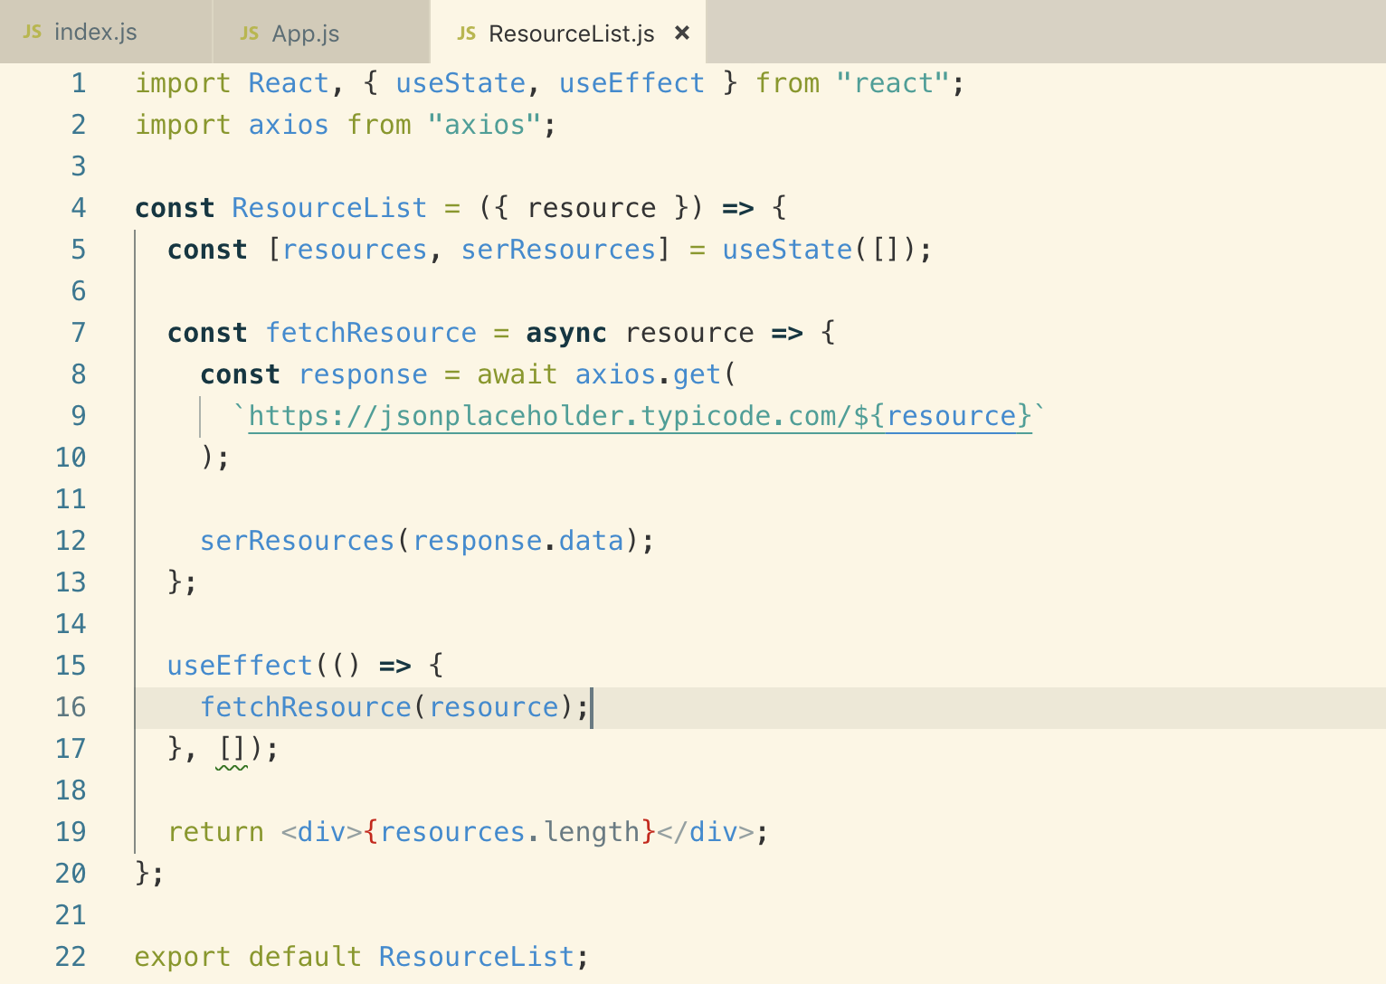

**The above code has the same issue, it is not updating on props change. Let’s see how “useEffect()” works**

**12. Updates with UseEffect**

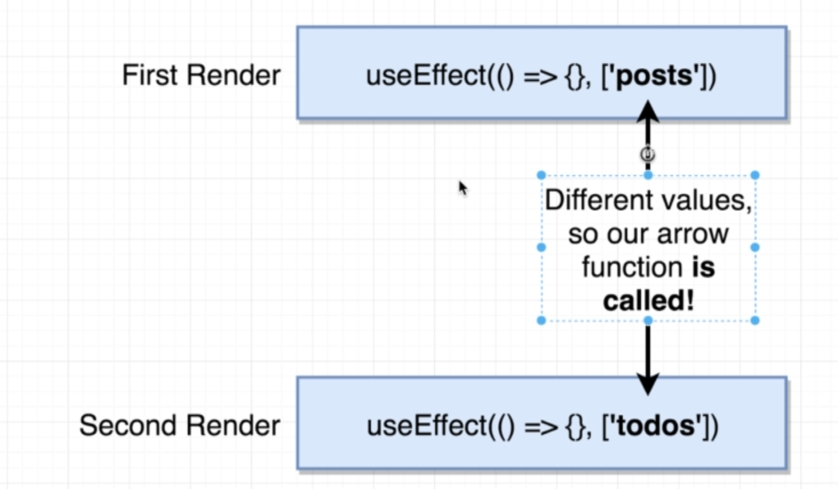

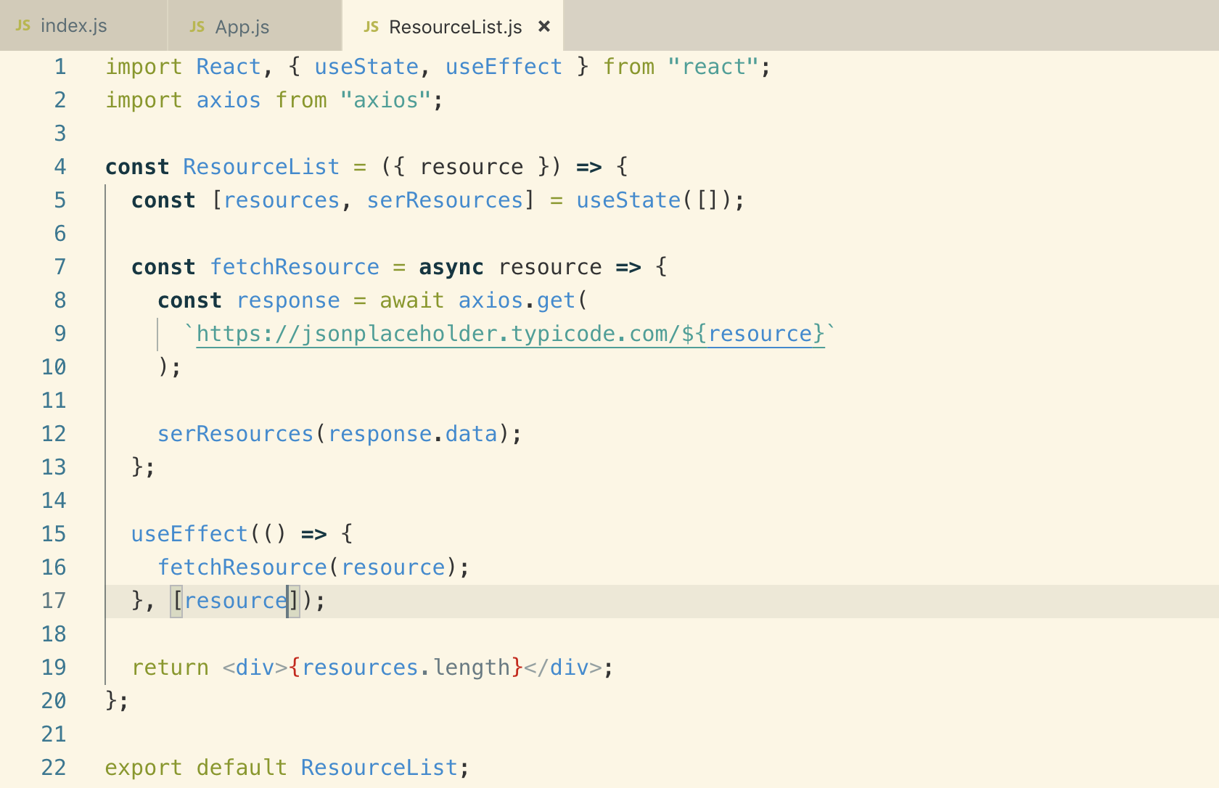

**13. Does It Get Called**

**If we do not pass the second array argument to useEffect(), it will create an infinite loop as we saw above with componentDidUpdate()**

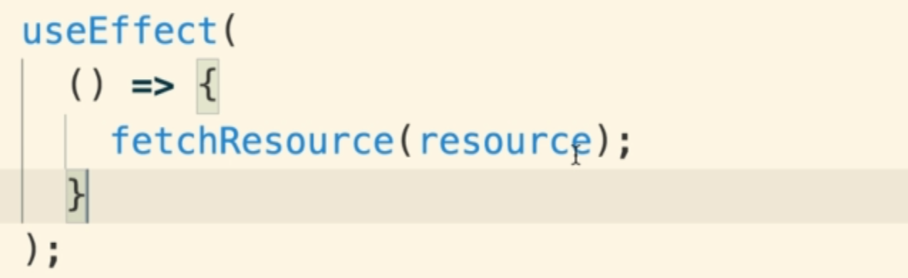

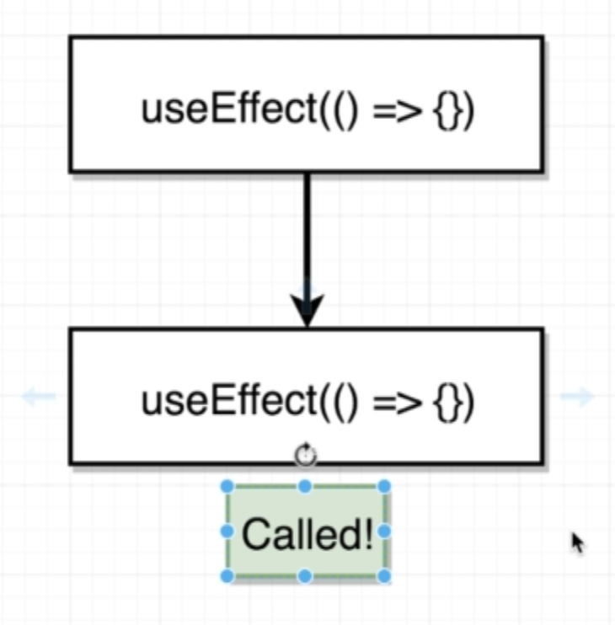

**If we pass an empty array, the useEffect() will not call second time or update**

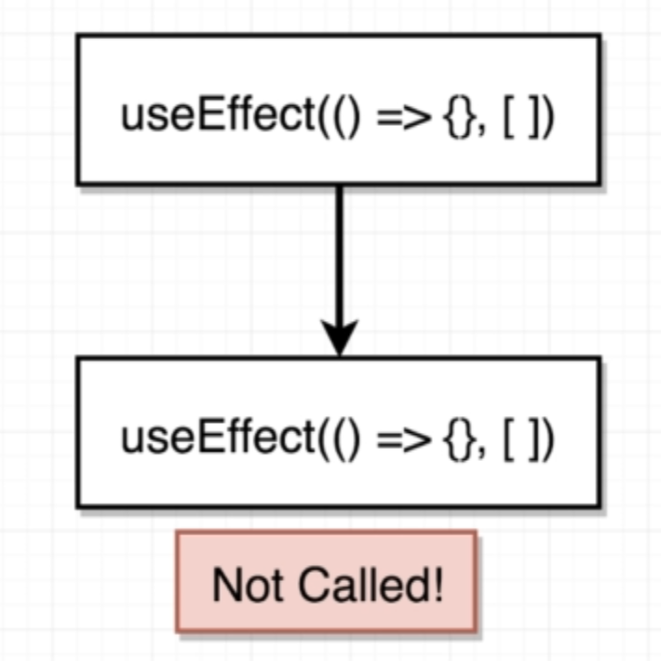

**{color: red}**

**Objects are different in memory location so it will not be the same. It will create an infinite loop again**

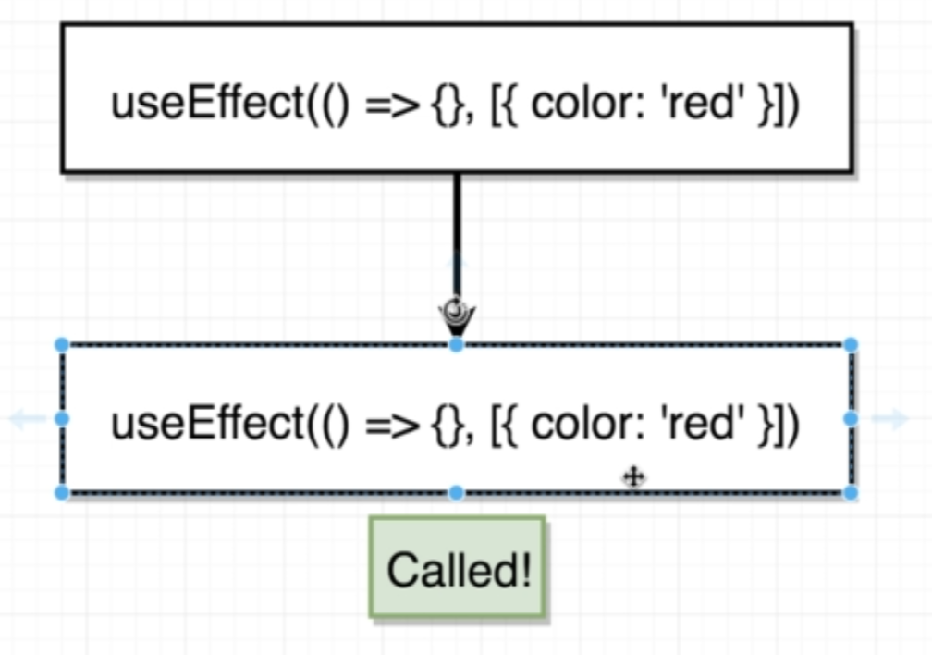

**With Array, it will not call second time**

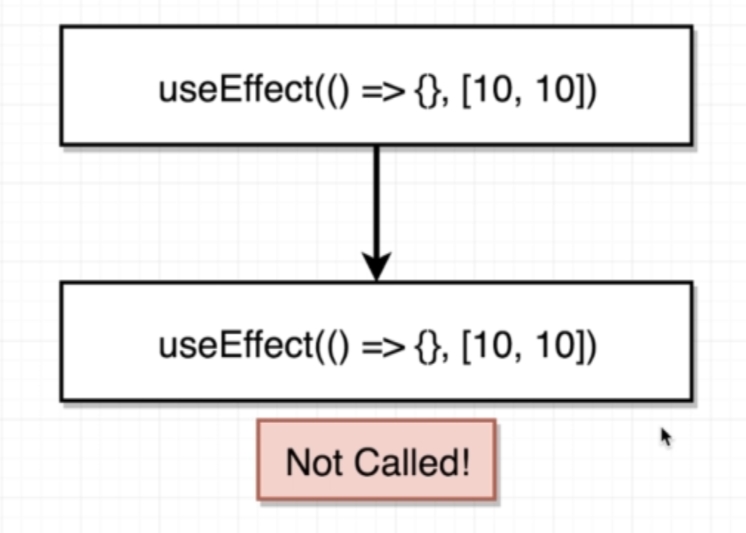

**Array with different values, useEffect() will be called a second time.**

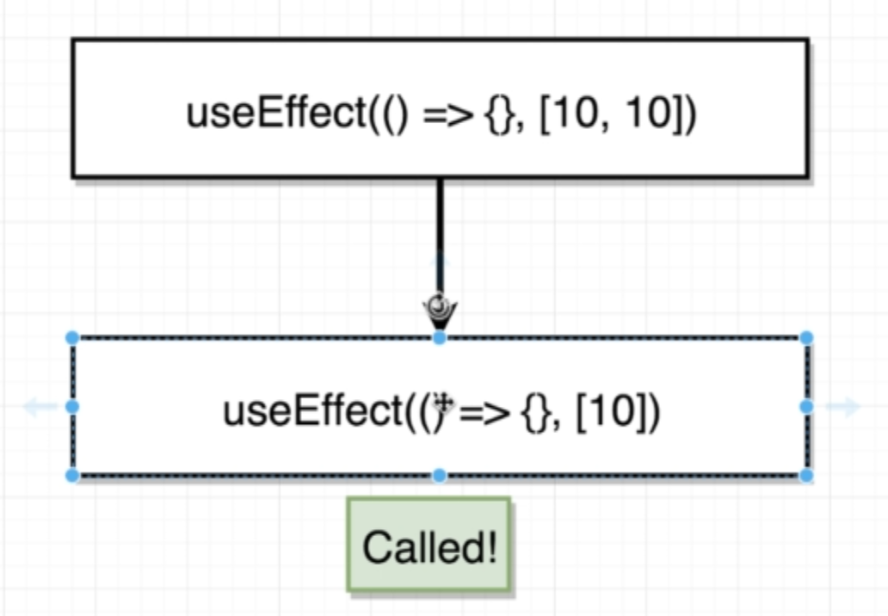

**14. Quick Gotcha with UseEffect**

**We can add direct code using effi() function like this.**

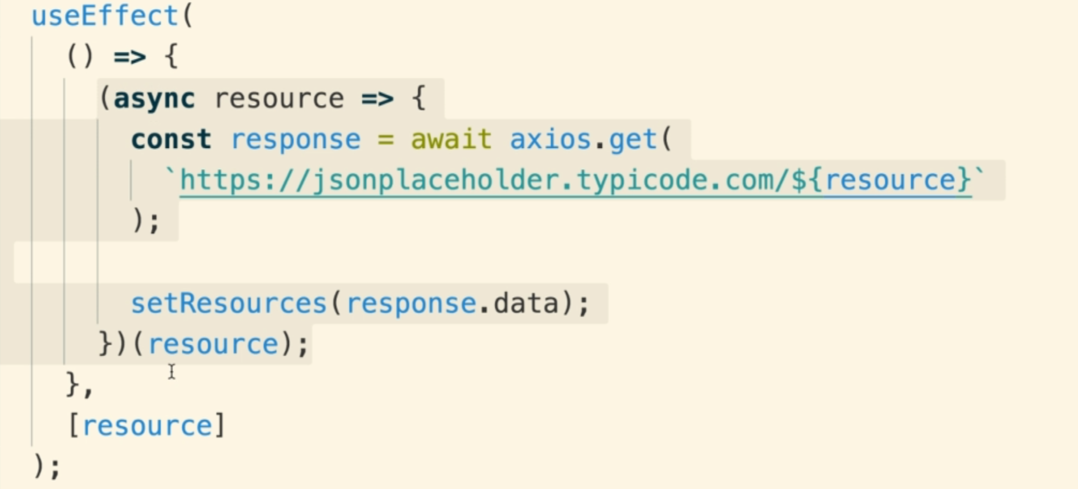

**15. Rendering a List**

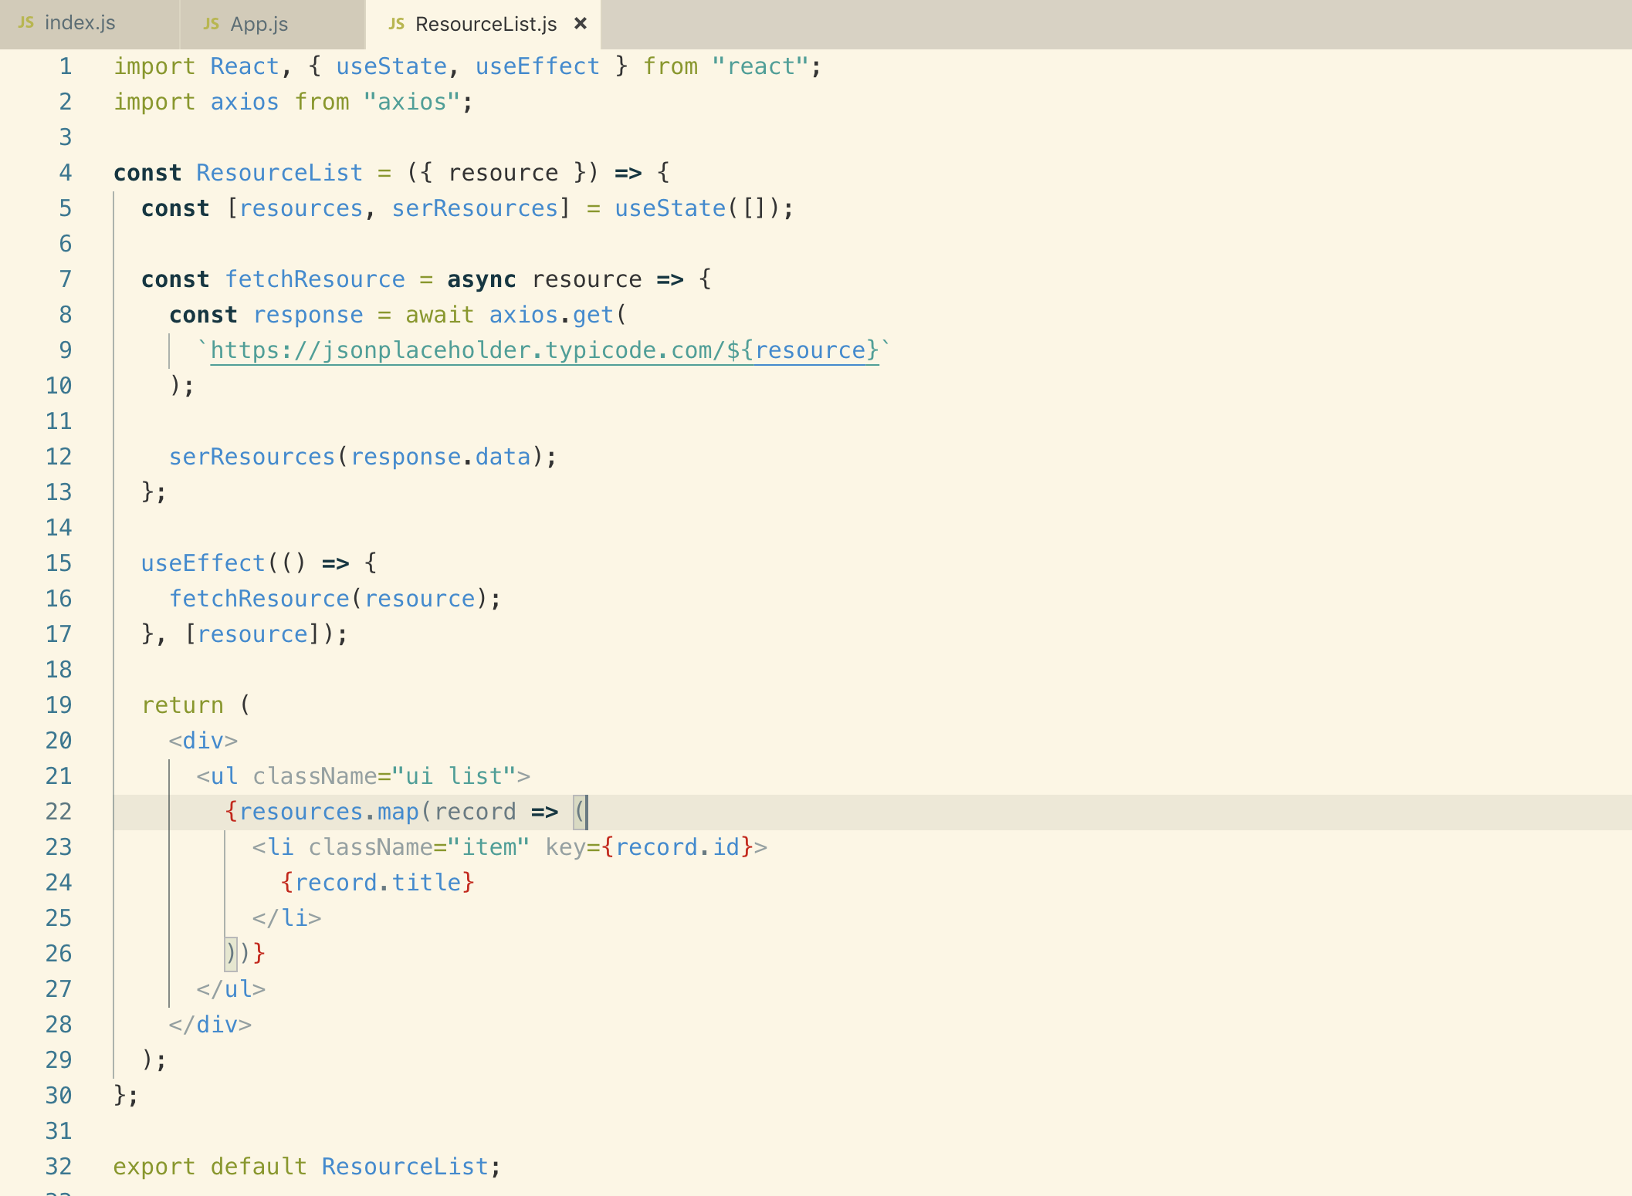

**16. Actual Code Reuse!**

**Here we will see how we can share hooks related logic between different functional components.**

**We have “input” as resource and “output” as resources[]. We just need to take care that to reuse the logic that we use implemented inside hook above**

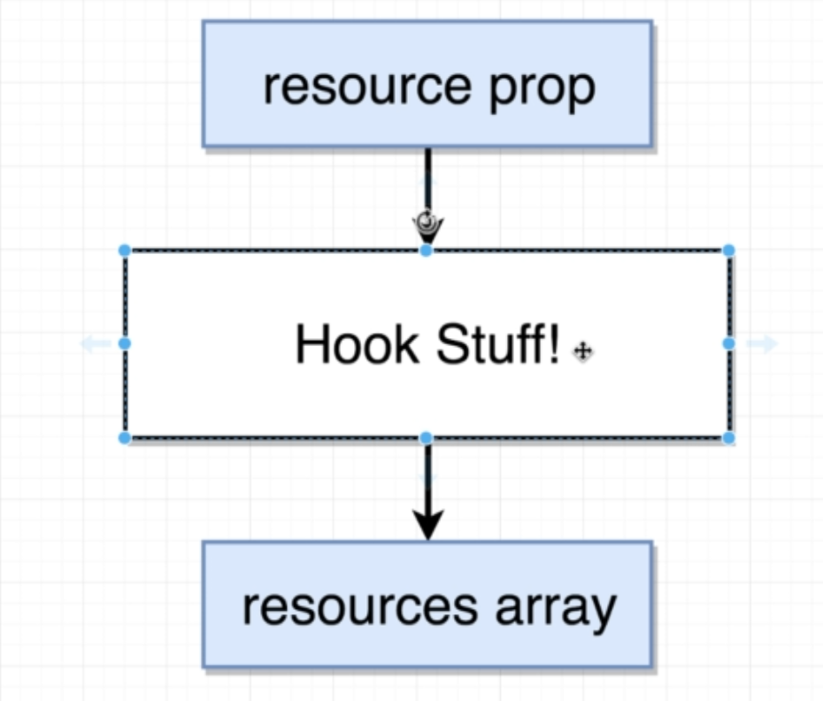

**Now we can export useResource() to reuse the code**

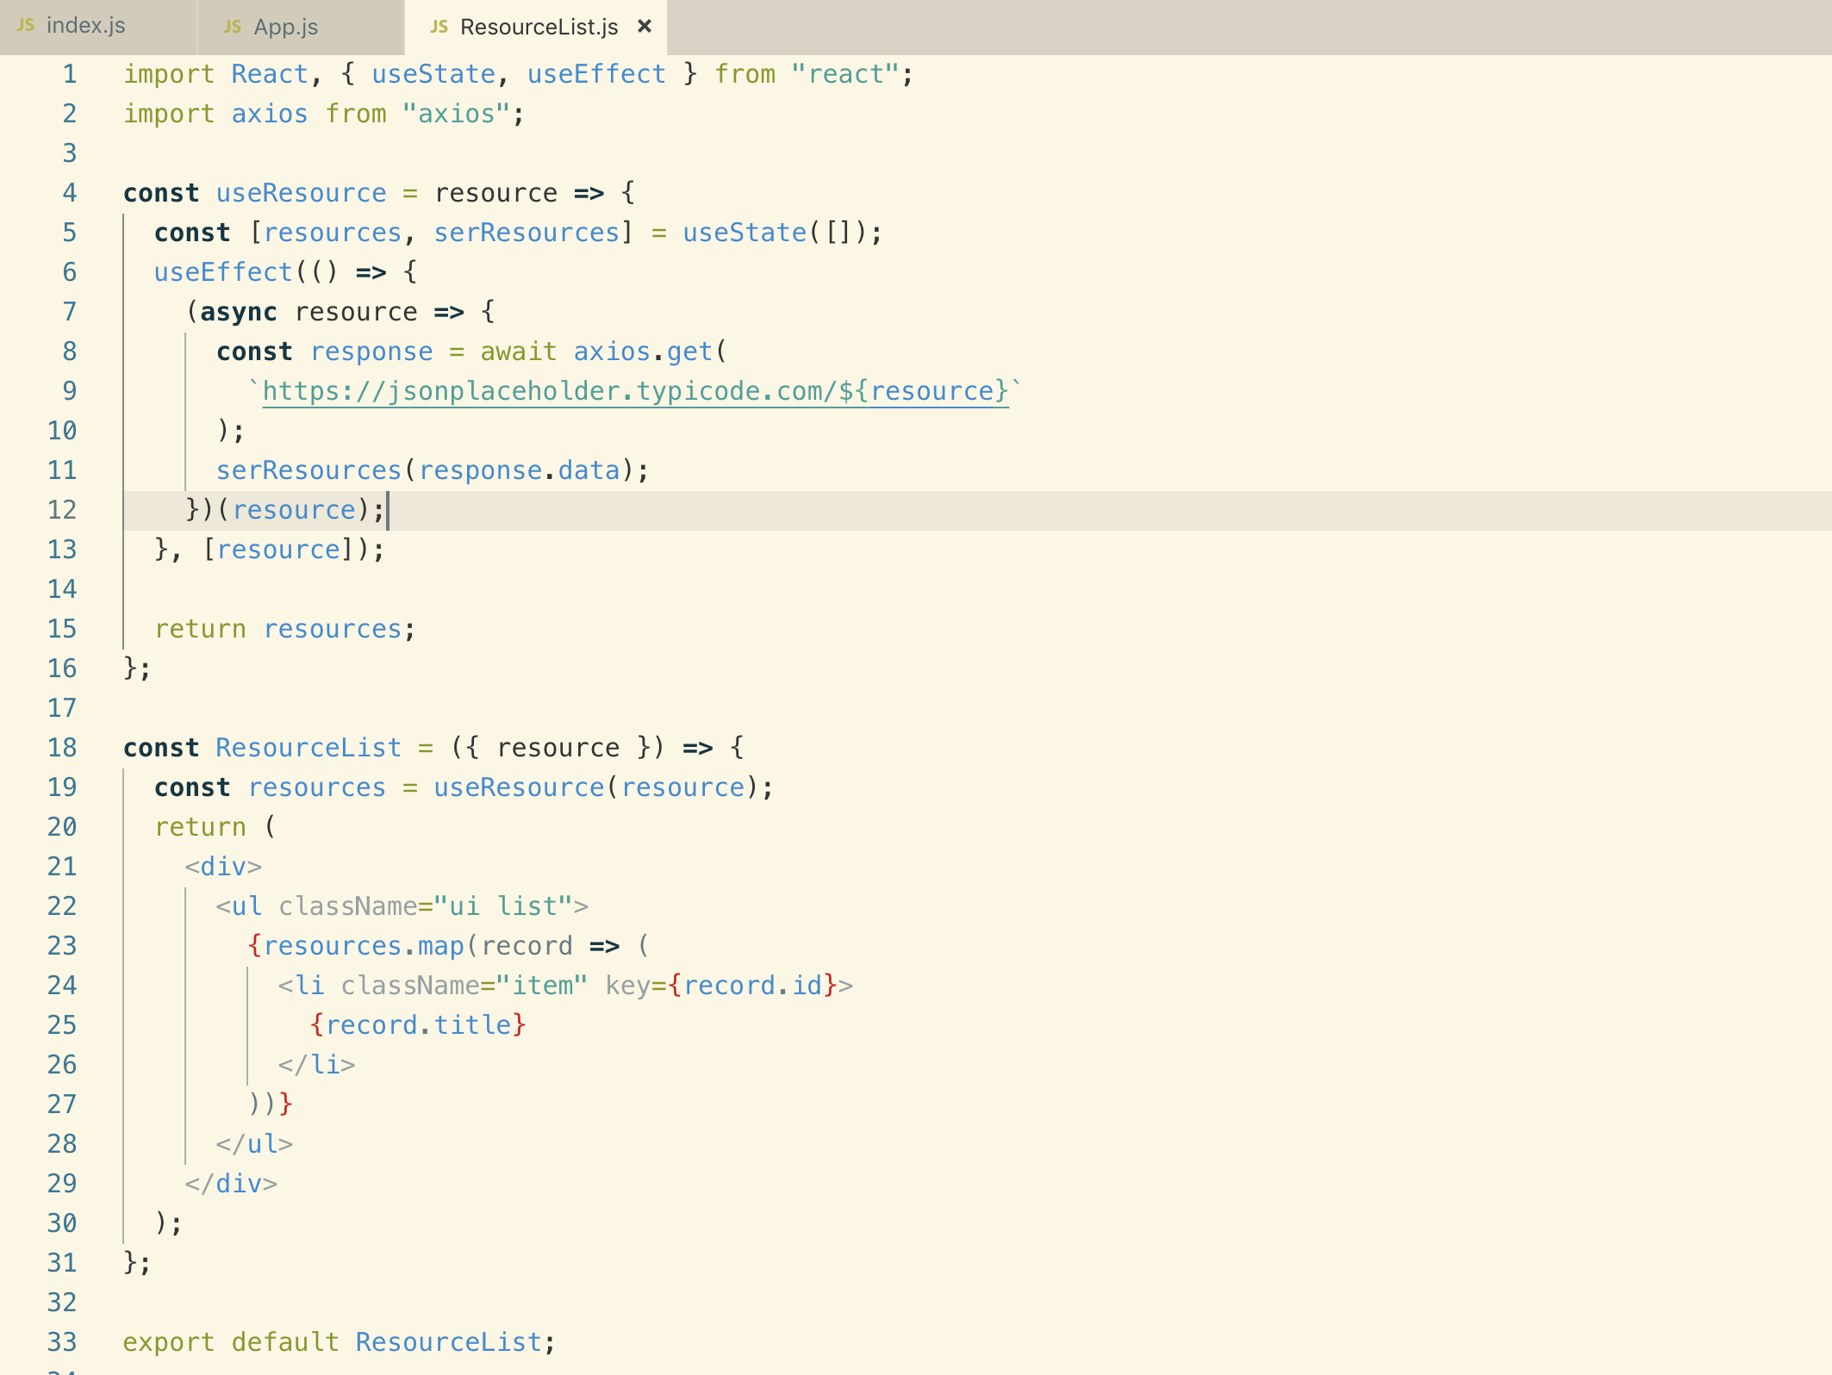

**17. Code Reuse with Hooks**

**A file that exports a function usually starts with small letter. We will create a file called components/useResources.js**

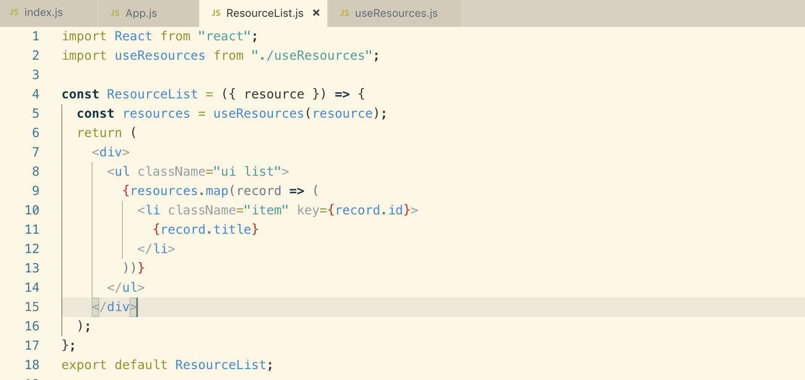

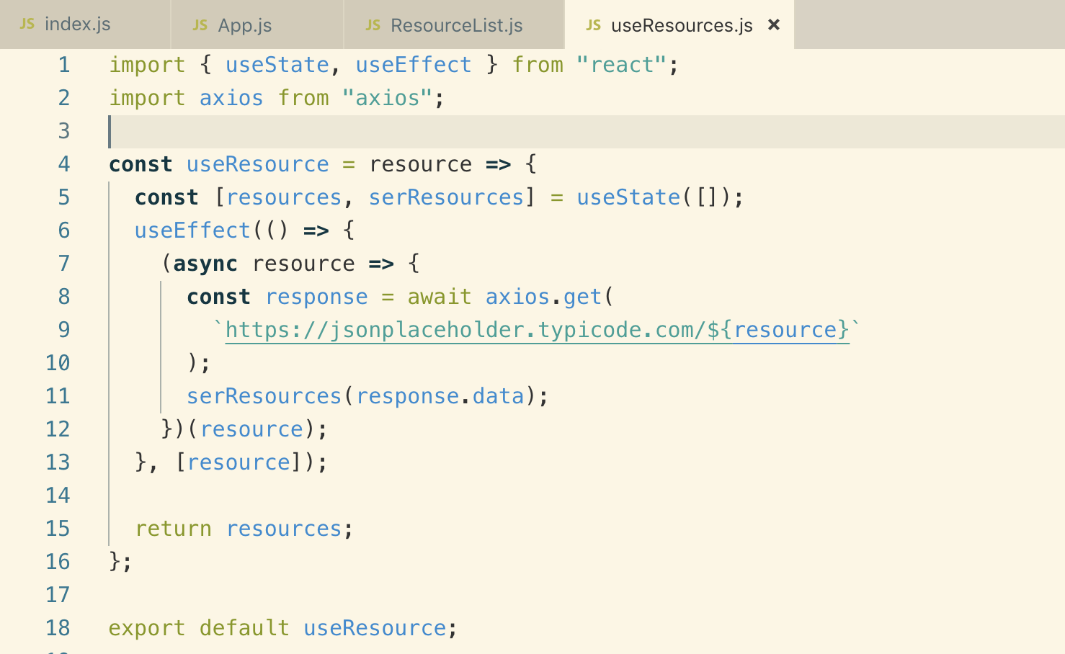

**Let’s create a UserList.js component and use useResource.js inside that**

**This is how we reuse hooks that we created above**

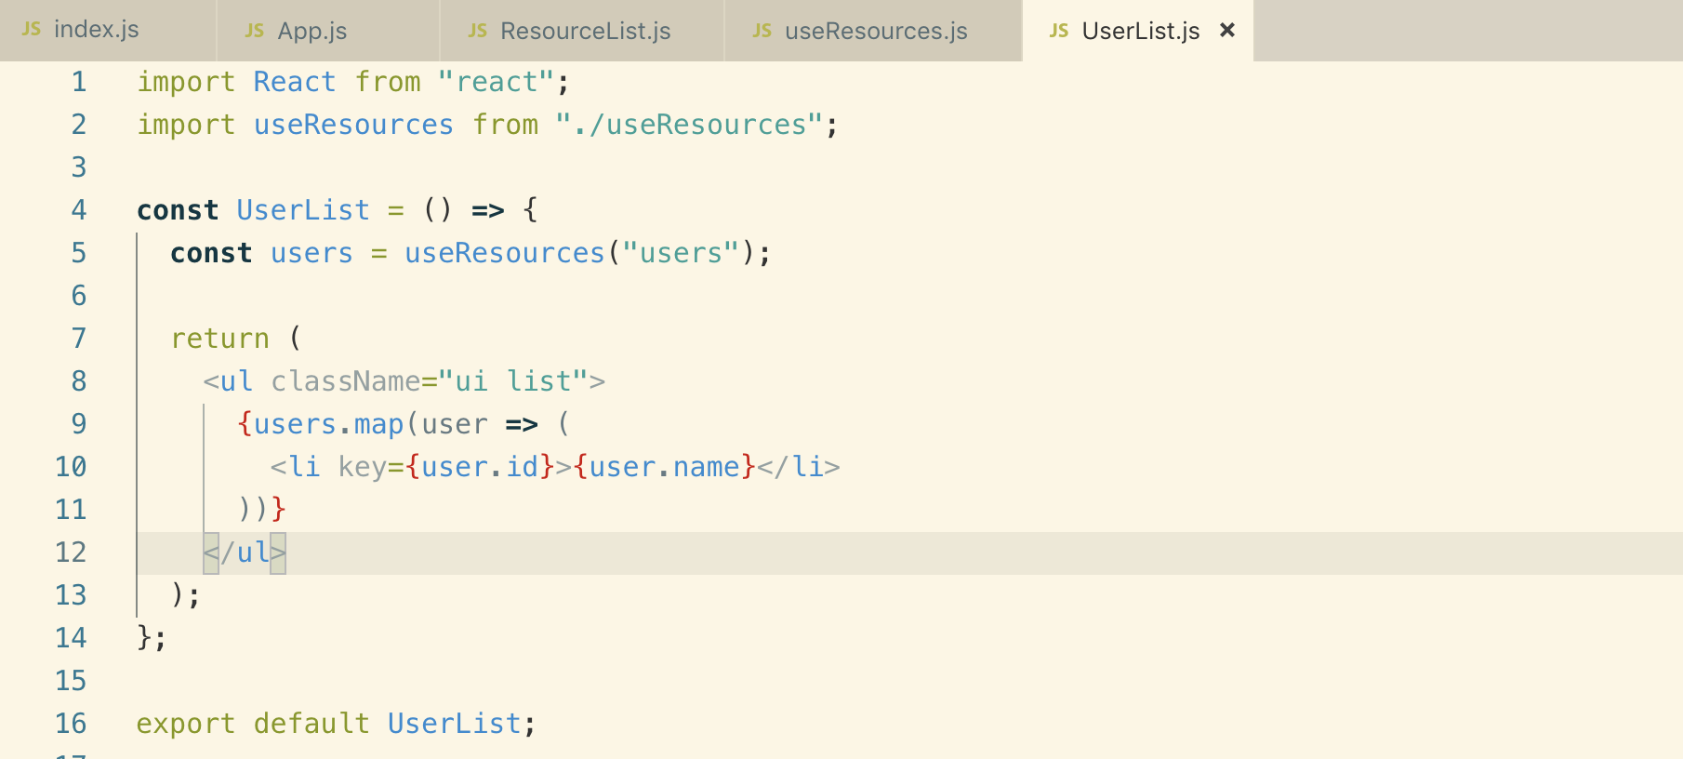

**26. More Fun with Hooks**

**1. Weather Hooks**

**This is the application that we are going to build in this section**

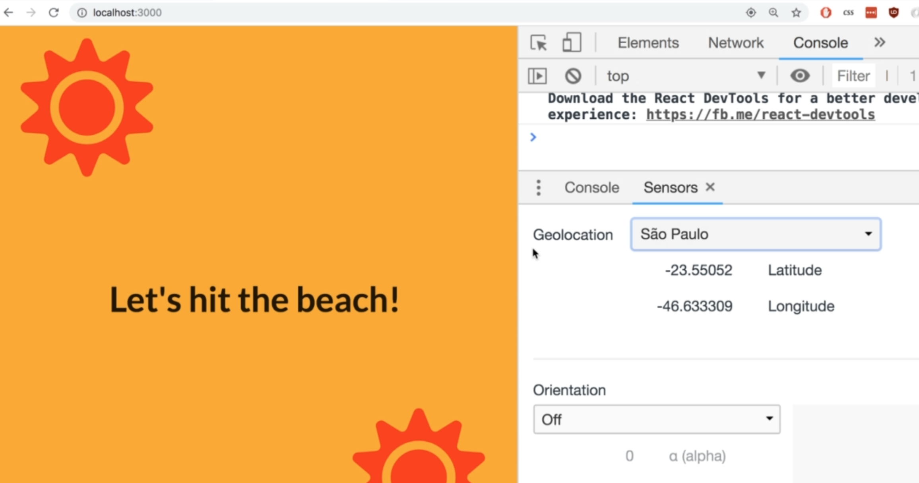

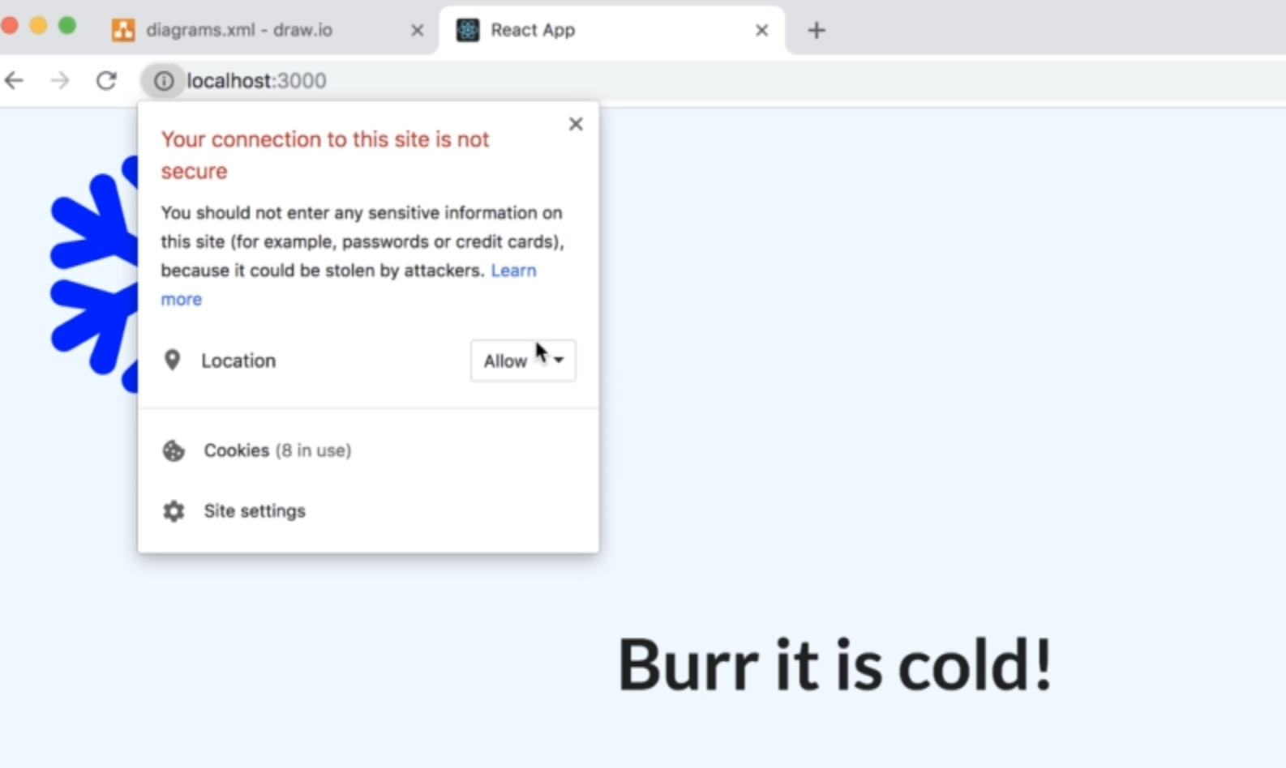

**5. Refactoring a Class to a Function**

**Refactoring below class based component into functional component using Hook System.**

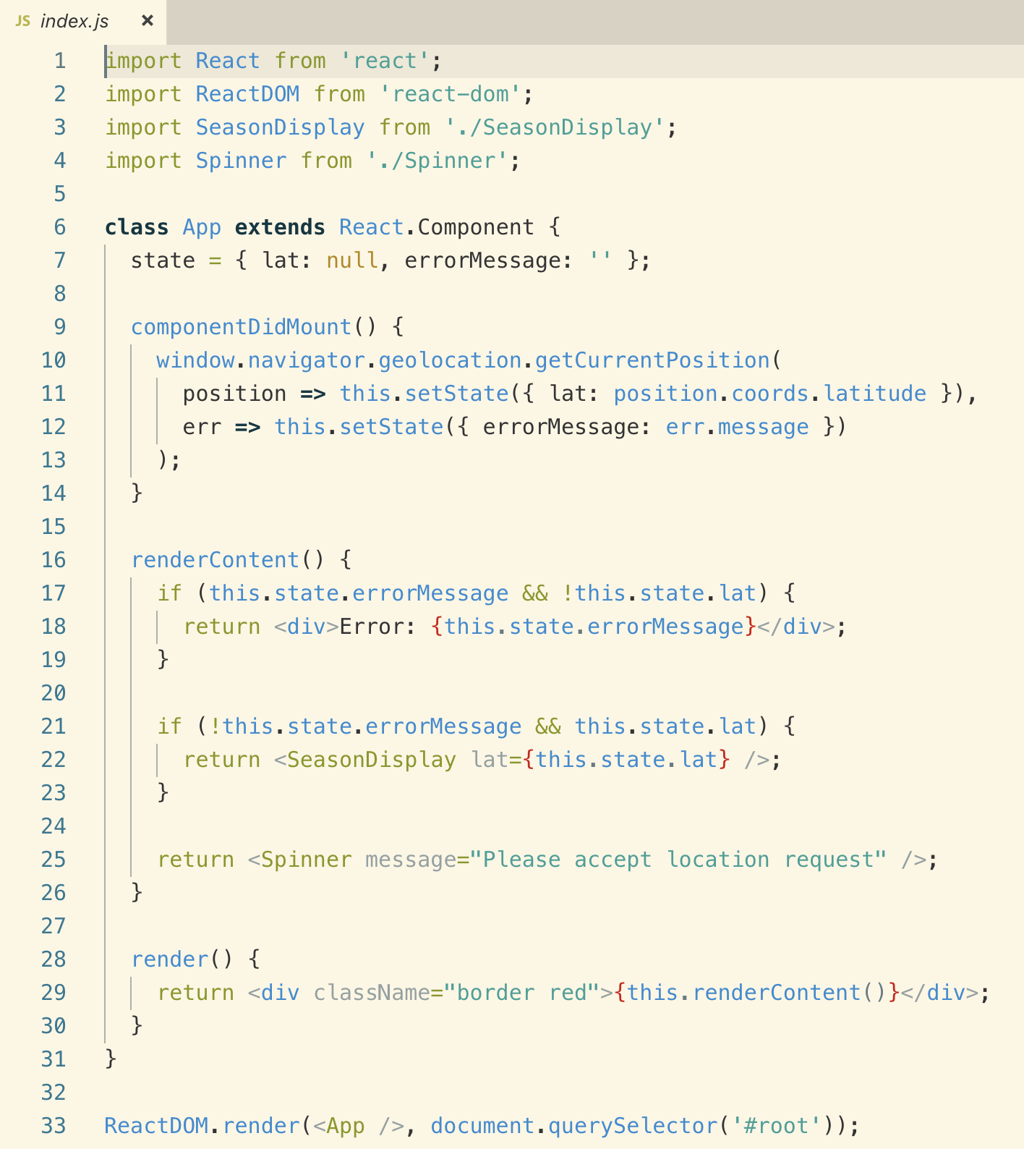

**Note: empty array in “useEffect” means, only try to run this function one time in total for the entire lifecycle of this component.**

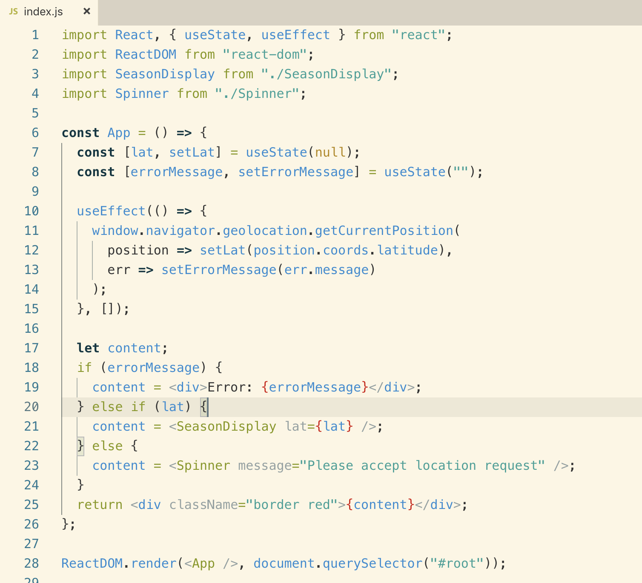

**6. Extracting Reusable Logic**

**Let’s try to separate the above Hook Logic into a separate file so that we can reuse it**

**Note: returning array like [lat, errorMessage] is a convention, but we can also return object if we want**

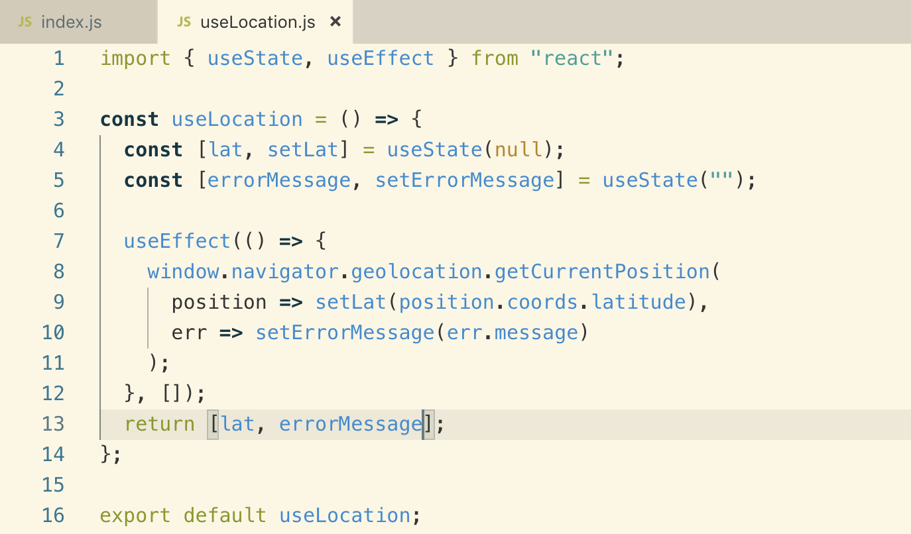

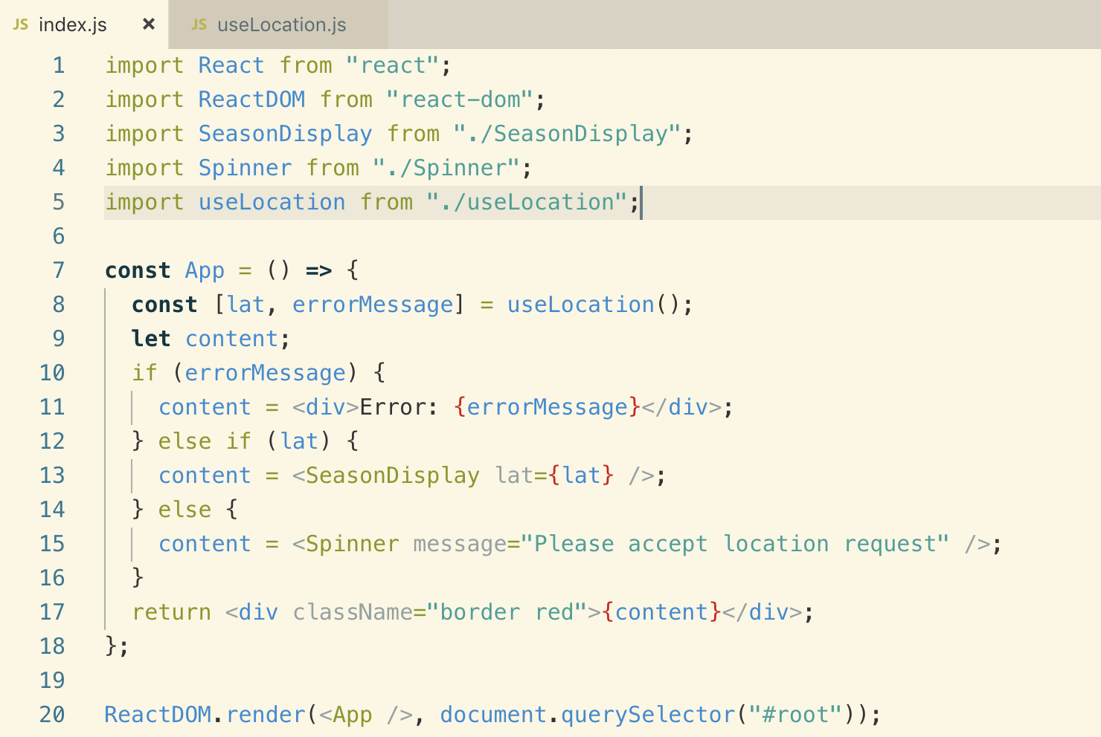

**Styled Component -- from youtube**

[**https://www.youtube.com/watch?v=3SpAg5tr7Ws**](https://www.youtube.com/watch?v=3SpAg5tr7Ws)

**StyledComponent is a library that we can use to create any HTML element and give them a CSS and use them into our entire application.**

**Benefits:**

1. Each component contains its own CSS.
2. It reduces the amount of CSS loading
3. No classname bugs
4. Easier deletion of code
5. Easy maintenance

To use it, we need to install it

npm install styled-components

Naming convention : Pascal => first letter should be capitalized

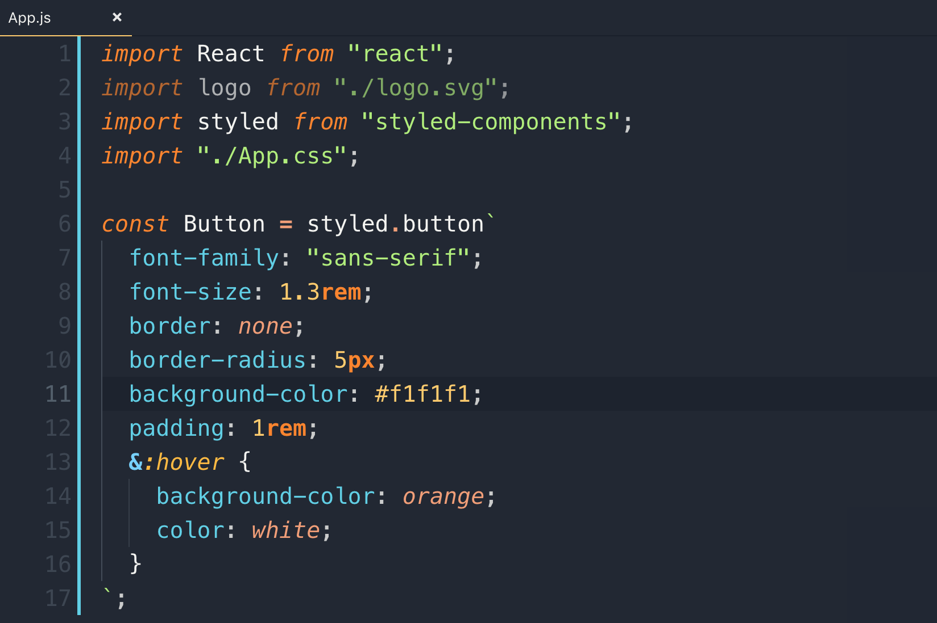

We can also make it dynamic like by passing props same as Bootstrap does for different buttons styling by adding classes

button btn-sm primary

Example:

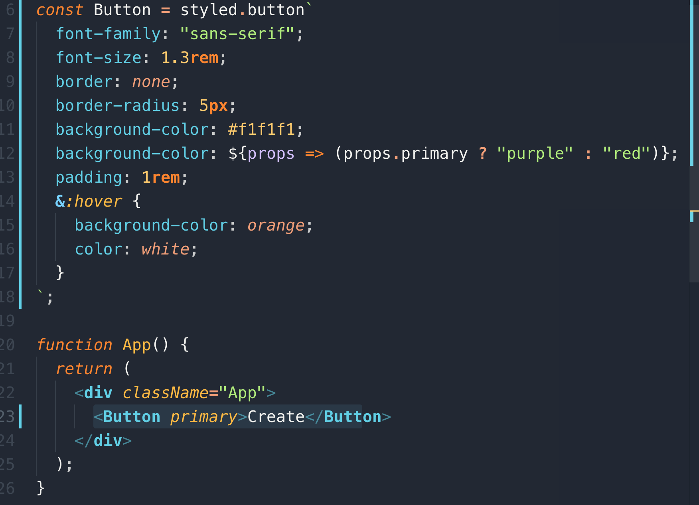

**ThemeProvider:**

We can create a theme and give it to our application and we can use it within our components.

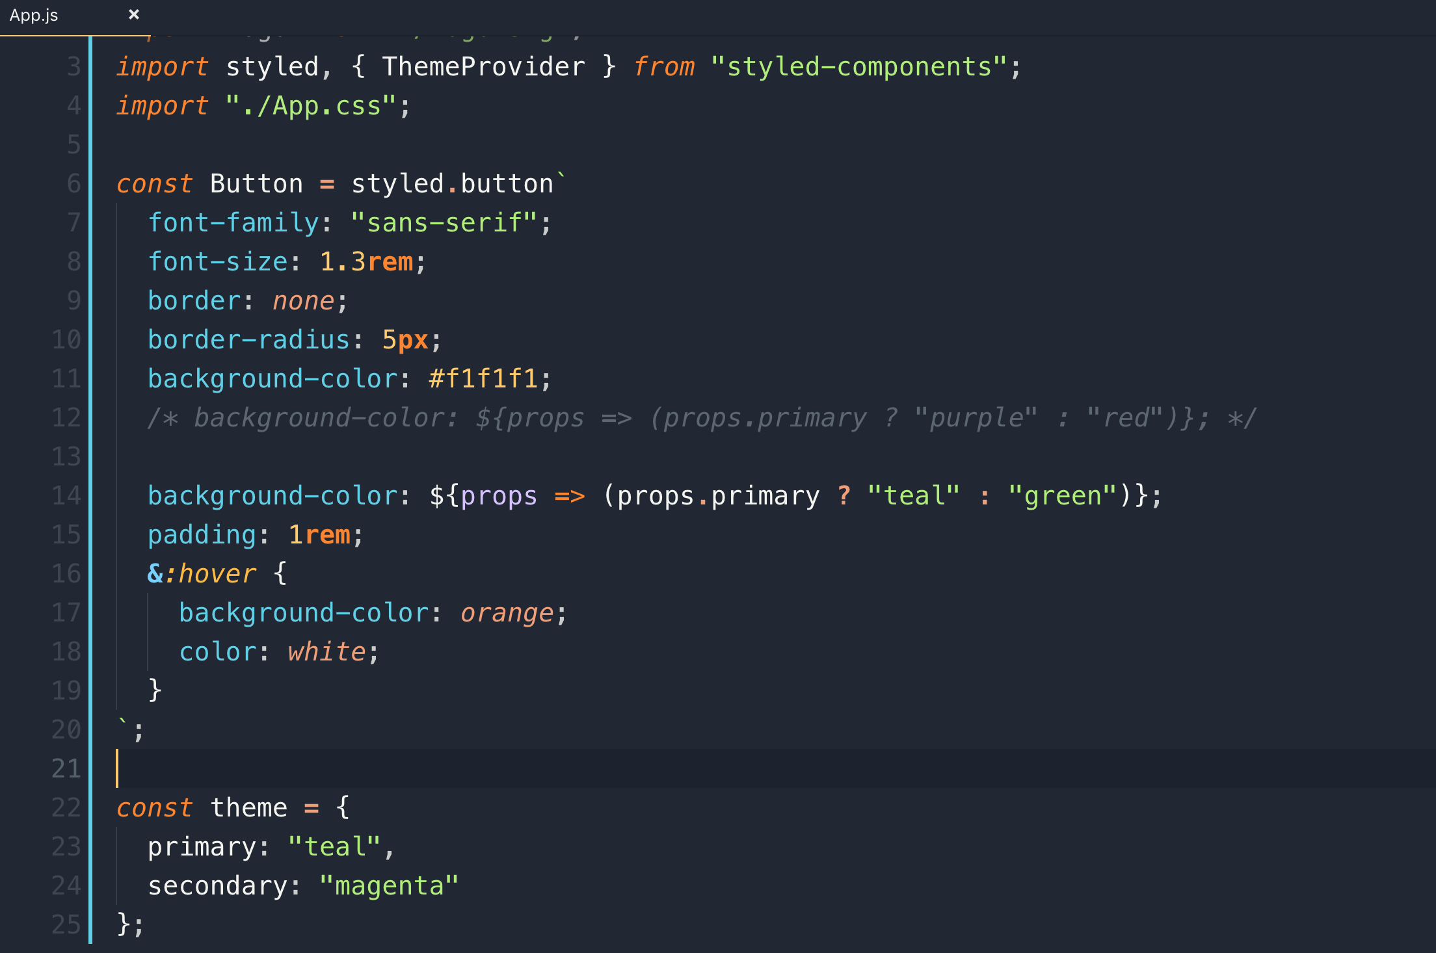

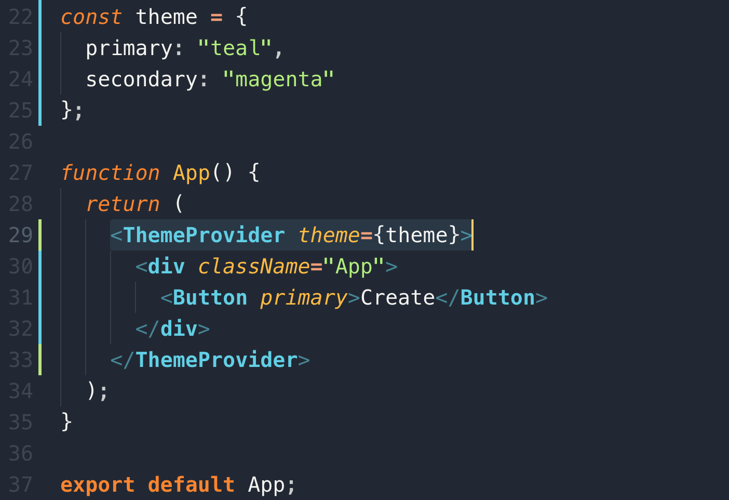

In the background it uses context API so you can pass property from the <ThemeProvider>

Let’s create a custom **h1**

**You can re-use the pre-defined CSS property like we have used “font-family” below**

**Example:**

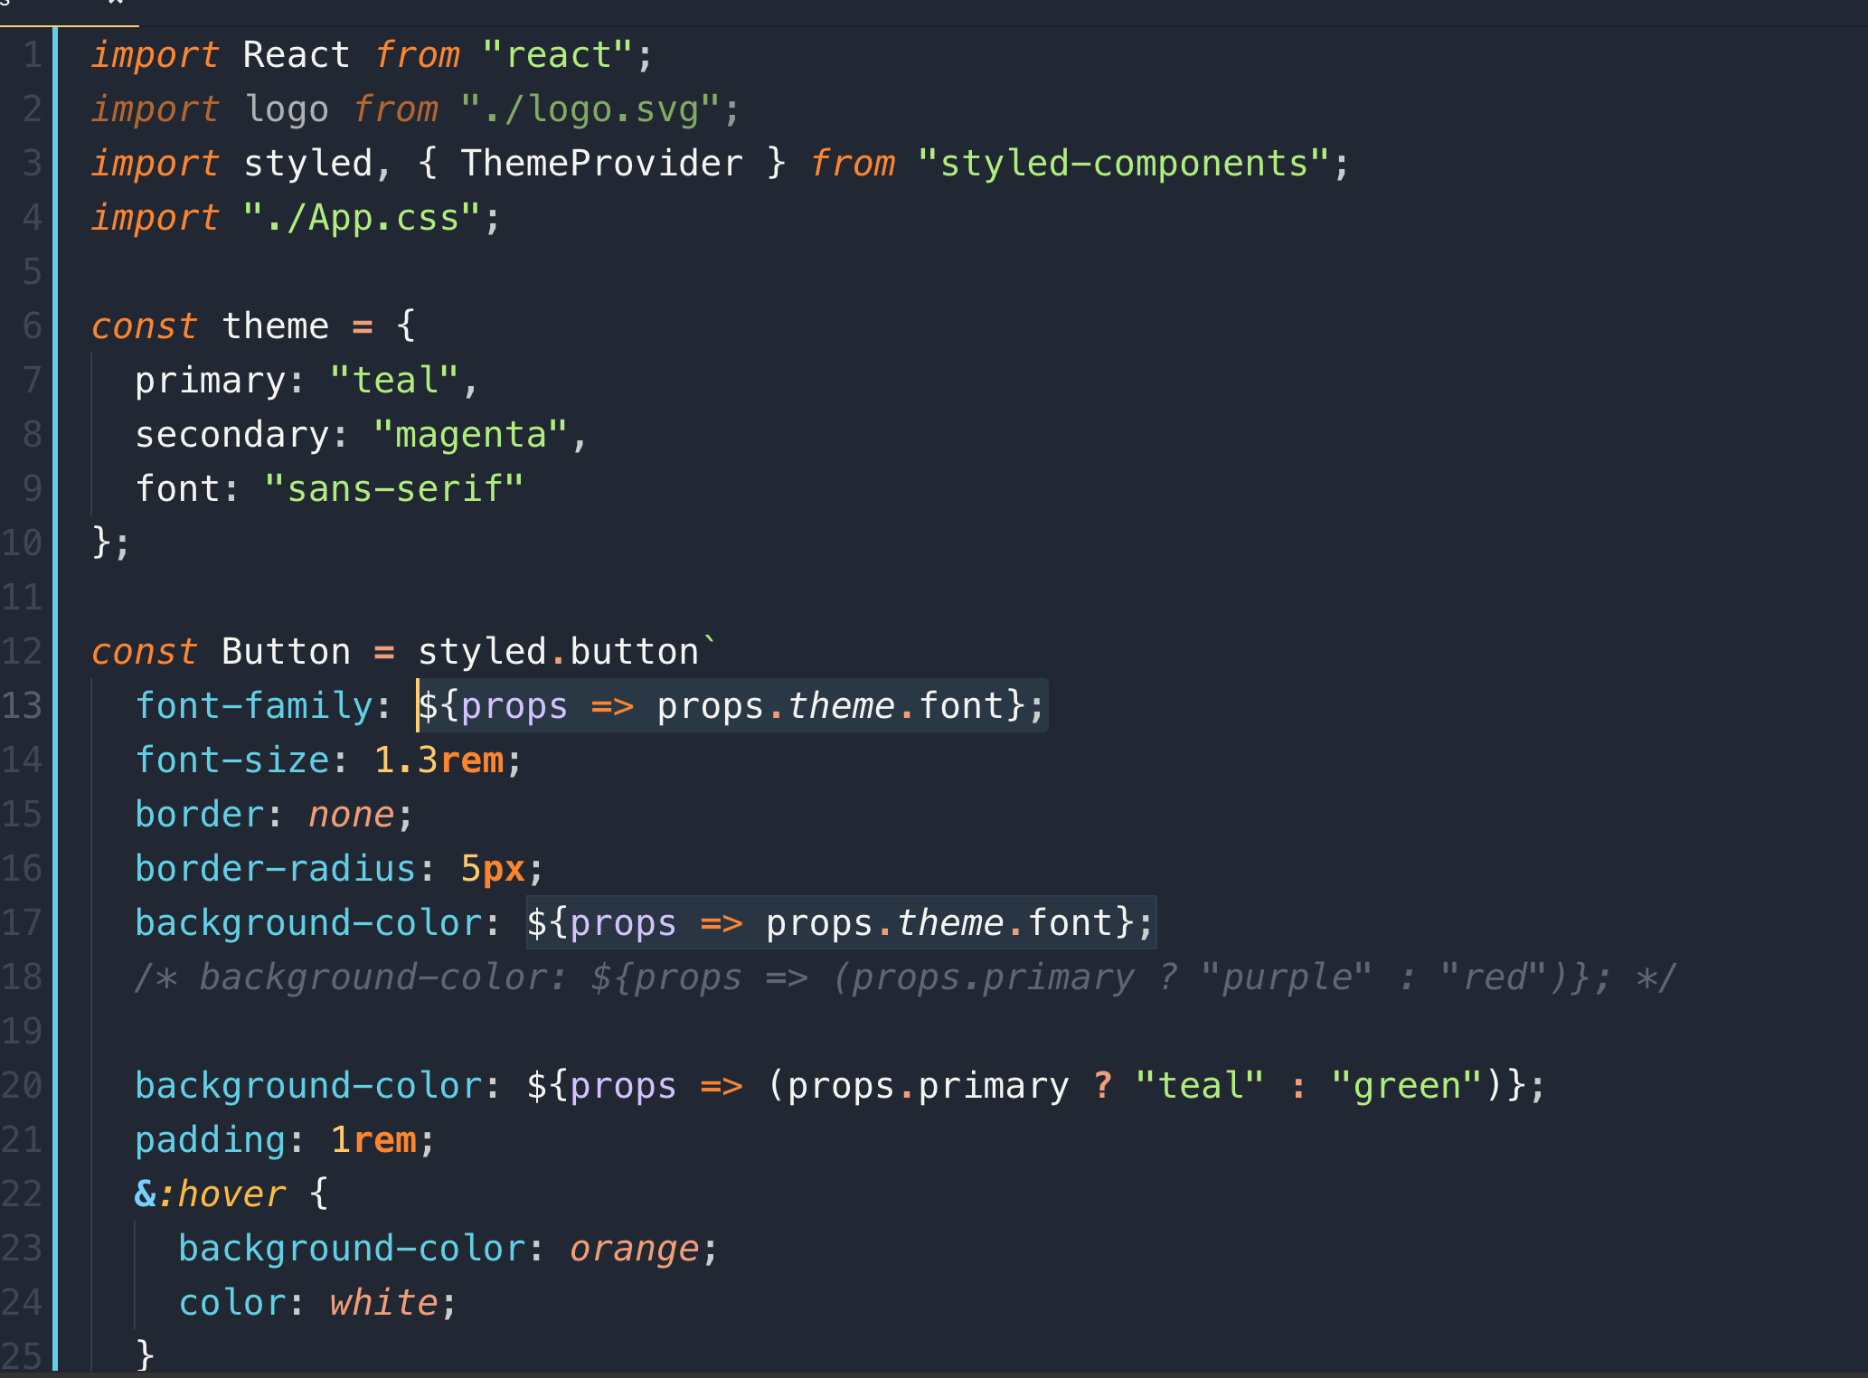

**If we want to change the font into the entire application, we can do that easily**

**Note:** you can have multiple theme provider

**We can add conditional color based on input**

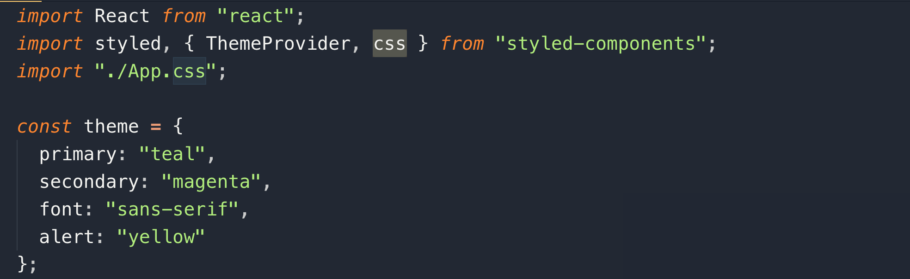

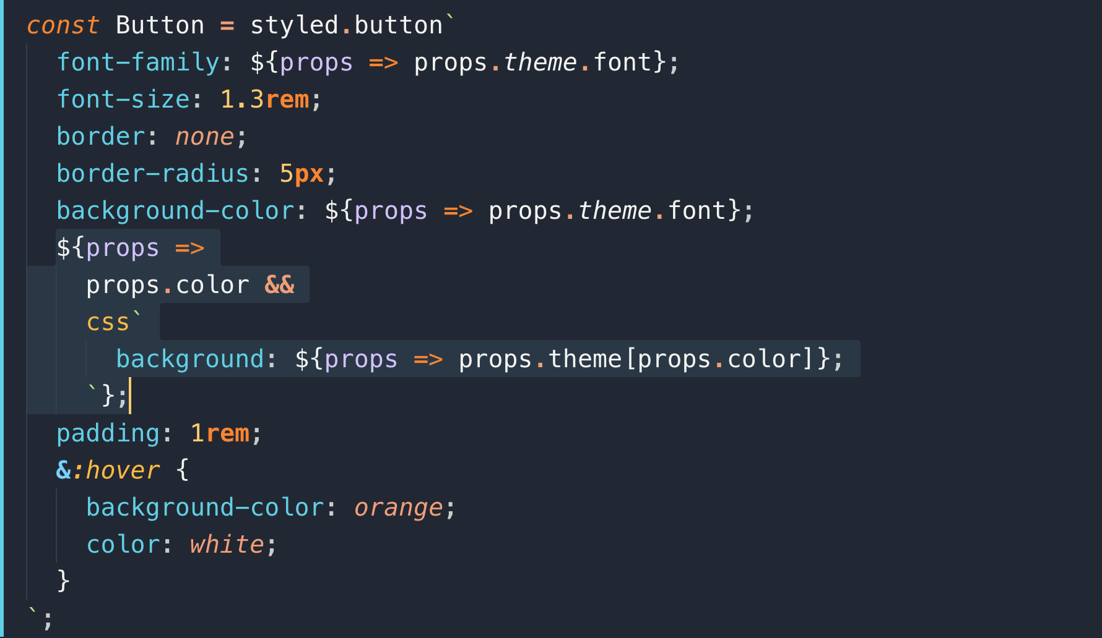

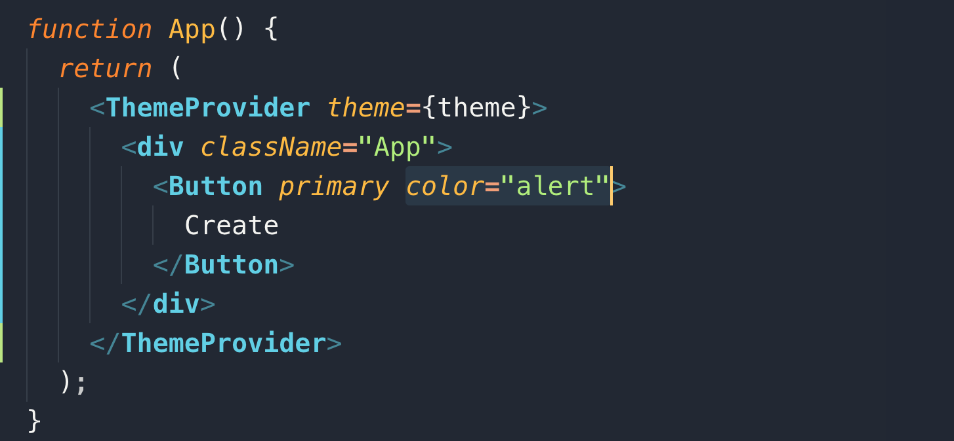

**Let’s make this Button component a separate component**

**FAQs**

**------**

**Q. Package.json vs package.lock.json**

**Ans: Package.lock.json file keeps the record of dependencies and it’s nested dependencies versions so when we run “npm install”,. We get exact same versions.**

**Q. where to use this “getDerivedStateFromProps” Lifecycle Method?**

**Ans:**

1. **ComponentWillReceiveProps**
2. **ComponentWillUpdate**
3. **ComponentWillMount**

**The above 3 methods are deprecated, but we can still use them with prefix “UNSAFE”**

1. **UNSAFE_ComponentWillReceiveProps**
2. **UNSAFE_ComponentWillUpdate**
3. **UNSAFE_ComponentWillMount**

**These will be completely remove in React version 17**

**These are migrated/updated lifecycle methods:**

**ComponentWillMount -> componentDidMount (used for setting initial state)**

**ComponentWillReceiveProps -> static getDerivedStateFromProps(nextState, prevState)**

**ComponentWillUpdate -> getSnapShotBeforeUpdate(prevProps, prevState)**

**Q. What are new components in React 16.3 and above ?**

**Ans:**

* **Mounting Methods**

These methods are called in the following order when an instance of a component is being created and inserted into the DOM:

1. Constructor()
2. static getDerivedStateFromProps()

Why it is a static method?

It is because we don’t want user to access “this” directly inside the method.

You cannot directly setState(). To change state you return new state or null

in case you don’t want to change state.

1. render() : you cannot setState() here otherwises you will go infinite loop
2. ComponentDidMount(): This method runs after a component is mounted. It assures you that DOM is ready.

* **Updating Methods**

An update can be caused by changes to props or state. These methods are called in the following order when a component is being re-rendered:

1. static getDerivedStateFromProps()
2. componentShouldUpdate(nextProps, nextState) : you can make decision if the component should update or not based on props and state.
3. render()
4. getSnapShotBeforeUpdate() : The reason to introduce this method is that React is using lazy loading. Sometime there is a delay between you render a component and it’s next phase. Let’s say if you user does something in between like user scroll or resize a window then you need to remember where the scroll was before so you can do something after the render
5. componentDidUpdate()

* **Unmounting Methods**

This method is called when a component is being removed from the DOM: you can do something just it removes from the DOM

1. componentWillUnmount()

**Q. Why do we use arrow function in React?**

**Ans:** In React you can have “onclick handles” which is not actually a class method, it is actually a class property.

In the below example, render() is a method whereas loginHandle is a class property.

Generally, we define property into Constructor() function like this.name and so on, but in the newer version of React, you can assign property like “loginHandle”

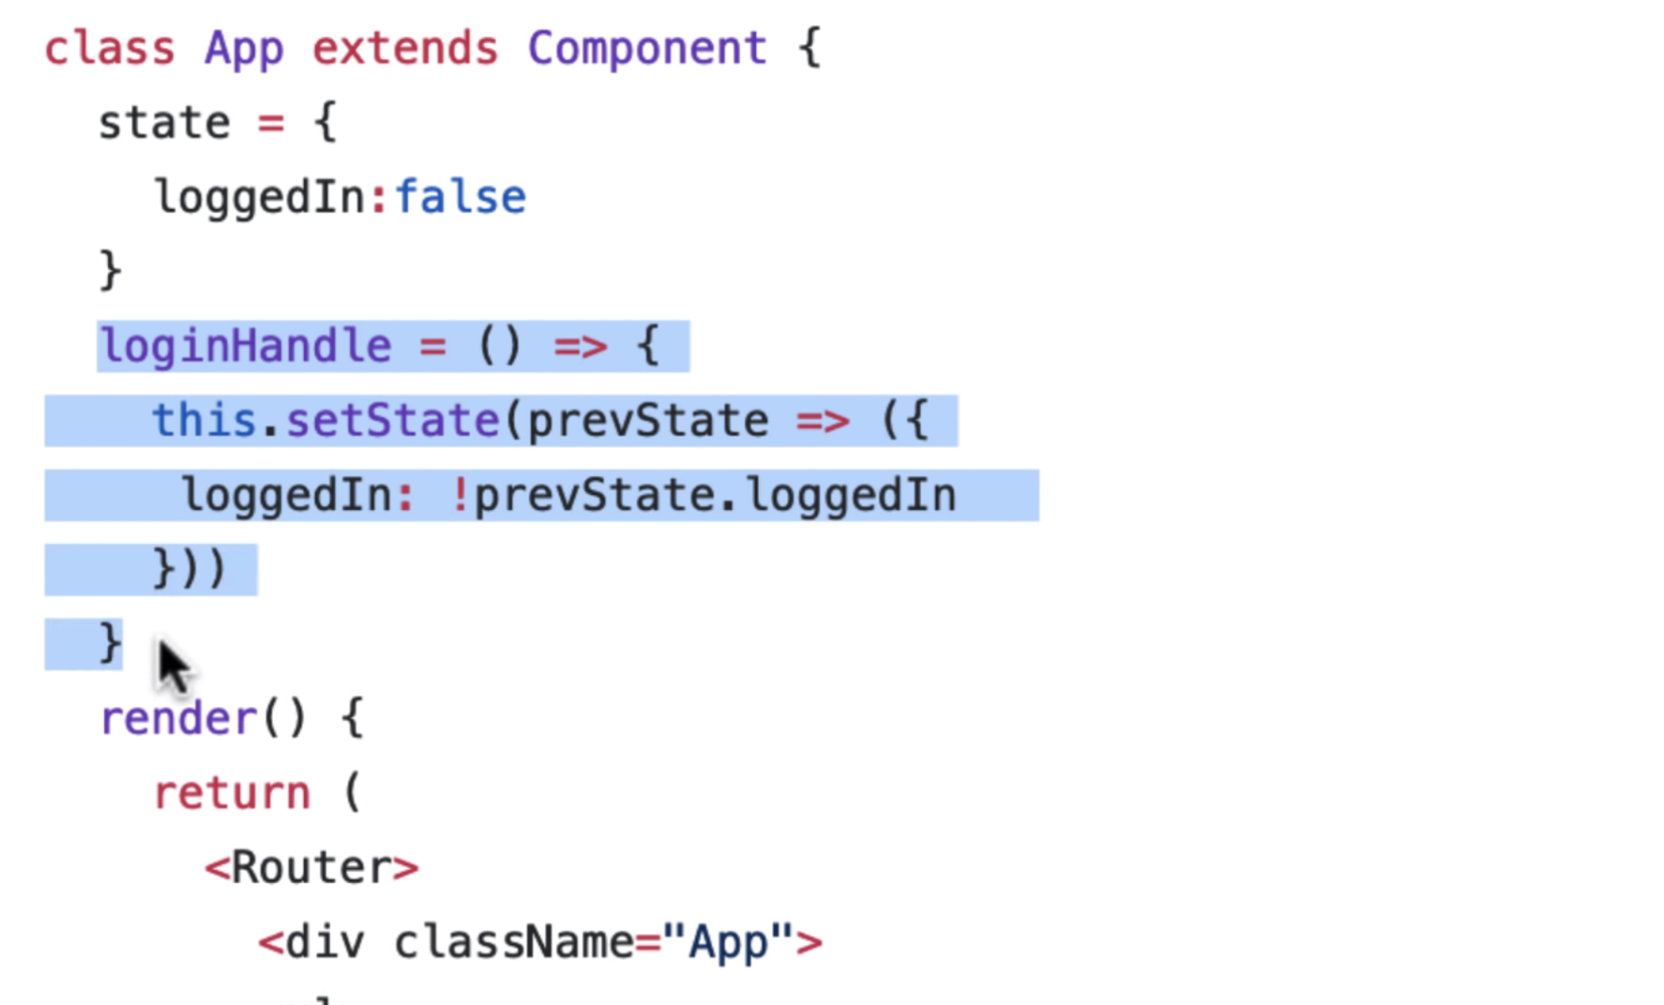

**Q2. How to prevent component from re-rendering?**

**Ans:** There are 3 ways to do it.

1. ShouldComponentUpdate.
2. React.PureComponent : Cannot use ShouldUpdate component with PureComponent
3. React.memo

**Q3. How to handle errors in React Component using “ErrorBoundaryCom”?**

**Ans:** Error Boundaries are React components that catch Javascript errors anywhere below them in the component tree. If an Error Boundary catches an error, it will first log the error, and then it will display a fallback UI instead of the crashed component tree

There are 2 lifeCycle methods which we use with this

1. getDerivedStateFromError: should be used for rendering a fallback UI
2. componentDidCatch: you can set Error and message here

Note: - Here are the error types they do *NOT* catch:

Event Handlers

- Asynchronous code

- Server side rendering

- Errors thrown in the Boundary component itself

**Q4. Name some of the patterns that React uses?**

**Ans:**

1. Context API

2. Render props

3. Presentational Component Pattern

**Q5. Why would you use React in your project?**

**Ans:**

1. first factor is that if my Project is of 6 month and React is changing before 6 months then will not use it. I may use something else
2. Comparing other frameworks like Angular or Ember which are easy to configure, but hard to use. They come as a huge package like Angular CLI which is itself a large package.
3. React is functional programming, This is the framework that allows you to do a lot of javaScript
4. Compare to Angular, you have remember lot of different syntax

**Q6. What is CSS-IN-JS pattern in React?**

**Ans: “CSS-in-JS” refers to a pattern where CSS is composed using JavaScript instead of defined in external files.**

**You can CSS that doesn’t affect other parts. Its like scoping CSS.**

**You can pass CSS as literal objects and this way you can do inline. Inline CSS doesn’t pollute other parts.**

**Another advantage of inline CSS is that you can conditionally render and some of the common styles we can import because they are JavaScript Objects.**

**Q6. Why can’t you update state without setState()?**

**The main motive to to set state using setState() is to re-render() the component which doesn’t happen if we directly change it.**

**Q7. How many ways can you conditionally render in React?**

**The main motive to to set state using setState() is to re-render() the component which doesn’t happen if we directly change it.**

1. **This is one way**

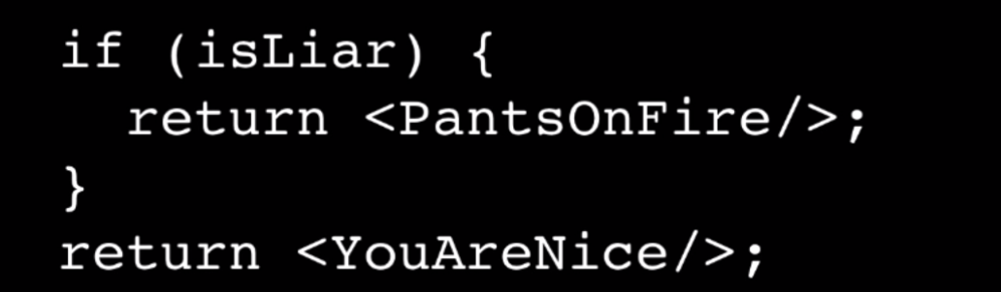

**2. Second way**

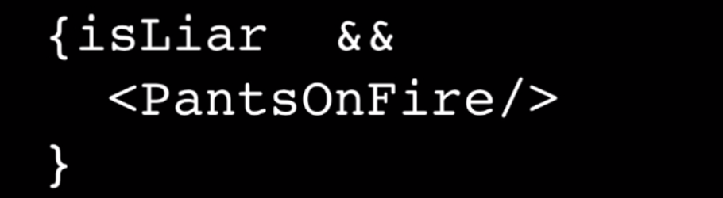

**3. Third way**

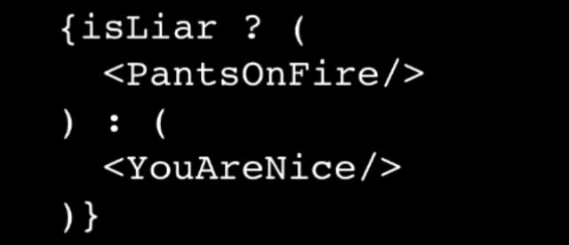

**Q8. What is Fragment and why do we use it?**

**Adding parent element to children creates so many tags and it might be problem for CSS.**

**React.Fragment allows to Return children without adding parent div element.**

**Note: it only works latest version of webpack**

**Q9. How to do code splitting in React?**

**When the React code compiles, the bundler bundles the entire application into one single file and this can be problematic if you have a huge project and your initial load will be very huge.**

**There are cases where user may visit only few pages so React introduce a way to split the code into multiple bundles**

**Note: The lazy loading bundles load synchronously**

**Q10. What is the alternative to Redux?**

**MobX**

**Q11. What is the Redux Middleware?**

**You add another layer in the main layer.**

**Example:**

**You are making a POST request and at the same time you are calling action to get some data and somehow your POST request gets failed then your Store and DB will not be synced as given in the below picutre**

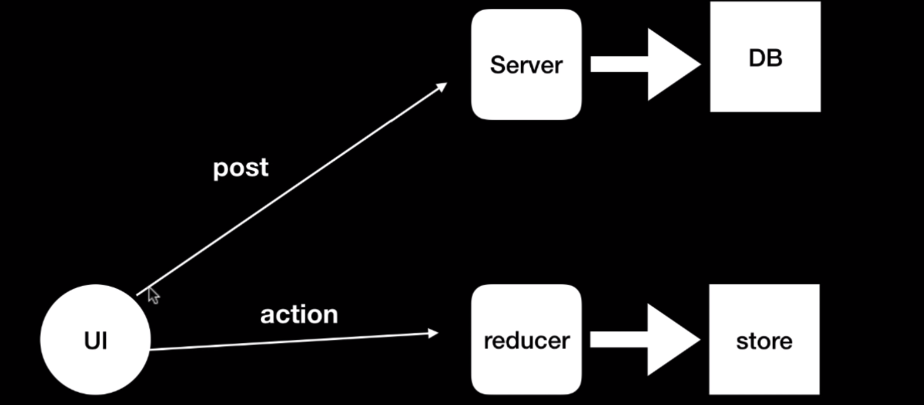

**The solution to the above problem is Middleware like this**

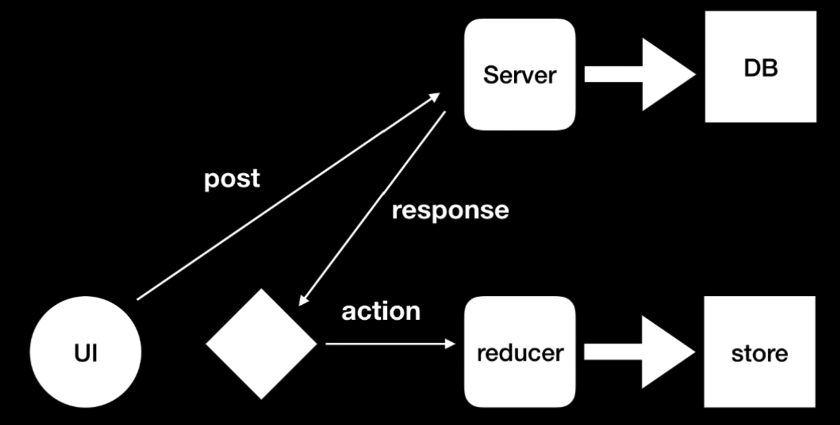

**Q12. What is difference between Redux-saga and Redux-thunk?**

**In Saga, you can cancel action, if you want**

**Q12. How to optimize a React app?**

**Ask the interviewer how big is the application? Which version of React it is running?**

**What do you mean by bad performance?**

1. **First we need to profiling React app and see which area is causing problem.**
2. **The reason to speed is that there might be components that are not supposed to be re-rendering. For example, if you are not changing state, but you are setting state over-2 that would update the virtual DOM. To prevent this, we can use ShouldComponentUpdate or PureComponent or we can use React.memo.**
3. **If your package size is too large, we can split it into bundles and using lazy loading for rarely used components**
4. **You may have some slow APIs**
5. **It may be that your assets are loading slowly like images or slow CDN**
6. **For rendering component like Buttons, you may be using classes, converting them into functional component will improve code.**
7. **Instead of binding function with class, use arrow functions that may improve it**
8. **There are some external packages available that can analyse your application speed**

**Q12. what is virtual DOM?**

**React has its own DOM tree and it updated only that what is change by props and update the specific in the Real DOM. It uses Diffi algorithm**

**Q13. {} VS {{}}?**

React uses {} as it does not use templates rather it used JSX which is behind the scene is just JavaScript.

**Q14. What is CSS in JS / styled component?**

It is by default scoped CSS and you have most of the functionality as you in SCSS. It makes your code more readable.

**Q14. Web Worker?**

Ans: Web worker provides a mechanism spawn a separate script in background for your web application where you can do any complex kind of calculation without disturbing the UI.

Because Web worker has a separate thread, it doesn’t have this access

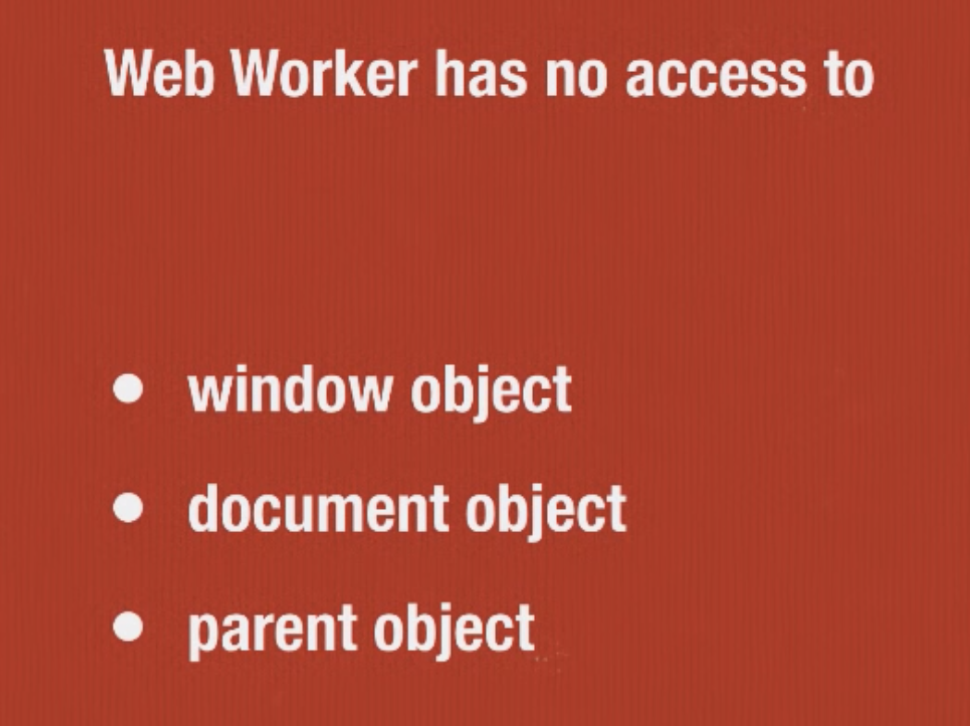

Web worker has access of the following

1. XMLHttpRequest
2. Navigator Object
3. userAgent
4. Geolocation
5. cookeyenabled
6. setTimeout()
7. clearTimeout()
8. clearInterval()
9. seInterval();
10. It has also access to application cache
11. From one worker you can delegate some other worker using importScripts()
12. You can terminate worker worker.terminate()

Communication between browser and worker happened using post messages

postmessage(), and onmessage() callback function

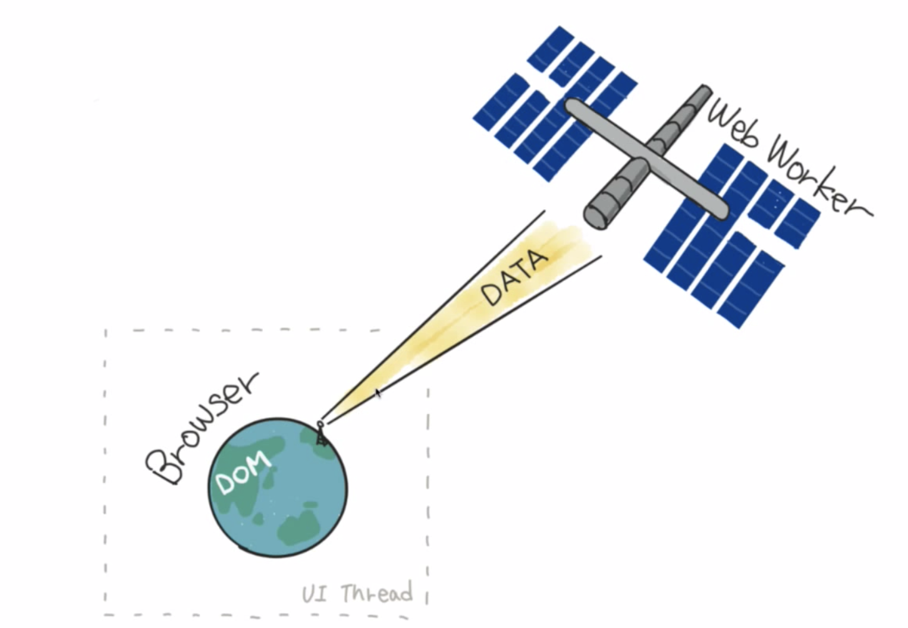

Web Worker is an actual second thread for JavaScript like proper parallelism and then you have a very simple ways to communicate with your original main thread.

The kind of work we can do with web workers are

1. Image canvas
2. Image processing
3. Image filtering

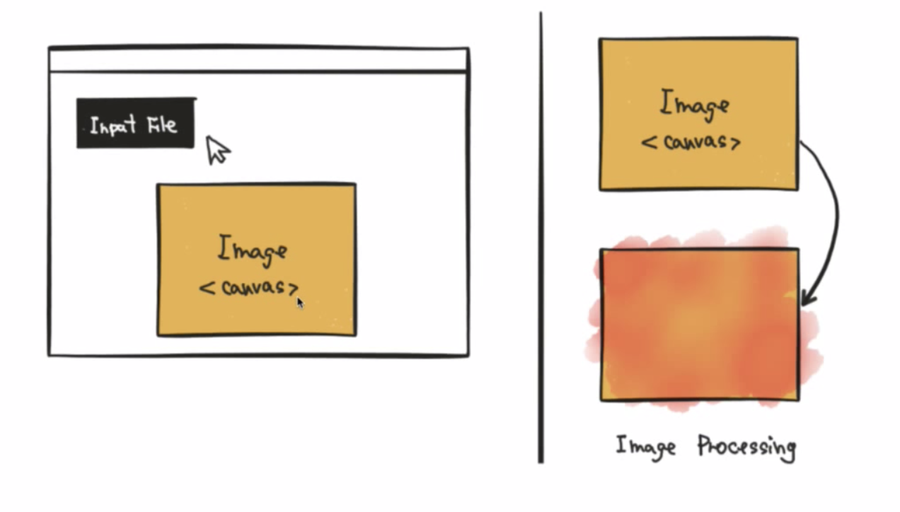

**FileReader** API: it is available on browser to read the file

The **Image()** constructor creates a new [HTMLImageElement](https://developer.mozilla.org/en-US/docs/Web/API/HTMLImageElement) instance. It is functionally equivalent to [document.createElement('img')](https://developer.mozilla.org/en-US/docs/Web/API/Document/createElement).

**Q14. Canvas vs SVG?**



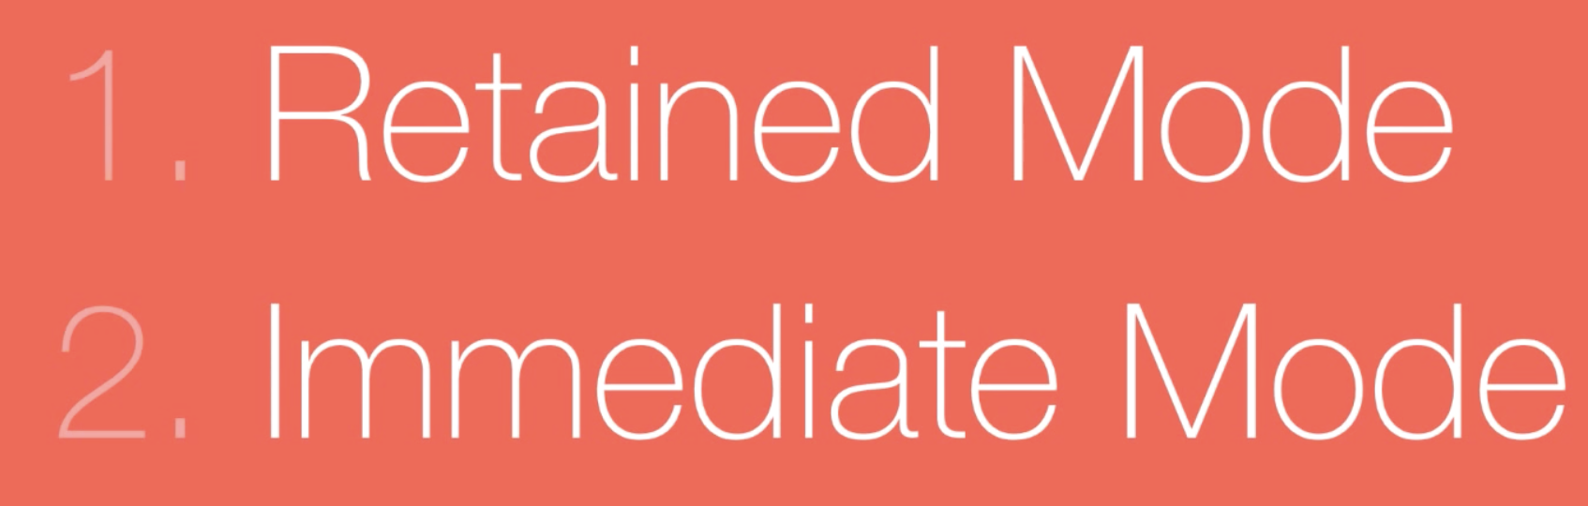

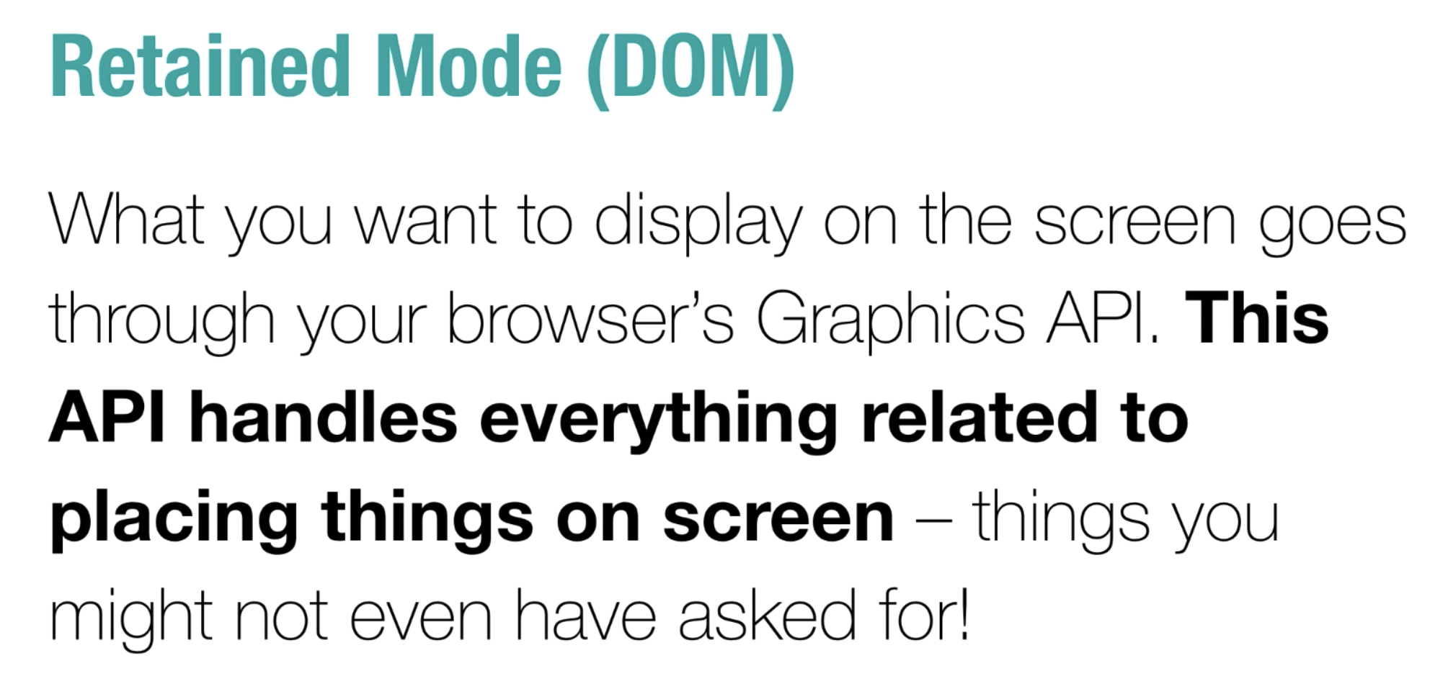

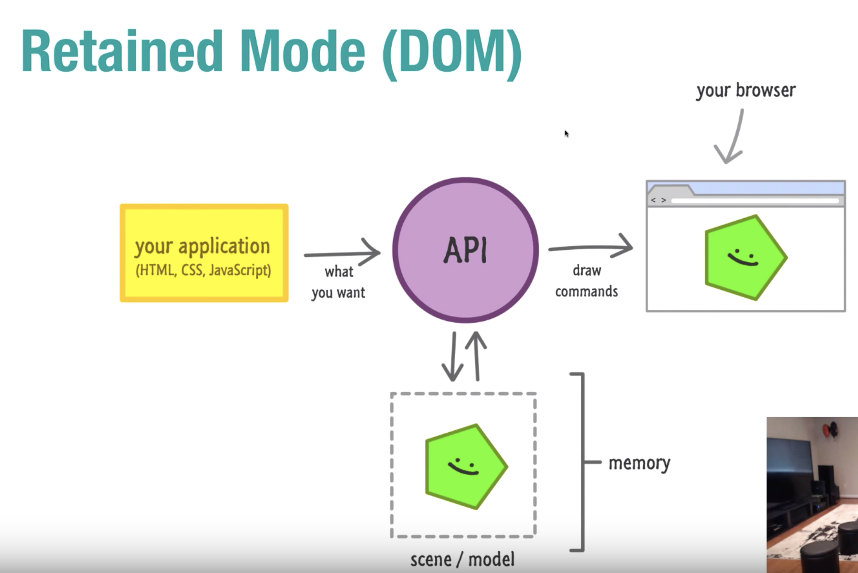

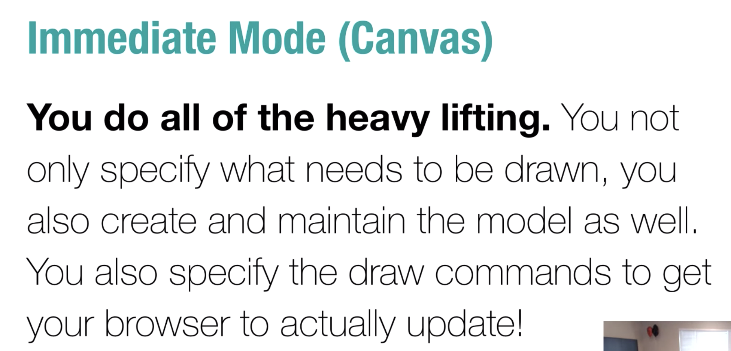

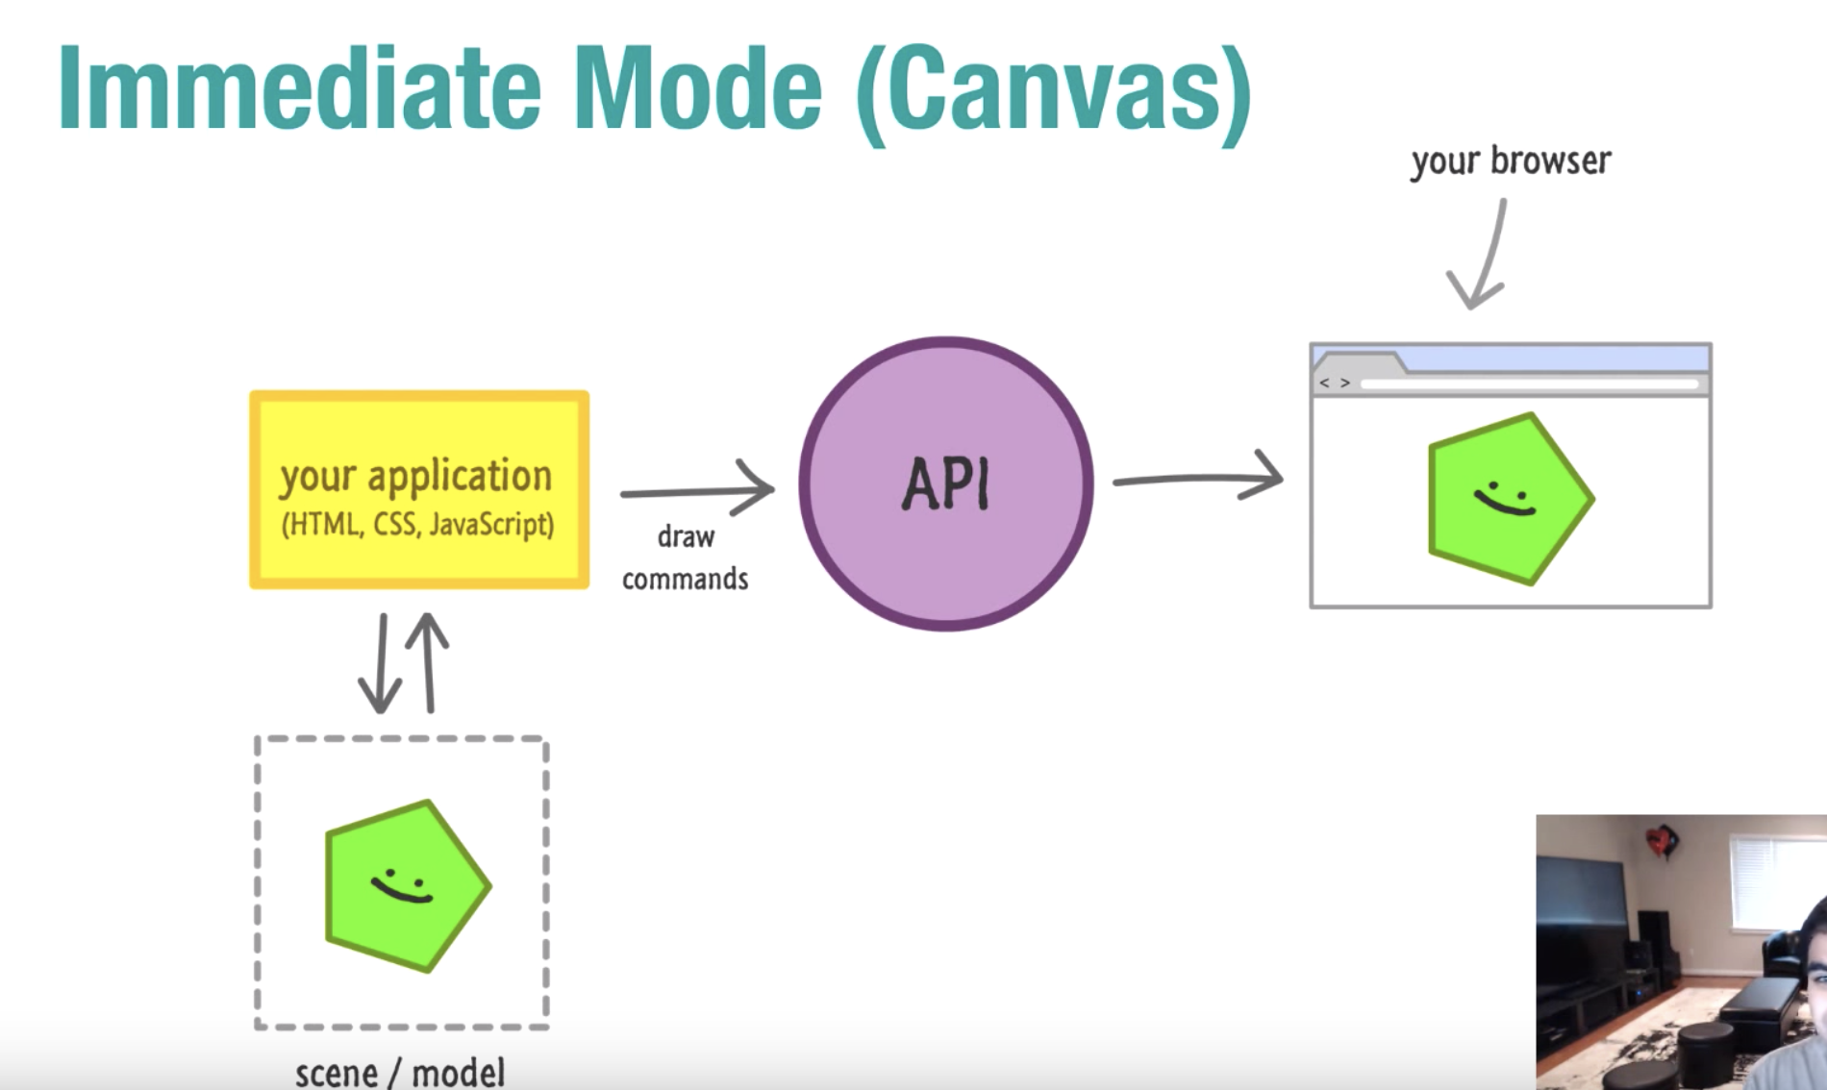

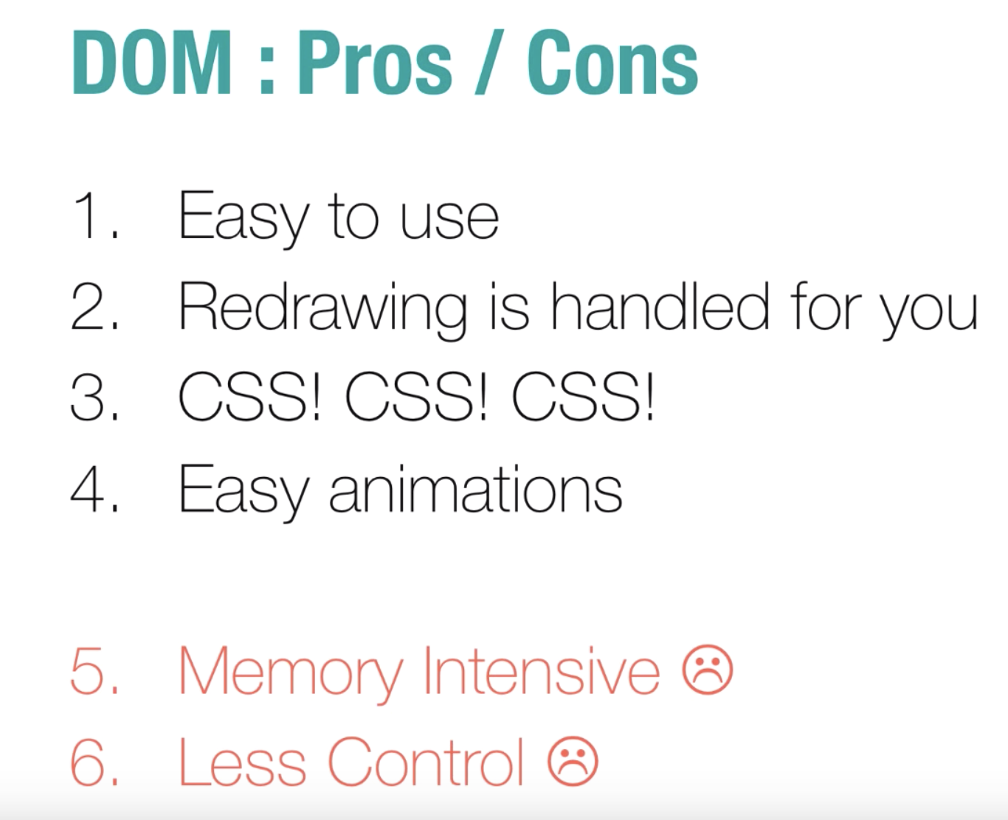

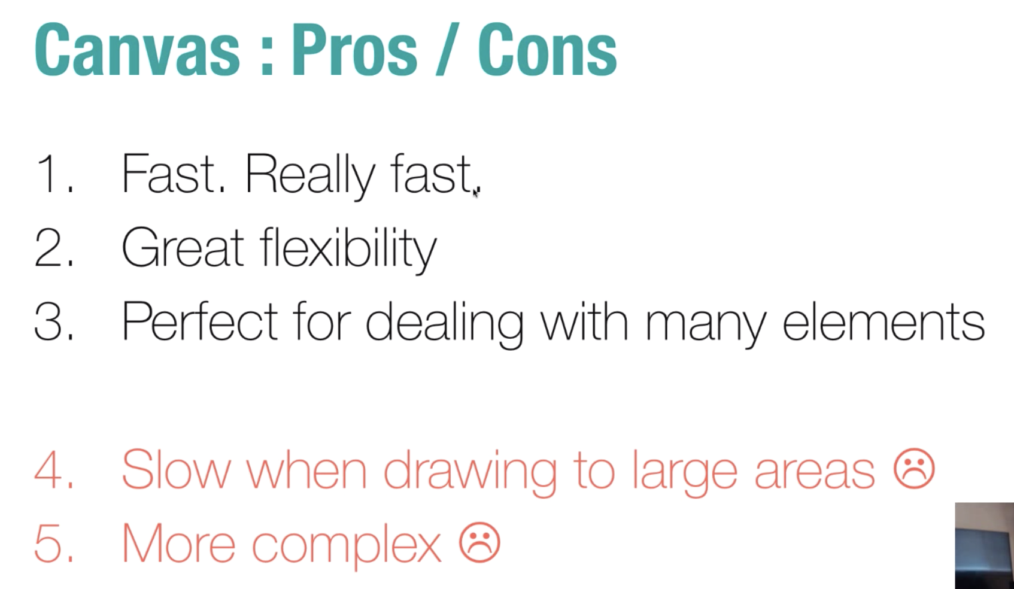

JPG and JPEG are raster images and they don’t work for all the screen sizes.

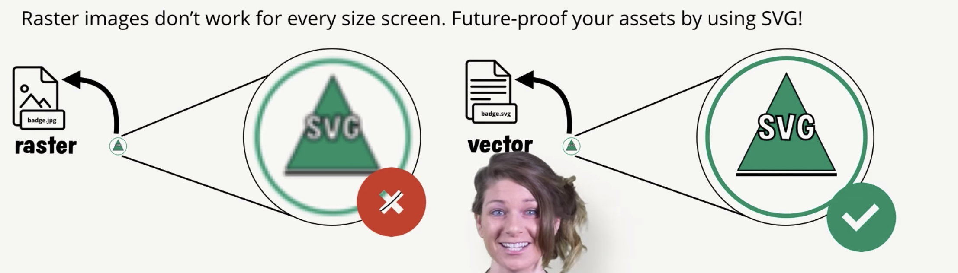

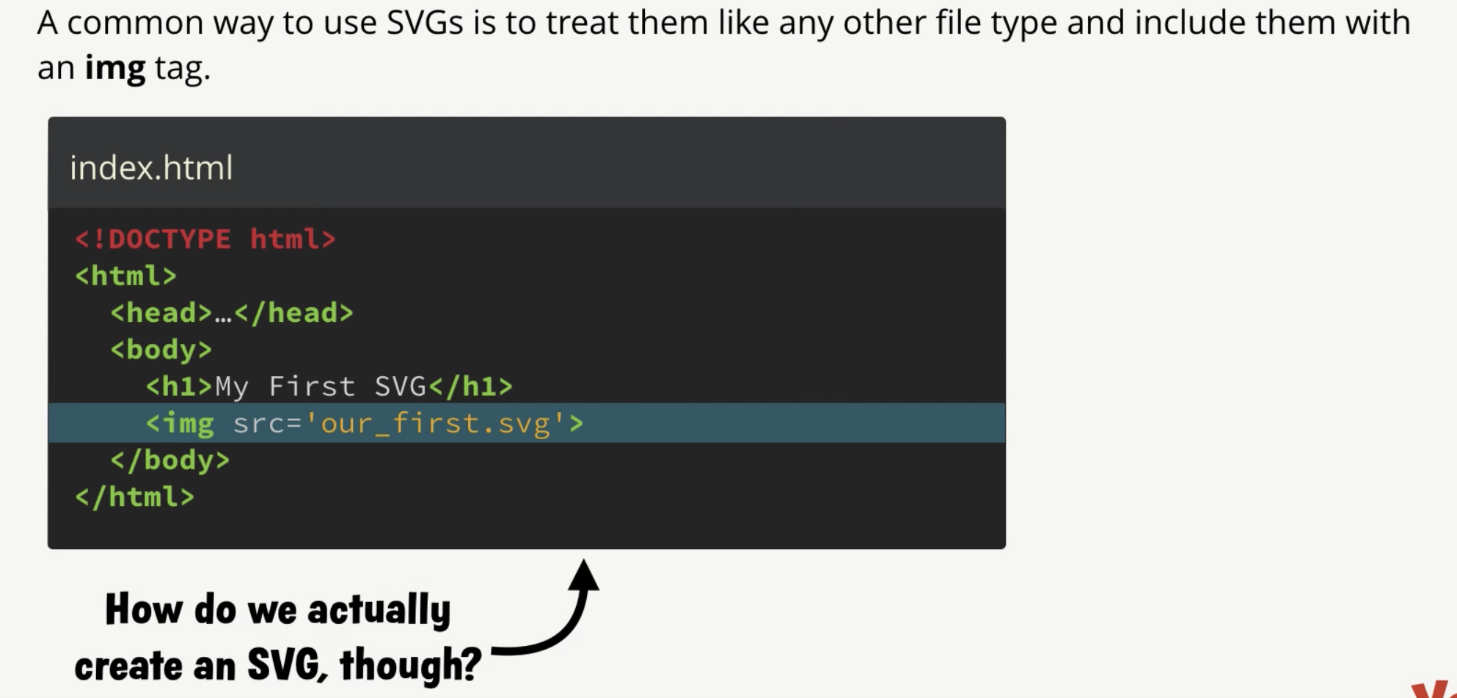

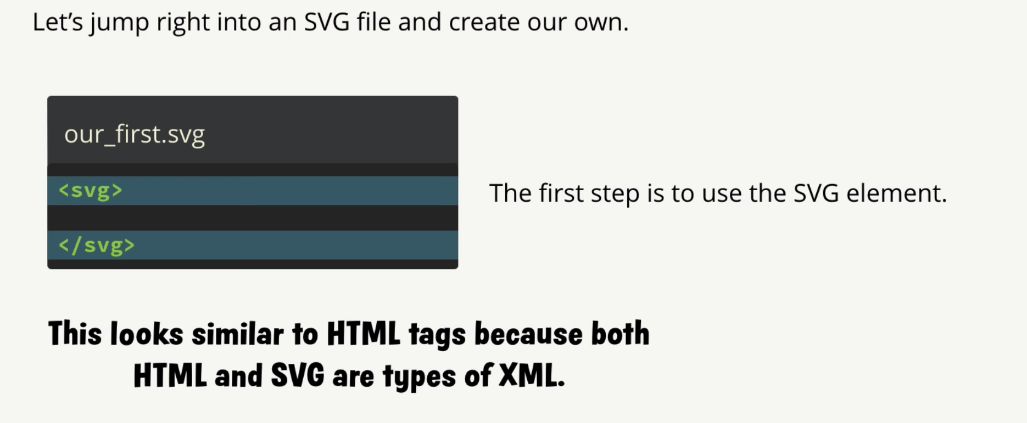

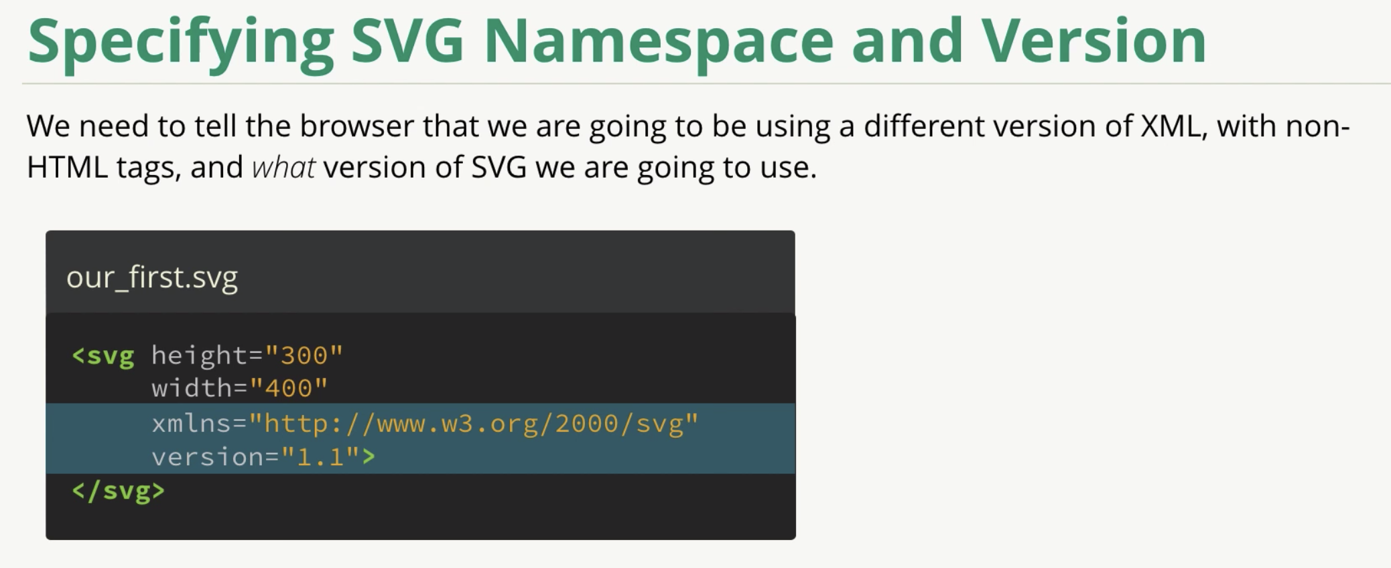

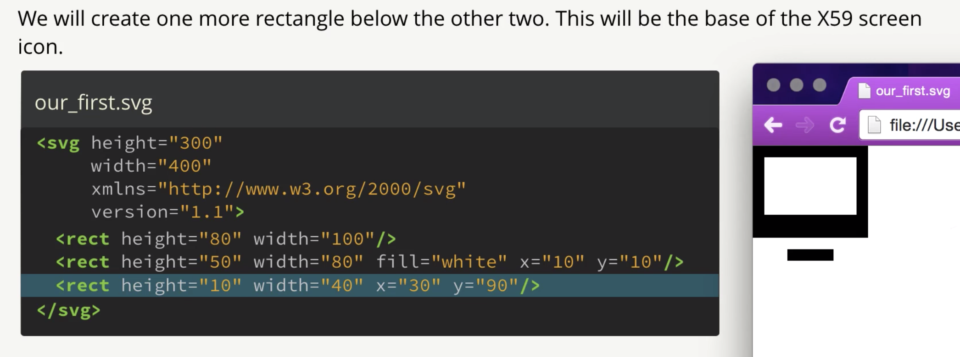

View port important to actually ship to the browser.

